History of Partnership with VAEAI
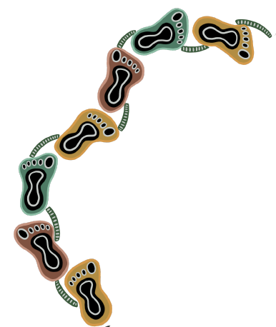
The Department and the Victorian Aboriginal Education Association Inc. (VAEAI) have worked in partnership for over 30 years. Today, VAEAI representatives, including those from its constituent Local Aboriginal Education Consultative Groups (LAECGs), sit on governance groups that oversee all Department-funded Koorie specific programs. VAEAI representation is also integral to the governance structures that oversee significant universal reforms and programs across the Department.

In its formative years, VAEAI was first established in 1976 as the Victorian Aboriginal Education Consultative Group (VAECG). The intent of the VAECG was to increase the presence and voice of Koorie people in education and training decision making, and representatives from Koorie communities across Victoria came together to participate in the development of this formal advocacy body.

Today, VAEAI represents the Koorie Community in relation to education and training policy development and strategic programming at the local, state and national levels. VAEAI supports the provision of education and training that reinforces the Koorie community’s cultural identity and increases awareness in the wider community of Koorie culture and aspirations in education and training.

The following timeline outlines the key milestones in the partnership between the Department and VAEAI.

1990
The partnership between the Victorian Government and VAEAI is first formalised in Partnership in Education: Koorie Education Policy.

1994
VAEAI’s first Koorie State Training Plan for the Vocational Education and Training (VET) sector is published. The National Aboriginal Education Policy Review is also held.

1996
Tripartite Agreement between VAEAI, the Victorian Government and the Commonwealth Government.

1997
The Koorie 2000 strategy is launched by VAEAI, providing the framework for initiatives that operate in the schooling sector to improve outcomes for Koorie students. The Indigenous Education Strategic Initiative Policy Per Capita Funding is also introduced.
2000
An equal partnership between VAEAI and the VET sector is formalised through the Wurreker strategy. Wurreker builds on the success of the 1990 Partnership in Education which developed a supportive and culturally relevant learning environment in the TAFE sector and saw a marked increase in the participation of Koorie students.

2001
The formalised partnership between the Department and VAEAI is updated in the policy Yalca – A Partnership in Education & Training for the New Millennium.

2006
The first whole-of-government Victorian Indigenous Affairs Framework (VIAF) is launched to address the gaps between Aboriginal and non-Aboriginal Victorians.

2008
The Wannik: Learning Together – Journey to Our Future strategy is launched, ensuring that every Koorie child receives a first-class education. The Department and VAEAI also conduct a state-wide review into educational outcomes.

2011
VAEAI releases the Framework for Embedding Koorie Cultures, Histories and Perspectives in Victorian Schools.

2016
VAEAI and the Department collaborate for the first ever ten-year plan for Koorie education in Victoria with the creation of Marrung. Marrung ensures that Koorie learners have full access to the benefits of the Education State, with the Marrung vision driving the work of the Department to improve educational outcomes and opportunities for Koorie people.

2021
The Department and VAEAI embark on a new reform process addressing self-determination in education.

