Current Data – Population and Dispersal

Koorie students in Victoria
The Victorian Koorie community is young and growing. Unique to the Victorian context, it is also the most dispersed in Australia, which is particularly evident across both early childhood and school enrolments. For instance, in 2020 there were approximately 2,600 funded kindergarten services across the state and 1,276 of these had Koorie children enrolled; meaning that 49% of services had at least one Koorie child enrolled. Of these 1,276 funded kindergarten services, 487 had one Koorie enrolment and 27 kindergartens had 10 or more Koorie enrolments.

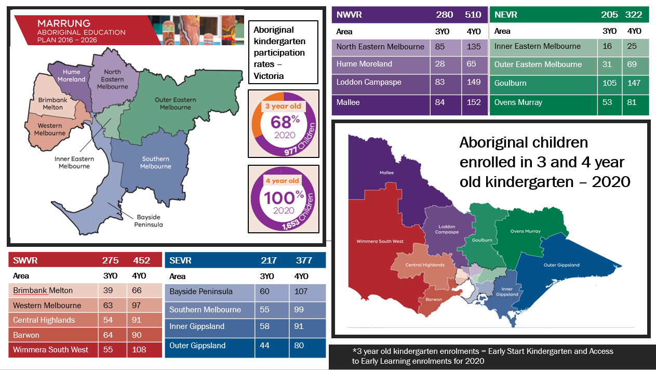

The Koorie student population in Victorian Government schools has grown from approximately 9,200 students in 2011 to 15,174 in 2020, an increase of almost 65%. In 2020, 15,174 Koorie students were enrolled in 1,341 Victorian Government schools across 1,424 school campuses, comprising 87% of Victorian Government schools having one or more Koorie students enrolled. Of the 1,424 school campuses with Koorie students enrolled, 683 (48%) had a cohort of fewer than six Koorie students at the campus, 190 (13%) had over 20 Koorie students, and just 7 (0.5%) had over 100 Koorie students.

The significant dispersal and variability of learning environments for Koorie students highlights the importance of systemic approaches that build schools’ and early childhood services' capacity to be more culturally inclusive and responsible for improving Koorie students' outcomes. It also highlights the importance of supporting schools to engage effectively with their Koorie community on shared responses to locally identified issues and aspirations.

Cultivating a culturally safe learning environment is so important for the schools with small numbers of Koorie students, as it is these students (and families) who will often be living away from their community or may not have the strong community networks to call on, compared with students attending large Koorie-populated schools in bigger Koorie communities. Schools also play an important role in teaching non-Koorie students about Koorie cultures and histories to ensure that the Victoria of the future is a more inclusive, tolerant and safe place for all. Given the young, highly dispersed and quickly growing Koorie population in Victoria, the 13% of schools that do not have Koorie students enrolled today are likely to have Koorie enrolments in the very near future.

Please note that due to the COVID-19 pandemic, enrolment data from 2021 was not available at time of writing.

