Current Data – Early Childhood

Marrung promotes lifelong learning for Koorie Victorians by seeking to make all services inclusive, responsive and respectful, and through supporting culturally safe environments and celebrating the cultural identity of Koorie learners. Thanks in no small part to the tireless work and expertise of our Aboriginal community partner organisations such as VAEAI, other Aboriginal Community Controlled Organisations, and of course Koorie communities, families, and learners themselves, we have travelled a long way in recent times and have seen some significant progress in Early Childhood Education and Care (ECEC) outcomes. Despite the need for continued and accelerated improvement, it is important to take stock, celebrate and learn from the successes.

We know the early years are so important for preparing children for school, and this is particularly the case for language acquisition, as well as for addressing specific developmental vulnerabilities and challenges.

In 2020, almost 100% of Aboriginal four-year-old children in Victoria were enrolled in a funded kindergarten program (1,653 children). This was up from 83% of Aboriginal four-year-old children (1,331 children) in 2017. Impressively, Koorie kids now participate in four-year-old kindergarten at higher rates than non-Koorie children.

The number and proportion of Aboriginal children participating in Early Start Kindergarten programs (three-year-old kindergarten) has also increased, from 44.6% (642 children) in 2016 to 68% (977) in 2020.

Between 2009 and 2015, the proportion of Koorie children identified as developmentally ‘on-track’ in all five domains increased, as assessed through the triennial Australian Early Development Census (AEDC), a population-based measure of how children in Australia have developed by the time they start their first year of full-time school.

However, Koorie children continue to experience developmental vulnerability over all five AEDC domains, and Koorie children’s vulnerability has increased in all domains since 2015, and in all domains except Communication compared with 2012 data (by a marginal amount). Many Koorie children continue to experience very high levels of vulnerability in one or more domains (42.4%) and in two or more domains (26.6%).

The 2018 AEDC data suggests that Koorie children were more than twice as likely to be developmentally vulnerable across all five AEDC domains (click here for more information on these domains), compared to non-Koorie children. 42.4% of Koorie children were developmentally vulnerable in one or more domains, compared with 19.4% of non-Koorie children, and 26.6% of Koorie children were developmentally vulnerable 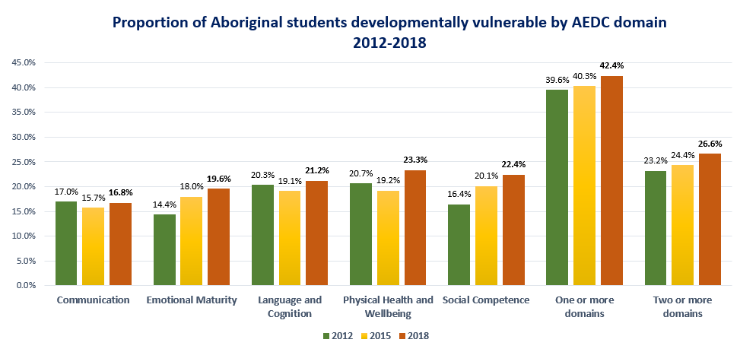
in two or more domains, which was almost three times that of non-Koorie children at 9.8%.

Proportion of Aboriginal students developmentally vulnerable by AEDC domain 2012-2018 data
Domain | 2012 | 2015 | 2018
Communication | 17.0% | 15.7% | 16.8%
Emotional maturity | 14.4% | 18.0% | 19.6%
Language and cognition | 20.3% | 19.1% | 21.2%
Physical health and wellbeing | 20.7% | 19.2% | 23.3%
Social competence | 16.4% | 20.1% | 22.4%
One or more domains | 39.6% | 40.3% | 42.4%
Two or more domains | 23.2% | 24.4% | 26.6%

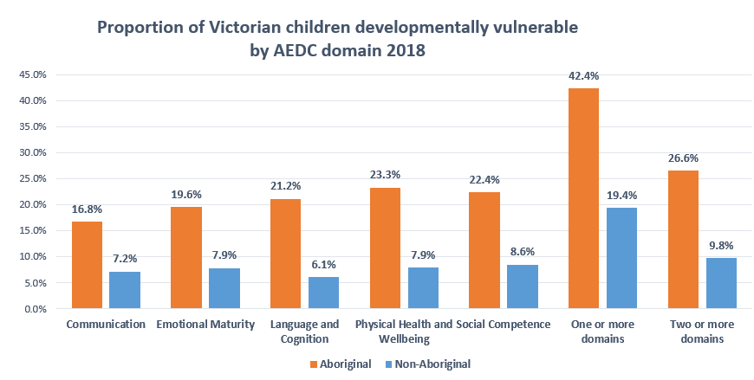
Proportion of Victorian children developmentally vulnerable by AEDC domain 2018 data
 | Aboriginal | Non-Aboriginal
Communication | 16.8 | 7.2
Emotional maturity | 19.6 | 7.9
Language and cognition | 21.2 | 6.1
Physical health and wellbeing | 23.3 | 7.9
Social competence | 22.4 | 8.6
One or more domains | 42.4 | 19.4
Two or more domains | 26.6 | 9.8

Early development measures — especially language acquisition — are important indicators of school readiness and are considered effective signals of potential future developmental vulnerability. Research also shows that children who suffer from early developmental vulnerability, record significantly lower achievement in NAPLAN.

