Navigator
Program Overview

BackgrounD
Education is the centrepiece of the Victorian state. Our education system underpins our shared social and economic prosperity, and strengthens Victoria’s communities and culture. Education provides the means for Victorians to make a living and, even more importantly, to create a life.

The Victorian Government’s Education State reform agenda sets out clear aspirations for creating an inclusive education system where schools can support all learners to stay in education and reach their potential. A system that ensures all Victorians have equal access to the benefits and opportunities that come from education and ensures that every Victorian learner is afforded the opportunity to succeed.

An inclusive education system tailors its approach to all learners. By providing an inclusive and excellent education system, we can break the links between a person’s postcode and their life chances. All students should be engaged in their education, and should they ever disengage from schooling, our education system should work toward their re-engagement in partnership with other systems.

In Victoria, there are a significant number of learners who have been disengaged, or are vulnerable to disengaging, from education or training. Evidence from across Australia demonstrates that the likelihood of disengagement is increased by Indigenous status, having a language other than English spoken at home, living in rural areas and lower socio-economic status. Learners who have mental health issues and/or a disability are also more likely to be disengaged. Homelessness, alcohol and drug use, exposure to family violence and trauma also feature in the backgrounds of disengaged young people. As a result, disengaged young people often need intensive, multifaceted supports to enable them to overcome these barriers and pursue educational success.

The Navigator Program fills this essential service gap by providing individualised, intensive case management support – it is a targeted education support service, that works in partnership with young people, families, support services and schools to enable young people to achieve their educational goals.

NAVIGATOR
In September 2015, the Victorian government announced the $566 million (over four years) state-wide Education State: Schools reform agenda, which included funding of $8.6 million over two years to pilot Navigator services. The Navigator pilots were a key initiative under the Education State agenda and have contributed to ensuring that every student in Victoria, regardless of background, place or circumstance, has the chance to succeed in learning and in life.
Navigator has been operational in 8 pilot Areas across Victoria since it commenced in July 2016.

The 2018-19 State Budget allocated $43.8 million over four years and $14.9 million ongoing to continue and expand the Navigator program state-wide. The expansion of Navigator is to be phased over 2019-2021.
In January 2019, Navigator commenced in Brimbank/Melton, Loddon Campaspe and Inner Gippsland.
In January 2020, Navigator will commence in North East Melbourne, Barwon and Wimmera South West. Further information on the Department of Education and Training (DET) Area boundaries can be found at: https://www.education.vic.gov.au/about/department/structure/Pages/regions.aspx
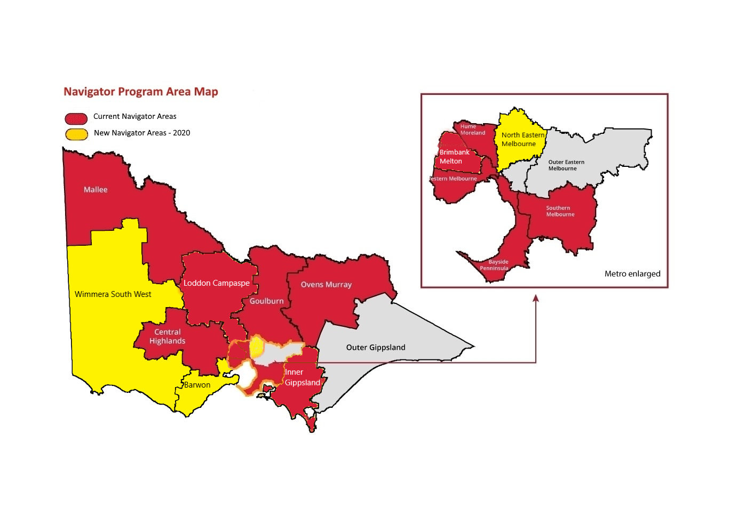Figure 1: Map of Navigator Areas
The purpose of the Navigator program is to provide direct case management support to disengaged young people, to support them to successfully re-engage with education. The Navigator program model is defined by its partnership approach between the community sector, DET and education providers to enable a service that:
- actively seeks out disengaged young people and provides individualised support that is targeted to supporting their re-engagement back into education, and that is focused on the young person’s needs, strengths and interests
- can work with their families, carers and support networks to provide holistic support
- supports place-based responses to disengagement by drawing on a range of local services and working collectively to solve local issues.
Each of these partners have particular expertise, resources and roles in delivery of the program (see Figure 1).

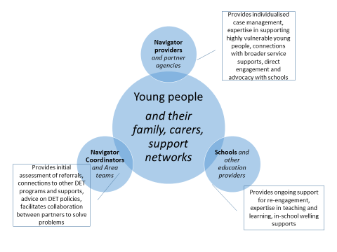
Figure 2: Program structure
Navigator is available to young people who:
- are aged between 12 and 17 years of age
- have attended less than 30% of the previous school term or equivalent time period (if enrolled in a school)
- either live in or have most recently been enrolled in an education setting in a current Navigator Areas.
Anyone can make a referral to the Navigator program.

Program Structure
Service Provider
A lead community service organisation (Service Provider) is contracted to deliver the service in each Area, and this may involve delivery through consortia of local organisations working in partnership.

The service delivery model for Navigator involves Service Providers:
- receiving referrals from the Navigator Coordinator, seeking out and connecting with learners who have disengaged from schooling
- working with the young person to identify their learning needs, capabilities and aspirations and develop an education re-engagement plan that involves family, carers, school and community supports
- working closely with other community services and education providers to ensure the relevant provision of wrap around supports for the young person and their family
- assisting young people to overcome learning, social and other barriers so that they can successfully engage and transition through education, including engaging support services where required
- monitoring and supporting a young person as they re-engage in education for a period of up to six months and then following up six months later to see if they have remained engaged.

Navigator Coordinator
The DET Navigator Coordinator is the primary contact for Service Providers - they play a key role in the implementation of the Navigator program and facilitate the connections between Service Providers and educational insititutions. They work closely with their local Service Provider and play a key role in managing the relationship between Service Providers, schools, DET Area teams and other key services.
Navigator Coordinators receive all referrals to the program and engage in relevant data reporting processes that monitor re-engagement processes and outcomes for young people. Navigator Coordinators establish eligibility for the program and facilitate the linkage of young people to broader Area and community supports.
Governance
It is expected that Service Providers, in collaboration with DET have strong program governance structures that support effective service coordination, ongoing collaboration with DET, schools, services and the community sector. Relationships and partnerships with relevant stakeholders are essential to align service responses to young people who have disengaged with education, and reduce service duplication in local areas.
There are three levels of governance that inform the operation and development of the Navigator program model at the local level. It is important that there is a degree of flexibility in the implementation of governance structures, to ensure that local contexts are catered for, and existing mechanisms of governance can be utilised where appropriate.
The establishment of local governance structures are a key component of the partnership approach to the delivery of the Navigator program – it provides a forum to bring together local Department and community initiatives, to share Navigator data and to discuss emerging issues in the context of student disengagement. These levels of governance are to be developed in a partnership approach between the Department Area team and the Provider.
At the Program level
This primarily involves the regular weekly/fortnightly meetings held between the Navigator Coordinator and the Provider regarding referrals and program implementation. This includes case management issues, referrals and program progress. Also discussed at this level is the operation and the status of young people receiving Active Holding support, and any issues relating to clients who may be exiting the program.
This is an important forum for the Provider and DET to work in collaboration regarding program implementation, to have an understanding of the support that Navigator is providing to particular young people, and to also facilitate the interface between Navigator referrals and any further support that the Area can provide via the Navigator Coordinator.
Operational governance
This level of governance is to discuss broader implementation and practice issues relating to the service model in the Area. Membership of this group can be locally determined, however may involve Providers and Partners (including management level staff), Navigator Coordinators and relevant area based staff (Services Support Manager), and other relevant support services that may be important in the delivery of the service model, and in addressing issues that relate to the cohort of young people being supported by the Navigator program. This level of governance is a foundation for collaborative working between Providers and DET Area staff, including the opportunity to identify and progress issues related to working with schools. It is an opportunity to involve relevant services at the operational level in order to ensure that the program is addressing the needs of eligible young people in the most effective way.
Strategic governance
This is a higher-level strategic forum to assist in the identification of broader opportunities to support vulnerable young people and their families and in addressing broader issues concerning student disengagement. It is an opportunity to share relevant quarterly data with the appropriate networks to provide information and context of emerging issues. Membership of this level of governance can be determined locally and should take into account other available services within the Area. This level of governance can also assist in identifying particular sub-cohorts of the Navigator population, which may require further locally targeted supports such as particular CALD communities, or issues that are particular to a certain area.
It is important that this level of governance is initiated and led by the DET Area, in order for it to align with DET Area priorities.

navigator service capabilities
- Service Providers will be required to demonstrate the knowledge and experience outlined in Table 1
Table 1: Knowledge and Experience
1: A sound knowledge of the:
- Victorian education system, education and training pathways and relevant legislation , including the Education and Training Reform Act 2006, the Victorian Curriculum, Primary and Secondary schooling (including alternative schools) and other training options such as Learn Locals and TAFE institutes
- local context in the Area where they propose to operate
- the key stakeholders in the Area
- supports available to young people to assist them overcoming barriers to education
- student inclusion and engagement guidance and re-engagement policy
- services and support operating within the DET, including social and emotional learning curriculum and resources

2: Experience in:
- working with vulnerable young people who encounter barriers to engaging in education or training such as alcohol and other drug (AOD) issues, anxiety, depression, family conflict, caring responsibilities or homelessness
- working with schools, local education providers and local support services (such as School Focused Youth Service and Local Learning and Employment Networks)
- working with Indigenous learners and learners from culturally and linguistically diverse backgrounds, and developing interventions and programs that are culturally appropriate to these learners
- planning and delivery of services to young people over a wide geographical area
- establishing or linking with existing governance committees to oversee work and impact
- assessing the learning needs of young people

- Navigator Service Providers will be required to demonstrate the ability to deliver the key service components that are outlined in Table 2
Table 2: Key Service Components
1: Assertive Outreach
- Seeking out, and connecting with, learners who have disengaged from schooling
- Following up on referrals from schools or agencies, making personal contact with the young person and developing effective working relationships

2: Active Hold / Waitlist support
- Implementing processes for prioritisation of referrals, managing demand for service, and to deliver differentiated levels of support to young people and their families.
- Young people should receive a ‘light touch’ service whilst on Active Hold including, where appropriate, linkages to other services

3: Working with young people and their families
- Delivering individual coaching and mentoring to assist young people to enhance wellbeing and develop resilience, self-efficacy and social skills
- Providing advocacy support to successfully engage support services within schools and other education settings, as well as for re-engagement with family or community networks
- Assisting young people to overcome learning, social and other barriers so that they can successfully engage and transition through education to the completion of Year 12 or equivalent

5: Collaborative working relationships with local agencies and schools
- Working with other agencies (particularly local agencies) to form a functioning network of services that will identify and support young people who are disengaged, or vulnerable to disengaging, from school and training
- Establishing strong working relationships and referral pathways with key local agencies who provide services to vulnerable, complex and marginalised young people in the local Area (for example AoD, mental health, out-of-home care, homelessness and family violence)
- Working with schools leaders, teachers and communities
- Working closely with local DET Area staff
- Working closely with other governance bodies and programs targeting disengaged learners, or learners vulnerable to disengagement such as the Education Justice Initiative, Children and Youth Area Partnerships, School Focused Youth Service (SFYS) and Local Learning and Employment Networks

6: Follow up in schools
- Monitoring learner integration in the school for the first six months following re-engagement, and for a further six months to ensure sustained engagement.
- Referring learners to services that can support them in school

navigator outcomes
The three overarching outcomes Navigator is seeking to achieve are:
- Re-engaging young people to education
- Developing students with greater social and emotional capabilities
- Supporting schools to be better equipped to engage all young people (indirect outcome)

Table 1: Program outcomes and success measures
Outcomes | Measure of success | Target
Re-engagement
Return to education | Numbers of learners returned to education (commence education or increase attendance) | 70% of learners engaged with Navigator will return to education
Sustained engagement in education | Levels of attendance – sustained re-engagement | Of the learners that re-engage in school, 50% will remain engaged for six months (measured by attendance of greater than 70%)
Growth in social and emotional capabilities
Greater connection to education | Comparison of entry and exit survey | Navigator clients reporting higher school connectedness
Greater motivation to stay in education | Comparison of entry and exit survey | Navigator clients reporting higher student motivation
Greater motivation and confidence | Comparison of entry and exit survey | Navigator clients reporting higher levels of student motivation and learner confidence

Re-engagement: The key outcome of the Navigator program is to re-engage as many young Victorians back into education as possible. Service Providers should work with the learner to identify an appropriate school, flexible learning program, TAFE or other RTO that can best meet the needs of the young person. Given that this cohort of learners typically experience barriers to strong engagement with learning, Service Providers will also be expected to support learners in their transitions back into education and reconnect with learners who disengage again.

Growth of social and emotional capability: Growing learners’ resilience and social and emotional capability will strengthen their ability to manage the re-engagement process.
These capabilities are not static traits. They need to be learnt and developed alongside the development of cognitive skills.
To this end, the Navigator Service Providers will also need to focus on holistic outcomes for learners, including:
- improved resilience, self-confidence and skills in problem solving
- the development of career goals and pathways
- being more active members of the local community
- improved skills in language and literacy

Working with schools: An indirect outcome of Navigator is that schools will be supported to develop a better understanding of how to cater for learners vulnerable to disengaging and reconnect with learners who cease attending. Through close collaboration with providers, schools will be able to learn and access the supports and practices available to help overcome the barriers that stop some of their learners from fully engaging in schooling.

Reporting requirements
At the commencement of the contract, successful Providers will complete an initial Service Plan which will outline their model for service delivery. Data reporting for the program is an ongoing requirement – Providers are expected to keep their student outcomes data up to date (at least weekly) and submit a quarterly financial report detailing income and expenditure.
The reporting process and measures are designed to:
- Demonstrate and monitor the outcomes of the provision of Navigator services
- Provide specific place-based snapshots of the performance of the program in engaging young people
- Inform future directions for re-engagement initiatives in Victoria.

Lamb, S., Jackson, J., Walstab, A. and Huo,S. (2015) Educational opportunity in Australia 2015 Who succeeds and who misses out. Mitchell Institute; and Dandolo Partners (2014). Evaluation of the National Partnership on Youth Attainment and Transitions. A report for the Department of Education
Lamb, S., Jackson, J., Walstab, A. and Huo,S. (2015) Educational opportunity in Australia 2015 Who succeeds and who misses out. Mitchell Institute; and Dandolo Partners (2014). Evaluation of the National Partnership on Youth Attainment and Transitions. A report for the Department of Education

