Marrung Education Scholarship
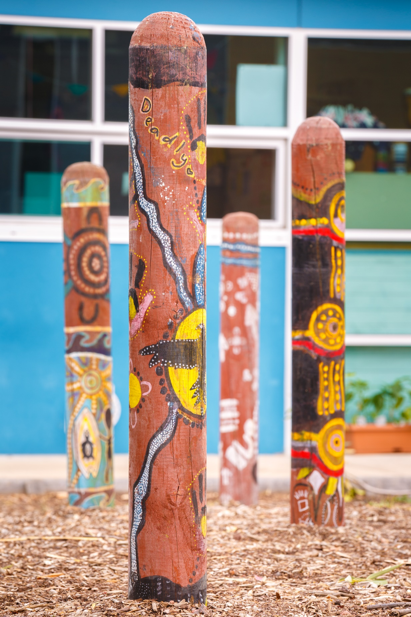
Guidelines

Marrung (pronounced: MA-roong):
Wemba Wemba word for the Murray Cypress pine tree (Callitris columellaris) – representing branches of education and knowledge. We thank the Wemba Wemba people for allowing the use of their language in the naming of Marrung.

Artwork:
The stories painted on the timber bollards were designed as part of the Spreading the Message project which brought together a group of Koorie young people from Northern Bay P-12 College to share their experiences and stories through art. Their art illustrates the diversity of Koorie young people, their understanding of culture and aspirations for connections to family and community. This project has opened a dialogue between Koorie and non-Koorie young people in their local school community, a fundamental step to building relationships that break down stereotypes and progress reconciliation.

Acknowledgement of Traditional Owners
The Department of Education and Training acknowledges and honours the Traditional Owners of Victorian lands and waters, and we pay respect to Elders past and present of all Victorian Aboriginal communities.

Language used in these guidelines
The Department of Education and Training recognises the diversity of Aboriginal people living throughout Victoria. While the terms ‘Koorie’ or ‘Koori’ are commonly used to describe Aboriginal people of southeast Australia, this plan uses the term ‘Aboriginal’ to include all Aboriginal and/or Torres Strait Islander people living in Victoria. Koorie is maintained when it is the name of a program or title.

Accessibility
If you would like to receive this publication in an alternative format, please contact the Relay service on 133 677 or www.relayservice.com.au. Word version (accessible) and online version available at https://www.education.vic.gov.au/about/programs/Pages/marrung.aspx

Contents

Applying for a scholarship 4
The Marrung Education Scholarship program 4
Who can apply? 4
How are successful applicants selected? 4
How to apply 4
Selection Criteria 5
A guide to respond to selection criteria. 5
Help with your application 7
Obtaining assistance in completing your application 7
The school’s role 7
Accessing and using the scholarship funds 8
Payment of funds 8
What can funds be used for? 8

Applying for a scholarship

The Marrung Education Scholarship program
The Marrung Education Scholarship program provides scholarships to support Aboriginal and/or Torres Strait Islander students in Victorian government schools to complete senior secondary education. The Victorian Pathways Certificate (VPC), Victorian Certificate of Education (VCE), VCE Vocational Major (VCE VM).
The program offers 30 scholarships of $5,000 each ($2,500 per year over two years).
The scholarships recognise students who demonstrate a high potential to succeed in their chosen pathway and commitment to education.

Who can apply?
The scholarship program deliberately recognises equity in excellence. Students in flexible learning programs, specialist education, VPC, VCE and VCE VM are eligible to apply. Marrung Education Scholarship, students must be:
- Aboriginal and/or Torres Strait Islander
- completing Year 10 at a Victorian government school
- planning on completing Year 11 and 12 (or equivalent) at a Victorian government school.

How are successful applicants selected?
A selection panel comprised of representatives of the Department of Education and Training (DET) and the Victorian Aboriginal Education Association Incorporated (VAEAI) review applications against the six criteria and select 30 successful applicants.
Selection is based on the following weighted criteria assessed for each applicant. Reasonable adjustment is applied to students attending flexible learning and specialist education programs.
- Commitment to complete years 11 and 12 (20%)
- Goals and aspirations (20%)
- Resilience and motivation (20%)
- Involvement in the Aboriginal community(25%)
- Learning reports and attendance (15%)
- Referees.

How to apply
Applications open Thursday 20 October 2022. To apply for a Marrung Education Scholarship, eligible students need to:
- Download the application form from https://www.education.vic.gov.au/about/programs/Pages/marrung.aspx
- Students to complete the application form themselves, responding to criteria 1-4 and nominating two referees to complete criteria 6.

Submit the completed application via email:
Subject: Marrung Scholarship [insert full name of applicant and school] marrung@education.vic.gov.au by the closing date, Friday 18 November 2022.

Selection Criteria

A guide to responding to selection criteria.
When responding to criteria, look at the weighting and the word count to think about how much information to include.
Criteria | Guide
Commitment to complete years 11 and 12  Question one:  Why is completing Year 12 important to you?  Words: up to 175 words  Weighting: 20% | In answering the question:  Why is completing Year 12 (or equivalent) important to you?  Clearly outline why you want to complete Year 12 (VCE, VCE Vocational Major, other).  Give examples such as:  - What will your completion mean to your family (e.g. first to do year 12, motivate younger siblings)?  - personal success, overcoming adversity, exceeding expectations  Tell us about your:  - education goals  - career goals  Up to 175 words, so plan your writing for maximum impact.
Goals and aspirations  Question two:  What are your goals for the future?  Words: up to 220 words  Weighting: 20% | In answering the question:  What are your goals for the future?  Give examples of what you want to achieve through further study and work, such as:  - What you would like to study (at university/TAFE/other)?  - Apprenticeship, Defence Force, College of Arts, or other aspirations  - Employment options you are exploring  - Additional classes external to your school that you attend/attended  Remember, you have up to 220 words – so dream big. You may include goals about the economic or social benefits of your intended study/work.
Resilience and motivation  Question 3:  Describe an achievement that you are proud of.  Words: 100-175  Weighting: 20% | In answering the question:  Describe an achievement that you are proud of.  Draw upon examples from an area of your life you are passionate about, maybe you want to describe two?  You have up to 175 words to answer.  It can be hard to talk yourself up … ask a friend for their ideas too!  Examples could include:  - Educational achievements: Awards  - Sporting achievements: as a coach or player  - Aboriginal community achievement: being selected to represent your school or community (i.e. raising the Aboriginal flag for NAIDOC Week)  - Personal development: taking on a challenge (long hike, marathon, bronze medallion)  - Community work: (soup kitchen on Christmas Day), volunteering (tutoring siblings, aged care, gardening)  - Arts achievement: in visual arts, media, music, or dance  - Part-time employment.
Involvement in the Aboriginal community  Question 4:  Tell us about your involvement in the Aboriginal Community and what it means to you.  Words: 100-250  Weighting: 25% | In answering the question:  Tell us about your involvement in the Aboriginal Community and what it means to you.  Provide two examples of your involvement in the Aboriginal community, such as:  - Learning cultural dances or language  - Involvement with your local Aboriginal organisation  - Your families and your involvement in NAIDOC Week  - Playing in Aboriginal sport events or carnivals  - Singing or doing stand-up at community gatherings or talent nights  - Organising activities or events for Aboriginal community  - Attending a Koorie youth group.  Remember! - part two of the question is why your involvement in the Aboriginal community is important to you.  - You have up to 250 words to share your involvement with mob and what that means to you.
Learning reports and attendance  Weighting: 15% | You do not need to respond to this criteria.  The Koorie Outcomes Division, which looks after the scholarship process, will receive your learning report and attendance during year 10 directly from your school.
Referees | Seek two referees:  - One who is Aboriginal, One from your school  You do not need to respond to this criteria. You can attach a letter from your two referees to your application.  Tips for your referees!  Information you may like to discuss in the reference you provide might include subjects such as:  - enhance social and emotional wellbeing  - individual talents and leadership  - strengthen identity, culture, and faith  - overcoming adversity and challenge  - community participation  - build relationships  - has made efforts to link into education, training and employment  - improvement.

Help with your application

Obtaining assistance in completing your application
Your family and/or school can contact a Koorie Engagement Support Officer (KESO) for guidance and advice on completing an application.

For enquiries regarding KESO support, contact the Koorie Education Coordinator (KEC) in the area that your school is in. A list of KECs is at Contact a Koorie education coordinator | Victorian Government (www.vic.gov.au).

The school’s role
The role of schools in supporting and monitoring the progress of successful applicants is core.
Scholarships are awarded on the understanding that schools will liaise with the student and family/caregiver/kin and seek advice and support from the KESO if needed, particularly if the student is disengaging, at risk of disengaging, or considered unlikely to complete senior schooling.
School accountabilities associated with the Marrung Education Scholarships are:
- At the completion of Year 11, the school is required to forward a report to the Koorie Outcomes Division, confirming the student’s satisfactory progress and commitment to completing Year 12. The second scholarship payment is conditional upon the provision of the report.
- Scholarship holders must demonstrate satisfactory attendance and progress to maintain their scholarship throughout the scholarship period.
- Year 12 students are asked to complete an evaluation questionnaire at the completion of the final year of the scholarship. (The questionnaire will be sent to the Principal in October).
If there are issues which may require intervention or decision-making with respect to the Marrung Education Scholarship, schools should contact the Koorie Outcomes Division directly marrung@education.vic.gov.au.

Accessing and using the scholarship funds

Payment of funds
The Marrung Education Scholarships are valued at $5,000 over two years.
The scholarship is paid in two instalments of $2,500, directly debited to a bank account nominated by the student.
Each instalment will be paid before the commencement of each school year.
The Koorie Outcomes Division checks in with your school to confirm successful completion of year 11 and enrolment in year 12 before paying the second instalment.
Scholarship holders must demonstrate satisfactory attendance and progress to maintain their scholarship throughout the scholarship period.

What can funds be used for?
The funds are to support students to complete years 11 and 12.
The student decides how the funds are used, with guidance from family/caregiver/kin and/or school.

Some ideas:
- tutoring
- study supplies (stationery), resource books and/or ibooks
- IT such as laptop, software, home printer
- specialist equipment for use in chosen VCE subjects. (e.g., camera, graphic set, musical instrument, calculator)
- specialist equipment for VCE Vocational Major (e.g., tools, personal protective equipment)
- school and specialist uniforms (e.g., sport, trade)
- annual travel passes to get to school/VCAL and/or job placements on public transport
- furniture to support study (e.g., desk, ergonomic chair)

Year 11 and 12 (or equivalent)

