Marrung Education Scholarship
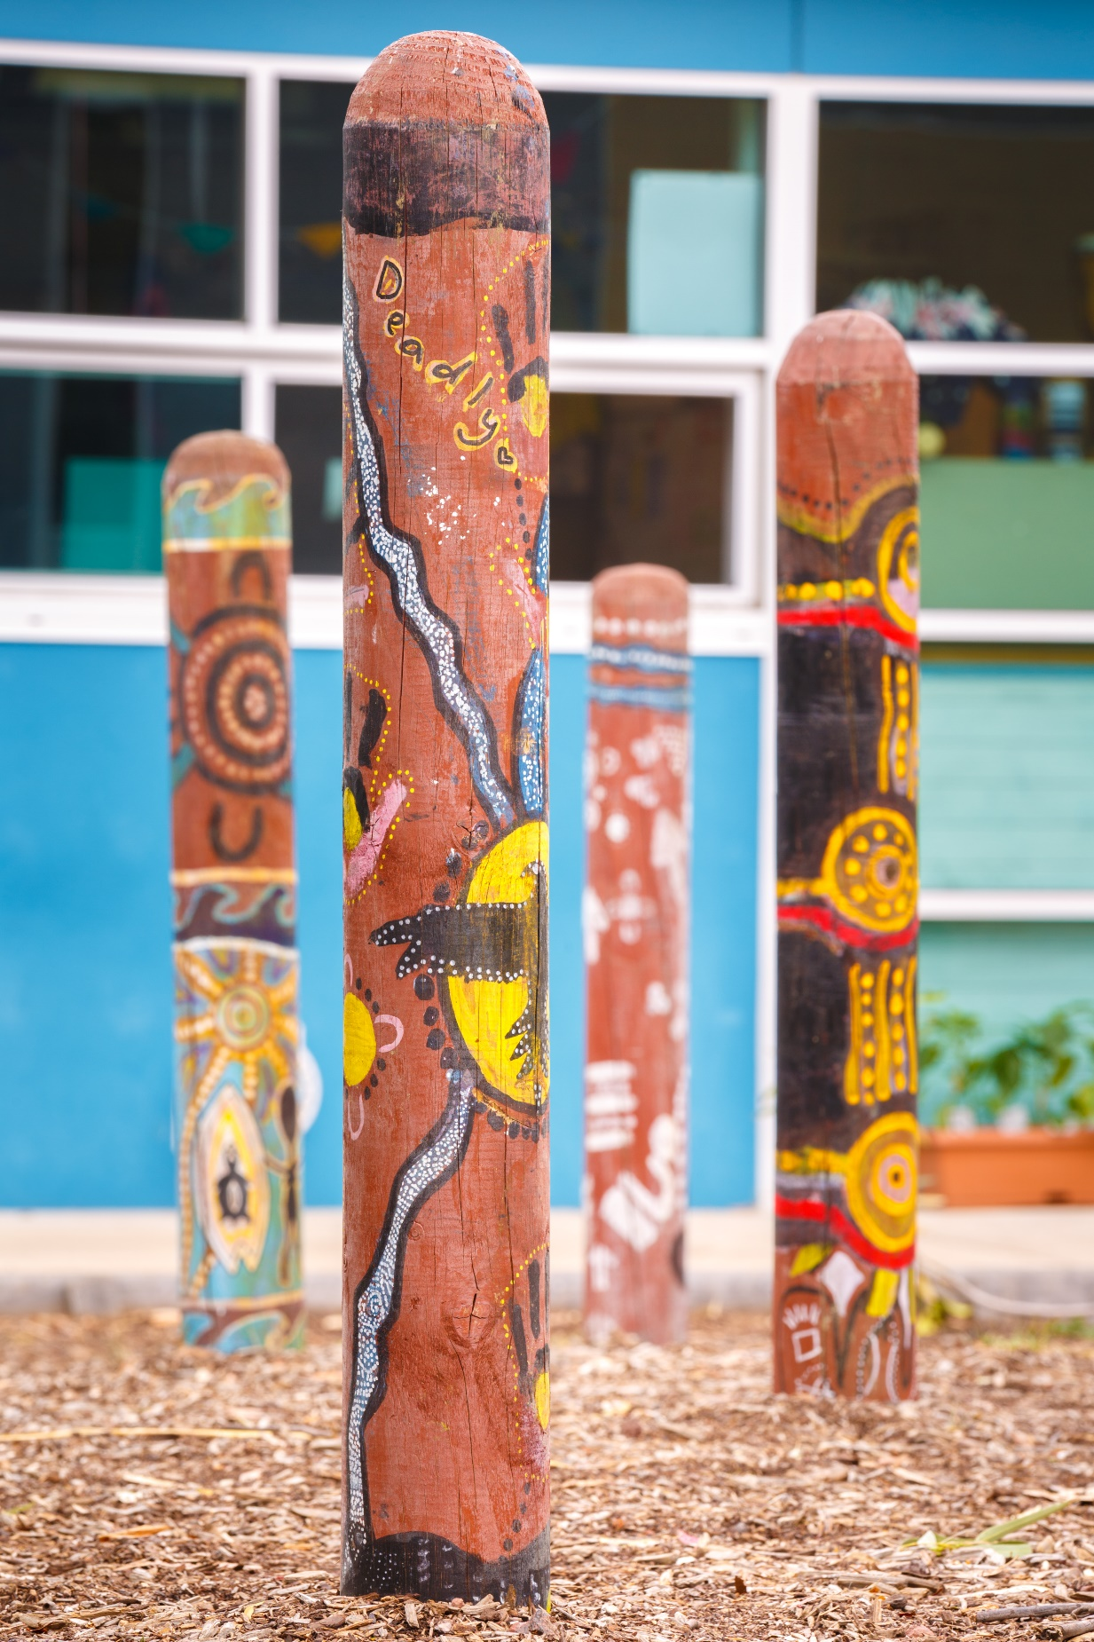
Application form

Marrung (pronounced: MA-roong):
Wemba Wemba word for the Murray Cypress pine tree (Callitris columellaris) – representing branches of education and knowledge. We thank the Wemba Wemba people for allowing the use of their language in the naming of Marrung.

Artwork:
The stories painted on the timber bollards were designed as part of the Spreading the Message project which brought together a group of Koorie young people from Northern Bay P-12 College to share their experiences and stories through art. Their art illustrates the diversity of Koorie young people, their understanding of culture and aspirations for connections to family and community. This project has opened a dialogue between Koorie and non-Koorie young people in their local school community, a fundamental step to building relationships that break down stereotypes and progress reconciliation.

Acknowledgement of Traditional Owners
The Department of Education and Training acknowledges and honours the Traditional Owners of Victorian lands and waters, and we pay respect to Elders past and present of all Victorian Aboriginal communities.

Language used in this Application form
The Department of Education and Training recognises the diversity of Aboriginal people living throughout Victoria. While the terms ‘Koorie’ or ‘Koori’ are commonly used to describe Aboriginal people of southeast Australia, this plan uses the term ‘Aboriginal’ to include all Aboriginal and/or Torres Strait Islander people living in Victoria. Koorie is maintained when it is the name of a program or title.

Accessibility
If you would like to receive this publication in an alternative format, please contact the Relay service on 133 677 or www.relayservice.com.au. Word version (accessible) and online version available at https://www.education.vic.gov.au/about/programs/Pages/marrung.aspx

Contents

Scholarship Application form 4
About the Marrung Education Scholarships……………………………………………………………....4
Who can apply? 4
How are successful applicants selected? 4
How to apply 4
Due date for applications 4
Marrung Education Scholarship application form 5
Section 1: Applicant and parent/caregiver details 5
Parent/caregiver details 5
Section 2: Selection Criteria 5
Education, future goals and achievement 5
Criteria Question 1…………………………………………………………………………………………...5
Criteria Question 2: What are your goals for the future?.............................................................6
Criteria Question 3…………………………………………………………………………………….……..6
Demonstrated involvement in the Aboriginal Community 7
Criteria Question 4…………………………………………………………………………………………...7
Learning reports and attendance 7
Referees 7
School Referee 7
Community Referee 8
Learning reports and attendance 8
Declarations and certification 9
Aboriginal and/or Torres Strait Islander status – applicant 9
Declaration – applicant 9
Declaration – parent/caregiver 9
Principal Certification 9
Section 6: Student photography and video consent form 10
Photographs and video for the Department of Education and Training 10
Your child’s privacy 10
Parental agreement explained 10
Withdrawal of consent 11
Payment and use of funds 12
What can funds be used for? 12
The school’s role 12

Scholarship Application form

About the Marrung Education Scholarships
The Marrung Education Scholarship program provides scholarships to support Aboriginal and/or Torres Strait Islander students in Victorian government schools to complete senior secondary education. The Victorian Pathways Certificate (VPC), Victorian Certificate of Education (VCE), and VCE Vocational Major (VCE VM).
The program offers 30 scholarships of $5,000 each ($2,500 per year over two years).
The scholarships recognise students who demonstrate a high potential to succeed in their chosen pathway and commitment to education.

Who can apply?
Marrung Education Scholarships are for students who:
- are Aboriginal and/or Torres Strait Islander people
- complete Year 10 at a Victorian government school in 2022
- are planning on completing Years 11 and 12 at a Victorian government school commencing in 2023.

How are successful applicants selected?
A selection panel comprised of representatives of the Department of Education and Training (DET) and the Victorian Aboriginal Education Association Incorporated (VAEAI) review applications against the six criteria and select 30 successful applicants.
Selection is based on the following weighted criteria assessed for each applicant. Reasonable adjustment is applied to students attending flexible learning and specialist education programs.
- Commitment to complete years 11 and 12 (20%)
- Goals and aspirations (20%)
- Resilience and motivation (20%)
- Involvement in the Aboriginal community (25%)
- Learning reports and attendance (15%)
- Referees.

How to apply
To apply, eligible students need to complete the application form themselves, responding to criteria questions 1-4 and nominating two referees to complete criteria 6. Submit the completed application via email to marrung@education.vic.gov.au with the subject line: Marrung Scholarship [insert full name of applicant and school] by the due date.

Due date for applications
Fully completed applications for the 2023-24 Marrung Education Scholarships must be received by Friday 18 November 2022. Incomplete applications or applications received after the due date may not be considered.

Marrung Education Scholarship application form

Section 1: Applicant and parent/caregiver details
Student details
Name
Date of birth |  | Female/Male/Gender neutral/Self described
School
Principal
Name of school you plan to attend in 2023
(if different from your current school)
Name of Koorie Engagement Support Officer
(if applicable)

Parent/caregiver details
Name
Relationship to student
Address (street name and number)
Suburb
State | Victoria
Postcode
Phone contact
Email address
Note: This is the address we will use for any written contact

Section 2: Selection Criteria
The Marrung Scholarship Guidelines have tips for you to complete the selection criteria. Please refer to the guidelines through this link https://www.education.vic.gov.au/about/programs/Pages/marrung.aspx

Education, future goals, and achievement
The student must complete this section. It provides evidence that students are committed to their goals and have a clear pathway in mind.
Criteria Question 1: Why is completing Year 12 important to you? (Up to 175 words)
Criteria Question 2: What are your goals for the future? (Up to 220 words)

Criteria Question 3: Please describe an achievement that you are proud of (this can be related to your school, community or extra-curricular activities). (Up to 175 words)

Demonstrated involvement in the Aboriginal Community
The student must complete this section.
Criteria Question 4: Tell us about your involvement in the Aboriginal Community and what it means to you (Up to 250 words)

Learning reports and attendance
You do not need to respond to this section: The Koorie Outcomes Division, which looks after the scholarship process, will receive your learning report and attendance during year 10 directly from your school.

Referees

School Referee
This section must be completed by a teacher, coordinator or principal who can verify the student’s progress and commitment to their schooling.
Student name
Referee name
Position
Contact Email
Contact Work phone
Contact Mobile

You can attach a letter with your completed Application form

Community Referee
The community referee must be completed by an Aboriginal person who is not an immediate family member of the applicant. The reference should verify the student’s commitment to and involvement in their Aboriginal community.
Student name
Referee name
Position
Contact Email
Contact Work phone
Contact Mobile

You can attach a letter with your completed Application form

Declarations and certification
Please complete all sections

Aboriginal and/or Torres Strait Islander status – applicant
Please tick the appropriate box (if completed by hand) or type “Yes” in the appropriate section (if completing on a computer).
I am Aboriginal, and I identify as such.
I am Torres Strait Islander, and I identify as such.
I am both Aboriginal and Torres Strait Islander, and I identify as such.

Declaration – applicant
I declare that everything in this application is true:
Student name
Signature |  | Date

Declaration – parent/caregiver
I declare that everything in this application is true:
Parent/caregiver name
Signature |  | Date

Principal Certification
I certify that _____________________________________________ (the applicant) is identified as Aboriginal and/or Torres Strait Islander on school enrolment records and verify the school reports and information included in this application.
Principal’s name
Signature |  | Date

Section 6: Student photography and video consent form
Child – Secondary student under 18 years
(Individual child and parent/guardian to sign)

Photographs and video for the Department of Education and Training
We would like your consent to take photos and/or video of your child if required as part of the Marrung Education Scholarship program. This may include your child in activities such as:
- interacting with other students or school staff in normal school activities
- playing in outdoor or indoor settings
- being interviewed about the program listed above or other.
Consent is when you agree to something. You can only give your consent if you are the child’s parent, guardian or carer. You are giving us consent to use these photos or video:
- on our website and social media (including those of the Victorian School Building Authority)
- in information or advertising about the Department of Education and Training
- in newsletters or other communications to the public
- on Ministerial and Members of Parliament social media accounts.
If your child is identified in these photos or video, it will be by first name only. If you have any questions about this event, please talk to the organisers at the event or staff at your school.

Your child’s privacy
The law says that photos or video of your child are their personal information. There are privacy laws in Victoria that say how personal information can be used. We will follow these laws. Find out more about privacy on our website at www.education.vic.gov.au or contact our privacy team at privacy@education.vic.gov.au

Parental agreement explained
When you sign this form, you are agreeing that:
- you have read this form
- you give us consent to take photos or video of your child
- you understand that we may use the photos or video of your child in the ways we list above
- your consent starts from the date written on this form.
Name of student
Name of parent, guardian, or carer
Relationship to student
Signature
Date

Withdrawal of consent
If you want us to stop using the photos or video of your child, you must tell our Communications Division at videoproduction@education.vic.gov.au or staff at your school.
We will not use them again, but we may not be able to remove them from things that have already been published.
Your details will be dealt with in accordance with the Public Records Act 1973 and the Privacy and Data Protection Act 2014. Should you have any queries or wish to gain access to your personal information held by this department, please contact our Privacy Officer at privacy@education.vic.gov.au

Payment and use of funds
The Marrung Education Scholarships are valued at $5,000 over two years.
The scholarship is paid in two instalments of $2,500, directly debited to a bank account nominated by the student.
Each instalment will be paid before the commencement of each school year.
The Koorie Outcomes Division checks in with your school to confirm successful completion of year 11 and enrolment in year 12 before paying the second instalment.
Scholarship holders must demonstrate satisfactory attendance and progress to maintain their scholarship throughout the scholarship period.

What can funds be used for?
The funds are to support students to complete years 11 and 12. The student decides how the funds are used, with guidance from family/caregiver/kin and/or school. Some ideas for the use of funds include:
- tutoring
- study supplies (stationery), resource books and/or ebooks
- IT such as laptop, software, home printer
- specialist equipment for use in chosen VCE subjects. (e.g., camera, graphic set, musical instrument, calculator)
- specialist equipment for VCE Vocational Major (e.g., tools, personal protective equipment)
- school and specialist uniforms (e.g., sport, trade)
- annual travel passes to get to school/VCAL and/or job placements on public transport
- furniture to support study (e.g., desk, ergonomic chair)

The school’s role
The role of schools in supporting and monitoring the progress of successful applicants is core.
Scholarships are awarded on the understanding that schools will liaise with the student and family/caregiver/kin and seek advice and support from the KESO if needed, particularly if the student is disengaging, at risk of disengaging, or considered unlikely to complete senior schooling.
School accountabilities associated with the Marrung Education Scholarships are:
- At the completion of Year 11, the school is required to forward a report to the Koorie Outcomes Division, confirming the student’s satisfactory progress and commitment to completing Year 12. The second scholarship payment is conditional upon the provision of the report.
- Scholarship holders must demonstrate satisfactory attendance and progress to maintain their scholarship throughout the scholarship period.
- Year 12 students are asked to complete an evaluation questionnaire at the completion of the final year of the scholarship. (The questionnaire will be sent to the Principal in October).
If there are issues which may require intervention or decision-making with respect to the Marrung Education Scholarship, schools should contact the Koorie Outcomes Division directly marrung@education.vic.gov.au.

Year 11 and 12 (or equivalent)

