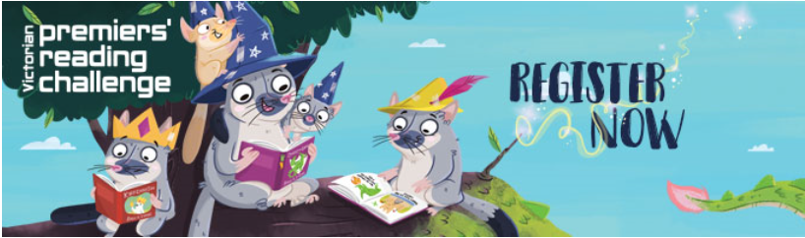

Are you an Early childhood service?
To register send an email to readingchallenge@edumail.vic.gov.au advising
  - Name of PRC Coordinator at your service
  - Name of service
  - Number of children who will be participating in the Challenge

Are you the parent/guardian of a child not yet attending school?
To register your child send an email to readingchallenge@edumail.vic.gov.au advising
  - Your name
  - Number of children who will be participating in the Challenge

August 2019
You will receive an email one month before the Challenge finishes requesting you to confirm
  - 40 books have been read
  - Postal address
  - Exact children’s names to be printed on the certificate

