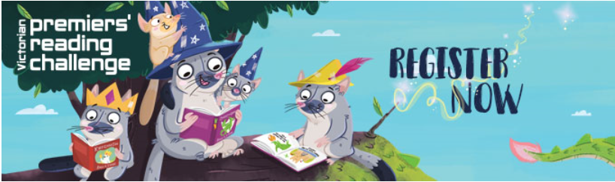

Information for Early childhood services and parents/guardians of children not yet at school

- There are two ways for children not yet at school to participate in the Early Childhood Premiers' Reading Challenge.
- Early childhood services are able to register children attending their service
- The parent/guardian of a child can register their child/ren.
- The child must be a young child who is not yet attending school or is not of school age.
- Between February and closing date of the challenge* each child must read or have read with them 40 books. There are lots of suggestions for books on the Challenge book list.
- Children can read books by themselves of with someone else, for example a parent or guardian, carer, brother or sister, buddy or friend. This support is important if the child is just learning to read.
- An email will be sent one month before the Challenge finishes to ask the Early childhood service or parent/guardian to confirm 40 books have been read, advise postal address and children’s certificate names.
- All the information must be completed before closing date of the challenge.
To register go to Early childhood log in
https://www.education.vic.gov.au/about/events/prc/Pages/getregistered.aspx

