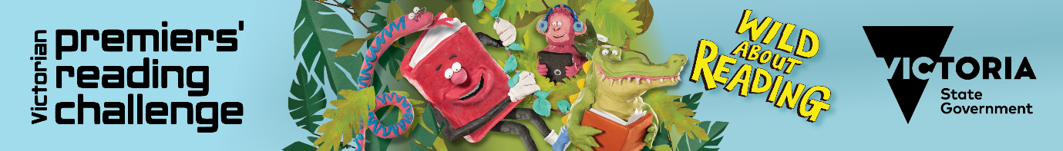

Victorian Premiers’ Reading Challenge
Dear «Name»
The Victorian Premiers’ Reading Challenge is now open and (insert school name) is excited to be participating. The PRC application offers a range of exciting features including:
- access to a library catalogue (including book images and blurbs)
- a modern user-friendly interface
- rewarding students with badges as challenge milestones are achieved
- the option for students to mark books as a favourite, give them a star rating or complete a book review

The Challenge is open to all Victorian children from birth to Year 10 in recognition of the importance of reading for literacy development. It is not a competition; but a personal challenge for children to read a set number of books by 8 September 2023.
Children from Prep to Year 2 are encouraged to read or ‘experience’ 30 books with their parents and teachers. Children from Year 3 to Year 10 are challenged to read 15 books.
All children who meet the Challenge will receive a certificate of achievement signed by the Victorian Premier and former Premiers.
To read the Premier’s letter to parents, view the booklists and for more information about the Victorian Premiers’ Reading Challenge, visit: https://www.vic.gov.au/premiers-reading-challenge
Here are your login details for the 2023 Premiers’ Reading Challenge.
Username: «Username»
Passcode: «Password»
Further information about how to use the Challenge application is available at:
School students and parents
To log in go to:
Register and log in
Kind regards
XXXXX

