**To Victoria’s incredible parents and carers,**

Welcome to the **2025 Victorian Premiers’ Reading Challenge**.

The Challenge is all about discovery: helping young Victorians discover new books, and a love of reading.

And this year is even more special. We’re wishing the Premiers’ Reading Challenge a very happy 20th birthday!

Over those past 20 years, more than 4.5 million young Victorians have taken up the Challenge, reading more than 63 million books.

They couldn’t have done it without support from the very important people in their lives – just like you.

Reading together is one of the most powerful ways we can help kids build their literacy skills.

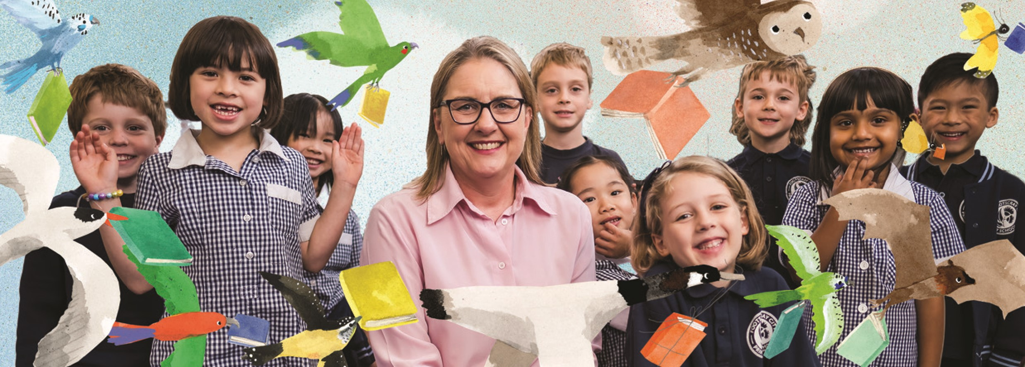(And if you’ve read the same books together so many times you can recite them in your sleep, the Challenge is a great way to find some new favourites!)

When your child completes the Premiers’ Reading Challenge, they will receive a Certificate of Achievement. More importantly, they’ll have the satisfaction of having read a whole lot of books.

If you’re looking for more – you can follow the official **Victorian Premiers’ Reading Challenge Facebook page** and join a community of participating parents, teachers and families.

Good luck and happy reading,

**Jacinta Allan**

Proud mum of two

Member for Bendigo East

Premier of Victoria

PS. Last year I loved hearing from kids about the books they were reading, and I received some beautiful drawings inspired by Challenge stories. So please let me know how you’re going – tell me about your favourite books or share some amazing art – by emailing **jacinta.allan@parliament.vic.gov.au**