Education State Ambition:
Pride and confidence in our schools
We want Victorians to be proud of the great government schools
in their communities.

The Education State is about improving outcomes for every student, in every classroom, for every community. Delivering a broad range of initiatives will see more Victorians proud of their government school system.
Why is this important?
The achievement of this target will mean that the community takes pride in local government schools, and feels confidence that they are delivering excellent outcomes for Victorian students.

What are we trying to achieve?
By 2025, 20 per cent more parents will report high levels of confidence in the government school system in Victoria.
EDUCATION STATE INITIATIVES
Victorian School Building Authority
The Victorian School Building Authority is delivering hundreds of upgrades, new schools and early childhood centres across the State. To date $5.6 billion has been invested in infrastructure projects as part of the Education State reform agenda, with a focus on cutting-edge school design and innovative school settings.

Building excellence in teacher education
The Victorian Teaching and Learning Model is providing a whole school improvement approach to classroom practice. This combined with the creation of high quality pathways into teaching and the improvement of the quality of teaching courses is building excellence in teacher education and improving teacher quality.

How has Victoria performed IN 2017*?

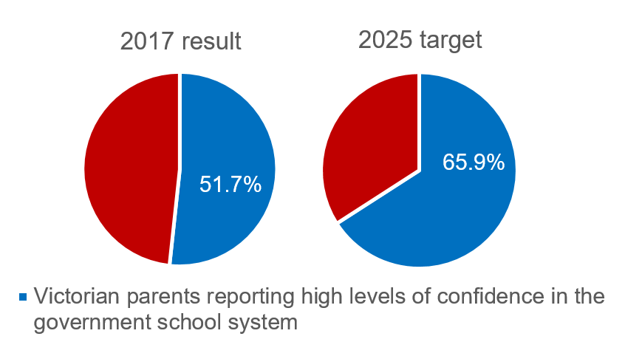
PRIDE AND CONFIDENCE

* measured through the Victorian Child Health and Wellbeing Survey (VCHWS), which is a biennial survey; the most recent results are from 2017

more information
For more information about Education State targets and to view the work that is being achieved in schools in 2019, visit www.education.vic.gov.au

