Education State Ambition: Happy, healthy and resilient kids
Building resilience and increasing physical activity in our children

The Education State aims to set students up for happy, healthy and prosperous lives by promoting resilience and physical activity.

Why is this important?
Building personal resilience benefits students both within school and through the rest of their lives. Our focus on building high resilience, is equipping students with the skills and strategies they need to tackle current and future challenges.
Physical activity is vital for health and fitness, developing coordination and motor skills, and has a positive effect on general wellbeing, including mental and social development.

What are we trying to achieve?
By 2025, 20 per cent more Victorian students will report having high resilience.
By 2025, 20 per cent more students will be doing physical activity for an hour a day, five times a week.

EDUCATION STATE INITIATIVES
Enhancing mental health support in schools
This program ensures that every government secondary school has access to a mental health professional to provide direct counselling and other intervention services to students.

Breakfast Clubs
The aim of the School Breakfast Clubs Program is to establish breakfast clubs in disadvantaged primary schools to offer a healthy breakfast for students who may otherwise arrive at school hungry.
How has Victoria performed in 2018?

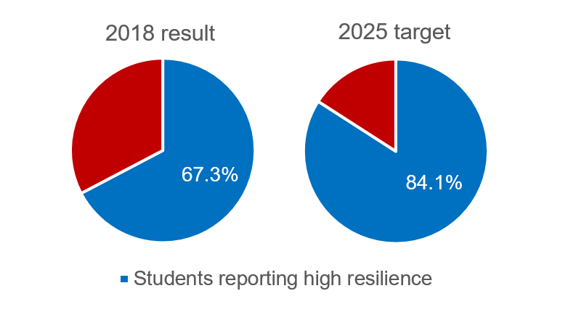
Resilience

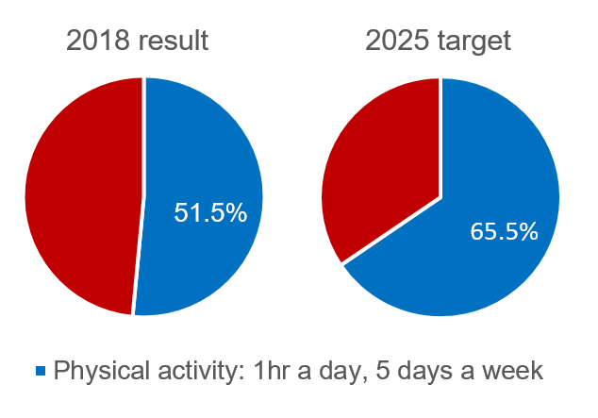
Physical activity

more information
For more information about Education State targets and to view the work that is being achieved in schools in 2019, visit www.education.vic.gov.au

