Education State Ambition: Breaking the link
Supporting more students to stay in education and breaking the link between disadvantage and student outcomes.
The Education State aims to reduce the impact of disadvantage on student outcomes, to give students the skills, knowledge and attributes they need.

Why is this important?
Research shows that children and young people from disadvantaged backgrounds are at a greater risk of poorer educational outcomes than their peers.
Targeted programs for disadvantaged students, high needs students and young people in out-of-home care have been proven to reduce absences from school, lift aspirations and increase positive perceptions of students’ own ability.

What are we trying to achieve?
By 2025, there will be a 15 per cent reduction in the gap in average achievement between disadvantaged and other students in Year 5 and Year 9 reading.
By 2025, the proportion of students leaving education during Years 9 to 12 will halve.
EDUCATION STATE INITIATIVES
Equity funding
Record targeted school funding is supporting schools with students who face more barriers to success than their peers. Schools have received more funding for disadvantaged students to enable them to invest in additional resources and expertise.
LOOKOUT
LOOKOUT Education Support Centres improve educational outcomes for children and young people in out-of-home care by boosting the capacity of schools and services, supporting individual students and facilitating opportunities for students to participate fully in school life.
Navigator
The Navigator Program provides intensive case management and outreach support to disengaged young people to address barriers to engagement and return them to education.
Rural and Regional Students
The Victorian Government has established an Expert Advisory Panel for Rural and Regional Students to examine the opportunities and challenges associated with rural and regional education across Victoria.
How has Victoria performed in 2018?

Breaking the link – Year 5
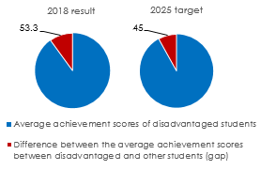

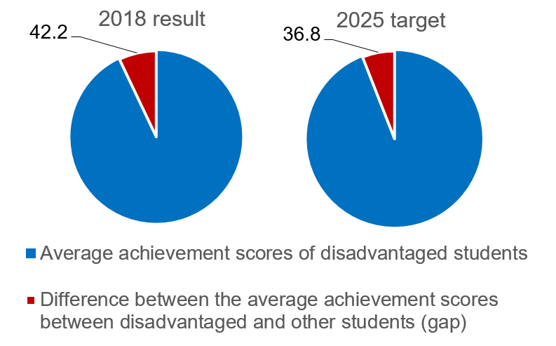
Breaking the link – Year 9

Staying in education
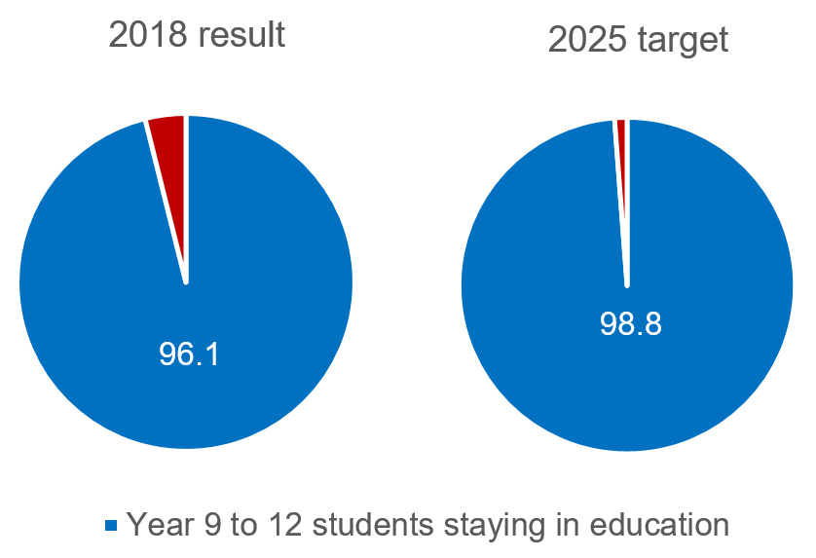

more information
For more information about Education State targets and to view the work that is being achieved in schools in 2019, visit www.education.vic.gov.au

