Navigator – Program Overview

COntext
The Victorian Government’s Education State reform agenda sets out clear aspirations for creating an inclusive education system where schools can support all learners to stay in education and reach their potential. A system that ensures all Victorians have equal access to the benefits and opportunities that come from education and ensures that every Victorian learner is afforded the opportunity to succeed.

In Victoria, there are a significant number of young people who have been disengaged, or are vulnerable to disengaging, from education or training. Many of these young people face multiple barriers to re-engaging with education. As a result, disengaged young people often need intensive, multifaceted supports to enable them to overcome these barriers and pursue educational success.

The Navigator Program fills this need by providing individualised, intensive case management support – it is a targeted support service, that works in partnership with young people, families, support services and schools to enable young people to achieve their educational goals and re-engage with education.

BackgrounD
In September 2015, the Victorian Government announced the $566 million (over four years) state-wide Education State: Schools reform agenda, which included Navigator pilot programs. Since its commencement in July 2016, the Navigator Program has progressively expanded, and currently operates in 14 of the 17 DET Areas.
In January 2021 Navigator will commence in the final 3 Areas, Outer Gippsland, Inner Eastern Melbourne and Outer Eastern Melbourne. Further information on the Department of Education and Training Area boundaries can be found at:
https://www.education.vic.gov.au/about/department/structure/Pages/regions.aspx
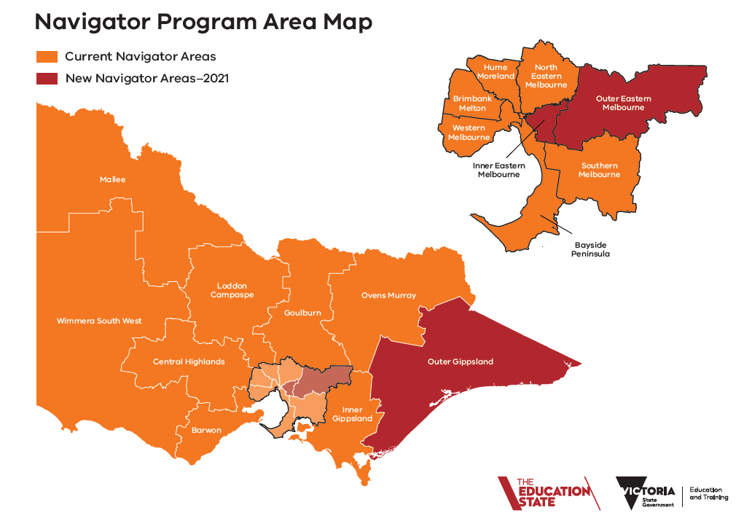

THE NAVIGATOR Program
What is the purpose of the Navigator Program?
The purpose of the Navigator program is to provide assertive outreach (including case management) to disengaged young people, to support them to successfully re-engage with education. The Navigator program model is defined by its partnership approach between the community sector, DET and education providers to enable a service that:
- actively seeks out disengaged young people and provides individualised support that is targeted to supporting their re-engagement back into education, and that is focused on the young person’s needs, strengths and interests
- can work with their families, carers, support networks and schools to provide holistic support to aid re-engagement with education
- supports place-based responses to disengagement by drawing on a range of local services and working collectively to solve local issues and support re-engagement with education.

Who are the program participants?
Navigator is available to young people who:
- are aged between 12 and 17 years of age
- have attended less than 30% of the previous school term or equivalent time period

Participation in Navigator is voluntary, free to the young person and by referral. Anyone can refer a young person to the program.

What are the key service delivery elements of the Navigator Program?
The elements of Navigator include:
- Referral
- Assessment / intake
- Active Hold* (if case management is over-subscribed)
- Case management
- Supported re-engagement with education

* In addition to providing case management support, Service Providers are required to actively and regularly support any young people who are on their waiting list for case management. This is known as ‘Active Hold’ or Active Holding’. Service providers are expected to dedicate FTE to the management of Active Hold and should view it as a ‘light-touch’ case management service, or the delivery of brief interventions/supports that resolve the young persons need to progress to case-management.

How do the program partners work together to deliver the Navigator Program?
Each of the program partners bring different expertise, resources and roles to the delivery of Navigator, and work collectively to support the program participants.
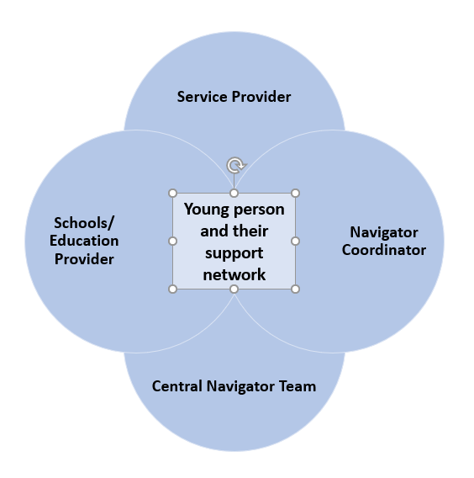

Service Providers
**This expression of interest process is to fill the role of Service Provider**
A lead community service organisation (Service Provider) is contracted to deliver the case management/ active hold services in each Area. This may involve delivery through consortia of local organisations working in partnership.

The service delivery model for Navigator involves Service Providers supporting young people to re-engage with education through:
- receiving referrals from the Navigator Coordinator, seeking out and connecting with young people who have disengaged from schooling
- working with the young person to identify their learning needs, capabilities and aspirations and develop an education re-engagement plan that involves family, carers, school and community supports
- working closely with other community services and education providers to ensure the relevant provision of wrap around supports for the young person and their family
- assisting young people to overcome learning, social and other barriers so that they can successfully engage and transition through education, including engaging support services where required
- monitoring and supporting a young person as they re-engage in education for a period of up to six months and then following up six months later to see if they have remained engaged.

Navigator Coordinators
The DET Navigator Coordinator is the primary contact for Service Providers - they play a key role in the local implementation of the Navigator program and facilitate the connections between Service Providers and educational insititutions. They work closely with their local Service Provider and play a key role in managing the relationship between Service Providers, schools, DET Area teams and other key services. Building the capacity of schools and the broader service system is also part of their role.
Navigator Coordinators receive all referrals to the program and engage in relevant data reporting processes that monitor re-engagement processes and outcomes for young people. Upon referral, Navigator Coordinators establish a young person’s eligibility for the program and facilitate the linkage of young people to broader Area and community supports.

Navigator Central Team
The Navigator Program has a small, central DET team that oversees the program at a state-wide level. They play a key role in identifying and monitoring state-wide trends, managing reporting, contractual and funding arrangements and providing state-wide operational support.

Schools
Schools are well placed to identify disengaged students and can refer young people to Navigator when they have exhausted other options to re-engage the young person. They work with the other program partners to ensure each young person is supported in their Navigator journey and re-engagement to school. Schools can also be supported by the Navigator Program, through capacity building, to strengthen their approach to supporting disengaged students and ensuring a supporting environment for their whole school community.

It is expected that Service Providers, in collaboration with DET have strong program governance structures that support effective service coordination, ongoing collaboration with DET, schools, services and the community sector. Relationships and partnerships with relevant stakeholders are essential to align service responses to young people who have disengaged with education, and to reduce service duplication in local areas.

What are the outcomes the Navigator Program is seeking to achieve?
The three overarching outcomes Navigator is seeking to achieve are:
- Re-engaging young people to education
- Developing students with greater social and emotional capabilities
- Supporting schools to be better equipped to engage all young people

Measures of success and targets will be discussed and negotiated with prospective Service Providers prior to contract execution.

Re-engaging young people to education
The key outcome of the Navigator program is to re-engage as many young Victorians back into education as possible. Service Providers should work with the learner to identify an appropriate school, flexible learning program, TAFE or other RTO that can best meet the needs of the young person. Given that this cohort of young people typically experience barriers to strong engagement with learning, Service Providers will also be expected to support transitions back into education and reconnect with young people who disengage again. Identifying appropriate referral pathways and options for ongoing support for young people exiting the program will also be required.

Developing students with greater social and emotional capabilities
Growing young people’s resilience and social and emotional capability will strengthen their ability to manage the re-engagement process. These capabilities are not static traits and need to be learnt and developed alongside the development of cognitive skills.

To this end, the Navigator Service Providers will also need to focus on holistic outcomes for young people, including:
- improved resilience, self-confidence and skills in problem solving
- the development of career goals and pathways
- being more active members of the local community
- improved skills in language and literacy

Supporting schools to be better equipped to engage all young people
The Navigator Program supports schools to develop a better understanding of how to support young people who are vulnerable to disengaging and reconnect with students who cease attending. Through close collaboration with Navigator partners, schools can build their capacity and knowledge of supports available to help young people overcome the barriers that prevent them fully engaging in education.

Reporting requirements for SUCCESSFUL APPLICANTS
At the commencement of the contract, successful Service Providers will complete an initial Service Plan which will outline their model for service delivery.
Data reporting is an ongoing requirement of all Service Providers. Providers are expected to keep their data up to date in line with DET expectations and submit financial and progress reports as required.
The reporting process and measures are designed to:
- Demonstrate and monitor the outcomes of the provision of Navigator services
- Provide specific place-based snapshots of the performance of the program in engaging young people
- Inform future directions for re-engagement initiatives in Victoria.

Service Providers are required to maintain their own case management data systems, and to utilise the Navigator Data Management System.

Key selection criteria and required capabilities

Key Selection Criteria

Applications will be assessed against the following key selection criteria and selection will be a merit-based process - refer to the Application Form for further details
- High Quality Service Model (30%)
- Proven Outcomes (25%)
- Strong Partnerships (25%)
- Value for Money (20%)

Required Capabilities
Table 1 outlines the knowledge and experience required of Navigator Service Providers.
Table 2 outlines the key service components and functions that successful applicants will be required to deliver.

Your application should address these key points/ criteria.

TABLE 1
Knowledge and Experience
A sound knowledge of:
- the Victorian education system, education and training pathways and relevant legislation , including the Education and Training Reform Act 2006, the Victorian Curriculum, Primary and Secondary schooling (including alternative schools) and other training options such as Learn Locals and TAFE institutes
- the local context in the Area where they propose to operate and local key stakeholders (and their services)
- evidence-based strategies and supports that assist young people to overcome barriers to engaging with education
- school/ education provider strategies, services and supports that promote and enable student inclusion, engagement and re-engagement with education (that align with DET policies and guidance) including social and emotional learning curriculum and resources.

Experience:
- working with vulnerable young people who encounter barriers to engaging in education or training such as alcohol and other drug (AOD) issues, anxiety, depression, family conflict, caring responsibilities or homelessness
- working with schools, local education providers and local support services (such as School Focused Youth Service and Local Learning and Employment Networks)
- working with vulnerable cohorts (such as Indigenous young people, young people from culturally and linguistically diverse backgrounds, those involved in the Youth Justice or Child Protection systems, and those in out-of-home care) and developing interventions and programs that are appropriate for them
- planning and delivering services to young people over a wide geographical area
- establishing or linking with existing governance committees to oversee work and impact
- assessing the learning needs of young people
- implementing processes for prioritisation of referrals, managing demand for service, and delivering differentiated levels of support to young people and their families.

TABLE 2
Key Service Components and Functions
1: Assertive Outreach
- connecting with young people who have disengaged from education
- following up on referrals, making personal contact with the young person and developing effective working relationships
- developing processes to prioritise and identify young people who are likely/expected to benefit from Navigator and achieve the programs purpose of re-engagement in education (in an appropriate timeframe)
- identify, through working with young people and their family which young people may not yet be at a state of readiness for educational re-engagement, or are not engaging with the program, and would benefit from other programs/support prior to participating in Navigator case management

2: Active Hold (waitlist support)
- ensuring young people receive a strength based ‘light touch’ case management service while they are on the waitlist for case management. This includes regular check-ins, brief interventions or linkages and referrals to other services etc.

*Some current Navigator Service Providers have identified investing in Active Hold has resolved disengagement issues for some young people, who then do not need to progress to case management, but instead re-engage with education. Service providers are expected to dedicate FTE to the management of Active Hold

3: Case Management
- using strengths-based case management approaches
- working with young people and their family, with the aim of facilitating their return to education
- delivering individual coaching and mentoring to assist young people to enhance wellbeing and develop resilience, self-efficacy and social skills
- providing advocacy support to successfully engage young people’s support services within schools and other education settings, as well as for re-engagement with family or community networks
- assisting young people to overcome learning, social and other barriers to enable them to successfully engage and transition through education to the completion of Year 12 or equivalent
- having processes to identify if/when a young person is not engaging with, or responding to Navigator case management, and strategies to identify and implement suitable referral pathways and supports for these young people
* Service Providers are expected to keep administration costs to a minimum and maximise frontline FTE

4: Monitoring re-engagement
- following up with schools/education providers and monitoring young people who have re-engaged in education, for a period of 12 months, to ensure sustained engagement
- work with Navigator partners to ensure schools and education providers successfully (re)integrate young people into their setting

5: Partnerships with local agencies, schools and DET staff
- Formation of collaborate partnerships or working relationships with other agencies (particularly local agencies) to form a functioning network of services that can identify and support young people who are disengaged, or vulnerable to disengaging, from school or education
- establishing referral pathways with key local agencies who provide specialist services to vulnerable, complex and marginalised young people in the local Area (e.g. AoD, mental health, out-of-home care, homelessness and family violence services)
- working effectively with school leaders, teachers and communities
- working effectively with local DET Area staff
- Working effectively with other governance bodies and programs targeting disengaged learners, or learners vulnerable to disengagement such as the Education Justice Initiative, School Focused Youth Service (SFYS), Aboriginal Community Controlled Organisations and Local Learning and Employment Networks

