Kindergarten Central Registration and Enrolment Scheme (CRES)
Self-Assessment Tool
Version 1 – November 2020
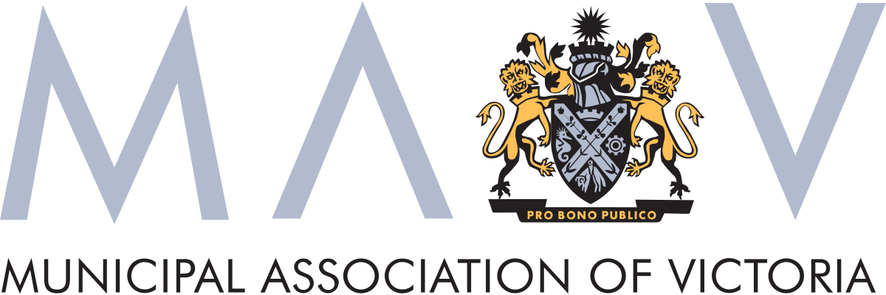
This page is intentionally left blank.

Glossary of stakeholders and terminology
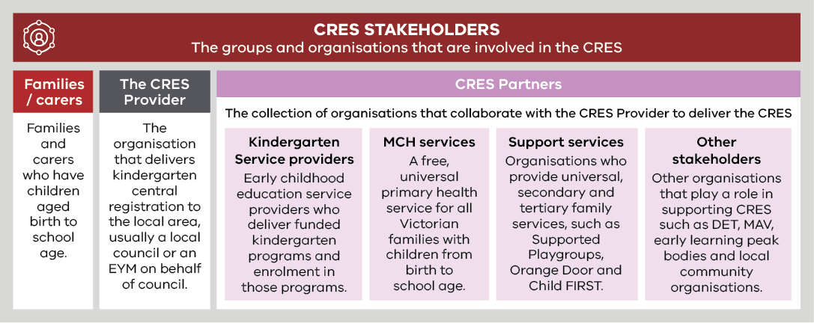
Term | Definition
Central Registration and Enrolment Scheme (CRES) | A best-practice model that streamlines the process of registering and enrolling children in kindergarten for families and service providers, ensuring the process is simple, consistent, inclusive and equitable.
Central Enrolment (CE)/ Central Enrolment Scheme | A predecessor to CRES that has successfully improved the equitable and accessible allocation of kindergarten places to date but is implemented differently across the state.
Early Childhood Education and Care (ECEC) | Services provided to children in the years before primary school that develops a child’s social, emotional, cognitive and physical abilities, building a solid foundation for future learning.
Enrolment | In-depth information collection in line with state legislation for a child soon to begin kindergarten. This includes ensuring the service provider has the health and emergency information to provide a safe experience for children and informs state government planning and subsidies.
Early Start Kindergarten (ESK) | The Early Start Kindergarten grants enable an eligible child to access a kindergarten program in the year two years before school. There are two types of Early Start Kindergarten grants:  - Aboriginal Early Start Kindergarten grant  - Early Start Kindergarten grant for children known to Child Protection.  Eligibility can be established in discussion with the family or services working with the family such as Maternal and Child Health nurses.  Children can be enrolled in a three-year-old group, a four-year-old group, a mixed age group or can be enrolled in a combination of groups delivered by a qualified early childhood teacher, to maximise their access to 15 hours of kindergarten.  Early Start Kindergarten grants can be used in combination with the Commonwealth Child Care Subsidy or Additional Child Care Subsidy to reduce costs to parents and carers and to promote inclusive practice in the service.
Early Years Management (EYM) | Formerly “Kindergarten Cluster Management”, Early Years Managers are local government and community-based organisations that provide professional leadership and centralised management to a group of kindergartens as the authorised service provider. EYM is a key strategy to build a stronger, responsive universal kindergarten system.
Kindergarten Fee Subsidy (KFS) | Promotes kindergarten participation by enabling eligible children in funded three and four-year-old groups to access up to 15 hours of kindergarten delivered by a qualified early childhood teacher free of charge or at low cost.  A child enrolled in a long day care service is not eligible for KFS where approved Commonwealth Child Care subsidy is applied.
Kindergarten | An early childhood educational program delivered by a qualified early childhood teacher to children in the two years before school. The term “preschool” is used nationally and in some municipalities.  In Victoria, a “funded kindergarten program” complies with applicable requirements as set out in the Kindergarten Funding Guide and provides a program in accordance with the Victorian Early Years Learning and Development Framework.  Funded kindergarten programs may operate in a variety of settings, including long day care centres, standalone services, schools or community centres, and is operated by a variety of service providers, including community organisations, local councils, schools, not-for-profit organisations or private providers.
LGA | Local Government Area. Often referred to as “council”.
Maternal and Child Health Service | A free, universal primary health service for all Victorian families with children from birth to school age. It includes the Universal MCH program, Enhanced MCH program and the MCH Line, a 24-hour telephone support service.
Registration | The process of families and carers giving initial information about their child to confirm their intention to enrol in kindergarten, administered by the CRES Provider. This includes collection of basic contact information, kindergarten preferences and any other details that may inform prioritised allocation in kindergarten.
Pre-Purchased Places | A Pre-Purchased Place (PPP) is a kindergarten place funded by DET and reserved for vulnerable or disadvantaged children who present outside normal enrolment periods. For each PPP, DET pays the service provider the full cost of a kindergarten place (per capita plus KFS) upfront.  PPPs can only be accessed by children who are eligible for Kindergarten Fee Subsidy, Early Start Kindergarten grants or Early Start Kindergarten extension grants. A state-wide Expression of Interest process is conducted by DET each year, to allocate PPPs for the following year in the areas and services where they are needed most.
Universal, secondary and tertiary support services | “Universal support services” are targeted at an entire population, to provide support and education before problems arise. Examples of universal support services include funded kindergarten programs, the Universal MCH program, community playgroups and libraries.  “Secondary support services” are targeted at families who may need more support to avoid problems escalating. An example of secondary support is Supported Playgroups.  “Tertiary services provide” interventions and treatment where a problem has already occurred. An example of a tertiary service is Child Protection.

About the CRES Self-assessment tool
The CRES Self-Assessment Tool will help a CRES Provider critically examine their scheme to identify strengths and opportunities to improve and work towards achieving the strategic objectives for the CRES in the municipality.

Who should use this Tool?
This Tool should be used by officers responsible for ensuring children are registered and enrolled in a funded kindergarten program.
If you are yet to establish a CRES, refer to the CRES Development Guide for guidance on the steps to take to establish a CRES. The CRES Development Guide also contains background on early childhood education and the CRES.

How to use this Tool
The CRES Self-Assessment Tool is designed to be used annually to review and evaluate the CRES. Regularly reviewing your CRES will help embed the cycle of continuous improvement to best deliver for the community’s children, especially those who are experiencing vulnerability or disadvantage.
The self-assessment should be an internal process, however consulting with CRES Partners to answer some parts of this Tool is encouraged to ensure you get a complete perspective of current strengths and areas for improvement. It is also recommended that the internal CRES team answer the assessment questions together.
After completing the self-assessment, you will have a clear idea of:
- The strengths of your CRES that you should continue to build on and sustain;
- Areas to focus on so that you can make targeted improvements to the CRES, and
- Gaps that could to be addressed by expanding early childhood education services and the CRES.
The Tool will help you identify what you may want to change or improve – upon completion, you should compile a list of improvement opportunities. Considering your organisation’s overall strategic objectives, you can prioritise these opportunities.
For detail on how to improve or expand, refer to the CRES Development Guide.
The Tool is organised in three sections:
- Section A: Council profile. In this section you will collect data to understand kindergarten demand, supply and utilization in your area. This information will help you understand the impact of your CRES and identify opportunities for expansion or improvement.
- Section B: Enablers. In this section you will assess your organisation’s capability across the six CRES enablers:
- Capability and capacity
- Governance structure
- Partnerships
- Systems, data and digital tools
- Templates and documents
- Policies and procedures
- Section C: Action plan. After completing the Tool’s assessment questions, you can use this section as a template to form an action plan of how to improve your CRES.
This Self-Assessment Tool should be used in conjunction with the CRES Practice Guide, which explains how to deliver a best-practice CRES once it is operating. Figure 1 below maps the different CRES documents.
Figure 1 | A map of CRES documents
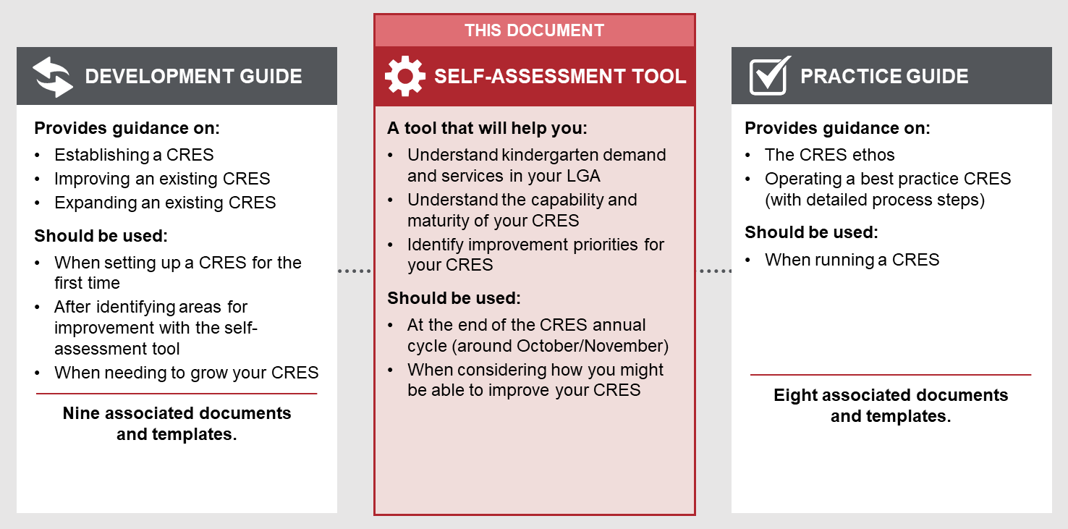
The CRES Practice Guide, Development Guide, Self-Assessment Tool, and associated templates and documents were co-designed by the Department of Education and Training (DET), the Municipal Association of Victoria (MAV), stakeholders representing councils, kindergarten service providers, MCH staff and other support services.

Section A: Council profile
A clear understanding of the early childhood education landscape in your LGA will help you identify supply and demand challenges and opportunities to improve the CRES. These data points can inform strategic planning of how the CRES may need to develop.
Tables 1 and 2 provide a structure to collect information about kindergarten demand and service providers from the last complete year of data. This structure will help you analyse where there are gaps in the CRES. For example, by comparing the number of enrolments through the CRES and the total enrolments in the LGA, you may be able to see if the CRES needs to be expanded. You will also be able to assess the scale of the CRES by comparing total enrolments in your LGA with the number of enrolments through the CRES. You may also want to look at historical data to see the trends over several years.
If you cannot find values against all items in the tables, it is important to reflect on why the data is difficult to collect and how you might obtain the data in the future. Estimates can also be used where specific data is not available.
Table 1 | Kindergarten demographic and demand statistics
Demographic | Age group | Total number in the LGA last year | Growth rate trend in the LGA | Confirmed total kindergarten enrolments last year | Enrolments through the scheme last year | Data source (select one per data point)
All kindergarten-aged children | 3-year-old |  |  |  | Number:  % enrolments through CRES: | Victoria in Future (VIF) data  Kindergarten Information Management System (KIM) data (confirmed enrolments)  Birth notification data  Council population data  Kindergarten Capacity Assessment Program data (KCAP)  Kindergarten Infrastructure and Services Plan  (KISP)
 | 4-year-old |  |  |  | Number:  % enrolments through CRES:

Children eligible for Early Start Kindergarten (ESK) | 3-year-old |  |  |  | Number:  % enrolments through CRES: | VIF data  KIM data (confirmed enrolments)  Child Development Information System (CDIS)  Children in Out-of-home care (data held by DHHS and local government OoHC authorised contact)
Children eligible for the Kindergarten Fee Subsidy (KFS) | 4-year-old |  |  |  | Number:  % enrolments through CRES:

Table 2 | Kindergarten service provider statistics (data source: LGA Profile [DET] or Capacity report [DET])
Service provider name | Session type (LDC/sessional/ both) | Three-Year-Old services |  | Four-Year-Old services |  | CRES participation  (Y/N)
 |  | Licenced capacity | Enrolments | Licenced capacity | Enrolments
<Service provider 1>
<Service provider 1>
<…>
TOTALS |  |  |  |  |  | % of services participating in CRES

Section B: Enablers
There are many factors that will determine how well your CRES can support the community to have a clear understanding of and access to kindergarten programs. These have been organised into six enablers below. For each enabler, rate your CRES’ level of maturity by answering the questions.
For most questions there are three options aligned to three levels of maturity:
- Foundational – The CRES is established and is developing
- Developed – The CRES is a well-established system that operates effectively
- Advanced – The CRES is a comprehensive system that integrates as a strategic part of the LGA’s early childhood education environment.
Some questions have only two options: Foundational or Advanced.
CRES Providers will have enablers that are appropriate for their context – e.g. CRES Providers in smaller LGAs may only need a very basic data capture system (like Microsoft Excel) compared to a large LGA that may need a complex customer relationship management (CRM) system. Regardless, both should achieve the same outcome. The statements for each maturity level are therefore outcomes-based, to recognise the varied tools and methods that CRES Providers will use. The assessment questions are also designed to promote self-reflection and identify where to target efforts rather than provide a comparative metric, and so, has no ‘final score’.
After answering all the questions relating to an enabler, you should tally the number of items you have at each maturity level. This will give you an indication of which enablers may need improvement, recognising that, depending on your context some enablers may be more important than others.
There is also a ‘comments’ column to justify the selection of a maturity level. Note a particular challenge or strength in that area and record general feedback.

Capability and capacity
Do we have enough people with the right skills to deliver the CRES?
Question | Foundational | Developed | Advanced | Comment
Capability
Leadership and program management:  Does the CRES Provider have established structures to facilitate effective decision making and leadership? | ☐  There is a clear understanding of the CRES function and process, and issues are managed appropriately. | ☐  There is an overarching vision for the CRES.  Problems are resolved effectively.  Opportunities for improvement are identified on an ad hoc basis. | ☐  A long-term strategic vision and plan for the scheme is implemented.  Issues are proactively managed and resolved.  Opportunities for improvement are regularly identified and supported.
Frontline service delivery and operations:  Does the CRES Provider support officers with the resources to perform their role effectively? | ☐  CRES officers can answer stakeholder queries with their own knowledge of the CRES. | ☐  CRES officers put stakeholders at ease and can confidently responding to queries.  CRES officers receive ad hoc training and resources to support delivery of the annual CRES process. | ☐  CRES officers perform their role expertly, can respond to all queries with care and confidence and flexibly solve problems when they arise.  CRES officers have access to regular, ongoing training and resources to facilitate continuous improvement.
Engaging families/carers who can face barriers to enrolling in kindergarten:  Does the CRES Provider actively train staff to sensitively and respectively engage with families/carers who are experiencing disadvantage or vulnerability, and/or are from a diverse background? | ☐  CRES officers do not have access to training that will help them effectively engage with families/carers who can face barriers to enrolling in kindergarten. | ☐  CRES officers have access to entry-level or basic training that will help them effectively engage with families/carers who can face barriers to enrolling in kindergarten. | ☐  CRES officers have access to comprehensive training and learning resources that will help them effectively engage with families/carers from various cultural, linguistic, social and economic backgrounds.
IT and systems support:  Does the CRES Provider have the technical skills and resources (i.e. website, registration platform, communications tool, etc.) to support the CRES? | ☐  This function is not currently performed. | ☐  IT systems and digital tools are proficiently supported. | ☐  All IT systems and digital tools are expertly supported and systems are continuously improved in response to changing requirements.
Relationship development and maintenance:  Does the CRES Provider develop and maintain relationships with partners (i.e. service providers, support services etc.), and build strong working relationships? | ☐  There is an awareness of stakeholders relevant to CRES. | ☐  Relationships with partners are formed and they are contacted at the appropriate times to keep them informed. | ☐  Contact with partners is proactively sought to build strong and productive working relationships.  There is a formalised regular review of local partnerships, including identification of potential new partners.
Data management and administration:  Does the CRES Provider effectively manage data and information? | ☐  This function is not currently performed. | ☐  Data and information are managed proficiently to ensure all administration runs smoothly. | ☐  Data and information are managed efficiently and meticulously.  Initiative is taken to ensure issues rarely arise and are solved quickly.  A comprehensive data management strategy is in place.
Business and process improvement:  Does the CRES Provider have the capability and processes to evaluate and improve their scheme? | ☐  This function is not currently performed. | ☐  This function exists but no CRES evaluations or improvements to CRES have been addressed. | ☐  Challenges with the CRES are systematically connected with solutions that they can be practically implemented.
Capacity
Is the CRES appropriately staffed so CRES officers can complete their full responsibilities to a high quality? | ☐  CRES officers are performing functions outside of their capability, so work is sometimes delayed, or CRES officers are over-worked during the peaks of the CRES cycle, leading to delays. | ☐  CRES officers are stretched to complete their duties so officers respond in a timely manner but with some delays. The CRES team is also sufficiently resourced during peaks and troughs. | ☐  CRES officers complete their responsibilities within their FTE allocation and can respond promptly and effectively to their work. CRES officers seamlessly transition through peaks and troughs, so the CRES team is always appropriately resourced.

Governance structure
Does the CRES Provider’s structure ensure accountability and responsibility?
Question | Foundational | Advanced | Comment
Accountabilities
Is it clear who / what group is accountable for the overall performance of the CRES and its outcomes? | ☐  No | ☐  Yes
Is it clear who / what group is accountable for the satisfaction of families and carers, and other partners in the CRES? | ☐  No | ☐  Yes
Responsibilities
Is it clear who / what group is responsible for developing and maintaining relationships with partners, and following up when issues arise? | ☐  No | ☐  Yes
Is it clear who / what group is responsible for following up with families and carers when they have particular challenges or complaints? | ☐  No | ☐  Yes
Is it clear who / what group is responsible for making decisions about changes and improvements to the CRES process and its components (e.g. the website content, items on a form etc.)? | ☐  No | ☐  Yes
Is it clear who / what group is responsible for performance of the CRES’ systems and digital assets, and the security of data? | ☐  No | ☐  Yes
Is it clear who / what group is responsible for approving communications? | ☐  No | ☐  Yes
Structure
Are leaders of the CRES in the right roles so they can keep up to date and make informed decisions? | ☐  No | ☐  Yes
Do operational staff report to management and/or the council at appropriate and regular times? | ☐  No | ☐  Yes

Partnerships
Do we have strong enough relationships with stakeholders to deliver the CRES?
Question | Foundational | Developed | Advanced | Comment
Does the CRES team collaborate with a network of partners (kindergarten service providers, MCH staff, support services and other stakeholders)? | ☐  We understand some of the work of our major external partners and have contacts in these partner organisations. | ☐  We have a comprehensive understanding of the work of our external partners within our LGA and have good contacts in these partner organisations. | ☐  We have a clear understanding of our external partners and their relevant operations, even outside our LGA, so we know how to best respond to and assist them.
How many funded kindergarten service providers currently participate in the CRES? | ☐  Less than 50% of service providers are a part of the scheme. | ☐  Between 50% and 75% of service providers are a part of the scheme. | ☐  More than 75% of service providers are a part the scheme.
Do we have a strong relationship with service providers, and do they work with us to help improve the CRES? | ☐  Some service providers support the scheme. | ☐  Service providers support the scheme and they are responsive to our requests. | ☐  Service providers actively engage with us to collaboratively work towards a common goal.
Do we have a relationship with kindergarten teachers, so we understand their needs and they support the CRES? | ☐  We do not have relationships or contact with the kindergarten teachers. | ☐  Teachers receive some information on the CRES through management / administration. | ☐  Teachers are supporters of the CRES and are willing adopters of CRES initiatives.
Do we have a strong relationship with MCH staff so they are confident to speak about the CRES to families and carers, and proactively identify families and carers who may need extra support getting to kindergarten? | ☐  MCH staff are aware of the CRES and some pass the information on to families and carers. | ☐  MCH staff are supportive of the CRES and most promote the CRES to families and carers. | ☐  MCH staff work with us collaboratively and are proactive advocates of the CRES to families and carers.
Do we have a strong relationship with support services and other partners so they can confidently assist families and carers to begin the enrolment process, and proactively identify families and carers who may need extra support getting to kindergarten? | ☐  Support services and other stakeholders are aware of the CRES and some pass the information on to families and carers. | ☐  Most support services and other partners promote the CRES to families and carers. They also inform the CRES team of families and carers who might need extra support with enrolments. | ☐  Support services and other partners work with us collaboratively and are advocates of the CRES to their families and carers. They proactively identify families and carers who may need extra support and provide assistance to get them into the CRES process.

Data, systems and digital tools
Do we have the right digital assets to communicate to stakeholders and support our processes?
Question | Foundational | Developed | Advanced | Comment
Family/carer-facing
Does the website have comprehensive and accessible information, so families and carers clearly understand CRES? | ☐  Information is limited, and families and carers may have difficulties accessing the information. | ☐  Information is comprehensive and well-structured so finding clear information is simple for families and carers. | ☐  Information is comprehensive and well-structured and can be accessed and understood by all families and carers.
Are families and carers kept informed about their progression through the registration, allocation and enrolment process? | ☐  We do not currently communicate with families and carers to keep them informed. | ☐  We communicate with families to keep them informed but the process is manual and time intensive. | ☐  We communicate with families to keep them informed using tools that are efficient for CRES officers.
Council business processes
Is the registration and allocation platform fit-for-purpose to securely store data and efficiently enable allocation? | ☐  The platform securely stores information about families and carers, and kindergarten sessions and times (if applicable). | - | ☐  The platform securely stores information and helps CRES officers complete the allocation process efficiently.
Has planning been undertaken to ensure systems and digital tools continue to meet our needs and the needs of other stakeholders? | ☐  We do not undertake any service planning to anticipate the future needs of the CRES and ensure our systems will support them. | ☐  We have undertaken some planning to understand the requirements of systems and digital tools in the future so we can find ways to maintain service quality. | ☐  We undertake regular planning to improve our systems and digital tools and anticipate the needs of the CRES in the future.

Policies and procedures
Are our policies and procedures documented and clear, so our staff know how things should be done, and external stakeholders understand how and why we do things?
Guidance on the contents of these policies and procedures can be found in the CRES Development Guide in Section 3.2.3.
Question | Foundational | Developed | Advanced | Comment
Does our CRES policy clearly articulate the vision, purpose, principles, and function of the CRES in our LGA to guide the direction of the CRES? | ☐  The CRES policy is documented, and it is clear. | - | ☐  The CRES policy is published publicly and is accessible so that other stakeholders can understand it.
Does our data retention and information sharing policy support delivery of the CRES and is it clear for other stakeholders to understand? | ☐  We do not have a data retention and information sharing policy or it is unclear. | ☐  Our data retention and information sharing policy is documented and it is clear. | ☐  Our data retention and information sharing policy is published publicly and is accessible so that other stakeholders can understand it.
Does our kindergarten registration and allocation (and enrolment, if applicable) procedure support delivery of a CRES, and is it clear for other stakeholders to understand? | ☐  We do not have registration and allocation procedure, or it is unclear. | ☐  Our kindergarten registration and allocation procedure is documented and it is clear. | ☐  The publicly available version of our kindergarten registration and allocation procedure is available and accessible so that other stakeholders can understand it.
Does our IT and systems procedures clearly articulate how to operate systems and databases related to the CRES, and how to resolve common issues? | ☐  We do not have IT and systems procedures. | - | ☐  Our IT and systems procedures are clearly articulated so CRES officers can work efficiently with CRES systems and databases.
Does our CRES resourcing procedure clearly articulate how to the CRES will be staffed during peaks and troughs? | ☐  We do not have a CRES resourcing procedure. | - | ☐  Our CRES resourcing procedure clearly articulates when and how to move CRES officers into and out of the CRES team during peaks and troughs.

Documents and templates
Do we have all the right resources to ensure a smooth CRES process?
All of the documents and templates required to effectively operate a CRES have been provided as appendices to the CRES Development Guide and Practice Guide. These documents and templates have been developed as ‘best practice’ examples and are designed to support every stage of the CRES process. You are encouraged to use these documents and apply them to your specific context.
Regardless of whether the provided documents and templates or ones bespoke to your context are used, schemes should include all the templates listed in Table 3.
No maturity levels can be applied to this enabler as all documents and templates are required to operate a CRES.
Table 3 | Full list of documents and templates
 | Template | Template reference | Purpose
 | CRES Stage 1: Proactive engagement and awareness
☐ | Promotional materials and CRES fact sheets for families and carers | CRES Practice Guide  Appendix A.1 – A.3 | Communicates to families and carers about what the CRES is, how it helps them and what they need to do.
☐ | Information and communication materials for CRES Partners | CRES Practice Guide  Appendix B | Communicates to MCH staff and support services about what the CRES is, how it helps children and how they can support it. This will include advice on how they can support families/carers through the registration and enrolment process.
☐ | Referral form and guidelines for support services | CRES Practice Guide  Appendix C | Provides support services with instructions and a standard form to refer a family/carer to the CRES so the CRES Provider knows to follow-up.
☐ | Pre-registration email reminder template | CRES Practice Guide  Appendix G | Reminds families about registration opening dates and directs them to the website where they can find further information.
☐ | Data request template to obtain service provider and session information | CRES Practice Guide  Appendix E | Provides a standard structure to request information from service providers about session times and dates.

 | CRES Stage 2: Registration
☐ | Registration form (including relevant low literacy and alternative language variants) | CRES Practice Guide  Appendix D | Captures information about the child and their family and carers, to allocate them an available kindergarten place.
☐ | Template for registration data capture | CRES Practice Guide  Appendix F | Provides a standard structure to record all registration data.
 | CRES Stage 3: Assessment and allocation
☐ | Allocation process update email template | CRES Practice Guide  Appendix G | Informs families and carers about where the CRES Provider is in the process of finding a place for their child.
 | CRES Stage 4: Confirmation
☐ | Notification of offers email template (both ‘successful’ and ‘wait list’ messages) | CRES Practice Guide  Appendix G | Informs families and carers that their child has either been allocated a place in a kindergarten or is on a waiting list, and requests they reply to confirm.
☐ | Confirmation of message receipt email template | CRES Practice Guide  Appendix G | Informs families and carers that their confirmation message has been received.
☐ | Template for data transfer from CRES Provider to service providers about allocations | CRES Practice Guide  Appendix F | Provides a standard structure to transfer data between the CRES Provider and service providers about the children the service has been allocated.
☐ | Enrolment form (including relevant low literacy and alternative language variants) | CRES Practice Guide  Appendix H | Captures information required to enrol a child in the kindergarten they have been allocated.

 | CRES Stage 5: CRES planning, maintenance and development
☐ | Promotional and communication materials for service providers | CRES Development Guide  Appendix A.3 | Communicates to service providers about what CRES is, what their role is in the CRES and how they can help families.
☐ | Memorandum of Understanding (MoU) | CRES Development Guide  Appendix A.8 | A formal agreement between the CRES Provider and service providers that outlines the roles and responsibilities of the two parties.
☐ | Draft CRES clauses for inclusion in lease/service level agreements | CRES Development Guide  Appendix A.9 | Provides a standard clause for inclusion in lease agreements between service providers and councils that require the service provider to join the CRES.

Section C: Action plan
In this section you will take what you have learned in Sections A and B and develop an action plan to improve your CRES.
Use the table below as a template to identify what you might improve, how you will do it, and how you will know if you are successful. Chapters 4 and 5 of the CRES Development Guide have some suggestions on how to improve and expand your CRES, respectively.
What opportunities are there to improve the CRES? | What will we do to improve? What time frames will we make these improvements in? | How will we know if we have improved?

