Education State Ambition: Pride and confidence in our schools
We want Victorians to be proud of the great government schools
in their communities.

The Education State is about improving outcomes for every student, in every classroom, and for every community. Delivering a broad range of initiatives will see more Victorians grow their pride in our government school system.
Why is this important?
The Government is working to ensure that every community has access to great schools, and takes pride in the Victorian Government’s education system.

Growing pride and confidence in our government schools is part of our work to see the whole school community to engage with students, and support them to fully and proudly participate in school life. To this end, we are also working to build the best possible learning environments for all students.

How will thIS target be measured?
Target: By 2025, 20 per cent more parents will report high levels of confidence in the government school system in Victoria.
Progress towards the target is measured using a parent survey.
“The parents trust us – there’s a great deal of trust. They know that we want the best for
their children.”
Jenny Manuel, Principal
Wilmot Road Primary School

EDUCATION STATE INITIATIVES
The Education State funding boost will allow schools to provide additional programs​​ and resources to meet the needs of their students.
Over four years, key initiatives are in place to support the achievement of this target including:
Victorian School Building Authority
The Victorian School Building Authority will deliver hundreds of upgrades and 42 brand new schools across the State Victoria is at the cutting-edge of school design and we innovate in everything we do. Whether it's the delivery of a brand new vertical school model or reforming how maintenance is delivered at schools across the State.

Tech Schools
This exciting initiative involves constructing and establishing 10 state-of-the-art Tech Schools across the state, with further ongoing funding to support operation.

Framework for Improving Student Outcomes
The Framework for Improving Student Outcomes uses the latest research on student learning and global best-practice to assist schools to focus their efforts on key areas that are known to have the greatest impact on school improvement. This Framework will allow schools to make improvements based on the needs of their students, school and local community.

“My vision is to build pride and enthusiasm for our school that resonates through our students’ success.”
Peter Corkill, Principal and Victorian Education Excellence Award winner
John Monash Science School

How has Victoria performed in the first year of education state?

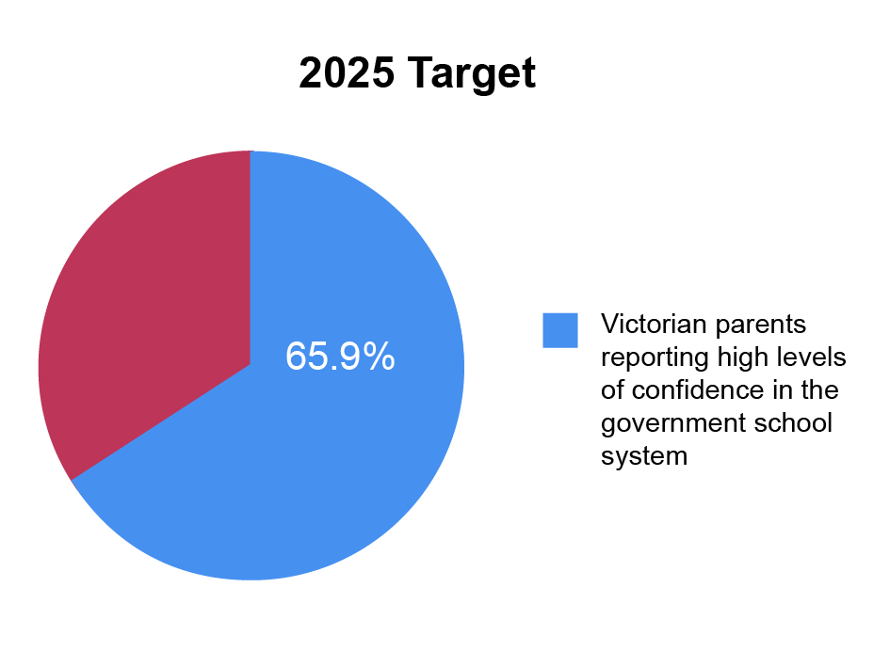
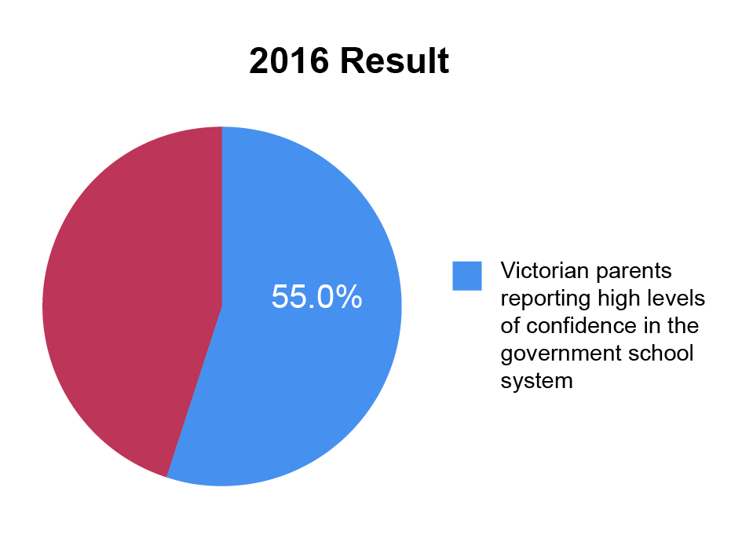

more information
For more information about Education State targets and to view the work that is being achieved in schools in the first twelve months, visit www.education.vic.gov.au

more information
For more information about Education State targets and to view the work that is being achieved in schools in the first twelve months, visit www.education.vic.gov.au

