Education State Ambition: Breaking the link

Supporting more students stay in education and breaking the link between disadvantage and student outcomes.

The Education State aims to reduce the impact of disadvantage on student outcomes, to ensure more students develop the skills, knowledge and attributes they need to build healthy, happy and prosperous lives.

## Why is this important?

Research shows that children and young people from disadvantaged backgrounds are at a greater risk of poorer educational outcomes than their peers.

Targeted programs for disadvantaged students, high needs students and young people in out-of-home care have been proven to reduce absences from school, lift aspirations and increase positive perceptions of students’ own ability.

Literacy ability gives students the fundamental skills to learn and engage in all curriculum areas, and is therefore one area of focus in working to reduce the impact of disadvantage on student outcomes.

## How will these targets be measured?

**STAYING IN EDUCATION**

**By 2025, the proportion of students leaving education during Years 9 to 12 will halve.**

Progress is measured using the Victorian Student Number.

**BREAKING THE LINK**

**By 2025, there will be a 15 per cent reduction in the gap in average achievement between disadvantage and other students in Year 5 and Year 9 reading.**  
Progress is measured using the National Assessment Program – Literacy and Numeracy (NAPLAN) Reading.

*“I’d like to see long term outcomes for these young people so that we don’t see them disengaged again down the track.”***Sandra Inserra, Anglicare  
Navigator program partner**

**EDUCATION STATE INITIATIVES**

The Education State funding boost means schools are providing additional programs​​ and resources to meet the needs of disadvantaged students.

Over four years, key initiatives that will support the achievement of this target include:

**Equity funding**Victorian students most in need are getting extra support at school to achieve their best and break the cycle of disadvantage, thanks to a record boost of $358 million in equity funding.

**Camps, Sport and Excursions Fund**The Camps, Sports and Excursions Fund commenced in 2015 for four years and provides payments for eli​gible students to attend camps, sports and excursions so that all Victorian students can take part in school trips and sporting activities.

**Affordable school uniforms**The Victorian Government has provided more than $15 million to State Schools’ Relief to help provide 100,000 students with free or discounted new school uniforms, shoes, books and graphic calculators.

**Breakfast Clubs**The School Breakfast Clubs Program establishes breakfast clubs in disadvantaged primary schools to offer a healthy breakfast for students who may otherwise arrive at school hungry.

**LOOKOUT**Children and young people in out-of-home care face unique educa​​tion and training challenges. LOOKOUT​ Education Support Centres employ education and allied health staff to give these vulnerable children and young people in out-of-home care a better chance of doing well in their education.

**Navigator**The two-year Navigator service pilot supports young people aged 12-17 years who are not connected to schools at all or at risk of disengaging. It aims to increase the numbers of young people connected to school and engaged in learning.

## How has Victoria performed in the first year of education state?

## BREAKING THE LINK – YEAR 5



*Pie represents average achievement scores of other students (i.e. disadvantaged score + gap)

## BREAKING THE LINK – YEAR 9



*Pie represents average achievement scores of other students (i.e. disadvantaged score + gap)

# STAYING IN EDUCATION

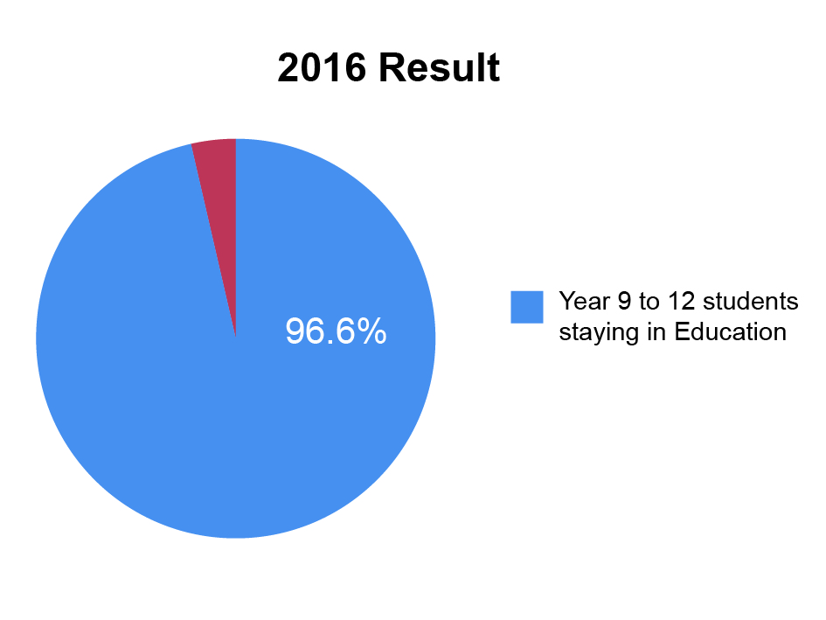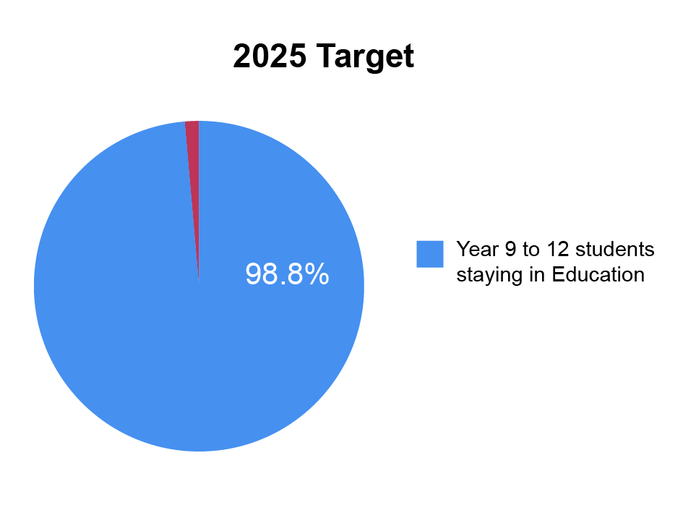

# more information

For more information about Education State targets and to view the work that is being achieved in schools in the first twelve months, visit [www.education.vic.gov.au](http://www.education.vic.gov.au)