Education State Ambition: Learning for life
  - Excellence in reading, maths, science, and critical and creative thinking

The Education State is equipping students with the broad range of skills they need to reach their potential, and achieve success in school and in life.

Why is this important?
Literacy and numeracy are key life skills that enable students to learn and thrive in all curriculum areas. Success in these foundational areas at school will benefit students for the rest of their lives.
Science, Technology, Engineering and Mathematics (STEM) skills, along with the ability to think critically and find creative solutions for complex problems, are vital for future employment opportunities in our rapidly changing world.

What are we trying to achieve?
READING
By 2020 for Year 5 and 2025 for Year 9, 25 per cent more students will be reaching the highest levels of achievement in reading.
MATHS
By 2020 for Year 5 and 2025 for Year 9, 25 per cent more students will be achieving the highest level in maths.
SCIENCE
By 2025, 33 per cent more 15 year olds will be reaching the highest levels of achievement in scientific literacy.
CRITICAL AND CREATIVE THINKING
By 2025, 25 per cent more Year 10 students will have developed excellent critical and creative thinking skills.
THE ARTS
By 2025, 20 per cent more Year 10 students will be achieving excellence in the Arts.

EDUCATION STATE INITIATIVES
Framework for Improving Student Outcome (FISO)
The FISO uses the latest research on student learning and global best-practice to assist schools to focus their efforts on the areas that are known to contribute most to school improvement.

Victorian Curriculum
The Victorian Curriculum ensures that Victorian students are better equipped to deal with our changing world. The curriculum includes a strong focus on the foundational skills of literacy and numeracy, personal and social skills and new areas of learning.

Literacy and Numeracy Strategy
The Literacy and Numeracy strategy is supporting teachers to strengthen assessment and teaching through professional development programs, tailored support to schools and teaching resources such as the Literacy Teaching Toolkit and the Numeracy Toolkit. A range of resources, activities and programs are available via the Victorian literacy portal and the Victorian numeracy portal.

Tech Schools Initiative
The 10 state-of-the-art Tech Schools are using leading-edge technology, discovery and innovation to deliver STEM education to Victorian students.

How has Victoria performed in 2018?

Reading- Year 5
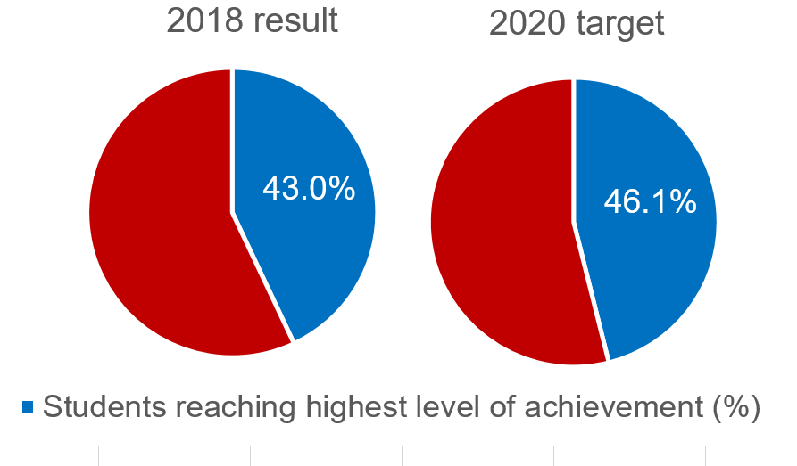

MATHS - Year 5
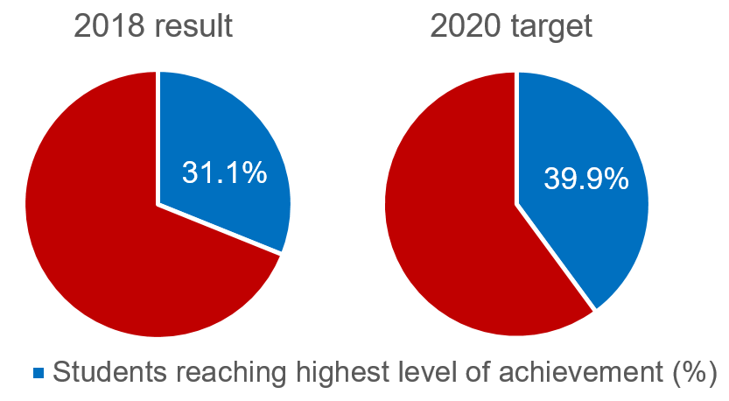

Science
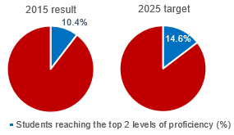

ARTS
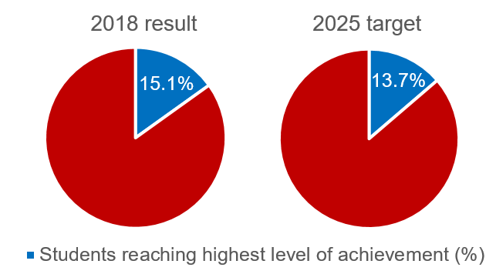

Reading- Year 9
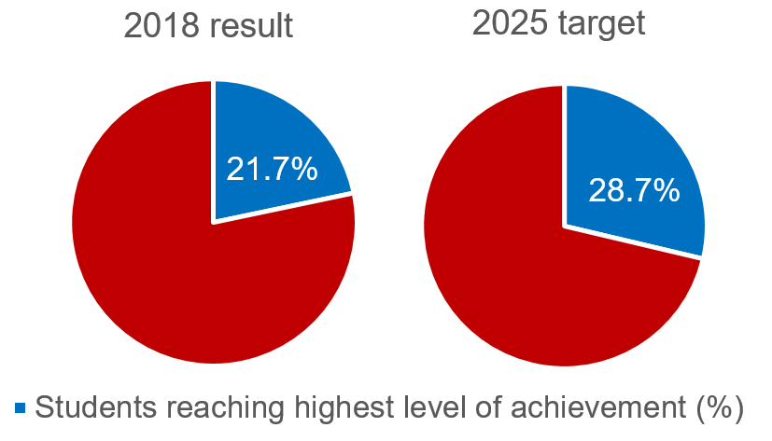

MATHS - Year 9
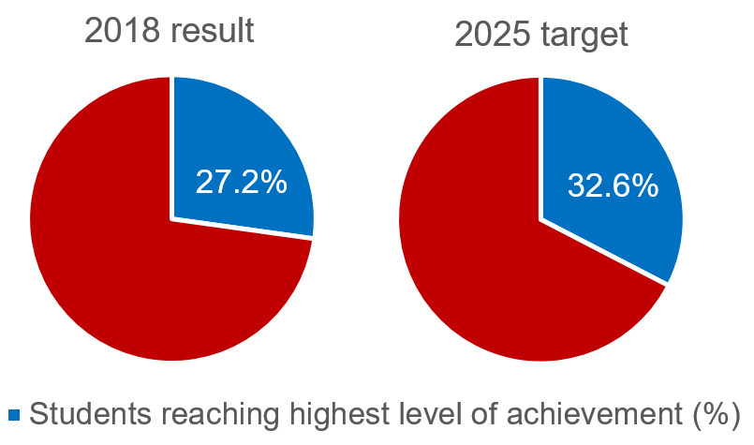

Critical and creative thinking
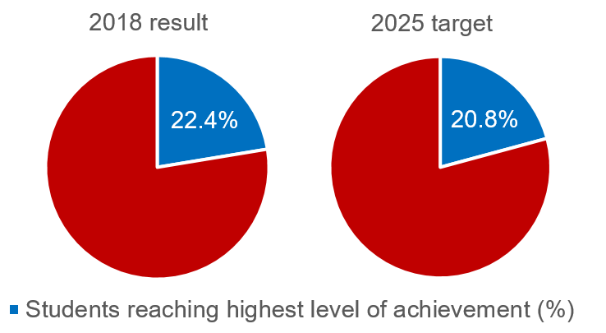

more information
For more information about Education State targets and to view the work that is being achieved in schools in 2019, visit www.education.vic.gov.au

