COMMUNIQUE FOUR - Early Years Compact Board August 2019
The Compact Board (the Board) held its fifth meeting in July 2019. Summarised below are key 2019 initiatives implemented to drive the Compact’s three state-wide priorities.
OUTCOMES
The Compact is showing benefits across multiple locations and an analysis of the data from the last three years shows improvement across the three Compact priorities:
- Increase the participation of children in out of home care and children known to child protection in early years services – improve sharing of data and information about children.
- Increase participation of Aboriginal families in early years services, with a focus on maternal and child health and kindergarten services.
- Improve the identification and referral of children and families at risk of family violence, including implementing a maternal and child health family violence consultation visit.
The Board acknowledges the work that has gone into implementing the Compact and would like to thank everyone for their contribution.  We would also like to acknowledge the leadership of the Marrung Aboriginal Education Plan and Aboriginal community controlled organisations for their extensive work on behalf of Aboriginal children and families.  The data contained in Figure 1 and Table 1 illustrates the increased participation rates for Children Known to Child Protection (CKCP) and Aboriginal families in early years services since the Compact was signed. | Figure 1: Proportion of eligible CKCP enrolled in Early Start Kindergarten
Table 1: Priority 2 – Number of Aboriginal children enrolled in early education services
 | 2016 | 2017 | 2018 | % increase in enrolments
 |  |  |  | 2016 to 2017 | 2017 to 2018
Number of Aboriginal children enrolled in Early Start Kindergarten and Access to Early Learning | 569 | 636 | 708 | 12% | 11%
Number of Aboriginal children enrolled in 4 year old kindergarten (year before school) | 1211 | 1331 | 1499 | 10% | 13%

AREA ACTIVITIES  EARLY START KINDERGARDEN  Outer Eastern Melbourne Compact group in collaboration with the Department of Education and Training’s (DET) Early Learning Access and Participation unit developed an Early Start Kindergarten (ESK) video. The video was recently released on the DET website to highlight the accessibility of ESK programs for vulnerable children. The video has two purposes:  - To demonstrate the benefits of ESK to service providers and educators  - To maintain awareness of the program in the context of the Three-Year-Old Kindergarten roll-out.  Brimbank Learning Futures  The Brimbank-Melton area identified various barriers to engaging in early childhood programs. To overcome these barriers, Brimbank Learning Futures (BLF) held a Playgroup Leader Program (PLP) for parents to learn about Australian education, digital literacy and employment pathways. The program is important as misinformation about education can affect key decisions for newly arrived families, many of whom are vulnerable.  The program identified two misconceptions some participants had about Australian education:  - Individuals receive a fixed amount of subsidised education funding in their lifetime, and sending their children to early childhood education means they reduce the funding available for later education.  - University places in Australia are only allocated to individuals who attend non-government secondary schools.  BLF corrected these misconceptions and provided program participants with further information and resources. The program is ongoing and will be assessed to see if it can be applied across other Areas.  vulnerable children and families. This approach shifts away from the traditional tiered primary, secondary and tertiary structure of the current system, which divides services and creates barriers to families accessing the joined-up support they need.  Aboriginal self-management is critical to the pathways approach. The pathways will prioritise self-management and increase opportunities for Aboriginal communities to lead the healing and recovery of their children, young people and families.  The pathways approach will provide better access to, and greater continuity of, child and family services for vulnerable children and families through a more unified child and family system with connected operating models. The three connected operating models are The Orange Door, child and family services (including Aboriginal Community Controlled Organisations and care services) and Child Protection (including the Aboriginal Children in Aboriginal Care program).  The three pathways align with the priorities of the Early Years Compact, seeking to increase the participation of children in Out of Home Care and involved with Child Protection in early years services. In particular, the Early Help pathway targets earlier intervention and the role of universal services to address vulnerability and better support and empower parents to care for their children and access the services they need as early as possible. The Compact provides opportunities for collaboration and service integration in line with the child and family reforms.  INITIAL EVALUATION (2019)  The purpose of this evaluation is to understand the strengths and challenges of the Compact to date, to support its continued implementation. This evaluation will occur towards the end of 2019 and will focus on:  - Understanding the effectiveness, efficiency and appropriateness of Compact implementation  - Identifying early impacts and outcomes resulting from the Compact  - Understanding and ensuring the sustainability of the Compact.  To inform the evaluation, consultation with all Compact stakeholders will be undertaken. These consultations will differ to the governance consultations as the focus will be on outcomes and progress against priorities.  OTHER UPDATES ON COMPACT ACTIVITIES  Machinery of Government (MoG) changes  MoG changes have resulted in the transfer of Maternal and Child Health (MCH) and Parenting Support (PS) portfolios from DET to the Department of Health and Human Services (DHHS).  The PS portfolio now sits within the Children and Families Policy Branch of DHHS. The intent of the change is to integrate early parenting support services and children and families programs with health and wellbeing services. This will strengthen links between services that provide early help to families and specialist support services.  The MCH, Early Parenting Centres and Policy and Strategy teams have come together under one Maternal, Child and Family Health Branch. This will provide an integrated approach to care for women, children and families from antenatal to early childhood and beyond. MCH and PS services will continue to link families into early childhood education and care, including promoting participation in kindergarten. |  | DHHS PATHWAYS MODEL  The Roadmap for Reform (the Roadmap) is the Victorian Government’s blueprint for transforming the child and family service system from crisis response to earlier intervention and prevention, reducing vulnerability and enabling children to reach their full potential. Directions over the next five to 10 years focus on new ‘pathways’ to support (Figure 3). The pathways approach has been generated with significant input from people who use, deliver and engage with the child and family system.  Figure 3: DHHS Pathways Model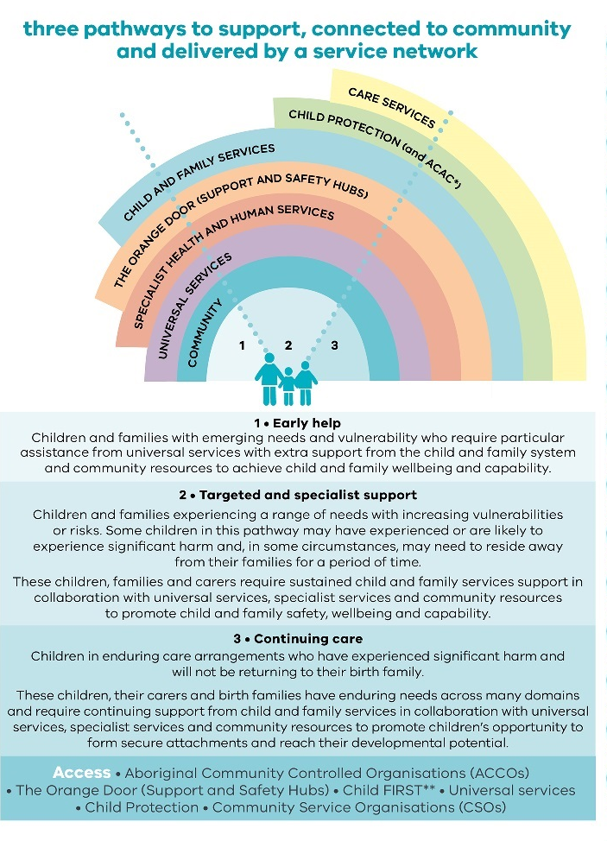  The pathways approach looks at how all parts of the child and family system (The Orange Door, child and family services, Child Protection, care services, including Aboriginal Children in Aboriginal Care) connect to work with vulnerable children and families, as well as how the system links to other service platforms.  The three proposed pathways to support are based around the needs of  GOVERNANCE MODEL  The Board has engaged Grosvenor Performance Group (Grosvenor) to review the Compact’s governance arrangements and develop an evidence-informed, Area-based governance model. This will support the ongoing implementation of the Compact.  Grosvenor consulted with a wide range of stakeholders, including the Board and Compact Steering Group (CSG) and Central and regional staff.  The Board has approved the governance model and a simplified and practical document will be prepared for Areas to use, to support good governance.  An Implementation Framework and Plan (including a Communications and Engagement Plan) will be developed to support the roll-out of the governance model recommendations.  The Board would like to thank everyone involved in the development of the governance model for their participation, time and support of this work.  MONITORING AND EVALUATION FRAMEWORK  Grosvenor was also engaged by the Board to produce a framework to support monitoring and evaluation of the Compact. The Board is currently providing feedback on the draft monitoring and evaluation framework and Grosvenor will be updating the framework based on the feedback received.  The Board would like to thank those involved in the development of the monitoring and evaluation framework.  Compact Issues Resolution Register  The Compact Issues Resolution Register (formerly known as the Barrier Mitigation Strategy) enables system-based barriers that have been identified and raised at area-based Compact meetings to be reviewed, discussed and addressed by senior leaders at the area level as well as by the CSG and Board at a Central level. The Register will help ensure that issues and solutions are being captured, shared and actioned.  Local Aboriginal and Education Consultative Group (LAECG) Representation Area Compact Chairs are reminded that LAECG representatives should be invited to upcoming area-based Compact meetings.  To invite your LAECG to your Area meeting, contact Kim Powell, Early Years Coordinator, Victorian Aboriginal Education Association Incorporated (kim@vaeai.org.au)  FURTHER INFORMATION  If you have questions please contact:  DET staff:  Alison Williams  Manager, Early Childhood Implementation early.years.compact@edumail.vic.gov.au  DHHS staff:  Janice Robertson  Manager, Parenting Support, Children and Families Policy  early.years.compact@dhhs.vic.gov.au  Council staff:  Wendy Allan  MAV Early Years Policy Adviser  wallan@mav.asn.au

Brimbank Learning Futures is a program run by Brimbank City Council, which aims to provide community members with information and services to help with education, training and employment.

