Kindergarten Central Registration and Enrolment Scheme (CRES)
PRACTICE GUIDE
VERSION 1 – NOVEMBER 2020

CONTENTS

Foreword 3
About the CRES Practice Guide 4
Glossary of stakeholders and terminology 5
1. Background 7
2. The CRES Model 9
3. The CRES Ethos 10
4. The CRES PROCESS 12
Stage 1: Proactive engagement and awareness 13
Stage 2: Registration with CRES 18
Stage 3: Allocation 21
Stage 4: Confirmation and communication 24
Stage 5: CRES planning, maintenance and development 28
5. Further reading 30
6. for further information 30

Foreword
The Victorian Government is committed to ensuring all Victorian children have access to a high-quality kindergarten programs, and making the process for families as simple and accessible as possible.
Central Registration and Enrolment provides a single point of contact for families to apply for multiple kindergarten services in their area and helps ensure children secure a place that best suits their needs. It also allows local government to establish strong links with support services, including the Maternal and Child Health Service, to identify and engage children and families who may need more support. This is why the Victorian Government is investing over $5.5 million to support local governments to adopt, establish and enhance Central Registration and Enrolment.
These Kindergarten Central Registration and Enrolment resources will support the implementation of the largest social, economic and educational reform in Victoria’s history – the introduction of funded Three-Year-Old Kindergarten. The Victorian Government is investing nearly $5 billion over the next decade in kindergarten programs for all three-year-olds, giving children an extra year of learning, playing and making friends.
In partnership with the Municipal Association of Victoria, these resources were developed through extensive consultation with local government, kindergarten service providers, Maternal and Child Health services, family and children support services, peak bodies and organisations representing Victoria’s diverse community. The Department would like to thank everyone that contributed to the development of these guides, and in particular, the local government representatives on the Central Enrolment Working Group for sharing their knowledge and experience.
We know that early education can have a profound impact on the life trajectory of child, and a system that supports families to access a quality kindergarten program can make a sustained positive impact on families and children for years to come.

About the CRES Practice Guide
This CRES Practice Guide provides guidance on how to deliver a best-practice Central Registration and Enrolment Scheme (CRES), a local government-led program that supports families and carers to register and enrol their children in kindergarten. The Practice Guide provides information for individuals involved in the delivery of a CRES. The Guide has a companion set of documents and templates that facilitate CRES delivery. All are editable documents and are provided as appendices to the guide.
The Practice Guide comprises four sections:
- Background – Context to early childhood education and how the CRES can help improve outcomes for children
Use section 4 to guide your activities as you deliver the annual CRES cycle.

- The CRES model – An overview of the best-practice model and process
- Ethos – The vision, purpose and principles for the CRES that serve to align practice across the state and provide overall direction for the CRES.
- Process – The steps that all CRES stakeholders will follow to deliver a best-practice CRES, anchored in the family journey.
The Practice Guide is accompanied by a CRES Self-Assessment Tool and CRES Development Guide. The Self-Assessment Tool will help you understand the capabilities of your existing scheme and identify areas for improvement. The Development Guide provides guidance on establishing, developing and expanding a CRES.

Figure 1 | A map of CRES documents
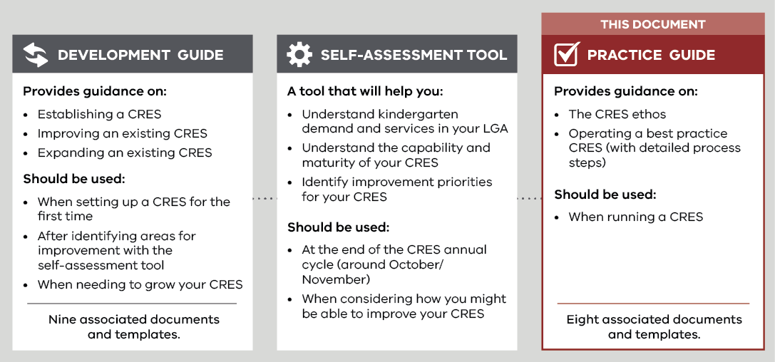
The Practice Guide, Development Guide, Self-Assessment Tool, and associated templates and documents were co-designed by the Department of Education and Training (DET), the Municipal Association of Victoria (MAV), stakeholders representing councils, kindergarten service providers, MCH staff and other support services.

Glossary of stakeholders and terminology
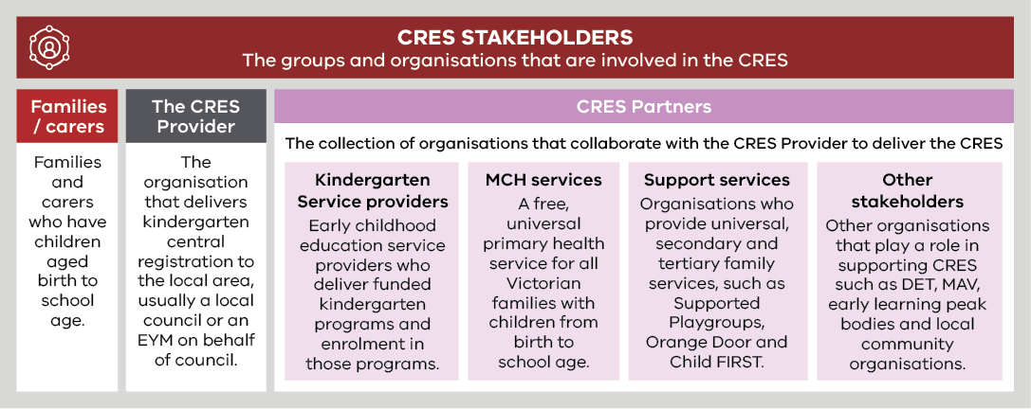

Term | Definition
Central Registration and Enrolment Scheme (CRES) | A best-practice model that streamlines the process of registering and enrolling children in kindergarten for families and service providers, ensuring the process is simple, consistent, inclusive and equitable.
Central Enrolment (CE) / Central Enrolment Scheme | A predecessor to CRES that has successfully improved the equitable and accessible allocation of kindergarten places to date but is implemented differently across the state.
Early Childhood Education and Care (ECEC) | Services provided to children in the years before primary school that develop a child’s social, emotional, cognitive and physical abilities, building a solid foundation for future learning.
Enrolment | In-depth information collection in line with state legislation for a child soon to begin kindergarten. This includes ensuring the service provider has the health and emergency information to provide a safe experience for children and informs state government planning and subsidies.
Early Start Kindergarten (ESK) | The Early Start Kindergarten grants enable an eligible child to access a kindergarten program in the two years before school. There are two types of Early Start Kindergarten grants:  • Aboriginal Early Start Kindergarten grant  • Early Start Kindergarten grant for children known to Child Protection.  Children can be enrolled in a three-year-old group, a four-year-old group, a mixed age group or can be enrolled in a combination of groups delivered by a qualified early childhood teacher, to maximise their access to 15 hours of kindergarten.  Early Start Kindergarten grants are able to be used in combination with the Commonwealth Child Care Subsidy or Additional Child Care Subsidy to reduce costs to parents and carers and to promote inclusive practice in the service.
Early Years Management (EYM) | Formerly “Kindergarten Cluster Management”, Early Years Managers are local government and community-based organisations that provide professional leadership and centralised management to a group of kindergartens as the authorised service provider. EYM is a key strategy to build a stronger, responsive universal kindergarten system.
Kindergarten Fee Subsidy (KFS) | Promotes kindergarten participation by enabling eligible children in funded three and four-year-old groups to access up to 15 hours of kindergarten delivered by a qualified early childhood teacher free of charge or at low cost.  A child enrolled in a long day care service is not eligible for KFS where approved Commonwealth Child Care subsidy is applied.
Kindergarten | An early childhood educational program delivered by a qualified early childhood teacher to children in the two years before school. The term “preschool” is used nationally and in some municipalities.  In Victoria, a “funded kindergarten program” complies with applicable requirements as set out in the Kindergarten Funding Guide and provides a program in accordance with the Victorian Early Years Learning and Development Framework. The Kindergarten Funding Guide can be found at www.education.vic.gov.au/childhood/providers/funding/Pages/kinderfundingcriteria.aspx  Funded kindergarten programs may operate in a variety of settings, including long day care centres, standalone services, schools or community centres, and are operated by a variety of service providers, including community organisations, local councils, schools, not-for-profit organisations or private providers.
LGA | Local Government Area. Often referred to as “council”.
Maternal and Child Health Service | A free, universal primary health service for all Victorian families with children from birth to school age. It includes the Universal MCH program, Enhanced MCH program and the MCH Line, a 24-hour telephone support service.
Registration | The process of families and carers giving initial information about their child to confirm their intention to enrol in kindergarten, administered by the CRES Provider. This includes collection of basic contact information, kindergarten preferences and any other details that may inform prioritised allocation in kindergarten.
Pre-Purchased Places | A Pre-Purchased Place (PPP) is a kindergarten place funded by DET and reserved for vulnerable or disadvantaged children who present outside normal enrolment periods. For each PPP, DET pays the service provider the full cost of a kindergarten place (per capita plus KFS) upfront.  PPPs can only be accessed by children who are eligible for Kindergarten Fee Subsidy, Early Start Kindergarten grants or Early Start Kindergarten extension grants. A state-wide Expression of Interest process is conducted by DET each year, to allocate PPPs for the following year in the areas and services where they are needed most.
Universal, secondary and tertiary support services | “Universal support services” are targeted at an entire population, to provide support and education before problems arise. Examples of universal support services include funded kindergarten programs, the Universal MCH program, community playgroups and libraries.  “Secondary support services” are targeted at families who may need more support to avoid problems escalating. An example of secondary support is Supported Playgroups.  “Tertiary services provide” interventions and treatment where a problem has already occurred. An example of a tertiary service is Child Protection.

Background

Early childhood education and care is an important part of childhood development
The foundations of a child’s long-term development are laid in early childhood. In these years, children develop crucial cognitive and emotional skills such as reasoning, problem solving, and how to get along with others.
A high-quality kindergarten experience sets up a child for a life full of learning and prepares them for school. In the long term, evidence shows that children who have positive early childhood experiences grow up to contribute to a harmonious, healthy and prosperous society .
Despite the recognised benefits, families and carers may choose not to enrol their children in kindergarten. Two possible reasons contributing to this outcome are:
- While most parents acknowledge the opportunity for socialisation of their children, some may not understand the value of play-based or early childhood education.
- Kindergarten services can be difficult to access, because registration and enrolment processes can be laborious for families to navigate. This is particularly the case when English is not the primary language spoken, and/or for more newly arrived communities.

Children experiencing disadvantage and vulnerability benefit the most from early childhood education
Access to early childhood education is particularly important for children experiencing vulnerability, or from a disadvantaged background. Children considered vulnerable on even one Australian Early Development Census domain are half as likely to achieve scores in the top two NAPLAN reading bands in Year 3, and even less likely in Year 5 (DET, Education State Early Childhood Reform Plan, 2018). It is important that early childhood initiatives target children who are most at-risk of missing out on the foundational social, emotional and cognitive experience provided by kindergarten
“A high-quality kindergarten experience is the gateway to a life full of learning”
Education State Early Childhood Reform Plan, DET (2018)

Research indicates that the availability of services is critical to successfully engaging vulnerable and disadvantaged families. Designing an equitable and inclusive system that proactively engages and supports these families ensures all children can access a kindergarten program that suits their needs. This includes:
- using approaches that reach out to families and communities
- ensuring that staff are sensitive to families who have limited awareness of established processes and work with them to facilitate access.

Central Registration and Enrolment can support improved access and engagement with Victoria’s kindergarten services
The greatest impact of centralised kindergarten registration and enrolment comes from engaging families, carers and their children who would otherwise face barriers to enrolment in kindergarten. It simplifies kindergarten registration and enrolment processes for families and encourages local government to work with community and support services, such as Maternal and Child Health (MCH), to proactively identify and engage children and families who may need more support.
The overarching vision for centralised registration and enrolment in Victoria is:
- Families and carers experience a smoother pathway to enrol in and attend kindergarten, by encouraging more local government areas and funded kindergarten programs being part of a CRES.
- Vulnerable and disengaged families are identified early and proactively engaged and enrolled in funded kindergarten programs, by working in collaboration with MCH and other community and support services to work with families during the registration process.
- Kindergarten places are allocated in a transparent, consistent and equitable way, and in line with the Department of Education and Training’s (DET’s) Priority of Access criteria.
- Councils and early years services can better respond to the needs of the community, through the collection of accurate, consistent and timely kindergarten data, to monitor and proactively manage capacity and utilisation of services.
- Administrative burden for kindergarten service providers is minimised, ensuring they can focus on ensuring children arrive at school ready to succeed.
The Central Registration and Enrolment Scheme (CRES) provides one easily accessible way for local families to register for and secure a place for their children in kindergarten, without having to work through the different processes and priorities used by individual service providers. It is a collaborative model that brings together councils, service providers, MCH staff, support services and other stakeholders to support children and their families and carers.
“Early childhood presents an opportunity to invest early and reap the long-term dividend from this investment, as well as avoiding significant long-term costs to society.”
Education State Early Childhood Reform Plan, DET (2018)

The CRES model has been co-designed by DET, the Municipal Association of Victoria (MAV) and a range of service providers, councils and services supporting children and families. It serves as blueprint for councils and other CRES providers to maximise consistent experiences of kindergarten registration and enrolment across Victoria.
Local government, with the support of DET and DHHS, is well-placed to implement initiatives that optimise the uptake of kindergarten in Victoria. Detailed knowledge of local context and community is essential to provide an effective service, and councils play an important role in the planning, development and provision of early childhood services.
In 2020 more than half of all local councils across Victoria operate a form of central enrolment or central registration scheme. These schemes provide a single point of entry for families, simplifying the kindergarten enrolment process and improving equity of access. The new CRES model builds on, and does not replace, schemes that are already operating in many councils across Victoria.

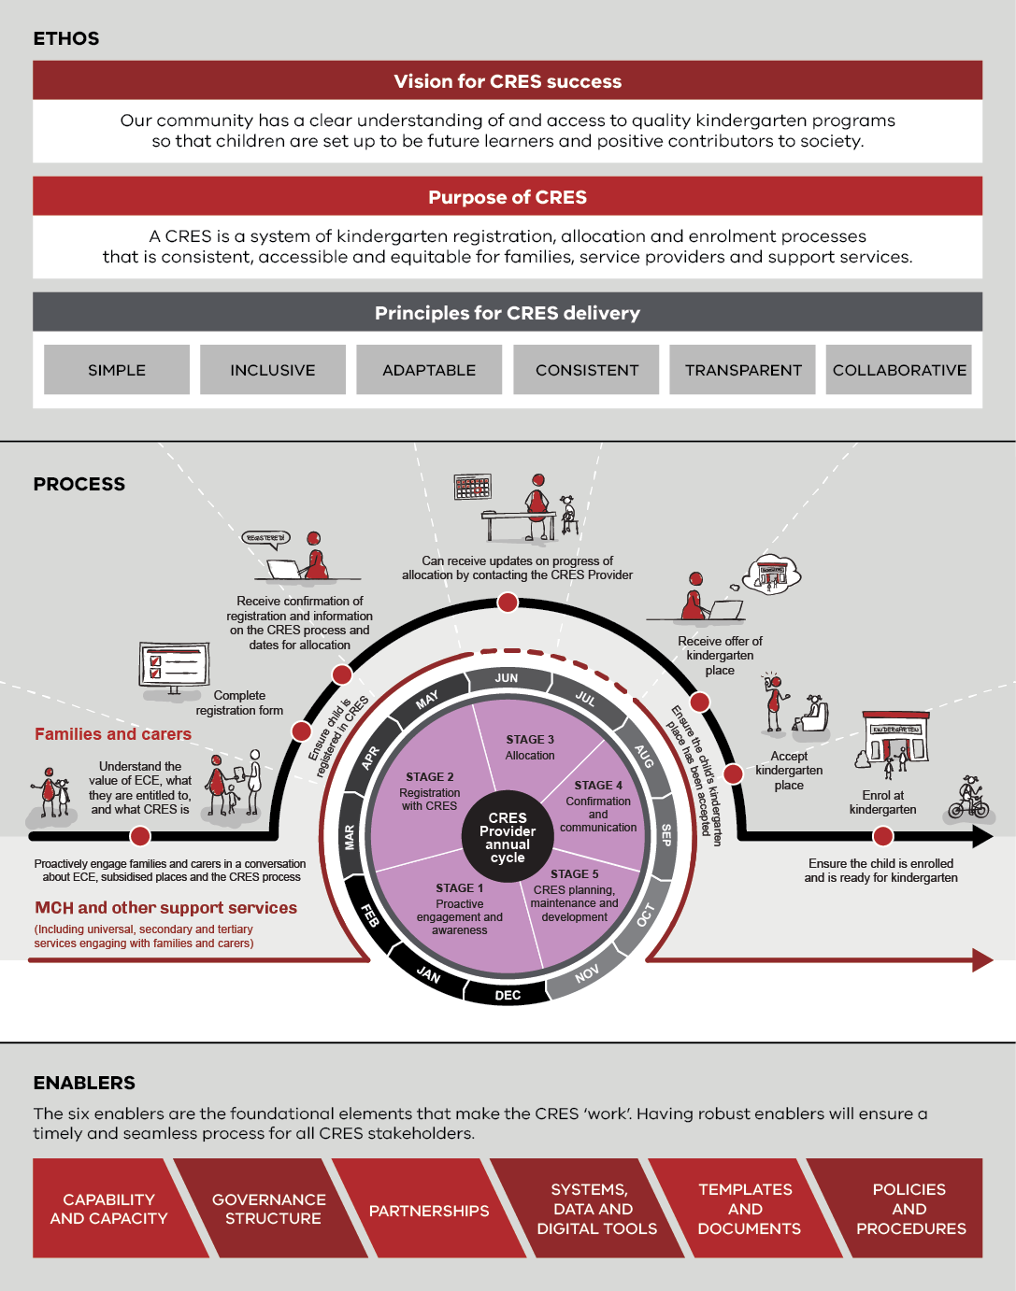
The CRES Model

The CRES Ethos

The CRES ethos guides CRES providers to align their practice with a state-wide vision for central enrolment in Victoria.
The vision statement describes what a CRES aims to achieve and aligns all schemes across the state. The vision is the central rallying point for all CRES Partners that will be involved in delivering the CRES. Using the vision statement as a tool to unite everyone involved with the CRES will create a foundation for strong relationships and an effective CRES.
This purpose statement sets a concrete direction that provides the rationale for why the CRES exists and what it does. The purpose statement encompasses who the CRES is for – the CRES builds a network of partners who coordinate to ensure that families and carers have a seamless experience. Keeping this in mind when conducting CRES-related work will set a clear direction and intention. The purpose statement sets the expectation for the CRES, and for you this means that the purpose should be used as the basis for viewing progress and success.

There are six principles for CRES delivery:
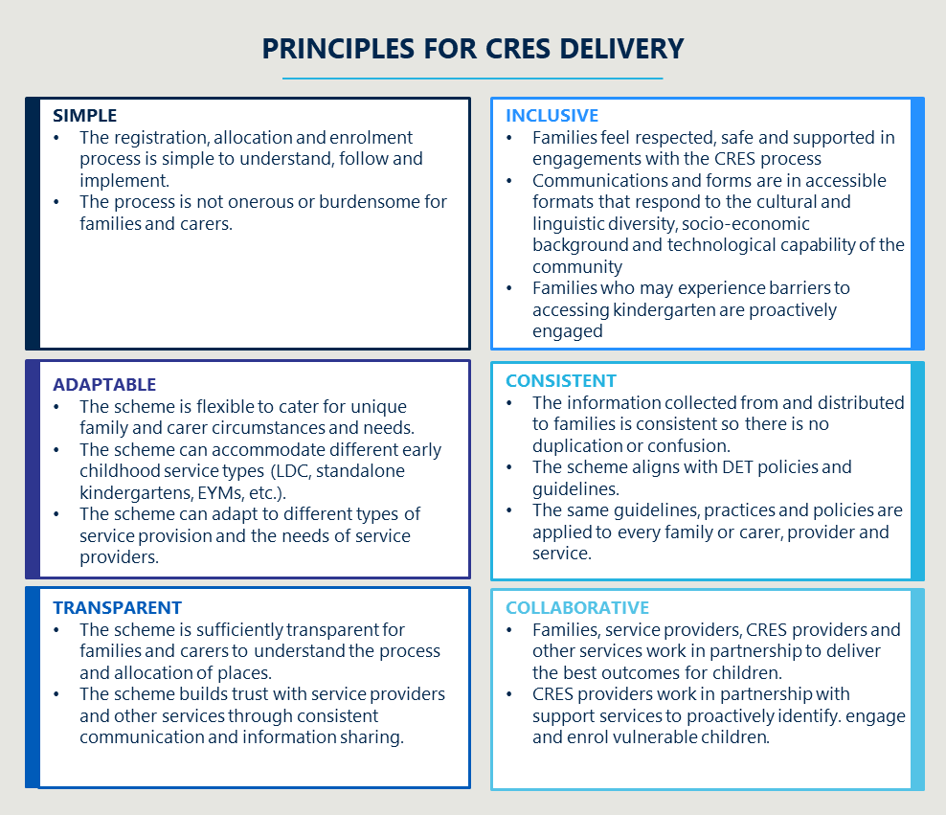

The principles serve to guide the establishment and delivery of the CRES across the state. These six pillars will ensure that consistently high-quality schemes are implemented across Victoria’s many unique council and community contexts. The principles are the reference points for a best-practice CRES. If you check that your CRES related activities and decisions are aligned to these principles, you can be sure that you are fulfilling the CRES vision and purpose

The CRES Process

Stage 1: Proactive engagement and awareness
The objective of this stage is to ensure families and carers are aware of the importance of kindergarten, the CRES and the available assistance to help them engage with the CRES. Specific attention should be paid to ensuring children that are currently disengaged from the service system can engage with the CRES
Working with CRES Partners in this stage to engage families and carers will result in as many children as possible being registered. Investing effort early will reduce the number of late registrations further down the line and minimise the number of children who get missed.

 | December to February
Family experience |  | Is proactively engaged in initial conversations about ECEC and kindergarten. | Searches for or receives information about ECEC, and how to register and enrol their child in kindergarten. | Talks with MCH nurse and support service staff about kindergarten and the enrolment process. | Receives information that kindergarten registration will open shortly.
CRES Provider | Provides partners who have contact with families and carers with promotional and registration materials including:  - Promotional materials for families and carers pack  - Registration form copies or link to online form  - “Information for CRES Partners” pack  (List of organisations to distribute to enclosed in Appendix A)  Ensure frontline CRES staff feel confident ensuring a safe and welcoming environment to appropriately support all families and carers (including marginalised and vulnerable families) to register for kindergarten. | Actively works with support services, community leaders, MCH and other CRES partners to promote the upcoming registration cycle and plan how to best engage families and carers across the municipality.  Collates a list of kindergarten-aged children in their LGA for the coming year through referrals from MCH at two-year visit or by support services.  Collates notes on which children on the list may be experiencing vulnerability and the service/s working to support them. | Broadcasts information about ECEC and CRES, including through:  - Council website  - Immunisation sessions  - Social media  - Local papers and newsletters  - Public noticeboards including at community hubs and services (e.g. playgrounds, pools, leisure centres and libraries). |  | Reminds MCH and support services of CRES deadlines to encourage on-time registrations and provides registration forms and other materials if needed.  Contacts families and carers on the list compiled by MCH and support service referrals to encourage on-time registrations.  Fields questions from families and carers about CRES.
Service Providers | Receives CRES information for the year from CRES Provider.  Communicates with CRES Provider to revise service agreement and provide any necessary information for the following enrolment cycle (such as capacity and session times). | Notifies CRES Provider of vulnerable families currently accessing their service with pre-kindergarten aged children and an action plan to ensure they reach kindergarten. | Provides information about ECEC/CRES to families and carers through:  - Promotional materials for families and carers  - Teachers and staff acting as advocates during family interactions
MCH Service | Receives CRES information for the year from CRES Provider. | Notifies CRES Provider of vulnerable families they are working with and an action plan to ensure they reach kindergarten.  With the parent’s permission, registers child’s name, guardian name and contact number with the CRES Provider using the referral form at the 2-year Key Age and Stage (KAS) consultation. | Broadcasts information through newsletters and bulletins.  Provides information about ECEC/CRES to families and carers at KAS visits. | Reminds families about the CRES enrolment process and provides guidance on how to register children for the next year.  Ensures at 2-year and 3.5-year KAS visits that children are enrolled or attending kindergarten (or ready for enrolment if not attending Three-Year-Old Kindergarten).
Support Services | Receives CRES information for the year from CRES Provider. | Notifies CRES Provider of vulnerable and/or disengaged families they are working with and an action plan to ensure they reach kindergarten.  Registers child’s name, guardian name and contact number with the CRES Provider using the referral form. | Broadcasts information through newsletters, bulletins, websites and community groups. Provides information to families and carers who attend playgroups or use other services, but do not receive direct support.  Provide information about ECEC/CRES to families and carers with children aged two to six. | Reminds families and carers about the CRES enrolment process and provides guidance on how to register children for the next year.
DET |  |  | KESO provides information to Aboriginal families and carers on the importance and safety of ECEC for Aboriginal children.
Tools / Templates | - Appendix A - Promotional material for families and carers template  - Appendix B - CRES Information pack for CRES Partners template  - Appendix C - Referral form template  - Appendix D - Registration form template  - Appendix E – Provider session time request template

Activities for success in Stage 1

Build strong relationships with CRES Partners to advocate for the CRES and get information to families and carers
Service providers, MCH services and support services in your local area are essential advocates for CRES as they have direct connection with the families and carers who must engage with the scheme. This is particularly essential for families and carers experiencing vulnerability or disadvantage. These families and carers are less likely to seek information themselves or have access to typical sources of information about CRES but are more likely to be in regular contact with support services or enhanced MCH.
It is recommended that you actively seek opportunities to interact face-to-face with groups and leaders of CRES Partner organisations (e.g. at monthly staff meetings). Having an identifiable CRES contact person who understands their working context builds trust and leads to productive relationships with CRES partners. Making these visits regular (once every three to four months) will give you an opportunity to refresh partners on the CRES purpose and help educate newer staff (this is important due to the typically high turnover of staff in some support service organisations). For more information about how to develop or build relationships, refer to the Development Guide.

Clear information and easy-to-use marketing materials make it simple for everyone to get the right information to families and carers
Spending time tailoring the communications and promotional materials to your LGA and specific audience (e.g. MCH nurses who are time-poor and must convey a lot of information, or families and carers with limited English) will improve their effectiveness. Communications and promotional materials should be translated into common languages other than English in your area, as well as accompanied by listen links for accessibility on your website. Keeping your website up to date ensures that families or carers can quickly and reliably find the information they need. Other ways to ensure active engagement with your messaging could include:
- Working with community representatives to create kindergarten information so that messaging can be culturally and linguistically informed, and available in formats accessible to the communities you want to reach.
- Seek expert or community advice on how to engage specific cohorts, for example by consulting with respected advocacy groups.
- Think about alternatives to online information and forms, on the advice of what will work for key groups in the community (e.g. paper-based translated information, audio or video messages, text messages, communication via certain social media, face-to-face or telephone information with an interpreter.
- When conducting community outreach, think about taking information to communities where they are (e.g. cultural events, supermarkets, shopping centres, social housing estates, playgrounds) and using media sources familiar to that community (e.g. community run radio stations, bulletins, social media).
Send tailored, updated materials to partners each year to ensure they are well-equipped to engage families and carers. Materials should be distributed to as many partner organisations as possible. Casting a wide net in your local community gives you the greatest opportunity to inform families and carers of the benefits of ECEC and the process for enrolling their child in kindergarten. For a detailed list of recommended places to distribute information about CRES, refer to Appendix A – Promotional material for families and carers template.

Disengaged families require time, commitment and flexibility
The greatest impact of the CRES comes from engaging families, carers and their children who would otherwise face barriers to enrolment in kindergarten. This can only be achieved through proactive engagement with vulnerable families, carers and communities in your local area. Investment in communicating with vulnerable families and support services working with them is required throughout the CRES annual cycle to support registration.
It is critical to consider the capacity and capability of the CRES staff to foster respectful, non-judgemental and flexible approach with families and carers to ensure the CRES is accessible. It is also important to factor in the time required to establish effective relationship with both families and services that support families and carers to ensure effective engagement throughout the CRES cycle. Not all families and carers will face the same barriers or have the same needs, so CRES staff should be responsive to the specific needs of the families and carers they engage with.
For more information on building CRES staff capability to engage with vulnerable families, refer to the Development Guide.
‘No wrong time, no wrong door’
The CRES Provider should engage in a ‘no wrong time, no wrong door’ policy, meaning that the option to seek information and register a child for kindergarten is available whenever and however a family member or carer engages with CRES. This is particularly important for vulnerable families and carers who may need to register their child at any time of year. December through February is the ideal time to focus attention on proactive engagement with families and carers. However, it is essential that CRES and ECEC is promoted to families and carers throughout the year.
Pre-Purchased Places
The use of Pre-Purchased Places (PPPs) ensures that when vulnerable families or carers do register outside of the regular schedule, there are kindergarten places available for their children. PPPs are DET funded kindergarten places which are held for high priority children registering late in the year. When service providers indicate their available places for the year, they should include how many PPPs they have to offer.

Collect referral information early
Referral information can be collected with consent from families and carers and given to the CRES Provider using Appendix C – Referral form template. This is usually done by MCH nurses at the child’s two-year KAS consultation or by support services to make the CRES Provider aware of vulnerable children in the LGA. This data helps the CRES provider compile a list of kindergarten-aged children in the LGA to contact for registration at the appropriate time. The referral form collects: the name of the child, name and contact information of the parent or carer, whether an interpreter is required and the details of the referring service staff member.
While referrals will not produce a comprehensive list of kindergarten-aged children in your LGA, it can capture those children who may fall through the cracks due to vulnerability. Referrals should be used in conjunction with promotional material for families and carers.

CRES templates and documents for Stage 1
- Appendix A - Promotional material for families and carers template
- Appendix B - Information for CRES Partners template
- Appendix C - Referral form template
- Appendix D - Registration form template

Stage 2: Registration with CRES
The objective of this stage is to register all children for allocation to a kindergarten place.
The formal process of registration starts in this stage. Some families may require additional support to complete this step and the CRES Provider must ensure that support can be provided to these families by either the CRES Provider, an MCH nurse, staff from a support service or a trusted friend or community member. Having the right systems, policies and procedures set up will make capturing, storing and distributing registration data easier.
 | March to May
Family experience | Completes a single, accessible and simple registration form. | Receives assistance from support services or MCH to complete the form if necessary.
CRES Provider | Provides the registration form, or link to the form, to families and carers. Supports families and carers to complete the registration form if necessary.  Captures registration data in a standard format. | Fields queries from families and carers, and stakeholders to facilitate registration.  Refers any families who need additional support to a relevant support service, in line with their needs.
Service Providers | Directs families and carers to the online form or provides a hard copy paper. Supports families and carers to complete the registration form if necessary. Encourages families and carers not aware of the CRES system to learn about CRES and register.  Where applicable, ensures that families and carers with children enrolled in Three-Year-Old Kindergarten understand that they need to register for Four-Year-Old Kindergarten. | Fields queries from families and carers to facilitate registration or connect with CRES Provider.  Refers any families who need additional support to a relevant support service, in line with their needs.
MCH Service | MCH nurse supports vulnerable families and carers through registration process or registers on their behalf using existing information sharing protocols. Nurse provides support either through Enhanced MCH visits or additional time requested by families or carers.
Support Services | Assists vulnerable families or carers in registering or registers on their behalf using existing information sharing protocols.
Tools / Templates | - Appendix D - Registration form template  - Appendix F – Data transfer template from CRES Provider to service provider

Activities for success in stage 2

Take registrations only for children who will attend kindergarten in the following year
The CRES provider will only accept registrations for children who will attend a kindergarten program in the following year, unlike some LDC and kindergarten providers that accept enrolments well in advance. This is because opening CRES registrations to families from birth can lead to:
- The impression for families and carers that registration is ‘first-in, first-served’ when, in fact, kindergarten places are allocated based on need (through the DET Priority of Access criteria and potentially local criteria, refer to Stage 3 for more information) and are otherwise randomly assigned for fairness.
- Clogging of the system for families who register at birth but move out of the area by the time their child is of kindergarten age.
Keeping registration open only to children who are about to start kindergarten mitigates these challenges. Depending on systems available, the CRES Provider could set up a reminder database that sends an automated message to families and carers when their child is eligible for registration to capture families and carers who may drop back from MCH services and support services after birth.
Families and carers whose children have attended Three-Year-Old Kindergarten will need to register again for Four-Year-Old Kindergarten. This ensures that kindergarten places can be allocated in response to need. Your CRES may include a local priority criterion which allows children enrolled at a provider for Three-Year-Old Kindergarten to receive priority allocation there for Four-Year-Old Kindergarten (after allocations have been made in line with the DET Priority of Access criteria). This should be determined in consultation with CRES partners while developing your CRES (see Development Guide section 3.2.3).
Information to help families and carers decide when their child is ready for kindergarten can be found at www.education.vic.gov.au/parents/child-care-kindergarten/Pages/when-start-kindergarten.aspx.

Using the right templates to capture data makes for an efficient process
Registration information that is captured will be passed on to service providers in Stage 4. Maintaining a consistent format to capture and share information will minimise transfer errors and maximise efficiency. A data capture and sharing template is available in Appendix F – Data transfer template from CRES Provider to service provider to provide consistency across the state.

Registration forms in languages other than English and accessible formats
We recommend translating your registration form into all commonly spoken first languages in your LGA and ensuring online registration forms include a ‘listen’ link. You can confirm the commonly spoken first languages in your LGA via ABS Census data at www.abs.gov.au/census.

Know who is supporting families and carers
The CRES template registration from includes a section to allow families and carers to nominate an additional contact person to be kept up to date on the progress of the child’s registration and enrolment.
Encourage CRES Partners such as Enhanced MCH nurses or support service staff to list their contact details on the registration form if supporting a family or carer to complete it (e.g. listing the details of a case worker for a child known to Child Protection). Alternatively, if you as the CRES Provider staff member are supporting the family or carer to complete registration, encourage them to list a trusted friend, family member or community member who can support them with the CRES process.
CRES templates and documents for Stage 2
- Appendix D - Registration form template
- Appendix F – Data transfer template from CRES Provider to service providers

Stage 3: Allocation
The objective of this stage is to equitably allocate kindergarten places, ensure access for vulnerable families and carers, and fill kindergartens as efficiently as possible.
Equitable allocation starts with having the right procedures set up to apply the DET Priority of Access policies. The task of allocating children according to preferences and available places is time consuming, so be prepared to invest some time in this stage each year.
 | June to July
Family experience | Receives confirmation that their registration has been received and a timeline for allocation and enrolment processes. | Late or out-of-cycle registrations:  If the family or carer completed the registration form after the closing date, they receive a timeline for second round allocations once the form is completed.
CRES Provider | Allocates children to kindergarten places, working with service providers to ensure that sessions are at appropriate capacity and all children have kindergarten options.  Allocates children to kindergarten places based on registered preferences, applying a standardised set of guidelines to prioritise children based on:  - DET’s Priority of Access criteria  - Locally agreed criteria developed at the establishment of the scheme.  Sets aside a number of positions for late registration of priority groups, using historical data to estimate the number required. Uses PPPs where available. | Continues to accept registrations after the closing date and informs families and carers of the process for the second round of allocation.
Service Providers | Identifies children who may be eligible for a second year of funded kindergarten, and flag this with the CRES Provider. | Assists any families or carers who did not register before the closing date to register and informs them of the process for second round allocation.
MCH Service | Receives confirmation of kindergarten places for the families and carers where an MCH nurse was listed as an additional contact person on the registration form. | Assists any families or carers who did not register before the closing date to register and informs them of the process for second round allocation.
Support Services | Receives confirmation of kindergarten places for the families and carers where a support service staff member was listed as an additional contact person on the registration form.  Connects with kindergarten to share any relevant information about the child, family or carer to support their transition into kindergarten. | Assists any families or carers who did not register before the closing date to register and informs them of the process for second round allocation.
DET |  | DET regional staff member supports with the placement of children in a kindergarten service where needed (including if there is an undersupply of kindergarten places in the local area).
Tools / Templates | - Appendix G – Draft family and carer communications pack

Activities for success in Stage 3

Estimate late registration demand for priority applicants and reserve enough places for them
Experience shows that families and who are experiencing disadvantage or require a second year of kindergarten due to developmental delays are more likely to register late. These children are the most likely to benefit from kindergarten. For more information on children who require a second year of kindergarten, visit www.education.vic.gov.au/parents/child-care-kindergarten/Pages/kindergarten-second-year.aspx
Using data from previous years of registrations, the CRES provider can predict a rough number of late registrations that will be allocated to children who meet the Priority of Access criteria. Try to reserve places in kindergartens to accommodate that number of children. Where possible, Pre-Purchased Place allocations may be used to reserve a placed for eligible children.

Apply the DET Priority of Access criteria to equitably allocate places
The DET Priority of Access criteria are the foremost criteria which you must apply to allocate kindergarten places. The most recent and complete description of the DET Priority of Access criteria can be found in the DET Kindergarten Funding Guide.
Children who meet the POA criteria should be allocated first. Then, if the CRES Provider has additionally defined ‘local criteria’ for prioritising allocations, children who meet these should be allocated to their top available preferences. For more detail on local criteria, see Development Guide section 3.2.3.
Children who do not meet the Priority of Access or local criteria should then be randomly selected to be allocated according to their nominated kindergarten / session preferences. For fairness, no priority should be given to families and carers who registered early.

The DET Kindergarten Funding Guide
The DET Kindergarten Funding Guide provides information about kindergarten funding programs, eligibility criteria and service provider obligations. Reading the guide will help you understand the funding and operational context of service providers in your scheme. The Funding Guide also includes the details of DET Priority of Access criteria. All CRES Provider staff should be familiar with the Funding Guide.
The guide can be found at www.education.vic.gov.au/childhood/providers/funding/Pages/kinderfundingcriteria.aspx

Find an alternative place if you do not have enough places in your CRES
Sometimes it will not be possible to find a kindergarten place within the CRES for all children who have registered. It is important that you support the family or carer to find an alternative place if this occurs. There are a number of ways to do this, depending on your context:
- Contact services in your LGA (such as long daycare services) who do not participate in the CRES to find vacancies which may be appropriate for the child
- Contact the CRES Provider or kindergartens in neighbouring LGAs to find vacancies which may be appropriate for the child
- Contact your local DET regional staff member for support to find nearby places.
The CRES should ensure that families and carers feel they only have to register their child in one place, rather than lodging and withdrawing registrations at many locations. Supporting families who cannot be provided a place through CRES to find an alternative is consistent with the aim of helping all children access kindergarten.
The CRES process provides information to support long-term kindergarten capacity planning in LGAs to, over time, decrease the likelihood of this situation. If you think your CRES will receive more registrations in a year than you have places, contact DET or nearby CRES Provider/kindergartens early to consider solutions. Then, in Stage 5, reflect on how to ensure there are enough places in your CRES for future years.

CRES templates and documents for Stage 3
- Appendix G – Draft family and carer communications pack
- CRES Development Guide Section 3.2.3 (if considering different allocation methods)

Stage 4: Confirmation and communication
The objective of this stage is to clearly communicate with families and carers to confirm their child’s allocated place, inform service providers of their allocated children and ensure service providers have all necessary information to facilitate a warm welcome to allocated children at kindergarten.
Consistent and transparent communication about their child’s allocation will reassure families and carers about the process. You should ensure that families and carers understand the process and timeline for allocation throughout this stage, especially if running multiple rounds of allocation.
 | August to September |  |  |  | January
Family experience | First round allocations:  Receives confirmation of placement or waitlist status.  Families and carers who are on the waitlist can update their preferences or inform the CRES Provider of any changes to their circumstances before the next round of allocations. | Accepts or declines the kindergarten place offered to them. If declined, parent or carer receives a timeline for second round allocations and can update their preferences.  If a change of mind occurs after the place has been accepted, the parent or carer calls the CRES Provider to be re-allocated or returned to the wait list. | Subsequent round allocations:  Receives confirmation of their child's placement in kindergarten and accepts the offer or is assisted to find an alternative place if none are available. | Receives information about next steps to enrol their child with the kindergarten directly.  Completes enrolment forms with their kindergarten with help from support services and CRES Provider where necessary. | Attends first day of kindergarten.
CRES Provider | Informs the family or carer, any nominated additional contacts and any referring support services of the child’s placement or waitlist status.  Provides a list of allocated children to service providers, including contact details for support services where consent has been given. | Adds any families or carers who have declined their offered position to the list of next round allocations. | Completes subsequent round allocations, including for late registrations and declined places.  Informs the family or carer and any related support services of child's placement in kindergarten in subsequent allocation rounds.  Receives an updated list of allocated registrations. | Provides an updated list of allocated children to service providers, including contact details for support services connected with any of the children on their allocation list. | Monitors any “change of mind” to ensure all children are either enrolled in kindergarten or prepared for next year’s CRES cycle.
Service Providers | Receives list of allocated children for their kindergarten sessions.  Informs the CRES Provider if a child they are aware of (through siblings or community, or a child requiring a second year of funded kindergarten) should be registered but is not and requests that a space is held in the next allocation round. Supports these families and carers to register. |  | Receives an updated list of allocated registrations. | Speaks with support services who work with the children allocated to their service and confirms any actions that could make the child, family or carer more comfortable on the first day of kindergarten.  Enrols children through a consistent internal process, including  interviews, orientation days and other preparation activities. | Follows up with any families or carers of children allocated to their service who do not attend the first day of kindergarten. Assists in attendance or refers family or carer back to the CRES Provider.  Informs related support services if children do not attend on the first day of kindergarten.
MCH Service | Receives notifications of place or waitlist status for children who list an MCH nurse as an additional contact. |  |  | Confirms that families and carers understand and have the support they need to enrol in and prepare for kindergarten. | Follows up with any families or carers in Enhanced MCH who do not attend on the first day of kindergarten to assist in attendance or refer back to the CRES Provider.
Support Services | Receives notifications of place or waitlist status for children who list support service staff member as an additional contact. | Receives confirmation of kindergarten places for the children and families or carers they support. | Connects with confirmed kindergarten to share any relevant information about the child, family or carers they support. This might include recommendations to make the child, family and carers feel comfortable on the first day of kindergarten. | Confirms that families and carers understand and have the support they need to enrol in and prepare for kindergarten.  Assists families with the transition into kindergarten, including by supporting completion of enrolment forms and attending preparation activities.  Supports any families who have missed enrolment to enter CRES. | Follows up with any families or carers they support who do not attend on the first day of kindergarten to assist in attendance or refer back to the CRES Provider.
Tools / Templates | - Appendix G – Draft family and carer communications templates pack | - Appendix G – Draft family and carer communications templates pack | - Appendix F – Data transfer template from CRES Provider to service providers

Activities for success in Stage 4

Follow up if an offer of a kindergarten place to a vulnerable or disadvantaged child is not accepted
Contacting the family or carer by phone in the first instance can easily resolve any issues as messages can sometimes get buried or missed. You should also contact their nominated alternative support person if this is unsuccessful. If the family or carer has regular contact with a support service, you should ask the support service to help you follow up.

Second and subsequent allocations should include late registrations and be conducted using the same process as the first round
A second round of allocations should be conducted after the period to accept or decline first round offers has closed. If families and carers do not respond to their offer of a place, assume that this is a rejection. If families and carers reject their offer of a place, they will be placed in a second-round allocation pool.
Any registrations that are submitted before you commence second-round allocations should be included in this process.
The second and subsequent-round allocations should be conducted just as the first-round allocations are – Priority of Access criteria are applied first to identify high-priority children, then local criteria are considered, and finally all others are randomly selected to be allocated.
Timeline flexibility
The CRES Provider should engage in a ‘no wrong time, no wrong door’ policy, meaning that the option to seek information and register a child for kindergarten is available whenever and however a family member or carer engages with CRES.
While August to September is the ideal time to have all kindergarten places accepted and registration details shared with service providers, some families and carers may not engage with the CRES process on this precise timeline. It is essential that registration, allocation and communication of kindergarten places can be completed ad hoc throughout the year. This is particularly important for vulnerable families and carers who may need to register their child at any time of year.
Pre-Purchased Places
Eligible children should be prioritised as per DET’s Priority of Access criteria whenever they register. The use of PPPs ensures that when vulnerable families or carers do register outside of the regular schedule, there are kindergarten places available for their children. PPPs are DET funded kindergarten places which are held for high priority children registering late in the year. When service providers indicate their available places for the year, they should include how many PPPs they have to offer.

Include support people in all communication
Families and carers experiencing vulnerability are most likely to experience barriers to accepting a child’s place in kindergarten and continuing the registration and enrolment journey. If the family or carer listed an additional contact person on their registration form, ensure that individual is included on all email communication and if the family or carer cannot be contacted, reach out to this support person. The aim of contacting a support person is to keep them informed on the progress of the registration so they can, where necessary, provide further support to the family or carer to accept the kindergarten place and prepare for kindergarten.
CRES templates and documents for Stage 4
- Appendix F – Data transfer template from CRES Provider to service providers
- Appendix G – Draft family and carer communications templates pack
- Appendix H - Enrolment form

Stage 5: CRES planning, maintenance and development
The objective of this stage is to prepare for success in the following year by evaluating and improving the CRES.
The end of the kindergarten year will give you an opportunity to review your CRES’ strengths and how it could improve. A period of reflection and feedback involving CRES Partners will help make the process even better for the upcoming year.
 | October to January
Family experience
CRES Provider | Evaluates scheme processes and procedures against Self-Assessment Tool and collects feedback from providers and other partners in the scheme. Considers data about kindergarten enrolment and attendance and compares against the profile of the whole LGA.  Makes decisions to change or improve the scheme are in collaboration with service providers and other stakeholders. | Plans for and implements scheme improvements or makes plan to implement improvements in the future when timing is appropriate. | Reaches out to providers to re-affirm their commitment to the scheme for next year’s process and recruits providers to join the scheme for the coming kindergarten year where possible.  Revises service agreements with service providers to confirm key information for the coming enrolment cycle, including  - kindergarten sessions and hours  - status as a provider of funded kindergarten  - any changes to quality of provision.
Service Providers | Gives feedback to the CRES Provider about the annual process when asked.
MCH Service | Gives feedback to the CRES Provider about the annual process when asked.
Support Services | Gives feedback to the CRES Provider about the annual process when asked.
DET |  |  | Upkeeps and version controls the central enrolment materials.
Tools / Templates | Self-assessment Tool |  | CRES Development Guide

Activities for success in stage 5

Actively seek feedback for improvement among CRES Partners
The perspectives of the CRES Partners are important to consider when looking at how to improve the CRES. Their experience of the CRES and how they support it is fundamental to operating an effective service that reaches the whole community. There are several ways to engage CRES Partners:
- Host focus groups / discussions with a range of CRES Partners to get diverse perspectives on what is working well in the CRES and what might be improved. A group discussion will also help identify how a certain strengths or issues affect multiple groups.
- Contact individuals for one-on-one discussions can help elicit frank, in-depth feedback that will help your CRES improve.
Complete the Self-Assessment Tool before engaging in the feedback process with Partners to ensure that you enter these conversations informed about your current CRES and potential improvements. The Tool includes reviewing data to assess how well your CRES is reaching vulnerable children, which should inform discussions with Partners about outreach and support for the following year.
If you are considering making changes to the CRES, ensure that CRES Partners broadly support the change.

Re-affirm CRES Partner commitments
It is essential that CRES Providers are on-board to continue their role in supporting the CRES for the next year. Initial engagements to get their feedback on the CRES will build trust among partners and highlight any potential barriers for them participating in the CRES for the coming year. If you are looking to grow the scale of your CRES, refer to the Expand your CRES chapter in the Development Guide.
Ensure CRES Provider staff are equipped for a successful cycle
CRES Providers should ensure all staff are prepared to meet any challenges in the year ahead. The Self-Assessment Tool will help you to improve your CRES delivery. You should also update any relevant organisational documents which sit around your CRES, such as:
- Ensure your CRES has an up-to-date risk management strategy. You should use a template or guide from your organisation to ensure your strategy meets any internal requirements. When updating and improving your CRES at the end of the cycle, review your risk management strategy.
- Ensure all staff involved in CRES delivery understand your organisation’s complaints handling process and how it applies to the CRES. This should include a process for responding to and resolving complaints, clear lines of escalation, and a list of common questions you have received and their answers.
CRES templates and documents for Stage 5
- Self-Assessment Tool
- CRES Development Guide (if making changes to the CRES for the next annual cycle)

Further reading
This Practice Guide and associated appendices refer to a number of external sources. New CRES Officers should review these resources to inform themselves about kindergarten in Victoria and the CRES.

Kindergarten Funding Guide
www.education.vic.gov.au/childhood/providers/funding/Pages/kinderfundingcriteria.aspx
Immunisation requirement information (No Jab No Play)
www2.health.vic.gov.au/public-health/immunisation/vaccination-children/no-jab-no-play
Department of Education and Training – Kindergarten resources
https://www.education.vic.gov.au/parents/child-care-kindergarten/Pages/default.aspx
Department of Education and Training – Three-Year-Old Kindergarten
https://www.education.vic.gov.au/about/programs/Pages/three-year-old-kinder.aspx
Department of Education and Training – Second year of kindergarten
www.education.vic.gov.au/parents/child-care-kindergarten/Pages/kindergarten-second-year.aspx

for further information

Further information, including contact details, can be found at:

Department of Education and Training - Central Enrolment
www.education.vic.gov.au/about/educationstate/Pages/central-enrolment.aspx

Municipal Association of Victoria – Central Enrolment Project
www.mav.asn.au/what-we-do/policy-advocacy/social-community/children-youth-family/central-enrolment-project

Education State Early Childhood Reform Plan, DET (2018)

