This page is intentionally left blank

Foreword
The Victorian Government is committed to ensuring all Victorian children have access to a high-quality kindergarten programs and making the process for families as simple and accessible as possible.
Central Registration and Enrolment provides a single point of contact for families to apply for multiple kindergarten services in their area and helps ensure children secure a place that best suits their needs. It also allows local government to establish strong links with support services, including the Maternal and Child Health Service, to identify and engage children and families who may need more support. This is why the Victorian Government is investing over $5.5 million to support local governments to adopt, establish and enhance Central Registration and Enrolment.
These Kindergarten Central Registration and Enrolment resources will support the implementation of the largest social, economic and educational reform in Victoria’s history – the introduction of funded Three-Year-Old Kindergarten. The Victorian Government is investing nearly $5 billion over the next decade in kindergarten programs for all three-year-olds, giving children an extra year of learning, playing and making friends
In partnership with the Municipal Association of Victoria, these resources were developed through extensive consultation with local government, kindergarten service providers, Maternal and Child Health services, family and children support services, peak bodies and organisations representing Victoria’s diverse community. The Department would like to thank everyone that contributed to the development of these guides, and in particular, the local government representatives on the Central Enrolment Working Group for sharing their knowledge and experience.
We know that early education can have a profound impact on the life trajectory of child, and a system that supports families to access a quality kindergarten program can make a sustained positive impact on families and children for years to come.

CONTENTS
Foreword 3
Glossary of stakeholders and terminology 5
About the CRES Development Guide 7
1 Background 9
2 The CRES model 11
3 Establish a CRES 12
3.1 Obtain commitment 13
3.1.1 Write a discussion paper 13
3.1.2 Develop a stakeholder engagement plan 14
3.1.3 Develop and present a business case 16
3.2 Plan and develop the CRES 18
3.2.1 Set up contract management 18
3.2.2 Establish the project working group 19
3.2.3 Develop CRES components in consultation with partners 20
3.2.4 Confirm all partners in an MOU 29
3.2.5 Prepare for launch 29
4 Improve your CRES 31
4.1 Complete annual review using CRES Self-Assessment Tool 32
4.2 Secure additional funding, if necessary 32
4.3 Enhance internal capability 32
4.4 Improve governance structures 34
4.5 Improve and develop systems 34
4.6 Develop relationships 35
5 Expand your CRES 37
5.1 Drivers for CRES expansion 37
5.2 Extend the policy commitment to the CRES, if necessary 38
5.3 Ensure enablers can meet expansion 38
5.4 Confirm partnerships 39
Appendix A | Documents and templates 43

Glossary of stakeholders and terminology
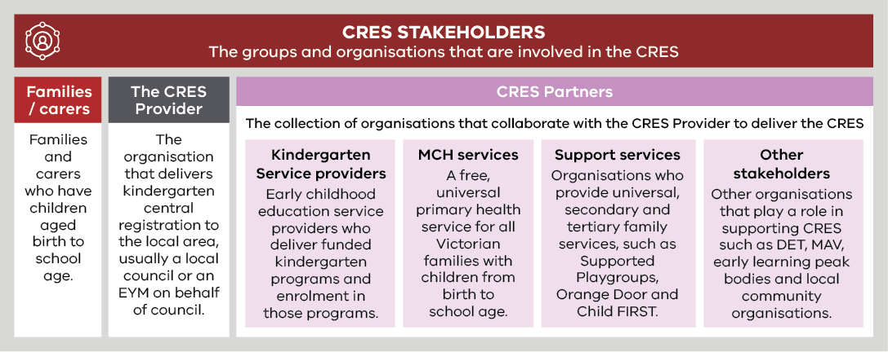
Term | Definition
Central Registration and Enrolment Scheme (CRES) | A best-practice model that streamlines the process of registering and enrolling children in kindergarten for families and service providers, ensuring the process is simple, consistent, inclusive and equitable.
Central Enrolment (CE)/ Central Enrolment Scheme | A predecessor to CRES that has successfully improved the equitable and accessible allocation of kindergarten places to date but is implemented differently across the state.
Early Childhood Education and Care (ECEC) | Services provided to children in the years before primary school that develops a child’s social, emotional, cognitive and physical abilities, building a solid foundation for future learning.
Enrolment | In-depth information collection in line with state legislation for a child soon to begin kindergarten. This includes ensuring the service provider has the health and emergency information to provide a safe experience for children and informs state government planning and subsidies.
Early Start Kindergarten (ESK) | The Early Start Kindergarten grants enable an eligible child to access a kindergarten program in the year two years before school. There are two types of Early Start Kindergarten grants:  - Aboriginal Early Start Kindergarten grant  - Early Start Kindergarten grant for children known to Child Protection.  Eligibility can be established in discussion with the family or services working with the family such as Maternal and Child Health nurses.  Children can be enrolled in a three-year-old group, a four-year-old group, a mixed age group or can be enrolled in a combination of groups delivered by a qualified early childhood teacher, to maximise their access to 15 hours of kindergarten.  Early Start Kindergarten grants are able to be used in combination with the Commonwealth Child Care Subsidy or Additional Child Care Subsidy to reduce costs to parents and carers and to promote inclusive practice in the service.
Early Years Management (EYM) | Formerly “Kindergarten Cluster Management”, Early Years Managers are local government and community-based organisations that provide professional leadership and centralised management to a group of kindergartens as the authorised service provider. EYM is a key strategy to build a stronger, responsive universal kindergarten system.
Kindergarten Fee Subsidy (KFS) | Promotes kindergarten participation by enabling eligible children in funded three and four-year-old groups to access up to 15 hours of kindergarten delivered by a qualified early childhood teacher free of charge or at low cost.  A child enrolled in a long day care service is not eligible for KFS where approved Commonwealth Child Care subsidy is applied.
Kindergarten | An early childhood educational program delivered by a qualified early childhood teacher to children in the two years before school. The term “preschool” is used nationally and in some municipalities.  In Victoria, a “funded kindergarten program” complies with applicable requirements as set out in the Kindergarten Funding Guide and provides a program in accordance with the Victorian Early Years Learning and Development Framework.  Funded kindergarten programs may operate in a variety of settings, including long day care centres, standalone services, schools or community centres, and is operated by a variety of service providers, including community organisations, local councils, schools, not-for-profit organisations or private providers.
LGA | Local Government Area. Often referred to as “council”.
Maternal and Child Health Service | A free, universal primary health service for all Victorian families with children from birth to school age. It includes the Universal MCH program, Enhanced MCH program and the MCH Line, a 24-hour telephone support service.
Registration | The process of families and carers giving initial information about their child to confirm their intention to enrol in kindergarten, administered by the CRES Provider. This includes collection of basic contact information, kindergarten preferences and any other details that may inform prioritised allocation in kindergarten.
Pre-Purchased Places | A Pre-Purchased Place (PPP) is a kindergarten place funded by DET and reserved for vulnerable or disadvantaged children who present outside normal enrolment periods. For each PPP, DET pays the service provider the full cost of a kindergarten place (per capita plus KFS) upfront.  PPPs can only be accessed by children who are eligible for Kindergarten Fee Subsidy, Early Start Kindergarten grants or Early Start Kindergarten extension grants. A state-wide Expression of Interest process is conducted by DET each year, to allocate PPPs for the following year in the areas and services where they are needed most.
Universal, secondary and tertiary support services | “Universal support services” are targeted at an entire population, to provide support and education before problems arise. Examples of universal support services include funded kindergarten programs, the Universal MCH program, community playgroups and libraries.  “Secondary support services” are targeted at families who may need more support to avoid problems escalating. An example of secondary support is Supported Playgroups.  “Tertiary services provide” interventions and treatment where a problem has already occurred. An example of a tertiary service is Child Protection.

About the CRES Development Guide
The CRES Development Guide provides guidance on establishing and developing a Central Registration and Enrolment Scheme (CRES), a predominately local government-led program that supports families and carers to register and enrol their children in kindergarten.
The CRES Development Guide provides information for two audiences:
- For local government officers who are investigating establishing a CRES; this document provides guidance on how to establish a CRES in your municipality, including how to build internal support for the CRES and what a successful CRES looks like.
- For managers of a current central enrolment (CE) scheme; this document provides guidance on how to improve and expand your scheme to align with the best practice CRES model.
The Development Guide comprises five chapters:
- Background – Context to early childhood education and how the CRES can help children get enrolled in kindergarten.
- The CRES Model – An overview of the CRES best-practice model and process.
- Establish a CRES – The steps to follow to establish a CRES in your municipality.
- Improve your CRES – For organisations who are already operating a CRES, steps on how to improve and refine the CRES.
- Expand your CRES – For organisations already operating a CRES, steps on how to expand the CRES to cover more services.
This Development Guide is accompanied by a Self-Assessment Tool and Practice Guide, as mapped in Figure 1:
- The Self-Assessment Tool will help you understand capabilities of your existing scheme and help identify areas for improvement.
- The Practice Guide explains how to operate a best-practice CRES once it is established.
Figure 1 below maps the different CRES documents.
Figure 1 | A map of CRES documents
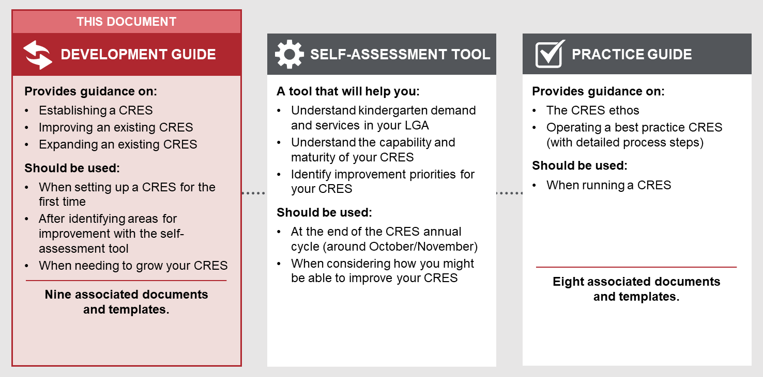
The CRES Practice Guide, Development Guide, Self-Assessment Tool, and associated templates and documents were co-designed by the Department of Education and Training (DET), the Municipal Association of Victoria (MAV), stakeholders representing councils, kindergarten service providers, MCH staff and other support services.

Background
EARLY CHILDHOOD EDUCATION IS AN IMPORTANT PART OF CHILDHOOD DEVELOPMENT
The foundations of a child’s long-term development are laid in early childhood. In these years, children develop crucial cognitive and emotional skills such as reasoning, problem solving, and how to get along with others.
A high-quality kindergarten experience sets up a child for a life full of learning and prepares them for school. In the long term, evidence shows that children who have a positive early childhood experiences grow up to contribute to a harmonious, healthy and prosperous society .
Despite the recognised benefits, families and carers may choose to not enrol their children in kindergarten. Two possible reasons contributing to this outcome are:
- While most parents acknowledge the opportunity for socialisation of their children, some groups may not understand the value of play-based education, or the value of early childhood education.
- Kindergarten services can be difficult to access, because registration and enrolment processes can be laborious for families to navigate. This is particularly the case when English is not the primary language spoken, and/or for more newly arrived communities.
CHILDREN EXPERIENCING DISADVANTAGE AND VULNERABILITY BENEFIT THE MOST FROM EARLY CHILDHOOD EDUCATION
“A high-quality kindergarten experience is the gateway to a life full of learning” ¹
– Education State Early Childhood Reform Plan, DET (2018)
Access to early childhood education is particularly important for children experiencing vulnerability, or from a disadvantaged background. Children considered vulnerable on even one Australian Early Development Census domain are half as likely to achieve scores in the top two NAPLAN reading bands in Year 3, and even less likely in Year 5 (DET, Education State Early Childhood Reform Plan, 2018). It is important that early childhood initiatives target children who are most at-risk of missing out on the foundational social, emotional and cognitive experience provided by kindergarten¹.
Research indicates that the availability of services is critical to successfully engaging vulnerable and disadvantaged families. Designing an equitable and inclusive system that proactively engages and supports these families ensures all children can access a kindergarten program that suits their needs. This includes:
- using approaches that reach out to families and communities
- ensuring that staff are sensitive to families who have limited awareness of established processes and work with them to facilitate access.

Central Registration and Enrolment can support improved access and engagement with Victoria’s kindergarten services
The greatest impact of centralised kindergarten registration and enrolment comes from engaging families, carers and their children who would otherwise face barriers to enrolment in kindergarten. It simplifies kindergarten registration and enrolment processes for families and encourages local government to work with community and support services, such as Maternal and Child Health (MCH), to proactively identify and engage children and families who may need more support.
The overarching vision for centralised registration and enrolment in Victoria is:
- Families and carers experience a smoother pathway to enrol in and attend kindergarten, by encouraging more local government areas and funded kindergarten programs being part of a CRES.
- Vulnerable and disengaged families are identified early and proactively engaged and enrolled in funded kindergarten programs, by working in collaboration with MCH and other community and support services to work with families during the registration process.
- Kindergarten places are allocated in a transparent, consistent and equitable way, and in line with the Department of Education and Training’s (DET’s) Priority of Access criteria.
- Councils and early years services can better respond to the needs of the community, through the collection of accurate, consistent and timely kindergarten data, to monitor and proactively manage capacity and utilisation of services.
- Administrative burden for kindergarten service providers is minimised, ensuring they can focus on ensuring children arrive at school ready to succeed.
The Central Registration and Enrolment Scheme (CRES) provides one easily accessible way for local families to register for and secure a place for their children in kindergarten, without having to work through the different processes and priorities used by individual service providers. It is a collaborative model that brings together councils, service providers, MCH staff, support services and other stakeholders to support children and their families and carers.
“Early childhood presents an opportunity to invest early and reap the long-term dividend from this investment, as well as avoiding significant long-term costs to society.” ¹
– Education State Early Childhood Reform Plan, DET (2018)

The CRES model has been co-designed by DET, the Municipal Association of Victoria (MAV) and a range of service providers, councils and services supporting children and families. It serves as blueprint for councils and other CRES providers to maximise consistent experiences of kindergarten registration and enrolment across Victoria.
Local government, with the support of DET and DHHS, is well-placed to implement initiatives that optimise the uptake of kindergarten in Victoria. Detailed knowledge of local context and community is essential to provide an effective service, and councils play an important role in the planning, development and provision of early childhood services.
In 2020 more than half of all local councils across Victoria operate a form of central enrolment or central registration scheme. These schemes provide a single point of entry for families, simplifying the kindergarten enrolment process and improving equity of access. The new CRES model builds on, and does not replace, schemes that are already operating in many councils across Victoria.

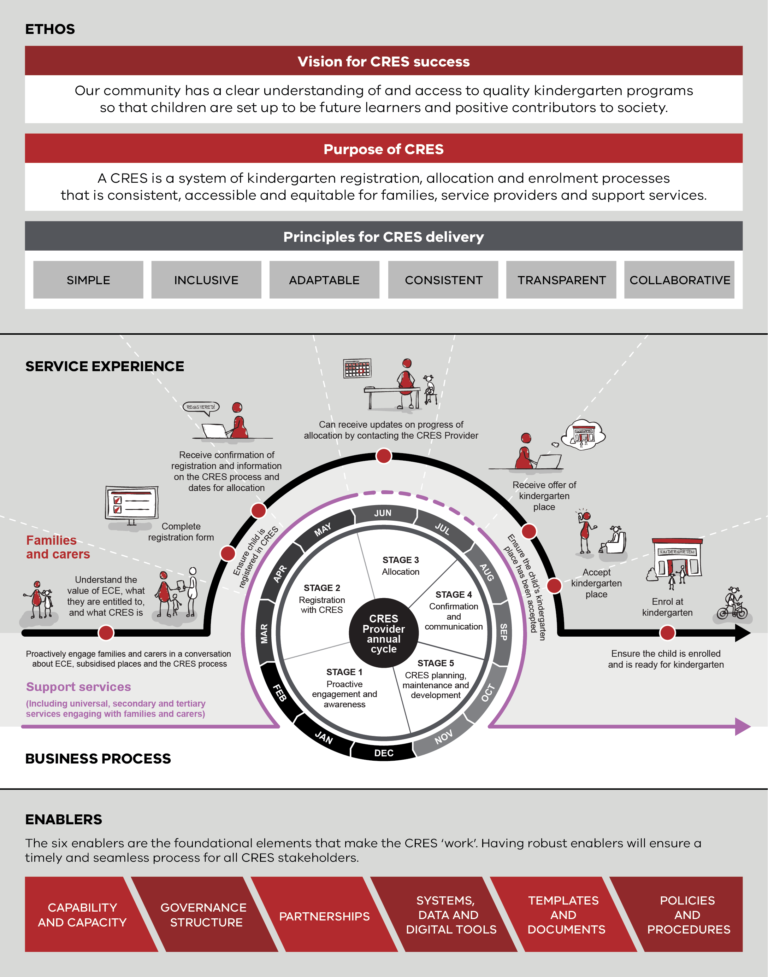
The CRES model

Establish a CRES
A successful CRES requires commitment from council, clear business processes and engaged external partners. Investing effort up-front to establish the CRES will lay the groundwork for future success.
This chapter provides guidance on the two phases to establish a CRES, shown in Figure 2. The first phase institutes a formal commitment to the CRES and will set up the relationships that will be important for CRES delivery. The second phase develops the CRES to be ready for launch. Establishing a CRES will require authorising decisions to be made. Ensure that any decisions follow conventional lines of accountability in your council.
The CRES Model shows the stages of a best practice annual cycle that you will operate when you have finished establishing your CRES. In line with this cycle, you should aim to have the CRES established before March (in the year you aim to launch) to be ready for the first intake of kindergarten registrations.

Figure 2 | CRES establishment phases
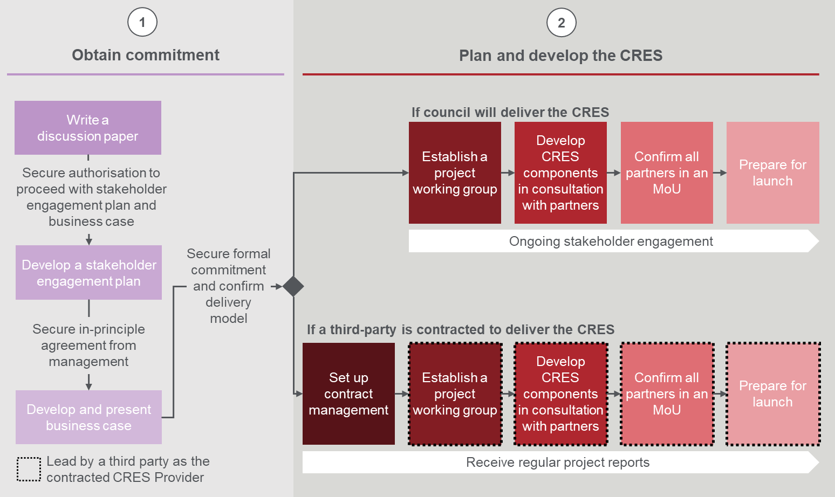

Obtain commitment
Establishing support for a CRES is the first step to building one. A discussion paper will start this process by building a compelling narrative to authorise delivery of a formal business case and stakeholder engagement plan to secure your council’s commitment to CRES.

Write a discussion paper
The objective of this step is to begin creating a support base for a CRES and obtain authorisation to develop a stakeholder engagement plan and business case. The simplest approach to get initial support from your manager is to develop a discussion paper. This paper is an internal paper only and should explain the current state of kindergarten enrolments and the benefits of the CRES for the community and the council.
The discussion paper template at Appendix A.1 includes background research and information that can inform early conversations about CRES, even prior to writing the discussion paper.
To begin the discussion paper, confirm with your line manager that capacity can be allocated to developing the paper and develop the paper using the template provided at Appendix A.1: Discussion paper template.
You should discuss the concept of the CRES with some internal stakeholders (e.g. council officers involved with ECEC, MCH leaders) to confirm what should be included in the paper. When complete, the discussion paper should be presented to your line manager who will decide if the paper will be discussed with more senior leadership at council.
At this stage, you should also consider, in collaboration with your line manager, who should be the Project Sponsor. This person should be an executive or senior decision maker who can advocate for the CRES and provide the authorising environment to undertake a CRES establishment project.
Appendix A.1: Discussion paper template is attached.
Move on to the next step if you have:
- Identified a potential Project Sponsor.
- Completed the discussion paper template and presented it to your line manager.
- Received approval from leadership to commence writing a stakeholder engagement plan and business case.

Develop a stakeholder engagement plan
The CRES model is highly collaborative, and a strong CRES is delivered by engaged stakeholders and partners. Internal stakeholders must be engaged to support set up and investment in a CRES, and external stakeholders who will help deliver the future CRES should be seen as partners.
To achieve the goal of stakeholders collaborating to deliver a positive result for children, a robust and thoughtful stakeholder engagement plan is essential. You should seek approval from your line manager to develop this plan after you have presented the discussion paper. The plan will engage a breadth of stakeholders including:
Contact your local regional DET staff or MAV for support in securing internal or external support for CRES
- MCH nurses and related officers
- Other internal council teams involved in early childhood education and that interact with families and carers regularly (e.g. outreach teams, education department).
- Kindergarten service providers, including EYM organisations, private providers, long-day care services, family day care services and standalone providers
- Local community organisations, such as multicultural or ethno-specific groups and Aboriginal Community Controlled Organisations
- Support services (e.g. Child FIRST, Child Protection, Orange Door etc.)
- Relevant peak bodies
Strong and productive relationships with these partners is key to CRES delivery and a structured approach to stakeholder engagement will give you the best chance of success.
Appendix A.2: Stakeholder engagement plan template includes a suggested stakeholder analysis model and engagement activities and messaging for each stakeholder group.
The network of external partners will differ in each LGA. It is important that you supplement the engagement plan with knowledge of your LGA’s context and iterate the plan as you learn more through engagements with stakeholders that represent the diversity of the community. Be sure to check that your stakeholder engagement plan is consistent with your council’s stakeholder engagement policies and procedures.
As per the stakeholder engagement plan template, engagement should be embedded in all stages of setting up and delivering the CRES, shown in Table 1.
Table 1 | Stages of stakeholder engagement to establish a CRES
Stage of CRES | Document reference | Objective of engagements
Develop and present a business case | CRES Development Guide  Section 3.1.3 | Obtain in-principle support and begin to understand preferences of stakeholders in relation to the CRES. Note that Appendix A.3: Promotional materials and Appendix A.4: Letter of Intent template will support these engagements.
Develop CRES in consultation with partners | CRES Development Guide  Section 3.2.3 | Understand stakeholder resources and/or limitations to deliver a CRES to inform the planning and development of the CRES components.
Prepare for launch | CRES Development Guide  Section 3.2.5 | Make all stakeholders aware of the launch date and supporting frontline CRES partners, such as MCH nurses, support service case workers and service providers to distribute information to families and carers.
Ongoing CRES delivery | CRES Practice Guide | Collect reflections and feedback about the experience of stakeholders to inform CRES improvements.

Move on to the next step if you have:
- Completed the stakeholder engagement plan template and had it reviewed by your manager and communications team.
- Conducted any initial engagements with influential partners and/or stakeholders listed in your stakeholder engagement plan.
- Received in-principle support from these partners and/or stakeholders.

Develop and present a business case
The objective of this step is to obtain a policy and/or funding commitment for the set up and running of the CRES from the executive and/or councillors.
The business case will cover similar points to the discussion paper but in greater depth and with an analysis of options for the CRES delivery model.
A compelling business case must include thoroughly researched evidence base for the core arguments of the case.
You should be prepared to iterate the business case several times with feedback from senior management and executives, so it should be completed well before the annual council budget review.
A business case should present a clear logic that explains the purpose of the CRES, how it improves outcomes for the community, the required investment by the council (in financial and human resources), and how the CRES will be set up and delivered.
The business case will propose options for operating the CRES at your council and the project road map to plan and develop the CRES. To scope the proposed project, you should present the following options for CRES coordination:
- The CRES Provider is the council.
- The CRES Provider is a contracted third party; the council provides funding to the third party to establish and operate a CRES.
Whether the council acts as the CRES Provider autonomously or in a partnership, the business case should reflect council’s ownership of the development project and ongoing delivery of CRES. The council will, in both circumstances, play an important relationship-building role with support services that facilitate proactive identification and engagement of families (e.g. community groups, MCH, etc.).
The business case should also propose a cost-recovery model. There are three potential sources of revenue to help manage ongoing CRES costs. Each source has its own considerations, outlined in Table 2.
Table 2 | Revenue sources
Revenue source | Considerations
DET grants | - Grants to establish, improve or expand a CRES may be available.  - Administrative support grants may be available to contribute to the administration and operating costs of delivering a CRES.  - These grants will require the CRES to meet certain conditions.  - The availability of grants may change year-on-year depending on policy changes.
Charging families/ carers a registration fee | - Consider the demographic of your LGA when deciding if a fee should apply and the size of the fee.  - The fee should:  - Be set at a level that it is not a barrier to the majority of families and carers  - At most, only cover the cost of administering the scheme.  - A full waiver must apply for any child who is considered a “high priority” by the DET Priority of Access criteria (criteria can be found in the DET Kindergarten Funding Guide).  - Having any fee at all will be a barrier to some families and carers not considered a “high priority” by the DET Priority of Access criteria. This can be mitigated by providing a partial waiver for families and carers can demonstrate extenuating circumstances.  - The risk of some families and carers disengaging due to the fee should be weighed against the potential benefits of providing a strong CRES that supports more equitable and accessible kindergarten placements.  - This can support cost recovery if registrations are high.
Charging service providers a fee to participate in the CRES | - Either a flat-rate fee for all services participating in the CRES or a per-registration fee could apply. A flat-rate fee may disproportionately impact smaller service providers. A per-registration fee infers that the CRES Provider is adding value by reducing the cost of administration for the service provider.  - Having a fee for service providers may be a barrier to their engagement in the CRES. Consulting these partners on any fee will be crucial to making a decision about this revenue source. It will be important to outline the potential financial benefits of the CRES (reducing administrative burden for registrations, thus saving staff effort) when discussing this with service providers but recognise that these costs may be negligible for them.  - A full fee waiver should apply for any service that has an active social purpose.

The business case should be presented to the executive as an operational decision; however, the executive may decide to present the case to councillors if a policy change is required.
The decision-making group will then decide which CRES option to pursue (if any) and approve the project plan. If the business case is not accepted, you may need to re-scope or iterate the business plan in line with feedback from the decision-making group. When the business case is approved and, where necessary, a policy commitment is secured, you can move on to planning and developing the CRES.
Appendix A.5: Research plan template suggests research activities to build a deep understanding of the local context that can inform your approach to setting up the CRES.
Appendix A.6: Business case template includes a recommended structure, example prose and suggestions on how to tailor the business case for your local context to increase the chances of success.
Move on to the next step if you have:
- Completed the research plan.
- Completed the business case.
- Successfully secured a formal commitment from decision-makers. This may be the executive if the commitment is operational or councillors if the commitment includes a policy change.

Plan and develop the CRES
The process for delivering the CRES must be tailored for the CRES Provider. The objective of this phase is to design a robust back-end process that helps families and carers secure a kindergarten place for their child, and that is developed and supported by internal and external stakeholders. Planning and developing the CRES will have up to five stages that follow sequentially:
- Set up contract management (for councils that choose to include a third party in the CRES operating structure)
- Establish the project working group
- Develop CRES components in consultation with partners
- Recruit service partners
- Prepare for launch.

Set up contract management
Note: step 3.2.1 is not relevant to councils that elect to be the CRES provider, please move to step 3.2.2.
A contract must define the terms of funding between the council and the third party if the council has chosen to delegate CRES operations to an external supplier.
At a minimum, this contract should include:
- A service level agreement (SLA) that defines the metrics which must be measured and the standard for each metric to continue funding.
- Reporting requirements that provide the council with timely and accurate information on the activities, outputs and outcomes of the CRES.
- Probity rules and guidelines to ensure all kindergarten providers who participate in the CRES are treated equally.
- Termination clauses.
Work with your legal team to develop a contract and, where required, involve the third-party CRES Provider.
You must also establish contract management processes that will ensure the third party meets their obligations.
Move on to the next step if you have:
- Established a contract management team within the council.
- Signed a contractual agreement between the council and the third-party CRES Provider.
- Confidence in handing over responsibility for establishing a CRES should to the third party who will complete all further steps in establishment and operation.

Establish the project working group
A clear structure for the team that will set up the CRES is crucial to meet objectives. This stage of establishing the CRES is primarily about laying the foundations for a successful CRES establishment project, but importantly it is also a change management activity. The project working group can take this opportunity to build buy-in from internal stakeholders who will be ready to implement when the CRES launches. It is crucial, therefore, that everyone who will be involved in the day-to-day delivery of CRES is involved at some point in establishing the CRES.
An important part of the establishment project will be the Project Sponsor, who you identified through your line manager earlier in Step 3.1.1. This person is a senior leader in the organisation who can guide the CRES project to success management.
A recommended high-level project structure is described in Figure 3, noting that the exact composition of each group will vary depending on the size, capacity and organisational structure of the CRES Provider.
Figure 3 | CRES establishment working structure
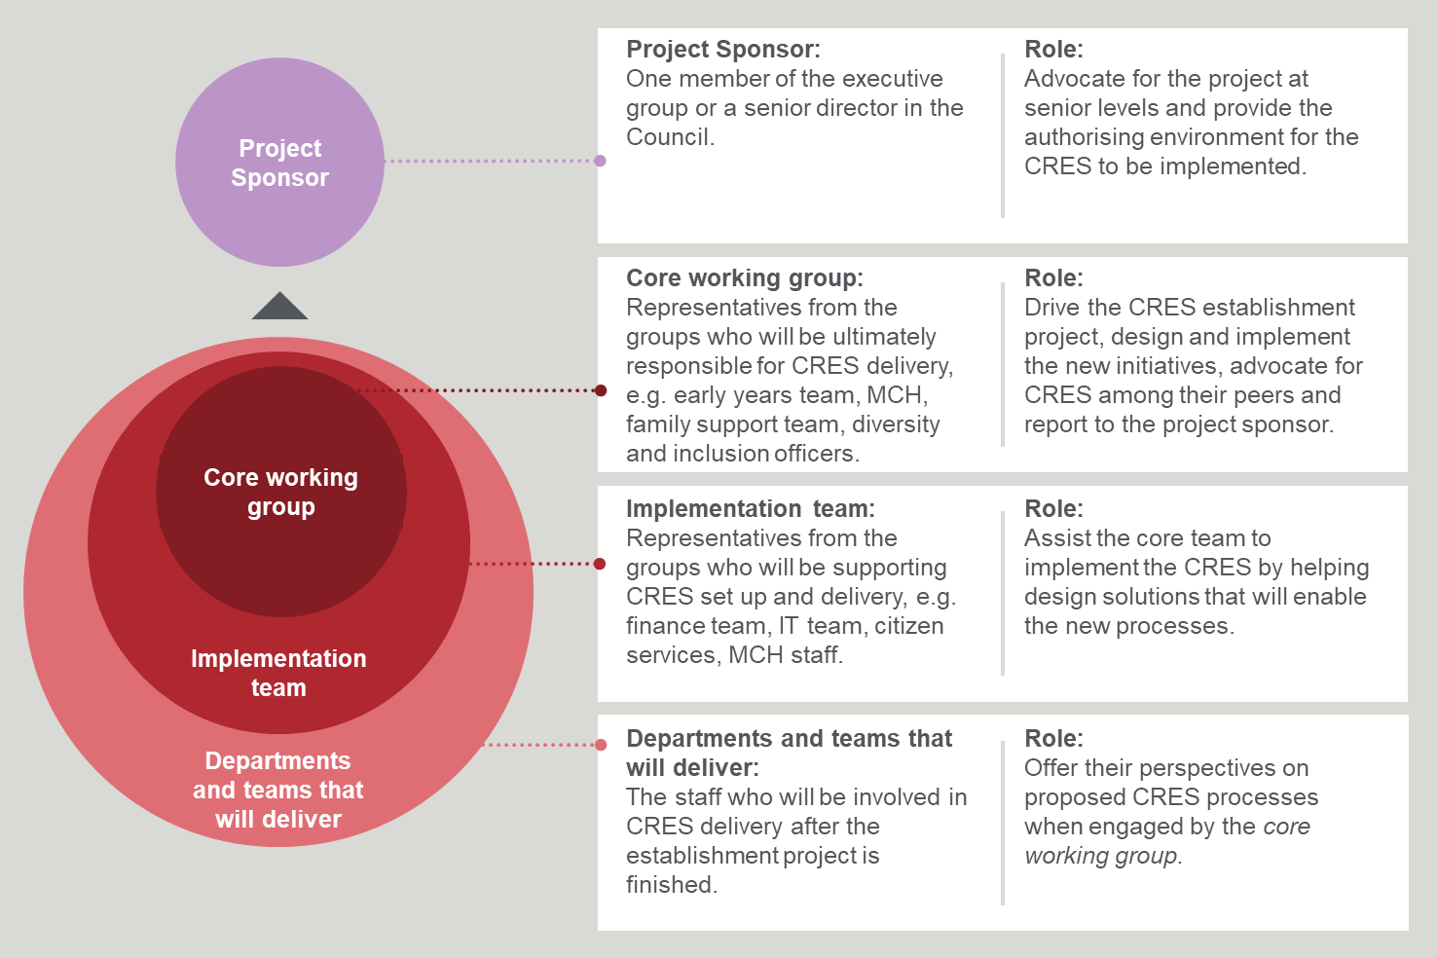

Move on to the next step if you have:
- Set up a core CRES project working group.
- Communicated with the implementation team and departments and teams that will deliver about their role in establishing the CRES.

Develop CRES components in consultation with partners
The major activity in establishing a CRES is to build out all of the CRES’ components. These components will be the foundations of a simple, transparent and accessible process that helps families and carers enrol their children in kindergarten.
The basis for developing CRES components are the six Enablers that form the foundation of the CRES model:
- Capability and capacity
- Governance structure
- Partnerships
- Systems, data and digital tools
- Templates and documents
- Policies and procedures.
Implementing a CRES that works for everybody
As you are setting up the CRES, remember that the CRES needs to be simple, inclusive, adaptable, consistent, transparent and collaborative.
These enablers will facilitate the delivery of the CRES process which is detailed in Chapter 4 of the CRES Practice Guide. The CRES process describes the ideal journey for a family to register and enrol their child in kindergarten, and the activities that must be completed by each supporting stakeholder to make this journey a reality. It is recommended that you refer to the CRES Practice Guide throughout the CRES establishment project to understand the future state for the CRES.
The requirements of each enabler are described below. Note that these requirements are only recommendations and it is important to tailor the implementation of these recommendations with expert knowledge of your council’s context. Furthermore, the requirements should be met by leveraging existing staff capacity, systems or processes where possible to minimise duplication and the accrual of additional costs.

Capability and capacity
Delivery of a high-quality experience for families, carers, providers and other stakeholders is contingent on the capability (skills, knowledge and experience) and capacity (availability) of the CRES delivery team.
The composition of the CRES delivery team will differ depending on the CRES Provider’s size and existing organisational structure, but the team’s functions should be similar to those described in Table 3. One person may fulfil multiple functions for a council with a smaller kindergarten environment and multiple people may be required to effectively fulfil one function for a larger municipality.

Table 3 | Overview of roles, responsivities and capability for a CRES
Function | Responsibilities | Skills and knowledge
CRES program management | Manages the CRES on a day-to-day basis, delegating tasks and assigning priorities and acting as a point of escalation for any issues that may arise. | - People management skills and leadership  - Writing skills  - Problem-solving skills  - Organised  - ECEC sector knowledge, including kindergarten programming and funding
Frontline service delivery and operations | Allocate children to kindergarten places according to DET Priority of Access criteria and other local criteria. Respond to enquiries by families and carers, and all other CRES stakeholders. | - Problem-solving skills  - Customer service skills  - Organised  - Responsive  - Cultural competence
Relationship development and maintenance | Build strong relationships with all CRES stakeholders including service providers (and teachers), MCH nurses and support services. This may involve regularly attending meetings of each group and advocating for CRES. Engaging with stakeholders is elaborated on in Section 4.6. | - Strong relationship-building skills  - Group facilitation skills  - Knowledge of the early childhood education and support services landscape
Data management and administration | Accurately record information in internal database and provide data to service providers to support enrolment processes. Lodge data requests with other stakeholders if necessary. | - Data entry and information management skills  - Problem-solving skills  - Attention to detail  - Understanding of data privacy requirements and other relevant legislative and regulatory responsibilities
IT and systems support | Ensure that all systems are running as intended and repair reported errors. Maintain the website to ensure information is up to date. | - Strong technical IT capabilities  - Problem-solving skills  - CRES business process and data requirements
Business and process improvement | Monitor the CRES process to identify areas for improvement, develop plans to improve the CRES and work with the rest of the team to implement improvements (The CRES Self-Assessment Tool and Chapters 4 and 5 of this document will be useful). | - Problem-solving skills  - Change management skills  - Business process mapping skills  - Planning skills  - CRES best practice model knowledge
Family support | Work closely with MCH nurses and other family support services to identify vulnerable or disengaged families and children. Actively reach out to these families and carers to ensure they are aware of and engaged in the CRES process. | - Strong relationship-building skills  - Empathetic  - Cultural competence

The required capacity to run an effective CRES will depend on the profile of enrolments and services in your LGA, the efficiency of technology and systems, and the strength of existing relationships with partners. You should estimate the capacity required in your organisation using knowledge of the aforementioned factors. Reaching out to a neighbouring council with a similar population profile who already manages a CRES (as suggested in the Appendix A.5: Research Plan) can also help you gain a better understanding of the likely staff EFT required to establish and operate a CRES.

Governance structure
The CRES, like any other initiative, must have a clear governance structure to balance accountability, responsibility and responsiveness. The structure will be tailored to your organisation’s current operating model but the principles of good governance will apply.
The recommended basic CRES governance structure includes two accountabilities and five responsibilities. An individual may hold multiple accountabilities and responsibilities if they are able to. It is important that individuals with accountabilities and responsibilities are in the appropriate role or position to make practical and informed decisions. Decision-makers must be of appropriate seniority in the organisation to provide the authorising environment to enact changes.
For example:
- The Director of Community Services could hold accountability for overall CRES performance. The CRES may need additional resources for operation on peak periods and the Director provides the authority to allocate resources to CRES tasks that need to be completed.
- The Manager of Family and Children’s Services could hold accountability for satisfaction of stakeholders with the CRES. Some stakeholders may suggest some changes to improve the CRES experience for families/carers and the Manager will have the authority to agree to and implement the change.
- The responsibility for day-to-day decisions about communications, processes and relationships could be distributed among the Team Leaders and Coordinators of Children’s Services.
Figure 4 shows a recommended basic governance structure.
Figure 4 | Recommended simple governance structure
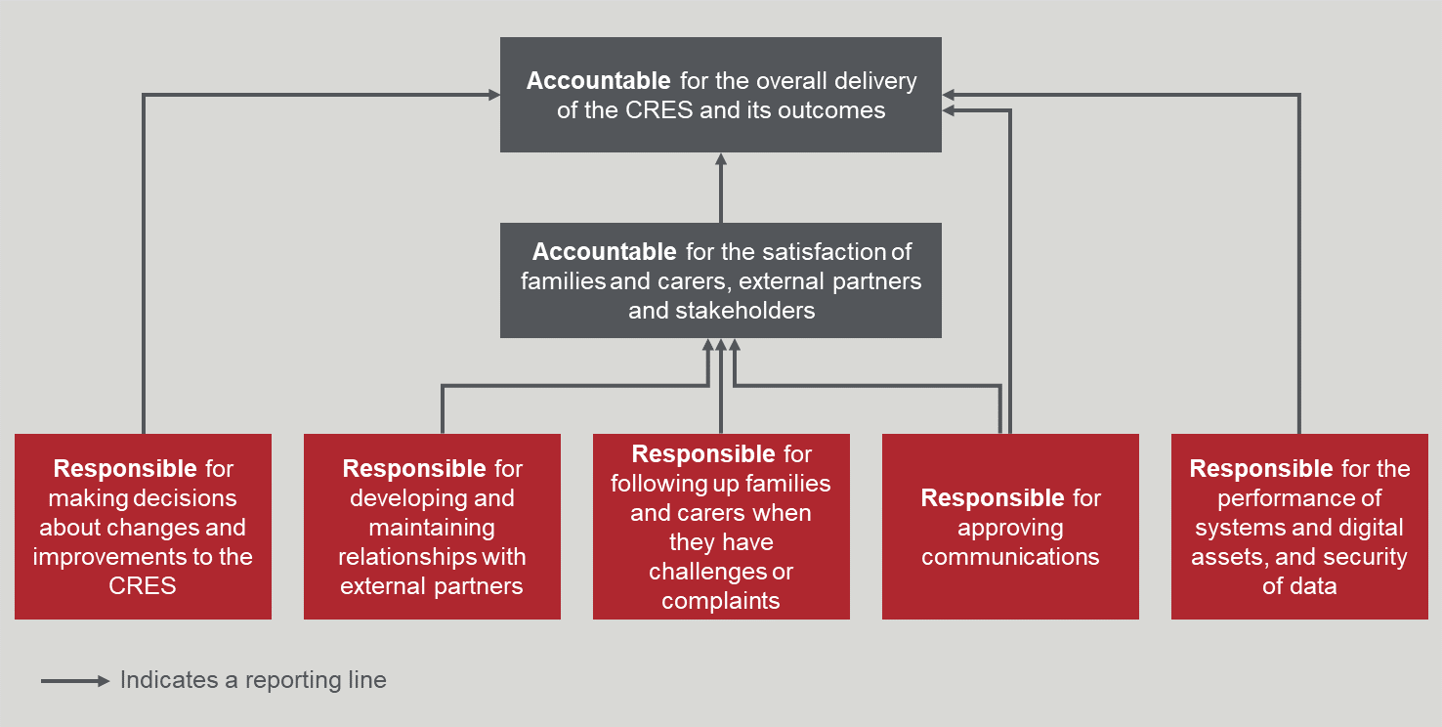

Partnerships
Developing relationships over time
Highly effective working relationships rarely emerge immediately, and relationships develop over time. With a potentially significant number of diverse providers, support services and other interested parties it may take some time and effort to get all the details “ironed out”.
Effective engagement while the scheme is being established will set the CRES in good stead for when it launches. Partners are the linchpin of the CRES, so it is crucial that you engage partners (building on the relationships formed in the earlier stages) for two purposes:
- To gather information about how the CRES might best work for CRES partners
- As a change management activity to garner support for the CRES.
The network of partners will differ in each LGA. In some LGAs, for example, most services are provided by the council whereas in others they may be mostly run by independent providers. It is important that you supplement the engagement strategy template with knowledge of your LGA’s context and the findings of the research plan.
It will be important to engage partners at the right time, provide the right information and have the right level of follow-up.
The stakeholder engagement plan prepared while developing the business case will help shape this strategic approach.

Systems, data and digital tools
Digital is a great enabler but can also a barrier
Remember that some members of the community do not have ready access to a computer, smartphone or internet. Make sure that crucial artefacts and processes (e.g. CRES information and registration forms) have parallel paper options.
Having fit-for-purpose systems and digital assets will make the process easier for CRES officers, families and other stakeholders. Table 4 provides a description of the recommended systems/digital assets that are required to run an efficient CRES, including an outline of minimum feature requirements and optional features that may be added to enhance the experience of CRES officers or other stakeholders.
Table 4 | Description and features of systems/digital assets
System/digital asset | Description | Features
Website | A dedicated, accessible web page on the council website that contains essential information about the CRES. A recommended website page structure is available in Appendix A.7: Website content template. | Minimum:  - Includes video that explains CRES and how parents should interact with it (preferably in an accessible format, languages appropriate for your LGA and with a hearing link).  Optional:  - Includes an online registration form (available in an accessible format and languages) that families and carers can use to register their child for allocation.
Registration and allocation platform (CRM) | A database that securely stores registration information about each child and provider information | Minimum:  - Secure and private database to store sensitive contact information of families, carers and providers.  - Clear and straightforward user interface for CRES officers who must enter and use data.  - Outputs registration information into a commonly used format (e.g. .csv file) that is simple to read.  Optional:  - Automatically draws information into the database from registration forms submitted through the CRES web page.  - Has an automatic allocation function that matches family and carer preferences for kindergartens and times to provider availability.  - Interface with other early years’ systems (e.g. Child Information Development System (CDIS))
Communications platform (optional) | A platform that can be used to send mass communications (email/SMS) to stakeholders about the CRES process | - Sends SMS messages to phone numbers from the registration and allocation database.  - Reads phone number and email information from the registration and allocation platform.  - Automatically personalises the message (e.g. uses their first name) by pre-filling the details of the recipient.  - Messages can be composed in advance and an automated workflow will send them at the appropriate time.

Documents and templates
Documents and templates that will be used frequently when the CRES is established include registration forms (paper and digital), suggested communications with families and carers, and text message templates. These documents and templates are provided in the Appendices of the CRES Practice Guide and are mapped to each stage of the process where they are needed.
You should make sure that you develop versions that are accessible to everyone in the community including those who do not speak English as a first language (Appendix A.5 Research Plan should have identified which languages are commonly spoken in your LGA and you should translate materials accordingly).

Policies and procedures
Comprehensive policies and procedures ensure day-to-day activities and decision making are fast and consistent. Some policy and procedure documents should also be accessible to external stakeholders who may be involved so they can understand how the CRES Provider will administer the CRES. The policies and procedures that should be in place to support the CRES are listed in Table 5. All policies and procedures related to the CRES should align to the parent policies of the CRES Provider.
Your team should work to develop these policies and procedures in line with your organisation’s standard operating policies (e.g. privacy, data security, complaints management).
Table 5 | Recommended policies and procedures
Policies and procedures | Contents
Policies
CRES policy (to be publicly available. May be included as a part of an existing Family and Children’s Services Policy or similar) | - Scope and purpose of the CRES.  - A commitment to affordability, quality, equity, transparency and accessibility.  - Statement about the ethos, principles  - The CRES stages and the intent of each stage  - How children will be fairly allocated to places  - Fees and fee support for families (if relevant)  - How the CRES will be developed, implemented and improved  - How decisions are made in the CRES, e.g. the lines of accountability for decisions, how changes may be brought about  - How accountabilities and responsibilities are organised
Data retention and information sharing | - How data will be securely captured, stored, shared and destroyed  - Under what circumstances data will be permitted to be shared, and with whom. Make sure you state (at a minimum) whether:  - registration data will be shared with a third-party CRES Provider  - registration data will be shared with council-run kindergartens and/or NFP kindergartens and/or commercial kindergartens  - any stakeholders who will be receiving data have/have not agreed to the same capture/store/share/destroy policy.
Procedures
Kindergarten registration and allocation (more detail below) | Internal version:  - How to process registrations  - How kindergarten allocations are made, including how to apply the Priority of Access criteria (criteria can be found in the DET Kindergarten Funding Guide)  Publicly available version:  - How kindergarten allocations are made, including how the Priority of Access criteria and any local criteria are applied to ensure equitable allocations for all children  - How second-round registrations are managed
IT and systems | - How to operate systems and databases related to the CRES  - How to resolve common issues
CRES resourcing | - How CRES will be resourced, especially during peaks and troughs

The kindergarten registration and allocation procedure must include detailed information on:
- Parent preferences and how they will be allocated
- Local criteria (if applicable) that specify prioritisation factors beyond the DET Priority of Access criteria, and how it relates to information collected on registration forms.
- The actual procedure of allocating and scheduling places and how it relates to kindergarten preference selection at registration.

Local criteria
The DET Priority of Access (POA) policy direction prioritises the allocation of places for children experiencing disadvantage or vulnerability, and details on the criteria can be found in the DET Kindergarten Funding Guide . Children meeting these criteria must always be allocated places first.
It is recommended that once POA has been applied, other places are simply allocated by ballot. However, some councils choose to include additional “local criteria” that will prioritise children (outside of the Priority of Access criteria).
When determining if local criteria should be included (and what these criteria might be), you should consider that one of the key objectives of the CRES is to more equitably allocate kindergarten places in the LGA. Local criteria should then be established in consultation with CRES Partners and other stakeholders to ensure ongoing buy-in to the CRES.
Information on how these local criteria affect a child’s allocation should be transparent and available to families, carers and service providers or the CRES webpage. It is recommended that a weighting system be used if there are multiple criteria considered in the allocation process.

Allocation and scheduling procedure
There are broadly three potential allocation and scheduling models. The right one for your LGA will depend on the service provider landscape i.e. how many kindergartens are run by the council, an EYM or an independent committee. The different allocation models and considerations are described in Table 6.

Table 6 | Different kindergarten allocation models
Allocation model | Considerations
Kindergarten nominations  During registration families and carers can nominate their preference for kindergartens. The approximate session times for each kindergarten should be published in the registration form or on a website (so the family or carer can be informed about likely times for sessions) with the caveat that the times could change. Once children are allocated, the registration list is provided to the service provider who then collects session time preferences from families and carers directly. The service providers can then create their own schedule based on this data. | This model provides the least certainty about session times for families and carers but the most control to service providers (although they will have to invest effort seeking session time preferences).  This model is the simplest logistically and is recommended if no automated allocation systems are available. It also gives the service providers a clear way to begin building relationships with families and carers by asking about preferred session times.
Preference driven  During registration families and carers nominate their preferred kindergartens and times (days and session hours). The CRES Provider drafts a schedule for all service providers in the LGA that maximises family and carers preferences and minimises the number of empty spaces in kindergartens. | Allocations in this model can create a complex optimisation problem. A digital allocation tool is suggested if there are many registrations and many service providers in the LGA. This method is also contingent on service providers being open to having their session times and days shaped for them.  This model is generally used by scheme providers who are also the primary or only service provider in the LGA.
Specific session times  In April each year, service providers tell the CRES Provider what sessions they will be running for the coming kindergarten year. The CRES Provider collates this information and publishes this schedule in the registration form so families and carers can see each kindergarten and specifically which session times they are hosting. | This model can be the most inflexible for families and carers who cannot find a location or time that suits them. It also requires service providers to give their session times to the CRES Provider early in the year, which may be a challenge for providers who are used to more flexible scheduling and planning.  Families and carers are provided with more certainty about session times for their child, and the model also makes allocations more straightforward for the CRES Provider.

The CRES working group should decide on a model in consultation with service providers.
Regardless of which model is selected, high priority children (defined by the POA criteria) should be allocated first, followed by those who meet local criteria (if there are any), and all subsequent registration should be allocated in a random ballot.
The method of allocating children will depend on the allocation model you choose and the profile of kindergarten demand and service providers in your LGA. You could ask someone from a similar LGA who operates a scheme about what their approach is for some guidance. Also consider what tools might be appropriate for the scale of your CRES that can help you with allocations.
Move on to the next step if you have:
- Set up all six components required to operate a CRES:
  - Confirmed staff capability and capacity to operate the CRES
  - Agreed to a governance structure for decision making
  - Confirmed support of partners that will help deliver the CRES
  - Established the systems and digital tools that will support the CRES
  - Tailored all documents and templates to the local context
  - Created policies and procedures that will define how the CRES is operated
- Sought feedback of these components from CRES partners and iterated the components with them where necessary.

Confirm all partners in an MOU
A formal commitment to the CRES by relevant stakeholders should be secured. Building upon the relationship formed by ongoing engagement with stakeholders through the establishment process (guided by a stakeholder engagement plan), you should approach stakeholders with a Memorandum of Understanding (MOU). The MOU should outline the responsibilities of each partner group to deliver the CRES.
Appendix A.8: Memorandum of Understanding template provides a template MOU that can be adjusted in consultation with prospective signatories.
Move on to the next step if you have:
- Sought feedback on the MOU and iterated it with your partners where necessary.
- Confirmed all partners have signed the MOU.

Prepare for launch
A successful launch involves communication and preparation to ensure that:
- All internal CRES officers understand what is required of them and when to deliver the CRES.
- All external stakeholders understand what they need to do in the new world of CRES
- The systems and tools that the CRES relies are tested and ready to use.
In this stage you should keep the CRES Practice Guide close at-hand for advice on how to operate the CRES as you transition from establishing the CRES to operating a regular annual cycle.

For internal stakeholders
Plan for success but prepare contingencies
Good planning will greatly improve your chances of success, but the launch of a new program is always challenging so be prepared to tackle unexpected problems as they arise.
It is important that the CRES project working group communicate with all officers involved in delivering the CRES so they understand how and when they will begin a new way of working. This communication should include some amount of training for officers so they are competent using new systems and processes, engaging with families (including Aboriginal, Torres Strait Islander and culturally and linguistically diverse families) and they understand what their responsibilities are.

For CRES Partners
CRES Partners should be given guidance and training on how to work with the CRES systems. This should include how data will be shared, what to expect when CRES goes live and what role they can play to make CRES a success.

Community networks
You should contact and distribute information about the launch and operation of CRES to as many official and unofficial community networks in your municipality as possible. Many families and carers who disengage from formal services like MCH and Child Protection will have social networks that can be leveraged. Distributing information about the CRES to leaders in these community networks will help cast the net wide to reach the most disadvantaged and vulnerable children. These networks and services may include:
- Community playgroups and Supported Playgroups
- Community cultural or ethnic groups/networks
- Libraries
- Religious groups
- Family day care providers
- Parents’ groups.
These groups may have social media or other communication channels where information is shared and members should be encouraged to distribute information about kindergarten and the CRES on these channels.

For families and carers
Information about the CRES, what it involves and how the process will change from previous years should be broadcast to families and carers. It will be important to use communication channels that are relevant and accessible.
Templates that can support communications with families, carers and community networks are available in the Appendices of the CRES Practice Guide.

You are ready to launch your CRES if you have:
- Communicated with all relevant internal officers about how things will change with the implementation of the CRES.
- Equipped all partners and community networks with the right knowledge, tools and skills to deliver the CRES when it launches.
- Commenced marketing the CRES to families and carers that describes the new process and what is required of them.
- Tested and confirmed that all systems, data and digital tools work as expected and can support the CRES upon launch.
- Confirm that all policies and procedures are ratified and providers for CRES users and service providers are available.

Improve your CRES
The CRES model is designed to be iteratively improved through understanding current strengths and identifying areas for improvement to operate at best practice. The methodology summarised in Figure 5 can be used by:
- Central Enrolment or Central Registration scheme managers who plan to grow their existing scheme into a best practice CRES, and
- CRES providers who have delivered the CRES for 12 months or more.
Figure 5 | Process for improving your CRES
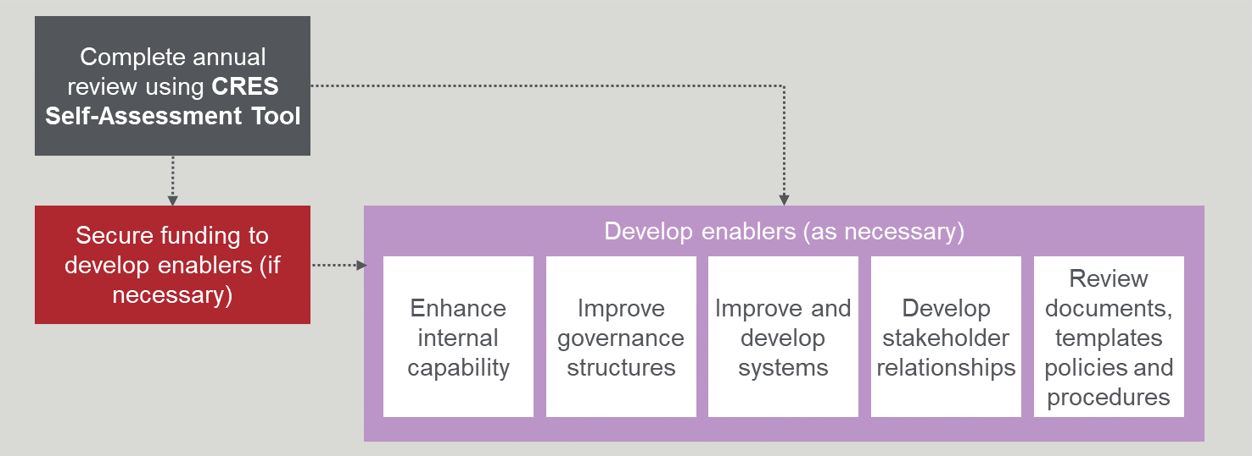
Completing the CRES Self-Assessment Tool annually and consulting with stakeholders will help identify areas for improvement or any issues with your CRES.
Before approaching areas for improvement, be sure to analyse the CRES to determine if the issue should be taken at face value or if a deeper root cause exists. This process will ensure that the underlying cause is addressed to form a systematic approach to improving the CRES. Also consider that for any one issue there may be several contributing factors and each may require a different response.
Developing the CRES may require additional funding or may need improved or different procedures and use of resources. This chapter is organised into the following sections:
- Complete annual review using the CRES Self-Assessment Tool
- Secure additional funding or resources, if necessary
- Enhance internal capability
- Improve governance structures
- Improve and develop systems
- Develop stakeholder relationships
- Review documents, templates and policies and procedures.
It is important to link any improvement initiative to outcomes so you can define performance indicators and demonstrate how improvements you implement have a real impact.
Improvement initiatives will be approved by a decision-maker in your organisation. If the initiative constitutes a policy change, the executive group will put this decision to the councillor.

Complete annual review using CRES Self-Assessment Tool
Understanding the CRES’ strengths and weaknesses is the first step to identifying potential improvements. The CRES Self-Assessment Tool is designed to help a CRES manager to evaluate the CRES and indicate which specific enablers may need developing.
The CRES Self-Assessment Tool is available on the DET website.

Secure additional funding, if necessary
You may need additional funding to implement a specific improvement or expansion to the CRES that will have a significant positive impact (identified through completing the CRES Self-Assessment Tool or by other means). Regardless of the reason for seeking additional funding, it is recommended that the business case for additional funding structure follow the general format of Appendix A.6: Business case template, although it can be much shorter depending on the amount of funding requested. Potential revenue sources to support a cost recovery for a business case are described in Table 2.
The process for business case approval will depend on the decision-making structure of your organisation and the amount of funding requested.

Enhance internal capability
Enhancing internal capability can be done in two ways:
- Upskilling existing officers to acquire skills, knowledge or attributes that will improve their performance.
- Recruiting a new CRES officer or re-allocating an existing officer that has the requisite skills or knowledge to fulfil the role.
The first case is addressed by learning and training and the second is supported by recruitment.

Upskilling officers
The first step to developing effective learning experiences is to assess the learning need. You should identify the specific skills, knowledge or attributes that must be acquired. This will define the requirements and outcomes of the learning experience. There are formal and informal methods of developing capability, as outlined in the Four E’s of learning experiences in Figure 6.
Figure 6 | Four E's of learning experiences
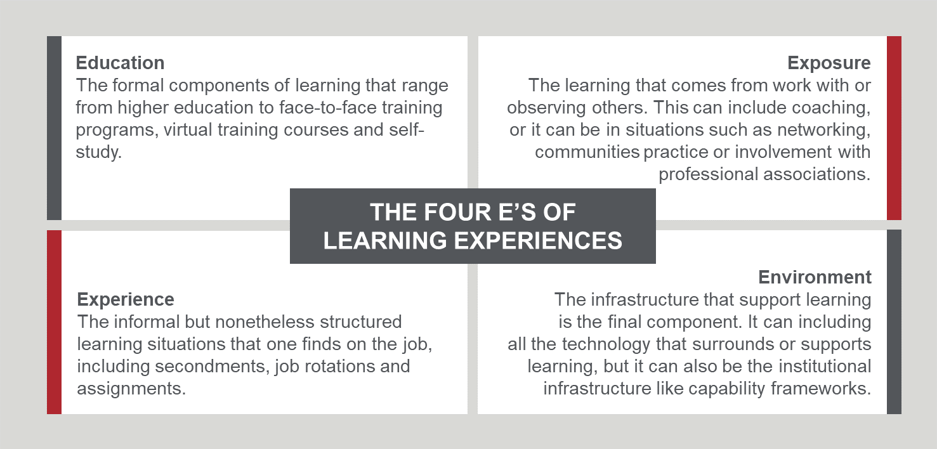
When choosing a learning experience, consider:
- Learning programs may combine the Four E’s in a blended learning program.
- Technology can be used to support any kind of learning experience, including virtual delivery to remote learners.
- The learner’s immediate needs (i.e. what the learner needs right now), intermediate needs (i.e. what the learner needs for their role) and transitional needs (i.e. what the learner needs for the next career move).
Designing the right learning experience is dependent on the skills, knowledge or attributes that must be acquired, what the target council officer will be receptive to, budget constraints, capacity and available tools.
It is particularly important that CRES officers have the skills to appropriately work with families/carers who are typically disengaged from the system due to their experiences of disadvantage or vulnerability. Existing resources that are a good starting point to support this training are:
- Engaging Marginalised and Vulnerable Families ; research by the Royal Children’s Hospital
- Access and Inclusion modules from the School Readiness Funding menu : developed by DET
Your DET regional office can also provide helpful resources.

Recruiting a new CRES officer or re-allocating an existing officer
The first step in finding the right person for a role is to identify the specific skills, knowledge or attributes that are required to proficiently perform the role. Consider longer-term business and CRES needs when determining what skills, knowledge and attributes are important. Also consider that someone you recruit could have CRES responsibilities integrated with other work (e.g. a broader early years or education role).
When you confirm the requirements of the role you are seeking to fill, work with your organisation’s human resources/talent department to recruit a resource or find an existing officer who could move into the CRES team and fulfil the role.

Improve governance structures
Good governance will provide clarity, direction and effective decision-making. Issues in governance can be addressed by clarifying roles and reorganising the governance structure.

Role clarity
Uncertainty about who makes decisions and who reports to decision-makers (to keep them informed about the CRES) can stall progress. The CRES Self-Assessment Tool can help identify where the responsibilities and accountabilities are ambiguous. Implementing the recommended basic governance structure in Figure 4 can provide greater clarity.

Governance architecture
The positions of people with responsibilities and accountabilities are important to ensure they can make informed decisions and/or provide the authorising environment for changes to be made. If this is not the case, consider changing the team’s governance structure to align responsibilities and accountabilities with roles and activities.
It may also be necessary to recruit through your line manager or a more senior member of the organisation with the authority to make the level of changes that are required to run an efficient CRES. Consider who is best placed to play this role and what their relationship to the rest of the governance structure will be (i.e. who will report to them and what accountabilities they will take on).

Improve and develop systems
Digital systems and tools can make work more efficient but deficiencies can cause frustration for users. Technical inadequacies can be remedied by either improving existing systems or developing/procuring new ones.

Improve existing systems
Identifying an issue with a system or tool is the first step to improvement but systems and tools are not valuable in-and-of themselves. A system supports a process which in turn, creates an outcome, as shown in Figure 7.
Figure 7 | The relationship between systems, processes and outcomes
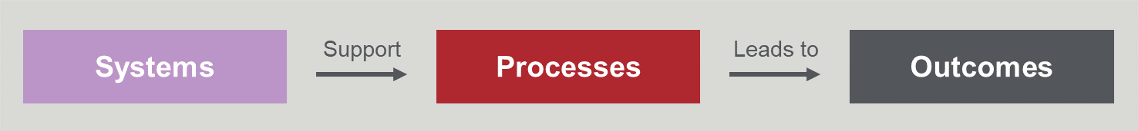
You should closely analyse how a system issue leads to problems in the process and subsequently poor outcomes. Specifying how and why a system issue leads to suboptimal outcomes will help define the requirements for the system and the objective for the improvements. It may be an improved user experience for families and carers, increased efficiency for CRES officers or enhanced data insights for infrastructure planning.
When the system requirements and improvement objectives are defined, you can plan how to approach system improvement. If you discover that the future state system requirements are beyond current capability, then consider developing or acquiring a fit-for-purpose system or tool drawing on the instructions below.

Procure or develop new systems and tools
Developing new fit-for-purpose systems and tools may be necessary, especially if your CRES has grown (either in registrations and enrolments or in number of providers in the system) beyond the capability of an existing system/tool. Scheme growth may also make it infeasible for some activities to be completed manually and a system/tool that automates the activity or assists a CRES officer to efficiently complete the activity will be necessary. In either case, following the process in Figure 8 will ensure a fit-for-purpose solution is implemented.
Figure 8 | Process for developing new systems/tools
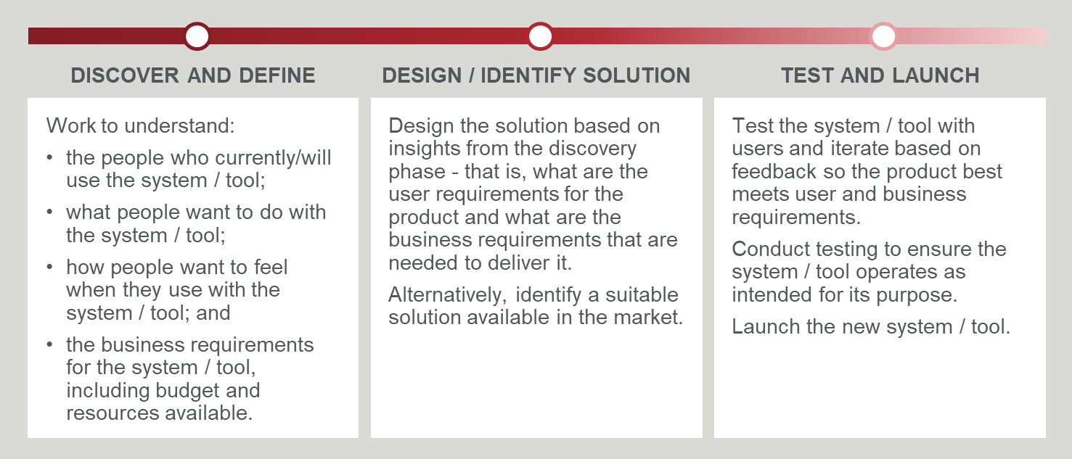

Develop relationships
Improving the CRES may involve creating new relationships or strengthening existing relationships. In both cases, being prepared and having a plan for engagements is the key to success. Good stakeholder engagement relies on engaging stakeholders at the right time and having a structured approach. In the case of the CRES, it is also important that external partners feel listened to and develop some ownership over the scheme.

Engage with stakeholders at the right time
Getting the rhythm and timing of stakeholder engagements right is important to foster a trusted and responsive relationship. It is likely that you will have to regularly engage stakeholder groups, such as support services who typically have a high turnover of staff to maintain connections.
It is also important to respond to concerns and queries swiftly to build trust. This makes stakeholders feel that their issue will be handled quickly and appropriately. It is, however, important to balance the need to respond quickly with taking the time to develop a well-considered response.
Attending a CRES Partner’s meetings on a regular basis is an effective way to maintain strong relationships, market the CRES, address concerns and deepen your understanding of the group that you are working with.

Create a structured engagement approach
A well-planned approach to engagement ensures that the interaction delivers a positive outcome for both parties. Considering your objectives and the stakeholder’s position will inform how to best engage a stakeholder as shown in Figure 9. Appendix A.2: Stakeholder engagement plan template is designed for users who are establishing a CRES but will also have useful content and provide some ideas about how you might frame some of these engagements.
Figure 9 | Stakeholder engagement planning
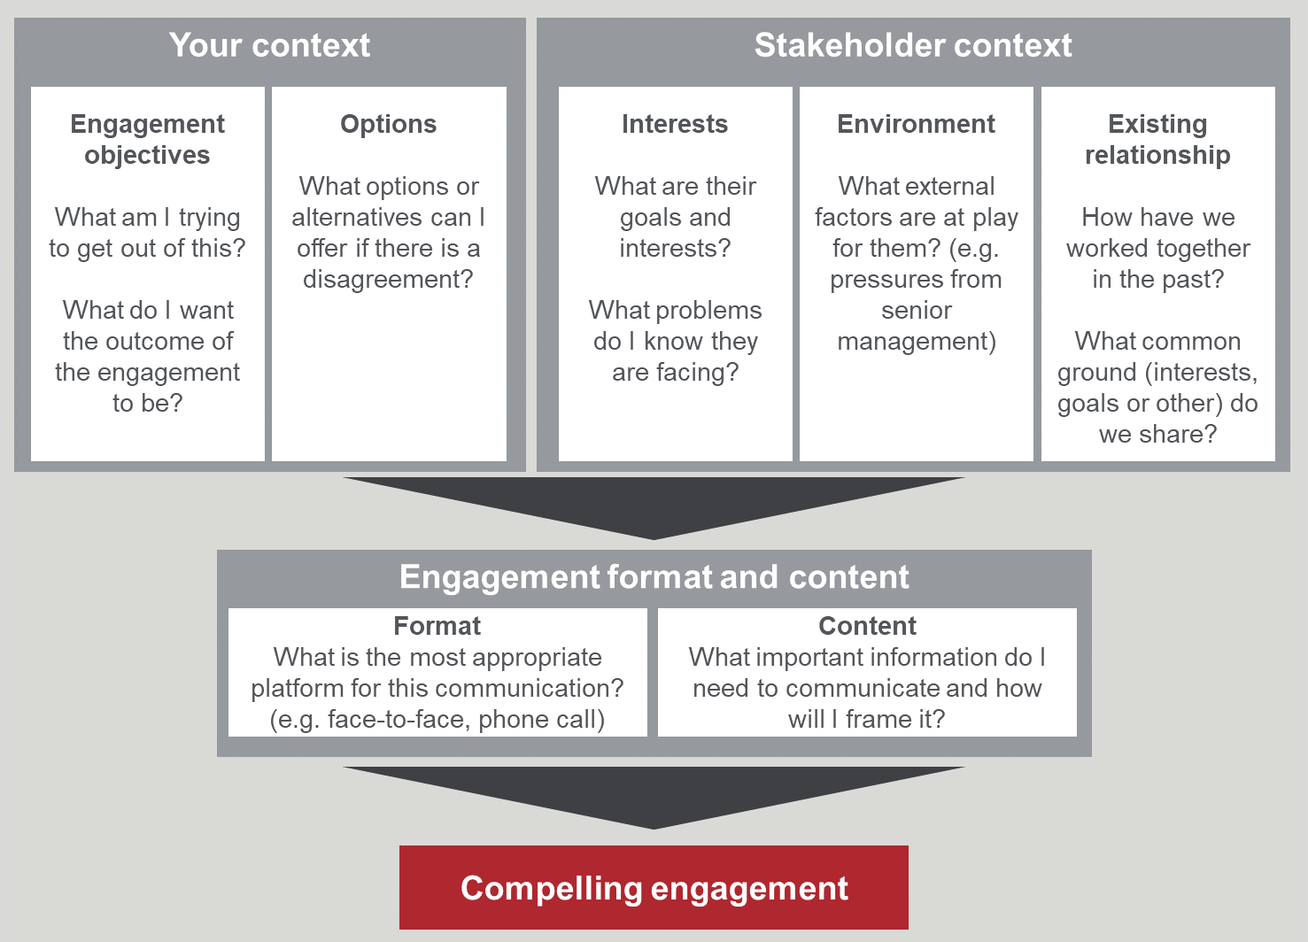

Be collaborative
Collaboration between the CRES Provider and partners can be strengthened by giving partners the opportunity to input during scheme establishment or development and give candid feedback.
Some suggestions for ways to build collaboration between the CRES Provider and partners may be to:
- Include partners in co-design sessions when a new system or tool is being developed.
- Host an annual meeting where the results of the CRES are presented to the external partners.
- Host annual discussion forums where external partners have the opportunity to suggest changes to the CRES.
- Contact partners at the end of the annual cycle to ask for their feedback on the CRES.
- Reach out to partners when undertaking the CRES Self-Assessment Tool to get their perspective on some of the questions in the tool.

Expand your CRES
CRES expansion should be built on a policy commitment from the council that facilitates expansion and robust enablers which can support growth. There are up to four steps for CRES expansion after a driver for expansion is recognised, shown in Figure 10.
Figure 10 | Steps to expand your CRES
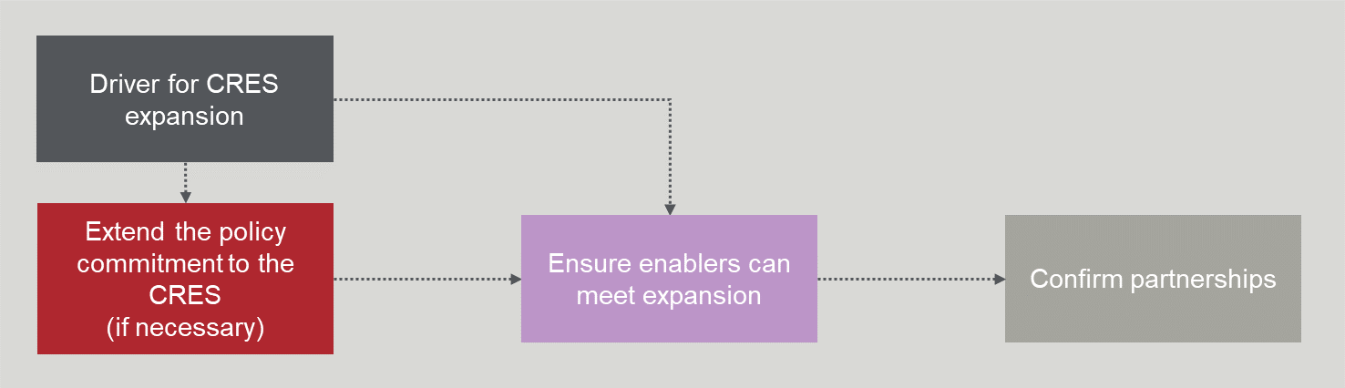

Drivers for CRES expansion
The core driver for expanding your CRES should be council’s commitment to fulfil their role to develop the wellbeing of the municipal community, as stated in the Local Government Act (2020). A more comprehensive CRES will improve accessibility to kindergarten and set the next generation up for success. The state-wide vision for CRES also includes a goal to have CRES delivering registration for most funded kindergarten programs.
There are several other reasons that the CRES will need to expand. The drivers for expansion can be external or internal and some examples are given in Table 7. The expansion driver will inform how you will approach service providers.
Table 7 | Potential drivers for expansion
Source | Example driver for expansion
Internal | - Councillor or executive requests that the CRES be expanded  - The CRES team (or other internal team such as MCH) identifies a service gap  - Council needs more data that would be efficiently captured by the CRES to plan investment in new kindergarten infrastructure (buildings).
External | - Changes in state-wide kindergarten policy (for example, the roll out of subsidised Three-Year-Old Kindergarten)  - Service provider requests to join the CRES  - Parents or other community organisation requests the CRES expand to encompass more services.

Extend the policy commitment to the CRES, if necessary
The existing policy commitment to the CRES may limit the CRES’ scope. Extending the council’s policy commitment to encompass a broader range of services will require a business case. The case should follow the general format of Appendix A.6: Business case template. A strong case will clearly describe the issues with the current policy and detail the enhanced outcomes for the community if the policy was changed.
A change in policy will need the executive group to seek a decision from Councillors.

Ensure enablers can meet expansion
CRES expansion will lead to more registrations and enrolments being processed, more service providers added to the system and more engaging with the CRES. These factors will put pressure on the CRES’ enabling components. Checking that your organisations CRES has the appropriate mitigations to handle the CRES expansion, shown in Table 8, is crucial to success.
Table 8 | CRES Expansion implications and mitigations
Enabler | Expansion implications | Mitigations
Capability and capacity | - Increased workload for CRES officers manually handling administration, data entry and allocation  - Increased workload for CRES officers responding to family and carer enquiries  - Increase workload for CRES officers interacting with more kindergarten service providers  - Increased complexity of allocation activity with more diverse services and available times | - Maximise the use of CRES officers to meet the volume of incoming forms and enquiries. If CRES officers are already at capacity, look to increase CRES team resources.  - Identify efficient ways of working that can reduce human effort, such as developing an automated workflow to minimise data entry burden. This may require development of new systems or features of systems.  - Ensure the CRES team has advanced problem-solving skills to manage a more complex allocation process. Alternatively procure or design a tool that will support the complex allocation process.
Systems, data and digital tools | - Increased pressure on digital systems to capture and transfer information | - Conduct stress testing on digital systems and tools to ensure they can handle an increased number of form submissions and volume of data needing to be securely stored.
Partnerships | - Increased importance of MCH nurses and support services to clearly understand and communicate CRES process  - Larger network of relationships to maintain | - Ensure that MCH nurses and support services are provided with up-to-date materials and CRES information is communicated with their clients. Good working relationships with these partners will provide a strong platform to emphasise the importance of their role in the CRES.  - Ensure the CRES team has the capacity to establish and maintain additional relationships.

Confirm partnerships
Service providers may approach the CRES Provider, or you will have to contact service providers when you are confident that your CRES is set up to accommodate an increased number of participating services. To recruit service providers, you should:
- Identify key contacts
- Introduce yourself and the CRES
- Engage formally
- Approach with a proposal.
If a member of the CRES team or the wider organisation already has a relationship with the service provider, request a ‘warm introduction’ to the key contact and skip step 1.
If a service provider approaches the CRES Provider to join the CRES, skip to step 4 where you can formalise the service provider’s participation in the scheme with a Memorandum of Understanding (MoU).

1. Identify key contacts
A simple phone call to the public number of the service provider should lead you to the right person to speak to.
The most appropriate contact to discuss entering the CRES will vary for different service providers. For some smaller private kindergartens, the service’s owner may be the primary contact but for a larger organisation it may be a regional manager who can influence final decision-makers.

2. Introduce yourself and the CRES
An initial informal personalised phone call should open the discussion about CRES. In this conversation you should:
- Introduce the CRES,
- Promote the CRES’ benefits,
- Introduce your proposal to bring them into the CRES, and
- Articulate the council’s policy commitment to the CRES.
It will also be helpful to probe the provider’s understanding of the CRES (or Central Enrolment/Registration schemes already operating in other LGAs), gauge how receptive they are to the idea and ascertain their organisation’s decision-making process. Make note of any enthusiasm or apprehensions they have about CRES to inform subsequent discussions.
You should aim to organise a time to have a more in-depth discussion about CRES membership at the end of the conversation.

3. Engage formally
Planning an engagement for an in-depth discussion about the CRES will be crucial to success. Similar to the engagement plan structure shown in Figure 9, it will be important to attend the engagement ready to appeal to the service provider’s goals and interests with a sensitivity to their working context.
A discussion about the CRES should cover the following content:
- Background to the CRES
- The purpose, vision and principles of the CRES
- The council decision to proceed
- An overview of the CRES model
- Benefits for families and carers (emphasising accessibility and consistency)
- Benefits for the service provider (suggested discussion points in Table 9) and how their processes will be affected
- Concerns they may have about the CRES (suggested discussion points in Table 10)
- How to reach a member of the CRES team if they have further questions.
You may also want to include anecdotes, statistics and successes from the experiences of the service providers who participate in the scheme to enrich your description of the CRES.
Table 9 | CRES benefits for service providers
CRES feature | Benefit for the service provider
CRES Provider manages queries about registrations and allocations | Staff administration effort is reduced.
CRES Provider assesses and allocates children according to DET Priority of Access Guidelines and other local criteria
The CRES Provider has a more complete picture of kindergarten demand and supply in the LGA | Spaces at the kindergarten are maximally filled according to demand.
The centralisation of registration will ensure there are no ‘double-up’ of children being enrolled across multiple service providers | Provides greater certainty for service providers that the children allocated to their kindergarten are not also enrolled across other kindergartens.
Collaborative CRES processes create the opportunity for networking amongst peers | A community of practice is established through CRES membership where service providers can learn from each other and collectively improve their practice.
Integrated network of the CRES Provider, service providers, MCH and support services to deliver the CRES | Increased access to the network supporting children who attend their kindergarten so they can be more informed about a child’s circumstance.  This will also open the opportunity for the kindergarten to help shape the future of kindergarten provision in their LGA.

Table 10 | Potential service provider and EYM concerns
Potential concerns | How the CRES addresses the concern
All service providers:  Difficulty explaining the new system of CRES to families and carers | The CRES Provider will provide materials to support communications with families and carers.
All service providers:  Loss of relationship-building opportunities with families and carers | Allocated positions will be sent to the service provider well before the kindergarten year begins giving ample time to engage families and carers. There is also the opportunity to build relationships during enrolment (which may still be done at the kindergarten).
All service providers:  Loss of control over who gets a place at their kindergarten | DET Priority of Access guidelines will be applied to most equitably distribute kindergarten places, and service providers will be consulted for their input on other local allocation criteria (such as prioritising sibling groups, children who are moving from Three-Year-Old sessions to Four-Year-Old sessions). This way, service providers will have an opportunity to maintain control over how children are allocated and families/carers will have a consistent experience across the LGA.
All service providers:  Additional resourcing requirements to manage data collection and coordination, creating additional costs | Data collection and transfer processes will be straightforward and standardised across the state so will add little or no administration burden on service providers.
For services that are not run by council:  The lack of transparency around allocation processes meaning services may not be treated equally | Allocation processes will be transparent and bound by policies that govern the equitable allocation of children to kindergarten places and no preferential treatment of any service provider.
For EYMs:  Integration/duplication of existing systems | The CRES’ centralised system for allocating registrations will mean that service providers will not need to have parallel systems so they can streamline their operations. Information will be communicated to service providers in a format that will be standardised state-wide to simplify any data processing activities they might wish to retain on their side.
For all services, potentially more so for private service providers:  The strong reputation a service has built over several years that keeps their enrolment number high will lose relevance | Families/carers will still be asked to prioritise which services they would like their children to attend. A strong reputation will still be important for families/carers to select a service provider as a first choice.
For community-based or purpose-led service providers:  Inability to ‘hold’ places and operate at below maximum capacity for the start of the year to allow for late enrolments from disadvantaged/vulnerable children | The CRES team will use historical and population data to project the likely demand for late registration from disadvantaged/vulnerable children. This will be accounted for in allocations and there will be capacity across the system to get these children into a kindergarten.
For providers who are concerned about their operating budgets:  Lack of control will result in low enrolments and threaten financial viability | With more centralised information, children can be efficiently allocated to maximise kindergarten occupancy. This will minimise the number of children who register and are accepted to multiple kindergartens (who then only show up to one service, leading to a wasted place for another service).
For providers who run LDC programs:  The fee structure and subsidies available to LDC programs are different to sessional kindergarten. This is more complicated to explain and this may lead to LDC not being as involved in the CRES.  Many LDC program places are allocated to children who grow up and move from day care into the funded kindergarten programs, and centralised allocations will mean this is not able to occur. | CRES public information (e.g. CRES website, marketing materials) will clarify how LDC and sessional kindergarten are different, but also how they are both funded kindergarten services that fulfil the same state-wide requirements. Clear information about the cost and format for each type of service will be communicated so families/carers can make informed decisions about what works best for them.  By participating in the CRES, a service provider will have input on how different factors (e.g. continuity of attending the same service as a child moves from day care to funded kindergarten programs) are accounted for by prioritising allocations. The service provider will also have the opportunity to negotiate how many places from their groups are available to be filled by the CRES.

There may be multiple engagements in this step depending on the decision-making process of their organisation.

4. Approach with a proposal
A formalised agreement between the CRES Provider and the service provider will finalise the agreement. Appendix A.8: Memorandum of Understanding template is attached.
You may also include a clause that requires the service provider participate in the CRES in any service agreement or lease agreement. You may use clauses drafted in Appendix A.9: Suggested clauses for inclusion in service level agreements.

Appendix A | Documents and templates
- Discussion paper template
To begin to build support for the CRES among internal stakeholders and get permission from management to develop a stakeholder engagement template and business case.
- Stakeholder engagement plan template
To guide the stakeholder engagement strategy as the CRES is being established and during ongoing delivery.
- Promotional materials for service providers and peak bodies
To encourage all service types to participate in CRES with transparency around any service fees for scheme participation where applicable, reducing fees for community service organisations that have an active social purpose to support disadvantaged families and carers.
- Letter of Intent template
For service providers to indicate their intent to participate in a prospective CRES and strengthen a potential business case.
- Research plan template
To guide the research that will inform the business case and development of the CRES.
- Business case template
The formal case to put to council’s executive team that aims to secure a policy commitment to the CRES.
- Website content template
To guide the structure of the CRES web page and provide draft content for the page.
- Memorandum of Understanding (MOU) template
A formal agreement between the CRES Provider and CRES Partners to support the CRES.
- Suggested clauses for inclusion in service level agreements
Draft clauses to include in lease/service agreements that require service providers to join the CRES.

Education State Early Childhood Reform Plan, DET (2018)
https://www.education.vic.gov.au/childhood/providers/funding/Pages/kinderfundingcriteria.aspx
https://www.rch.org.au/uploadedFiles/Main/Content/ccch/PB18_Vulnerable_families.pdf
https://www.education.vic.gov.au/childhood/providers/funding/Pages/SRFmenu.aspx?queryid=Access%20and%20Inclusion
Kindergarten Central Enrolment: Current State Analysis, ACIL Allen (2018)

