Appendix h | CRES ENrolment form template

About this template
Note: please remove these instruction pages when completing the template
This template should be used and prepared by CRES Providers for distribution to service providers to standardise enrolment processes. The template should be complete by families and carers during the CRES annual cycle Stage 4: Confirmation and communication, usually occurring before September. Refer to section 4.4 of the CRES Practice Guide for more information.
This document is a part of a suite of CRES documents. Figure 1 below maps the relationship between the Development Guide, Self-Assessment Tool, Practice Guide and this document.
Figure 1 | A map of CRES documents
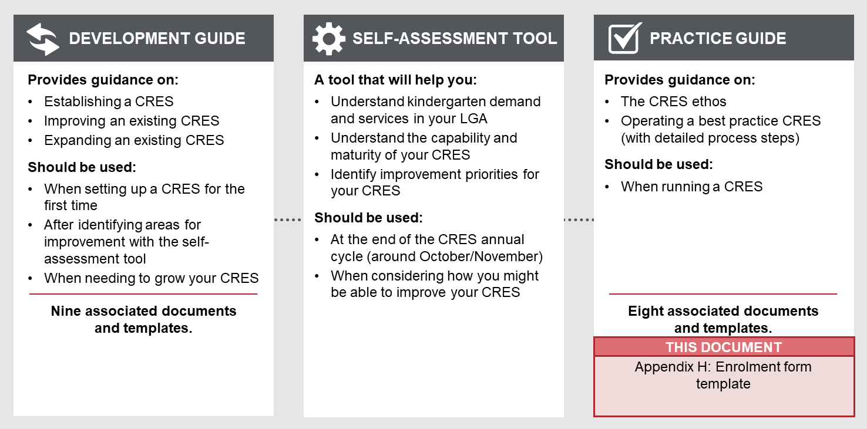

to complete this template:
- All template content can be tailored, but content highlighted in yellow must be updated to be relevant to your CRES. Consider your location and context, whether your CRES charges fees and whether you have additional local priority criteria. For example, “[council name]” must be replaced with the name of your council for content to make sense.
- Review the form to ensure if meets the current requirements of the Education and Care Services National Law and Regulations. The Department of Education and Training cannot guarantee that the form will always be current and reflect the requirements of the National Law and Regulations.
- Change this form to CRES Provider branding.
Refer to the instructions listed in each section in these purple boxes. Once the text is complete, delete all instruction boxes.

HOW TO USE THIS FORM WHEN COMPLETE:
- Remove the first two pages of this document.
- This enrolment form template is designed to work as both a printable paper form and digital form.
  - for use as a paper form, format the template with appropriate council branding and colours, and keep all red text.
  - for use as a digital form, use your organisation’s existing online form capabilities and remove all red text.
- Distribute to kindergarten providers as a suggested standard form or use if your scheme includes enrolment.
- Pre-fill any information where applicable.

ENROLMENT FORM

Central Registration and Enrolment Scheme (CRES)

[CRES provider]

Date:
Version:

NOTE: It is the responsibility of approved providers for ensuring this form meets the current requirements of the Education and Care Services National Law and Regulations. The Department of Education and Training cannot guarantee that the form will always be current and reflect the requirements of the Law.

What is this enrolment form?
This enrolment form collects details about your child so that we can provide a safe and healthy kindergarten environment for them. Completing this enrolment form will confirm your child’s place in [provider name] to start on [provider’s kindergarten start date].
[CRES Provider] has passed on all the information you provided at the registration stage and it is included below. Please indicate if any fields need to be changed.
Investigate options to prefill parts of this enrolment form. A CRES should minimise the burden on families and carers in the registration and enrolment process. Some families and carers will find it difficult to provide written information so the process should minimise the number of times they have to do so. A pre-filled enrolment form allows families and carers to confirm or update information.
Depending on your scheme, pre-filling could occur when:
- The CRES Provider pre-fills forms and sends them to the service provider once allocated places are confirmed
- The service provider receives the registration information in a standard format and adds it to their systems, which then pre-fills the enrolment forms.
Consider the scale of your registrations, the capability and capacity of the CRES and service providers, and the needs of service providers to customise the enrolment form.

GENERAL DETAILS

Child information
Child’s first name
Child’s last name
Child’s gender | ☐ Male ☐ Female ☐ __________
Date of birth | DD / MM / YYYY
Child’s main residential address | Street address  Suburb  State  Post Code
Child lives with: | ☐ Parent  ☐ Informal kinship care  ☐ Formal kinship care  ☐ Foster care  ☐ Other
Main language spoken at home
Child’s cultural background
Are there any court orders, parenting orders or parenting plans relevant to the child? | ☐ No ☐ Yes (please attach details)
Does the child meet any of the following criteria?  (This information was collected at the registration stage to assist in placing the child and is confirmed now.) | ☐ Is Aboriginal  ☐ Is Torres Strait Islander  ☐ Is a triplet or quadruplet  ☐ Attends a Three-Year-Old program through Early Start Kindergarten or Access to Early Learning  ☐ Known to Child FIRST, Child Protection or family services  ☐ Been referred by a Maternal and Child Health nurse, support service or Out of Home Care provider
Do you or the child hold any of the following cards? (see below for pictures) | - Commonwealth Health Care Card  - Commonwealth Pensioner Concession Card  - Department of Veterans’ Affairs Gold Card or White Card  - Humanitarian or refugee visa
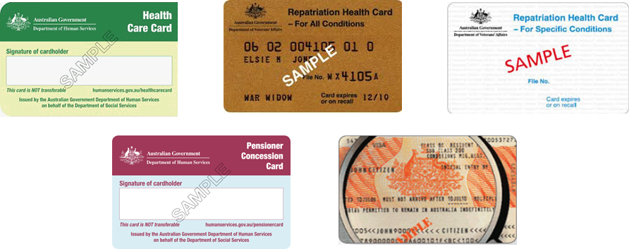

Parent / carer details
We already have the parent / carer information provided in the registration form you completed with the [CRES Provider]. This information is included below, please indicate if it needs to be changed.

 | First parent / carer (required) | Second parent / carer (required if known)
Name | First name Last name | First name Last name
Relationship to child
Residential address | Street address  Suburb  State  Post Code | Street address  Suburb  State  Post Code
Contact number
Email address
Main language spoken (if not English)
Cultural background
Interpreter required? | ☐ Yes ☐ No | ☐ Yes ☐ No
Would you like to participate in the program from time-to-time? | ☐ Yes ☐ No | ☐ Yes ☐ No

If you would like to participate in the kindergarten program as a volunteer from time-to-time, please complete the following details:
Parent / carer name | First name Last name
Working with Children Check (WWCC)* | Number: Expiry: DD / MM / YYYY
*All volunteers who wish to participate in the program are required to have a volunteer WWCC.

Authorised nominee
The following persons are authorised to collect the child from [provider name], and consent to medical treatment of, or authorise administration of medication to, the child. These people should be local to our area. Please provide the best contact number for between kindergarten hours.

Authorised nominee 1
Nominee name | First name Last name
Nominee best contact number
Nominee address | Street address  Suburb  State  Post Code
Relationship to child
Authorised nominee 2 (optional)
Nominee name | First name Last name
Nominee best contact number
Nominee address | Street address  Suburb  State  Post Code
Relationship to child

Emergency contact
The following persons are authorised to act if the parent / carer cannot be contacted in an emergency. You may nominate the same persons as your authorised nominee(s). Please specify at least one person for each area of authority selected below. These people should be local to our area. Please provide the best contact number for between kindergarten hours.

Emergency contact 1
Nominee name | First name Last name
Nominee best contact number
Nominee address | Street address  Suburb  State  Post Code
Relationship to child
Areas of Authority (may select multiple) | ☐ Notification in the event of an emergency involving the child if the parent / carer cannot be immediately contacted  ☐ Authorised to collect the child  ☐ Authorised to consent for the service provider to seek medical treatment for the child from a medical practitioner, hospital or ambulance service  ☐ May authorise the administration of medication to the child  ☐ Authorised to allow an early childhood teacher to take the child outside the premises  ☐ Authorised to consent for the service provider to seek transportation for the child by ambulance  ☐ Authorised to sign Incident, Injury Trauma and Illness Records and Medication Records  ☐ Authorised for a child to be transported
Emergency contact 2 (optional)
Nominee name | First name Last name
Nominee best contact number
Nominee address | Street address  Suburb  State  Post Code
Relationship to child
Areas of Authority (may select multiple) | ☐ Notification in the event of an emergency involving the child if the parent / carer cannot be immediately contacted  ☐ Authorised to collect the child  ☐ Authorised to consent for the service provider to seek medical treatment for the child from a medical practitioner, hospital or ambulance service  ☐ May authorise the administration of medication to the child  ☐ Authorised to allow an early childhood teacher to take the child outside the premises  ☐ Authorised to consent for the service provider to seek transportation for the child by ambulance  ☐ Authorised to sign Incident, Injury Trauma and Illness Records and Medication Records  ☐ Authorised for a child to be transported

Medical information
Eligibility to attend kindergarten
Are your child’s immunisations up to date? | ☐ Yes ☐ No  You must provide evidence of up to date immunisation within two months prior to beginning kindergarten. You should provide evidence of current immunisations, even if there are more immunisations required.  Only an Immunisation History Statement from the Australian Immunisation Register (AIR) will be accepted as evidence of immunisation. Letters from GPs or local councils are not accepted.  Families and carers can print a copy of their child’s Immunisation History Statement from their myGov account or:  - call the AIR on phone 1800 653 809  - visit a Medicare or Centrelink office.  More information can be found at https://www2.health.vic.gov.au/public-health/immunisation/vaccination-children/no-jab-no-play  You will be required to provide updated copies of this Immunisation History Statement at and following kindergarten commencement.
Have you attached an Immunisation History Statement to this form? | ☐ Yes ☐ No  If no, [provider name] will contact you to confirm if you are eligible for a grace period. This means we can confirm your enrolment and assist you to get the necessary vaccinations.
When is your child due for their next immunisation? (if applicable) | DD / MM / YYYY
Medical care information
When was your last Maternal and Child Health Key Age and Stage visit? (Note: this may be the 18 month, 2 year or 3.5 year visit) | MM / YYYY
Please detail any healthcare or medical conditions, including treatment
Please detail any dietary restrictions or sensitivities, including treatment
Please detail any allergies, including treatment*
Has your child been diagnosed at risk of anaphylaxis?* | ☐ Yes ☐ No
Does your child have asthma?* | ☐ Yes ☐ No
Does your child have an auto injection device e.g. EpiPen?* | ☐ Yes ☐ No
Medical care contact in case of emergency
Does the child have ambulance insurance cover? | ☐ Yes ☐ No  If Yes, please provide the ambulance subscription number:
Child’s registered medical practitioner or medical service (doctor / GP) | First name Last name  Street address  Suburb  State  Post Code  Phone number
Child’s Medicare number

*If your child has a diagnosed health care need (such as asthma, anaphylaxis or an allergy), before your child starts kindergarten you will need to:
- Provide a signed and completed Medical, Asthma, Anaphylaxis or Allergy Management plan.
- Provide your early childhood teacher with any listed medications with your child’s name and dosage clearly labelled by a pharmacist.
- Sign a Medical Conditions Risk Minimisation Plan completed in consultation with your early childhood teacher.
- Have been provided with the kindergarten’s Medical Conditions Policy.

Additional support information
Please detail any special considerations for the child, for example any cultural, religious or dietary requirements or additional needs.
Does the child have concerns with any of the following:  (Please tick the applicable boxes even if you have already specified above) | ☐ Speech / language  ☐ Hearing  ☐ Sight  ☐ Behaviour  ☐ Toileting  ☐ Other, please specify: | ☐ ADHD  ☐ Autism  ☐ Coordination difficulties  ☐ Hyperactivity
Is the child receiving support from or is on the wait list from any of the following support services | [Add any other common children’s support organisations in your LGA to this list if known]  ☐ Anglicare  ☐ Berry Street  ☐ Save the Children  ☐ Other, please specify: | ☐ Noah’s Ark  ☐ Scope  ☐ Paediatrician  ☐ Speech pathologist

PERMISSIONS

Photography
From time to time we may take photographs or videos at the kindergarten for the purposes of internal newsletters, marketing and other activities. We will not take photos / videos of the child or publish them without your express consent indicated with the below questions.

Do you give permission for your child to be photographed and/or videoed at the kindergarten? | ☐ Yes ☐ No
Can your child’s photograph be displayed within the kindergarten? | ☐ Yes ☐ No
Can your child’s photograph be shared with families / carers of the kindergarten (e.g. in portfolios, newsletters, sharing photos when multiple children are in the photo)? | ☐ Yes ☐ No
Can your child’s photograph be published in a newspaper and external publications? | ☐ Yes ☐ No

Outings
We may take outings or excursions during kindergarten hours.
Do you give permission for your child to attend regular outings under the supervision of [provider name] staff? | ☐ Yes ☐ No

Parent education and occupation details form
The form and information attached at the end of this document will be used to ensure your kindergarten receives School Readiness Funding. This is additional funding to help your child get even more out of their time at kindergarten. It helps us purchase additional programs and supports for your child.
This is the same information collected by schools when a child is enrolled in prep. All information provided during the enrolment process will only be used to inform kindergarten funding. For further information on the Department’s Privacy Policy, please visit https://www.education.vic.gov.au/pages/privacypolicy.aspx
For more information on the Parent Education and Occupation Details form, visit www.education.vic.gov.au/school-readiness

FOR SERVICE PROVIDER USE ONLY
I have sighted an up-to-date copy of the child’s health record | ☐ Yes ☐ No
I have sighted an up-to-date copy of the child’s Immunisation History Statement or contacted the family to confirm grace period eligibility | ☐ Yes ☐ No

Consent and Declaration
I / We
- Declare that information provided in this enrolment form is true correct and will contact the Kindergarten immediately in the event of any changes to the information
- Will abide by [provider name]’s Early Education and Care Services Policies and Procedures which are available at the service
- Agree to collect or make arrangements for the collection of the child if he or she becomes unwell
- Agree that I / We are responsible for any expenses incurred during a medical emergency in relation to the child
- Agree that I / We will not redistribute or post on electronic media (e.g. Facebook) and photographs given to me / us by the kindergarten or take by me / us that contain other children.

I / We authorise the Approved Provider, Nominated Supervisor or an Early Childhood Teacher to:
- Seek medical treatment for my child from a registered medical practitioner, hospital or ambulance service
- Seek transportation of my child by ambulance service
- Take the child outside the education and care services for emergency situations or emergency evacuation drills under the supervision of the approved provider, nominated supervisor or early childhood teacher.

Parent / Carer 1 Name:
Signature:

Parent / Carer 2 Name:
Signature:

attachments

Before returning this form, confirm that:
If implementing this form digitally, make all fields mandatory to ensure people cannot submit the form without completing all relevant sections and included document uploads where required.
- You have included a copy of your child’s Immunisation History Statement from the Australian Immunisation Register (AIR), or have contacted [provider name] to discuss an exemption
- You have attached a copy of your child’s health record
- You have completed all sections of this form
- You have attached a copy of any court orders relevant to the child
- You have signed the Consent and Declaration / Terms and Conditions of Enrolment.

If the CRES Provider does not collect proof of identity, residence, concession or support requirements in the registration form, the below bullet points should be included in this enrolment form.
If not, delete the below bullet points.

You have enclosed copies of:
- Proof of identity: your child's birth certificate, birth notice or passport
- Proof of residence: a utilities bill, rental agreement or rates notice with your family name and address (this must be the main residence of your child)
- Concession cards and immigration visas (where applicable)
- Documents from Family Support Services or a Maternal and Child Health nurse confirming high support needs and/or disability or letter from a doctor for complex medical needs (where applicable).
- [other proof required to verify the child meets local criteria]

Send this form by post to:
[insert kindergarten address]
You may also drop this form off at the kindergarten in-person.

Parental education and occupation details
Please complete this form in English
CHILD’S NAME:
KINDERGARTEN NAME:
Please tick this box if there is only one parent/guardian for the child: □ |  |  | Parent/guardian A  (primary carer) | Parent/guardian B  (must be completed, except where there is only one parent/guardian for the child)
Education
Equivalent overseas education and qualifications are recognised for the purposes of this data collection.
- What is the highest year of primary or secondary school the parent/guardian has completed? (tick one)  For persons who have never attended school, mark ‘Year 9 equivalent or below’. |  | Year 9 equivalent or below | ☐ | ☐
 |  | Year 10 or equivalent | ☐ | ☐
 |  | Year 11 or equivalent | ☐ | ☐
 |  | Year 12 or equivalent | ☐ | ☐
- What is the level of the highest qualification the parent/guardian has completed? (tick one) |  | No non-school qualification | ☐ | ☐
 |  | Certificate I to IV (including trade certificate) | ☐ | ☐
 |  | Advanced diploma / Diploma | ☐ | ☐
 |  | Bachelor’s degree or above | ☐ | ☐
Occupation
- What is the occupation group of the parent/guardian? (See Parental Occupation Index on page 2)  If the parent/guardian is not currently in paid work but has had a job in the last 12 months, or has retired in the last 12 months, please use their last occupation |  |  | ☐ A | ☐ A
 |  |  | ☐ B | ☐ B
 |  |  | ☐ C | ☐ C
 |  |  | ☐ D | ☐ D
If the parent/guardian has not been in paid work for the last 12 months, tick ‘N’ OR |  |  | ☐ N | ☐ N
If the parent/guardian has not been in paid work for the last 12 months because the person cares for their own children full time, tick ‘H’ |  |  | ☐ H | ☐ H
Name parent/guardian (print) |  |  | Date
Signature parent/guardian

Parental Occupation Index
MANAGERS
Chief Executives, General Managers and Legislators | Chief Executives and Managing Directors, Corporate General Manager, Defence Force Senior Officer, Local Government Legislator, Member of Parliament | A
Farmers and Farm Managers | Aquaculture Farmers, Crop Farmers, Livestock Farmers, Mixed Crop, Livestock Farmers | A
Specialist Managers | Advertising, Public Relations and Sales Managers, Business Administration Managers, Construction Managers, Education, Health and Welfare Services Managers | A
Hospitality, Retail and Service Managers | Accommodation and Hospitality Managers, Retail Managers | B
PROFESSIONALS generally with a bachelors degree or above
Arts and Media Professionals | Music Professionals, Photographers, Journalists and Other Writers | A
Business, Human Resource and Marketing  Professionals | Accountants, Auditors and Company Secretaries, Financial Brokers and Dealers, and Investment Advisers, Human Resource and Training Professionals, Information and Organisation Professionals, Sales, Marketing and Public Relations Professionals | A
Design, Engineering and Science Professionals | Architects, Designers, Planners and Surveyors, Engineering Professionals | A
Education Professionals | Early Childhood Teachers, School Teachers, Tertiary Education Teachers | A
Health Professionals | Health Diagnostic and Promotion Professionals, Health Therapy Professionals, Medical Practitioners, Midwifery and Nursing Professionals | A
ICT Professionals | Business and Systems Analysts, and Programmers, Database and Systems Administrators, and ICT Security Specialists | A
Legal, Social and Welfare Professionals | Barristers, Judicial and Other Legal Professionals, Solicitors, Counsellors, Psychologists, Social Workers, Ministers of Religion | A
TECHNICIANS AND TRADES WORKERS
Engineering, ICT and Science Technicians | Agricultural, Medical and Science Technicians, Building and Engineering Technicians, ICT and Telecommunications Technicians | B
Automotive and Engineering Trades Workers | Automotive Electricians and Mechanics, Mechanical Engineering Trades Workers, Panel beaters, and Vehicle Body Builders, Trimmers and Painters | C
Construction Trades Workers | Bricklayers, and Carpenters and Joiners, Floor Finishers and Painting Trades Workers | C
Electrotechnology and Telecommunications  Trades Workers | Electricians, Electronics and Telecommunications Trades Workers | C
Food Trades Workers | Chefs | B
 | Bakers and Pastry cooks, Butchers and Smallgoods Makers, Cooks | C
Skilled Animal and Horticultural Workers | Animal Attendants and Trainers, and Shearers, Horticultural Trades Workers | C
Other Technicians and Trades Workers | Hairdressers, Textile, Clothing and Footwear Trades Workers | C
COMMUNITY AND PERSONAL SERVICE WORKERS
Health and Welfare Support Workers | Ambulance Officers and Paramedics, Dental Hygienists, Technicians and Therapists, Health Workers, Massage Therapists | B
Carers and Aides | Child Carers, Education Aides, Personal Carers and Assistants | D
Hospitality Workers | Bar Attendants and Baristas, Cafe Workers, Gaming Workers | D
Protective Service Workers | Police | B
 | Defence Force Members - Other Ranks, Fire and Emergency Workers | C
Personal Service Workers | Beauty Therapists, Driving Instructors, Travel Attendants | D
Sports | Sports Coaches, Instructors and Officials, Sportspersons | C
 | Fitness Instructors, Outdoor Adventure Guides | D
CLERICAL AND ADMINISTRATIVE WORKERS
Office Managers and Program Administrators | Contract, Program and Project Administrators, Office and Practice Managers | B
Personal Assistants and Secretaries | Personal Assistants, Secretaries, Legal Secretaries | C
General Clerical Workers | General Clerks, Keyboard Operators | D
Inquiry Clerks and Receptionists | Call or Contact Centre Information Clerks, Receptionists | D
Numerical Clerks | Bookkeepers, Accounting, Financial and Insurance Clerks, Bank Workers | D
Clerical and Office Support Workers | Couriers and Postal Deliverers, Filing and Registry Clerks, Survey Interviewers | D
Other Clerical and Administrative Workers | Conveyancers and Legal Executives | B
 | Court and Legal Clerks, Insurance Investigators, Loss Adjusters and Risk Surveyors | C
 | Purchasing and Supply Logistics Clerks, Debt Collectors, Human Resource Clerks, Inspectors and Regulatory Officers | D
SALES WORKERS & MACHINERY OPERATORS, DRIVERS AND LABOURERS
Sales Agents | Auctioneers, and Stock and Station Agents, Insurance Agents, Real Estate Sales Agents | C
Sales Representatives, Sales Assistants, Salespersons and Sales Support Workers | Sales Representatives, Sales Assistants, Pharmacy Sales Assistants, Retail Supervisors, Checkout Operator | D
Machinery Operators, Drivers and Labourers | Machine and Stationary Plant Operators, Road and Rail Drivers, Storepersons, Cleaners and Laundry Workers, Factory Process Workers | D

