Appendix G | communications with families and carers pack

About this template
Note: please remove these instruction pages when completing the template
This template is a starting point for CRES Providers operating a Central Registration and Enrolment Scheme (CRES) to draft their communications with families and carers who have registered a child for kindergarten. Refer to section 4.3 of the CRES Practice Guide for more information on this step in the CRES annual cycle.
This document is a part of a suite of CRES documents. Figure 1 below maps the relationship between the Development Guide, Self-Assessment Tool, Practice Guide and this document.
Figure 1 | A map of CRES documents

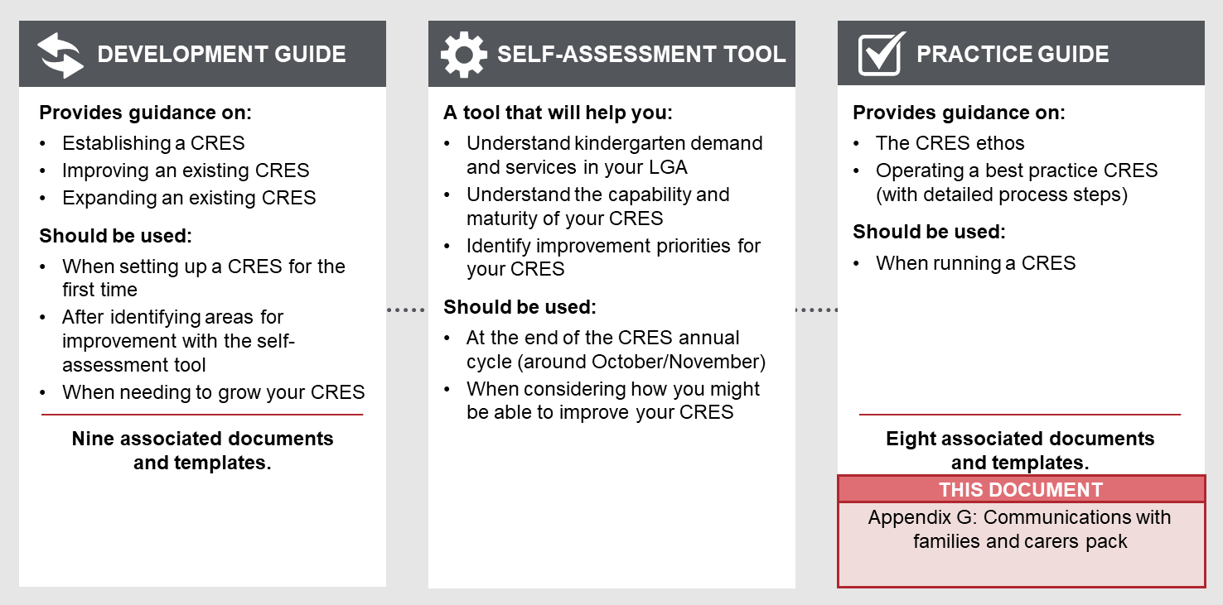

to complete this template:
- The writer of these emails should tailor the template to the needs and objectives of families and carers in your LGA. Thoughtful additions, deletions and edits to the template content will strengthen your plan and make delivery simpler.
- All template content can be tailored, but content highlighted in yellow must be updated to be relevant to your CRES. Consider your location and context, whether your CRES charges fees and whether you have additional local priority criteria. For example, “[council name]” must be replaced with the name of your council for content to make sense.
Refer to the instructions listed in each section in these purple boxes. Once the plan is complete, delete all instruction boxes.

TO USE THIS PACK WHEN COMPLETED:
- Remove the first two pages of this document.
- Ensure all staff who will communicate with families and carers have, and understand, the contents of this pack.

DRAFT FAMILY AND CARER COMMUNICATION PACK

Central Registration and Enrolment Scheme (CRES)

[CRES provider]

Date:
Version:

Confirmation of registration
The template text below can be used in an email to families and carers to confirm their registration form has been received. The timeline is particularly important in this document as providing information like this upfront often results in less questions from families and carers later in the process. Tailor the template to the dates for your CRES process each year.

Dear [name],
Thank you for submitting your registration for [child’s name and surname] to attend kindergarten in [year].
You have submitted the following preferences:
- [first preference here]
- [second preference here]
- [third preference here]
- [fourth preference here]
Please note the following important dates for completing enrolment and commencing kindergarten:
[date] – registrations close.
[date]-[date] – places allocated by [CRES provider name].
[date] – first round places offered. If a place is offered to you in this round, you will be required to accept for decline the offer. You will receive a [letter/email] with the details of the offer.
[date] – second round places offered. If a place is offered to you in this round, you will be required to accept for decline the offer.
[date] – kindergarten enrolments open. Your allocated kindergarten will contact you directly regarding the enrolment process for your child and to help you prepare for kindergarten.
[date] – kindergarten term begins.
It is highly likely that you will be offered a place in [LGA]. Across Victoria, almost all children who register for kindergarten through a central scheme are allocated a place. Last year XX% of children were allocated to kindergarten places through our system and we anticipate similar numbers this year. We have also created XX additional new kindergarten places/sessions/facilities since last year. [if surplus] As such, it is highly likely you will be offered a place in [LGA]. [if deficit] You are permitted to register your child for a kindergarten place in another local council area close to your home or work to minimise the chance of missing out on a kindergarten place.
If you have any questions during the registration, allocation and place offer stages of this process, or if your contact details change, please contact the Central Registration team at [CRES provider name] via:
[insert contact details here]

RESPONSES TO UPDATE REQUESTS

Messaging for families and carers who wish to update their preferences
- The method for central registration that [CRES provider] uses requires us to have all registrations for this round before we can allocate children to kindergarten places, which means that I cannot confirm your place before [date that places are offered].
- You can update your preferences by calling [CRES provider] or visiting [CRES Provider website] at [insert link here] until registrations close on [date] for first round allocations. After that, you can update your preferences and go into the pool for second round allocations before they are released on [date].
- You can update your preferences for:
  - Kindergarten service provider
  - Kindergarten sessions
- If you have declined an offer and would like to update your preferences, you will be entered into the pool for second round allocations, which will offered on [date].
- Sometimes [CRES provider] cannot meet the preferences of all registered children. We prioritise the allocation of places as per the Department of Education and Training’s Priority of Access criteria and local criteria including… . Priority of Access criteria can be found in the Kindergarten Funding Guide at: www.education.vic.gov.au/childhood/providers/funding/Pages/kinderfundingcriteria.aspx
- We endeavour to meet all preferences for registered children and their families or carers.

key Messaging for families or carers requesting information on the placement of their child
During the allocation process, families and carers can contact the CRES Provider to update their preferences or request information on the placement of their child. The key messaging below can be used in email communication, or as the basis of a phone conversation.

- The method for central registration that [CRES provider] uses requires us to have all registrations for this round before we can allocate children to kindergarten places, which means that I cannot confirm your place before [date that places are offered].
- Allocations are prioritised using criteria set out by the Victorian Government and defined by council. The full list is available on [CRES Provider] website at [URL].
- It is highly likely that you will be offered a place in [LGA]. Across Victoria, almost all children who register for kindergarten through a central scheme are allocated a place. Last year XX% of children were allocated to kindergarten places and similar numbers are anticipated this year. [Customise] XX additional kindergarten places/sessions/facilities have been added since last year. [if surplus] As such, it is highly likely you will be offered a place in [LGA]. [if deficit] You are permitted to register your child for a kindergarten place in another local council area close to your home or work to minimise the chance of missing out on a kindergarten place.
- The timing for this year’s registration and allocation process is:
- [date] – registrations close.
- [date]-[date] – places allocated by [CRES provider name].
- [date] – first round places offered. If a place is offered to you in this round, you will be required to accept for decline the offer.
- [date] – second round places offered. If a place is offered to you in this round, you will be required to accept for decline the offer.
- [date] – kindergarten enrolments open. You will communicate with your selected kindergarten directly to enrol your child and prepare for kindergarten.
- [date] – kindergarten term begins.

confirmation of NON-FINAL ROUND OFFER
The template text below can be used in an email to families and carers to inform them of their kindergarten offer and prompt them to accept or decline the offer. Use these templates for all rounds except for the final round.
There are two templates below to prompt families and carers to respond to the offer either via an online portal, email or phone call. Tailor the template that best suits your systems.

non-final round confirmation email for CRES providers with an online portal

To: parent / family member / carer
CC: support service staff, if confirmed by parent / family member / carer
Subject: [year] [Three-Year-Old / Four-Year-Old] kindergarten place offer

Dear [parent / family member / carer name],
We are pleased to offer [child’s name] the following kindergarten place for [year]:
[Three-Year-Old / Four-Year-Old] kindergarten
[kindergarten name]
[session times]

Please accept or decline this offer via [CRES providers]’s online portal. This enrolment offer is valid until [date]. Unfortunately, we will not be able to hold this enrolment opportunity if your response has not been received by [date].

To accept this allocation please click below.
Accept Offer [link]
If the offer is accepted, the kindergarten will be notified. The kindergarten will contact you later in the year for orientation, including enrolment, session times, fees and other service procedures.

Alternatively, if you wish to decline the offer please click below.
Decline offer and remove from all waitlists [link]
Decline offer and move to waitlist for preferred Kindergarten [link]
If you request to be placed on our waitlist, another offer will be made during the next round released on [date].

If you have any questions, please do not hesitate to contact the Central Registration team at [CRES provider name] via:
[insert contact details here]

NON-FINAL ROUND confirmation email for CRES providers without an online portal

To: parent / family member / carer
CC: support service staff, if confirmed by parent / family member / carer
Subject: [year] [Three-Year-Old / Four-Year-Old] kindergarten place offer

Dear [parent / family member / carer name],
We are pleased to offer [child’s name] the following kindergarten place for [year]:
[Three-Year-Old / Four-Year-Old] kindergarten
[kindergarten name]
[session times]

Please accept or decline this offer by replying to this email or calling [CRES Provider] on [phone number]. This enrolment offer is valid until [date]. Unfortunately, we will not be able to hold this enrolment opportunity if your response has not been received by [date].

If the offer is accepted, the kindergarten will be notified. The kindergarten will contact you later in the year for orientation, including enrolment, session times, fees and other service procedures.

If the offer is declined, you can request to be added to the waitlist or removed from all waitlists. If you elect to be placed on our waitlist, another offer will be made during the second round, released on [date].

If you have any questions, please do not hesitate to contact the team at [CRES provider name] via:
[insert contact details here]

non-final round confirmation of place on waitlist (portal or email)

To: parent / family member / carer
CC: support service staff, if confirmed by parent / family member / carer
Subject: [year] [Three-Year-Old / Four-Year-Old] kindergarten wait list

Dear [parent / family member / carer name],
[Child’s name] has been placed on a waiting list for a [Three-Year-Old / Four-Year-Old] kindergarten place in [year]. A place a likely be offered to you in the second round of kindergarten allocations, released on [date].
It is highly likely that you will be offered a place in [LGA]. Across Victoria, almost all children who register for kindergarten through a central scheme are allocated a place. Last year XX% of children were allocated to kindergarten places and we anticipate similar numbers this year. [Customise] We have also created XX additional new kindergarten places/sessions/facilities since last year. [if surplus] As such, it is highly likely you will be offered a place in [LGA]. [if deficit] You are permitted to register your child for a kindergarten place in another local council area close to your home or work to minimise the chance of missing out on a kindergarten place.
You can update your preferences until registrations close on [date] for second round allocations. Please use the online portal or contact us via the phone number below to update your preferences for:
Kindergarten service provider
Kindergarten sessions
If you have any questions, please do not hesitate to contact the Central Registration team at [CRES provider name] via:
[insert contact details here]

Confirmation of final round offer
The template text below can be used in an email to families and carers to inform them of their kindergarten offer and prompt them to accept or decline the offer. Use these templates for the final round of offers.
There are two templates below to prompt families and carers to respond to the offer either via an online portal, email or phone. Tailor the template that best suits your systems.

final round confirmation email for CRES providers with an online portal

To: parent / family member / carer
CC: support service staff, if confirmed by parent / family member / carer
Subject: [year] [Three-Year-Old / Four-Year-Old] kindergarten place offer

Dear [parent / family member / carer name],
We are pleased to offer [child’s name] the following kindergarten place for [year]:
[Three-Year-Old / Four-Year-Old] kindergarten
[kindergarten name]
[session times]
Please accept or decline this offer via [CRES providers]’s online portal. This enrolment offer is valid until [date]. Unfortunately, we will not be able to hold this enrolment opportunity if your response has not been received by [date].

To accept this allocation please click below.
Accept Offer [link]
If the offer is accepted, the kindergarten will be notified and will contact you later in the year for orientation, including enrolment, session times, fees and other service procedures.

Alternatively, if you wish to decline the offer please click below. If you choose to decline the offer, you will not be offered another kindergarten place, as this the final round of kindergarten place allocations for [year]. If you wish to discuss options for another kindergarten place in [LGA], please contact [CRES Provider] before [date].

Decline offer and remove from all waitlists [link]
Decline and register for next year [link]

If you have any questions, please do not hesitate to contact the Central Registration team at [CRES provider name] via:
[insert contact details here]

SUBSEQUENT ROUND confirmation email for CRES providers without an online portal

To: parent / family member / carer
CC: support service staff, if confirmed by parent / family member / carer
Subject: [year] [Three-Year-Old / Four-Year-Old] kindergarten place offer

Dear [parent / family member / carer name],
We are pleased to offer [child’s name] the following kindergarten place for [year]:
[Three-Year-Old / Four-Year-Old] kindergarten
[kindergarten name]
[session times]
Please accept or decline this offer replying to this email or calling [CRES Provider] on [phone number]. This enrolment offer is valid until [date]. The offer acceptance is required by this date. Unfortunately, we will not be able to hold this enrolment opportunity if your response has not been received by [date].

If the offer is accepted, the kindergarten will be notified and will contact you later in the year for orientation, including enrolment, session times, fees and other service procedures.

Alternatively, if you wish to decline the offer please click below. If you choose to decline the offer, you will not be offered another kindergarten place, as this the final round of kindergarten place allocations for [year]. If you wish to discuss options for another kindergarten place in [LGA], please contact [CRES Provider] before [date].

If you have any questions, please do not hesitate to contact the Central Registration team at [CRES provider name] via:
[insert contact details here]

final round confirmation of no offer

To: parent / family member / carer
CC: support service staff, if confirmed by parent / family member / carer
Subject: no place confirmed: [year] [Three-Year-Old / Four-Year-Old] kindergarten

Dear [parent / family member / carer name],
Unfortunately, we could not allocate [Child’s name] to a [Three-Year-Old / Four-Year-Old] kindergarten place for [year].
In [LGA], we have a deficit of kindergarten places. This year XX% of children were allocated to kindergarten places.
We recommend contacting the next closest local council to your home or work to discuss [Three-Year-Old / Four-Year-Old] kindergarten places they may have available. There are also some kindergartens in [LGA] which [CRES Provider] does not manage registration for. We recommend contacting those kindergartens to discuss places which may be available. If you would like support to locate a place for your child, please reply to this email or call us.
We apologise for this inconvenience and offer our support to help you register with another local council or central registration provider.
If you have any questions about our process or this result, please do not hesitate to contract the Central Registration team at [CRES provider name] via:
[insert contact details here]

Confirmed acceptance of kindergarten place
The template text below can be used in an email to families and carers once they have accepted a kindergarten place in your LGA.

To: parent / family member / carer
CC: support service staff, if confirmed by parent / family member / carer
Subject: Next steps: [year] [Three-Year-Old / Four-Year-Old] kindergarten place confirmed

Dear [parent / family member / carer name],
We are pleased to confirm that [child’s name] is now registered for the following kindergarten place for [year]:
[Three-Year-Old / Four-Year-Old] kindergarten
[kindergarten name]
[session times]

The information you provided in the registration form has been provided to the kindergarten, in line with our data and privacy policy. Your kindergarten will contact you shortly to confirm next steps to enrol in and prepare for kindergarten.
So you can prepare, please note that next steps will include:
- Providing documentation to the kinder, including birth certificate, immunisation records and dietary requirements
- Completing a detailed registration form, including selection of days and times for kindergarten sessions
- Attending an information session, open day or interview at the kindergarten.
If you have any questions in the meantime, you can contact the kindergarten directly:
[kindergarten contact details]

Warm regards,
Central Registration team,
[CRES Provider]

