APPENDIX E | service provider session time request template

About this template
Note: please remove these instruction pages when completing the template
This template is to be used by CRES Providers in Stage 5: CRES planning, maintenance and evaluation. Refer to section 4.5 of the CRES Practice Guide for more information on this step of the CRES process.
This document is a part of a suite of CRES documents. Figure 1 below maps the relationship between the Development Guide, Self-Assessment Tool, Practice Guide and this document.
Figure 1 | A map of CRES documents
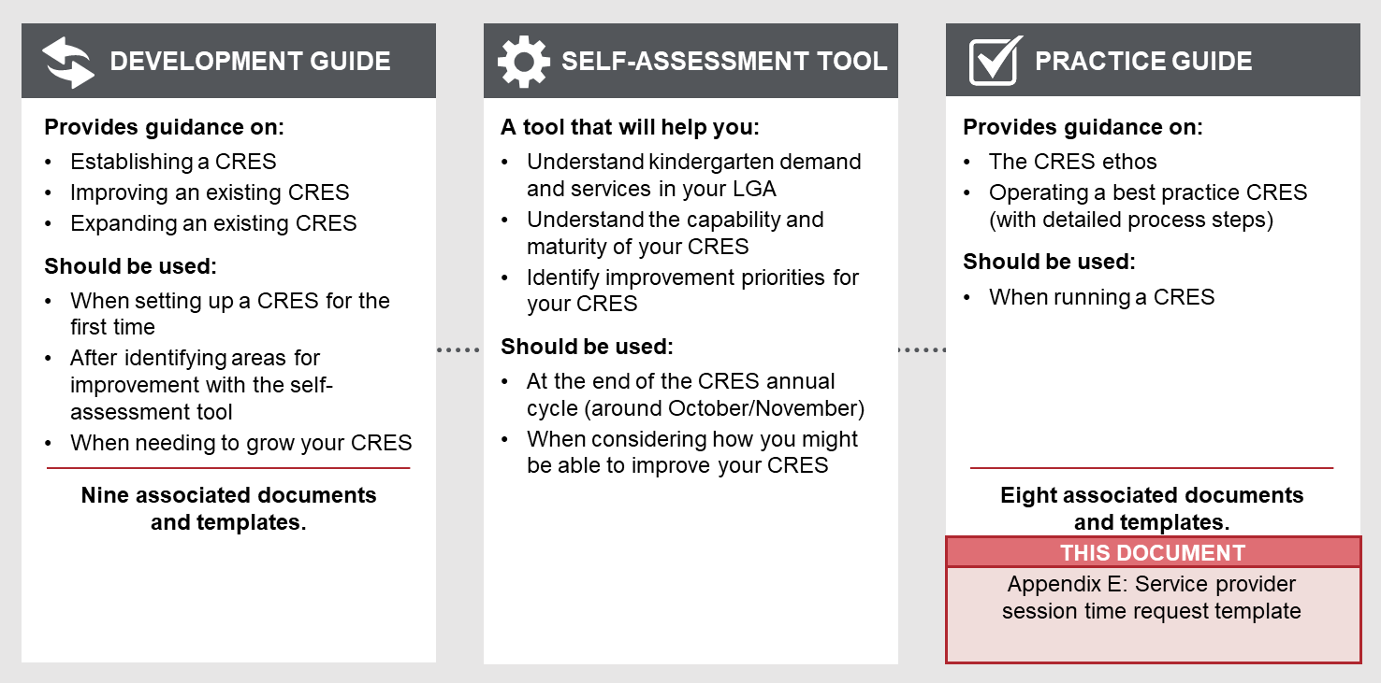

to complete this template:
- All template content can be tailored, but content highlighted in yellow must be updated to be relevant to your CRES. Consider your location and context, whether your CRES charges fees and whether you have additional local priority criteria. For example, “[council name]” must be replaced with the name of your council for content to make sense.
- Change this document to CRES Provider branding.

how to use this template when completed:
- Remove the first page of this document.
- Send this form to kindergarten service providers in so they can give some information about proposed session times for the upcoming kindergarten year. These session times will be used to help families / carers make informed decisions about the service that is right for them.

service provider session time request

Central Registration and Enrolment Scheme (CRES)

[CRES provider]

Date:
Version:

Data request – service provider session time information
[CRES Provider] is requesting that you provide information about groups and session times you are planning to run in 20xx.
By providing this information you agree that [CRES Provider] is permitted to publish this information on our website and on registration forms for the purposes of helping families / carers make decisions. The session times will be accompanied by the following caveat:
Session times displayed in this table are indicative only and are subject to change depending on each service provider’s individual circumstances. Please contact service providers if you would like more information about their groups and session times.
Please return this information by [due date] to [CRES contact person name and email address].

Service details
Name of Early Years’ Service
Address

Primary Contact Person for Central Registration and Enrolment (CRES)
Primary Contact Phone
Primary Contact Email

Group details
If your kindergarten offers mixed age group sessions, please alter the table below to reflect that.
CRES provider to add or delete rows as necessary
Age group | Group | Name of group | Registered capacity | Number of 2nd year places to be reserved | Number of pre-purchased places | Fees
4-year-old groups | Group 1
 | Group 2
 | Group 3
 | Group 4
3-year-old groups | Group 1
 | Group 2
 | Group 3

Session timetable
CRES provider to add or delete rows as necessary
Age group | Group | Monday  (start time – end time) | Tuesday  (start time – end time) | Wednesday  (start time – end time) | Thursday  (start time – end time) | Friday  (start time – end time)
4-year-old groups | Group 1
 | Group 2
 | Group 3
 | Group 4
3-year-old groups | Group 1
 | Group 2
 | Group 3

