Appendix D | CRES Registration form template

About this template
Note: please remove these instruction pages when completing the template
This template should be used by CRES Providers in Stage 2: Registration. Refer to section 4.2 of the CRES Practice Guide for more information on this step of the CRES process.
This document is a part of a suite of CRES documents. Figure 1 below maps the relationship between the Development Guide, Self-Assessment Tool, Practice Guide and this document.
Figure 1 | A map of CRES documents
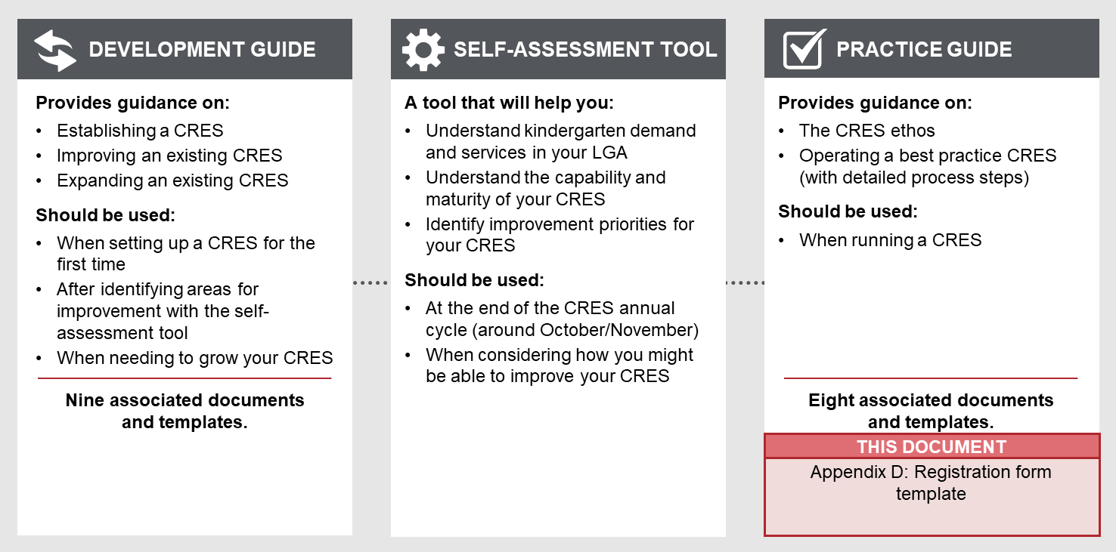

to complete this template:
- All template content can be tailored, but content highlighted in yellow must be updated to be relevant to your CRES. Consider your location and context, whether your CRES charges fees and whether you have additional local priority criteria. For example, “[council name]” must be replaced with the name of your council for content to make sense.
- This registration form template is designed to work as both a printable paper form and digital form.
  - For use as a paper form, format the template with appropriate council branding and colours and keep all red text
  - For use as a digital form, use your organisation’s existing online form capabilities and remove all red text
- Change this form to CRES Provider branding

Refer to the instructions listed in each section in these purple boxes. Once the form is complete, delete all instruction boxes.

how to use this form when completed:
- Remove the first two pages of this document.
- Distribute a paper form or link to all CRES Partners and local organisations who may have contact with families and carers.

REGISTRATION FORM

Central Registration and Enrolment Scheme (CRES)

[CRES provider]

Date:
Version:

What is this registration form?
This registration form is the first step toward getting your child into kindergarten in 20XX. The information collected with this form will be used to allocate your child a place in a kindergarten service. Only kindergartens that participate in the CRES are included in this allocation process. A full list of these kindergartens and their indicative session times for the coming year are provided on our website: [insert link to full list of providers participating in CRES] or on page XX. If your preferred kindergarten is not on this list, please contact the kindergarten directly to enrol.
If you have a stable internet connection and an email address you check regularly, you can complete a digital version of this form online at [link to online form].
The information you provide in this form will be shared with the kindergarten once you have accepted an offered place.

Backround information

Timelines for the kindergarten year
Date | Activity
1 March | Registrations open
30 May | Registrations close*
Beginning of August | First round offers
Mid-August | Acceptance of first round offers due
Beginning of September | Second round offers
Mid-September | Acceptance of second round offers due
Weekly or when vacancies become available | Subsequent offers
*Note that registrations will still be accepted past 30 May but only will be considered after initial on-time registrations are processed.

Eligibility

Age
Only complete this form if you are planning on sending your child to kindergarten in 20XX [insert next kindergarten year]. Your child will be eligible for kindergarten only if they meet the following age criteria:
- To be eligible for Three-Year-Old Kindergarten, your child must turn 3 by April 30 20XX [insert next kindergarten year]
- To be eligible for Four-Year-Old Kindergarten, your child must turn 4 by April 30 20XX [insert next kindergarten year].
Check your child’s date of birth against the table below:

Child’s date of birth is between | The year the child can attend kindergarten
 | Three-Year-Old Kindergarten | Four-Year-Old Kindergarten
1/5/2018 – 30/4/2019 | 2022 | 2023
1/5/2019 – 30/4/2020 | 2023 | 2024

For further information about when to start kindergarten, go to https://www.education.vic.gov.au/parents/child-care-kindergarten/Pages/when-start-kindergarten.aspx

Immunisations
According to the No Jab, No Play law in Victoria, your child must be fully vaccinated to start kindergarten. An Immunisation History Statement from the Australian Immunisation Register is not required for this registration form, but you should ensure that your child’s immunisations are up to date and you have a copy of this statement before commencing the enrolment process that will likely happen in October.
A grace period applies for families and carers who may find it difficult to provide an up-to-date statement by October. Please contact [CRES Provider] for more information.
Further information on immunisation requirements for enrolment in early childhood services is available through the DET website at www.education.vic.gov.au/parents/child-care-kindergarten/Pages/enrol-in-kindergarten.aspx .

Priority of access
[CRES provider] follows the Department of Education and Training’s Priority of Access criteria, that prioritises allocation of kindergarten places for children who:
- Are at risk of abuse or neglect
- Are Aboriginal and/or Torres Strait Islander
- Are, or have parents or carers who are, asylum seekers or refugees
- Are eligible for the Kindergarten Fee Subsidy (hold a valid concession card or are a triplet or quadruplet)
- Have additional developmental needs.
Children that fit one or more of those criteria will be allocated to a place in kindergarten as a high priority. This form will collect all the information required to determine if a child is eligible for Priority of Access.
If your CRES includes local prioritisation criteria beyond the Department’s Priority of Access guidelines, it is recommended that the weighting for each factor is transparently described to the public.
If your CRES does not have local prioritisation criteria, delete the next paragraph and following table.

[Council name] have made the policy decision to include local criteria that will be factored in when allocating a child’s place. Children with a higher priority weighting will be allocated next, after all children eligible for the DET Priority of Access Criteria. The table below outlines the relative weighting for each factor [Council name] will consider when allocating a place.
Factor | Relative weighting
Local criteria 1 | X
Local criteria 2 | X
Local criteria 3 | X

If you believe you or your child are in exceptional circumstances which require prioritisation and are not covered by any of the above criteria, please contact [CRES Provider] to discuss.

Fees
Only include this section if your CRES charges a fee for registration. This decision should have been made during the development of your CRES.
You should also include your organisation’s standard credit card charge form with any paper forms that are distributed.
It is strongly recommended that you do not charge a registration fee for children who fit within the Department of Education and Training’s Priority of Access criteria.
Families and carers who meet the Priority of Access criteria do not have to pay a fee to register.
Families and carers who do not meet these criteria must pay a one-time non-refundable fee for kindergarten registration of [administration fee amount]. This can be paid online by credit card, at a [CRES Provider] service desk, by completing the credit card charge authorisation form or by submitting a bank cheque with this form.

It is strongly recommended that you do not collect documents proving the child’s birth date, address, visa status, concession card status or similar at the registration stage. A statement at the end of this form that certifies the information provided is true can suffice as a legal declaration. Once registered, the CRES Provider, kindergarten provider, MCH or support service staff can assist the family or carer to gather documentation for the enrolment stage.
This will make accessing kindergarten as easy as possible for families and carers, particularly those who are experiencing vulnerability or disadvantage. Gathering documentation can be a barrier for many families and carers attempting or completing the form and establishing contact with the CRES.
If you do determine that collecting documentation is necessary, you should include the below paragraph here.

Before you start, make sure you have copies of:
- Proof of identity: your child's birth certificate, birth notice, or passport
- Proof of residence: a utilities bill, rental agreement or rates notice with your family name and address (this must be the main residence of your child)
- Concession cards and immigration visas (where applicable).
- Documents from Family Support Services or a Maternal and Child Health nurse confirming high support needs and/or disability or letter from a doctor for complex medical needs (where applicable)
- [other proof required to verify the child meets local criteria] (where applicable)

Registration form
I am registering my child for:
☐ Three-Year-Old Kindergarten to start in 20__
☐ Four-Year-Old Kindergarten to start in 20__
Please check the box that applies:
☐ This is the first registration form I am completing for this child this year
☐ I am re-submitting a child’s registration form to change my preferences or details (only complete child’s name and any fields for changed details)

Child’s details
Child’s first name
Child’s last name
Gender (optional) | ☐ Male ☐ Female ☐ __________
Date of birth | DD / MM / YYYY
What is the main language spoken at home?
Has this child already attended a kindergarten program? | ☐ 3-Year-Old  ☐ 4-Year-Old  ☐ No
Are this child’s immunisations up to date? Your child must be fully vaccinated by the time they attend kindergarten under the No Jab No Play law.* | ☐ Yes  ☐ No  If you have answered no, please visit a health professional or Maternal and Child Health nurse to organise your immunisations before the kindergarten year begins. Evidence of up-to-date immunisation must be provided within two months of commencing kindergarten.
Is this child Aboriginal or Torres Strait Islander? | ☐ Yes, Aboriginal  ☐ Yes, Torres Strait Islander  ☐ Yes, Aboriginal and Torres Strait Islander  ☐ No
Is the child a triplet or quadruplet? | ☐ Yes  ☐ No
Does the child meet any of the following criteria? | ☐ Attends a 3-Year-Old program through Early Start Kindergarten or Access to Early Learning  ☐ Known to Child FIRST, Child Protection or family services  ☐ Been referred by a Maternal and Child Health nurse, support service or Out of Home Care provider  ☐ Local criteria 1  ☐ Local criteria 2  ☐ Local criteria 3
Does the child require any additional support due to a disability including intellectual, sensory or physical impairment? | ☐ No  ☐ Yes  If yes, please provide details:
Do you or your child hold any of the following cards? (see below for pictures) | - Commonwealth Health Care Card  - Commonwealth Pensioner Concession Card  - Department of Veterans’ Affairs Gold Card or White Card  - Humanitarian or refugee visa
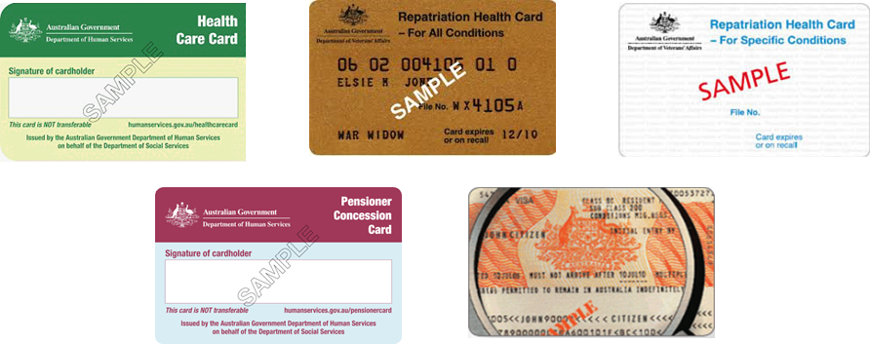
* An Immunisation History Statement is not required for this application form but will be requested when the child enrols with the kindergarten.

Parent or guardian details
If you are implementing a paper form, use the template below.
If you are also implementing this form in a digital version, you may want to include a question: “Would you like to enter the details of a second parent or guardian? You must do this if a court order requires that this person be kept informed about the registration and enrolment process”. The digital form logic should then open the fields for second parent / guardian details if “Yes” is selected.

Please complete your contact details below. If you would like to enter details for a second parent /or guardian or if a court order requires another person must be kept informed about the registration and enrolment process, please do so here.

 | First parent / guardian (required) | Second parent / guardian (optional)
Name | First name  Last name | First name  Last name
Relationship to child
Residential address | Street address  Suburb  State  Post Code | Street address  Suburb  State  Post Code
Contact number*
Email address*
Main language spoken (if not English)
Interpreter required? | ☐ Yes ☐ No | ☐ Yes ☐ No
* Note that you will be sent communications via text message to this phone number or email.
If there anyone else supporting the child you would like to keep informed (child’s grandparent, child’s aunt / uncle, case worker), please fill in their details below. [CRES Provider] will include this person on communications to you about registration and enrolment. They will not be able to make decisions on the registration or enrolment process.
 | Support person
Name | First name Last name
Relationship to child
Agency (if applicable)
Residential address (if known) | Street address  Suburb  State  Post Code
Contact number
Email address

Kindergarten session preferences
Different CRES Providers will have different allocation procedures. These allocation procedures will shape how this registration form is structured. The three options are listed below with the labels used in the Development Guide and a brief description. Confirm which of the following options your CRES uses:
- (Kindergarten nominations) Families and carers nominate kindergartens only – The approximate session times for each kindergarten should be published in the registration form or on a website (so the family or carer can be informed about likely times for sessions) with the caveat that the times could change. Once children are allocated, the registration list is provided to the service provider who then collects session time preferences from families and carers directly. The service providers can then create their own schedule based on this data.
- (Preference driven) Families and carers nominate preferred kindergartens and times – Families and carers nominate preferred kindergartens and session times. The CRES Provider drafts a schedule for all service providers in the LGA that maximises family and carers preferences and minimises the number of empty spaces in kindergartens.
- (Specific session times) Families and carers choose specific sessions – In April each year, service providers tell the CRES Provider what sessions they will be running for the coming kindergarten year. The CRES Provider collates this information and publishes this schedule in the registration form so families and carers can see each kindergarten and specifically which session times they are hosting.
Draft text for each kind of these three allocation processes is included below. Select the appropriate version for your CRES.

Option 1: Families and carers nominate kindergartens only
Delete the below text if this allocation model does not apply to your CRES.

Please nominate, in order, the top three kindergartens you would like your child to attend.
- First choice
- Second choice
- Third choice
A full list of these kindergartens and their indicative session times for the coming year are provided [link to full list of providers participating in CRES] or on page XX.

You may nominate less than three kindergartens but choosing three kindergartens will increase your child's chance to be offered a kindergarten place.
Every attempt will be made to place your child at one of these centres. Where only one preferred kindergarten is chosen your child will remain on the central waiting list until all children with second and third choices are placed.

Option 2: Families and carers nominate preferred kindergartens and times
Delete the below text if this allocation model does not apply to your CRES.

You may nominate session days and times and three preferred kindergartens.
If you have a preferred kindergarten, you may want to contact them to understand what likely session times they are planning on having next year to check that they are running sessions that work for you.
  - Session days and times
Please indicate your preferred session format (please select all that apply):
☐ 5-hour sessions for 3 days per week
☐ 6-hour sessions for 5 days per fortnight
☐ 7.5-hour sessions for 2 days per week
☐ No preference

Please indicate the preferred days your child would attend kindergarten (please select all that apply):
☐ Monday
☐ Tuesday
☐ Wednesday
☐ Thursday
☐ Friday

  - Kindergartens
Please nominate, in order, the top three kindergartens you would like your child to attend.
- First choice
- Second choice
- Third choice
You may nominate less than three kindergartens but choosing three kindergartens will increase your child's chance to be offered a kindergarten place.
Every attempt will be made to place your child at one of these centres. Where only one preferred kindergarten is chosen your child will remain on the central waiting list until all children with second and third choices are placed.
Option 3: Families and carers choose specific sessions
Delete the below text if this allocation model does not apply to your CRES.
Note that the table below is a sample table. Information to complete the table should be collected between December and February before registrations begin.

Please select a maximum of four preferences.
Start with number 1 for your most preferred group. Number your preferences from 1 to 4 for groups you are willing to accept. If you are not willing to attend the kindergarten group DO NOT select it.
Please number your preferences, do not tick them.
Note that Three-Year-Old Kindergarten services are highlighted in blue.
Examples of how to fill out your preferences are shown below
[screenshots of a sample form filled out correctly]
  - 20xx session times
Kindergarten | Preference | Group | Monday | Tuesday | Wednesday | Thursday | Friday
SUBURB X
Kindergarten1 name  Kindergarten1 address  4 y/o kinder sessions |  | A | 9am – 2pm |  | 9am – 2pm |  | 9am – 2pm
 |  | B |  | 8.30am – 4pm |  | 8.30am – 4pm
 |  | C |  | 9am – 4.30pm |  | 9am – 4.30pm
3 y/o kinder sessions |  | D |  |  | 2pm – 5pm
Kindergarten2 name  Kindergarten2 address  4 y/o kinder sessions |  | A | 8am – 1pm |  | 8am – 1pm |  | 8am – 1pm
 |  | B | 8.30am – 4pm |  |  | 8.30am – 4pm
SUBURB Y
Kindergarten3 name  Kindergarten3 address  4 y/o kinder sessions |  | A | 9am – 2pm |  | 9am – 2pm |  | 9am – 2pm
3 y/o kinder sessions |  | B |  | 2pm – 5pm
 |  | C | 1.30pm – 4pm |  | 1.30pm – 4pm

Declaration
You can insert your council’s own pro-forma data privacy statement in here

Do you give permission for this information to be shared with the kindergartens and [council name]’s [name of council’s early years education team / department] to improve the service for the future?
- I give permission for this information to be shared with kindergartens participating in the [council name]’s CRES and [council name]’s [name of council’s early years education team / department] for the purposes of:
  - accessing kindergarten and,
  - if applicable, applications for State funding necessary to provide additional support for my child’s participation.
- I give permission for this data to be anonymised, de-identified and aggregated (and shared with identified third parties) to help forecast future needs and help to improve the service.
- I declare that all of the information provided is true and correct.

Parent / guardian name (please print):
Parent / guardian signature:

Before returning this form, please check the following:
If implementing this form digitally, simply make all the fields mandatory to ensure people cannot submit the form without completing all relevant sections and included document uploads where required. Then delete the text below.

- You have completed all sections of this form.
- You have selected your preference for kindergartens and / or session times.
- You have given permission for information to be shared with service providers.
- You have signed this form.
- This is the only kindergarten registration form you have lodged with [CRES Provider] for this child. If you would like to change any details on a form your previously completed for this child, please contact [CRES Provider contact].

If you have determined that collecting other documentation is absolutely necessary, you should include the below bullet points that align with the “Before you start, make sure you have copies of:” section at the start of the form.
- You have enclosed copies of:
- Proof of identity: your child's birth certificate, birth notice or passport.
- Proof of residence: a utilities bill, rental agreement or rates notice with your family name and address (this must be the main residence of your child).
- Concession cards and immigration visas (where applicable).
- Documents from Family Support Services or a Maternal and Child Health nurse confirming high support needs and/or disability or letter from a doctor for complex medical needs (where applicable).
- [other proof required to verify the child meets local criteria]
If not, delete this.

Only include the below bullet point if your CRES charges a fee for registration. For an online form, include a payment page which includes the option to pay by credit card or in person at the nearest council office. The form should be built such that if any of the fields which make a child eligible for a fee waiver are selected, the payment page is deactivated or can be skipped.
- You have enclosed a sum of [administration fee amount] in the form of a bank cheque or credit card charge form or have provided proof that you are eligible for a fee waiver.
Send this form by post to:
CRES registrations
[insert council PO Box]
You may also drop this form off at the council office at [insert council address]

List of kindergartens and times
Complete the table below that provides a full list of kindergarten services that participate in the CRES. For particularly large councils, however, it may not be practical to provide a complete list of services in paper. Use your judgement to determine if including a full list of services is appropriate.
Delete this table if your CRES Provider operates a Specific session times allocation model.
If you are implementing this form in a digital version, you may want to include a Google Maps widget that shows all of the kindergarten services on a map.

  - 20xx session times
Kindergarten | Group | Places | Monday | Tuesday | Wednesday | Thursday | Friday
SUBURB X
Kindergarten1 name  Kindergarten1 address | A | 30 | 9am – 2pm |  | 9am – 2pm |  | 9am – 2pm
 | B | 22 |  | 8.30am – 4pm |  | 8.30am – 4pm
 | C | 30 |  | 9am – 4.30pm |  | 9am – 4.30pm
3 YO | D | 30 |  |  | 2pm – 5pm
Kindergarten2 name  Kindergarten2 address | A | 20 | 8am – 1pm |  | 8am – 1pm |  | 8am – 1pm
 | B | 21 | 8.30am – 4pm |  |  | 8.30am – 4pm
SUBURB Y
Kindergarten3 name  Kindergarten3 address | A | 25 | 9am – 2pm |  | 9am – 2pm |  | 9am – 2pm
3YO | B | 28 |  | 2pm – 5pm
 | C | 30 | 1.30pm – 4pm |  | 1.30pm – 4pm

