Appendix C | Referral form template

About this template
Note: please remove these instruction pages when completing the template
This template should be used by CRES Providers in Stage 1: Proactive engagement and awareness. Refer to section 4.1 of the CRES Practice Guide for more information on this step of the CRES process.
This document is a part of a suite of CRES documents. Figure 1 below maps the relationship between the Development Guide, Self-Assessment Tool, Practice Guide and this document.
Figure 1 | A map of CRES documents
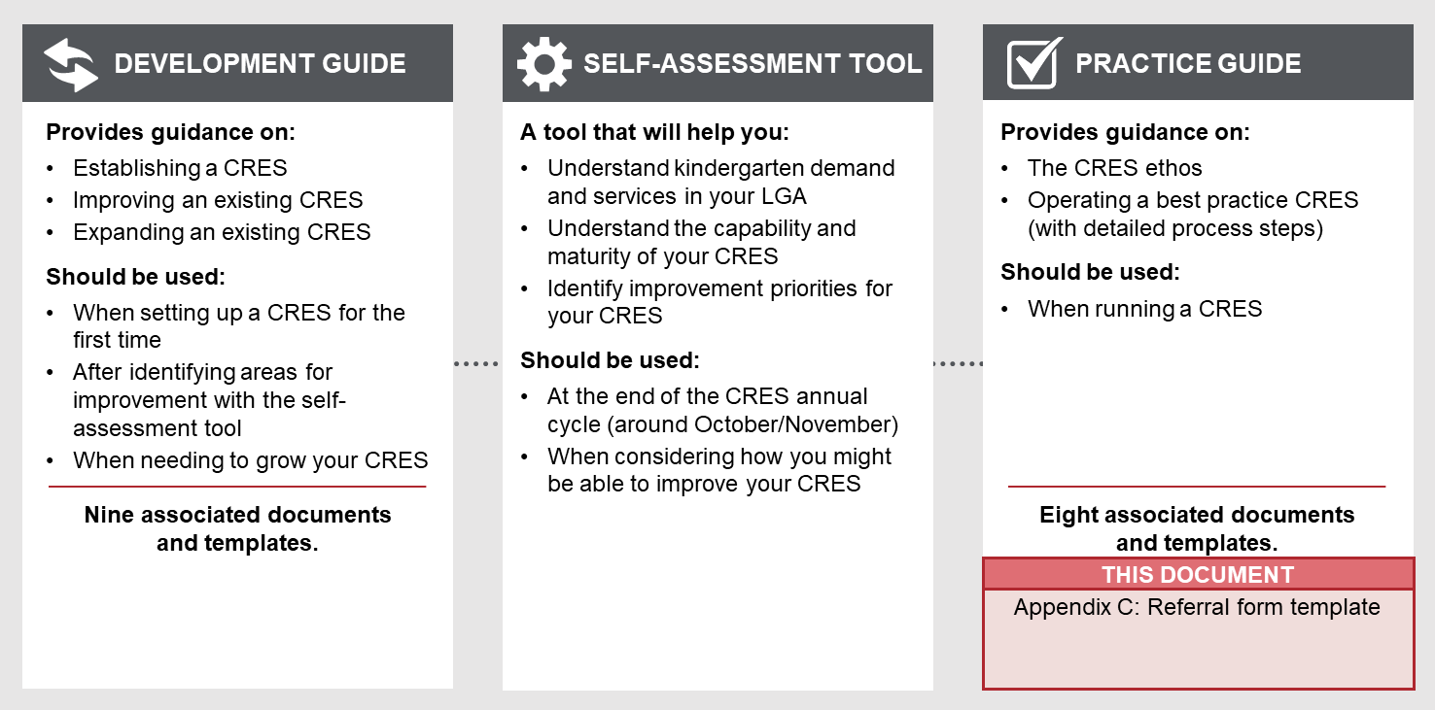

to complete this template:
- All template content can be tailored, but content highlighted in yellow must be updated to be relevant to your CRES. Consider your location and context, whether your CRES charges fees and whether you have additional local priority criteria. For example, “[council name]” must be replaced with the name of your council for content to make sense.
- Change this form to CRES Provider branding

HOW TO USE THIS FORM WHEN COMPLETED:
- Remove the first page of this document.
- Distribute to MCH staff and support service staff for use referring families and carers who need additional support.

REFERRAL FORM

Central Registration and Enrolment Scheme (CRES)

[CRES provider]

Date:
Version:

Central Registration and enrolment SCHEME REFERRAL FORM

What is this referral form?
This form should be used to collect the information from families and carers that you believe may find it difficult to complete kindergarten registration for their child.
This form is used by MCH, Child Protection, Child FIRST, Orange Door, LOOKOUT and other child and family support services staff to obtain consent from families and carers to have their contact information shared with [CRES Provider] for kindergarten registration and (where applicable) enrolment.
The contact information collected allows [CRES Provider] to initiate contact with the family or carer and provide support throughout the registration process.

How to use this form
If you assess that a family you are supporting will have difficulties completing the registration process alone, explain and complete this form with the family.
Information to assist in conversations about kindergarten, registration and enrolment, Priority of Access criteria and reduced cost kindergarten is available in the Information for CRES Partners pack you received from [CRES Provider] and on the DET website at www.education.vic.gov.au/parents/child-care-kindergarten/Pages/default.aspx.
If you assess that the family or carer may have difficulties completing registration alone:
- Explain that you and [CRES Provider] can help them to register
- Explain that any information collected is only for the purposes of supporting them to register their children for kindergarten, and the information will not be shared with any other organisation for any other purpose
- Request that they sign this form to indicate they consent to you / your organisation sharing their details with [CRES Provider]
- Note any need for an interpreter on the form
- Return the form to the [CRES Provider] at [CRES contact email address].
If they are unable to give written consent or if it is impractical for them to do so, you may use the right column for verbal consent procedures. If you require a translated copy of this form to assist in your conversation with the family or carer, please contact [CRES Provider].
The referral form can be used to refer multiple children if the same family or carer is their legal guardian. Simply include each name in the Child’s name field in the form below.

Referral from local support services to the [CRES Provider]’s Central Registration and Enrolment Scheme
The information you are providing here will be sent to the [CRES Provider] so they can contact you to discuss enrolling your child in kindergarten. This information will not be shared with anyone else.
For the referrer: Please read out the above statement if you are seeking verbal consent from a family or carer.
[insert your organisation’s pro-forma privacy policy statement here]
Details
Child’s name
Parent / Authorised rep name
Parent / Authorised rep contact number
Parent / Authorised rep email address
Do you require an interpreter? | ☐ No ☐ Yes  Language required _______________
Work / Practitioner organisation
Worker / Practitioner name
Worker / Practitioner position
Worker / Practitioner contact details | Phone –  Email –
Worker / Practitioner Signature
Date | ____/____/____

Written consent | Verbal consent (this option should only be used where it is not practical to obtain written consent)
I agree to __________________________ (insert agency name) contacting [CRES Provider] Central Registration and Enrolment Scheme team and giving them this information so they can help get my child into kindergarten.  Parent / Authorised rep signature:  ____________________________________ | I have discussed the content of this consent form with the parent / authorised representative and they have agreed to __________________________ (insert agency name) contacting [CRES Provider] Central Registration and Enrolment Scheme team and giving them this information so they can help get my child into kindergarten.  Worker / Practitioner Signature  ___________________________________________

