Appendix A.9 | Suggested clauses for inclusion in service level agreements – COUNCIL-OWNED FACILITIES

About this document
Note: please remove these instruction pages when the template is complete
This document provides suggested clause topics to include in legal agreements between your council and kindergarten service providers who occupy council-owned buildings. Refer to section 5.4 of the CRES Development Guide for more information on expanding your CRES.
This document is a part of a suite of CRES documents. Figure 1 below maps the relationship between the Development Guide, Self-Assessment Tool, Practice Guide and this document.
Figure 1 | A map of CRES documents
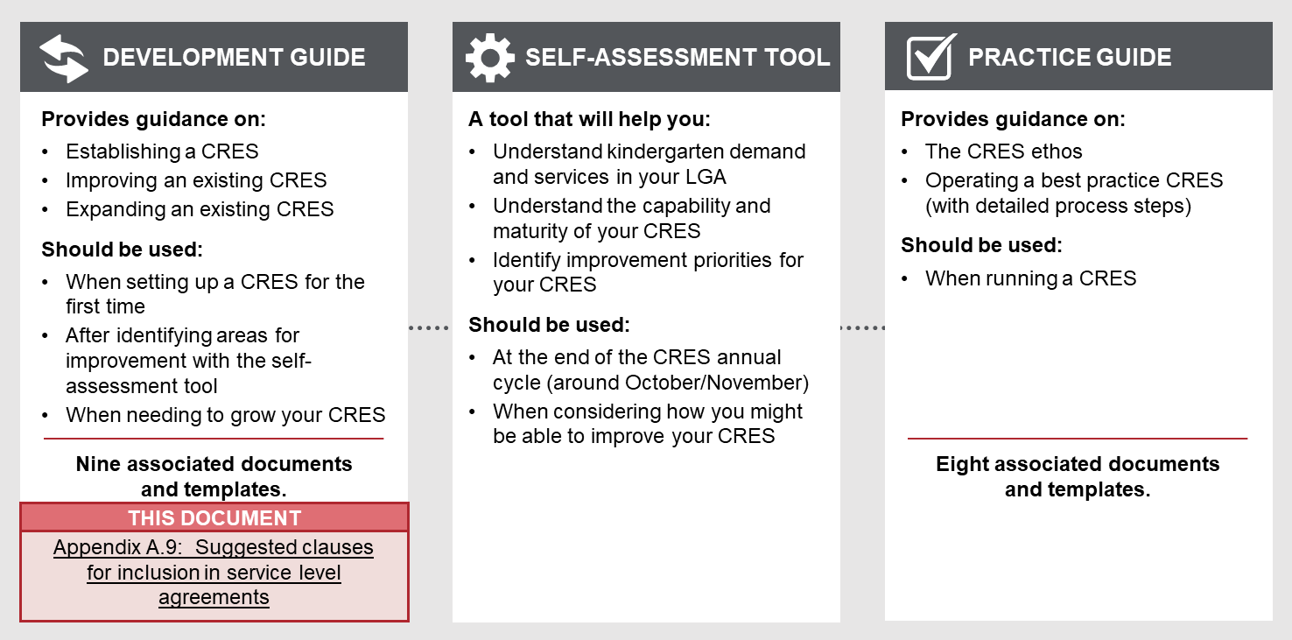

To complete these draft clauses
- You must tailor the content in this document to the needs and objectives of the parties to the agreement.
- This document does not include draft legal language. Lease agreements and SLAs will differ between councils, and legal advice should be sought to ensure any final clauses are in keeping with the particular agreements in your council.
- This document does not detail any clauses unrelated to CRES (e.g. reporting requirements, restrictions on the use of the premises) which should be included in a standard lease SLA. Instead, this document provides some topics you may wish to include in agreements as relevant to your CRES and the kindergarten providers you are working with.
- All template content can be tailored, but content highlighted in yellow must be updated to be relevant to your CRES. Consider your location and context, whether your CRES charges fees and whether you have additional local priority criteria. For example, “[council name]” must be replaced with the name of your council for content to make sense.
Refer to the instructions listed in each section in these purple boxes. Once the text is complete, delete all instruction boxes.

How to use these clauses when completed
Service level agreements provide an opportunity for scheme providers to require CRES participation for all kindergarten providers operating in council-owned buildings, as well as legally record the obligations which come with CRES participation. These clause topics can be incorporated into such service level agreements.

Suggested clause TOPICs
Read the suggested clauses and decide which are appropriate for your CRES. When making this assessment, consider:
      - The specifics of your CRES model and what it requires from providers
      - The key collaboration points for ongoing scheme development with providers which you may want to make mandatory (e.g. how often you will conduct meetings or information sessions)
      - How you might use the lease to encourage new kindergarten providers into the scheme.
Once your CRES is in operation, incorporate the relevant clauses into all service level agreements (SLAs). For those providers involved in establishing the CRES, the clauses will incorporate the agreed roles into their existing SLAs. For all subsequent providers, the standard clauses allow the scheme provider to require participation for all providers using council property.
Seek legal advice to incorporate your chosen clauses into your council’s service level agreements. Ensure clauses are included in any new service level agreements and seek advice on adding them to existing agreements.

Category | Clause topic | Intent
Partnership in the CRES | Service provider will only accept kindergarten registrations through CRES. | This clause requires the service provider to use the CRES, and to direct all families and carers through it for registrations.  This may be adapted where a service provider has previously agreed with the CRES Provider that only a portion of its places will be included in the CRES.
 | Service provider will operate at their fullest licenced capacity should the scheme require it. | A CRES provider must respond to demand in the municipality. This clause requires the service provider to use the space they are leasing to its fullest capacity, unless previously agreed with the CRES provider.
 | Service provider will communicate to the CRES Provider annually their proposed:  - Number and time of groups  - Number of total places  - Fees  - Information required to be passed on to families (e.g. website URL for completing enrolment)  - [Add other agreed upon information] | The CRES Provider requires some information about the services to communicate accurately to families, for example through the CRES Provider’s website. The CRES Provider can also help coordinate more effective early childhood education services with more data. This clause should outline all the information the CRES requires from the service provider, and when it should be communicated.
Ongoing work with the CRES | Service provider will participate in all CRES information sessions and meetings conducted. | Ongoing engagement with kindergarten providers is important to keep the CRES running smoothly. This clause ensures kindergarten providers stay up to date on changes and engaged with the continual development of CRES.
 | Service provider will work in partnership with/adhere to any policies enacted by the CRES Provider to respond to ongoing changes to the Early Years sector, including but not limited to:  - Funding changes  - State and Federal Government initiatives  - Infrastructure planning and development needs | The Early Years sector, and the local context of kindergarten provision, changes over time. In particular, changes to universal access initiatives could alter the provision of kindergarten places. This clause ensures CRES Providers can respond flexibly to this changing environment. Note that this clause should reflect the role you wish the service provider to play in that response.
Council actions | Council will undertake strategic planning for the provision of kindergarten in the municipality. This planning may include the construction of new kindergarten facilities and the extension, amalgamation and closure of existing facilities. | Some councils may wish to include this clause to indicate that their leasing one property to a kindergarten provider does not preclude other initiatives in the kindergarten provision space.
 | Council will promote early years services operating in council-owned facilities through the CRES.

