Appendix A.8 | Memorandum of Understanding Template

About this template
Note: please remove these instruction pages when the template is complete
This template is for CRES Providers seeking to formalise the stakeholder relationships to deliver a Central Registration and Enrolment Scheme (CRES). The Memorandum of Understanding (MOU) outlines the roles of all parties to support CRES delivery.
This Memorandum of Understanding (MOU) forms an agreement between the CRES Provider, funded kindergarten service providers, or relevant family and carer support services.
Refer to section 3.2.4 of the CRES Development Guide for more information on this step in setting up a CRES.
This document is a part of a suite of CRES documents. Figure 1 below maps the relationship between the Development Guide, Self-Assessment Tool, Practice Guide and this document.
Figure 1 | A map of CRES documents
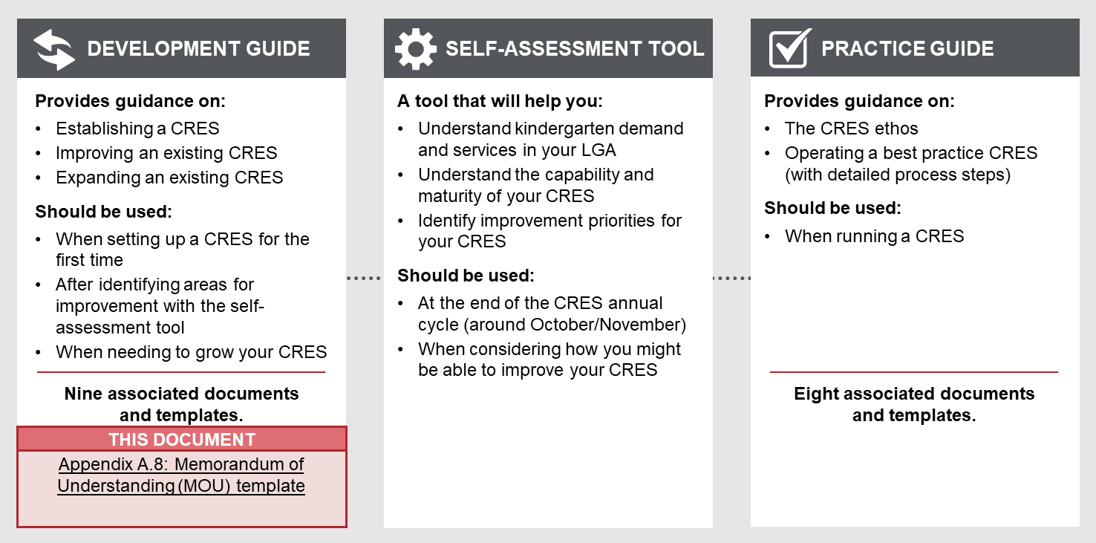

To complete this template
- The writer of the MOU must tailor the template to reflect the consultations and agreements reached regarding their CRES. Thoughtful additions, deletions and edits to the content will help the MOU to best reflect the CRES being established.
- All template content can be tailored, but contents highlighted in yellow must be thoughtfully updated. For example, “[CRES Provider]” must be replaced with the name of your organisation for content to make sense.
- This MOU should be converted into the CRES Provider’s branding to communicate that this agreement is not a DET-led process.
- Attach a document detailing the CRES process agreed to in Schedule 1.
- Seek legal advice to ensure the MOU is in alignment with your organisation’s practice.
Refer to the instructions listed in each section in these purple boxes. Once the text is complete, delete all instruction boxes.

How to use this MOU when complete
The MOU should act as the formal agreement between CRES Partners after an agreement has been reached with each of these parties. The completed MOU, after all parties have had an opportunity to give input to its contents, should be signed by CRES Partners involved to clarify their role and confirm their commitment to deliver the CRES.

Memorandum of Understanding
in relation to:

Central Registration and Enrolment Scheme (CRES)

A partnering agreement between

[CRES provider],

and: [list relevant services and kindergarten providers. This could include local family and child support officers, EYMs or local government where relevant]

1. PARTIES TO THE AGREEMENT
The parties to this Memorandum of Understanding (MOU) are [CRES Provider] and the services providing funded kindergarten or family and carer support in the CRES.
Information detailing the parties to this agreement and their representatives can be found in clause 6.

2. CONTEXT
The foundations of a child’s long-term development are laid in early childhood. In these years, children develop crucial cognitive and emotional skills such as reasoning, problem solving, and how to get along with others.
A high-quality kindergarten experience sets up a child for a life full of learning and prepares them for school. In the long term, evidence shows that children who have a positive early childhood experiences grow up to contribute to a harmonious, healthy and prosperous society.
The Victorian Government’s Education State Early Childhood Reform Plan (2018) outlines a vision of early childhood reform in Victoria, to create a higher quality, more equitable and inclusive early childhood system.
The Early Years Compact (2017) is a commitment from local governments (represented by the Municipal Association of Victoria, MAV), the Department of Health and Human Services (DHHS) and the Department of Education and Training (DET) to work together with the goal of improving outcomes for young children. The Compact defines roles and responsibilities, joint planning, consistent goals and coordination across the early years services system to support effective delivery of early years services. The Compact also recognises the importance of place-based approaches which can effectively respond to unique local contexts.
A Central Enrolment and Registration Scheme (CRES) is a [CRES Provider]-led program that aims to simplify access to kindergarten services for families and carers and provide better outcomes for Victoria’s children. The CRES takes a holistic view of a child’s journey from birth to their first day at kindergarten. It is a collaborative model that coordinates councils, service providers, MCH staff, support services and other stakeholders to support families and carers.

3. AIMS OF THE AGREEMENT
As partners to this agreement, through the agreed division of work, we will together to:
- Deliver the CRES
- Ensure vulnerable (priority) children in our municipality can access free or low-cost quality funded kindergarten programs through the CRES
- Equitably apply agreed local criteria

Delivering the CRES
The [LGA] Central Registration and Enrolment Scheme is a centralised system, administered by [CRES Provider] to allocate kindergarten places on behalf of participating funded kindergarten providers. Parties to this MOU each have outlined responsibilities to engage families and carers with the CRES, deliver the CRES process, support families and carers and deliver kindergarten services.
Details of the CRES processes can be in Schedule 1 of this agreement.

Ensuring access for vulnerable children
Children experiencing vulnerability or disadvantage are the most likely to get the most benefit out of kindergarten, but for various reasons may not access kindergarten. The CRES will cater to all children but have a particular focus on ensuring that these vulnerable children can access kindergarten through the CRES. This includes:
- Prioritising the allocation of places for children experiencing disadvantage or vulnerability
- [include any priorities from council’s Early Years Plan]
- Ensuring families and carers are aware of the value of early childhood education and the role of the CRES
- Supporting families and carers to navigate the CRES process
- Ensuring all appropriate support is provided for children to enrol in and attend kindergarten.
The CRES will allocate children to kindergarten places in line with the DET Priority of access criteria , as outlined in the DET Kindergarten Funding Guide.
In particular, partners will work to ensure awareness of and access to:
- Early Start Kindergarten (ESK) – A State Government initiative that provides free or low-cost quality funded kindergarten program for two years prior to school for:
- Aboriginal and/or Torres Strait Islander children
- Children known to Child Protection.
- Kindergarten Fee Subsidy (KFS) – A State Government initiative that provides free or low-cost quality funded kindergarten program for one year prior to school for:
- Children who identify on their birth certificate as being a multiple birth child (triplets or more)
- Holds, or has a parent or guardian who holds, any of the following; Commonwealth Health Care Card, Commonwealth Pensioner Concession Card, Department of Veterans Affairs Card, Humanitarian or Refugee Visa.

Equitably applying agreed local criteria
Only include this section if your CRES has local criteria that will prioritise allocations beyond the State’s Priority of access criteria. You should explain the reasoning behind including these local criteria in this section.

While children who meet DET’s Priority of access criteria will always receive the highest priority, the CRES will also apply agreed local criteria to prioritise allocations of other children. The table below outlines the relative weighting for each factor [CRES Provider] will consider when allocating a place.

Factor | Relative weighting
Local criteria 1 | X
Local criteria 2 | X
Local criteria 3 | X

The CRES Providers and partners agree that these criteria will best serve the community by [insert reasoning behind various local criteria].

4. RESPONSIBLITIES
Customise the below table to reflect the agreements you have reached with key stakeholders.
- Include all stakeholders involved in CRES delivery – add any which are missing and remove any which are not relevant to your CRES.
- The example table below assumes the CRES Provider is not the council. If the CRES Provider is the council, you should merge the first and second rows.
- List the agreed responsibilities for each stakeholder. Responsibilities should not include detailed tasks or processes, but broad responsibilities. The template includes suggested responsibilities, but ensure that you add, edit and remove as appropriate for your CRES.
- Where a specific subset of the stakeholder group will take responsibility for an action, list their title in italics (e.g. Maternal and Child Health Nurses will support …).

Party | Responsibility
[CRES Provider] | - Provide a system for registering and allocating children to kindergarten places  - Share relevant information about the CRES to partners  - Host meetings with partners to communicate information, take feedback and discuss matters related to the CRES  - Coordinate engagement and support of families and carers to ensure this process can be completed for all children in the municipality  - Prioritise and support the allocation of vulnerable children (as per DET Priority of access criteria)  - Ensure timelines, processes and key information is clear to all parties of the MOU, including communicating any changes to the scheme  - Monitor and evaluate the CRES  - Work to continuously improve the CRES with support and feedback from partners
[Local government, if CRES Provider is not the council] | - Maternal and Child Health Nurses will support eligible families and carers to enrol within the central enrolment windows  - Supported Playgroup Facilitators will support eligible families and carers to enrol within the central enrolment windows  - The Immunisation Team will support the provision of immunisation status information and catch up immunisations for eligible children  - [Include details of any council teams who have agreed to be involved in the CRES]
Funded kindergarten service providers | - Facilitate access to CRES for all families and carers they are in contact with  - Ensure priority children are identified appropriately within the Kindergarten Information Management System for ESK or KFS  - Provide kindergarten places in the CRES to allocated children  - Actively work with families and carers, and relevant support services, to support child engagement and participation in kindergarten.

5. TERMS OF THE MOU
This MOU commences [insert date that CRES operation will begin].
[Scheme provider] will conduct an annual review process for the CRES. That process will include a review of this MOU to reflect any changes to the responsibilities involved with delivering the CRES.
Parties may be added to this agreement where agreed upon between that party and [CRES Provider]. Where a new party involvement would impact the roles and responsibilities of existing parties, all parties will be consulted.
Any party can exit this agreement at the conclusion of a CRES cycle on [date]. Written notice of intention to exit must be provided to the scheme provider no less than 14 days before this date.
[CRES Provider] can choose to cease operating the CRES at the conclusion of any CRES cycle on [date]. Written notice of intention to cease provision must be provided to all parties no less than 60 days before this date.

6. SIGNATORIES
All fields in this table should be completed, listing one signatory per row.

Name | Signature | Date | Organisation representing | Position at organisation | Email | Phone
 |  | DD/MM/YY | [CRES Provider]

Schedule 1 – Details of the CRES process
Add here the information about the objectives and operations of CRES in your local area. This should include information about the purpose, vision and principles of the CRES, the intent of different CRES stages and the annual CRES cycle.
To write Schedule 1, you should draw on the CRES Policy that was written previously in Develop CRES components in consultation with partners (refer to Section 3.2.3 of the CRES Development Guide for details on this step and the contents of the policy)

Education State Early Childhood Reform Plan, DET (2018)
Priority of Access criteria is defined in the Kindergarten Funding Guide: https://www.education.vic.gov.au/childhood/providers/funding/Pages/kinderfundingcriteria.aspx

