Appendix A.6 | Business case template

About this template
Note: please remove these instruction pages when the template is complete
This template is for local Councils wanting to establish a Central Registration and Enrolment Scheme (CRES) to attain a policy and, if required, funding commitment from Councillors and executive. Refer to section 3.1.3 of the CRES Development Guide for more information on this step in setting up a CRES.
There are three main sections in this template:
- Executive summary of the business case. This section presents the options for council, summarises the challenge the CRES is trying to solve, how the CRES will solve it and presents a risk/benefit analysis for each option. Senior executives and council may only read this summary.
- Full business case. This section more fully discusses the points that are summarised in the executive summary. Management and senior audiences may come to this section for a more in-depth look at the core arguments.
- Appendices. The appendices provide details on calculations and research. Management and senior audiences may come to this section for more details on data that informed the core arguments.
This document is a part of a suite of CRES documents. Figure 1 below maps the relationship between the Development Guide, Self-Assessment Tool, Practice Guide and this document.
Figure 1 | A map of CRES documents
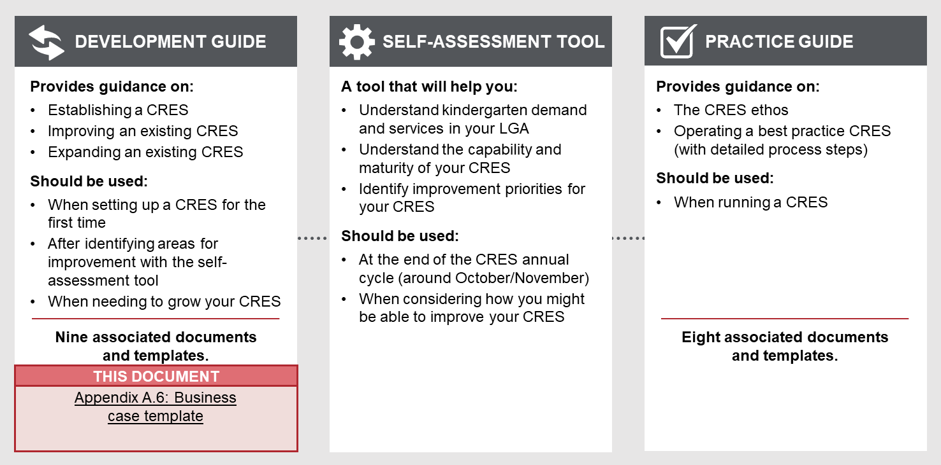

To complete the business case
- The writer of the business case should tailor the template to the needs and objectives of the council leaders who will review and decide on the business case. Thoughtful additions, deletions and edits to the template content will strengthen your plan and make delivery simpler.
- All template content can be tailored, but contents highlighted in yellow must be updated. For example, “[council name]” must be replaced with the name of your council for content to make sense.
- This business case must be converted to your council’s branding.
Refer to the instructions listed in each section in these purple boxes. Once the text is complete, delete all instruction boxes.

How to use the business case when complete
The completed business case will be presented to the executive through your line manager. The business case should be presented to the executive as an operational decision; however, the executive may decide to present the case to Councillors if a policy change is required.

[Council name]

Executive summary of business case:

Kindergarten Central Registration and Enrolment Scheme (CRES)

Date:

Version:
Prepared by:

In this section you present a summary of the business case. State what the problem or opportunity is, and how this investment will solve it. It is often easier to write this page last after the other sections are completed. When writing this section, consider that this executive summary may be the only part of the full business case the Councillors or executive will read so it must contain all essential information required to make a decision.

This business case puts forward three options for consideration in relation to developing a Central Registration and Enrolment Scheme (CRES) in the municipality. These three options are:
- Maintain the current state
- Establish a CRES that is developed and operated by [council name]. The CRES will simplify and standardise the kindergarten registration process and equitably allocate available places
- Contract the establishment and operation of a CRES to a third party. The council would manage the contract for a third party.

[council name] is committed to improving outcomes for children
Tailor the following paragraph to reference key documents such as the Council Plan, Municipal Early Years Plan or Municipal Education Plan. Identifying that the CRES can help the council achieve its objective and overall strategy will create a more compelling argument.

Councils play an important role in the planning, development and provision of early childhood services. This is demonstrated by [council name]’s commitment in [Council Plan / Municipal Early Years Plan / Education Plan] to [reference any priorities articulated in these plans that relate to improving early childhood outcomes and education].
The Victorian Government’s Early Childhood Reform Plan (2018) outlines a vision to simplify access to early childhood education services for families and carers and provide better outcomes for children. The Early Years Compact formalises the partnership between local government (represented by MAV), the Department of Education and Training (DET) and the Department of Health and Human Services (DHHS) to achieve these objectives. More detail on council’s role in the delivery of early childhood initiatives can be found in Chapter 1 of the Full Business Case.

Early childhood education and care is an important part of childhood development
The foundations of a child’s long-term development are laid in early childhood. In these years, children develop crucial cognitive and emotional skills such as reasoning, problem solving, and how to get along with others. A high-quality kindergarten experience sets up a child for a life full of learning and prepares them for school. In the long term, evidence shows that children who have a positive early childhood experiences grow up to contribute to a harmonious, healthy and prosperous society .

There is a strong case for change
There are XX children in [LGA] of which XX attend kindergarten; a further XX do not. XX of vulnerable children miss out even though funding is available to cover or subsidise their place.
Tailor the following list based on the problem definition you settle on in Chapter 2.

There are five problems impeding the access of children to kindergarten services:
- Access problem – there are some/many children in our LGA who are missing out on their places in kindergarten
- Equity problem – there are vulnerable children in our LGA who are missing out on places in kindergarten
- Efficiency problem – the registration and enrolment process in our LGA is high cost/burden for providers and families and carers
- Information problems – council lacks the data necessary to plan for and improve service delivery
- Confusion problems – the lack of consistency between councils causes confusion for families or carers who need to access services outside the council where they live.
While these problems may not impact every child, in aggregate they reduce the opportunity for children in our community. Addressing the problems will benefit children, their families and carers, kindergartens and teachers, and council. Chapter 2 of the Full Business Case further elaborates on the impact of these problems in [LGA].

The CRES can address these problems
A Central Registration and Enrolment Scheme (CRES) was designed by DET and MAV and is being adopted as a local government-led program across the state.
Tailor the following list based on any additional benefits you might discuss in Chapter 3.

It delivers five important benefits:
- A smoother enrolment experience for families and carers
- Standardised transparent, fair and equitable allocation of kindergarten places
- Early identification of vulnerable children through proactive engagement
- Reduced administrative burden for service providers
- [council name] will have better ability to plan for early years services.
These benefits are in line with what is experienced by other councils who have implemented a similar scheme.
Initial estimates have identified that XX more children will enrolled in kindergarten in the first year due to simplified and consistent processes. This includes an estimated XX vulnerable children first year, increasing to XX in subsequent years. More detail on these benefits can be found in Chapter 3 of the Full Business Case

Key stakeholders are supportive of the CRES
Key stakeholders were engaged, in line with (LGA) community engagement policy, as a part of a feasibility assessment to determine if they would support the implementation of a CRES in [LGA]. All / Most kindergartens and Early Years Managers signed a letter of intent to explore CRES and XX% have since committed to be part of a CRES if it goes ahead. Council Early Years officers, MCH nurses and support services are also broadly committed to the concept of a kindergarten CRES.

Summary of options
There are three potential options. Risks and benefits of each option are elaborated in Chapter 4, and the investment and cost recovery options are explored in Chapter 6 of the Full Business Case.
Table 1 should not exhaustively list each risk or benefit but summarise the main points you discuss in Chapter 4. Add or remove items to Table 1 as appropriate.
Table 1 | Summary of investment, risks and benefits for CRES delivery options
Option | Investment | Risk | Benefit
- Maintain the current state | - | - Many families and carers do not enrol their children in kindergarten due to lack of awareness, confusion about processes, or lack of access  - XX vulnerable children who are eligible for State Government funded places will not attend kindergarten | - There is no cost to the council  - There is no disruption to existing practice
- Establish a CRES that is operated by [council name] | Establishment: $XX or YY FTE one-off  Ongoing delivery: $XX per annum  Include below clause if applicable  Ongoing cost-recovery: $XX per annum | - Reputational risk if the CRES is overly onerous on CRES Partners  - [Investment yields minimal benefit due to large EYMs already operating a similar system that covers the municipality]  - [Investment yields minimal benefit due to very few kindergarten services operating in the municipality]. | - More children enrol in kindergarten, including vulnerable children.  - Contributes to the achievement of [council name] [Council Plan / Early Years Plan / similar]  - Delivers on the Early Years Compact  - [EXAMPLE: (Compared to Option 3) Leverage existing council relationships to get CRES buy-in from key partners.]  Demonstrates to its ratepayers a commitment to kindergarten provision in the municipality  increases leverage over the kindergarten facilities it owns
- Contract the establishment and operation of a CRES to a third party | Establishment: $XX one-off  Ongoing delivery: $XX per annum | - As above.  - (Compared to Option 2) Council has less control of the CRES and it will be more challenging to improve or make changes to the CRES  - (Compared to Option 2) Potential risk that, if third party is also a service provider, allocations would unfairly favour the organisation that operates the CRES. | - As above.  - (Compared to Option 2) Reputational risk is mitigated by having delivery outsourced  - (Compared to Option 2) Potentially more efficient delivery of the CRES by an organisation who can demonstrate their capability in operating similar programs.

[Council name]

Full business case:

Kindergarten Central Registration and Enrolment Scheme (CRES)

Date:

Version:
Prepared by:

Table of Contents
Glossary of stakeholders and terminology 10
1 [Council name] is committed to improing outcomes for children 12
2 The case for change 13
3 Response and benefits 16
4 Feasibility and options assessment 20
5 Resourcing and cost recovery options 23
Appendix A | Background information on CRES in Victoria 26
Appendix B | Local context data and impact modelling 29
Appendix C | Cost recovery analysis 32
Appendix D | Implementation plan 33
Appendix E | Stakeholder engagement plan 36
Appendix F | Implementation risk assessment 37

Glossary of stakeholders and terminology
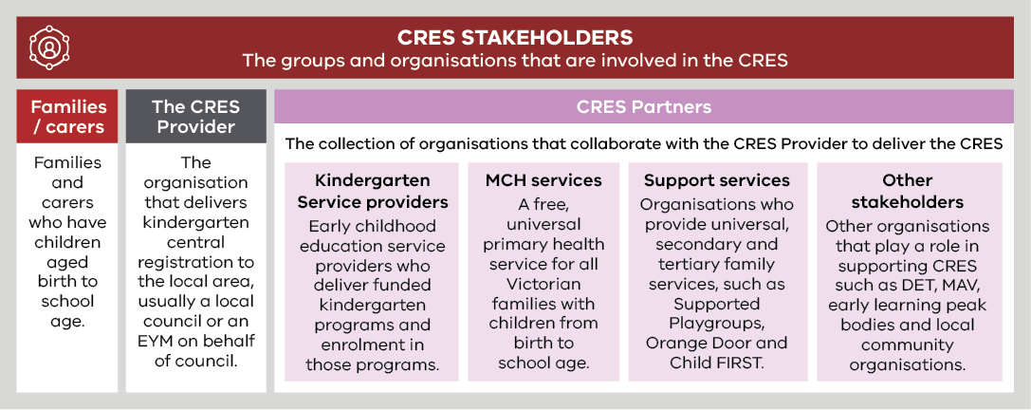
Term | Definition
Central Registration and Enrolment Scheme (CRES) | A best-practice model that streamlines the process of registering and enrolling children in kindergarten for families and service providers, ensuring the process is simple, consistent, inclusive and equitable.
Central Enrolment (CE)/ Central Enrolment Scheme | A predecessor to CRES that has successfully improved the equitable and accessible allocation of kindergarten places to date but is implemented differently across the state.
Early Childhood Education and Care (ECEC) | Services provided to children in the years before primary school that develops a child’s social, emotional, cognitive and physical abilities, building a solid foundation for future learning.
Enrolment | In-depth information collection in line with state legislation for a child soon to begin kindergarten. This includes ensuring the service provider has the health and emergency information to provide a safe experience for children and informs state government planning and subsidies.
Early Start Kindergarten (ESK) | The Early Start Kindergarten grants enable an eligible child to access a kindergarten program in the year two years before school. There are two types of Early Start Kindergarten grants:  - Aboriginal Early Start Kindergarten grant  - Early Start Kindergarten grant for children known to Child Protection.  Eligibility can be established in discussion with the family or services working with the family such as Maternal and Child Health nurses.  Children can be enrolled in a three-year-old group, a four-year-old group, a mixed age group or can be enrolled in a combination of groups delivered by a qualified early childhood teacher, to maximise their access to 15 hours of kindergarten.  Early Start Kindergarten grants are able to be used in combination with the Commonwealth Child Care Subsidy or Additional Child Care Subsidy to reduce costs to parents and carers and to promote inclusive practice in the service.
Early Years Management (EYM) | Formerly “Kindergarten Cluster Management”, Early Years Managers are local government and community-based organisations that provide professional leadership and centralised management to a group of kindergartens as the authorised service provider. EYM is a key strategy to build a stronger, responsive universal kindergarten system.
Kindergarten Fee Subsidy (KFS) | Promotes kindergarten participation by enabling eligible children in funded three and four-year-old groups to access up to 15 hours of kindergarten delivered by a qualified early childhood teacher free of charge or at low cost.  A child enrolled in a long day care service is not eligible for KFS where approved Commonwealth Child Care subsidy is applied.
Kindergarten | An early childhood educational program delivered by a qualified early childhood teacher to children in the two years before school. The term “preschool” is used nationally and in some municipalities.  In Victoria, a “funded kindergarten program” complies with applicable requirements as set out in the Kindergarten Funding Guide and provides a program in accordance with the Victorian Early Years Learning and Development Framework.  Funded kindergarten programs may operate in a variety of settings, including long day care centres, standalone services, schools or community centres, and is operated by a variety of service providers, including community organisations, local councils, schools, not-for-profit organisations or private providers.
LGA | Local Government Area. Often referred to as “council”.
Maternal and Child Health Service | A free, universal primary health service for all Victorian families with children from birth to school age. It includes the Universal MCH program, Enhanced MCH program and the MCH Line, a 24-hour telephone support service.
Registration | The process of families and carers giving initial information about their child to confirm their intention to enrol in kindergarten, administered by the CRES Provider. This includes collection of basic contact information, kindergarten preferences and any other details that may inform prioritised allocation in kindergarten.
Pre-Purchased Places | A Pre-Purchased Place (PPP) is a kindergarten place funded by DET and reserved for vulnerable or disadvantaged children who present outside normal enrolment periods. For each PPP, DET pays the service provider the full cost of a kindergarten place (per capita plus KFS) upfront.  PPPs can only be accessed by children who are eligible for Kindergarten Fee Subsidy, Early Start Kindergarten grants or Early Start Kindergarten extension grants. A state-wide Expression of Interest process is conducted by DET each year, to allocate PPPs for the following year in the areas and services where they are needed most.
Universal, secondary and tertiary support services | “Universal support services” are targeted at an entire population, to provide support and education before problems arise. Examples of universal support services include funded kindergarten programs, the Universal MCH program, community playgroups and libraries.  “Secondary support services” are targeted at families who may need more support to avoid problems escalating. An example of secondary support is Supported Playgroups.  “Tertiary services provide” interventions and treatment where a problem has already occurred. An example of a tertiary service is Child Protection.

[Council name] is committed to improving outcomes for children
In this section you outline the role of local government in developing the community and initiatives to support early childhood education.

Councils play a vital role in promoting positive outcomes for children. State-wide plans for reform recognise the importance of local government in delivering effective early childhood education initiatives. [council name] plans also prioritise [related point about ECEC outcomes].

There is a statewide drive to improve outcomes for children
The Victorian Government’s Education State Early Childhood Reform Plan (2018) outlines a vision of early childhood reform in Victoria, to create a higher quality, more equitable and inclusive early childhood system. The Plan recognises the importance of strong relationships between DET, local government and other Victorian departments, to simplify access to services for families and carers, and provide better outcomes for children.
The Early Years Compact between local government (represented by MAV), DET and DHHS is the core mechanism to formalise these objectives.
The Local Government Act (2020) also explicitly highlights the role of council is to provide good in its municipal district for the benefit and wellbeing of the municipal community. Working with the State Government, councils play an important role in the planning, development and provision of early childhood services. Local government, with the support of DET and DHHS, is well-placed to implement initiatives that optimise the uptake of kindergarten in Victoria. Detailed knowledge of local context and community is essential to provide an effective service.
More than half of all local councils across Victoria operate a form of central enrolment/central registration scheme. These schemes provide a single point of entry for families, simplifying the kindergarten enrolment process and improving equity of access.

Improving early childhood outcomes is a priority in our [strategy / plan]
In this section you should make a statement about how improving early childhood outcomes aligns with a cornerstone document for your council. This document could be an organisational strategy, Council Plan, Early Years Plan, Education Plan or similar. You should quote the statement from the document(s) you are drawing on, clearly articulate the reason for originally including that statement in the document and relate this back to improving outcomes for the community in your LGA.

The case for change
In this section you will present the opportunity or problem that the business case addresses. This needs to be supported by evidence, most of which can be drawn from the preliminary discussion paper. There are five narratives that you can present.
Choose the right mix of these for your context. You may want to present all five.

Background
The population in [LGA name] has been [growing/static/reducing] and we expect the number of kindergarten age children will also [grow/remain the same/reduce] in the coming years. In our council delivery of kindergarten services to these children faces five problems:
- Access – there are some/many children in our LGA who are missing out on their places in kindergarten.
- Equity – there are vulnerable children in our LGA who are missing out on places in kindergarten, even though financial support is available.
- Efficiency – the registration and enrolment process in our LGA is high cost/burden for providers and families and carers.
- Information – council lacks the data necessary to plan for and improve service delivery.
- Confusion – the lack of consistency between councils causes confusion for families and carers who need to access services outside the council where they live or the lack of consistency across the kindergartens in in our council cause confusion for families and carers.
While these problems don’t impact each child equally, the cumulative effect is a loss of opportunity for our children. These problems are explained in the following section and estimates of the impact of each are beneath that.

Access problems
In the last year [count] of children missed out on any place at kindergarten, while a further [count] did not receive their preferred place in a kindergarten. [Add a sentence if there were any complaints to Councillors or council officers on this matter].
This is not just an issue of the total number of places. While we have had an increase of XX places with the opening / extension of [list examples], it is also one of coordination. There were also XX unfilled places because families and carers were unaware or unable to access the place. [Add a note if there was some geographic issue such as the spare capacity was a long way from demand].

Equity problems
The State Government provides funding for children identified as vulnerable including Aboriginal and/or Torres Strait Islander children and those known to Child Protection. The funding provides 15 hours per week of free or low-cost kindergarten for these children. In [LGA], [percentage] of our children fulfil the vulnerable criteria and so are eligible for the funding. [Many/some/none] of these children attend kindergarten which indicates that a sizeable proportion are missing out.

Efficiency problems
The present distributed enrolment model, where each kindergarten or kindergarten provider manages their own enrolment, presents problems for both families and carers and the kindergarten management.
For families and carers, the inconsistent model means they must navigate the enrolment processes at multiple kindergartens in order to secure a place for their child. This requires monitoring the registration period for each kindergarten (they can be different) and then completing many, and often identical, registration forms.
To ensure their child gets a place, families and carers often register for several sessions and at more than one kindergarten. This adversely impacts kindergarten management as there are high rates of withdrawal as families and carers secure their higher preference places. This means management must run several rounds of offers and maintain communication with a long waiting list.

Information problems
Under the current distributed enrolment process council receives actual enrolment data for some / all of the kindergartens. This data is typically provided to council XX months after the kindergarten year starts. This means that council does not have a definitive picture of the total demand for kindergarten places and has an incomplete picture of the utilisation. The makes it difficult for council to plan for future services.

Confusion problems
There are also some children who attend kindergarten outside our LGA, typically at a place close to where a parent or guardian works, while we also have children who come from other LGAs as their parents work within [LGA]. There is also some movement across the boundary with our neighbouring LGAs, especially in [suburb names] as families and carers chose places close to their homes or schools. [council name] does not currently have detailed figures on these and will collect as part of the business case research.

Impact of these problems in [LGA]

Demographics and demand for kindergarten in [LGA]
Tailor the content in the section below according to the narratives you have presented above.

There are XX children aged 0-4 in LGA, of which X% do not attend kindergarten. X% of vulnerable children do not attend kindergarten in LGA, even though State Government funding allows low cost or free kindergarten. To meet this demand, LGA has XX kindergartens that offer approximately XX places per year. X% of these places were filled last year.
There are a number of cohorts, including vulnerable children and families and carers, who would benefit from implementation of a CRES at [council name]. At the last census, [council name] was home to:
- Overall population and growth/decline
- XX% of population aged 0-4 and growth/decline
- MCH birth notification indications for kindergarten demand in coming 12 and/or 24 and/or 36 months
- XX children in Out of Home Care
- XX children known to Child Protection
- XX Aboriginal and/or Torres Strait Islander children
- XX refugee and asylum seeker families
- Any other significant population / demographics data to be included.

Burden of existing enrolment process in [LGA]
There are two parts to presenting this argument. First, explain the process – the number of steps or hand-offs, and the choices that families and carers must make. Second, present evidence that this is a burden. If you have the data, show this by calculating the time taken by families completing multiple enrolments and kindergartens handling multiple rounds. If you do not have data, share some anecdotal evidence. This could be a summary of the complaints received, or the observations of staff who currently take enrolments. Supplement the text below with arguments and evidence appropriate to your LGA.

The existing enrolment process is onerous. Parents and carers must repeatedly fill out their details if they are applying at multiple services. Without a central repository of information about available places, if the child does not get allocated a place at a kindergarten they applied for, families and carers must contact each service provider in the area to find out if places are still available. The processes at each service provider may also be different leading to confusion.
Children registering at multiple kindergartens also means service providers must manage duplicated registrations. This can cause multiple offers going to one child leading to suboptimal filling rates for the kindergarten or multiple offer rounds that must be handled by the kindergarten.
These challenges are evidenced by [insert data and/or anecdotal evidence.]

Response and benefits
In this section you need to explain how a CRES operates and how it will solve the problem described in the section above. Most of the benefits will just be the reverse of the problem, however you should note indirect benefits such as reputation and alignment to the Council Plan.

The CRES model
A CRES is a system of kindergarten registration, allocation and enrolment processes that is consistent, inclusive and equitable. When successful, a CRES supports the local community to understand and access quality kindergarten programs so that children are set up to be future learners and positive contributors to society. A background on the CRES model is given in Appendix A | Background information on CRES in Victoria.
The design and implementation of a CRES at [council name] will be guided by a CRES vision, purpose and principles. This ethos, and the CRES model it underpins, was co-designed for state-wide implementation by the Department of Education (DET) and the Municipal Association of Victoria (MAV) through the Central Enrolment Working Group (CEWG) and is shown overleaf.
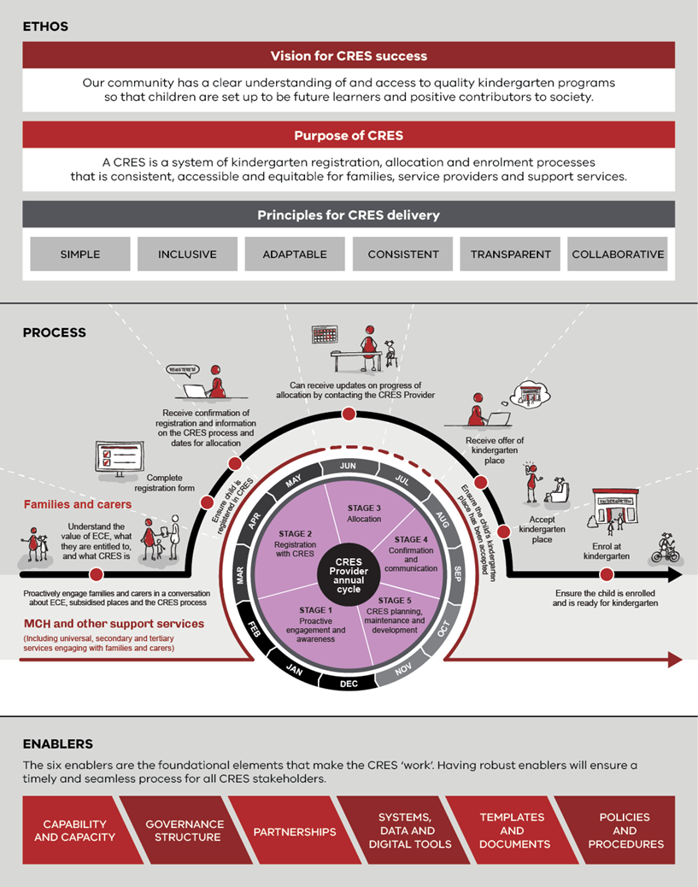

Operating a CRES will deliver five benefits for children, families and carers in [LGA name], kindergarten operators, and for the council itself. These benefits are:
- Families and carers experience a smoother to enrol their children in kindergarten
- The process to allocated kindergarten places is recognised as transparent, equitable and fair
- Vulnerable children are identified early and enrolled in quality kindergarten places
- The administrative burden is reduced, especially for kindergartens and service providers more generally
- [LGA Name] is well placed to respond to the early childhood needs of the community.
These are discussed below.

Families and carers experience a smoother to enrol their children in kindergarten
For families and carers, a CRES will provide a significantly smother experience. It will start with a single starting point and pathway, so minimal research is required and the possibility of missing a milestone or making the wrong decision is reduced. The process will collect the necessary information once, when required, so families and carers won’t have a sense of paperwork deja vu. Lastly there will be minimal hand-offs across organisation, so families and carers won’t get caught in referral loops.

The process to allocated kindergarten places is recognised as transparent, equitable and fair
The process will be comprehendible and published so families and carers will be able track and understand their progression. It will ensure the DET priorities are applied so vulnerable children receive the additional support they need, and the process eliminates unintentional structural bias.

Vulnerable children are identified early and enrolled in quality kindergarten places
The CRES will make it is easy for families and carers, support services and others in the community to ensure a child they care for is included in the allocation of places. The process has safety nets to minimise chance of those children falling off the list and missing out on places in kindergarten.

The administrative burden is reduced, especially for kindergartens and service providers
The CRES minimises the number hand-offs between MCH, councils and kindergartens (it is essentially a linear process) and sets clear data collection responsibilities for each organisation. Kindergartens or service providers will receive systematised participant information in a predictable manner, enabling them to automate business processes and systems.

[council name] is well placed to respond to the early childhood needs of the community
[council name] will have a comprehensive view of the supply and demand for kindergarten places in the following year. This will enable council to coordinate changes in session times to increase capacity. Over the longer-term council will have a view of the changes in demand, enabling it to initiate or lobby for increases in capacity through development of new facilities. Council can demonstrate to its ratepayers its commitment to kindergarten provision in the municipality and will have more leverage over the kindergarten facilities it owns.
The data will be collected in a consistent manner that will enable coordination with neighbouring LGAs and DET.
[There may be some additional benefits that you want to share here]
The standardised process will improve community engagement with council and provide a tangible connection to the services provided.

Modelling the impact of the CRES
Initial high-level modelling shows that XX children will enrol into kindergarten through the CRES in its first year with that number increasing to XX in 2022 and then to XX in 2023. This includes XX vulnerable children (determined by the child’s eligibility for ESK or KFS) in the first year of CRES operation. Further detail on these calculations is available in Appendix B | Local context data and impact modelling.

Benefits of central enrolment in other municipalities
The experience in [LGA] will be similar to other councils in Victoria. More than half of councils across the state currently operate a CE scheme including [adjacent/nearby Council/Shire]. In 2017, 63% of all kindergarten enrolments across the State were undertaken within a Central Enrolment scheme. These councils provided a number of reasons for establishing Central Enrolment as shown in Figure 2.
Councils operating a CRES do so through one of two commercial options; establish the function within council or contract the function to a third-party organisation, often a large EYM. These each have strengths and weaknesses that will be further discussed.
Figure 2 | Reasons councils implemented a CE scheme in their municipality (multiple answers could be selected)
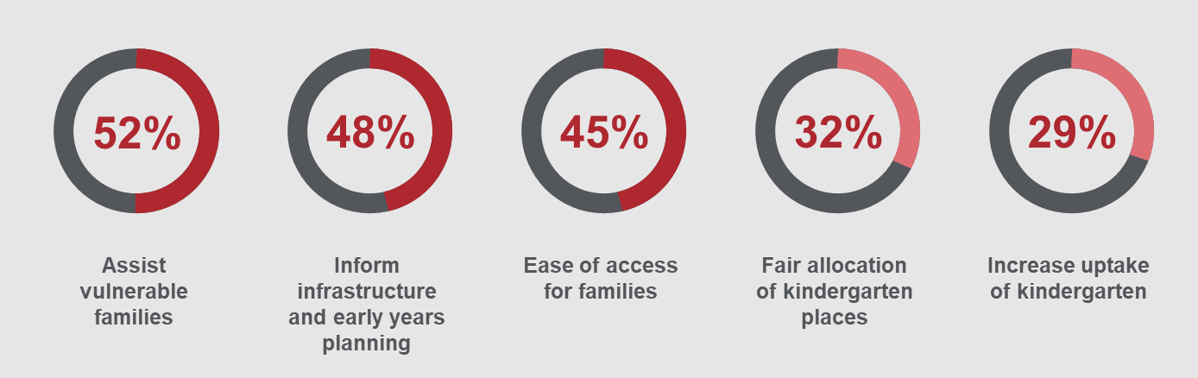

Feasibility and options assessment
In this section you will explore the feasibility of implementing a CRES in your LGA. This includes developing a risk assessment of the different options for CRES delivery.

A feasibility assessment was undertaken to determine if key stakeholders – council officers from relevant departments, families and carers, kindergarten service providers, EYMs, support services and peak bodies – would support the CRES if it was implemented in [LGA]. The risks and benefits were also analysed for each of the three CRES options:
- Maintain the current state
- The CRES is operated by the council
- The CRES is contracted to a third party.

Engagement with key CRES stakeholders
To assess the feasibility of a CRES, [council name], in line with its community consultation policy, engaged with council Early Years officers, kindergarten service providers, families and carers, MCH nurses and external support services such as [insert specific organisation name, e.g. Orange Door, Child Protection, Koori Health Service].
All kindergartens in the municipality were invited to attend workshops to discuss whether a CRES is likely to work in [Council name] and if so, what type of model would be most appropriate.
All / Most [list inclusions or exception] kindergartens and Early Years Managers signed a letter of intent to explore CRES and XX% have since committed to be part of a CRES if it goes ahead. The following kindergartens in [council name] have agreed in principle to be included in the CRES in 2021 in preparation for the 2022 kindergarten year:
- [Service provider name]
- [Service provider name]
- [Service provider name]
XX% of families and carers who were interviewed or surveyed supported the introduction of a central enrolment process. Reasons for supporting the CRES model included [insert commonly heard reasons from families and carers here].
Council Early Years officers, MCH nurses and support services are broadly committed to the concept of a kindergarten CRES. XX% of MCH nurses and XX% of support services committed to helping deliver the CRES through providing information to families and carers and facilitating registration where helpful.

Options assessment
There are three options for the CRES in [LGA]:
- Maintain the current state
- The CRES is operated by the council
- The CRES is contracted to a third party.
The risks and benefits of these options are discussed in Table 2 below.
Table 2 must be expanded with an assessment of the relative benefits and risks the three options. Consider the following questions when expanding the table:
- What important considerations did stakeholders raise during your consultations with them? (both concerns and benefits)
- What is the landscape of service providers in the area and their willingness to join a scheme operated by a third party or by council?
- What is the feasibility of either the council or an available third party to deliver the CRES if it was implemented? Comments could be aligned to some of the CRES enablers:
- Capability and capacity – Are there staff who will have the managerial, administrative, relationship management and customer service skills to successfully run a CRES?
- Governance – Are there existing structures to robustly manage the CRES (responsibility and accountability)?
- Partnerships – Are there existing relationships with partners that will support the CRES?
- Systems, data and digital tools – What current digital tools can be used? Do they securely capture and store data, and broadcast information?
- Do some third parties in the area have experience delivering anything similar to the CRES?
- Have some third parties in the area demonstrated the ability to produce clear and timely reports so that council can stay informed if the CRES is contracted out?

Table 2 | Benefit and risk assessment of options
Option | Benefit | Risk
- Maintain the current state | - There is no cost to the council  - There is no disruption to existing practice | - Many families and carers do not enrol their children in kindergarten due to lack of awareness, confusion about processes, or lack of access  - XX vulnerable children who are eligible for State Government funded places will not attend kindergarten
- Establish a CRES that is operated by [council name] | - XX more children are enrolled in kindergarten due to simplified and consistent processes and are more likely to contribute to the community in future years  - Proactive engagement through CRES Partners identifies and assists XX vulnerable children to register for kindergarten in the first year, increasing to XX in subsequent years  - Equitable allocation processes ensure that vulnerable children are allocated a place  - Contribute to the achievement of [council name] [Council Plan / Early Years Plan / similar]  - Delivers on the Early Years Compact  - (Compared to Option 3) Leverage existing relationships and relationship management capability  Demonstrates to its ratepayers a commitment to kindergarten provision in the municipality  increases leverage over the kindergarten facilities it owns | - Reputational risk if the CRES is overly onerous on CRES Partners  - [Investment yields minimal benefit due to large EYMs already operating a similar system that covers the municipality]  - [Investment yields minimal benefit due to very few kindergarten services operating in the municipality].
- Contract the establishment and operation of a CRES to a third party | - As above.  - (Compared to Option 2) Reputational risk is mitigated by having delivery outsourced  (Compared to Option 2) Potentially more efficient delivery of the CRES by an organisation who can demonstrate their capability in operating similar programs. | - (Compared to Option 2) Council has less control of the CRES and it will be more challenging to improve or make changes to the CRES  - (Compared to Option 2) Potential risk that, if third party is also a service provider, allocations would unfairly favour the organisation that operates the CRES.

Resourcing and cost recovery options
The CRES will require funding to establish and operate. The evidence is clear that an investment made by council in its future leaders will pay dividends in the future in the form of better community health, reduced crime, and stronger educational outcomes. There are also several cost-recovery options to mitigate the cost of the CRES.

Establishment funding
If the CRES is established by the council, it is estimated that the CRES establishment project will require the attention of one policy officer for XX days per week over XX months. There will also be some oversight from a [coordinator / manager] [and investment in a new system to operate the CRES is required], resulting in a total establishment cost of $XX outlined in Table 3.
If you have engaged with EYMs who are keen to establish and operate the CRES in your LGA, you should also ask what their estimate of establishment costs would be and use the first statement below. If not, use the second statement.

Prospective third parties who could establish and deliver the CRES have indicated that the establishment cost of a CRES, which the council would fund, would be approximately $XX.
OR
Further investigation will be required to determine the cost of CRES establishment if it is contracted to a third party
CRES establishment will also follow a clear plan outlined in Appendix D | Implementation plan. This implementation plan will be supported by Appendix E | Stakeholder engagement plan, and will address risks identified in Appendix F | Implementation risk assessment.
Table 3 | Estimate of investment required to establish the CRES if [council name] establishes the CRES
Item | Unit value | Unit count | Total
Costs
Early Years Coordinator | $[monthly salary] | [FTE dedicated to CRES establishment x no. months] | $
Early Years officer | $[monthly salary] | [FTE dedicated to CRES establishment x no. months] | $
[new data capture system for registration and allocation, if required] | $XX | 1 | $
TOTAL ESTABLISHMENT COSTS | $

Cost recovery options
There are three potential sources of revenue that can help make the CRES a sustainable program. The proposed schedule of cost recovery is outlined in Table 4 and considers a number of factors that are elaborated in Appendix C | Cost recovery analysis.
Table 4 | Potential sources of cost recovery for the CRES
Revenue source | Proposed schedule
DET grants  Provided by DET to support the delivery of CRES across the state | - $XX [one off OR per year] of grant funding is available to [establish a CRES / operate a CRES / support the administration of the CRES / expand the CRES]
Registration fee  Charged to families and carers for registering with the CRES. | Choose one of the following options depending on the decision you have made about whether or not to charge registration fees.  - No fee should be charged to families and carers as initial research suggests this would be a significant barrier to some children.  OR  - A nominal fee of $XX will be charged for registration in the first year of the CRES. This is in line with practice from other councils in the state, and is appropriate for the demographic in our [LGA]  - A full waiver of this fee will apply for any child who is considered a ‘high priority’ by the DET Priority of Access criteria.  - [A partial waiver of XX% of this fee will apply if extenuating circumstances are demonstrated.]
Participation fee  Charged to service providers for participating in the CRES. | Choose one of the following options depending on the decision you have made about whether or not to charge participation fees.  - No fee should be charged to service providers as initial research suggests this will not make CRES participation favourable for most providers in our area.  OR  - A flat-rate fee for all services participating in the CRES of $XX will be charged. This fee is considered reasonable by the service providers in our area considering the value the CRES delivers to children and to the service providers themselves.  - A full fee waiver should apply for any service that has an active social purpose.  OR  - A fee of $XX per available kindergarten place will be charged to the service providers. This fee is considered reasonable by the service providers in our area considering the value the CRES delivers to children and to the service providers themselves.  - A full fee waiver should apply for any service that has an active social purpose.

The pursuit of these cost recovery options are recommended because [explain how you came to the cost recovery options decisions].

Operating funding
The benchmarking average cost of enrolling a child through a Central Enrolment Scheme in Victoria from an administrative perspective is approximately $154 per child. This may vary due according to the administrator’s tasks (just accepting registrations and allocating places or completing the entire enrolment process); the number and complexity of enrolments and placements; and the type of digital tools developed to support this process.
These costs will be mitigated by the revenues from cost recovery options as outlined in the above section.
An initial estimate of the net annual operating cost of a CRES is $XX as outlined in Table 5. It is expected that these annual operating costs will be similar regardless of if the council is the CRES Provider or if it is contracted to a third party.
Table 5 | Estimate of annual operating costs for the CRES
Item | Unit value | Unit count | Total
Costs
Enrolments | $154.00 | XX (number of CRES registrations) | $
Subtotal | $
Revenues
DET grants | $ | 1 | $
Include or delete this row depending on the decision made about cost recovery  Family and carer registration fees | $ | $[remember to consider that vulnerable families do not pay this fee, so this no. is less than number of registrations] | $
Include or delete this row depending on the decision made about cost recovery  Service provider participation fees | $ | $[remember to consider that providers with a social purpose do not pay this fee, and all providers may not pay the same fee] | $
Subtotal | $
TOTAL ANNUAL OPERATING COSTS | $[subtotal of costs - subtotal of revenues]

Appendix A | Background information on CRES in Victoria

Early childhood education is an important part of childhood development
The foundations of a child’s long-term development are laid in early childhood. In these years, children develop crucial cognitive and emotional skills such as reasoning, problem solving, and how to get along with others.
A high-quality kindergarten experience sets up a child for a life full of learning and prepares them for school. In the long term, evidence shows that children who have a positive early childhood experiences grow up to contribute to a harmonious, healthy and prosperous society .
Despite the recognised benefits, families and carers may choose to not enrol their children in kindergarten. Two possible reasons contributing to this outcome are:
- While most parents acknowledge the opportunity for socialisation of their children, some groups may not understand the value of play-based education, or the value of early childhood education.
- Kindergarten services can be difficult to access, because registration and enrolment processes can be laborious for families to navigate. This is particularly the case when English is not the primary language spoken, and/or for more newly arrived communities.

Children experiencing disadvantage and vulnerability benefit the most from early childhood education
“A high-quality kindergarten experience is the gateway to a life full of learning” ⁴
– Education State Early Childhood Reform Plan, DET (2018)
Access to early childhood education is particularly important for children experiencing vulnerability or from a disadvantaged background. Children considered vulnerable on even one Australian Early Development Census domain are half as likely to achieve scores in the top two NAPLAN reading bands in Year 3, and even less likely in Year 5 (DET, Education State Early Childhood Reform Plan, 2018). It is important that early childhood initiatives target children who are most at-risk of missing out on the foundational social, emotional and cognitive experience provided by kindergarten⁴.
Research indicates that the availability of services is critical to successfully engaging vulnerable and disadvantaged families. Designing an equitable and inclusive system that proactively engages and supports these families ensures all children can access a kindergarten program that suits their needs. This includes:
- using approaches that reach out to families and communities
- ensuring that staff are sensitive to families who have limited awareness of established processes and work with them to facilitate access.

Central Registration and Enrolment can support improved access and engagement with Victoria’s kindergarten services

The greatest impact of centralised kindergarten registration and enrolment comes from engaging families, carers and their children who would otherwise face barriers to enrolment in kindergarten. It simplifies kindergarten registration and enrolment processes for families and encourages local government to work with community and support services, such as Maternal and Child Health (MCH), to proactively identify and engage children and families who may need more support.

The overarching vision for centralised registration and enrolment in Victoria is:
- Families and carers experience a smoother pathway to enrol in and attend kindergarten, by encouraging more local government areas and funded kindergarten programs being part of a CRES.
- Vulnerable and disengaged families are identified early and proactively engaged and enrolled in funded kindergarten programs, by working in collaboration with MCH and other community and support services to work with families during the registration process.
- Kindergarten places are allocated in a transparent, consistent and equitable way, and in line with the Department of Education and Training’s (DET’s) Priority of Access criteria.
- Councils and early years services can better respond to the needs of the community, through the collection of accurate, consistent and timely kindergarten data, to monitor and proactively manage capacity and utilisation of services.
- Administrative burden for kindergarten service providers is minimised, ensuring they can focus on ensuring children arrive at school ready to succeed.
The Central Registration and Enrolment Scheme (CRES) provides one easily accessible way for local families to register for and secure a place for their children in kindergarten, without having to work through the different processes and priorities used by individual service providers. It is a collaborative model that brings together councils, service providers, MCH staff, support services and other stakeholders to support children and their families and carers.
“Early childhood presents an opportunity to invest early and reap the long-term dividend from this investment, as well as avoiding significant long-term costs to society.” ¹
– Education State Early Childhood Reform Plan, DET (2018)

The CRES model has been co-designed by DET, the Municipal Association of Victoria (MAV) and a range of service providers, councils and services supporting children and families. It serves as blueprint for councils and other CRES providers to maximise consistent experiences of kindergarten registration and enrolment across Victoria.
Local government, with the support of DET and DHHS, is well-placed to implement initiatives that optimise the uptake of kindergarten in Victoria. Detailed knowledge of local context and community is essential to provide an effective service, and councils play an important role in the planning, development and provision of early childhood services.
In 2020 more than half of all local councils across Victoria operate a form of central enrolment or central registration scheme. These schemes provide a single point of entry for families, simplifying the kindergarten enrolment process and improving equity of access. The new CRES model builds on, and does not replace, schemes that are already operating in many councils across Victoria.

Appendix B | Local context data and impact modelling
This section should be able to be mostly completed with the data found by completing the questions in the CRES Development Guide’s Appendix A.4: Research plan template. Potential sources of data are also listed in the Research plan template.

A summary for kindergarten demand and demographics for the last year of available data is presented in Table 6.
Table 6 | Demand and demographics summary
Demographic | Age group | Total number in the LGA last year | Growth rate trend in the LGA | Confirmed total kindergarten enrolments last year
All kindergarten-aged children | 3-year-old
 | 4-year-old
Children eligible for Early Start Kindergarten (ESK) | 3-year-old
Children eligible for the Kindergarten Fee Subsidy (KFS) | 4-year-old

Trends in enrolments
[Add summary of data]. Trends in key kindergarten indicators between 2015 and 2018 are captured in Table 7 and Table 8.
Table 7 | Kindergarten indicators in [LGA]
Kindergarten indicators | 2015 | 2016 | 2017 | 2018
Kindergarten participation rate | % | % | % | %
Number of children enrolled in 3-year-old kindergarten | X | X | X | X
Number of children enrolled in 4-year-old kindergarten | X | X | X | X

Table 8 | Kindergarten enrolments for vulnerable children and families and carers in [LGA]
Indicator | 2015 | 2016 | 2017 | 2018
ESK enrolments | X | X | X | X
KFS enrolments | X | X | X | X

Service provider details
Table 9 is identical to information presented in the Discussion paper prepared in an earlier stage (CRES Development Guide’s Appendix A.1: Discussion paper template). You can copy the information from the Discussion paper straight into here.

[Add summary of data]. A summary of the current state of kindergarten service providers in [LGA] is provided in Table 9.
Table 9 | Kindergarten details in [LGA]
Service provider | Offering type | Total number of available spaces | % of spaces filled last year
Service provider name  Run by: council, not-for-profit committee, EYM, private standalone | Long day care/sessional/both long day care and sessional programs | Three-Year-Old: XX | Three-Year-Old: XX
 |  | Four-Year-Old: XX | Four-Year-Old: XX
Service provider name  Run by: council, not-for-profit committee, EYM, private standalone | Long day care/sessional/both long day care and sessional programs | Three-Year-Old: XX | Three-Year-Old: XX
 |  | Four-Year-Old: XX | Four-Year-Old: XX
Service provider name  Run by: council, not-for-profit committee, EYM, private standalone | Long day care/sessional/both long day care and sessional programs | Three-Year-Old: XX | Three-Year-Old: XX
 |  | Four-Year-Old: XX | Four-Year-Old: XX
Service provider name  Run by: council, not-for-profit committee, EYM, private standalone | Long day care/sessional/both long day care and sessional programs | Three-Year-Old: XX | Three-Year-Old: XX
 |  | Four-Year-Old: XX | Four-Year-Old: XX

Modelling the impact for the LGA
The high-level modelling in Table 10 shows the likely impact of a CRES on residents of [council name], including children experiencing vulnerability. There is further potential impact for children whose parents and carers work in the municipality, depending on locally agreed criteria for priority enrolment, which will be explored and defined during the design and implementation of the CRES.
The Table below quantifies the impact of the CRES. Consider an appropriate way to estimate the CRES enrolment rate for children in your LGA. You may choose to remove this table (and previous references to it) if you believe there is little appetite from senior decision makers to see firm numbers but remember that these numbers will strengthen your argument.

Table 10 | High-level population modelling to demonstrate likely impact of a CRES in [LGA]
 | 20XX  Census data | 2021  # children enrolled via CRES (XX% anticipated*) | 2022  # children enrolled via CRES (XX% anticipated*) | 2023  # children enrolled via CRES (XX% anticipated*)
Kindergarten aged children | [Most recent population data] | = [most recent census #] + [% growth] x XX% | = [most recent census #] + [% growth] x XX% | = [most recent census #] + [% growth] x XX%
Children eligible for ESK | [Most recent population data] | = [most recent census #] + [% growth] x XX% | = [most recent census #] + [% growth] x XX% | = [most recent census #] + [% growth] x XX%
Children eligible for KFS | [Most recent population data] | = [most recent census #] + [% growth] x XX% | = [most recent census #] + [% growth] x XX% | = [most recent census #] + [% growth] x XX%
Other significant population / demographics (If applicable) | [Most recent population data] | = [most recent census #] + [% growth] x XX% | = [most recent census #] + [% growth] x XX% | = [most recent census #] + [% growth] x XX%
*XX% enrolment anticipated based on State Government modelling of central enrolment take up.
† Includes enrolment for 3-year-old kindergarten, to be rolled out in 2022.

Appendix C | Cost recovery analysis
Several cost recovery options for the CRES are available. Considerations taken into account when determining which are appropriate for [LGA] are listed in Table 11.
Table 11 | Potential sources of revenue for the CRES
Revenue source | Considerations
DET grants | - Grants to establish, improve or expand a CRES may be available, such as administrative support grants  - These grants will require the CRES to meet certain conditions.  - The availability of grants may change year-on-year depending on policy changes.
Charging families and carers a registration fee | - The fee should be nominal, so it is not a barrier to the majority of families and carers.  - This can be a good cost recovery option if registrations are high.  - Consider the demographic of people in your LGA when deciding if a fee should apply and the size of the fee.  - Having any fee at all will be a barrier to some families and carers. This can be mitigated by providing an avenue for families and carers who might struggle with the payment a partial waiver if extenuating circumstances are demonstrated. A full waiver should apply for any child who is considered a ‘high priority’ by the DET Priority of Access criteria.  - The risk of some families and carers disengaging due to the fee should be weighed against the potential benefits of providing a strong CRES that supports more equitable and accessible kindergarten placements.
Charging service providers a fee to participate in the CRES | - Either a flat-rate fee for all services participating in the CRES or a per-registration fee could apply. A flat-rate fee may disproportionately impact smaller service providers; however, a per-registration infers that the CRES Provider is adding value by reducing the cost of administration for the service provider.  - Having a fee for service providers will make them more reluctant to engage in the CRES. Consulting these partners on any fee will be crucial to making a decision about this revenue source. It will be important to outline the potential financial benefits of the CRES (reducing administrative burden for registrations, thus saving staff effort) when discussing this with a service provider but recognise that these costs may be negligible for them.  - A full fee waiver should apply for any service that has an active social purpose.

Appendix D | Implementation plan

Project scheduling
The [Early Years team] has drafted the below project plan and the detailed project plan below in line with the CRES Development Guide co-designed by DET and MAV to support councils through the two phases of setting up a CRES.
[Council / the executive’]s decision on this business case will conclude stage one of the project plan and, if successful in moving ahead with the development of a CRES, [council name] will deliver stages two and of the project plan, as shown in Figure 3.
Figure 3 | High-level steps to plan, develop and implement the CRES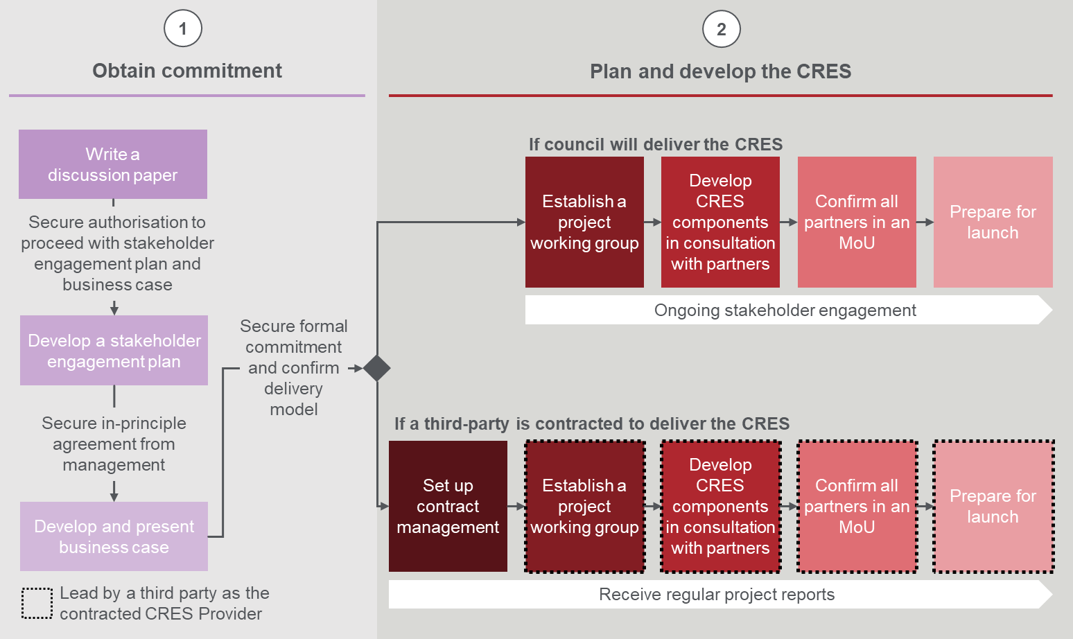

Obtain commitment
The preliminary discussion paper was circulated to [group] on [date] and received feedback that [insert summary of feedback on preliminary discussion paper].
This business case will be reviewed by [group] on [date] and a decision to commence stage two of the project will be delivered on [date]. If the business case for CRES must be revised or developed further, an updated business case will be reviewed by [group] on [date].

Plan and develop the CRES
The process for delivering the CRES annually must be tailored for the CRES Provider organisation. The objective of this step is to design a robust back-end process that helps families and carers get their children to kindergarten, and that is supported by internal and external stakeholders.
Planning and development of the CRES will have up to five main phases:
- Set up contract: Councils that choose to delegate the role of CRES Coordinator to an EYM or third party must negotiate an appropriate contract.
- Establish the project working group: Bring together the necessary officers in a multi-disciplinary project team to design all back-end systems and processes to deliver the CRES. The project working group will include council officers from the Early Years team and a senior leader as Project Sponsor, and may also include officers from IT, administration, finance, business development or community engagement.
- Develop CRES components in consultation with partners: Prepare and improve [council name]’s CRES enablers to deliver a best practice model.
- Confirm all partners in an MOU: Confirm the roles and commitment of CRES Partners in a Memorandum of Understanding (MOU). The MOU will define the responsibilities of each partner group in CRES delivery.
- Prepare for launch: Ensure all CRES officers and partners are trained, equipped and informed to launch the CRES ready for the first registration and enrolment cycle. This will include releasing communication materials to the community and testing all systems for CRES delivery.

Proposed timeline
The CRES will be ready for launch in XX months from approval of this business case. If the case is approved on [expected date of decision], the CRES will be delivered by [date] in time for the [year] registration and enrolment cycle.

Edit this detailed project plan to align with the proposed dates and crucial activities for development of your CRES. The template below demonstrates recommended timing based on the CRES Development Guide.
The plan below shows the proposed CRES implementation plan.
 | Mar | Apr | May | Jun | Jul | Aug | Sep | Oct | Nov | Dec | Jan | Feb
Stage 1 – Obtain commitment
Write a discussion paper
Develop a stakeholder engagement plan
Develop and present business case
Stage 2 – Plan and develop the CRES
Set up contract management [delete this if not recommending third party CRES]
Establish a project working group
Develop CRES in consultation with partners
Confirm all partners in an MoU
Prepare for launch

Appendix E | Stakeholder engagement plan
[Insert stakeholder engagement – or summary - plan here]

Appendix F | Implementation risk assessment
The risks of implementing the CRES and potential mitigations listed in Table 12 were identified following the stakeholder research conducted to develop this business case.
Table 12 | Risk factors and potential mitigations for delivery of a CRES in [LGA]
Perceived risk | Mitigation
Concern that a CRES will take away the personal touch of kindergartens, e.g. face to face interactions during the enrolment process. | The proposed model maintains enrolment as a responsibility of service providers after the CRES coordinator has collected registrations and completed allocations. This encourages kindergartens to continue with all face to face interactions associated with enrolment and kindergarten selection, e.g. open days, interviews, visits, etc.
Concern that the CRES will introduce zoning for children so that they must attend their closest kindergarten and not be able to go to their ‘community of interest’. | The Department of Education and Training requires all kindergartens to utilise the Priority of Access guidelines to ensure that vulnerable children can access kindergarten. The next layer of assessment is the local criteria. These criteria are determined by the CRES Provider in collaboration with service providers so their perspective about community of interest points (e.g. parent/s work or study in the town, etc) can be included. To ensure a fair, transparent and equitable process, these local criteria must be applied by the CRES Provider.  The proposed CRES does not influence assessment criteria.
Concern that families living outside [council name] will not be able to attend kindergartens in [council name]. | As per item 2.  Note that currently xx% of all kindergarten enrolments in the municipality are from children who live outside the municipality, but xx% of children who live in the municipality access kindergartens in neighbouring LGAs.
Concern that paid kindergarten administration staff who currently undertake enrolments will lose their job or some of their hours. | Administration staff will still be required to undertake the enrolment process (e.g. collection of all relevant documents, etc) at each kindergarten, however the time they spend on the initial registration form will be reduced. Some kindergartens (particularly those with voluntary enrolment officers) have indicated that they would welcome a reduction in hours and responsibilities for volunteers. Some administration hours will be required to oversee the Central Enrolment registration process, although these hours may be within capacity of existing kindergarten administration staff.
[remove if not relevant to your area]  Belief that such a scheme is unnecessary in a rural area, particularly towns where there is only one kindergarten to choose from. | Some of the key aims of the central enrolment scheme are:  To ensure that services collaborate more effectively with one another.  That vulnerable children are identified early and enrolled in kindergarten.  That kindergartens and Council are able to better plan ahead as they are more aware of potential enrolments in future years.  Hence the scheme is much more than a system where people register their child in a kindergarten in their town and are allocated accordingly (providing there is space). Further, some people choose to enrol their children in kindergartens outside their own town.  [council name] may consider contracting a single service provider to deliver the CRES in the LGA if appropriate.
Concerns regarding confidentiality and security of data collected from families and carers | Existing software packages have secure data storage built into them. Council will ensure that its privacy policy is promoted and adhered to.  Some Victorian Local Government Authorities have reported that developing and adapting IT systems to support CE scheme operations can be costly and time intensive as well as difficult to maintain if there is limited IT support available locally. There are numerous kindergarten central enrolment scheme products on the market, hence purchase of an off the shelf product is likely to be less expensive that developing a custom-made system. IT support will need to be monitored.
Concern that disadvantaged families would not be able to fill in an online registration form. | MCH nurses, support services, kindergarten staff and Council Early Years officers will all be trained up to assist disadvantaged and vulnerable families to fill in the online registration form.

Education State Early Childhood Reform Plan, DET (2018)
Kindergarten Central Enrolment: Current State Analysis, ACIL Allen (2018)
Central Enrolment Current State Analysis, ACIL Allen (2018)
Education State Early Childhood Reform Plan, DET (2018)

