Appendix A.5 | Research plan

About this template
Note: please remove these instruction pages when the template is complete
This template is a starting point for councils looking to develop a business case for a Central Registration and Enrolment Scheme (CRES). Refer to section 3.1.3 of the CRES Development Guide for more information on this step in setting up a CRES.
This document is a part of a suite of CRES documents. Figure 1 below maps the relationship between the Development Guide, Self-Assessment Tool, Practice Guide and this document.
Figure 1 | A map of CRES documents
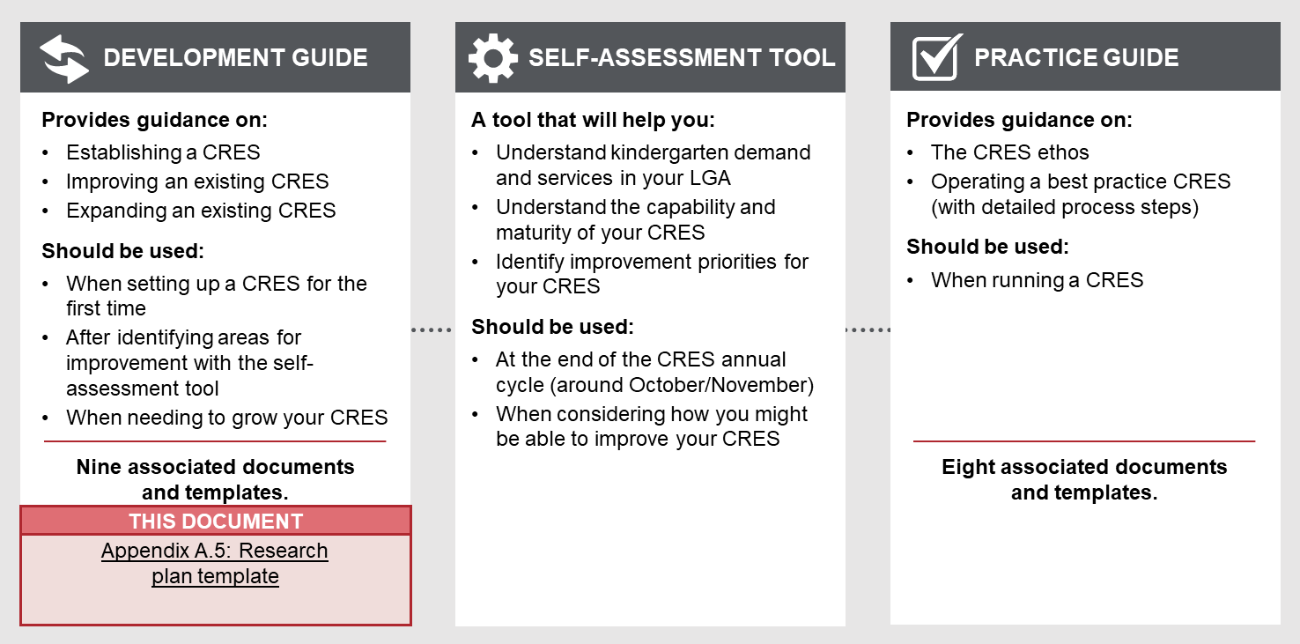

To complete the research plan
- The writer of the research plan should tailor the template to the needs and objectives of the council officer who will use the plan. Thoughtful additions, deletions and edits to the template content will strengthen your plan and make delivery simpler.
- This template is a practical guide to collecting data in the early stages of scoping a CRES and is not intended to be presented to senior leaders in the organisation. If the research plan is requested, replace instructional text for each section with contextual information that will be of interest to the audience.
- All template content can be tailored, but content highlighted in yellow must be updated. For example, “[council name]” must be replaced with the name of your council for content to make sense.

how to use this research plan when completed
This plan should be used to guide research to help you understand the context of kindergarten in your area and potential resources required to establish and operate a CRES and will therefore contribute to well-informed business case. This research should be conducted by the council officer leading the development of the CRES business case.

Research plan

Central Registration and Enrolment Scheme (CRES)

[CRES provider]

Date:
Version:

Population profile
Understanding the current demand for kindergarten places and the families and carers you are designing the CRES around will help you predict the impact of a CRES in your municipality.
Table 1 provides a structure to collect information about kindergarten demand from the last complete year of data. If you cannot find values against all items in the tables, it is important to reflect on why the data is difficult to collect and how you might obtain the data in the future. Estimates can also be used where specific data is not available.
The questions in Table 1 will help you understand kindergarten-aged children in your area to give you a better idea about:
- The potential scale of your CRES and give some indication of number of CRES officers that will be required to run the CRES (i.e. respond to queries, manage allocations etc.)
- The potential role of your CRES in supporting vulnerable children.
The questions in Table 2 will help you understand the population of CRES ‘users’ – the families and carers who will be interacting with the CRES regularly. This will inform how your design the components of your CRES and will highlight the demand for certain types of kindergarten.
Table 1 | Kindergarten demand and demographic statistics
Demographic | Age group | Total number in the LGA last year | Growth rate trend in the LGA | Confirmed total kindergarten enrolments last year | Data source (select one per data point)
All kindergarten-aged children | 3-year-old |  |  |  | Victoria in Future (VIF) data  Kindergarten Information Management System (KIM) data (confirmed enrolments)  Birth notification data  Council population data
 | 4-year-old
Children eligible for Early Start Kindergarten (ESK) | 3-year-old |  |  |  | VIF data  KIM data (confirmed enrolments)  Enhanced MCH data  Children in Out-of-home care
Children eligible for the Kindergarten Fee Subsidy (KFS) | 4-year-old
Table 2 | Broader population characteristics
Question | Use of data | Data source (select one per data point)
What languages other than English are commonly spoken? | Confirm the languages that communications materials will have to be translated into. | Australian Bureau of Statistics (ABS) Census
What is the technological literacy of the population? | Predict how many paper forms you will receive and how much manual processing will be required. | ABS Census (Type of Internet Connection by Dwelling Structure)
What is the rate of full-time and part-time employment, and unemployment? | Highlight potential need for CRES officer to support people with registrations | Council Social and Community Planning department  Socio-Economic Indexes for Areas (SEIFA) data from the ABS  VIF data
How many parents are single (or lone) parents and what % of the total number of parents is this?
What are the participation rates for the MCH 2-year-old and 3.5-year-old Key Ages and Stages visits? | Understand how much contact families and carers have with this potential information channel | DHHS MCH Annual Report

Profile of service provision
A thorough knowledge of the number of kindergarten places and profile of service providers that supply them will contextualise your CRES implementation.
The questions in Table 3 will help you understand the potential scale of your CRES, effort involved with managing relationships and can inform your stakeholder engagements.
Table 3 | Kindergarten service provider statistics
Question | Use of data | Data source (select one per data point)
What is the profile of service providers in your area? How many are…  - Sessional and LDC?  - Council-run, NFP, private, run by big EYMs?  - Run Three-Year-Old and Four-Year-Old programs? | Plan the breadth of your engagements and how you might want to tailor the engagement to appeal to each service provider’s needs. | LGA Profile (DET)  Local business / service directory
What is the total number of available kindergarten spaces in the LGA? What % of these spaces were filled last year?  - 3-year-old and 4-year-old? | Understand the potential scale of your CRES
What existing relationships do people in the Council have with service providers?  - Formal relationships (e.g. service agreements, involvement with committees)  - Informal relationships  - Service providers using council facilities | List the relationships and contacts you can leverage to save time and effort. | Interviews with council officers
What issues are you aware of that service providers are facing in your area? | Informs engagements with service providers and how to pitch the CRES as something that can help them | Interviews with council officers

CRES Partners
A clear understanding of the CRES stakeholders that will eventually help you deliver the CRES is important to inform how you approach relationship-building.
The questions in Table 4 will help you understand the network of potential CRES Partners in your area and how they may be able to support CRES. This will also help inform your stakeholder engagement plan and how you may (formally or informally) decide to engage with these stakeholders.
Table 4 | Supply of health and support services for kindergarten-aged children
Question | Use of data | Data source (select one per data point)
Who are the key people or contacts for:  - MCH staff  - Service providers  - Support services  - Peak bodies for vulnerable groups  - DET regional officers  - MAV  - ACCOs  - Other community groups | Build a list of individuals and organisations to reach out to and build relationships with (as per the stakeholder engagement plan). | Organisation chart  Interviews with council officers
Is MCH delivered by the council or a third-party provider? | Understand how to best engage with MCH staff and what processes or structures may be required to pass data between organisations. | Organisation chart
How many MCH nurses work in the LGA (in FTE)? | Understand how many nurses are available to distribute information about ECE and CRES to families and carers. | MCH workforce data (reported to DHHS)  Organisation chart  Interviews with MCH staff
What other early years services are operated by the council? | Understand how to best engage with other early years and what processes or structures may be required to pass data between organisations. | Organisation chart  Interviews with council officers
How many support services for children and families and carers operate in the LGA? | Understand how many support services and case workers are available to distribute information about ECE and CRES to families and carers in vulnerable circumstances. | Local business / service directory  Google search  Interviews with council officers  Interviews with service providers
Who are the active groups that the community trusts or has regular contact with? This could be:  - Religious groups  - Community cultural groups  - Parent groups  - Volunteer organisations | Build a list of organisations, community groups or collectives that can help spread the word about ECE and CRES, particularly to vulnerable groups. Your stakeholder engagement plan should be expanded to include any particularly active and potentially influential community groups that you identify. | Local business / service directory  Google search  Interviews with council officers  Interviews with service providers  Existing MoU

CRES implementation at a similar council
Many councils already run a version of the CRES (Central Enrolment or Central Registration schemes). Investigating how their LGA compares to yours and the implementation of their scheme will give some indication of the effort involved in our establishing and operating a CRES, and the potential outcomes for your LGA.
Table 5 will help you identify a comparable LGA. MAV can help you identify an appropriate person to contact in that LGA.
Arrange a time with the contact to discuss their scheme, during which you could ask questions to complete the information in Table 5 and begin Table 6. The officer may not have all the data on hand, so you could follow-up the conversation with an email with your remaining questions.
Table 5 | Comparison of similar/adjacent council to [council name]
Feature | [your council name] | [similar/adjacent council name] | Data source (select one per data point)
Regionality (metro, interface, rural) |  |  | Regional Development Victoria
Population |  |  | ABS Census
Socio-economic conditions |  |  | SEIFA data from ABS (Indices of Relative Socio-Economic Advantage and Disadvantage)
Population age 0-6 |  |  | ABS Census  VIF data  Kindergarten Capacity Assessment Program data (KCAP)  Kindergarten Infrastructure and Services Plan (KISP)
Trends (increase or decline) in population aged 0-6 |  |  | ABS Census  VIF data
% of kindergarten aged children enrolled in kindergarten | 3-year-old:  4-year-old: | 3-year-old:  4-year-old: | KIMS data
Number of kindergarten service providers and types of services |  |  | Local business / service directory  Google search  NQAITS  Interview with CRES officer
FTE of MCH nurses |  |  | MCH workforce data (reported to DHHS)  Interview with scheme officer
Type of early years support services |  |  | Local business / service directory  Google search

Table 6 | CRES outcomes data in [similar/adjacent council]
Question | Use of data | Data source (select one per data point)
What is the scope of the [similar/adjacent council] scheme? Does it cover registrations or enrolments, or both? How many providers are in the scheme? | Frame the other questions by giving a sense of the scheme service that they offer. | Interview with scheme officer
What challenges did the [similar/adjacent council] face when setting up the scheme and how did they overcome it? | Provide useful information about how your council may be able to avoid the challenges of the other council.
What increase or decrease in kindergarten enrolments did [similar/adjacent council] measure after the first year of the scheme? | Estimate potential impact of CRES in your LGA in the first year.
What increase or decrease in services joining the scheme did [similar/adjacent council] measure after the first year of scheme? | Estimate potential impact of CRES in your LGA in the first year.
What trend in kindergarten enrolments has [similar/adjacent council] observed over the years of delivering the scheme? | Estimate potential impact of CRES in your LGA over many years.
What was the cost of setting up your scheme? | Estimate the funding required for CRES set up
What is the cost of running a scheme? | Estimate potential costs for delivering a CRES in your LGA.
What EFT is required to run a CRES, including to fulfil functions in:  - Management  - Frontline service delivery  - Data collection and entry  - Systems administration and maintenance | Estimate potential resourcing for delivering a CRES in your LGA.
What systems are used to capture and store registration information, and allocate places? | Understand the technological requirements for a CRES in your LGA.
What additional funding (if any) is available to support delivery of a CRES? | Understand DET funding opportunities. | Interview with scheme officer  DET website

