Appendix A.4 | Letter of Intent template

About this template
Note: please remove these instruction pages when completing the template
This template is for documenting preliminary commitments by stakeholders to a Central Registration and Enrolment Scheme (CRES). This letter should act as formal documentation of a relationship you have already built with CRES partners through delivery of your stakeholder engagement plan.
Refer to section 3.1.3 of the CRES Development Guide for more detail on developing and presenting a business case.
This document is a part of a suite of CRES documents. Figure 1 below maps the relationship between the Development Guide, Self-Assessment Tool, Practice Guide and this document.
Figure 1 | A map of CRES documents
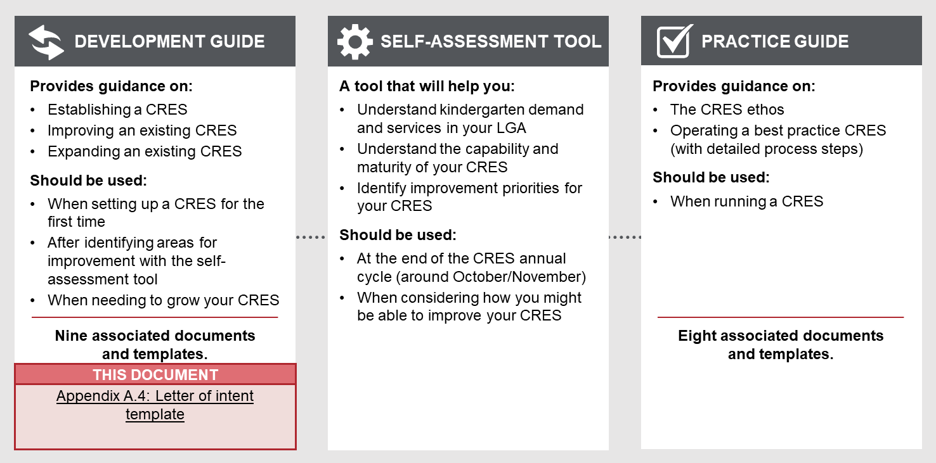

To complete the letters of intent
- Tailor a draft letter for each organisation you have gained support from.
- The writer of the letter of intent must tailor the template to the needs of the CRES partner who will sign the letter. Thoughtful additions, deletions and edits to the template content will help the letter best reflect the agreements and support you have created.
- All template content can be tailored, but contents highlighted in yellow must be thoughtfully updated. For example, “[council name]” must be replaced with the name of your council for content to make sense.
- As each letter of intent is signed and returned to you, record that stakeholder’s support in the business case template.
Refer to the instructions listed in each section in these purple boxes. Once the text is complete, delete all instruction boxes.

How to use the completed template
Present the letters of intent to organisations who you have discussed the CRES with. Explain that this letter is not a commitment to joining the CRES, but rather as an indication that their organisation supports the exploration and development of a CRES. Signed letters of intent can be presented as part of your business case to demonstrate the viability of a CRES in your LGA.

letter of intent to support the CRES
[ORGANISATION REPRESENTATIVE NAME]
[ORGANISATION ADDRESS]
[ORGANISATION STAFF MEMBER NAME]
[ORGANISATION CONTACT INFORMATION]

[NAME OF CRES TEAM LEADER]
[TITLE OF CRES TEAM LEADER]
[COUNCIL NAME]
[COUNCIL ADDRESS]
[DATE]
Add, edit or remove responsibilities in the following paragraphs to reflect the agreements reached with stakeholders.

When presenting the letter of intent template to stakeholders, it should be made clear that this does not formally implicate them to participate in a future CRES. The letters only demonstrate their support for further investigation and development of the CRES in your LGA.
You should also emphasise that they will be drawn upon to help collaboratively develop the CRES to create a scheme that works for everyone.

Dear [CRES team leader name]
I write to indicate my support for a Central Registration and Enrolment Scheme (CRES) to operate in [LGA] on behalf of [organisation name].
We understand and support that [council name] is preparing a business case to:
- Provide a simple, transparent and accessible system for registering and allocating children to kindergarten places.
- Co-ordinate engagement and support of families and carers to ensure this process can be completed for children in the municipality.
- Prioritise and support the allocation of vulnerable children (as per DET Priority of Access criteria).
- Provide information and support materials to involved stakeholders.
Should the CRES business case be approved by [council name], [organisation name] will be asked if they would like to join the CRES and to sign a Memorandum of Understanding committing to:
- Support families and carers to enrol within the CRES window
- Provide information and advice about the CRES to relevant families and carers
- Refer families and carers information to the CRES where appropriate
- Assist in connecting vulnerable children to the CRES
- [use the below dot points for kindergarten providers only]
- Provide kindergarten places to be allocated through the CRES
- Ensure eligible children are identified for targeted funding and support such as Early Start Kindergarten and Kindergarten Fee Subsidy via the Kindergarten Information Management (KIM) system
- Actively work with the family or carer and relevant support services to support child engagement and participation in kindergarten.

I understand that this letter of intent does not require my organisation to be part of the CRES
Sincerely,
[leave space for organisation representative signature]
[organisation representative name]
On behalf of [organisation name]

The DET POA criteria can be found in DET Kindergarten Funding Guide at: https://www.education.vic.gov.au/childhood/providers/funding/Pages/kinderfundingcriteria.aspx

