APPENDIX A.3 | Promotional materials for service providers and peak bodies

About this template
Note: please remove these instruction pages when the template is complete
This template contains promotional material to be shared with kindergarten service providers and support service peak bodies, respectively. Refer to section 3.1.2 of the CRES Development Guide for more detail on how to construct a stakeholder engagement plan.
This document is a part of a suite of CRES documents. Figure 1 below maps the relationship between the Development Guide, Self-Assessment Tool, Practice Guide and this document.
Figure 1 | A map of CRES documents
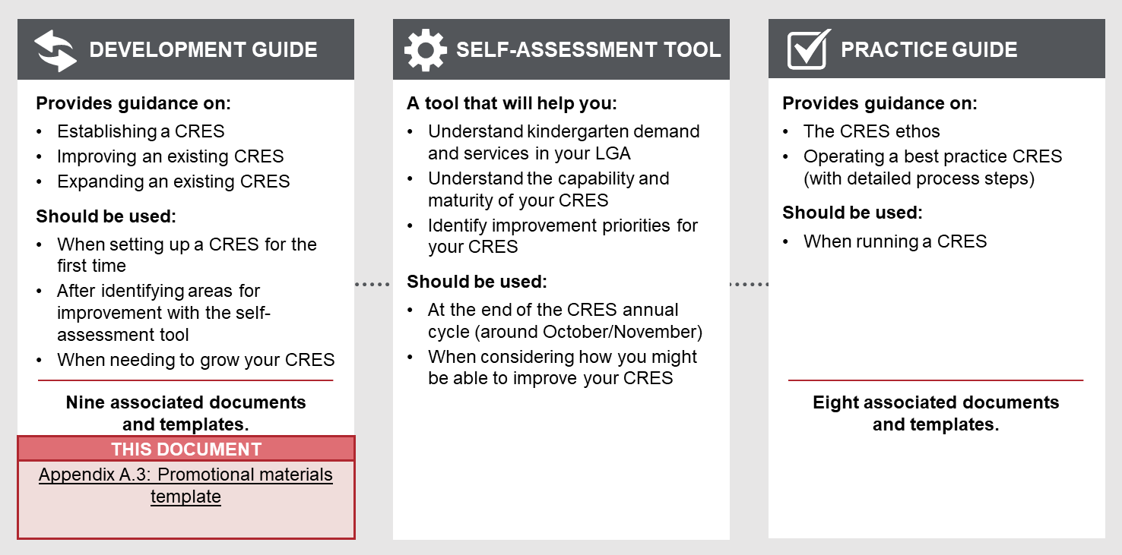

to complete this template
- You must tailor the template to the needs and objectives of the audience for the material. Thoughtful additions, deletions and edits to the template content will strengthen your materials.
- All template content can be tailored, but content highlighted in yellow must be updated to be relevant to your CRES. Consider your location and context, whether your CRES charges fees and whether you have additional local priority criteria. For example, “[council name]” must be replaced with the name of your council for content to make sense.
Refer to the instructions listed in each section in these purple boxes. Once the text is complete, delete all instruction boxes.

How to use these materials when complete
This material can be printed and provided as a conversation starter for service providers and peak bodies and should be delivered as part of your stakeholder engagement plan.

materials for service providers
This template can be used both when initially establishing the CRES and when engaging new service providers to your already established scheme. This content is easily customisable to become a pamphlet, brochure or webpage content.
When tailoring the content, think deeply about the audience you are creating for:
- Who will receive these materials?
- What are their goals and challenges?
- What questions are they asking?
- When will they receive the information?
- How will they receive the info?

THE [LGA] CENTRAL REGISTRATION AND ENROLMENT SCHEME
[LGA] is establishing / operates a Central Registration and Enrolment Scheme (CRES).

WHAT IS A CRES?
A CRES is a centralised process where families / carers can register their children to attend a kindergarten in the municipality. The CRES Provider then assesses the applications and allocates children to participating kindergarten places available in a fair and equitable manner, in line with the Department of Education and Training’s (DET) Priority of Access criteria.
The CRES is a collaborative model which relies on the co-ordinated work of kindergarten providers, services which support families / carers, and the CRES Provider.

WHAT ARE THE BENEFITS OF A CRES?
The CRES aims to simplify kindergarten registration, improve equity of access, lower barriers to kindergarten enrolment, and support the easier and better provision of kindergarten. We are confident that a CRES will deliver significant value to all involved with kindergarten provision in our municipality.
The CRES will deliver a number of key outcomes for the [LGA] community:
- Reduced administration workload for kindergarten service providers
- Increased early identification, support and enrolment of vulnerable children
- More data about kindergarten enrolments in the municipality to help council and providers plan to meet future demand
- A transparent allocation process to ensure appropriate allocation of children to kindergarten places
- A reduction in last minute withdrawals, enrolments at multiple kindergartens, and late enrolments
- Coordinated centralised registrations to more optimally fill kindergarten places so that ratepayers get the most value out of council-owned facilities.

what does CRES MEAN FOR MY SERVICE?
DET and the Municipal Association of Victoria (MAV) have designed a best practice CRES model that will be tailored to work at [LGA]. We will consult with all kindergarten providers to deliver the CRES in the best way for all in [LGA] community.
Allocation processes are equitable for both children and the service providers involved in the scheme. DET Priority of Access guidelines will be applied to distribute kindergarten enrolments, and service providers will be consulted to ensure that important local criteria can be included.
The CRES is designed to ease administrative burden on kindergarten providers without affecting the close connections that are essential to the work you do with families / carers. The CRES provider will distribute key information and communications materials to assist you in engaging families / carers to the CRES, as well as managing all queries throughout the registration and allocation process. Allocations will be communicated to you with plenty of time to engage with families / carers before the kindergarten year begins.

Involvement with the CRES brings many benefits for kindergarten service providers:
What you will do | What the CRES delivers for you
Distribute information about ECE and CRES to families / carers you engage with.  Communicate with the CRES each year the sessions and places your kindergarten will offer.  Enrol children allocated to your service by the CRES and provide kindergarten services to them. | Reduced staff administration as the CRES centrally manages registration and queries, and reduced number of children enrolled in multiple kindergartens.  A new avenue for gaining enrolments.  Access to a community of practice to collectively develop kindergarten provision.  Increased access to the network supporting the children which attend your kindergarten.  Opportunities to provide feedback on the CRES and shape future kindergarten provision in [LGA].  Communication materials and assets to support you in engaging families / carers with the CRES.

how can I get involved?
Contact [staff member name], the [position name] at [CRES Provider]:
[email address] or [contact number]
Read more about the [LGA] CRES at [website URL]

Materials for peak bodies
This template can be used both when initially establishing the CRES and when engaging new service providers to your already established scheme. This content is easily customisable to become a pamphlet, brochure or webpage content.
When tailoring the content, think deeply about the audience you are creating for:
- Who will receive these materials?
- What are their goals and challenges?
- What questions are they asking?
- When will they receive the information?
- How will they receive the info?

ThE [COUNCIL NAME] CENTRAL REGISTRATION AND ENROLMENT SCHEME
[council name] is establishing / operates a Central Registration and Enrolment (CRES).

wHAT IS A CRES?
A CRES is a centralised process where families / carers can register their children to attend a kindergarten in the municipality. The CRES Provider then assesses the applications and allocates children to participating kindergarten places available in a fair and equitable manner, in line with DET’s Priority of Access criteria.
The CRES is a collaborative model which relies on the co-ordinated work of kindergarten providers, services which support families / carers, and the CRES provider.
You, or the organisations you support, may have worked within a CRES in other LGAs and we hope to build the learnings from other schemes to deliver similar positive impact to our community.

What are the benefits of a cres?
CRES will help families / carers understand and gain access to quality kindergarten programs so that children are set up to be future learners and positive contributors to society. We are confident that a CRES will deliver significant value to all involved with kindergarten provision in our municipality.
The CRES will create a collaborative system to deliver:
- Increased early identification, support and enrolment of vulnerable children
- Stronger connections between support service, the council, and kindergarten providers to ensure a network of support for families / carers
- More information about kindergarten enrolments in the municipality to help all plan to meet future needs
- A transparent process to ensure the children are allocated to a kindergarten place that best suits the families’ needs and preferences.

what does it mean for the organisations I support?
The Department of Education and Training and the Municipal Association of Victoria have designed a best practice CRES model that we tailor to work at [LGA]. We consult with all organisations involved in the [LGA] CRES to ensure that the collaborative model is delivered best for the [LGA] community. As a body representing and supporting many organisations which are essential to delivering a CRES, you can provide a key role in engaging these organisations with the CRES provider. The organisations you support will have new responsibilities under the CRES but will also experience significant benefits through the collaborative scheme.
The state-wide vision for CRES aims to have as many funded kindergarten services under schemes as possible. This includes both sessional and long day care kindergarten types, and the CRES will enable both to be successful.
With support from the CRES provider, organisations in the CRES each play a different role.
Kindergarten service providers | Services which support families / carers
Distribute information about ECE and CRES to families / carers  Communicate proposed sessions and places to the scheme each year  Enrol children allocated by the CRES and provide kindergarten services to them | Distribute information about ECE and CRES to families / carers they engage with  Support families / carers they assist to engage with CRES  Work with kindergarten service providers to ensure all children can access kindergarten

how can I get involved?
Contact [staff member name], the [position name] at [CRES Provider]:
[email address] or [contact number]
Read more about the [LGA] CRES at [website URL]

