Appendix A.1 | discussion paper template

About this template
Note: please remove these instruction pages when the template is complete
This template is intended as a starting point for councils that want to set up Central Registration and Enrolment Scheme (CRES). The objective of this discussion paper is to gain support for a CRES and to obtain permission to prepare a full business case. Refer to section 3.1.1 of the CRES Development Guide for more information on this step in setting up a CRES.
This document is a part of a suite of CRES documents. Figure 1 below maps the relationship between the Development Guide, Self-Assessment Tool, Practice Guide and this document.
Figure 1 | A map of CRES documents
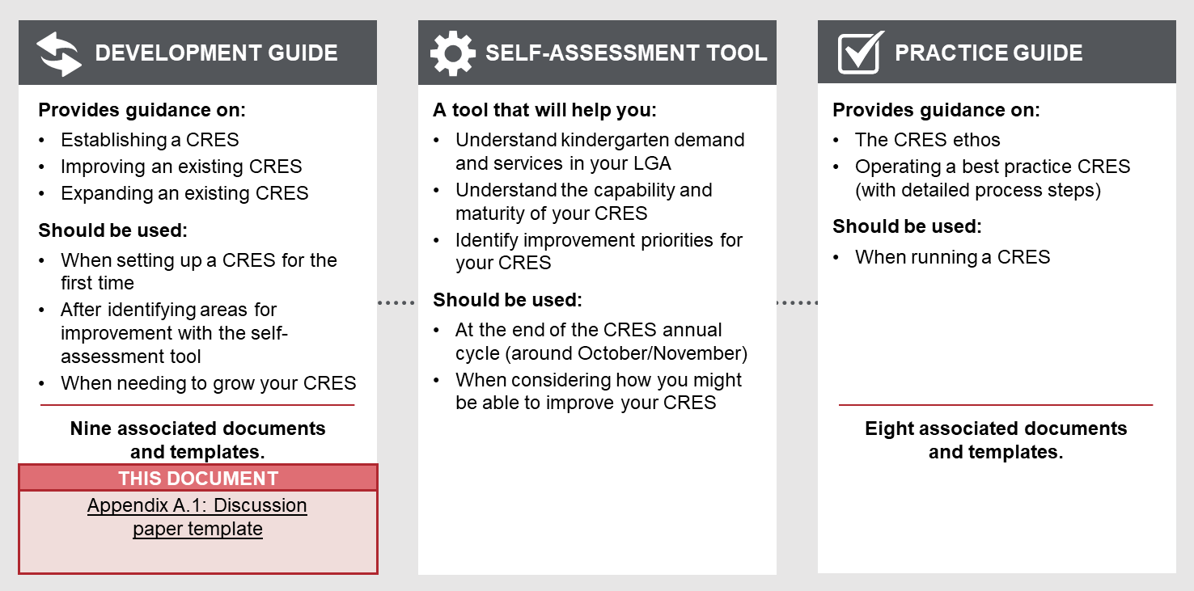

To complete this discussion paper
- You should tailor the template to the needs and objectives of the line manager who will read the paper. Thoughtful additions, deletions and edits to the template content will strengthen your plan and make delivery simpler.
- All template content can be tailored, but content highlighted in yellow must be updated to be relevant to your CRES. Consider your location and context, whether your CRES charges fees and whether you have additional local priority criteria. For example, “[council name]” must be replaced with the name of your council for content to make sense.
- This discussion paper must be converted to your council’s branding.
Refer to the instructions listed in each section in these purple boxes. Once the text is complete, delete all instruction boxes.

How to use this discussion paper when completed
Upon completion, this discussion paper should be submitted to your line manager for approval. Your line manager may then choose to further take this paper to the executive group before you obtain permission to proceed with preparation of a business case. This process will be entirely internal – engagement with external parties will have to be approved and be conducted as a part of the business case.

[Council name]

discussion paper:

Central Registration and Enrolment Scheme (CRES)

Date:

Version:
Prepared by:

Overview
This section summarises the discussion paper document, like an executive summary. Tailor this section to present what your line manager would find most crucially important to approve resources to develop the business case and stakeholder engagement plan for CRES.

This paper recommends that [council name] undertake research and prepare a business case and stakeholder engagement plan to consider options to establish and operate a Kindergarten Central Registration and Enrolment Scheme (CRES) for the municipality. [XX] hours of time from the [Early Years] team is required to prepare the business case, which we estimate will take [XX] weeks so that the business case can be presented to [the executive / Council] at the [date] meeting.
Considerations for establishing and operating a CRES aligns with the current Council Plan objectives [insert objectives here]. CRES is also aligned with [Council name]’s current Early Years Plan objectives, such as [insert objectives here].
There are approximately [approximate number] three- and four-year old kindergarten-aged children in our LGA. Of these [percentage, rounded to whole number] attend kindergarten at one of the [count of kindergartens] services in our LGA.
At present, families and carers must navigate enrolment processes at multiple kindergartens in order to secure a place for their child. This can place a burden on families and carers, particularly those experiencing vulnerability, and increases the barriers for children accessing a funded kindergarten program. It also adversely impacts kindergarten management as there can be high rates of withdrawals as families and carers secure their higher preference places.
A key objective of the Department of Education and Training (DET) is to ensure children and families can easily access and secure a place in a kindergarten that best suits their needs. As such, DET is providing grants to councils to support the implementation of a CRES, as well as an ongoing contribution to the operational costs of running a scheme. A suite of guides, tools and templates have also been produced to simplify implementation, which were developed in consultation with the Municipal Association of Victoria (MAV), representatives of councils across the state, MCH and support services, and other stakeholders.
A CRES will centralise kindergarten registration in the municipality so that families / carers will have a single point of contact to register their child for kindergarten. The CRES will also:
- Improve the early identification of children who need more support getting into kindergarten
- Transparently, fairly and equitably allocate kindergarten places
- Proactively identify and enrol vulnerable children in quality kindergarten programs
- Minimise administrative burden on service providers
- Prepare councils to respond to the needs of the community in early years services and infrastructure provision and planning
- Reaffirm council’s commitment to kindergarten provision
- Strengthen leverage over council-owned kindergarten facilities.
This, in turn, can increase participation in kindergarten services, and families and carers are empowered to secure a place for their child that suits their need.
We believe [council name] can achieve these aims through delivery of a CRES. The research and subsequent detailed business case will investigate whether Central Registration and Enrolment is right for [LGA name] and if so, which model could be implemented.
This discussion paper presents more detail on:
- The demographics and demand for kindergarten places in [LGA]
- The current provision of kindergarten services in [LGA]
- The benefits of CRES in [LGA].
If agreed by the [title of your line manager], a detailed stakeholder engagement plan, consistent with the council’s community engagement policy, and business case with be prepared by [council officer title] including a detailed project plan, stakeholder analysis, and feasibility and resourcing assessment. This business case will be presented to the executive group (who may decide to submit it to councillors) to determine if a project to design and establish a CRES at [council name] will be pursued.
A summary of proposed project activities to establish a CRES is shown in Figure 2. It is anticipated that, if confirmed, the project to establish a CRES will take 12 months. The activities and timeframes will be confirmed in the business case upon discussion with other council teams and departments. A significant information source for the business case will be service providers and other external partners, and a comprehensive stakeholder engagement plan will be prepared before these organisations are contacted.
Figure 2 | Project activities for setting up a CRES, as suggested by the CRES Development Guide
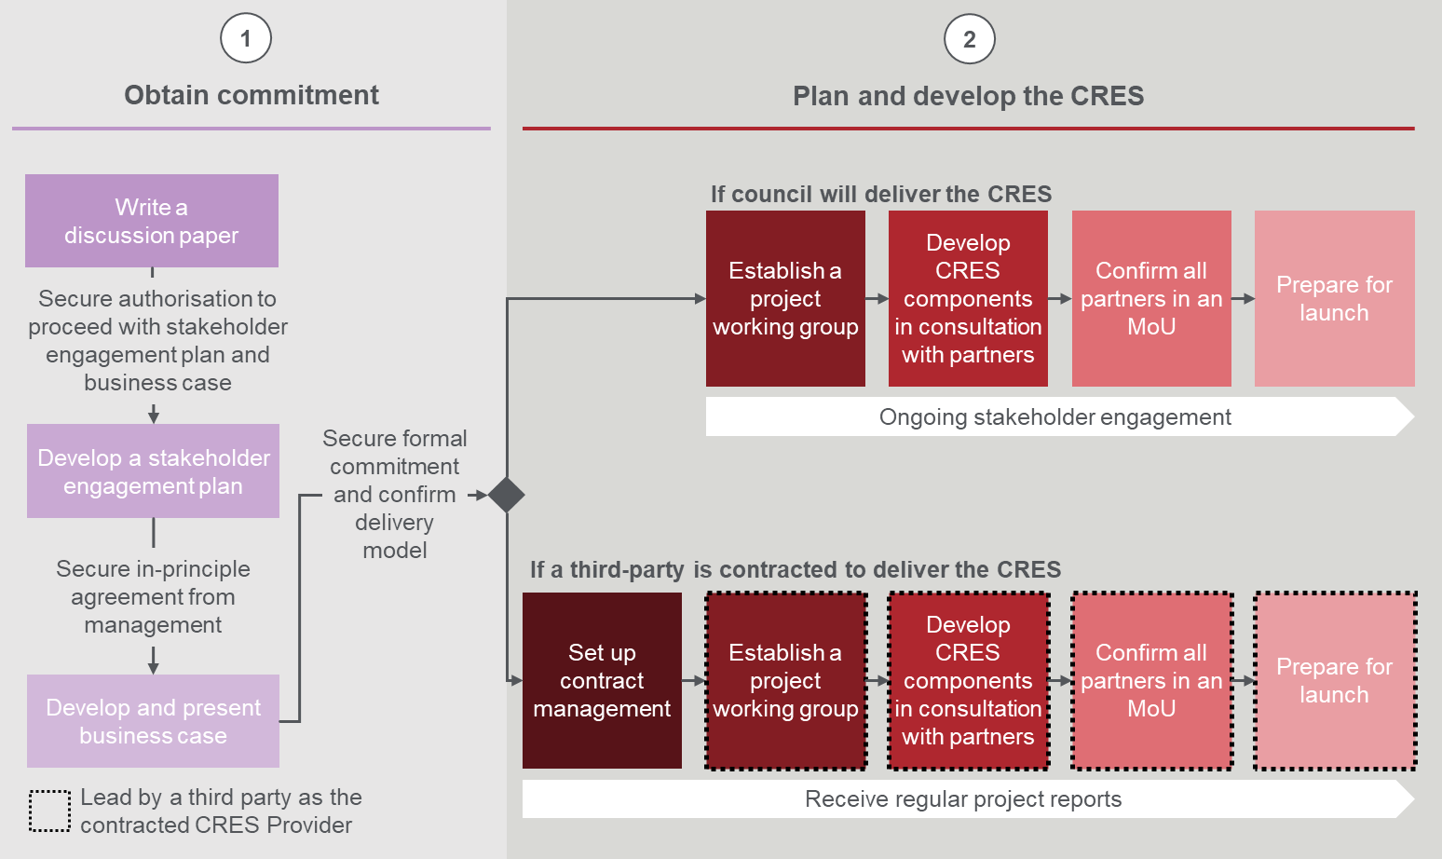

The demographics and demand for kindergarten places in [lga]
This section begins to build a case for the potential value of a CRES in your LGA. It should provide a snapshot of the kindergarten-aged population that will benefit from the CRES.

Demographics and demand for kindergarten in [LGA]
The population in [LGA name] has been [growing/static/reducing] and we expect the population of kindergarten-aged children will also [grow/remain the same/reduce] in the coming years, which will be confirmed in the business case research. These children and their families / carers and support networks will be the primary beneficiaries of a CRES in [LGA].
The Victorian Government is also rolling out funding for three-year-old kindergarten across the state with coverage of all municipalities from 2022. This will increase the demand and provision of kindergarten services around Victoria.
The Victorian Government also provides funding for children identified as vulnerable to attend 15 hours of free or low-cost kindergarten. There are two funding programs:
- Early Start Kindergarten (ESK) - enables children who are Aboriginal and/or Torres Strait Islander or known to Child Protection to attend 15 hours per week of free or low-cost kindergarten in a program two years before school.
- Kindergarten Fee Subsidy (KFS) - promotes kindergarten participation by enabling eligible children in funded three- and four-year-old groups to access up to 15 hours of kindergarten free of charge or at low cost. Children are eligible if they are Aboriginal and/or Torres Strait Islander children, refugees, multiple birth children, or children who hold (or have parents/carers who hold) valid concession cards.
In [LGA], [percentage] of our children are eligible for ESK or KFS funding. [Many/some/none] of these children attend kindergarten which indicates that a sizeable proportion are missing out. [Alternative: We do not have data on the proportion of high needs children attending kindergarten and will research this in the preparation of the business case]
There are also children who may not be eligible for ESK or KFS but face barriers to accessing kindergarten due to social, cultural and economic factors.

Delete the paragraph below if not relevant to your area.
There are also some children who attend kindergarten outside our LGA, typically at a place close to where a parent or guardian works, while we also have children who come from other LGAs as their parents work within [LGA]. There is also some movement across the boundary with our neighbouring LGAs, especially in [suburb names] as families / carers chose places close to their homes or schools. [Council name] does not currently have detailed figures on these and will collect as part of the business case research.

current kindergaRten service provision in [LGA name]
This section continues to build a case for the potential value of a CRES in your LGA. It should demonstrate how kindergarten service providers are currently operating and draw attention to the % of spaces vacant or filled in the last year.
Where a high % of kindergarten places are left unfilled, the case for CRES is that a centralised system will fill more places.
Where a demand exceeds supply and 100% of kindergarten places are filled, the case for CRES is that a centralised system will ensure vulnerable families / carers do not miss out on access to kindergarten.

In [LGA] there are [count of kindergartens] services and these provide approximately [count of places] places each week. These kindergartens are managed by a variety of organisations including [Delete as appropriate - our council, not-for-profit committees, EYMs, and private standalone providers]. A complete list of providers offering a funded kindergarten program is in Table 1 below. [Alternative: We do not have data on the proportion of kindergarten places that were filled or unfilled last year and will research this in the preparation of the business case]
You will not be able to engage with external service providers to get information for Table 1 at this stage. If you cannot find information internally to make Table 1 useful, you may remove it.
Table 1 | List of Kindergarten providers in [LGA name]
Service provider | Offering type | Total number of available spaces | % of spaces filled last year
Service provider name  Run by: council, not-for-profit committee, EYM, private standalone | Long day care/sessional/both long day care and sessional programs | 4-year-old: XX | 4-year-old: XX
 |  | 3-year-old: XX | 3-year-old: XX
Service provider name  Run by: council, not-for-profit committee, EYM, private standalone | Long day care/sessional/both long day care and sessional programs | 4-year-old: XX | 4-year-old: XX
 |  | 3-year-old: XX | 3-year-old: XX
Service provider name  Run by: council, not-for-profit committee, EYM, private standalone | Long day care/sessional/both long day care and sessional programs | 4-year-old: XX | 4-year-old: XX
 |  | 3-year-old: XX | 3-year-old: XX
Service provider name  Run by: council, not-for-profit committee, EYM, private standalone | Long day care/sessional/both long day care and sessional programs | 4-year-old: XX | 4-year-old: XX
 |  | 3-year-old: XX | 3-year-old: XX

Challenges of the present enrolment model
The present enrolment model presents problems for both families / carers and the kindergarten management.
For families / carers, the un-coordinated model means they must navigate the enrolment processes at multiple kindergartens in order to secure a place for their child. This requires monitoring the registration period for each kindergarten (they can be different) and then completing many, but near identical, registration forms.
This is even more challenging for families and carers experiencing vulnerability who may find it difficult to make their way through discordant and complex registration processes. These families and carers are also sometimes disengaged from the system and conventional methods of communication entirely. A more proactive approach to reach out to children in these environments is required.
Additionally, families often register for several sessions and/or at one kindergarten to ensure their child gets a place. This adversely impacts kindergarten management as there can be high rates of withdrawal as families secure their higher preference places. A centralised system means that there will be no duplication of registrations, and kindergarten management will can avoid running several rounds of offers.

The benefits of CRES for [lga]
This section is the final element to build a case for the potential value of a CRES in your LGA. It demonstrates the value that other councils get out of operating a CRES and can be used to highlight the potential benefits for your council. Focus on the benefits that will be of the greatest interest to your audience.

Benefits of Central Enrolment (CE) in other municipalities
More than half of the municipalities in Victoria currently operate what was known as a CE scheme including [adjacent / nearby Council/Shire]. In 2017, 63% of all kindergarten enrolments across Victoria were undertaken within a CE scheme. These councils provided a number of reasons for establishing CE as shown in Figure 3.
Councils operating a CRES do so through one of two commercial options: establish the function within council or contract the function to a third-party organisation (often a large EYM). These options each have strengths and weaknesses that will be discussed in the business case.
Figure 3 | Reasons councils implemented a CE scheme in their municipality (multiple answers could be selected)
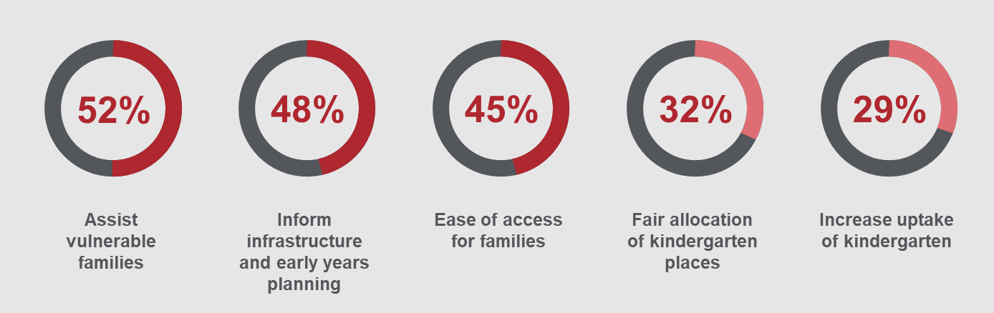

CRES can help deliver benefits to the community in line with [council name]’s current Council Plan and Early Years Plan
[Insert here text to explain which objectives in the current Council Plan and current Early Years Plan align with the objectives and outcomes of CRES.]
[Council name]’s involvement in designing and implementing a CRES will build on the success of CE in other municipalities and deliver a model tailored for [council name]’s objectives, resources and community.
In line with the objectives set out in the [council name] Council Plan and Early Years Plan, [council name] can prioritise the following potential benefits of a CRES:
[Note this list should be re-ordered, added to or streamlined to align with council’s current objectives]
- Assist vulnerable families: families / carers who are at risk of not enrolling their child in kindergarten can be registered in the CRES and eventually enrolled through routine engagements with services such as MCH and support services.
- Inform infrastructure, early years planning and investment: the recommended CRES annual cycle (refer to Figure 3) includes a stage for evaluation and future planning, during which Council can gather data on current and projected demand for early years services.
- Ease of access for families: a CRES enables families / carers to register for enrolment at the number of kindergartens with a single registration form. This minimises burden on parents to scope and enrol in multiple kindergartens to ensure a place.
- Fair allocation of kindergarten places: CRES ensures the Victorian Priority of Access criteria are applied so that children experiencing vulnerability or disadvantage have priority access to kindergarten. Additionally, children can also be prioritised based on locally agreed criteria.
- Increase uptake of kindergarten: the CRES seeks to find and register as many kindergarten-aged children as possible through a network of stakeholder relationships.
The CRES will also ease the burden on individual kindergartens so that they can run most effectively, and the value of council-owned facilities is maximised.
The scale of these benefits will be researched and compiled in the business case, along with a recommendation for the CRES model which will achieve the greatest benefit for [council name] and [LGA].

Weekly places are used to give a sense of scale. It does not factor for children enrolled in more than one kinder or session.
Kindergarten Central Enrolment: Current State Analysis, ACIL Allen (2018)

