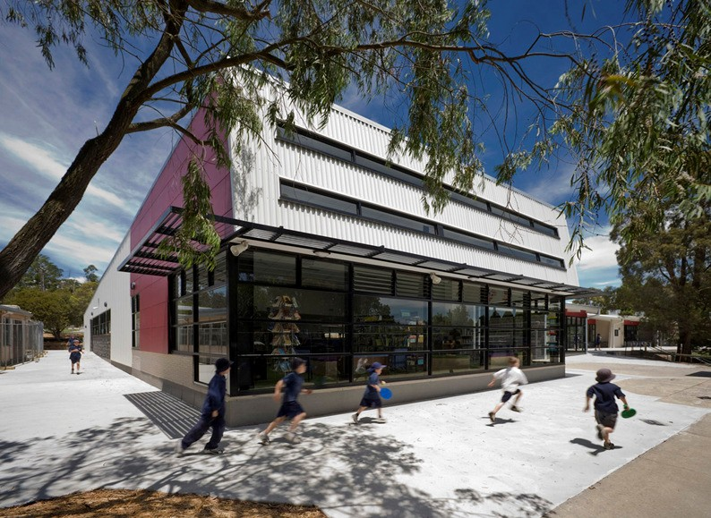
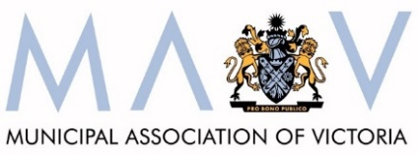
Partnership Agreement 2018-2023

Contents
1. Preamble 1
2. Aim 2
3. History of agreement 2
4. Principles 2
5. The partners 3
6. Obligations of the partners 4
7. Relationship to other Agreements 4
8. Managing difference 4
9. Monitor and review 4
10. Term of the agreement 5

Preamble
The Victorian Department of Education and Training (Department) and the Municipal Association of Victoria (MAV), on behalf of councils in Victoria, commit to this partnership agreement (Agreement) that is based on a spirit of cooperation and shared commitment to help ensure that every Victorian is given the best learning and development experience, making our state a smarter, fairer and more prosperous place.

The Victorian Government recognises that local government is a distinct and essential tier of government consisting of democratically elected councils having functions and powers that are necessary to ensure the peace, order and good government of each municipal district.

This Agreement recognises the collaborative relationship between the Department and councils in the planning, development and provision of education and early childhood services and the complementary roles played by the Victorian Government and councils in planning, funding and delivering a range of services.

This Agreement, together with the Victorian State-Local Government Agreement 2014, provides an overarching framework to guide current and future relationships, agreements and activities undertaken between the Department and MAV including but not limited to:

- agreements related to the operation of specific programs;
- funding arrangements between the Department and specific councils; and
- policies and plans at a statewide, regional or local level.
The parties intend to give effect to this Agreement but acknowledge that it does not create and must not be construed as creating a legally binding and enforceable contract.

Signed on the 30 day of March 2018, by:

Gill Callister
Secretary
on behalf of the Department of Education and Training

Rob Spence
Chief Executive Officer of the Municipal Association of Victoria on behalf of local councils in Victoria

Aim
This Agreement establishes a set of principles in relation to agreements, funding arrangements, plans and policies between the Department and MAV.

History of agreement
The Victorian Government has a strong, productive partnership with the Municipal Association of Victoria (MAV) and local councils.

The relationship between MAV and Early Childhood in particular has existed formally since 2002 (DHHS Partnership Protocol). Since 2008, the relationship between all state government agencies local government agencies has been underpinned by the Victorian State Local Government Agreement (VSLGA). On 6 August 2009, the initial Partnership Agreement was signed, building on the existing mutual support and collaboration in order to improve outcomes for children, young people and their families.

This version of the Partnership Agreement refreshes the 2013 version to consolidate the collaborative relationship between the Department and the MAV.

Principles
This Agreement is based upon a relationship between the parties emphasising cooperation and commitment to the following principles:

- understanding and respect for each party’s mandates and responsibilities;
- subject to relevant legislation and policies [i.e. Financial Management Act 2008], the transparency of financial relations between the Department and MAV in order to enhance decision making;
- mutual support of the other when making representations to the Commonwealth Government that have implications for the other level of government;
- awareness of the synergies between councils, MAV and the Department;
- the fostering of opportunities to work collaboratively;
- shared focus on sustaining and improving outcomes for children and families across all Victorian communities; and
- transparent and timely communication and consultation.

The partners

The Department
The Department of Education and Training brings together a range of learning and development services for Victorian children, young people and adults.

The Department’s responsibilities cover three overlapping life stages:

- Early childhood development (birth to eight) – covering health, learning and development services
- School education (five to eighteen) – covering primary, secondary and special school services for children and young people from Prep to Year 12
- Higher education and skills (fifteen and over) – covering higher education, vocational education and training, apprenticeships and traineeships, and adult, community and further education.
The Department notes that this Agreement is principally of relevance to the work that the Department carries out in conjunction or consultation with MAV in the fields of strategic planning, policy, infrastructure development and service delivery and coordination.

The Municipal Association of Victoria
The MAV, formed in 1879, is the legislated peak representative body for Victorian local government established by the Municipal Association Act 1907. The Act vests the MAV with the responsibility to promote the interests of and represent all 79 councils in Victoria. In this capacity, the MAV has negotiated and entered into this Agreement on behalf of all Victorian councils. The MAV is not a direct provider of education or early childhood services to the community.

As the sphere of local government in Australia, councils have legislative authority and community responsibility based on an electoral mandate to plan for local areas and ensure community health, well being and development. Local government has statutory authority to promote community-based planning and to negotiate resource allocation and service agreements with other spheres of government. In Victoria this authority is principally derived from the Victorian Local Government Act 1989, and any successor.

Victorian local government is acknowledged as a national leader in the provision of universal and targeted human services, which includes a significant investment in the planning, provision and coordination of family, youth and children’s services. Some of the services provided by councils are mandated by statute and others reflect identification of community need. In many cases these reflect a partnership with the Victorian Government.

Obligations of the partners
The Department and MAV agree to:

- engage in timely, cooperative and meaningful consultation and negotiation regarding the formulation of policies which affect the other party;
- relate to the other party in a manner that is coordinated and consistent;
- ensure that specific contracts, arrangements, policies and plans entered into or carried out by the parties are consistent with the Agreement;
- subject to privacy legislation and policies, share relevant data and information to inform strategic planning and service delivery;
- develop processes to promote a common understanding of mutual priority needs; and
- develop a process for review of the effectiveness of this Agreement with progress assessed twelve months from the date that the Agreement comes into effect.

Relationship to other agreements
This Agreement is not intended to supersede or alter existing contractual arrangements or other agreements between the Department and MAV or councils.

The Victorian State-Local Government Agreement
This Agreement was entered into by the Premier of Victoria (on behalf of the Victorian Government) and the President of the MAV (on behalf of local government in Victoria) on 10 September 2014 states over-arching principles for improving interaction between the Victorian Government and councils.

Supporting children and families in the early years: A Compact between Department of Education and Training, Department of Health and Human Services and Local Government (represented by MAV) 2017 – 2027
The Early Years Compact is a commitment to strengthen the collaborative relationship between these departments and local government in the planning, development and provision of early years services to improve outcomes for children (0 - 8 years) and families.

Managing difference
The parties agree:

- that they have legitimate differences in governance, roles and responsibilities
- to work constructively to honour the terms of the Agreement
- that in the event of a party stating that one or more undertakings in the Agreement is not being fulfilled, the parties will use best endeavours to ensure that the undertaking is satisfied or that an alternative solution is agreed.

Monitor and review
The parties agree to monitor the implementation of the Agreement and review its effectiveness after the first/second year of operation and following that, as agreed on a joint basis.

Term of the agreement
This agreement will have a five year term, commencing from the date of signing.

