

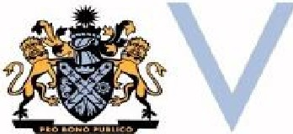

MUNICIPAL ASSOCIATION OF VICTORIA
HDE UCATIO� TATE
IA I
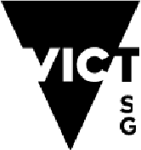
ment
tote
OR
overn
Department of Education



Partnership Agreement 2024-2027

Contents
Preamble 4
Aim 5
History of agreement 5
Principles 5
The partners 6
The department 6
The Municipal Association of Victoria 6
Obligation of the partners 7
Relationship to other agreements 7
The Victorian State-Local Government Agreement 7
Supporting children and families in the early years: A Compact between Department of Education, Department of Families, Fairness and Housing and Local Government (represented by MAV) 2017 – 2027 8
Managing difference 8
Planning, monitoring and review 8
Term of the agreement 8


© State of Victoria (Department of Education) 2024
The Department of Education and Municipal Association of Victoria Partnership Agreement is provided under a Creative Commons Attribution 4.0 International licence. You are free to re-use the work under that licence, on the condition that you credit the State of Victoria (Department of Education), indicate if changes were made and comply with the other licence terms, see: Creative Commons Attribution 4.0 International
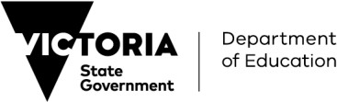
The licence does not apply to:
- any images, photographs, trademarks or branding, including the Victorian Government logo and the DE logo; and

© State of Victoria (Department of Education) 2024


The Department of Education and Municipal Association of Victoria Partnership Agreement is provided under a Creative Commons Attribution 4.0 International licence. You are free to re-use the work under that licence, on the condition that you credit the State of Victoria (Department of Education), indicate if changes were made and comply with the other licence terms, see: Creative Commons Attribution 4.0 International
The licence does not apply to:
- any images, photographs, trademarks or branding, including the Victorian Government logo and the DE logo; and

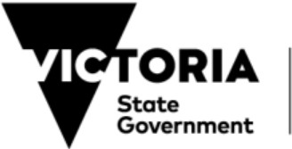
Deportment of Education

Preamble
The Victorian Department of Education (the department) and the Municipal Association of Victoria (MAV), on behalf of councils in Victoria, commit to this partnership agreement (the Agreement) that is based on a spirit of cooperation and reflects a shared commitment to help ensure that every Victorian is given the best learning and development experience, making our state a smarter, fairer and more prosperous place.
The Victorian Government recognises that local government is a distinct and essential tier of government consisting of democratically elected councils having functions and powers that are necessary to ensure the peace, order, and good government of each municipal district.
This Agreement recognises the collaborative relationship between the department and councils in the planning, development and provision of education and early childhood services and the complementary roles played by the Victorian Government and councils in planning, funding and delivering a range of services.
This Agreement, together with the Victorian State-Local Government Agreement 2014, provides an overarching framework to guide current and future relationships, agreements and activities undertaken between the department and MAV including but not limited to:
- agreements related to the operation of specific programs;
- funding arrangements between the department and specific councils; and
- policies and plans at a statewide, regional or local level.
The parties intend to give effect to this Agreement but acknowledge that it does not create and must not be construed as creating a legally binding and enforceable contract.

Signed on the 16th day of October 2024
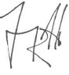

Jenny Atta
Secretary
on behalf of the Department of Education and Training

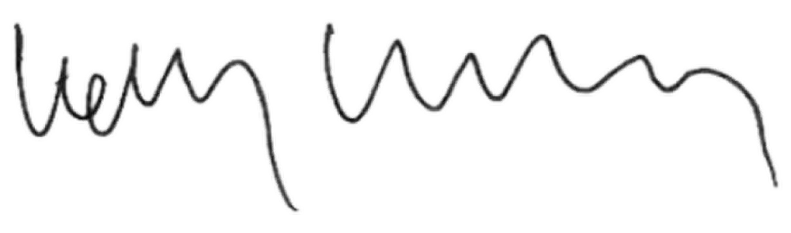

Kelly Grigsby
Chief Executive Officer of the Municipal Association of Victoria on behalf of local councils in Victoria

Aim
This Agreement establishes a set of principles in relation to agreements, funding arrangements, plans and policies between the department and MAV.

History of agreement
The Victorian Government has a strong, productive partnership with the MAV and local councils. Since 2008, the relationship between all state government agencies and local government agencies has been underpinned by the Victorian State Local Government Agreement (VSLGA).
On 6 August 2009, the first Partnership Agreement specifically between the department and the MAV was signed, building on existing mutual support and collaboration to improve outcomes for children, young people and their families.
On 28 April 2017, the Department of Education and Training, the MAV and the former Department of Health and Human Services (DHHS) entered a ten-year Compact with Local Government (represented by MAV): Supporting Children and Families in the Early Years – A Compact between DE, DHHS and Local Government 2017- 2027 (the Early Years Compact)
The support demonstrated by local councils across Victoria towards the delivery of early childhood education and care is deeply valued by local communities and by the Victorian Government.
The Victorian Government recognises that maintaining strong, ongoing partnerships with local governments is critical to the successful implementation of a long-standing reform agenda and future reforms.
This version of the Agreement refreshes the 2018 - 2023 Partnership Agreement and consolidates the collaborative relationship between the department and the MAV.

Principles
This Agreement is based upon a relationship between the parties emphasising cooperation and commitment to the following principles:
- understanding and respect for each party’s mandates and responsibilities
- subject to relevant legislation and policies [i.e., Financial Management Act 2018], the transparency of financial relations between the department and MAV to enhance decision making
- mutual support, where appropriate, of the other when making representations to the Commonwealth Government that have implications for the other level of government
- awareness of the synergies between councils, MAV and the department
- the fostering of opportunities to work collaboratively
- shared focus on sustaining and improving outcomes for children and families across all Victorian communities; and
- transparent and timely communication and consultation.

The partners

The department
The Department of Education (the department) brings together a range of learning and development services for Victorian children and young people.
The department’s responsibilities cover two overlapping life stages:
- Early childhood development (birth to 8) – covering early years learning and development, including early childhood education and care services
- School education (5 to 18) – covering primary, secondary and special school services for children and young people from Prep to Year 12.
The department notes that this Agreement is principally of relevance to the work that the department carries out in conjunction or in consultation with the MAV in the fields of strategic planning, policy, reforms, infrastructure development and service delivery and coordination.

The Municipal Association of Victoria
The MAV, formed in 1879, is the legislated peak representative body for Victorian local government established by the Municipal Association Act 1907. The Act vests the MAV with the responsibility to promote the interests of and represent all 79 councils in Victoria. In this capacity, the MAV has negotiated and entered into this Agreement on behalf of all Victorian councils. The MAV is not a direct provider of education or early childhood services to the community.
Today, the MAV is a driving and influential force behind a strong and strategically positioned local government sector. The MAV’s role is to represent and advocate the interests of local government; raise the sector's profile; ensure its long-term security; facilitate effective networks; support Councillors; provide policy and strategic advice; capacity building programs; and insurance services to local government.
As the sphere of local government in Australia, councils have legislative authority and community responsibility to plan for local areas and ensure community health, wellbeing, and development. Local government has statutory authority to promote community-based planning and to negotiate resource allocation and service agreements with other spheres of government. In Victoria this authority is principally derived from the Victorian Local Government Act 2020.
Victorian local government is acknowledged as a national leader in the provision of universal and targeted human services. This includes a significant investment in the planning, provision, and coordination of family, youth, and children’s services. Some of the services provided by councils are mandated by statute and others reflect identification of community need. In many cases these reflect a partnership with the Victorian Government.

Obligation of the partners
The department and the MAV agree to:
- engage in timely, cooperative, and meaningful consultation and negotiation regarding the formulation of policies which affect the other party.
- relate to the other party in a manner that is coordinated and consistent.
- ensure that specific contracts, arrangements, policies, and plans entered or carried out by the parties are consistent with the Agreement.
- subject to privacy legislation and policies, share relevant data and information to inform strategic planning and service delivery.
- develop processes to promote a common understanding of mutual priority needs, and
- develop a process for planning and for review of the effectiveness of this Agreement with progress assessed every twelve months from the date that the Agreement comes into effect.

Relationship to other agreements
This Agreement is not intended to supersede or alter existing contractual arrangements or other agreements between the department and the MAV or councils.

The Victorian State-Local Government Agreement
This Agreement was entered into by the Premier of Victoria (on behalf of the Victorian Government) and the President of the MAV (on behalf of local government in Victoria) on 10 September 2014 and states over-arching principles for improving interaction between the Victorian Government and councils.
Agreed Principles under the Victorian State-Local Government Agreement are as follows:
- Relations between state and local government should be conducted in a spirit of mutual respect with an emphasis on improving communication and cooperation.
- Local government is accountable to its local communities and its operational autonomy is recognised and supported.
- The Victorian Government is accountable to the people of Victoria and its state-wide obligations are recognised.
- The diversity of local government’s financial capacity and the Victorian Government’s fiscal position should be mutually recognised.
- The transparency of the financial relations between state and local government should be improved to enhance decision making. The Victorian Government commits to reporting its financial relationships with local government in its annual Budget.
- The use of intergovernmental agreements should be promoted to ensure that roles and responsibilities are clearly articulated and full financial considerations are made.
- State and local government recognise the value in seeking the support of the other when making representations to the Commonwealth Government that have implications for another level of government.
- Local government recognises that it is responsible for significant community assets and commits to sound public governance through good financial and asset management reporting.
- Collaboration and cooperation of local governments with each other to support initiatives such as regional or sub-regional development should be encouraged.

Supporting children and families in the early years: A Compact between Department of Education, Department of Families, Fairness and Housing and Local Government (represented by MAV) 2017 – 2027
The Early Years Compact is a ten-year commitment to strengthen the collaborative relationship between these departments and local government in the planning, development and provision of early years services to improve outcomes for children (0 - 8 years) and families. Current signatories include the former Department of Education and Training (now Department of Education), MAV and the Department Families, Fairness and Housing, which previously encapsulated Maternal and Child Health (MCH). While Department of Health is not a formal signatory, officials understand and support the role of MCH in the Compact.
The Early Years Compact provides a common set of principles to support how the parties will work together to improve coordination, collaboration, information sharing and accountability to improve the outcomes for all young children and their families. Compact Area Groups have focussed their efforts on coordinating efforts to improve access and participation for priority cohorts. These include children known to child protection, children in out-of-home care, Aboriginal and Torres Strait Islander children and families, and children and families at risk of or experiencing family violence.

Managing difference
The parties agree:
- that they have legitimate differences in governance, roles and responsibilities.
- to work constructively to honour the terms of the Agreement.
- that in the event of a party stating that one or more undertakings in the Agreement is not being fulfilled, the parties will use best endeavours to ensure that the undertaking is satisfied or that an alternative solution is agreed.

Planning, monitoring and review
The Agreement is supported by the Municipal Association of Victoria Service Plan for ECE Activity
which plan which details funding to the MAV for key early years initiatives.

Term of the agreement
This Agreement will have a four-year term (2024 – 2027), commencing from the date of signing.

