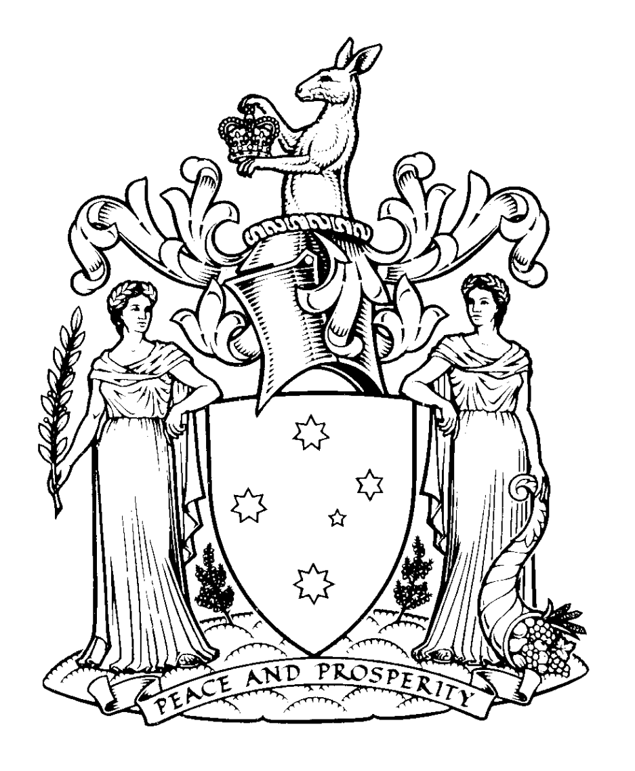

OFFICIAL MINISTERIAL OVERSEAS TRAVEL
Outcomes Report

The provision of the information below is consistent with the Guidelines for Official Ministerial Overseas Travel. This report must be sent to the Premier within 40 working days of return, and published on the relevant department website within 60 working days of the Minister’s return. The published version of the report does not need to include the ’next steps / follow up’ section or the signature block.

Name of Department / Agency | Department of Education and Training
Departmental / Agency Contact | Joel Backwell
Telephone Number | 9637 5381
TRAVEL DETAILS
Minister’s Name | Jenny Mikakos
Portfolio/s | Families and Children, Minister for Youth Affairs
Did the Minister’s spouse accompany the Minister in an official capacity?  If Yes – please outline the role of the spouse in achieving the outcomes of the visit |  |  | NO
Accompanying Ministerial staff | Jacob Clifton, Chief of Staff, Minister for Families and Children
Countries visited | China
Date of travel | 3—9 July 2016
Number of official travel days (include day of departure and day of return) | 7 days
Funding source (list Department/s or Agency) | DET with contribution from DHHS.
EXPENSES  Include combined expenses for Minister, accompanying staff and spouse (if accompanying in an official capacity) |  | $
Air fares (including taxes and fees) |  | 19,382
Accommodation (including taxes and fees) |  | 2,009
Other expenses (including surface travel and travel allowances) |  | 645
Travel cost for Minister and ministerial staff (and spouse or de facto partner if applicable) |  | 22,036
Are the above costs final and complete? |  | YES

Context
The Andrews Labor Government has embarked upon an ambitious reform agenda to make Victoria the Education State. The aim is to give every Victorian child the opportunity to succeed in life, regardless of background, place or circumstance.
This starts with early childhood education. Research shows that the first years of life are crucial to lifelong learning, wellbeing and success. I am committed to strengthening early childhood services, including kindergarten, for Victorian children and families.
Our Government has also made a commitment to building stronger economic and people-to-people links with China, and to ensuring Victorian learners have the requisite skills to be culturally-aware, active global citizens in an increasingly complex and inter-connected world.
Challenges
In terms of ensuring all Victorians benefit from early childhood education, key focuses are:
- supporting participation in kindergarten for all children, with extra support for those experiencing vulnerability and disadvantage, who are less likely to attend, and for those with additional needs
- supporting the drivers of quality in early childhood education, as research indicates that the long term benefits of kindergarten are linked to quality.

A global outlook is also essential to providing our learners with the skills they will need to succeed in the future, in terms of both engaging with other countries to develop best practice and connecting our learners with the rest of the world. Government has an important role to play in forging these relationships and creating linkages with other countries, from which future engagement will flow.
Purpose of travel
From 3-9 July 2016, I travelled to China with the Deputy Premier and Minister for Education, James Merlino MP. The purpose of our travel to China was to:
- Strengthen the bilateral relationship between Victoria and China, in line with the Victorian Government’s new China Strategy ‘partnerships for prosperity’ and, in particular, to lay the foundation for a Sister State Agreement with Sichuan Province prior to the Premier travelling there in September 2016.
- Support the strong education relationships Victoria has with China, including through the Memorandum of Understanding with the Chinese Ministry of Education, our collaboration on a range of programs at a provincial/ municipal level and the support Victoria receives for Chinese language learning in its schools.
- Continue to build people-to-people links between Victoria and China, including the many existing and potential sister school partnerships, teacher exchanges and curriculum collaborations (including offshore Victorian Certificate of Education delivery).
- Promote Victoria as a destination for Chinese international students, supporting the aims of the Government’s International Education Sector Strategy. In particular, this involved highlighting the State’s liveability credentials, high quality education and early childhood system, and safe and diverse community.
- Share information to strengthen whole-of-life education outcomes for children in both of our jurisdictions, including:
  - maternal and child health, early childhood, primary and secondary education
  - intercultural understanding, language learning, STEM and critical thinking.
Itinerary
Over five days on the ground, the Deputy Premier and I visited the cities of Shanghai, Beijing, Chengdu and Tianjin. I attended 11 meetings with a range of senior government officials and practitioners, visited four high-quality kindergartens, to compare best practice between Chinese and Victorian service delivery models, and addressed three receptions for Victorian Alumni and students about the importance of early childhood education to the success of the Education State.
I met with leaders from academia, government and the education sector and gained significant insights into early childhood education in China, including curriculum and research directions. I also met with a peak youth body in Tianjin, Melbourne’s sister city, and discussed youth engagement, exchange and entrepreneurship – topics of relevance to my Youth Affairs portfolio.
While the Chinese early childhood education sector operates very differently to Victoria’s, there are areas of mutual interest, such as a growing focus on play-based learning and a commitment to equity of access, including for children in regional areas and those with additional needs. There was also interest in the recently revised Victorian Early Years and Development Framework.
I found there is considerable opportunity to engage with China in the early childhood space, at both the research, policy and practice levels.
Further details about key meetings and outcomes are contained below. A list of the main representatives with whom I met is at Appendix one.

Benefits of travel to the State of Victoria
The meeting and activities undertaken during this trip directly supported the following directions of the Victorian Government’s China Strategy ‘Partnerships for Prosperity’:
- Establishing Victoria as Australia’s centre of excellence for Asia insights and capabilities
- Building connections through reciprocal cultural partnerships and by establishing new platforms for people-to-people engagement
- Strengthening government alliances within China’s economic development zones
The visit also supported the Victorian Government’s vision for Victoria, the Education State, where we are recognised nationally and internationally for the skills, knowledge, expertise and outlook of our people and as a place where our innovation and pursuit of new knowledge, skills and jobs draws others to live, work and invest.
The visit produced several new agreements and partnerships, trade outcomes, and new initiatives to increase collaboration between our jurisdictions, and identified further opportunities to collaborate in future. In particular, I announced two significant new initiatives:
- A partnership with Sichuan Province – Victoria’s future Sister State – for cooperation in the area of early childhood education and development.
- The establishment of the China-Victoria Early Childhood Educational Engagement Program, a partnership with the Chinese Ministry of Education. Under this program, early childhood experts, educators and policy makers will exchange research and knowledge.
Objective 1: Strengthen the bilateral relationship between Victoria and China
- In Chengdu I signed the Addendum to the Memorandum of Understanding between Victoria and Sichuan Province – Victoria’s future Sister State – for cooperation in the area of early childhood education and development. This is the first such arrangement relating to early childhood between Victoria and China. It will facilitate the exploration of mutually beneficial opportunities to collaborate on early childhood research, educator professional development and partnerships between service providers.
- In Tianjin, I met with the Tianjin Youth Federation to discuss youth leadership programs in Victoria and Tianjin, and civic engagement in Melbourne’s sister city. The Federation has a membership of 575 youth organisations based in Tianjin.
- In Tianjin, I attended a reception hosted by Melbourne City Council, with the Deputy Premier, to acknowledge their sister city relationship with Tianjin. The event also involved RMIT, which has a presence in Tianjin, as well as key decision makers, education agents and other friends of Victoria.
Objective 2: Support the strong education relationships Victoria has with China
- In Beijing, the Deputy Premier and I met with the Chinese Ministry of Education, to discuss a draft Memorandum of Understanding between the Victorian Department of Education and Training and the Chinese Ministry of Education – the fifth such agreement in a close collaboration dating back almost thirty years. As part of these discussions, we considered possibilities for future collaboration in early childhood development.
- In Chengdu, the Deputy Premier and I met with the Chengdu Education Bureau to discuss areas of future collaboration in education, including early childhood education.
Objective 3: Continue to build provider and people-to-people links
- In Chengdu I visited a publicly funded service, Chengdu No. 3 Kindergarten, a flagship kindergarten service in the municipality, to compare Chengdu’s early childhood education system to that of Victoria’s, and to discuss opportunities for collaboration.
- In Chengdu, I also met with leading private providers, the Chengdu Golden Apple Group and Cathay Future Education Group, to discuss kindergarten delivery models and the potential for future collaboration with Victorian kindergartens.
Objective 4: Promote Victoria as a destination for Chinese international students
- The Deputy Premier and I hosted two significant evening receptions in Beijing and Shanghai. These “Victorian Connection” events were designed to promote Victoria to education agents, the Victorian alumni, prominent members of government and industry and other ‘friends of Victoria’. It also gave us the opportunity to promote the new relationships we were forging with China in the areas of early childhood education. At these two events, the Deputy Premier made significant announcements aimed to promote Victoria as a destination for Chinese international students:
  - The Deputy Premier announced the Chinese language ‘study.vic’ website, as part of the Victoria-China Digital Connections Package, to make it easier for prospective Chinese international students to learn about and enrol in our school system.
  - The Deputy Premier announced the employment by DET and the Victorian Curriculum and Assessment Authority (VCAA) of a staff member, to be based in Shanghai, who will support the recruitment of Chinese international students in addition to other work to build education connections between Victoria and China.
  - The Deputy Premier announced the results of a competition to support two Chinese students, each accompanied by one parent, to travel to Victoria on a study tour and later be champions for Victorian education upon their return to China. The competition winners visited Victoria in August 2016 and their visit was promoted in China through DET’s Chinese-language media channels.
Objective 5: Share information to strengthen whole-of-life education outcomes
- In Beijing, I met with representatives of the Beijing Normal University. At this meeting, I discussed the establishment of the China-Victoria Early Childhood Educational Engagement Program, a partnership with the Chinese Ministry of Education. Under this program, early childhood experts, educators and policy makers will exchange research and knowledge. I have approved funding of $50,000 to establish the program.
- In Shanghai I visited Kids’R’Kids Learning Academy Shanghai, a high quality service provider which is connected to the prestigious East China Normal University, to exchange knowledge about early childhood education in Victoria and Shanghai.
- At all of my appointments with government officials, I discussed Victoria’s commitment to being Australia’s Education State. I shared Victoria’s expertise across a range of educational areas, and discussed with my Chinese colleagues areas where they excel. These discussions included maternal and child health, early childhood, primary and secondary education.

Next Steps / Follow Up

Premier’s travel to China in September
- Support the educational component of the Premier’s upcoming travel to China, including by leveraging relationships built through my travel and following up on the early childhood initiatives that I announced while in China.
Promote Victorian capabilities in early childhood education
- The Department of Education and Training has initiated discussions with the University of Melbourne for developing a joint research partnership with Beijing Normal University. This initiative will be included in a “Victoria-China: Learning Together” brochure on Victoria’s educational capabilities that is being developed by the Department of Economic Development, Jobs, Trade and Resources for the Premier’s trip.

Further strengthen key relationship with Victoria’s future Sister State, Sichuan Province
- The Department of Education and Training is working with the Victorian Government Business Office in Chengdu to begin implementation of the Addendum to the Memorandum of Understanding agreement with Sichuan Province.

Noted by Acting Department Secretary
(Signature)
Name
Date | / /
Approved by Minister
(Signature)
Name
Date | / /

Appendix one

Representatives with whom I met during official travel to China, included:

Early Childhood Education and Care
- JoAnn Peterson – Executive Principal, Kids ’R’ Kids Learning Academy, East China Normal University Campus
- Gao Xiang- Principal, Chengdu No.3 Kindergarten
- Huang Ping – Deputy Principal, Chengdu No. 3 Kindergarten
- Chenling Xia – General Manager, Golden Apple Education Investment Group
- Qizhi Li – Deputy General Manager, Golden Apple Education Investment Group
- Ping Meng – Deputy General Manager, Golden Apple Education Investment Group
- Liu Yang – Principal, Golden Apple Art Training School for Children
- Nigel Stewart Jones – Director, Golden Apple Preschool Education Group International Education Exchange Centre
- Jin Xu – Principal, Golden Apple International English Kindergarten
- Chen Xiaoming – Principal, Beijing No. 6 Kindergarten
- Zhao Qian – Board Chairman, Cathay Future Education Group
- Christine Liang – General Manager, Shanghai Children’s Art Theatre (Shanghai lunch)

Education
- Tracy Wang – Branch Manager, IDP Promising Education, Shanghai (Shanghai lunch)
- Sebastian Sun – Dean, Paramitta Institute of Culinary and Hospitality, Shanghai Industrial & Commercial Polytechnic (Shanghai lunch)
- Dr Wang Xiaoming – Director General, Shanghai Science and Technology Museum (Shanghai lunch)

Intergovernmental collaboration
- Fang Jun – Deputy Director, Department of International Cooperation and Exchanges, Chinese Ministry of Education
- Dai Zuoan – Deputy Director General, Education Department of Sichuan Province
- Lin Yifan- Director, Early Childhood Division, Chengdu Education Bureau

International engagement
- Justin Hayhurst – Deputy Head of Mission, Australian Embassy Beijing
- Katherine Vickers – Minister-Counsellor (Education and Research), Australian Embassy Beijing
- Wang Luning – Executive Vice President, Shanghai Overseas Returned Scholars Association (Shanghai lunch)

Research
- Professor Zhou Zuoyu – Vice President, Beijing Normal University
- Dr Du Jigang - Deputy Director, Institute of Early Childhood Education, Beijing Normal University; Deputy Director, Committee of Curriculum and Instruction, China National Society of Early Childhood Education
- Associate Professor Liu Qiang – Assistant Dean, Institute of International and Comparative Education, Faculty of Education, Beijing Normal University
- Professor Zhang Minxuan – Shanghai PISA NPM, Shanghai Normal University (Shanghai lunch)

Youth engagement:
- Wang Feng - Deputy Secretary, Tianjin Youth Federation

