Victorian Early Years Awards Communications Kit

The Victorian Early Years Awards (VEYA) celebrate the outstanding work of our early childhood education professionals to improve the health, learning, development and wellbeing of Victorian children and their families.

There are seven award categories with winners in each category receiving a grant of up to $15,000 for professional development or to support their initiative. The finalists in each category are also eligible to win the prestigious Minister’s Award, selected by the Minister for Early Childhood.

Help us spread the word about this year’s VEYA and encourage nominations to recognise the early childhood sector.

Thank you for your support.

Promotional posters
Included is a digital poster and flyer with details on this year’s Awards, including how people can get more information about the nomination process. Click the links below to download the PDFs to print and display or share electronically.
A3 Poster | A4 Flyer
2021 Victorian Early Year Awards A3 poster (PDF) | 2021 Victorian Early Year Awards A4 flyer (PDF)
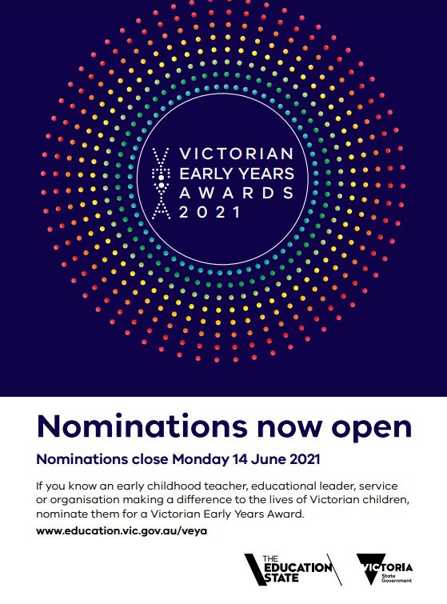 | 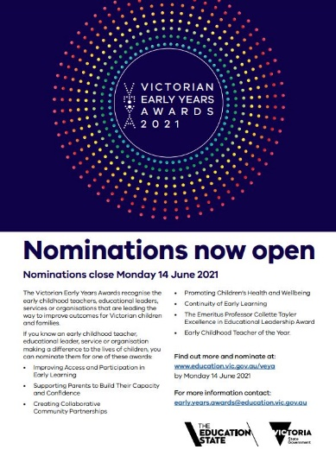

Social media tiles
We encourage you to share information about VEYA on your social media channels, such as Twitter, Facebook and LinkedIn, and link to: www.education.vic.gov.au/veya
Social media tile name | Social media tile image
Nominations now open | 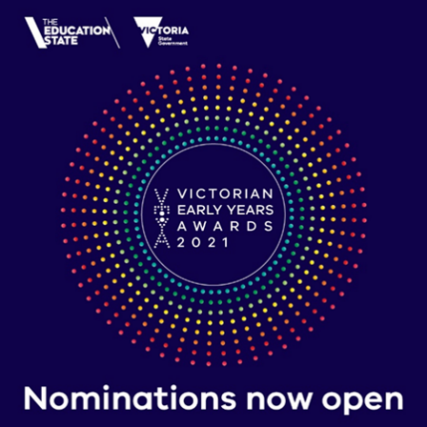
Nominations closing soon | 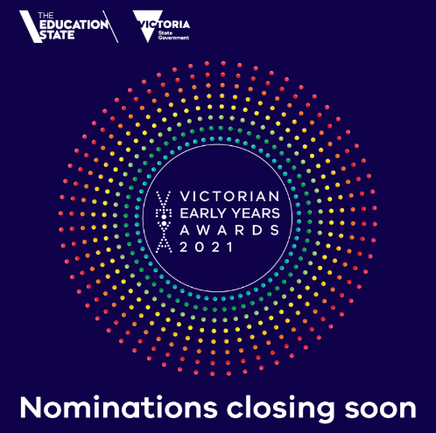

Suggested social media posts

Twitter
Post | Copy | Social media tile
Nominations now open! | Recognise an early childhood teacher, educational leader, early childhood service or organisation that is making a difference in the lives of Victorian children and their families by nominating them for a VEYA today!  www.education.vic.gov.au/veya | Twitter tile (nominations now open)
Nominations close soon! | Don’t let the great work of the early childhood education workforce go unnoticed. Nominate them for a Victorian Early Years Award by 14 June.  www.education.vic.gov.au/veya | Twitter tile (nominations closing soon)

Facebook
Post # | Copy | Social media tile
Nominations now open! | Nominations for the 16th annual Victorian Early Years Award are now open!  Recognise the great work of early childhood teachers, educational leaders, services, organisation or projects by submitting a nomination by 14 June.  More info: www.education.vic.gov.au/veya | Facebook tile (nominations now open)
Nominations close soon! | Don’t miss the chance to nominate an early childhood teacher, educational leader, service or organisation that is making a difference to improve the health, learning and wellbeing of Victorian children and their families.  Victorian Early Year Awards winners will receive up to $15,000 towards professional development or to further develop their winning initiative.  Nominations close 14 June.  More info: www.education.vic.gov.au/veya | Facebook tile (nominations closing soon)

LinkedIn
Post | Copy | Social media tile
Nominations now open! | The Victorian Early Year Awards recognise the hard work and dedication of the early childhood education sector.  Winners across seven categories will receive up to $15,000 towards professional development or to further develop their initiative.  Nominate yourself, a colleague, individual, early childhood service, organisation or initiative helping give every Victorian the best start in life.  Submit a nomination today: www.education.vic.gov.au/veya | LinkedIn tile (nominations now open)
Nominations close soon! | You have until 14 June to submit a nomination for the 2021 Victoria Early Years Awards.  Don’t let the great work of the early childhood education workforce go unnoticed. Recognise yourself, a colleague, individual, early childhood service or organisation, or initiative helping Victorian children and their families.  There are seven award categories. Winners will receive up to $15,000 towards professional development or to further develop their winning initiative.  More info: www.education.vic.gov.au/veya | LinkedIn tile (nominations closing soon)

Suggested newsletter copy

Nomination are now open for the 16th annual Victorian Early Year Awards!

Early childhood professionals play a vital role to give Victorian children the best start in life. Their dedication and hard work is set to be celebrated at the Department of Education and Training Victorian Early Year’s Awards.

Now in its 16th year, the Victorian Early Year’s Awards recognise individuals, early childhood services, organisations and initiatives that are helping Victorian children and their families through leadership and innovation.

There are seven award categories:
- Improving Access and Participation in Early Learning
- Supporting Parents to Build Their Capacity and Confidence
- Creating Collaboration Community Partnerships
- Promoting Children’s Health and Wellbeing
- Continuity of Early Learning
- Emeritus Professor Collette Tayler Excellence in Educational Leadership Award
- Early Childhood Teacher of the Year.

Winners of each category will receive a grant of up to $15,000 for professional development or to support their early childhood initiative. The finalists in each category are also eligible to win the prestigious Minister’s Award, selected by the Minister for Early Childhood.

Nominations are open until 14 June 2021. You can submit your nomination by visiting www.education.vic.gov.au/veya. For questions regarding the nomination application, contact the Department of Education and Training’s Early Years Awards team at early.years.awards@education.vic.gov.au.

​
© State of Victoria (Department of Education and Training) 2021. Except where otherwise noted, material in this document is provided under a
Creative Commons Attribution 4.0 International Please check the full copyright notice

