Real Training for Real Jobs

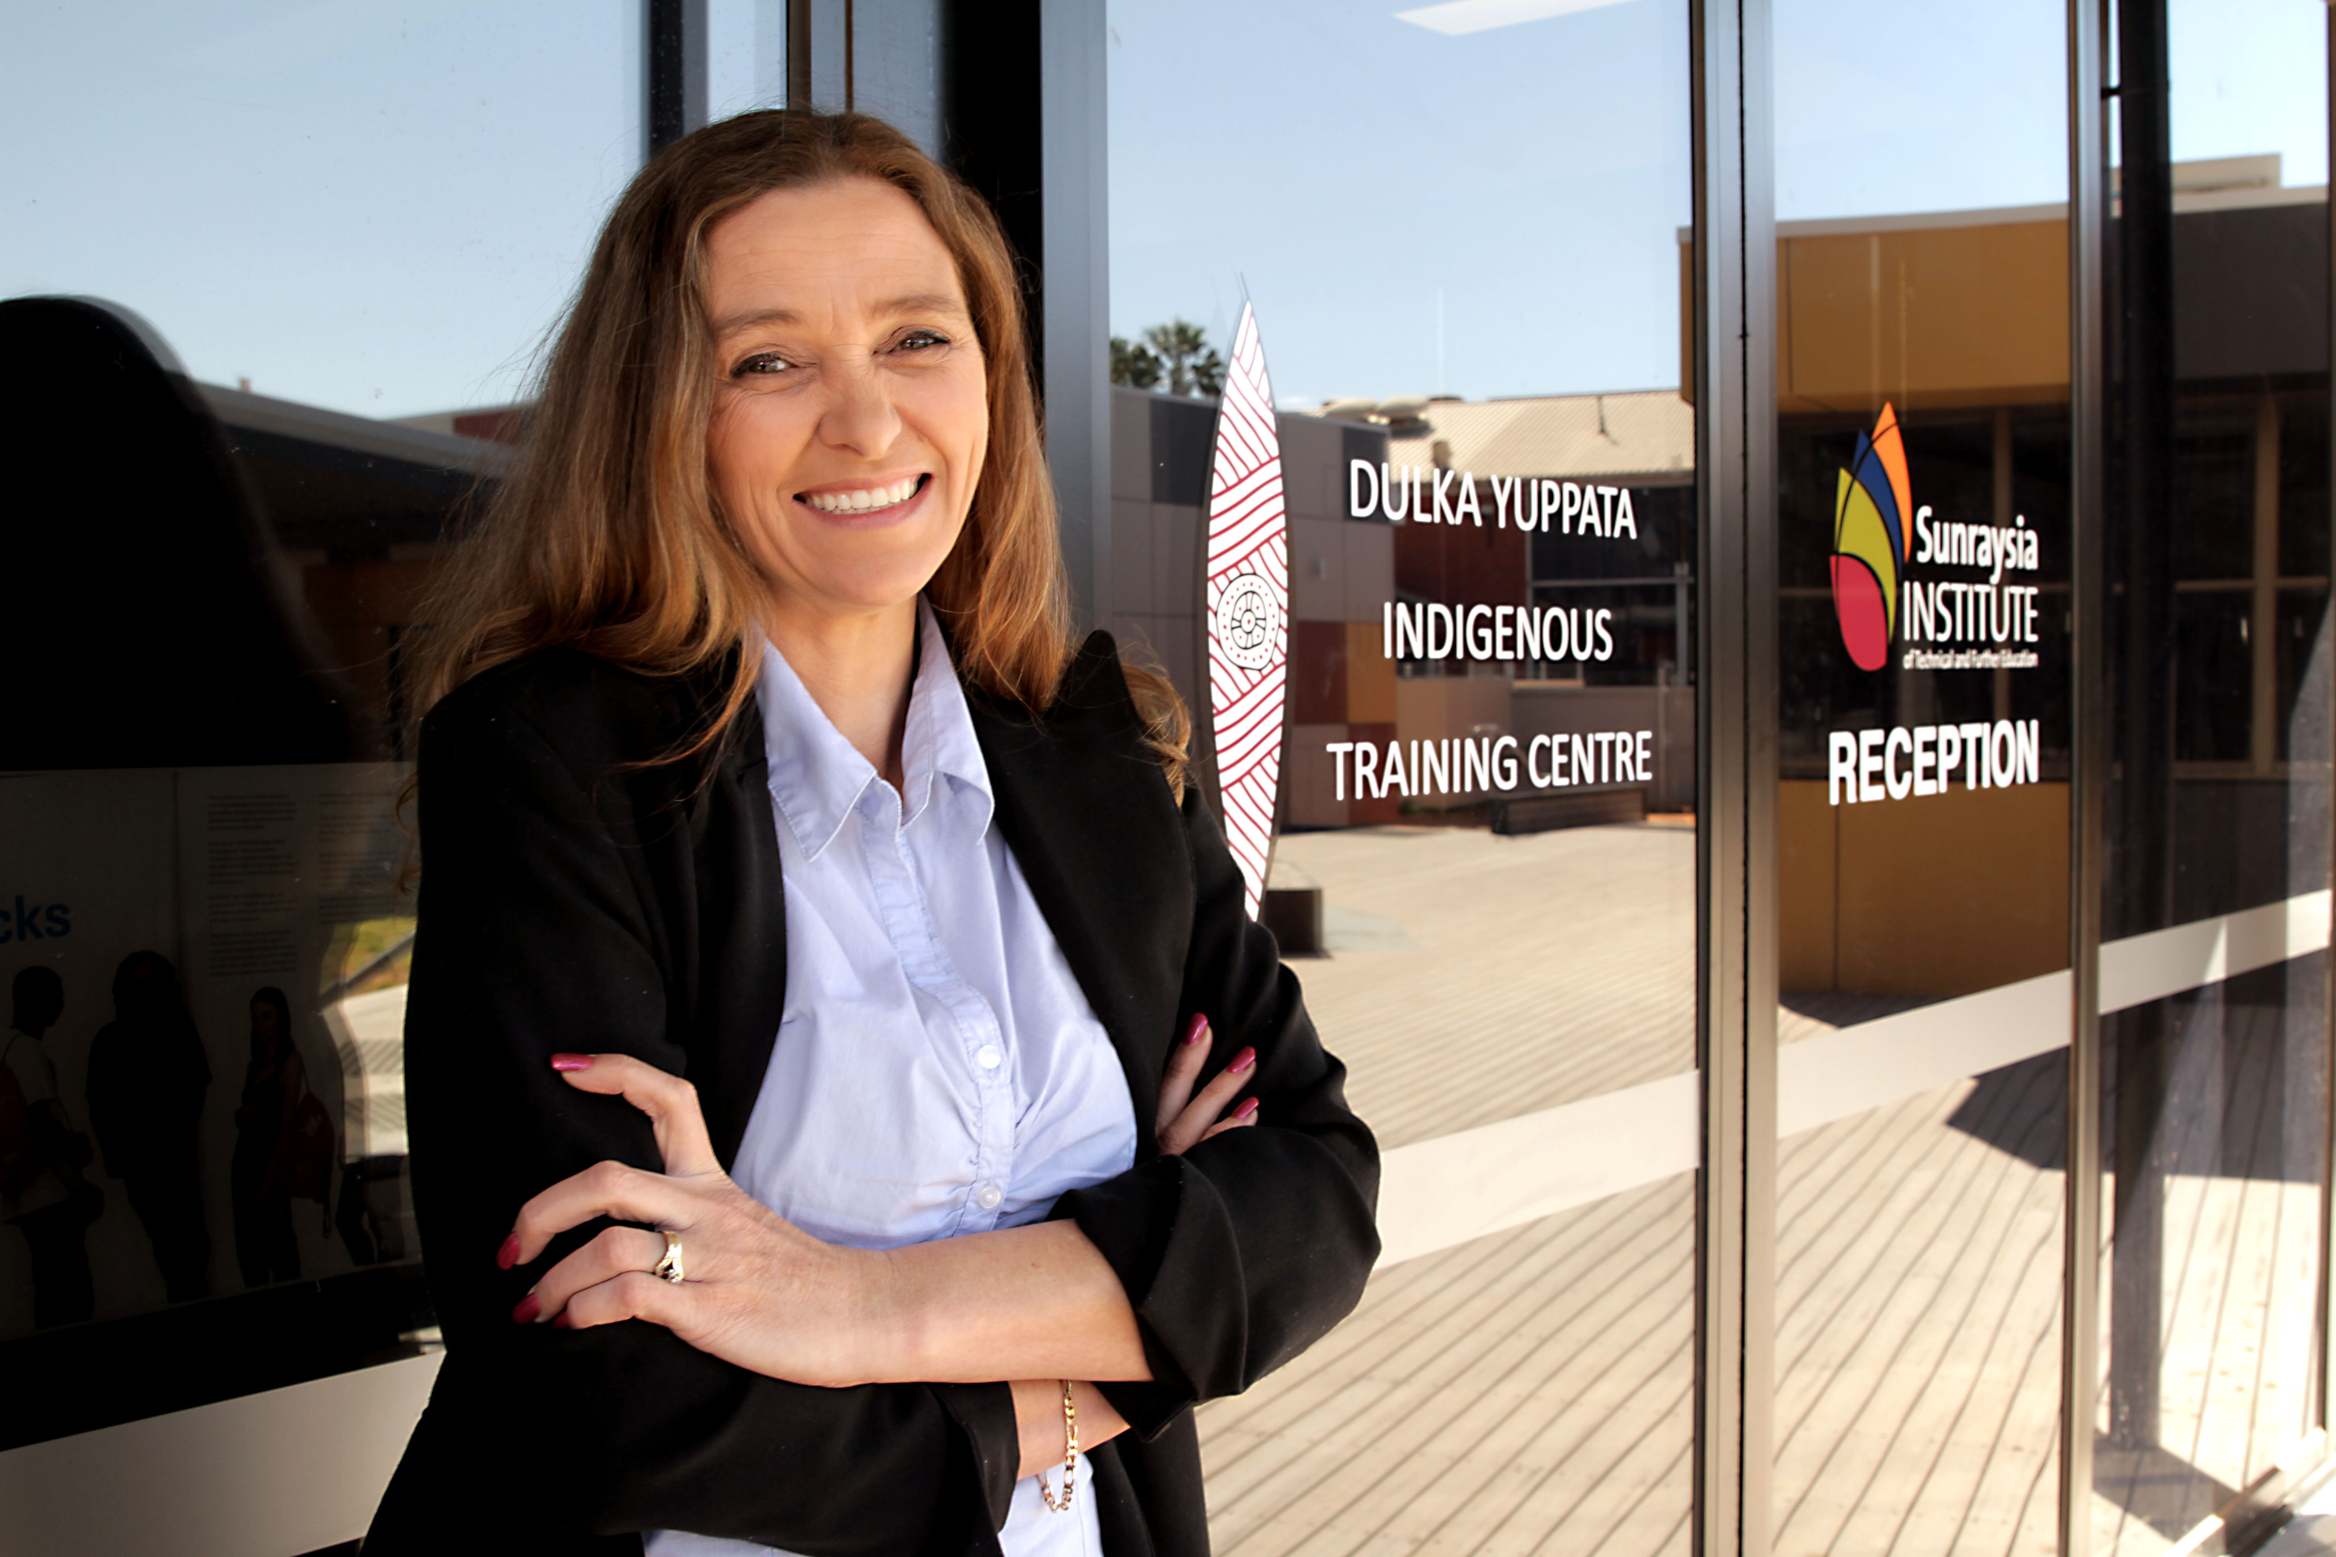
TRACY MOLLISON

FINALIST - 2017 KOORIE STUDENT OF THE YEAR

Tracy’s goal to help students achieve their dreams a step closer
Tracy Mollison’s goal is to help students from diverse backgrounds, especially Koorie students, to fulfil their goals in education and life.
Her ultimate dream to be a Koorie Liaison Officer (KLO) came one-step closer when she was offered the opportunity last year to enrol in a Certificate IV in Training and Assessment through the Dulka Yuppatta Indigenous Training Centre at Sunraysia Institute of TAFE.
The Centre provides support and assistance to Indigenous students enrolled at SuniTAFE.
Koorie Liaison Officers (KLO) are based at the Mildura and Swan Hill campuses to assist students with all aspects of their studies including arranging tutors if required.
“My goal for the future is to help students from diverse backgrounds to fulfil their goals in education and life.”
Koorie Student of the Year

The Koorie Student of the Year Award recognises the achievement of a Koorie student who displays a strong understanding and knowledge of the vocational education and training system and demonstrates the relevance of lifelong learning for themselves and their community.
The opportunity to take on a Certificate IV, led Tracy to re-evaluate her commitments – she was studying a Diploma of Horticulture, working as a part time gardener at Mildura Airport and spending time with her children and grandchildren. She decided to relinquish her job at the airport as she felt she needed to make sacrifices in order to fit in more study time to achieve her 15-year-old dream to be a trainer.
Tracy’s decision to focus on her study has paid off. In March she received the Academic student of the year award in Certificate IV Training and Assessment. Her attitude is “grab life by the horns” – needless to say, she is taking her own advice.

“Education is the key to get a job in the positons that make the decisions, not only for your future but your community.”

ABOUT THE VICTORIAN TRAINING AWARDS
Each year, the prestigious Victorian Training Awards recognise and honour the outstanding achievements of vocational education and training students, teachers, training providers and employers.
The Awards celebrate excellence in the training and TAFE system, highlight student achievements and the businesses’ who train them. Showcases innovation and collaboration between industry and training providers - continuing to put Victoria's top achievers in the spotlight.
Through Skills First, the Victorian Government is delivering a trusted training and TAFE system that delivers real training for real jobs. The Awards bring confidence and pride to vocational education and training.

AWARD CATEGORIES
Individual Categories
- Vocational Student of the Year
- Apprentice of the Year
- Trainee of the Year
- Koorie Student of the Year
- School-based Apprentice/Trainee of the Year
- Teacher/Trainer of the Year
Training Provider Categories
- Small Training Provider of the Year
- Large Training Provider of the Year
- Community Training Provider of the Year
Employer Categories
- Small Employer of the Year
- Medium Employer of the Year
- Large Employer of the Year
- Employer Award for Apprenticeship Development
Industry Collaboration Award
Lynne Kosky Memorial Award for Lifetime Achievement​
Australian Training Awards
There are five Australian Training Awards categories open for direct entry:
- National Achievement Award
- Excellence in Language, Literacy and Numeracy Practice Award
- International Training Provider of the Year Award
- School Pathways to VET Award
- Australian Apprenticeships - Employer Award

WHY APPLY?
The Awards set the standards for vocational education and training in Victoria; promoting high quality training and workplace skill development.
Being a finalist puts organisations at the forefront, building brand recognition and a strong industry reputation. In turn attracting a better standard of employees.
Students have the opportunity to showcase skills and their journey within the training and TAFE system. Plus students have the chance to network with industry experts and employers from across the state to help build their careers.
Award winners receive $5,000 prize money.
Winners go on to be ambassadors for the Victorian Training Awards and have the opportunity to represent Victoria nationally at the Australian Training Awards (in aligned categories).

For more information visit Victorian Training Awards www.education.vic.gov.au/vta
For all enquires email victorian.training.awards@edumail.vic.gov.au
phone 03 9907 6635.

