Quick Reference Guide:

Supplier and Supplier User Registration and Updating in the DE Oracle Supplier Portal

# Introduction

DE runs many of its approaches to market, both open and select, through the DE Oracle Supplier Portal (the Portal). This applies to both goods & services procurement and construction works & services procurement. Education portfolio entities using DE’s procurement framework have also adopted this approach.

This Quick Reference Guide (QRG) explains how an organisation can be set up as a supplier in the Portal, add staff members as users and maintain its corporate details in our records.

# Important information

* Organisations who are registering to participate in DE sourcing activities should register themselves as **prospective suppliers**.

Jump to: Registering as a new prospective supplier

* Organisations should only register as **spend authorised suppliers** if directed to do so by DE staff.

Jump to: Registering as a new spend authorised supplier

* Suppliers previously engaged by DE but that have never used the Portal are already registered. DE will assist you to register a user account against our existing supplier record.

Jump to: Registering as the first user of an existing supplier

* Once a supplier is registered and has active users, those users can make updates to the supplier’s corporate details through the Portal.

Jump to: Updating supplier details (including new user accounts)

# Registering as a new prospective supplier

1. Click the prospective supplier registration link.

[For **prospective** suppliers of general goods and services](https://enyw.fa.ap1.oraclecloud.com/fscmUI/redwood/supplier-registration/register-supplier/register-supplier-verification?id=AKJ293KwqRA8yXhdRsVLdFfQRXMMIzLSPbHdaoyLWc4IrLZjMhqFr6jdBw%3D%3D).

[For **prospective** suppliers of construction services and works](https://enyw.fa.ap1.oraclecloud.com/fscmUI/redwood/supplier-registration/register-supplier/register-supplier-verification?id=AKJ293KwqRA8yXhdRsVGdFfQRXMMIzLSPbHdpkeJ4DV96pLGfNA86Tel2A%3D%3D).

*If you supply both, use the first link.*

1. Enter your email address to receive a one-time access code.

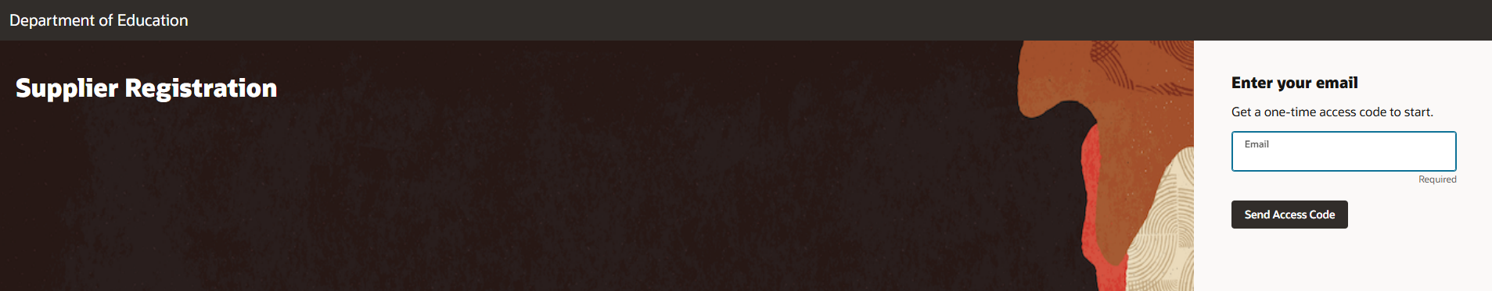

Enter the code that is emailed to you on the following screen.

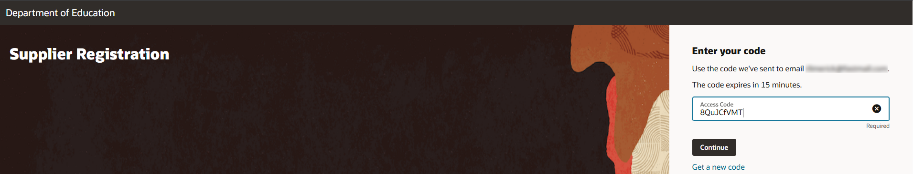

1. There are three screens of information that require completion

**Company Details (1/3)**

* Company – insert your organisation’s registered name.
* Country – insert the country where your organisation is registered for tax purposes.
* Tax Registration Number – insert your organisation’s tax identifier in that country. For Australian businesses, this is your 11-digit ABN. Please do not use any spaces in this field.
* Organisation Type – select a relevant value from the list.
* Supplier Type – select a relevant value from the list.
* *No notes to approver, attachments or URLs are required.*

Click Continue when done.

**Contacts (2/3)**

* First Name
* Last Name
* Email
* Job Title (optional)
* Mobile/Phone (optional)
* Is this an administrative contact? – select Yes for at least the first user.
* Does this contact need a user account? – select Yes.
* *Oracle will automatically tick ‘DE Supplier Portal Role’ below this.*

If you wish to register multiple users for your organisation, click ‘+ Add Another Contact’ and repeat these inputs. Click Continue when done.

**Addresses (3/3)**

* Address Name – please use the suburb/town of this address in ALL CAPS.
* What’s this address used for? – select the uses of this address.

*Your first address must be ticked for at least ‘Bid on RFQs’ to allow you to access our market documents. We strongly recommend that you also provide addresses for ‘Receive Purchase Orders’ and ‘Receive Payments’ at this time. Use ‘+ Add Another Address’ at the bottom of this form to create more addresses, if needed.*

* Country/Region – select the country of the address.
* Address Line 1/2/3 – insert the address details.
* City – select the city/suburb/town of the address.
* State – select the state/region of the address.
* Postal Code – select the post code of the address.
* *Email, phone and fax are not required for an address.*
* Which contacts are associated to this address? – ensure that the contact you created on the previous screen is ticked.

Click Submit when done.

1. You will receive an on-screen message confirming that your registration request was submitted.

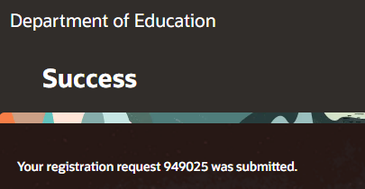

1. DE will review your registration request. If changes are required, you will be emailed at the address used for your one-time access code. You will need to click through that email to get back to your registration form and make those changes.
2. Upon approval by DE, three emails will be issued. The address used for your one-time access code will receive confirmation that the registration request was approved. The email address provided for the contact person will receive a welcome email, confirming user ID (your email address) and how to set a password.

# Registering as a new spend authorised supplier

*Only follow this process at the request of DE. Most new suppliers should only register as prospective.*

1. Click the spend authorised supplier registration link.

[For suppliers needing to be **spend authorised** for general goods and services](https://enyw.fa.ap1.oraclecloud.com/fscmUI/redwood/supplier-registration/register-supplier/register-supplier-verification?id=AKJ293KwqRA8yXhdRsVLdFTST24YOTDTIK%2FXXfYA1yYdU5jTVRoZjh2KuQ3kkSq3).

[For suppliers needing to be **spend authorised** for construction services and works](https://enyw.fa.ap1.oraclecloud.com/fscmUI/redwood/supplier-registration/register-supplier/register-supplier-verification?id=AKJ293KwqRA8yXhdRsVGdFTST24YOTDTIK%2FXXfYA1ybRmJpqrm9fqrjEc7SiDlJo).

*If you supply both, use the first link.*

1. Follow the instructions above for registering as a prospective supplier.
2. At the **Addresses** screen, you must provide addresses that cover all three ‘What’s this address used for?’ answers. Use ‘+ Add Another Address’ if you need to provide multiple addresses to cover all three use cases.
3. A third email will be issued when your registration is successful. The email address provided for the contact person will receive an email requesting you to input your organisation’s banking details into the Supplier Portal. Instructions will be provided for how to do this.
4. Your registration as a spend authorised supplier will not be complete until your banking details have been reviewed and approved by DE.

# Registering as the first user of an existing supplier

Organisations that have previously been engaged to supply DE will likely have an existing supplier record in our system. Any attempts to re-register an organisation will fail.

DE will instead manually add a user record to the existing supplier record.

Where a user from such an organisation wishes to create a user account for themselves, they should email the DE Supplier Portal team at [Oracle.Procurement.Cloud@education.vic.gov.au](mailto:Oracle.Procurement.Cloud@education.vic.gov.au).

DE will undertake any steps it deems appropriate to validate your association with the organisation before creating a user account.

# Updating supplier details (including new user accounts)

All users linked to an organisation can update the organisation’s supplier record.

* Updates to:
  + organisation name
  + user accounts and details

can be performed without review and will be automatically approved.

* Updates to:
  + addresses
  + banking details (spend authorised suppliers only)
  + business classifications (if required from your organisation)

will be manually reviewed by DE before approval.

## Start a Profile Change Request

1. Log in to the Supplier Portal using your User ID and password.
2. Click the Supplier Portal tile on the home page

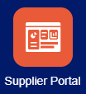

1. Click Manage Profile in the left-hand Tasks menu.

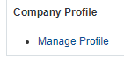

1. On the Company Profile screen, click the Edit button to begin a profile change request. Click Yes to confirm you wish to make changes. The Edit Profile Change Request screen will appear.

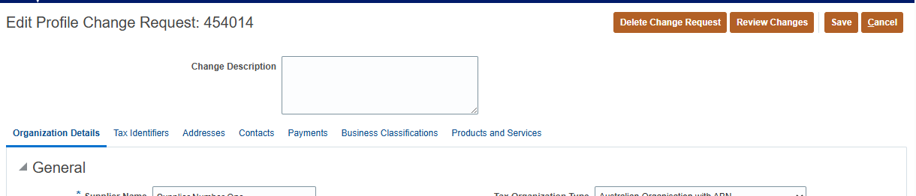

1. In the Change Description field, summarise the changes being made. Multiple changes can be made through the one change request.
2. Make changes as required using the following instructions. Ensure that you follow the final step – Review changes and submit changes – in full for the change to be properly submitted.

## Organisation name changes

1. On the Change Request screen, click the Organization Details tab if it is not already selected.
2. Edit the Supplier Name field as required.

*Note that your ABN (or other tax identifier) can never be changed. If for any reason your organisation changes its tax registration, you must create a full new supplier record and user accounts.*

## Address changes

1. On the Change Request screen, click the Addresses tab.
2. To edit an existing address, click the Address Name of the address to review the details and update it as required.
3. To create a new address, click the + icon just below the Addresses tab and complete the fields:

* Address Name – please use the suburb/town of this address in ALL CAPS.
* Address Purpose – select the uses of this address.
* Country – select the country of the address.
* Address Line 1/2/3 – insert the address details.
* City – select the city/suburb/town of the address.
* State – select the state/region of the address.
* Postal Code – select the post code of the address.
* *Language, email, phone and fax are not required for an address.*

Click OK when done.

## User changes and new user creation

1. On the Change Request screen, click the Contacts tab.
2. To edit an existing user’s details, click their Name to review their details and update as required.
3. To create a new user, click the + icon below the Contacts tab and complete the fields:

* First Name
* Last Name
* Email
* Job Title (optional)
* Mobile/Phone (optional)
* Administrative contact – check this box.
* Click the Select and Add icon (grey page with a + sign) under Contact Addresses and select an address to link with the new user.
* Request user account – check this box. A user will not be able to log into the Portal if they are not given a user account here.
* *Oracle will automatically select ‘DE Supplier Portal Role’ below this.*

Click OK when done.

## Banking details changes

1. On the Change Request screen, click the Payments tab.
2. In the second row of tabs that appears, click the Bank Accounts tab.

*Please do not edit an existing record of bank account details. Instead, create a new record with your new details, and DE will end-date the old details in favour of the new.*

1. Click the + icon that appears. A pop-up screen will open.
2. Details required:

* Country – where your account exists for tax purposes.
* Account Number
* Bank Name
* Bank Branch – branch names are preceded by their 6-digit BSB.
* Currency – your default transaction currency code.
* Attachments – any new banking details must be supported by uneditable supporting documents, such as a letter from your bank showing the account name and details.
* Account Name
* Remittance Advice Email ID – the email address to receive related remittance advice.
* PO Communication Email ID – the email address to receive related purchase order communications.

Click OK when done.

1. In the second row of tabs, click the Payment Methods tab.
2. Select the Electronic line item in the table that appears.
3. Click the >> icon above the table, and then the checkmark icon that pops up. This sets electronic payment as your default payment method.

## Business classification changes

1. On the Change Request screen, click the Business Classifications tab.
2. This section should only be updated at the direction of the VSBA. Please refer to guidance from the VSBA on how to update items in this section.

## Review changes and submit changes

1. Once all changes have been made, click Review Changes at the top of the Change Request screen.
2. This screen will summarise the changes you have made across all tabs.
3. Review these, and if you are ready to proceed, click Submit.
4. If any of your changes require manual review and approval by DE, this will now occur.
5. You will receive email notification of the approval or denial of your changes.

*Be aware: the Save and Close button only saves your changes as a draft change request. It does not submit the request, and this draft will prevent other users from making these or other changes.*

For support with these Supplier Portal processes, please email [oracle.procurement.cloud@education.vic.gov.au](mailto:oracle.procurement.cloud@education.vic.gov.au).

Version 7 April 2025