Quick Reference Guide:

Key Functions of the DE Oracle Supplier Portal

# Audience

Current and potential suppliers of goods and services to the Victorian Department of Education (DE), the Victorian Academy of Teaching and Leadership, the Victorian Curriculum and Assessment Authority (VCAA) and the Victorian Registration and Qualifications Authority (VRQA).

# Introduction

DE issues many of its procurement approaches to market, both open and select, through the DE Oracle Supplier Portal (the Portal). Portfolio agencies using DE’s procurement processes have also adopted this approach.

This Quick Reference Guide explains how suppliers can access and use the key functions of the Portal with regard to:

* Searching for negotiations, whether open market or select invitation;
* Navigating through the information provided with each negotiation;
* Creating a response, uploading relevant documents and submitting the response;
* Managing draft and submitted responses; and
* Managing recorded information for their organisation.

*The majority of negotiations issued by DE will be Requests for Quote, or RFQs. This Guide will nonetheless use the broader term ‘negotiations’.*

Contents

Audience 1

Introduction 1

The Portal and other platforms 2

Logging In 3

Finding a negotiation 5

Navigating a negotiation 8

Creating a Response 11

Manage Responses 14

Manage Profile 18

# The Portal and other platforms

The Portal is DE’s preferred platform for issuing procurement approaches to market, however Victorian Government procurement rules may require us to use other platforms in some circumstances.

## State Purchase Contracts (SPCs) and registers

DE will use the [**Digital Marketplace**](https://hubs.buyingfor.vic.gov.au/dm) or [**VendorPanel**](https://www.vendorpanel.com.au/) platforms as required for select market approaches linked to relevant SPCs and pre-qualification registers. In those cases, suppliers must be separately registered with both our Portal and the other relevant platform to allow us to maintain appropriate records of procurement activities and outcomes.

Suppliers selected to receive such an approach to market will receive an automated invitation from both platforms. Suppliers need only log into the Digital Marketplace or VendorPanel (as relevant) to receive our documentation – the invitation issued by the Portal will remind you of this.

## Open market

Open market approaches will continue to be advertised on the [**Buying for Victoria Supplier Portal**](https://www.tenders.vic.gov.au/) **(BFV)**, but all documentation and submissions for those will be managed through our Portal.

Our BFV listings will direct users to log into the Portal and search for the given negotiation reference number to retrieve our documentation. Submission of responses through the BFV system will be blocked, and will only be possible through the Portal.

# Logging In

Navigate to the login page for the Portal: <https://enyw.fa.ap1.oraclecloud.com>.

Enter your User ID and password, then click the **Sign In** button. *Your User ID is the five- or six-digit identity that you would have been allocated when you registered. It is not your email address.*

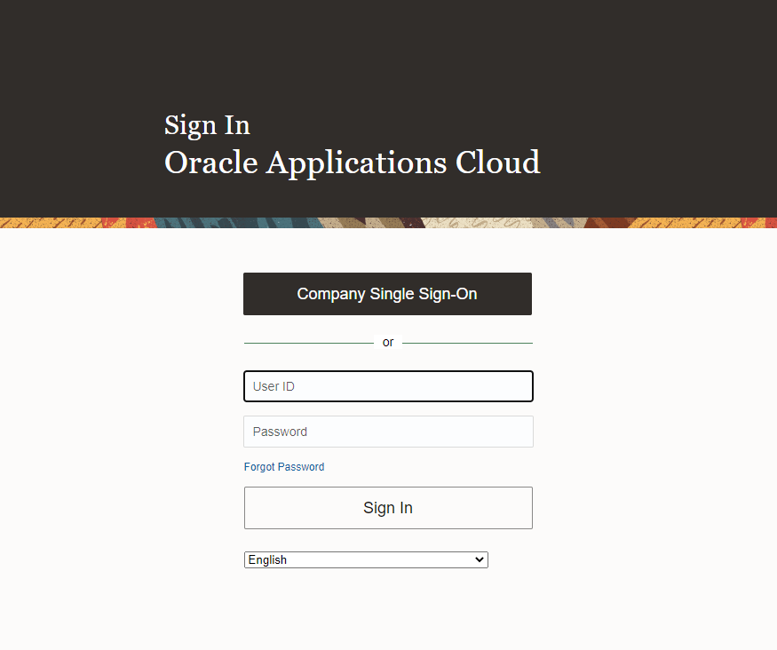

## Forgot Password

If you ever forget your password, it can be reset through the Oracle login page.

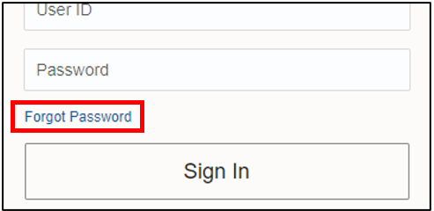

Enter the email address linked to your account and select the *Forgot password* radio button, then click Submit.

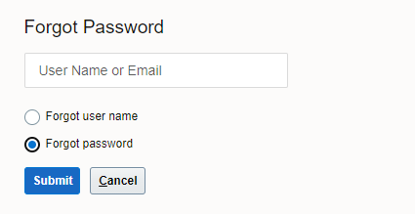

You will promptly receive an email with instructions to reset your password. Please check your junk mail folder if this email does not arrive promptly.

Contact the Oracle Procurement Cloud team (see the end of this Guide) if this process is unsuccessful or with any other login problems.

## Supplier Portal

Click the *Home* icon at top-right to be taken to your home page.

The Home icon from the Oracle interface

On the home page, click the *Supplier Portal* tile

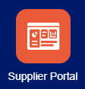

This will take you to the Supplier Portal dashboard.

# Finding a negotiation

There are two ways to find a negotiation from  
the Supplier Portal dashboard:

* + Search
  + View Active Negotiations

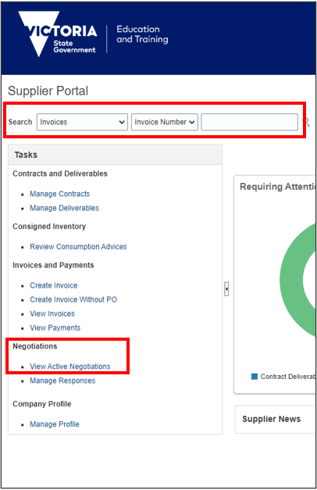

## Search

The Search box near the top of the screen is multi-purpose. Change the first drop-down field to ‘Negotiations’ and it will allow you to search for a negotiation by the reference number (N######) that DE has published.

To see a list of all negotiations that your organisation has been invited to, or all open negotiations from DE, click View Active Negotiations from the left-hand Tasks menu.

## View Active Negotiations

The Active Negotiations screen gives you access to all negotiations to which your organisation can respond. **By default, this view only shows negotiations to which you have been directly invited**, **i.e. it does not show open market approaches to which any supplier can respond.**

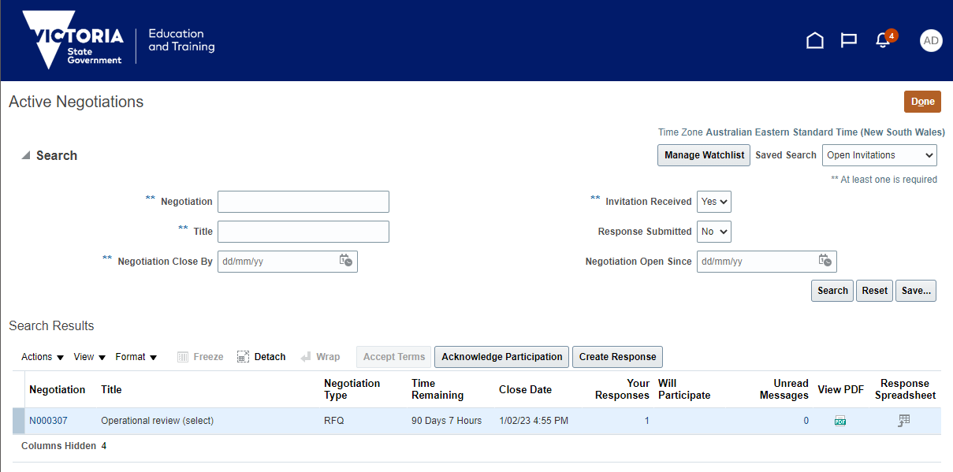

Notes on the search results:

* The *Accept Terms* button is inactive and not used by DE negotiations.
* For a select negotiation, the *Acknowledge Participation* button above the results table will be available. It is not mandatory for suppliers to confirm their intent to participate in a negotiation in this way, but it will be appreciated if it is used.
* For an open market negotiation, the *Acknowledge Participation* button is not used and there is no need for suppliers to otherwise indicate their intention to respond prior to submitting their response.
* The *View PDF* icon on each line will show you a preview of the Cover Page (see below) for this negotiation only. It is not a complete version of the negotiation.
* The *Response Spreadsheet* is not relevant for DE negotiations.

**To show our open market negotiations in these search results**, change the drop-down box for *Invitation Received* from ‘Yes’ to ‘No’ and click *Search*. Note that open market approaches may include approaches that are not relevant to your field of business.

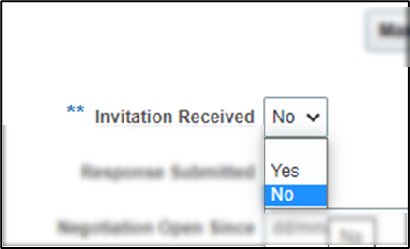

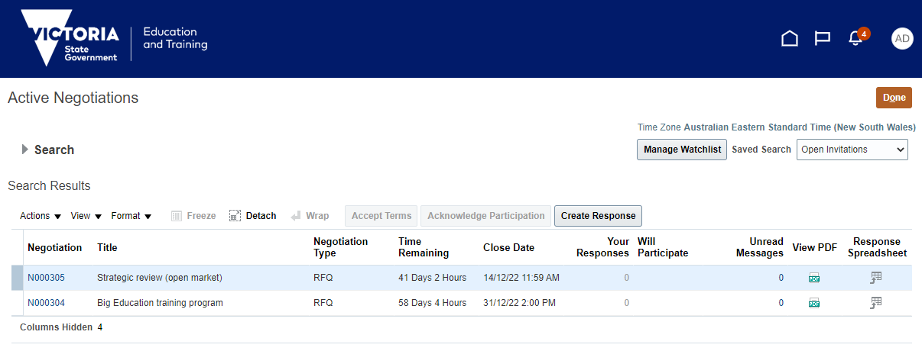

Click the Negotiation number in the list of results for the negotiation you wish to view. This will take you to the main screen for that negotiation.

If you have searched directly for a negotiation number on the dashboard, that will also take you to the negotiation.

# Navigating a negotiation

When you click into a negotiation, you will be presented with its Cover Page, and there will be a Table of Contents to the left of screen.

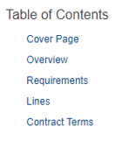

Only the **Cover Page** and the **Overview** will need to be viewed. The other three screens can be viewed but do not contain needed information.

## The Negotiation – Cover Page

The Cover Page of a negotiation starts with basic information like the opening and closing dates and times for this process.

The Cover Page will include a reference list of documents that have been attached to the negotiation for your consideration. This will include both informational documents that contain relevant details, and template documents that should be used as the basis of a response. **The Cover Page will indicate that all of these files are to be found on the Overview screen.**

If an industry briefing has been scheduled for a negotiation, the Cover Page will include the details of when and where it is being held, and any prerequisites for attendance, such as pre-registration or the completion of a Deed of Confidentiality.

## The Negotiation – Overview

The Overview screen contains a lot of Oracle-related information that will generally not be of use to suppliers. However, it is also where you will go to find the documents that we have attached, as described on the Cover Page. Look for the *Attachments* heading on the right-hand side.

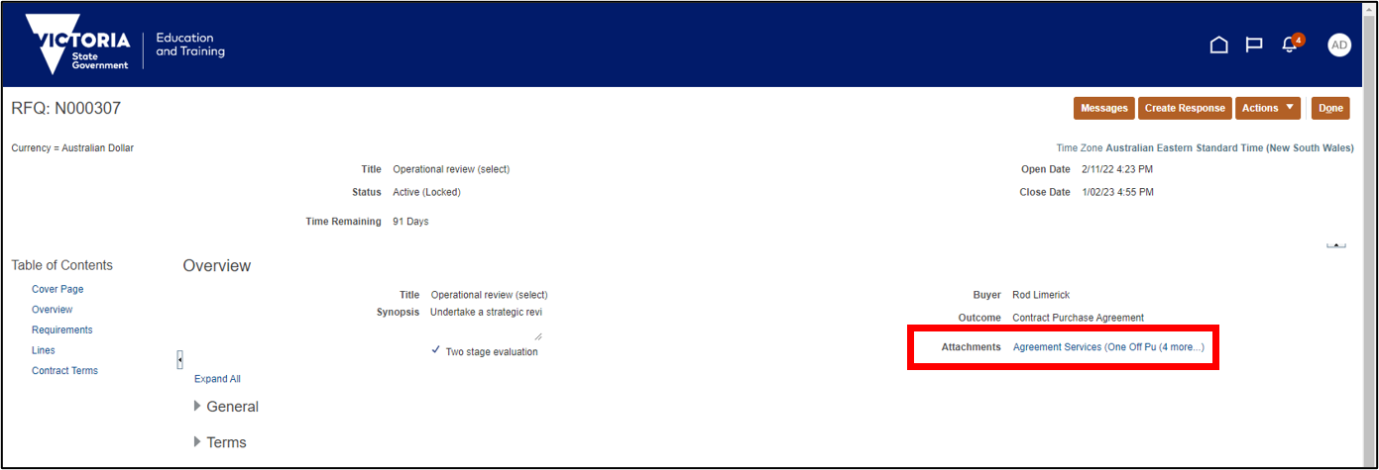

One file name will be visible, followed by ‘(# more…)’ to indicate how many other documents are available within. Click on the ‘# more’ to open up the full list of documents for download.

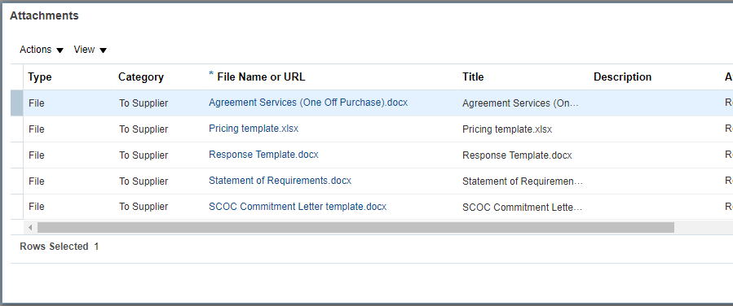

The primary document will almost always be titled the Statement of Requirements.

Most other file names will be self-explanatory, and all files will be cross-referenced where appropriate. Each file must be downloaded individually.

## Messages

At the top of nearly all pages within a negotiation, there is an orange Messages button.

The orange Messages button from the Oracle interface

The Portal’s messaging system will be the primary means of communication between DE and suppliers during the negotiation process. Any queries from a supplier should be submitted to DE using this Messages function as a first preference. DE will use this function if clarifications or other information are later required from a supplier.

The Messages function is negotiation-specific, i.e., there is no general-purpose messaging channel within the Portal. General queries should be directed to the email inbox specified at the end of this Guide.

## Preparing your response

The vast majority of your response materials can now be prepared offline. As you will see in the following section, very little data needs to be input directly into the Portal, and most information will be provided to DE via the upload of documents and other files.

In limited cases, you may also need to submit information through another website, such as the ICN Victorian Management Centre, which we use to capture information relating to your compliance with the Local Jobs First policy.

The documents you download from the Portal will provide clear direction whenever information is to be submitted in such a manner.

# Creating a Response

Click the orange **Create Response** button at the top of any screen within a negotiation when you are ready to start preparing a response.

The orange Create Response button from the Oracle interface

Responses are largely provided in the form of uploaded documents. There is minimal need for direct inputs into the Portal interface.

The response process comprises four steps which are visible at the top of the response screen. 

At any point, you may use the orange **Save** button to save your draft response. See the Manage Responses section below for how to re-commence editing of a previously saved draft.

The orange Save button from the Oracle interface

## Response – 1. Overview

The following fields may optionally be completed:

* **Response Valid Until**: If an offer has a limited validity (noting that DE’s Conditions of Participation require a response to remain valid for 120 days, by default), please note the relevant expiry date here.
* **Response Type**: If you are submitting multiple responses in accordance with DE’s Alternate Offer rules, please use this field to indicate Primary or Alternate response status.
* **Reference Number**: If you have an internal reference number, you may record it here.
* **Note to Buyer**: A general purpose text field for minor notes to the Buyer.
* **Attachments**: *It should not be necessary to attach any files here. Please only attach files as directed in the Requirements step.*

## Response – 2. Requirements

The Requirements step is where you will upload all the documents that form your response.

The step is broken into sections. Read the instructions in section 1 and upload the appropriate documents that are part of your response in sections 2 and 3. Use the drop-down menu on the right of the screen to navigate between sections.

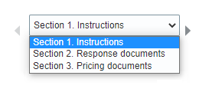

In sections 2 and 3, click the radio button on that page to bring up the Response Attachments field. Click the grey plus icon to upload files.

Screenshot of the radio button on the Requirements page that says 'Click here to upload your response documents', and the grey plus icon that appears when the radio button has been selected.

## Response – 3. Lines

Your pricing documents from the previous step will include a total price for your proposed goods or services. This figure needs to also be directly added into the system.

In this step:

* **Response Price**: insert the total price (ex GST) of the goods and/or services described in your response.
* *Ignore the* ***Response Minimum Release Amount*** *field.*

Where a total price is not an appropriate figure for a particular negotiation (e.g., if a rate card is being put forward for an uncertain volume of work), the Response Price can be given as $1. Your attached pricing documents are your binding pricing proposal in all cases, not this figure.

## Response – 4. Review

This final step allows you to review the information you have provided in steps 1 to 3.

To confirm that you have completed all mandatory fields, you can use the Validate function under the orange Actions menu. Note that the Portal will not allow submission of an incomplete response.

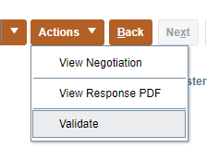

When your response is complete, click the orange Submit button.

The orange Submit button from the Oracle interface

You will receive both on-screen and email confirmation that your response has been successfully submitted.

**DE staff cannot access the contents of any draft response, nor can they access the contents of any submitted response until after the Close Time/Date for a negotiation. Draft responses that have not been submitted by the Close Time/Date are automatically deleted.**

# Manage Responses

Back on the main Supplier Portal Dashboard, you also have the option to Manage Responses. This is the page where you will find all draft, submitted and historical responses made by your organisation.

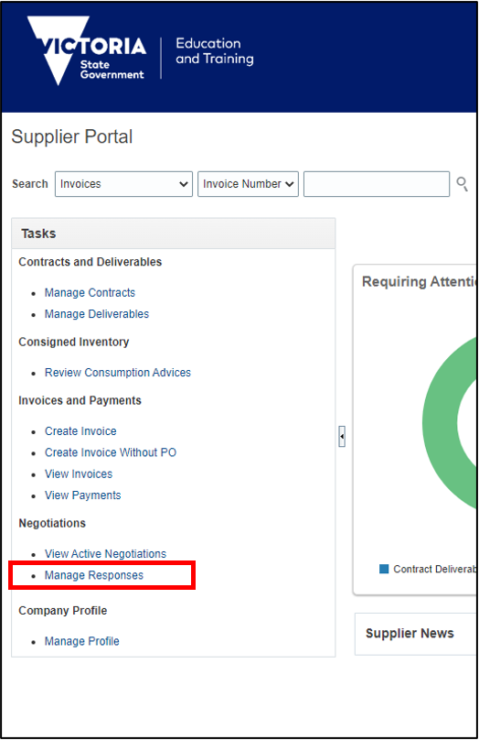

From here, you can:

* Continue editing a draft response
* View (and optionally revise) a submitted response to a negotiation that is still open
* View a submitted response to a negotiation that is closed and now under evaluation

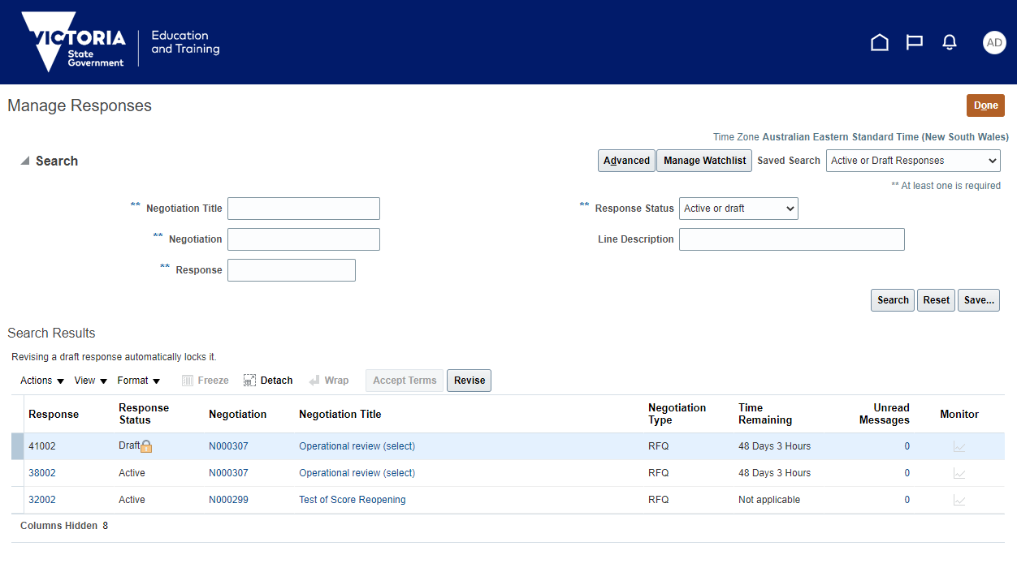

On this screen, the default Search Results shows your responses that are:

* **Draft**: this response is not yet submitted
* **Active**: this response has been submitted for a negotiation that is not yet closed (and may still be revised)

You can change the Response Status search setting at top-right to show other responses that have status types.

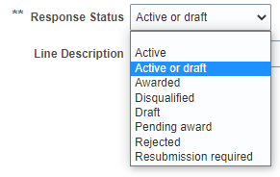

The most important of these is:

* **Pending award**: this response has been submitted to a negotiation that is now closed and under evaluation.
* **Resubmission required**: this response was submitted, but the (still open) negotiation has now been amended. In this scenario, you must update your response to any extent necessary, and then re-submit, *whether or not you actually make any updates*. In this situation, when you revise this response (see below), you will be presented with a screen detailing how the negotiation has been amended.

## Continue editing a draft response

To continue editing a response you’ve already commenced, highlight the response row in the search results (click within that row on any blank space or non-linked text) and click the grey **Revise** button which will have become visible.

## Editing a submitted (Active) response

Most DE negotiations will allow you to edit a response that has been submitted. Highlight the response row in the search results (click within that row on any blank space or non-linked text) and click the grey **Revise** button which will have become visible. This response is no longer submitted, will return to ‘Draft’ status and must be submitted again once your changes have been made.

If DE has enabled you to submit multiple responses to a negotiation, this action will create a duplicate response for you to edit. You can state on the Overview screen (Note to Buyer field) of this new response that previous responses should be ignored, if this is the case.

## Locking and unlocking a draft response

Responses can be worked on by multiple users from one organisation, but not simultaneously. The Portal will automatically lock a draft negotiation to whoever creates it, and must be manually unlocked by other users to allow them to continue the drafting.

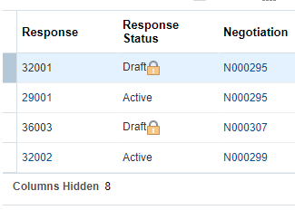

A locked draft will have a lock icon showing on the Manage Responses screen. If you put your mouse cursor over that icon, it will show you the name of the user who was last editing that response.

We strongly recommend that users talk to each other directly to confirm whether the previous editor has completed their changes before unlocking a response.

Any user can unlock a draft using the Actions menu that sits above the list of responses. 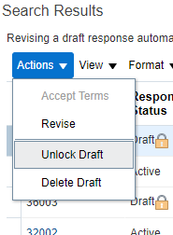

## Reviewing your submitted response

Submitted responses, whether in ‘Active’ or ‘Pending award’ status, can be reviewed by clicking on the Response number from the Manage Responses screen.

# Manage Profile

This screen, available from the Supplier Portal dashboard, allows you to access the current DE profile for your organisation. This includes key addresses, your ABN, and the list of registered users for your organisation in the Portal.

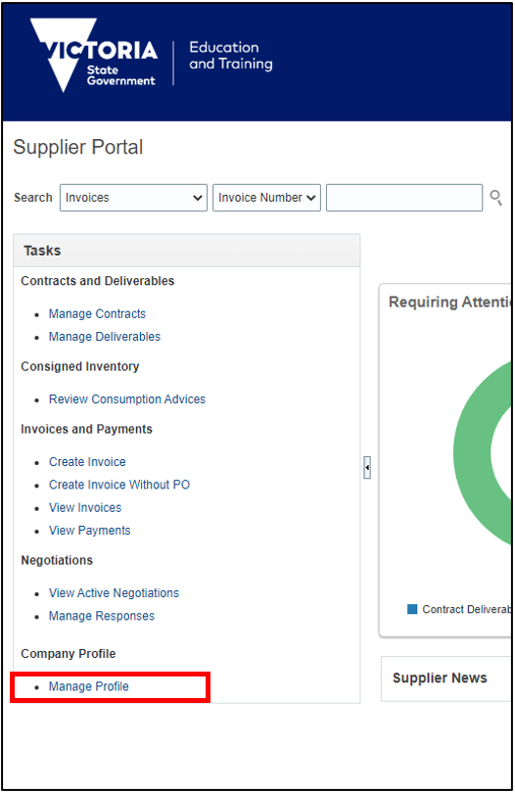

Please note that banking details are currently not accessible through this process. Contact DE if a change is required.

Suppliers are strongly encouraged to self-manage the users who have access to the Portal on their behalf. See our *Quick Reference Guide: Supplier and User Registration Process* for step-by-step guidance on creating new users from this screen.

More guidance on updating other details will be forthcoming.

**Please note that all edits to a supplier profile, including creation of new users, must be reviewed (‘Review Changes’ button) and then submitted (‘Submit’ button) in order to be processed. The ‘Save’ button will only save a draft request and does not submit it for processing. A draft request will prevent any other edits being made until it is either reviewed and submitted, or cancelled.**

**For further support with the Portal, contact the Oracle Procurement Cloud team:**

[**oracle.procurement.cloud@education.vic.gov.au**](mailto:oracle.procurement.cloud@education.vic.gov.au)