

The Navigator Program
Information session for potential Service Providers 2027 – 2029

Bayside Peninsula Hume Merri-bek Loddon Campaspe Western Melbourne

Welcome


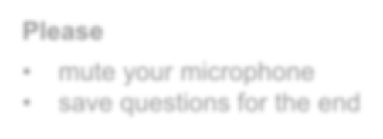
Central Navigator Team
Please
- mute your microphone
- save questions for the end
Manager: Ed Quin

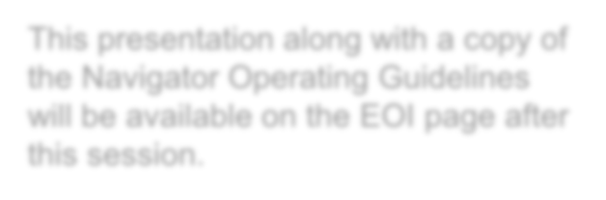
Senior Policy Officer: Tammy Cajkovac-Njari Program Advisor: Lindy Roberts
This presentation along with a copy of the Navigator Operating Guidelines will be available on the EOI page after this session.

Navigator Area Teams
North West Victoria Region (NWVR) | Loddon Campaspe, Hume Merri-bek Manager: Katrina Moody

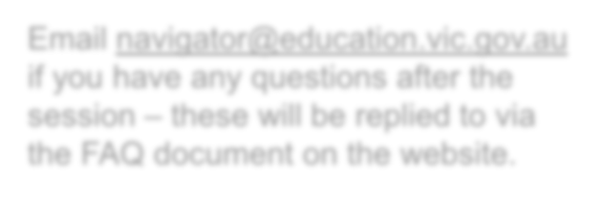
South West Victoria Region (SWVR) | Western Melbourne Manager: Karina Howard
Email navigator@education.vic.gov.au if you have any questions after the session – these will be replied to via the FAQ document on the website.
South East Victoria Region (SEVR) | Bayside Peninsula Manager: Katrina King

Today's agenda

Overview of the Navigator Program
Part 1
Part 2
Part 3
Part 4
Part 5

Key expectations of service providers

Local viewpoints from the Navigator area teams
Hume Merri-bek, Loddon Campaspe, Western Melbourne and Bayside Peninsula

EOI application process and key dates

Q&A

The Navigator Program

Provides individualised, targeted case management support to re-engage young people with mainstream education or other positive pathways and build their social, emotional and personal skills.

Strengthens the capacity of education providers to better support disengaged students, and improves the department’s monitoring, measurement, and response to student disengagement at both state-wide and area levels.

The Navigator Program is NOT

A grants program

Funding is to deliver
the DE Navigator model.

A general youth support program

The DE model directly focuses on educational re-engagement.

A program delivered by the service provider in isolation

Collaboration and partnership with DE and the Area team are essential to operating successfully.

The Navigator Program

- Department of Education (DE) program since 2016
- delivered by contracted service providers operating across each of the DE’s 17 areas, in partnership with local schools and Navigator area teams
- tailored to each local community
- offers holistic support, using an assertive outreach, strengths-based approach with a primary focus on achieving educational re-engagement
- participation is by referral, and anyone can make a referral via the online referral form
- A young person must meet the following criteria to be eligible for the program:
  - be 12 to 17 years of age (inclusive)
  - be enrolled in, or intend to enrol in a victorian education setting (including non-government schools)
  - have attended 30% or less of the previous school term, or equivalent, or not be attending an education setting at all
- re-engagement with education is always the primary goal for young people of compulsory school age, however the program acknowledges and records a range of positive outcomes
- young people beyond compulsory school age (i.E. 17 year olds) who are committed to educational re-engagement are
not excluded from participation. 7

Approach

Navigator draws on research to adopt a strengths based, person-centred approach, to overcoming the often highly complex barriers to engagement.

In doing so Navigator seeks to support/drive:

- development of goals and plans for the future
- improvement in school attendance
- re-engagement in education (and coordination of necessary educational supports)
- diversion from the youth justice system
- improvement in wellbeing & pro-social behaviours (inc. reductions in violent/anti-social behaviours)
- engagement with training courses, apprenticeships & employment;
- engagement with support services (e.g. mental health, drug & alcohol, housing)

Measures of success


Exit – sustained educational re-engagement
The young person successfully exited navigator after sustained re-engagement:
- attending 70% > for 2 consequent terms
- at a mainstream school, long-term FLO (where they will complete their education) or TAFE / RTO (where they will complete their education journey).

Exit – other engagement achieved
The young person
- is attending either a mainstream school, non-mainstream school setting (FLO,TAFE or RTO) on a permanent basis but sustained 70% is deemed unlikely, and the local navigator team believes continuing in the program will not result in further educational re-engagement for the young person (or a return to mainstream), or
- has commenced home-schooling, or
- has achieved a different planned positive outcome (e.g., long-term employment, education or training pathway that aligns with their career and post-compulsory education goals.

Barriers to education

Young people receiving Navigator support often present with multiple reasons for their disengagement
and have complex barriers to overcome. The Navigator program sees significant numbers of young people who:

  - have experienced family violence
  - are in statutory out of home care
  - experience anxiety, depression, and other mental health concerns
  - have a diagnosed or suspected cognitive disability(ies)
  - are below expected literacy and numeracy levels
  - experience financial distress
  - have involvement with child protection
  - are known to police, with some involved in the youth justice system
  - have high level of school suspensions, expulsions and informal exits from school as well as lengthy periods of no school attendance
  - are experiencing unstable housing situation

Navigator Service Providers
- deliver case management services and assertive outreach to young people
- support their re-engagement with education, including through engaging and supporting the young person’s school.

Schools
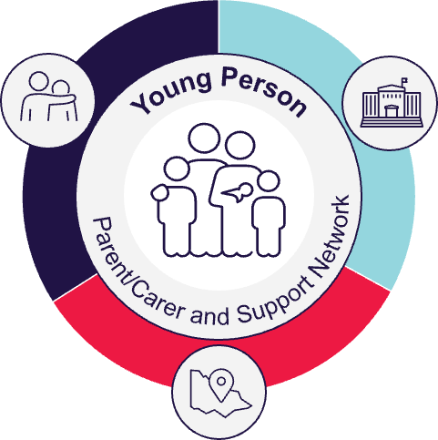
- work with Service Providers and Area teams to support the young person to re-engage with education
- with the support of the Navigator Coordinator, building local capacity to reduce and respond to chronic disengagement.

Collaboration and partnership

Navigator Regional Teams
  - first point of contact for enquiries
  - receive referrals
  - assist Service Providers to navigate the education system
  - build capacity of local schools to better support young people who are disengaged or re-engaging with education.

DE Central Navigator team
  - central oversight
  - drive consistency of practice
  - program monitoring and improvement
  - evaluation and reporting
  - set minimum expectations
  - approve budgets and yearly program delivery.
11

    - allocate referrals
    - work in partnership with the Service Providers (SPs) to co-design and deliver the program locally, ensuring that the expertise and requirements of both parties is reflected in the program
    - support the development of Service Delivery Plans (SDPs) and regularly monitor commitments and implementation
    - support SPs to navigate and work within school and education provider systems and facilitate and foster relationships with:
      - Koorie Education Support Officers (KESOs)
      - Student Support Services (SSS)

      - Senior Wellbeing Engagement Officer (SWEO)
DE Navigator Coordinators (NCs)
      - Regional Education Childrens Court Liaison Officers (RECCLOs)
      - Senior Education Improvement Leaders (SEILs)
      - LOOKOUT
      - Regional Disability Coordinator (RDC)
      - Community Liaison & Engagement Officer (CLEO)
      - other key DE Area staff

    - provide broader networking and engagement of stakeholders and schools
    - governance, reporting and general support to enable enhanced implementation of the program
    - key liaison with Central Navigator Team,
A positive working relationship
is essential

12

Navigator Data Management System (NDMS)

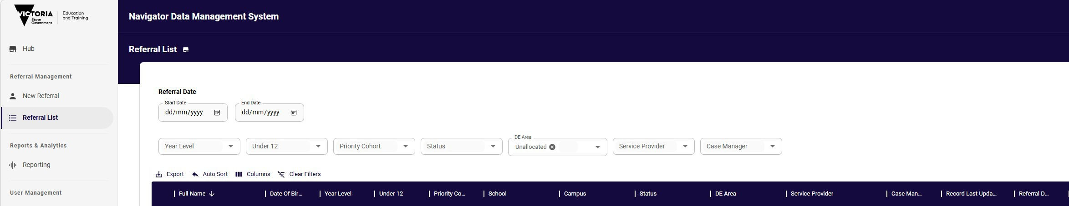

- a purpose-built records management system to allow tracking of progress, outcomes, program delivery and adherence to minimum expectations
- contains essential operating data about participants and is accurate, factual and directly relevant to the purpose of the program
- is not a case management tool and cannot be used as such
- must be used in-line with expectations
- service provider is expected to ensure all staff are competent in using the NDMS and updated as required

The Service Provider

Works directly with young people and their support networks to:
Expectations
- works collaboratively with local and central DE teams.
- works in partnership with other community services and education providers to assist the young person to access appropriate supports
- develops strategies to manage demand for service
- regularly reviews program participants and their progress to ensure Navigator remains the right program for them
- adheres to reporting, data and other stipulated requirements and delivers against Operational Guidelines and an agreed Service Delivery Plan
- delivers Intake and Assessment, Active Hold and Case Management phases

- deliver case management services and assertive outreach
- support re-engagement with education, including through engaging and supporting the young person’s school
- identify barriers to education
- co-ordinate relevant supports to address barriers impacting the young person’s participation in navigator or engagement with education
- identify and assist the young person and their family to access appropriate supports
- monitor and provide support as they re-engage in education.

16
The Service Provider

Initial engagement and assessment engage with the young person and their parent/carer, obtain consent, and complete a holistic assessment
Engagement use appropriate, flexible, and persistent methods, including assertive outreach, to establish and support engagement
Individualised case management co-create an Educational Re-engagement Plan, set clear and measurable goals, deliver tailored supports
Wrap-around support coordination coordinate relevant supports to address barriers impacting the young person’s participation in Navigator or engagement with education
Collaborative planning actively engage and collaborate with education providers, participate in SSG/care team meetings, share information and data to facilitate coordinated support
Capacity building provide professional learning and secondary consultation on Tier 1 and Tier 2 engagement strategies
Progress and exit support track attendance and wellbeing, coordinate supports that enable sustained re-engagement, implement a Supported Exit Plan
Maintain accurate and up-to-date records of progress and attainment through the Navigator Data Management System (NDMS)

Delivery

Navigator is delivered over four stages.

While not every young person will progress through each stage sequentially, the Service Provider must ensure that all stage-specific requirements are met for each relevant stage.



Stage 1.
Referral
Stage 2. Intake and Assessment
Stage 3a.
Active Hold
Stage 3b. Case Management
Stage 4.
Re-engagement and Exit

Stage 1. Referral

- A young person is referred to Navigator via the NDMS referral form and allocated to the relevant DE Area based on their school, or their residential address in specific cases.

- The Navigator Coordinator reviews the referral, may contact the school to confirm eligibility and collects only the essential information required to progress the referral. In some cases, they may also contact other relevant parties where needed to support verification.

- Once verified, the Navigator Coordinator either allocates the referral to the Service Provider, places it on Deferred Referral, or Exits (did not proceed to program) and refers the young person to an appropriate DE team if they are ineligible. They also inform relevant stakeholders of the outcome and next steps, including any expectations for school engagement during this stage.

Stage 2. Intake & Assessment

The SP conducts an initial assessment of the young person’s strengths, needs and barriers. This involves contacting the young person, their parent/carer and the school, as well as other key stakeholders where relevant.
- FTE is to be allocated to this function (usually about 0.5FTE)
- all referrals received need to be actioned and supported
- assertive outreach may be needed to complete Intake & Assessment and/or obtain consent to participate – this is an expectation.
- without consent to participate from the parent/carer, the referral cannot proceed
- the NDMS must be updated to reflect contact attempts, and record when required documents are completed (i.e. consent forms, entry surveys)
- Intake and Assessment should be completed
within 2 weeks under normal circumstances

Consent to participate must be obtained before the referral progresses and the Entry Survey should generally be completed during this stage.

Once completed, the SP either assigns the young person to Active Hold, Case Management or Exits the referral in line with program requirements.

Active Hold is intended for young people that are likely to re-engage with less intensive support, or while awaiting Case Management. May also include group support to help meet the program’s contact requirements while managing a larger caseload.
Stage 3. Active Hold and Case Management
Case Management is intended for young people with more complex barriers who require sustained, intensive support. Case Managers build strong, trust-based relationships with young people and their families, using an Assertive Outreach approach.

Both stages require individualised support, regular contact and collaboration with the young person, their parent/carer, school, and relevant services.
- FTE is to be allocated to both of these functions
- assertive outreach is the key element of these phases
- to be delivered to all referred young people once Intake and Assessment is complete
- Active Hold models may have to change in intensity of service with program demand - this is an expectation
- There is no set timeframe for participants to remain on Active Hold or Case Management
- Educational re-engagement plans must be developed for all participants - these should be live documents that change and grow as needed
- Case conferences are to be held after 6 months of service delivery and every 3 months thereafter to ensure Navigator remains the right program, and educational re-engagement is the focus
- The NDMS must be updated to reflect contact and contact attempts, record when required documents are completed (entry surveys, educational re-engagement plans), as the young person receives more support (school and externally based, e.g. referrals) and with the young person’s attendance rate
- The service provider and the local DE team determine a local process to obtain and monitor monthly attendance data for all participants.
20

Stage 4. Re-engagement and Exit


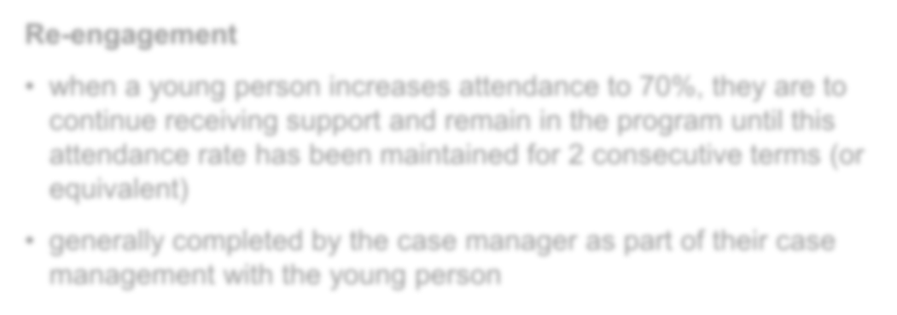

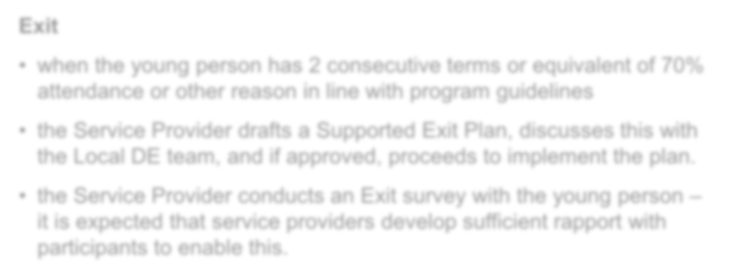
Navigator support concludes when a young person has either sustained re-engagement with education, transitioned to a positive alternative pathway, or ended their involvement
for another reason.
Exit
- when the young person has 2 consecutive terms or equivalent of 70% attendance or other reason in line with program guidelines
- the Service Provider drafts a Supported Exit Plan, discusses this with the Local DE team, and if approved, proceeds to implement the plan.
- the Service Provider conducts an Exit survey with the young person – it is expected that service providers develop sufficient rapport with participants to enable this.
Re-engagement
- when a young person increases attendance to 70%, they are to continue receiving support and remain in the program until this attendance rate has been maintained for 2 consecutive terms (or equivalent)
- generally completed by the case manager as part of their case management with the young person
The Service Provider works closely with the local DE team during this stage.
Service Providers must request Navigator Coordinator approval before exiting any young person allocated to them and must provide the required documentation as part of this process.
All young people must receive a Supported Exit Plan, and where applicable, complete an Exit Survey.

Key considerations


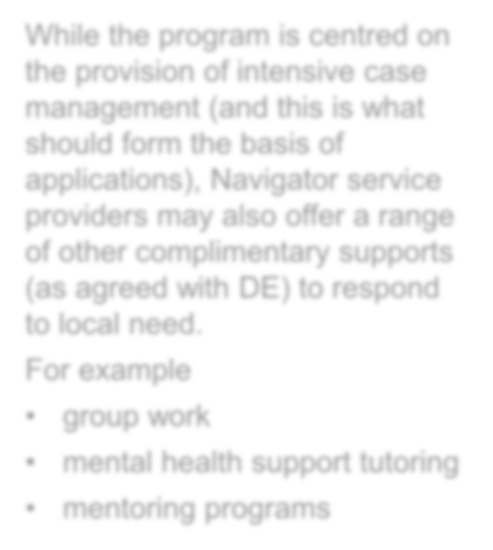
  - Commitment to working in the best interest of the young people, the Navigator program and educational re-engagement
While the program is centred on the provision of intensive case management (and this is what should form the basis of applications), Navigator service providers may also offer a range of other complimentary supports (as agreed with DE) to respond to local need.
For example
- group work
- mental health support tutoring
- mentoring programs
  - Navigator varies across areas; we are seeking a place-based approach that reflects the needs of the local area
  - A collaborative approach between the DE Navigator Team and the Service Provider is critical – this needs to be a true partnership
  - Navigator is not funded to service all eligible young people, nor is Navigator suitable for all eligible young people – but do expect high demand for service and waitlists
  - Innovation and creative approaches to service provision are welcome if you feel they will enhance the existing Navigator service delivery model.

24
Hume Merri-bek Area (NWVR)

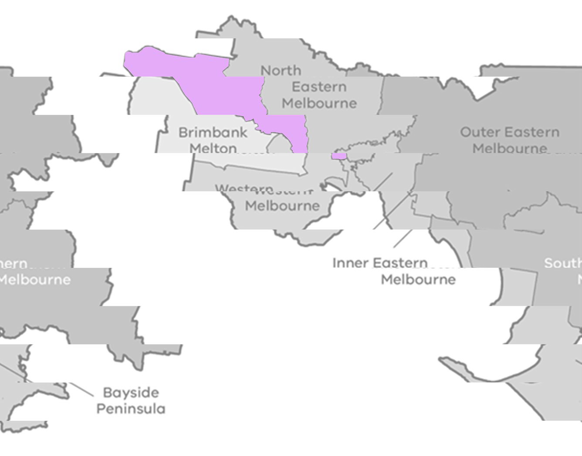

The Hume Merri-bek Area (HUMA) Navigator Program has a strong focus on supporting students experiencing multiple barriers to engaging in education, including a significant increase in those with mental health concerns, and those from priority cohorts.
Hume Merri-bek
The traditional lands of the City of Merri-bek (formerly Moreland) and Hume City are those of the Wurundjeri Woi-wurrung people of the Kulin Nation.
The Gunung-Willam-Balluk clan is specifically associated with the Hume area, while the Wurundjeri-willam clan is recognized as the original occupants of the northern suburbs, including the Merri Creek area.
HUMA covers a large geographical area of 554km2. Some parts are considered metropolitan with good access to transport and services, while others are rural/regional with limited or intermittent access to transport and services.
Although there are a large number of schools, there is limited access to complementary education options, with those available often at capacity.
71 Government schools
8 Specialist schools
50 Non-government schools
6 Flexible Learning Options (FLO’s)
2 Local Government Areas (LGAs) including Hume and Merri-bek
163 referrals made in 2025

The DE area office is based in Coburg.


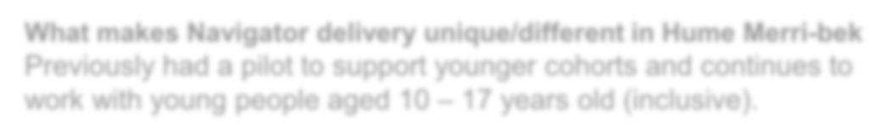
What makes Navigator delivery unique/different in Hume Merri-bek Previously had a pilot to support younger cohorts and continues to work with young people aged 10 – 17 years old (inclusive).

Loddon Campaspe Area (NWVR)

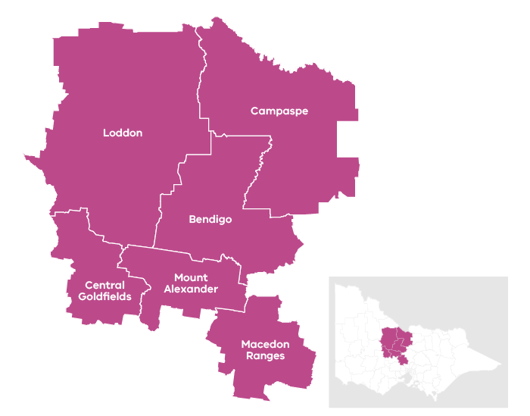

The Loddon Campaspe Area (LCA) Navigator Program has a strong focus on referrals for students experiencing multiple barriers to engaging in education, including a significant increase in those with mental health concerns, neuro diversity, and those from priority cohorts.

The Loddon Campaspe region spans the traditional lands of the Dja Dja Wurrung (Djaara), Taungurung, Yorta Yorta, and Wurundjeri peoples.
These groups have maintained a deep, ongoing connection to the region's land, waters, and skies for tens of thousands of years.

Loddon Campaspe covers a large geographical area of 19,100km2. Some parts are considered metropolitan with good access to transport and services, while others are rural/regional with limited or intermittent access to transport and services.

Although there are a large number of schools, there is limited access to complementary education options where enrolment is via referral for student at high risk of disengaging from education.
198 Government schools
4 Specialist schools
47 Non-government schools
8 Flexible Learning Options (FLO’s)
6 Local Government Areas including Campaspe Shire, Central Goldfields Shire, City of Greater Bendigo, Loddon Shire, Macedon Ranges Shire and Mount Alexander Shire.
210 referrals made in 2025

The DE area office is based in Bendigo.
25

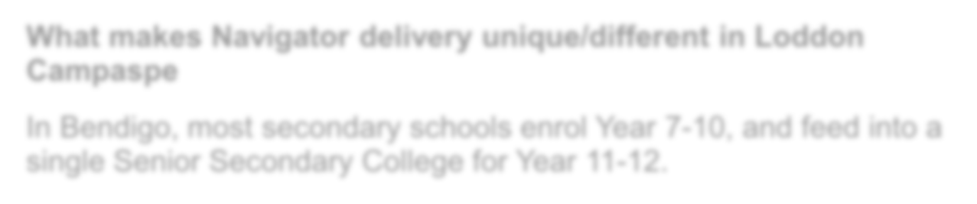
What makes Navigator delivery unique/different in Loddon Campaspe
In Bendigo, most secondary schools enrol Year 7-10, and feed into a single Senior Secondary College for Year 11-12.

26
Bayside Peninsula Area (SEVR)

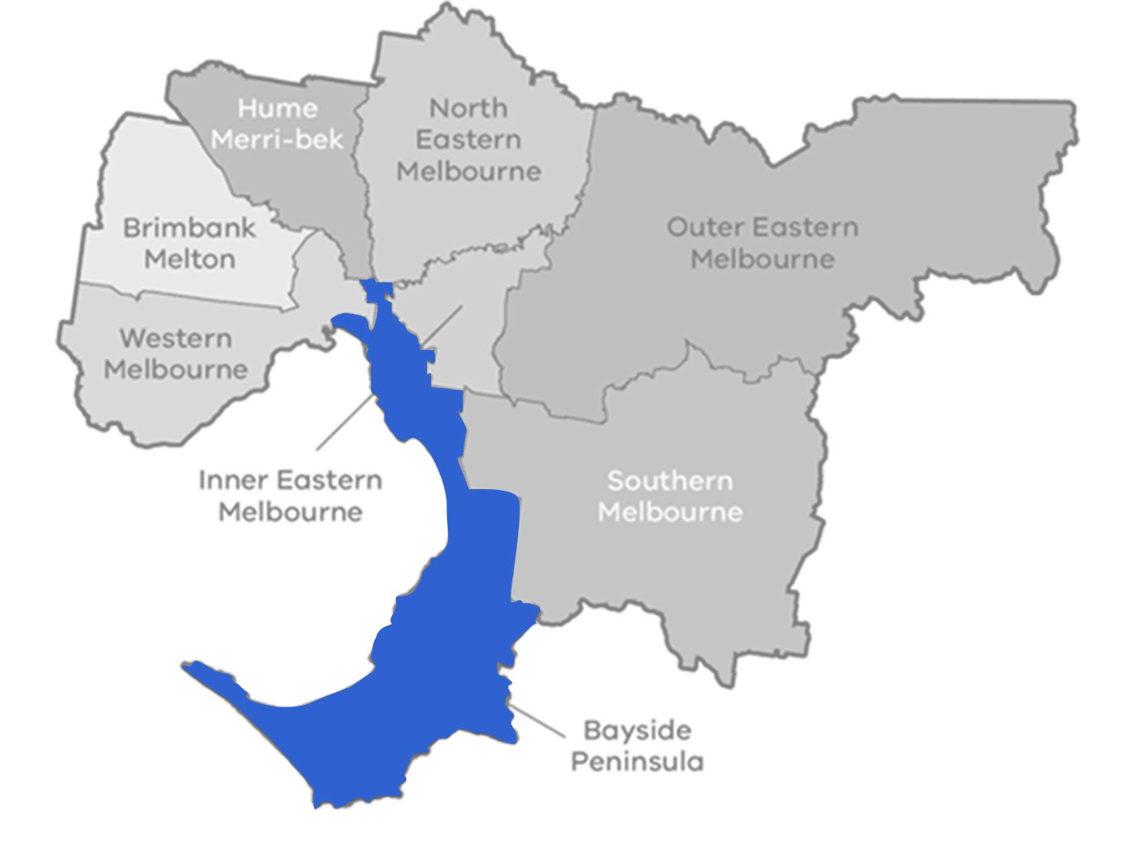

The Bayside Peninsula Area (BPA) Navigator Program supports students from approximately 300 government and non-government schools.
Bayside Peninsula
The traditional lands of the Bayside area are those of the Bunurong (also spelled Boonwurrung) people of the Kulin Nation.
Bunurong country spans from the Werribee River in the north-west, down to Wilsons Promontory in the south-east, including the Mornington Peninsula, Frankston, and Western Port Bay.

Most referrals however are from government schools and the 10 most referring schools in the last few years have been from the Frankston and Mornington Peninsula region.

The consistent themes for students being referred include complex cases representing family violence, mental health and neurodiverse concerns as opposed to school-based anxiety school refusal.
150 Government schools
21 Specialist schools
109 Non-government schools
12 Flexible Learning Options (FLO’s)
8 Local Government Areas (LGAs) including Bayside, Casey, Frankston, Glen Eira Kingston, Melbourne, Mornington Peninsula, Port Phillip and Stonnington
236 referrals in 2025

The DE area office is in Frankston.

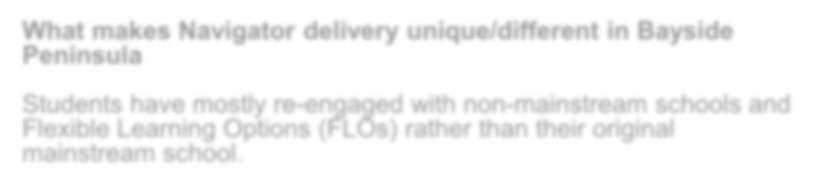
What makes Navigator delivery unique/different in Bayside Peninsula
Students have mostly re-engaged with non-mainstream schools and Flexible Learning Options (FLOs) rather than their original mainstream school.

Western Melbourne Area (SWVR)

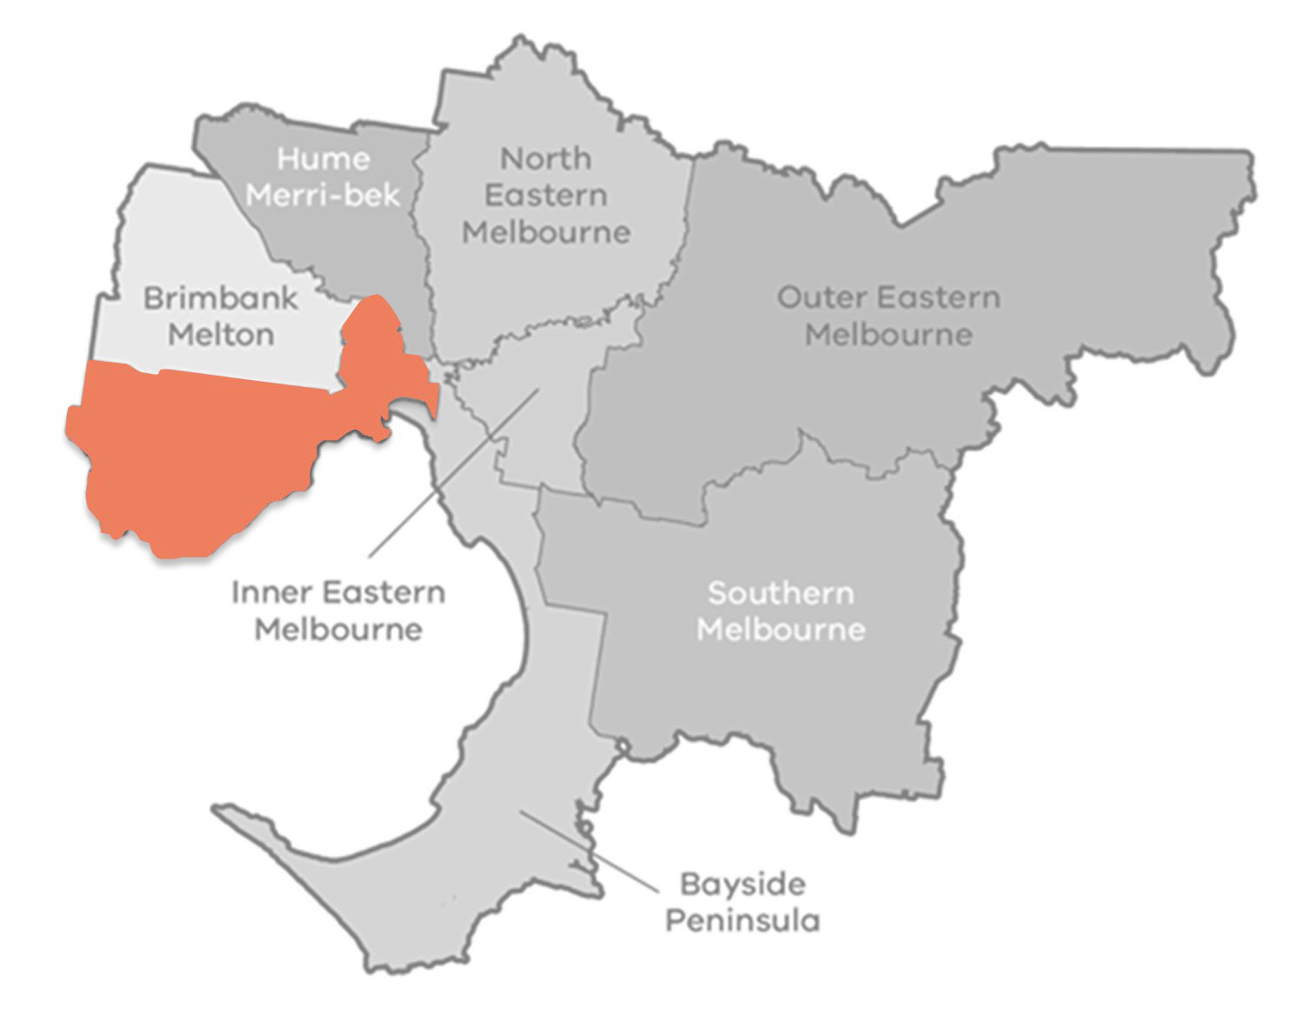

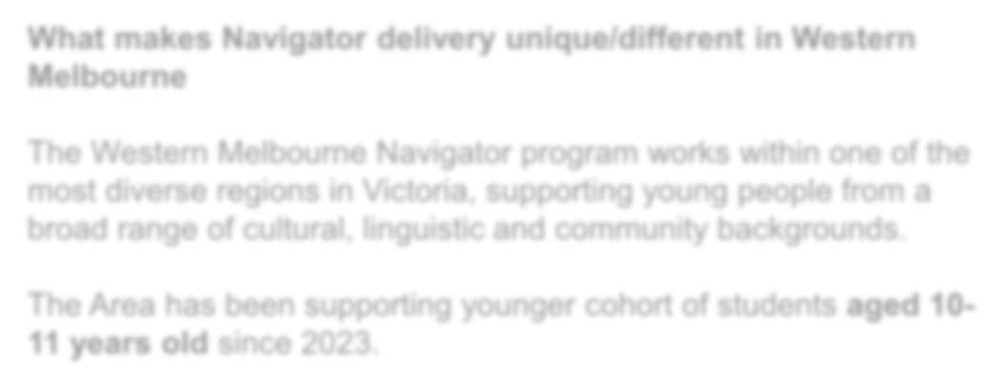

The Western Melbourne Area (WMA) Navigator Program has a strong focus on ensuring engagement and education outcomes for students from culturally and linguistically diverse (CALD) communities as well as young people involved with, or at risk of involvement with, the youth justice system.

Referral trends in recent years show a significant increase in the number of young people who are neurodiverse, experiencing complex mental health needs, and affected by family violence. Many of these young people present with overlapping vulnerabilities.

The DE area office is based in Footscray.

Western Melbourne

The traditional lands of Western Melbourne area are predominantly home to the Wurundjeri Woi-wurrung and Bunurong Boon Wurrung peoples of the Eastern Kulin Nation.
What makes Navigator delivery unique/different in Western Melbourne

The Western Melbourne Navigator program works within one of the most diverse regions in Victoria, supporting young people from a broad range of cultural, linguistic and community backgrounds.

The Area has been supporting younger cohort of students aged 10-11 years old since 2023.
100 Government schools
11 Specialist schools
83 Non-government schools
1 Flexible Government school
1 Flexible Learning Option (FLO) In School Program
5 Local Government Areas (LGAs) - Hobsons Bay, Maribyrnong, Melbourne, Moonee Valley and Wyndham
237 referrals made in 2025

These areas are part of a rich, continuous Indigenous history, with specific areas often recognising the Yalukit Willam clan of the Bunurong.
27

- DE will enter into a single contract for the delivery of Navigator in each of these areas and separate selection processes will be undertaken for each area
The application process
- a merit based, competitive process
- to be considered, an applicant must demonstrate the ability to begin delivering the service to young people starting in 2027.
- applications from consortia/partnerships are accepted but a lead provider will need to be identified, who will enter into a Common Funding Agreement and be ultimately responsible for program delivery
- to ensure equity for all applicants, questions cannot be responded to verbally (outside of this session), or individually - all questions must be in writing and a response will be added to the ‘Navigator Prospective Service Providers Frequently Asked Questions’ document, which is on the Navigator webpage.
Indicative funding (excl. GST) per annum in each of the areas is based on a demand-driven funding model and is as follows :

Bayside Peninsula
approximately $1.9 – $2.1 million

Hume Merri-bek
approximately $1.3 – $1.4 million

Loddon Campaspe
approximately $1.5 - $1.6 million

Western Melbourne
approximately $2.2 - $2.3 million

The application process

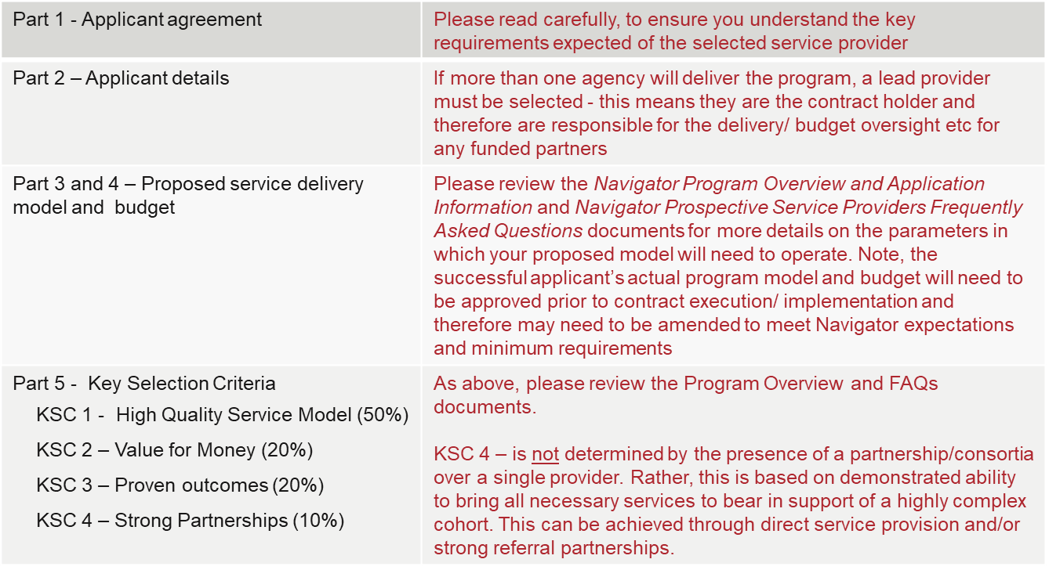
  - Submissions must be submitted by completing an Application Form.
  - The Application Form is made up of 5 parts

Key dates

May 2026 | Applications open
5 June 2026, 1pm – 2:30pm | Online Navigator Information Session for all interested parties
21 June 2026 at 11:59pm | Applications close - Late applications will not be considered
Early July 2026 | Interviews
July/August 2026 | Applicants notified of outcome
July/August 2026 | Successful applicants to submit a detailed project budget for approval prior to contract execution
August 2026 | If transition to new provider is required, transition planning will commence
01 January 2027 | Service delivery under the new contract commences

Q&A

Further information on the Navigator program can be found on The Navigator program website.

Email navigator@education.vic.gov.au if you have any questions.
Responses to questions will be provided via the FAQ document which can be found on The Navigator program website along with application documents and information.

