E-RISEC

Researcher/Applicant User Guidelines

Contents

1. Overview 3

1.1 What is E-RISEC? 3

1.2 Introduction to this guide 3

2. Researcher 4

2.1 The Researcher role 4

2.2 Accessing E-RISEC 4

Create an eduPass account with E-RISEC access 4

Request E-RISEC access with existing eduPass account 6

2.3 Researcher Homepage 7

Header Shortcuts 7

Homepage Body Shortcuts 8

3. E-RISEC Application 10

3.1 Application overview 10

3.2 Submitting an application 10

3.2.1 Adding additional researchers (including those who do not have E-RISEC access) 12

3.3 Application fields and response types 13

3.4 Application checks 17

3.5 Receiving and responding to feedback 18

3.6 Submitting an amendment application 19

3.7 Accessing your Approval Letter 19

4. Final Report 20

# Overview

## What is E-RISEC?

The Research in Schools and Early Childhood Settings (RISEC) application process is managed by the Department of Education. It aims to ensure that research conducted with the involvement of government schools and early childhood settings is appropriate to the goals of the education system and upholds the department’s duty of care for students and staff.

The RISEC process provides approval for researchers to approach schools and early childhood settings to request participation in research. Participation in research by either the school, site operator or individual participants is completely voluntary and at their own discretion.

E-RISEC is the department’s software tool used to manage the submission, review and approval processes for RISEC applications. It enables researchers to apply online to conduct research in department sites and supports the capture of research findings following the completion of the research.

The underlying software supporting E-RISEC is named eProtocol. General information regarding this software and vendor contact details can be found [here](https://www.keyusa.com/eprotocol.html).

## Introduction to this guide

This user guide is intended to be used in conjunction with the RISEC guidelines for anyone who is applying to conduct research with Victorian government schools, early childhood settings or other department sites. This guide provides an overview of the E-RISEC application process and the functions that Researchers are able to perform in the E-RISEC system, including:

* Requesting an E-RISEC account and logging into E-RISEC
* Viewing applications
* Completing and submitting an application
* Responding to return notes and feedback
* Submitting an amendment application
* Withdrawing an application
* Accessing your approval letter
* Submitting a completion report

## Glossary of Key Terms

|  |  |
| --- | --- |
| **Term** | **Definition** |
| Amendment | A revision or update to an approved application. Like new applications, amendments must be submitted and approved. |
| Protocol ID / RISEC number | A unique ID used for identification purposes that is assigned to an application when it is created. The Protocol ID remains assigned to the application permanently. If you need to contact the department regarding a RISEC application, please provide the Protocol ID/RISEC number to assist your request. |
| Comment/Response cycle | The Comment/Review Cycle has four steps:   1. Once your application is reviewed, Reviewers may make comments requiring your response before the application can be progressed. 2. The Reviewer will submit feedback and comments via E-RISEC, and you will be notified if there is feedback for your action via email. 3. The Researcher responds to the comments and resubmits the application with the responses (and changes to the application, if necessary).   *Researchers should take care to respond to the department within 3 weeks of receiving any actionable feedback or comments on their application.*   1. The Reviewer reviews the responses and changes made to the application (if any) and makes a recommendation on whether the application should be approved or whether another Comment/Review cycle is required. If no feedback is to be provided or action necessary on the Researchers end, then the application will be forwarded internally for approval.   *The number of Comment/Response cycles an application has gone through is indicated in the ‘Protocol Event’ column by the number next to ‘**Comment/Response cycle’.* For example, the first cycle will be indicated as ‘*Comment/Response cycle 1’.* |
| eduPass | eduPass allows access to the department’s services, allowing entry into secure systems and applications that the user is granted access to. Please follow the steps detailed in section 2.2 to obtain an eduPass account to access E-RISEC. |
| Principal Investigator | Investigator is used interchangeably with researcher in E-RISEC. The Principal Investigator is the Lead/Principal Researcher for a RISEC application. This person is responsible for submitting the RISEC application and usually has carriage of the research. |
| Protocol | Another word/term for Application. When Protocol is referred to in E-RISEC, it is referring to a RISEC Application. |
| Protocol Event | Protocol Event appears in the Researcher Home and gives the viewer information on the status of a RISEC Application. For example, ‘Submitted to IRB’, indicates the application has been submitted to the department for review. |

## Researcher

## 2.1 The Researcher role

The Researcher role refers to the person responsible for submitting an E-RISEC application for the department’s review for the purpose of conducting research in government schools and early childhood settings. The Researcher is also responsible for responding to reviewers’ feedback and comments and uploading a summary report at the end of the project.

The Researcher is generally the primary or lead researcher/investigator of a research project and is the main contact for the purposes of the RISEC application.

## 2.2 Accessing E-RISEC

### Create an eduPass account with E-RISEC access

To submit an E-RISEC application, you will need to create an account through eduPass.

To create an account, access the [eduPass homepage](https://edupass.education.vic.gov.au/community/welcome/).

Click on **Request an Account**. If you already have an eduPass account, click **Log in** instead.

After clicking on **Request an Account,** a list of applications will be shown. Tick the application you want to access (E-RISEC) and click **Next**.

**Please ensure you only tick E-RISEC.**

Follow the prompts to register user details, then click **Next**.

A verification code will be sent to the email address provided. Enter this code and click **Submit.**

**In order to have your access validated, you need to also email** [**research@education.vic.gov.au**](mailto:research@education.vic.gov.au) **advising of your request.**

Once the access request is approved, you will receive an email with your eduPass login ID and a temporary password. Click the email link provided and enter your username and temporary password.

Use the **Activate Account** form to set your own security questions and password.

You will then be able to use the eduPass account to access E-RISEC and submit applications.

### Request E-RISEC access with existing eduPass account

If you already have an eduPass account, the following screen will be displayed after you log in.

To request access to E-RISEC select **Manage Application Access**. Follow the prompts to register user details, then click **Next**. A verification code will be sent to the email address provided. Enter this code and click **Submit.**

**In order to have your access validated, you need to also email** [**research@education.vic.gov.au**](mailto:research@education.vic.gov.au) **advising of your request.**

Once the access request is approved, you will receive an email with your eduPass login ID and a temporary password. Click the email link provided and enter your username and temporary password.

Use the **Activate Account** form to set your own security questions and password.

You will then be able to use the eduPass account to access E-RISEC and submit applications.

Your E-RISEC credentials will be: (USERNAME)[@eduweb.edu.vic.gov.au](mailto:ECSSEVA3@eduweb.edu.vic.gov.au), and whatever password you have set for yourself.

## 2.3 Researcher Homepage

Once you log into E-RISEC, you will be taken to the Researcher homepage. The homepage is divided into two sections: the header and the homepage body. Each section has its own shortcuts that allow you to go to specific locations or functions.

|  |  |
| --- | --- |
| Warning | **Caution:** Do not use the browser’s forward and backward arrows to navigate. Since E-RISEC is a secure application, using the forward and backward arrows is a security risk and you will be logged out of E-RISEC. |
| Warning | **Caution:**You will need to ensure that your internet browser has pop-ups enabled while using E-RISEC. Pop-up blocking software prevents E-RISEC from opening certain windows. |
|  | **Note**: A Help button is located on every page in E-RISEC. Click a Help button at any time for tips about the current page. |

### Header Shortcuts

At the top left of the homepage is the header menu. To navigate to the Researcher submenu, click on **eProtocol**and then **Researcher**. From this submenu, you may perform the following functions:

1. Navigate to the Research homepage
2. View approved applications
3. Clone an application
4. Create an application
5. Delete an application
6. Search for an application

On the top right of the page, you can perform the following functions by clicking on the menu icon:

1. Access the Help page
2. View the E-RISEC version number
3. Sign out of E-RISEC

### Homepage Body Shortcuts

The homepage body is located below the header. In the homepage body, you can view and perform the following functions:

1. Know your location in E-RISEC by viewing the breadcrumbs
2. Create an application
3. Clone an application
4. Delete an application
5. View or edit an application by selecting the link under the Protocol ID column
6. Graphical user interface, application

   Description automatically generatedView new applications and amendments, applications under review, applications for which the completion report, approval applications and inactive applications.

# 3. E-RISEC Application

## 3.1 Application overview

An application consists of a header, the left-side navigation pane, and the application content pane.

The header consists of shortcuts that allow you to perform the following:

* Save your application
* Perform a Spell Check on the current page
* View the Help pop-up
* Close your application
* Navigate to the Previous page
* Navigate to the Next page

The left-side navigation pane allows you to perform the following functions:

* Navigate to a specific page in the application form
* Print all or part of the application (Print View)
* Event history of the application

The application content pane contains questions regarding your project that you must provide responses to in order to submit your application.

## 3.2 Submitting an application

To create a new RISEC application, navigate to the **Researcher Submenu** and select **Create Protocol** or select **Create Protocol** on the homepage. A new window will appear.

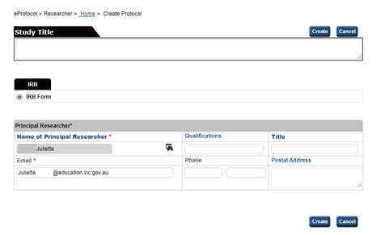

A pop-up page will open with the application form. **You will need to have pop-ups enabled on your web browser to use the E-RISEC system.**

Follow the prompts to complete the application. Please note that some of your selections determine which questions become enabled in subsequent sections. You may navigate to previous pages of the application at any time if you feel you have made a mistake in your responses.

You will need to complete all mandatory fields before navigating to the next page. If you attempt to proceed to a subsequent (and sometimes a previous) page and without completing the mandatory fields (*), a notification will appear at the top of the page.

**Important: Please note that many fields, while not mandatory in the E-RISEC form may be required to submit a complete application. Please consider each question and field in the form and provide adequate responses where applicable to your application. Incomplete applications will be returned and may result in longer timeframes of approval.**

Use the **Submit Form** tab to submit your application. When submitting your application, a pop-up will appear if your application includes incomplete sections. Click a link to navigate to the desired section and complete it.

Once you have saved and submitted your application, the pop-up window can be closed. You will then see ‘SUBMITTED’ in the Protocol event column confirming your submission. An email will also be sent to your email address, associated with your E-RISEC account confirming your submission.

Emails from the E-RISEC system will come from research@eduvic.keyusa.net. Please note this is a no reply email address. Any enquiries related to RISEC should be directed to [research@education.vic.gov.au](mailto:research@education.vic.gov.au)

## 3.2.1 Adding additional researchers (including those who do not have E-RISEC access)

If you are a **student researcher, your academic supervisor must also have an E-RISEC account**, to review, verify and also sign the research agreement of your application. Applications from student researchers cannot be submitted until both the student researcher and academic supervisor have electronically filled out the research agreement at the end of the application form.

Any additional researchers can be added using the binocular icon, and searching for their name, if they have an E-RISEC account. **If you wish to add any additional researchers to the application, they must also request access and set up an E-RISEC account (Section 2.2).** This will be necessary for any researchers who require visibility of the application. This is best done, before you commence the application process. However, you can save and come back once all additional researchers, to be listed on the application have set-up their E-RISEC account.

If you are submitting the application on behalf of another Chief Investigator, Lead Researcher, Project lead than please add them to the application under ‘Academic Supervisor/ Chief Investigator/Lead Researcher or Project Lead’ in the section for personnel and indicate their role. Please note anyone added here must verify your application and sign the research agreement at the end. This means they need to have a validated E-RISEC account (they must set up their account and login).

**All researchers involved in the project must be listed on the application.** If you wish to add additional researchers to the application form, who do not have an E-RISEC account, you may use the *Other Personnel* section to do so. See below.

* 1. Graphical user interface, text, application, email

     Description automatically generatedOn the *Personnel Information* section of the E-RISEC formyou can add researchers or other personnel involved in the project under the *Other personnel heading.*

* 1. Click Add
  2. Graphical user interface, text, application

     Description automatically generatedA pop-up will open. Click on the binocular login and then on the prompt circled above, to add other personnel.
  3. You will then be able to manually input additional researchers’ names and details to be listed on the application.
  4. Please note researchers added to an application in this way will not have visibility of the application in the system. This should only be utilised when additional researchers do not need to be involved in the RISEC approval process but will be involved in the research in some way.

### 3.3 Application fields and response types

To complete an application, you need to know the different response options you have and how to use them. The response options in E-RISEC include:

|  |  |
| --- | --- |
| [Binocular Icons](bookmark://_Text_Field) | for selecting an E-RISEC user from the existing set of active users |
| [Text Fields](bookmark://_Text_Field_2) | for providing an unstructured response |
| [Dropdowns](bookmark://_Option_Button) | for selecting one option from a predefined list |
| Yes, No, N/A Buttons | for providing a clear, succinct response to a question |
| [Calendar Icons](bookmark://_Calendar_Icon_2) | for selecting a date |
| [Add Buttons](bookmark://_Add_Button_1) | for adding items to a structured list |
| [Checkboxes](bookmark://_Checkbox_1) | for selecting one or more responses from a predetermined set |
| [Attachments](bookmark://_Dropdown_Menu) | for adding a pre-existing file to the application |
| Radio Button | For selecting an option (appears as a circular checkbox) |

#### **Binocular icons**

#### The **binocular icon** is used to search for a user. When you select the icon, the **Find User** pop-up appears. You may choose to search for a user by entering the User ID, the First Name, or the Last Name. Then, click **Find**.

Select the user by clicking the corresponding **radio button**. Then, click **OK**.

**Text fields**

A **text field** is a box where you can enter text, as long as the text field is enabled (contains a white background). When a text field is disabled (greyed-out), no information is needed. Click into the text field to add information.

Some text fields have character limitations. You will receive an error message if you exceed the character limit.

Your responses may determine if a text field is enabled or not. For example, if your response requires additional information, a text field enables and becomes mandatory for the section.

#### **Dropdowns**

#### **Dropdowns** allow you to select one value from a list. Click the downward facing arrow to open the dropdown. Then, click on one to select a value.

#### **Yes, No, N/A buttons**

These buttons allow you to answer **Yes** or **No** questions. Depending on the question, the **N/A** button may not always be available.

Select the appropriate button. A selected button has a dark background and displays a checkmark on the left. Your response may enable an additional Yes, No, or N/A buttons and/or a text field



#### **Calendar icons**

Use the **calendar icon** to input a date. When you click on the icon, a calendar pop-up appears. Select a date on the calendar. Use singular arrows to change the month and double arrows to change the year.

#### **Add buttons**

Use the **Add** button to add additional information to a subject. When you click **Add**, a pop-up appears. Complete the section and click **Save** when you are finished.

#### **Checkboxes**

A **checkbox** is a square icon that you can select, and a checkmark appears on the inside. Some questions allow you to select multiple checkboxes, as necessary.

#### **Attachments**

An **attachment** is a document that you need to upload to your application to clarify or explain a process or topic in your study.

All attachments to your RISEC application can be uploaded in the *Required Supporting Documentation* sectionin E-RISEC.

This section also details the list of attachments that need to be provided to submit your application. Please also refer to the RISEC Guidelines for further information on what should be attached to a RISEC application.

***Important: Ensure you upload all required documentation to ensure timely processing of your application. RISEC applications submitted without the required documentation will be returned to the researcher for re-submission.***

To upload an attachment, perform the following tasks:

Click **Add.**

Click **Browse.**

Select and **Open** the file.

Select the **Document Type** you are uploading from the drop-down menu.

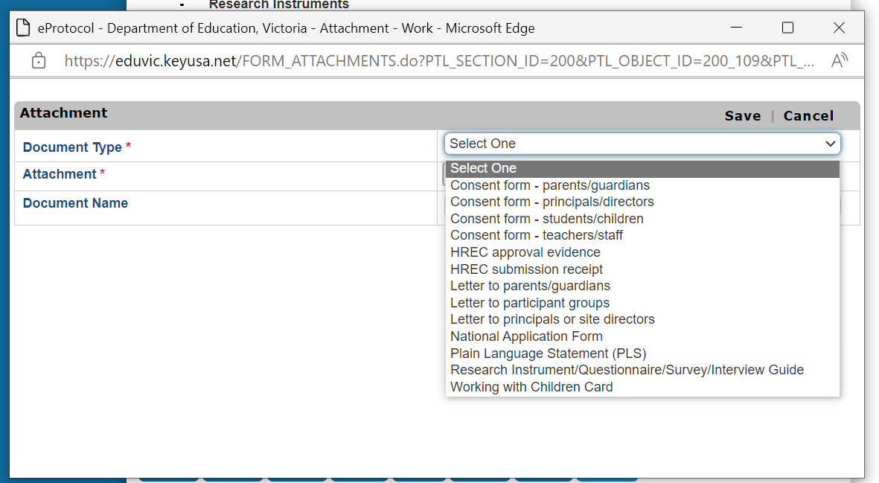

Click **Save.**

### 3.4 Application checks

When you are creating an application, E-RISEC checks for complete sections in two ways:

* 1. Page Level Check
  2. Check for Completeness

#### **Page Level Check**

The Page Level Check (PLC) scans the current page for mandatory questions which are incomplete. If you attempt to proceed to a subsequent (and sometimes a previous) page and without completing the mandatory fields (*), a PLC notification appears at the top of the page. Complete the mandatory fields in order to proceed.

#### **Check for Completeness**

The Check for Completeness (CFC) scans the entire application and notifies you if there are any areas that are incomplete. You cannot submit an application until the CFC confirms that all mandatory sections are complete. If you attempt to submit an application that contains incomplete sections, the CFC pop-up appears and displays links to the incomplete sections. Click a link to navigate to the desired section and complete it.

When you complete the initial sections of an application, the CFC button appears in the left-side navigation pane. You may use CFC as often as you want. If you use CFC and there are no incomplete sections remaining, the CFC pop-up appears stating that the application is complete.

***Important: Please note that many fields, while not mandatory in the E-RISEC form may be required to submit a complete application. Please consider each question and field in the form and provide adequate responses where applicable to your application. Applications that are not complete will be returned and may result in longer timeframes of approval.***

## 3.5 Receiving and responding to feedback

When your application has undergone review by the Research team at the department. They may send comments to you, that require action before the application can proceed further. You will receive an email notification from [research@eduvic.keyusa.net](mailto:research@eduvic.keyusa.net) advising you that your application has received feedback. **All comments should be responded to in E-RISEC.**

The ‘Protocol Event’ displayed on the home page will be changed to ‘Comments Received

(Cycle 1)’. Click in this wording to access the comments.



Read the Reviewer’s comments. If the Reviewer has selected **Response Necessary for Approval**, you will need to respond to the comment and make changes as necessary in order for your application to be considered for approval. If the Reviewer has selected **Suggestion Not Necessary for Approval** you do not have to make any changes or respond to be considered for approval, but you may consider the Reviewer’s suggestion.

After you have submitted your application, you may only make changes to the application when it is sent back to you.

To respond to a Reviewer’s comment. Click **Get Protocol** on the Comments page. Click **Edit** when prompted to open the application in Edit mode.

Make the necessary changes to your application and click **Save**. After saving the application, close the application to return to the Comments page.

Select the text field and enter your response to the Reviewer’s comments, then click **Save**. Once you save, you may exit the Comments page and continue later. Clicking Save will save all of your responses. You do not need to click save after each response, but it is a good idea.

When you have finished making edits to the application and responded to all of the appropriate comments, click **Submit.**

A resubmission confirmation pop-up will appear. Once you resubmit your revised application and responses, you cannot edit them. Click **OK** to confirm.

Once the Reviewer has reviewed your responses, they may send additional feedback that requires action. The review cycle will continue, as above until there is no further feedback.

Once your application has been approved it will appear under Approved Protocols on the Researcher homepage. You will receive an email notification noting the approval of your application. For instructions on how to access your approval letter see section 3.7.

## 3.6 Submitting an amendment application

Navigate to the Researcher homepage. Under the Approved Protocols section, click the link listed under the Protocol ID column. A pop-up window will appear.

Select **Start Amendment** and click **OK**.

Follow the prompts to complete the amendment form. Use the navigation sidebar to update specific sections of the application that you are requesting to amend. Use the **Required Supporting Documentation** tab to upload revised documentation.

If a document is being updated, please do not delete any of the previous versions. **No attachments submitted in the original application should be deleted, these should be retained for record keeping purposes.**

Please indicate in the title of the document the version number of the document so that the reviewer can assess the updated version against the previous version.

Navigate to the **Research Agreement** tab and complete the agreement.

Use the **Submit Form** tab to submit your amendment application. The review cycle will be undertaken as for the original application.

## 3.7 Accessing your Approval Letter

Once the application has been approved the contacts listed on the application will receive email

notification with instructions on how to access the approval letter in E-RISEC. Open the application and, on the left-hand navigation, last option, select ‘Event History’.

The approval letter can be accessed in the **‘Letters’ column**. Please ensure you save a copy for your own records and make note of the conditions of approval.

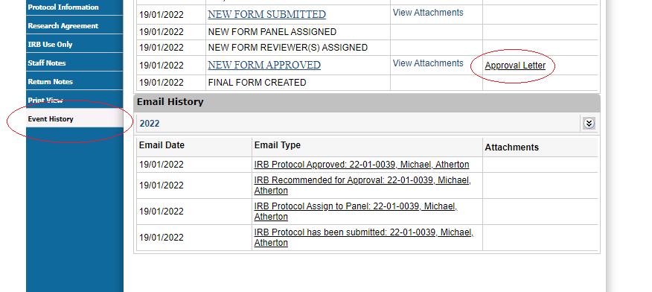

When the approval has been processed in the system it will appear at the bottom of your home page under ‘Approved Applications’.

# 4. Final Report

To close an application, a Final Report must be submitted once the research is finalised. A Completion Report is a concise summary report of the research and its key findings.

A condition of approval from the department is to provide the department with a summary of the approved research’s findings.

To submit a Final Report, navigate to the Researcher homepage. Under the Approved Protocols section, click the link listed under the Protocol ID column. A pop-up window will appear.

Select **Start Final Report** and click **OK**.

Follow the prompts to open the Final Report form and click **Continue**. A pop-up window will appear.

Use the **Submit Form** tab in the navigation panel to submit your Final Report.

# FAQ

|  |  |
| --- | --- |
| ***Question*** | ***Answer*** |
| **My login details aren’t working on E-RISEC, even after I’ve set up my EduPass account.** | *E-RISEC uses your EduPass credentials. Please use the full username for your E-RISEC login. This should be* ***‘username@eduweb.edu.vic.gov.au’*** *and your password you have used to set up EduPass.*  *If your issue continues to persist, please contact* [*research@education.vic.gov.au*](mailto:research@education.vic.gov.au) *to re-set your password.* |
| **I’ve requested an EduPass account for the purposes of E-RISEC, but nothing has happened yet.** | *Please note that access to EduPass for the purpose of E-RISEC is manually granted. Access requests are actioned during business hours of 9am – 5pm on weekdays. Please email* [*research@education.vic.gov.au*](mailto:research@education.vic.gov.au) *to validate your request.* |
| **My project will involve direct contact with children. How should I provide evidence of my valid Working with Children Check?** | *The department requires that all researchers in direct contact with children and young people have a current* [*Working with Children Check.*](https://www.workingwithchildren.vic.gov.au/) *Direct contact includes, but is not limited to, conducting interviews, focus groups, electronic communication, or visiting schools or early childhood settings to conduct observations.*  *Evidence of a valid WWCC must be emailed to* [*research@education.vic.gov.au*](mailto:research@education.vic.gov.au) *as part of the RISEC application. Researchers will be prompted to do this as part of the RISEC application.* |
| **My project is a National Application, can I use the National Application form, instead of the RISEC form in E-RISEC?** | *You may submit your RISEC application using the National Application form using E-RISEC. Please create a new application in E-RISEC and fill in the baseline information required on the application form (such as project title, keywords, project dates). Please upload the National Application form in the supporting documentation tab and indicate for the department to refer to this in the application form.* |
| **I’ve set up an EduPass account for the purposes of E-RISEC, my colleague/ student I am supervising who is submitting the application can’t find me in E-RISEC to add me to the application.** | *Please ensure you’re account is validated. This means you will need to set-up your account and login to E-RISEC for your account to be fully activated. Once you have logged in once, you will be searchable in the system and can be added to applications in the appropriate role.* |
| **I’ve submitted an application, however I need to edit it, but I can only view the application in view mode.** | *Please note that once an application is submitted you will not have edit access. For this reason please ensure the application has been reviewed and is completed before submitting. If you need to unlock your application for editing please email* [*research@education.vic.gov.au*](mailto:research@education.vic.gov.au) |
| **I am submitting the application on behalf of my research team, but I am not the Chief Investigator, Lead Researcher, Project lead etc.** | *E-RISEC will automatically make the person submitting the application the Principal Investigator. If you are submitting the application on behalf of another Chief Investigator, Lead Researcher, Project lead than please add them to the application under ‘Academic Supervisor/ Chief Investigator/Lead Researcher or Project Lead’ in the section for personnel and indicate their role. Please note anyone added here must verify your application and sign the research agreement at the end. This means they need to have a validated E-RISEC account (they must set up their account and login). Please see* ***section 3.2.1*** *of this guide for steps on how to add another researcher in this role.* |
| **I am a student researcher; the application form is not letting me get to the next page.** | *All student researchers must add their academic supervisor to their application, to proceed. The reason for this is that your academic researcher must verify your application and sign the research agreement at the end. This means they need to have a validated E-RISEC account (they must set up their account and login). Please see* ***section 3.2.1*** *of this guide for steps on how to add your academic supervisor.* |
| **I’ve created an application on the system and wish to delete it. How do I do this?** | *If you need to delete an application, you are yet to submit, please select ‘delete protocol’ from the top of the review home page. From here you can select which application you wish to delete by ticking the corresponding checkbox in the first column on*  *the left. You may tick multiple checkboxes to delete multiple applications at once. The checkbox at the top of the column will select and deselect all checkboxes. Once you’ve selected which submission you would like to delete, select ‘delete protocol’ from the top of the page. A pop-up window will appear. Confirm you wish to delete the selected applications by selecting ‘yes’.* |
| **I want to upload a video to E-RISEC as this is required for my project. How do I do this?** | *Videos cannot be uploaded directly into an E-RISEC application; however, they can be embedded into a document which can then be attached under the supporting documentation section of the application.*  *To embed a video into MS Word, PowerPoint or Excel, please refer to the following instructions:*  *1. On the Insert menu, click Object, and then click the Create from File tab.*  *2. Click Browse and locate the movie (video clip or sound wave) you want to insert.*  *3. Select Movie (video clip or sound wave)*  *4. Click Insert.*  *5. To play media clip, double-click its icon.*  *6. Save using the preferred file name.* |
| **I’ve submitted my application, but I haven’t heard anything back, what should I do?** | *RISEC applications can take approximately 6 weeks to be approved from the date* ***all*** *materials are received. If it has been longer than 6 weeks, you can reach out to* [*research@education.vic.gov.au*](mailto:research@education.vic.gov.au) |
| **I can’t find the answer to the response I need in this guide – who do I contact for assistance?** | *Please email* [*research@education.vic.gov.au*](mailto:research@education.vic.gov.au) *if you need assistance with something that is not contained within this guide.* |