
Disability Inclusion Implementation
Disability Inclusion is investing in improving supports for students with disability in Victorian government schools.
Workforce capability building
Disability Inclusion Proﬁles















Disability Inclusion is building knowledge and skills in inclusive education across the school system.
A new tiered funding model is introducing additional funding to support students with disability.
As of 2026, all Victorian government schools have transitioned to the Disability Inclusion funding and support model.

Tier 3: Student level funding Intensive and
individualised support informed by Disability
Inclusion Profile
3
Tier 2: School level funding
Additional targeted support and capacity building
2
Tier 1: Core student learning funding Universal support
for all students
1
Tiered funding model
The Disability Inclusion Proﬁle is a new strengths-based tool that

Stages of implementation
Inclusive Education Scholarships
The Inclusive Education Scholarships Initiative empowers schools to support every learner. It offers 8 postgraduate courses across 2 programs, the Master of Inclusive Education and the Graduate Certiﬁcate, designed to strengthen teachers’ skills and transform classroom practice. As of March 2026, over 650 educators have enhanced their practice, driving system-wide improvements in inclusive teaching. With annual application rounds, more schools and educators will continue to beneﬁt, embedding a lasting culture of inclusion across the education system.

Inclusion Outreach Coaching
Inclusion Outreach Coaches (IOCs) assist schools to set up school-wide systems to build capability, practice and conﬁdence of teachers and other staff to better meet the learning and wellbeing needs of all students, including students with disability and diverse learners.
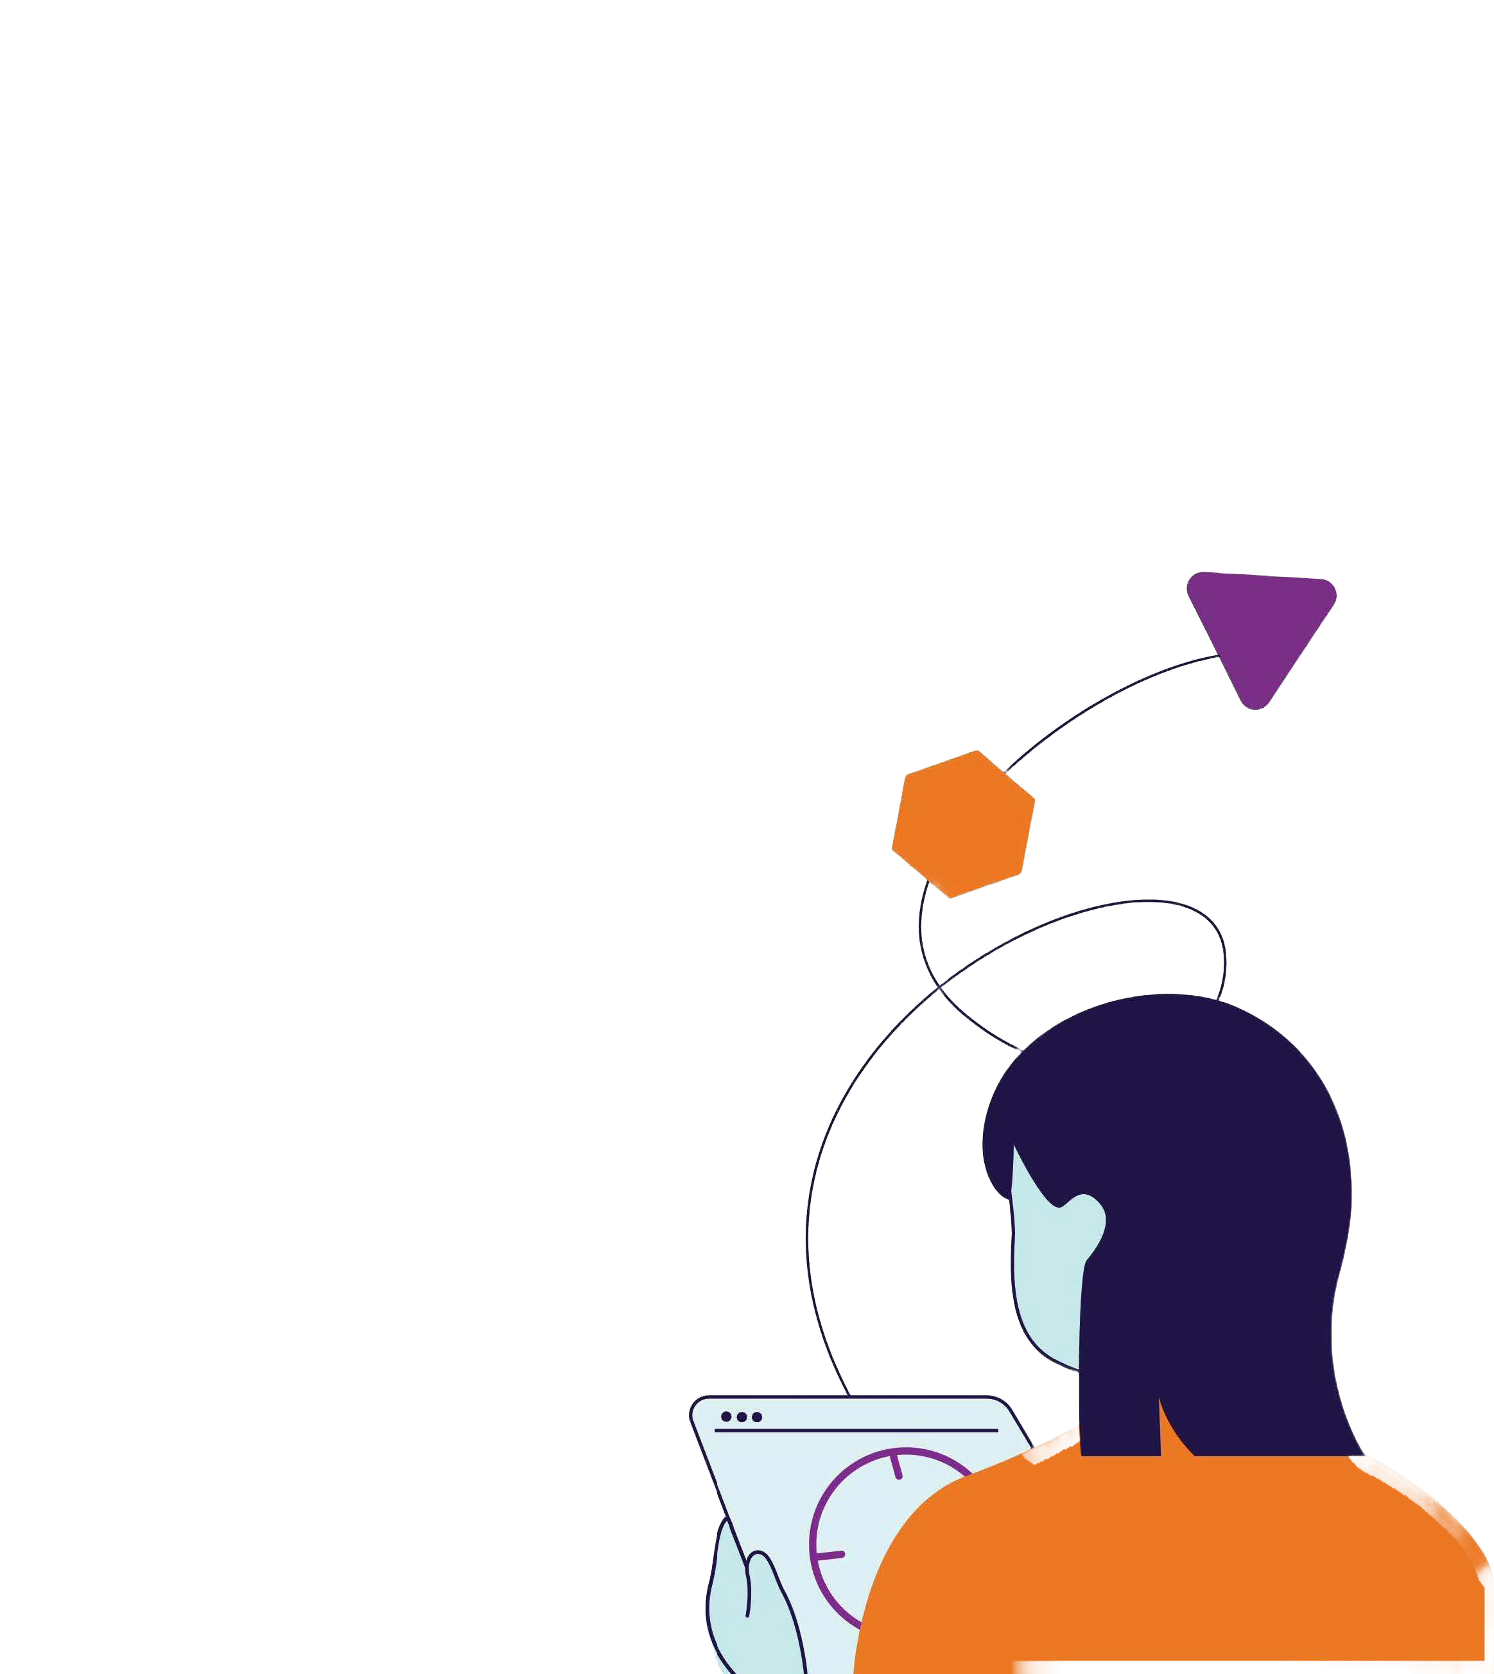
There are 91 coaching positions available state-wide in 2026. From January 2021 to March 2026, IOCs commenced 665 support agreements with schools, typically lasting two terms, and of these 467 were completed.
510 schools have been supported by an IOC.

Inclusive Classrooms
Inclusive Classrooms offers a suite of courses for school staff focused on practical teaching strategies, adjustments and supports at the school, classroom and individual levels. From January 2021 to March 2026, there have been 8213 successful blended learning course completions.

Diverse Learners Hub
The Diverse Learners Hub (Hub) is a Centre of Excellence building the capability of all schools and regional workforces across Victoria, providing evidence-based advice, resources and guidance to meet diverse learners’ needs. Diverse learners include students with characteristics of autism, ADHD and learning difﬁculties.
Since 2022, the Hub has provided direct coaching and support on whole-school inclusive practice change to 316 schools (18% of all government schools). In 2025, the Hub provided over 40 statewide professional learning opportunities attended by school and regional workforces, and 64 evidence-based responses to inquiries from school and regional workforces, helping them apply a diverse learner lens to their work.
identiﬁes a student’s needs to understand how to support them in the classroom. As of March 2026, over 28,000 Disability Inclusion Proﬁle meetings have been completed.
Disability Inclusion Proﬁle meetings are increasing over
28,000
24,370
20,000

Aug’25
Nov’25
Mar ’26

Over 95% of proﬁle meetings have incorporated student voice.

Disability Inclusion was introduced to Victorian government schools in five roll-out stages from 2021 to 2025.
Year 1
(2021)
- Bayside Peninsula
- Barwon
- Loddon Campaspe
- Five supported inclusion schools
Year 2
(2022)
- Outer Eastern Melbourne
- Central Highlands
- Mallee
- Two supported inclusion schools
Year 3
(2023)
- Inner Gippsland
- Ovens Murray
- Western Melbourne
- Three supported inclusion schools
Year 4
(2024)
- North Eastern Melbourne
- Southern Melbourne
- Brimbank Melton
- Goulburn
Year 5
(2025)
- Hume Merri-bek
- Outer Gippsland
- Wimmera South West
- Inner Eastern Melbourne

