NAVIGATOR – PROGRAM OVERVIEW AND APPLICATION INFORMATION
The Navigator Program (Navigator) is a state-wide Department of Education (DE) program which operates across all 17 DE Areas. Navigator provides Intensive Case Management and assertive outreach to severely disengaged young people aged 12 - 17 to help them re-engage with education. DE contracts community service organisations to become Navigator Service Providers (Service Providers) to deliver the program. They work closely with education providers, families and other community services to provide holistic support to young people. Service Providers work in collaboration with local DE Regional Navigator team and the DE Central Navigator team.
PART 1 – APPLICATION INFORMATION
What is this EOI for?
DE is running three separate EOI processes to seek a service provider to deliver Navigator from 2025 to 2027 inclusive in:
- Outer Eastern Melbourne DE area,
- Wimmera South West DE area
- Barwon DE area
DE will enter into a single contract for the delivery of Navigator in each of these areas and separate selection processes will be undertaken for each area. Applications will be accepted from individual agencies or a consortium. Consortiums will need to identify a lead provider who will be responsible for the delivery of the program.
Indicative funding for each of the areas is:
Outer Eastern Melbourne: approximately $988,000 (excl.GST) per annum.
Wimmera South West: approximately $838,000 (excl.GST) per annum.
Barwon: approximately $1,138,000 (excl.GST) per annum.
Please note that this is indicative 2025 funding - the final budget, including 2026 and 2027 funding will be discussed with the preferred applicant prior to contract execution. Applicants should base their applications on the annual indicative figures listed above.
Service provision is to reach eligible young people wherever they are located within the Area.
This EOI as part of a schedule of EOIs undertaken for all providers between 2021 - 2025 in line with best practice program management.
Selection Process
Interested applicants are to submit a written application to express interest in delivering Navigator specifying which areas they are applying to. Interested applicants may apply to delivery Navigator in more than one area but must submit separate applications for each area. Applicants will receive an email confirming receipt of their application and will be informed in writing of the selection panel’s final decision.
All questions about the selection process are to be submitted in writing to navigator@education.vic.gov.au. So as to not disadvantage any applicant, all responses to questions received will be published on the Navigator webpage (in the FAQs document).
A selection panel will assess all applications against the Key Selection Criteria and invite shortlisted applicants to interview. Referee checks may be completed on interviewed applicants. The preferred applicant will be invited to enter discussions to agree service parameters and funding before the process is finalised.
Key Dates
23 April 2024 | Applications Open
30 April 2024 | Online Navigator Information Session for all interested parties
19 May 2024 at 11.59pm | Applications Close- Late applications will not be considered
June 2024 | Interviews
July 2024 | Applicants notified of outcome
Early July 2024 | Successful applicant to submit a detailed project budget for approval prior to contract execution
August / September 2024 | If transition to new provider is required, transition planning will commence
01 January 2024 | Service delivery under the new contract commences

Application requirements
To be considered, applicants must:
- complete the application form, in full, which consists of:
  - Part 1 – Application Agreement
  - Part 2 – Applicant Details
  - Part 3 – Proposed Service Delivery Model
  - Part 4 – Proposed Program Budget
  - Part 5 – Address of Key Selection Criteria
- agree to all points listed in the Application Agreement (pg 1 Application Form)
- provide all required supporting documentation
  - a Certificate of Incorporation and verification of appropriate insurance* for the submitting agency and any partners who will be sub-contracted to deliver Navigator
  - documentation attesting financial viability. This should include an audited and complete statement for the most recent financial year
  - a statement detailing any real or potential conflict of interests (if any exist) and details on how these conflicts can be managed.
- *hold appropriate insurance that indemnifies for liability for child abuse (see Victorian funding requirements for services to children fact sheet for further information)
- be able to comply with stated timelines (see Key Dates above)
- guarantee service delivery from contract inception (this includes ensuring adequate staff are deployed to fill Navigator roles (permanently or temporarily)
- demonstrate local service capacity – the community service organisation is (ideally) currently operating within and across the entire DE area and providing equitable services to young people
- have case management systems that can be used for managing client files
- employ suitably qualified and/or experienced staff to deliver Navigator services, with a mix of training or relevant experience such as teaching, youth work or social work, and or with expertise in psychology or community health. Case Managers should be competent and capable of supporting young people with mental health issues, able to support young people presenting with complex challenges and equitably deliver assertive outreach to different cohorts. Staff will be expected to be employed in accordance with Victorian Common Funding Agreement (VCFA) terms and conditions, including securing a valid Working with Children Check, and the assurance of availability of adequate professional supervision and professional development opportunities for all Navigator staff.
- provide culturally appropriate support for young people who identify as Aboriginal or Torres Strait Islander.
- demonstrate they meet the key selection criteria (Application Form, pg 9) to a high level, including:
  - KSC 1: High Quality Service Model (50%)- propose a service delivery model that aligns to the Navigator Program parameters
  - KSC 2: Value for Money (20%) – proposes a budget that represents value for money
  - KSC 3: Proven Outcomes (20%) – a proven track record of achieving (similar) project outcomes
  - KSC 4: Strong Partnerships (10%) – evidence of community partnerships and positive working relationships with schools, education settings, project partners, funding bodies and the community

Information Session
An online information session will be held on 30 April 2024, 10.00am – 11:30pm. Interested organisations are invited to attend the session to learn more about the program, meet the Navigator teams and ask questions. Attendance at the Information Session is optional. To register, please email navigator@education.vic.gov.au by COB 26 April 2024 and specify which area/s you are interested in applying for.

PART 2 – PROGRAM OVERVIEW

Background
Navigator commenced as a pilot program in July 2016 and now operates state-wide, in each of the 17 DE Areas.
In Victoria, there are a significant number of young people who have disengaged, or are at risk of disengaging, from education or training. Many of these young people face multiple barriers to re-engaging with education and as a result, often need intensive, multifaceted supports to enable them to overcome these barriers and pursue educational success.
Aligning to the Education State agenda, Navigator fills this need by providing individualised, Intensive Case Management support – it is a targeted support service that works in partnership with young people, families, support services and schools to enable young people to achieve their educational goals and re-engage with education.
What is the purpose of Navigator?
The purpose of Navigator is to provide assertive outreach (including Case Management) to disengaged young people, to support them to successfully re-engage with education. Navigator is defined by its partnership approach between the community sector, DE and education providers to enable a service that:
- actively seeks out disengaged young people and provides individualised support that is targeted to supporting their re-engagement back into education, and that is focused on the young person’s needs, strengths and interests
- can work with families, carers, support networks and schools to provide holistic support to aid re-engagement with education
- supports place-based responses to disengagement by partnering with, and referring to, a range of local services and working collectively to solve local issues and support re-engagement with education.
Who are the program participants?
Navigator is available to young people who:
- are aged between 12 and 17 years of age (inclusive)
- have attended less than 30% of the previous school term or equivalent time period
- study, or intend to study in Victoria.
Participation in Navigator is voluntary, free to the young person, and by referral. Anyone can refer a young person to the program.
What are the key service delivery elements of the Navigator Program?
The elements of Navigator include:
- Referral
- Intake and Assessment
- Active Hold*
- Case Management
- Supported re-engagement with education / Exit

* In addition to providing case management support, Service Providers are required to actively and regularly support any young people who are on their waiting list for case management or who are assessed as not requiring Intensive Case Management - this is known as ‘Active Hold’. Service providers are expected to dedicate FTE to the management of Active Hold and should view it as a ‘light-touch’ case management service, or the delivery of brief interventions/supports that resolve the young person’s need to progress to case management.
Not every young person will move through each stage of Navigator sequentially and the local Navigator DE team and Service Provider will determine locally how they support young people to move through the stages of the program to best support their re-engagement in education.
(See below for Service Provider expectations against each element)
Who delivers Navigator and how do they work together?
Each of DE’s 17 Areas have a local Navigator team comprising:
- A Navigator Coordinator/s, a Navigator Practise Lead and their manager - DE staff who work together to oversee Navigator locally and work within a larger DE team.
- A Service Provider, contracted by DE to deliver Navigator to eligible young people.
The local Navigator DE team and Service Provider work together with schools and education providers to develop a network of local support services that can be drawn on to support young people and education providers and overcome local issues.
A Central team in DE oversees and manages the Navigator program at a state-wide level, working closely with local Navigator teams.
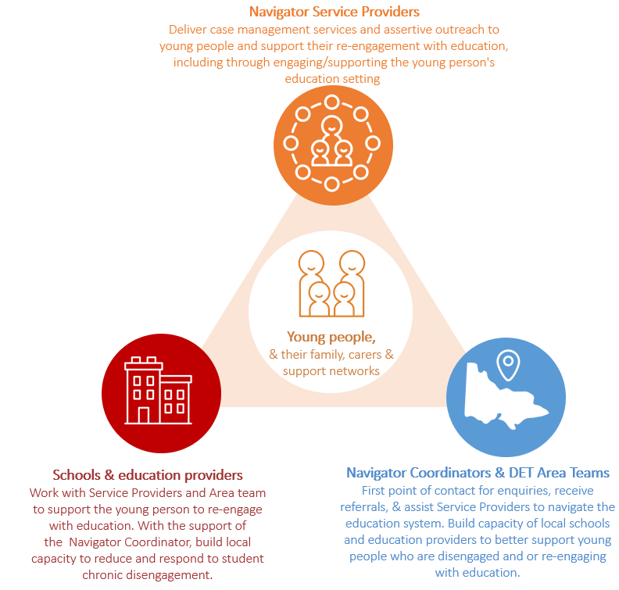

Service Providers
**This expression of interest process is to fill the role of Service Provider**
Service Providers are contracted to deliver (or be responsible for the delivery of) Intake and Assessment, Case Management and Active Hold services in each Area. This may involve delivery as a sole provider, or through a consortium of local organisations working in partnership.

The service delivery model for Navigator involves Service Providers supporting young people to re-engage with education through:
- receiving referrals from the Navigator Coordinator, then seeking out and connecting with young people who have disengaged from schooling (or their family) and conducting Intake and Assessment
- working with the young person to identify their learning needs, capabilities and aspirations and develop an education re-engagement plan that involves family, carers, school and community supports
- working closely with other community services and education providers to ensure the relevant provision of wrap around supports for the young person and their family
- assisting young people to overcome learning, social and other barriers so that they can successfully engage and transition through education, including engaging support services where required
- monitoring and supporting a young person as they re-engage in education (once a young person re-engages with mainstream school the service provider continues to support them until they maintain 70% attendance for 2 terms, then provides them with a Supported Exit from the program.)
Relationships and partnerships with relevant stakeholders are essential to align service responses to young people who have disengaged with education, and to reduce service duplication in local areas.
Navigator Coordinators and local DE team
The DE Navigator Coordinator/s is the primary contact for Service Providers – they, along with their local team play a key role in the local implementation of the Navigator program and facilitate the connections between Service Providers and education providers. They work closely with their local Service Provider and play a key role in managing the relationship between Service Providers, schools, local DE teams and other key services. Local DE teams also build the capacity of schools and the broader service system.
Navigator Coordinators receive all referrals to the program and, as part of the local Navigator team, monitor service delivery, re-engagement processes and outcomes for young people. Upon referral, Navigator Coordinators establish a young person’s eligibility for the program and may facilitate the linkage of young people to broader Area and community supports.
Navigator Central Team
Navigator has a small, Central DE team that oversees the program at a state-wide level. They play a key role in identifying and monitoring state-wide trends, managing reporting, contractual and funding arrangements and providing state-wide operational support.
Schools
Schools are well placed to identify disengaged students and can refer young people to Navigator when they have exhausted other options to re-engage the young person. They work with the other program partners to ensure each young person is supported in their Navigator journey and re-engagement to school. Schools can also be supported by the Navigator Program, through capacity building, to strengthen their approach to supporting disengaged students and ensuring a supporting environment for their whole school community.
What are the goals and outcomes Navigator is seeking to achieve?
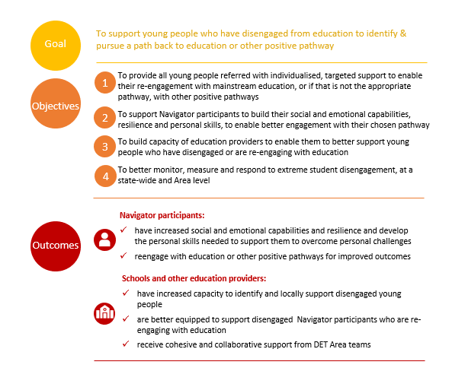

What are Navigator’s success and performance measures?

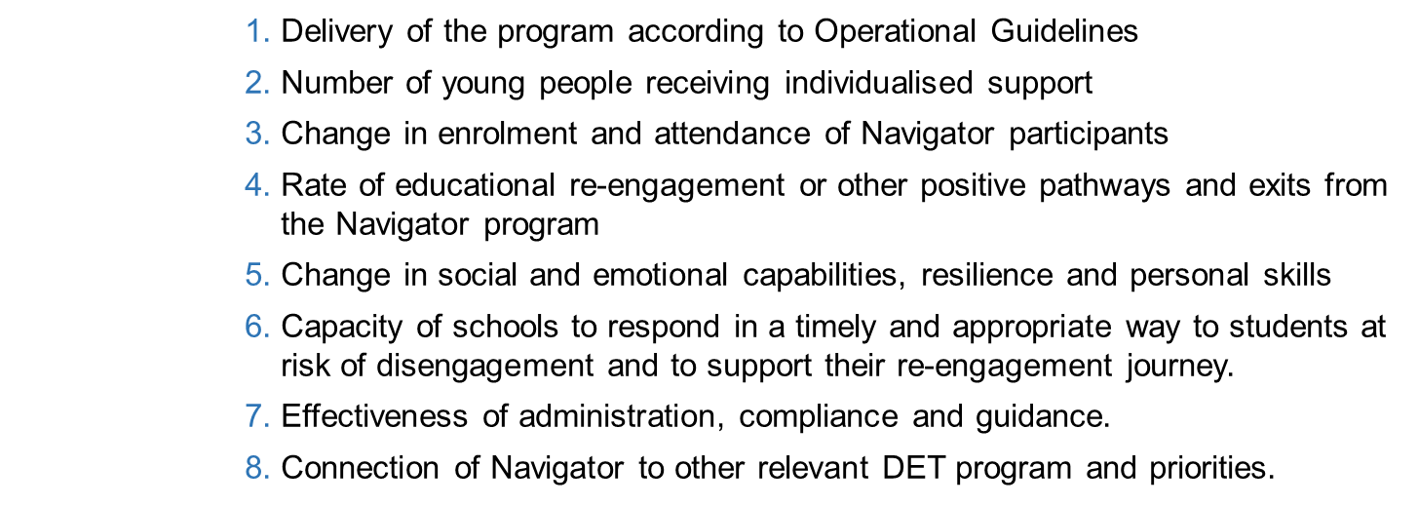

Targets will be discussed with the preferred Service Provider prior to contract execution.
Re-engaging young people with education
The key outcome of Navigator is to re-engage participants back into education, with a full time return to mainstream school being the key focus for young people of compulsory school age. Service Providers should work with the participant, their family/support network and the Navigator Coordinator to identify an appropriate school, or if not appropriate, a flexible learning program, Technical and Further Education (TAFE), or other Registered Training Organisation, or pathway planning option, that best meets the needs of the young person. Given that this cohort of young people typically experience severe barriers to engagement with learning, Service Providers will also be expected to support the young person as they transition back to education. Identifying appropriate referral pathways and options for ongoing support for young people exiting the program is also required.
Developing students with greater social and emotional capabilities
Growing young people’s resilience and social and emotional capability will strengthen their ability to manage the re-engagement process. These capabilities are not static traits and need to be learnt and developed alongside the development of cognitive skills.

To this end, the Service Providers will also need to focus on holistic outcomes for young people, including:
- improved resilience, self-confidence and skills in problem solving
- the development of career goals and pathways
- being more active members of the local community
- improved skills in language and literacy
All Navigator participants complete an Entry Survey when they start receiving support and an Exit Survey, when they finish receiving support – these surveys measure social and emotional capabilities.
Supporting schools to be better equipped to engage all young people
Navigator supports schools to develop a better understanding of how to support young people who are vulnerable to disengaging and reconnect with students who cease attending. Through close collaboration with Navigator partners, schools can build their capacity and knowledge of supports available to help young people overcome the barriers that prevent them fully engaging in education. Both the DE team and service providers are required to support schools.
How do service providers and DE achieve these outcomes?
Local partnerships are key to delivering Navigator successfully. A broad collaboration of organisations is often required to deliver the full continuum of services to ensure that disengaged young people have the support they require (e.g. through referrals). Similarly, to deliver the Navigator service components, Service Providers may choose to form a consortium with other organisations. This may include partnerships with community groups, Aboriginal Community Controlled Organisations, and other service providers, and may be an existing partnership in the service delivery Area. This can also ensure relevant expertise, full geographical coverage and wrap around support models are provided to young people in Navigator.
If a group of organisations wish to partner to deliver Navigator in an Area, one organisation must be nominated as the lead organisation. The nominated lead organisation is to submit the application on behalf of a partnership/consortium, and if successful, enters into a Common Funding Agreement with the Department and assumes responsibility for the delivery of the program in full.
Organisations that form partnership arrangements may or may not choose to be co-located with partner organisations. Any partnership arrangements must be fully collaborative with a united public face, to enable young people and other key stakeholders to easily identify where to go for services.
What is expected of the Service Provider during each stage of young person’s Navigator journey?
Navigator key phases | Minimum expectations of Service Providers
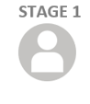  REFERRAL  Referrals are received and managed by the local DE Team | Service Providers are not involved in this phase of the program  NOTE: Referrals can only be submitted with the consent of the young person’s parent/carer
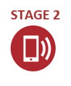  INTAKE AND ASSESSMENT  The Navigator Coordinator passes appropriate referrals onto their Service Provider, who conducts Intake and Assessment. | - Makes contact with the young person / family using a variety of methods and attempts, including assertive outreach where needed  - Explains the purpose of Navigator and how it works, answering any questions and providing required information  - Gains written consent for the young person to participate in Navigator (note, consent for a referral to be submitted has already been obtained in Stage 1)  - Assesses the young person’s needs and determines the supports they require  - Conducts an Entry Survey with the young person  - Contacts the young person’s school, (where enrolled)  - Determines whether to allocate the young person to Active Hold or Intensive Case Management
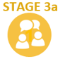  ACTIVE HOLD  The Service Provider delivers Active Hold (which is ‘light touch’ case management) while they are waiting for case management services, or in the event the young person does not need Intensive Case Management support | - Makes regular (fortnightly minimum) contact with young person or family  - Liaises with school or education settings as appropriate  - Identifies and implements / appropriate supports for the young person / family, including making necessary referrals to these supports  - Conducts an Entry Survey with the young person (if not yet done)
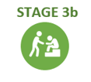  INTENSIVE CASE MANAGEMENT  The service provider delivers Intensive Case Management in an open-ended capacity, as long as the focus remains on educational re-engagement | - Makes regular face to face contact with young person  - Assists young people to overcome learning, social and other barriers so that they can successfully engage and transition through education, including engaging internal/ external support services where required  - Develops and implements an Educational Reengagement Plan for all young people receiving Case Management  - Holds Case Conferences after 6 months of service delivery (and every 3 months thereafter) to assess how the Educational Re-engagement Plan is tracking and make any adjustments necessary  - Liaises with school or education settings regularly  - Identifies and implements / appropriate supports for the young person/ family, including making referrals to additional supports as needed
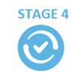  RE-ENGAGEMENT & EXIT  The young person either re-engages with education, is supported to pursue an alternate positive pathway or ends their Navigator journey for another reason. | - Recommends to the Navigator Coordinator when they believe a young person is ready to / should exit the program  - Prepares a Supported Exit Plan for every exiting young person  - Ensures the thorough implementation of the Supported Exit Plan  - Ensures all relevant parties (e.g. parents, young person, school) are aware of the exit and their role in the supported exit plan.  - Conducts an Exit Survey with the young person

What are the reporting requirements for service providers?
Local and central Navigator DE teams are heavily involved in the delivery and monitoring of Navigator and work closely with Service Providers delivering the program.
Service Providers complete a Service Plan each year, which is developed in collaboration with local Navigator teams and endorsed by the Central team, and outlines how the program will be delivered locally. This will be reviewed and acquitted twice per year, with ensuring integrity of data being an ongoing requirement of all Service Providers – which are expected to keep their data up to date in line with program guidelines and submit financial and progress reports as required.
The reporting process and measures are designed to:
- Demonstrate and monitor the outcomes of Navigator services
- Provide specific place-based snapshots of the performance Navigator in engaging young people
- Inform future directions for re-engagement initiatives in Victoria.
Service Providers are required to maintain their own case file systems and also use the Navigator Data Management System (NDMS), a Navigator specific data management system. The NDMS enables DE to collect and analyse program demand, participation, progress towards goals and outcomes. An NDMS file is created for every young person who is referred to Navigator and the Service Provider is expected to update this file each time there is contact (or a contact attempt), or there is a change in support (e.g. the young person moves from intake and assessment to Active Hold; new schools supports are put in place; the young person has increased their attendance rate or enrolled at a new school). The NDMS is not a Case Management tool and should not be used as such, but rather used in conjunction with the Service Provider’s case file systems.

