Two years of early childhood education – what the evidence says
- Early brain development shapes the learning, development, health and wellbeing outcomes of children.
- When children access 2 years of high-quality early childhood education before school, it has many benefits, especially for those who need additional support.
- In Victoria, the amount of Three- and Four-Year-Old Kindergarten that children receive is increasing threefold, giving children the ‘gift of time’ with highly trained early childhood professionals.

Making the most of childhood – the importance of the early years
The first 5 years of life are a period of rapid brain development – by the time a child turns 5, around 90% of their brain development has occurred.
While genes provide the initial map for a child’s brain, the wiring that happens early in life is strongly formed by their social and physical experiences and plays a key role in shaping development.
There is an opportunity to optimise a child’s executive function and self-regulation between the ages of 3 and 5. Evidence suggests that emotional development and cognitive development are far more closely intertwined in the early years than has been previously understood.
What a child experiences during these years can make a significant difference to their future cognitive, social and emotional outcomes, including how they manage their feelings and relate to others

The best outcomes for children are often achieved through sustained positive parenting and high-quality early childhood education. Skills developed in early childhood contribute to broader and longer-term outcomes, including improved employment prospects, health and wellbeing, and more positive social outcomes.

Skilled early childhood education professionals support young children to explore and make sense of the world through play. Children are naturally motivated to, and learn best through play, which helps them develop skills such as persistence, curiosity, and imagination. It can set up a lifelong love of learning. This is because the most successful approaches in early learning build on children’s interests and their curiosity to make sense of the world around them.
Neuroscience shows that responsive relationships that feature ‘serve and return’ interactions where adults respond to children’s expressions, gestures, and words in a back-and-forth exchange make a big difference to a child’s early development. An absence of this responsive care can have negative impacts on a developing brain.
When children have access to quality early childhood education and positive, responsive relationships with their teachers and educators, they are more likely to have improved outcomes relating to language, literacy, numeracy and social and emotional wellbeing.

Two years of kindergarten are better than one
Australian and international evidence shows that quality play-based learning helps lay the foundation for success throughout a child’s education and life.
Two years of quality early childhood education is shown to have more impact than one year and can lift children’s outcomes across all learning domains.
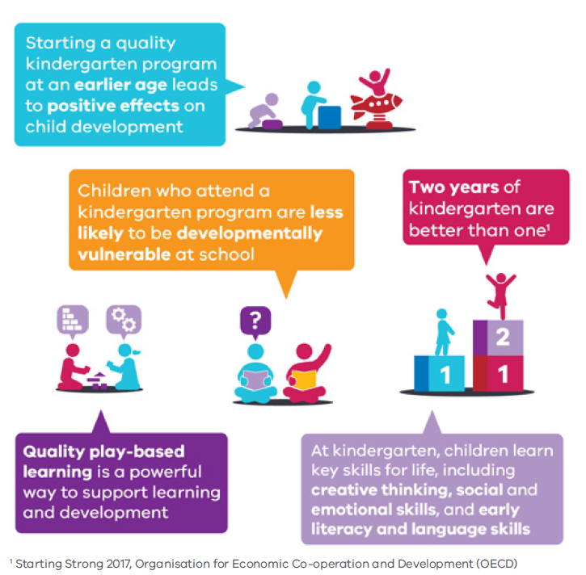
For example, a United Kingdom study showed that children who attended at least 2 years of kindergarten had:
- better development in language, pre-reading, early number concepts, independence and concentration when starting school
- higher exam scores, and better grades in English and maths
- better social behaviours and self-regulation.

Nearly a quarter of children are arriving at school with significant vulnerabilities. Evidence shows 2 years of early childhood education has a stronger positive effect on children who need extra support, giving them more time to maximise their full potential.
It is shown to reduce the risk of anti-social behaviour and improve overall quality of life. High-quality early childhood education is particularly beneficial for children who are from less stimulating home learning environments.

Three-Year-Old Kindergarten – moving to 15 hours of funded universal play-based learning
Victoria currently offers between 5 and 15 hours of Three-Year-Old Kindergarten. By 2029, children in Victoria will have access to 15 hours of funded, teacher-led Three-Year-Old Kindergarten.
Studies show that children who start kindergarten earlier generally have better cognitive development and are more sociable with other children. Internationally, many OECD countries are now prioritising the provision of 2 years of high-quality preschool and are framing this as a necessary investment in the future. Starting kindergarten at 3 provides children with the opportunity to attend 2 years of quality early childhood education – proven to lay a strong foundation for success at school and in outcomes that matter for their future prosperity, including literacy, numeracy, and social and emotional wellbeing.
Children who need extra support benefit the most from at least 15 hours of Three–Year–Old Kindergarten, as it provides time to participate in rich early learning experiences that contribute to positive developmental trajectories.

Pre-Prep – moving to 30 hours of funded universal play-based learning
Pre-Prep is a 30-hour-a-week program of play-based learning, led by a qualified teacher. From 2025, Four-Year-Old Kindergarten will gradually transition to Pre-Prep. Funded Four-Year-Old Kindergarten hours will double from 15 to 30 hours each week.
Increasing program hours to 30 hours of play-based learning in the year before school will give children even greater access to the many benefits that come with quality early childhood education.
Studies show that high-quality 30-hour early learning programs that provide appropriate learning opportunities for children can lead to improved learning and social outcomes.
In 2010, Ontario introduced a 30-hour per week program of play-based, teacher-led early learning. The full-day program increased children’s early literacy and numeracy, as well as self-regulation skills when compared with the previous half-day approach.
The best performing countries on international education assessments also perform strongly in the delivery of high-quality and accessible early learning for children. For example:
- Estonia provides low, or no cost, pre-school programs for children from age 3 until they start school, with the average Estonian 3- to 6-year-old attending 30 hours or more per week in formal early childhood education. Programs are provided in line with a national curriculum that features play-based activities as the primary basis for teaching and learning. This approach has led to positive outcomes in self-regulation, social-emotional skills, literacy and numeracy and is linked to smaller gaps in learning and development due to socio-economic background.
- In Finland, children have access to a kindergarten place that includes a play-based curriculum and high staff qualifications, and ratios that support quality across the system. The positive effects of participating in pre-primary education persist until secondary school, with PISA results showing that 15-year-olds who attended a pre-primary education program tended to perform better than those who did not.

Cumulative impact of Victoria’s kindergarten expansion
Victoria’s expansion of Three- and Four-Year-Old Kindergarten gives children the ‘gift of time’ with qualified early childhood teachers during a period of rapid brain development.
In 2019, most Victorian children had access to 600 hours of funded kindergarten in the year before school. In 2036 at full roll-out, all Victorian children will have access to 1,800 hours of funded kindergarten before school, comprising 600 hours of Three-Year-Old Kindergarten and 1,200 hours of Pre-Prep.
This means children will be able to access 3 times as much teacher-led, play-based- learning during a critical period of cognitive, social and emotional development.

Improving outcomes for all Victorian children
Children who participate in early childhood education programs tend to have better learning outcomes than their peers who do not attend.
The children most likely to miss out on accessing programs are those from non-English speaking backgrounds, children with a disability or developmental delay, or children experiencing poverty.
The roll-out of Pre-Prep prioritises children who will benefit the most from increased access to kindergarten. Delivering 2 years of free kindergarten means that children can access teacher-led, play-based programs without the barrier of cost.
School Readiness Funding will also continue to support evidence-based programs and resources to increase the capacity of kindergarten services to support key outcomes of communication, wellbeing, access and inclusion based on the needs of children at each service. Other services and programs, such as Kindergarten Inclusion Support and Pre-School Field Officers, will be scaled up alongside the reforms to continue to provide greater supports to children at risk of missing out on early childhood education programs.

Quality is key
Evidence shows that programs must be high-quality to achieve significant, lasting impact on children’s development and learning. Quality in early childhood education is influenced by the practice of teachers and educators and the experiences they offer children in early childhood education settings. Environments that have the greatest outcomes for children are engaging, caring, stimulating and respond to children’s individual abilities and interests. Learning outcomes for children are enhanced when early childhood professionals take an active role in children’s learning through observation, listening, questioning, constructive feedback and open communication.
Experiencing a high-quality early learning environment is shown to be especially important when starting school and remains so beyond the age of 16. It influences both attainment and progress in early school careers and sets children on particularly beneficial learning trajectories, especially if they come from more disadvantaged backgrounds.
A United Kingdom study, which followed almost 3,000 children from a range of socio-economic backgrounds from 1997 until 2013, found a significant association between those who attended 2 years of high-quality early education and pro-social behaviours at age 14 — an effect not evident for low or medium quality programs.
Quality early childhood education programs are designed to be flexible and responsive to children’s needs.
Quality program delivery is enabled through providing a balance of:
- structural quality elements (physical environment, qualifications, educator to child ratios, hours of care)
- process quality elements (educator-child interactions, learning activities, curriculum and pedagogies).
Structural parameters — including physical environment, educator to child ratios and hours of care — are important preconditions for process quality, which is most strongly related to child development, wellbeing, and learning.
Victoria’s early childhood sector already has many measures in place to ensure the delivery of quality kindergarten programs. Kindergarten programs are delivered by qualified teachers and guidance to support play-based programming and high-quality service delivery is provided in the Victorian Early Years Learning and Development Framework (VEYLDF), the approved learning framework for services in Victoria.
There is the potential that with more hours available in early childhood education programs, teachers and educators can provide deeper and more deliberate play experiences, which will give children opportunities to embed their learning. More time will allow for more opportunities for appropriate learning opportunities, including one-to-one instructional support and child-directed play.
As the sector continues to grow, it is important to reflect on how transformative these advances in Victorian early childhood learning are – gifting children vital skills for life, and providing significant benefits for society, including social cohesion, reduced inequality and a healthier and happier community.

Endnotes

Commonwealth Government. Your child and neuroscience: Learning potential, 2017
T Moore, A Noushin, A Deery, S West The First Thousand Days: An Evidence Paper, Centre for Community Child Health and Murdoch Childrens Research Institute, 2017.
C Raver and J Knitzer, Ready to Enter: What Research Tells Policymakers About Strategies to Promote Social and Emotional School Readiness Among Three- and Four-Year-Old Children. National Centre for Children in Poverty, Columbia University, 2002.
Raver and Knitzer, Ready to Enter.
S Pascoe and D Brennan. Lifting Our Game: Report of the Review to Achieve Education Excellence in Australian Schools through Early Childhood Interventions. Department of Education, Victoria, 2017
M Fleer, Play in the early years ( 3rd ed), Cambridge University Press, 2021 and L Marbina, A Church and C Tayler Victorian Early Years Learning and Development Framework, Evidence Paper Practice Principle 6: Integrated teaching and learning approaches. Victorian Government.
Center on the Developing Child at Harvard University. The science of early childhood development (in Brief), 2012
OECD, Starting Strong 2017: Key OECD Indicators on Early Childhood Education and Care, OECD Publishing, 2017
OECD, Starting Strong 2017: Key OECD Indicators on Early Childhood Education and Care
K Sylva, E Melhuish, P Sammons, I Siraj-Blatchford, B Taggart, Effective Pre-school, Primary and Secondary Education (EPPSE 3 – 16+) Project: Influences on students' dispositions and well-being in Key Stage 4 at age 16, Department for Education (UK), 2014
S Fox and M Geddes, Pre-school - Two years are better than one: Developing a preschool program for Australian 3 Year Olds – Evidence, Policy and Implementation . Mitchell Institute. 2016.
Fox & Geddes, Pre-school - Two years are better than one.
K Sylva, E Melhuish, P Sammons, I Sira-Blatchford, B Taggart The Effective Provision of Pre-School Education [EPPE] project: a longitudinal study (1997-2003). Department for Education (UK).
Fox and Geddes, Preschool – Two years are better than one:
Fox and Geddes, Preschool – Two years are better than one.
J Pelletier and J Corter, A longitudinal comparison of learning outcomes in full-day and half-day kindergarten The Journal of Educational Research, 112:2, 192-210, DOI: 10.1080/00220671.2018.14862802019.
Pelletier and Corter, A longitudinal comparison of learning outcomes in full-day and half-day kindergarten.
OECD, Early Learning and Child Well-being in Estonia, OECD Publishing, 2020.
OECD, Early Learning and Child Well-being in Estonia.
OECD Starting Strong IV: Early Childhood Education and Care Data Country Note. Finland. OECD Publishing, 2015
OECD Starting Strong IV: Early Childhood Education and Care Data Country Note. Finland.
T Moore, N Arefadib, A Deery, S West, The First Thousand Days.
Raver and Knitzer, Ready to Enter.
S Goldfeld et al. ‘The Role of Preschool in Promoting Children’s Healthy Development: Evidence from an Australian Population Cohort’, Early Childhood Research Quarterly, vol. 35, pp. 40-8. 2016.
The Front Project, Supporting all children to thrive: The importance of equity in early childhood education. The Front Project, 2022.
Pascoe and Brennan. Lifting Our Game.
K Sylva et al, The Effective Provision of Pre-School Education [EPPE] project.
K Sylva et al, The Effective Provision of Pre-School Education [EPPE] project.
P Slot, Structural characteristics and process quality in early childhood education and care; a literature review, OECD Publishing, Paris. 2018.
K Robin, E Frede, W.S. Barnett, Is more better? The effects of full-day vs. half-day preschool on early school achievement. National Institute for Early Education Research. 2006.
The Front Project, A Smart Investment for a Smarter Australia. The Front Project. 2019.

