Independent checklist self-monitoring flow chart
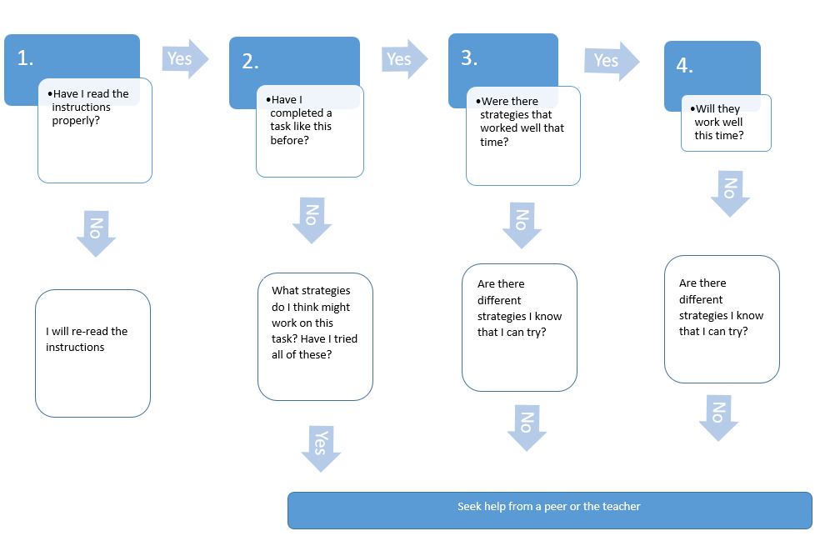
This flowchart is designed to support a high-ability student in upper-primary or lower secondary school working on a complex independent task.
Before I seek help:

