Student pathways and transitions stories – At a glance

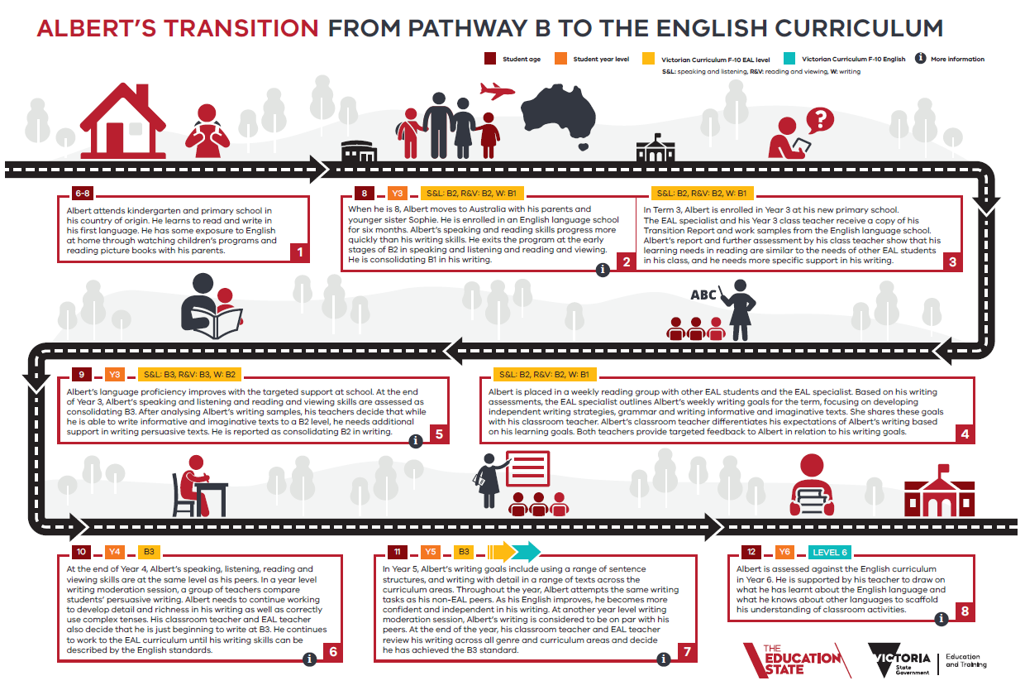
The yellow box indicates the student’s EAL levels on the EAL curriculum for each mode.
S&L: Speaking and Listening
R&V: Reading and Viewing
W: Writing

The level in the blue box indicates the English level that the student transitions into.

The number in the bottom right of each box indicates the order of the boxes in the pathways and transitions story.

The information icon indicates that annotated examples of student work at this level are available.
See:
Pathways and Transitions
TEAL oral assessment tasks – including samples
TEAL writing assessment tasks – including samples
VCAA Annotated Work Samples

The number in the orange box indicates the student’s year level at that point in time.

The number in the dark red box in the top left corner indicates the student’s age.

