Submit your application to the Job Opportunities Pool

- Start a Job Search
Open Recruitment Online (Jobs in Victorian Government Schools) via the ROL Search or Apply for a Job link on the Human Resources Recruitment Online page http://www.education.vic.gov.au/hrweb/careers/Pages/advacsSCH.aspx
Click on the Apply to the Job Opportunities pool link.
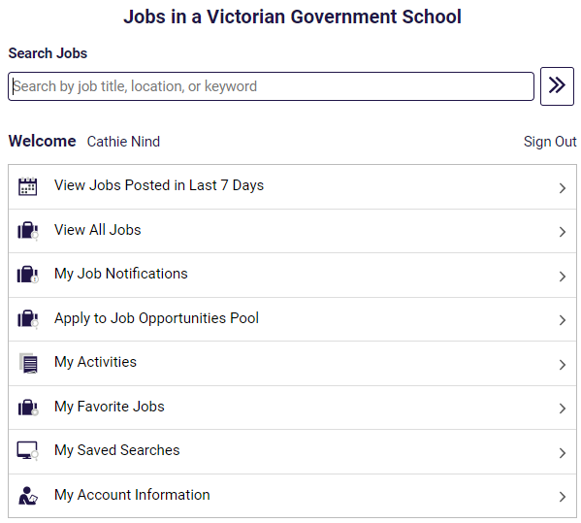
Click on Apply to Job Opportunities Pool.
- Sign into your Recruitment Online account
You will be prompted to sign into your Recruitment Online account using your User ID and Password.
Note: If you have not already created an account, click the “Register Now” link and follow the prompts to set up your account.
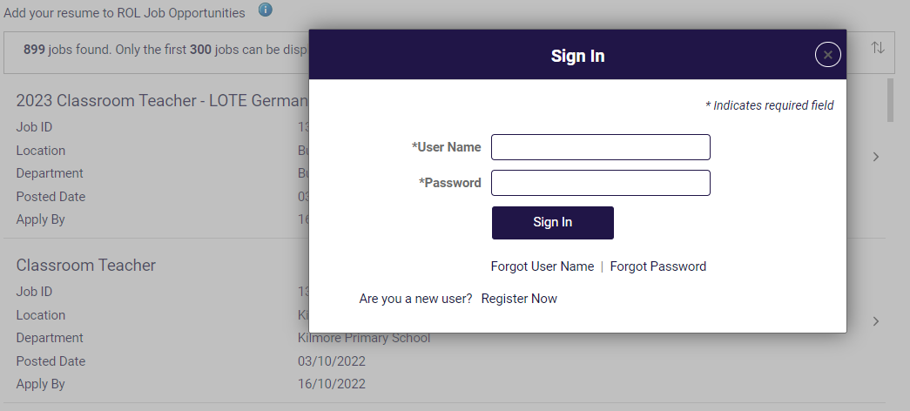
- Recruitment Online application process
After you have signed into Recruitment Online, the Job Opportunities profile screen will appear. At any time you can click Save as Draft so your profile is available for amending prior to submitting.
3.1 Step 1 of 9 - Start
Read the information provided in Start. Tick the box in the View Terms and Conditions bar and click the Next button to move to Step 2.
Note: In order to progress to Step 2 this checkbox must be ticked.
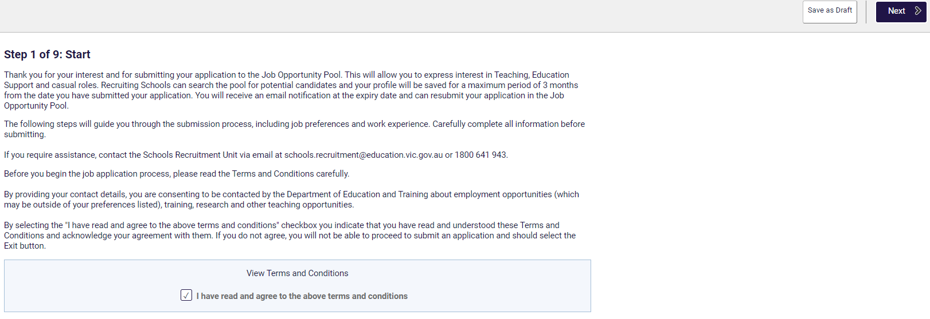
Note: To progress through each step you can click the Next button or click the step you want on the side menu.
3.2 Step 2 of 9 – Attachments
You can choose to add 1 or more attachments to support your application. It is recommended that you attach a covering letter and a recent resume/CV. You must attach at least 1 attachment in this section before you can proceed with your application. Click on the Attach Cover letter and Resume/CV button.
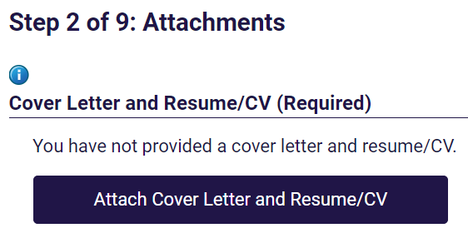
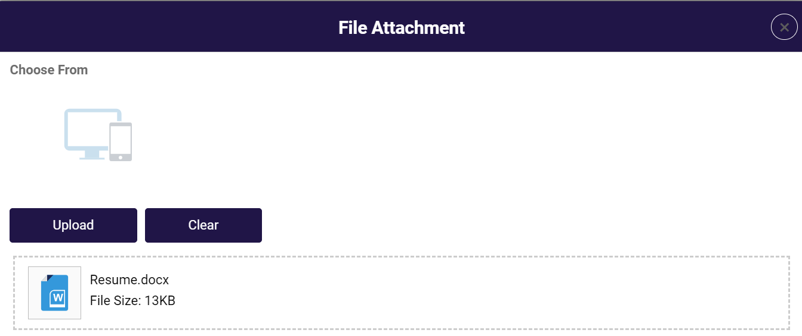
Click on Choose From and select the document you wish to upload. Click the Upload button. Repeat this process if you wish to upload more than one attachment.
Click the Next button to move to Step 3.
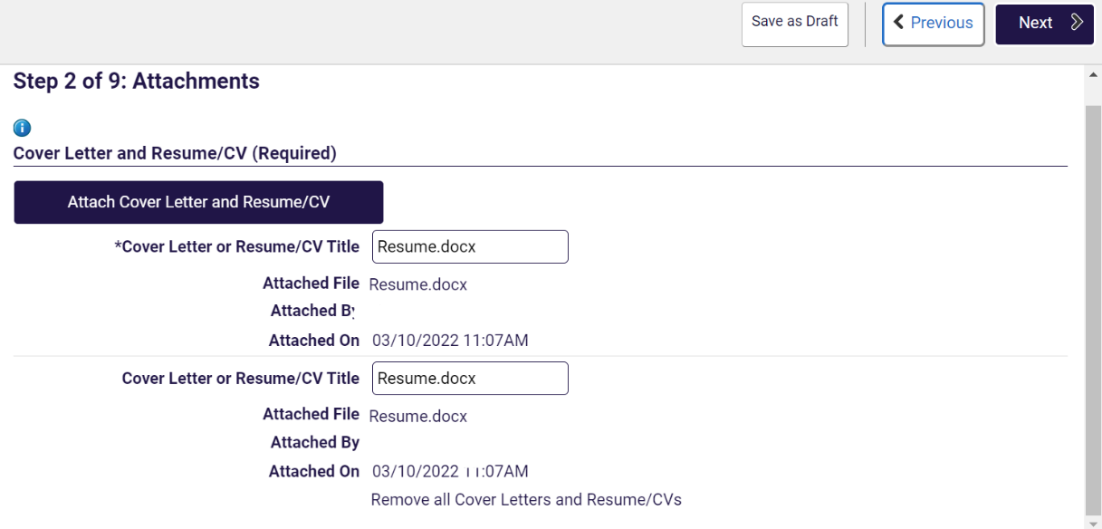

3.3 Step 3 of 9 – Preferences
You can customise your Job Opportunities profile to reflect the type of jobs you are interested in.
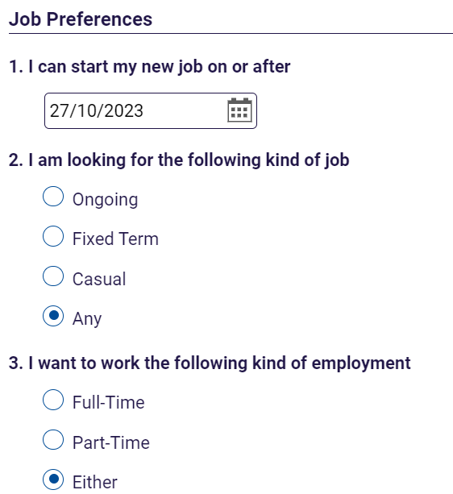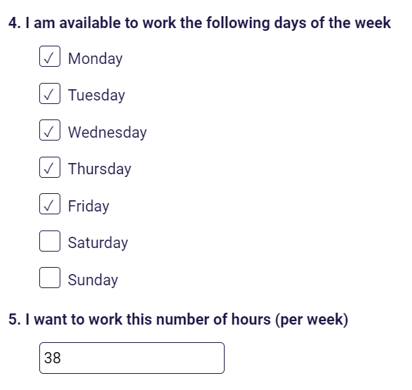
Note: The I can start my new job on or after date is a mandatory field. Click on the calendar to select the date you are able to commence.
Select the kind of job that interests you, i.e. Ongoing, Part time.
Select the kind of employment that interests you, i.e. Full or Part time.
Select the days of the week you are able to work, i.e. Monday, Tuesday.
Select the total number of hours you want to work weekly, i.e., 20, 38.
Scrolling down will allow you to Add Location Preferences and Role Types.
Click on the Add Location Preferences button.
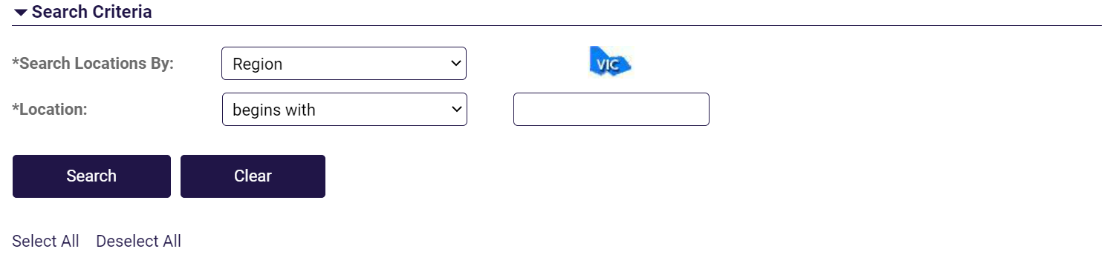
You are able to search by selecting the region and a specific area location.
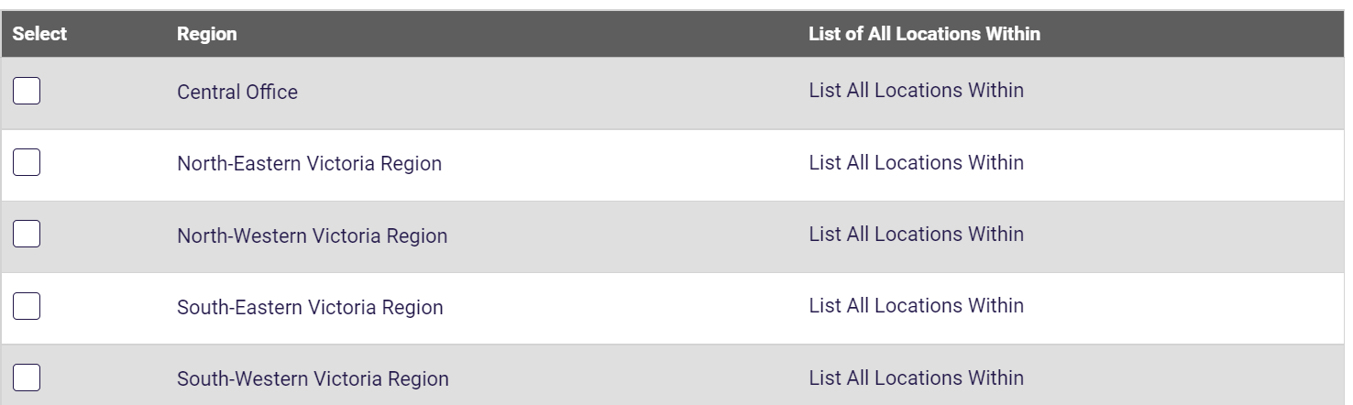
You can select a specific region/s which will indicate you are happy to work at any location within that region.
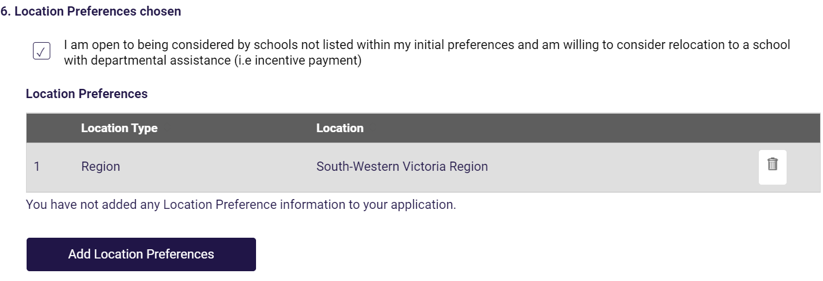
Note: You are able to indicate you if you would like to be considered for opportunities from schools not listed in your preference/s. To confirm this, tick the checkbox.
Location Preferences is a mandatory field so you must select at least one preference before moving on to the next step.
Click on the Done button once you have made your selection.
Click on the Role Type button.
Select the appropriate Role Type/s.
Note: You must select at least one Role Type.
Click the + button to add Role type/s preference.
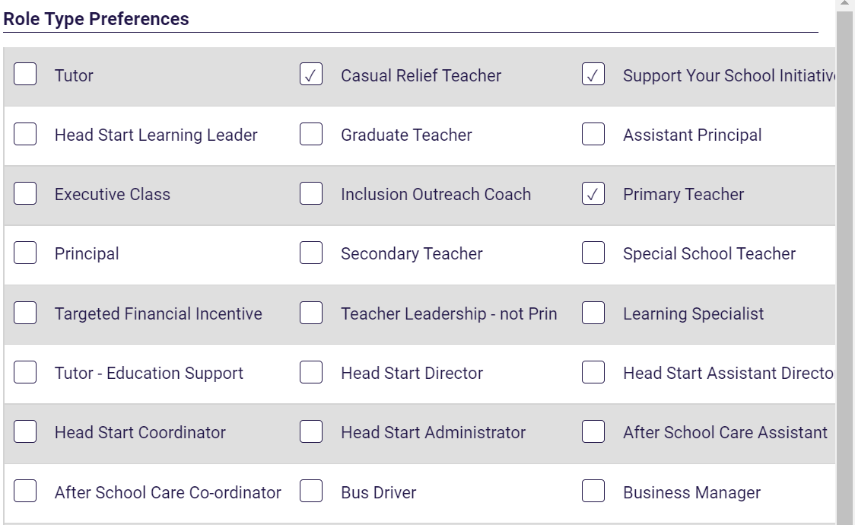
Click on the Done button once you have made your selection.
Click on the Next button to move to Step 4.
3.4 Step 4 of 9 – Education
You can add information about your education history to your Job Opportunities profile. Click on the + to add your education information.
Click the buttons in this section to add information. Noting that you can progress to step 5 without entering information in this step.
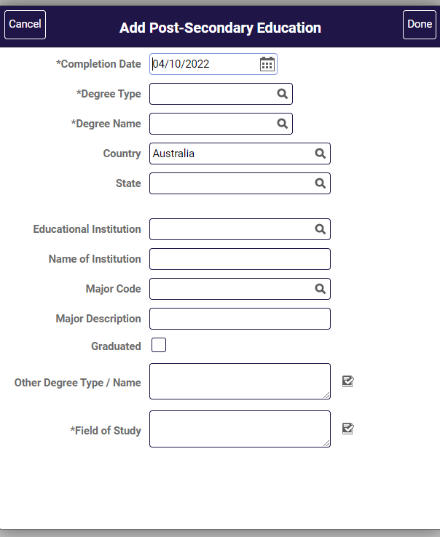
Once you have entered your information click on the Done button.
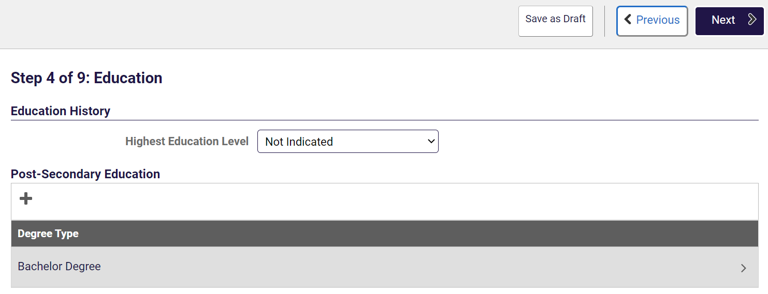
Click the Next button to move to Step 5.

3.5 Step 5 of 9 – Other Information
You can customise your Job Opportunities profile to reflect other details relevant to your application such as Licenses & Certifications and Language Skills.
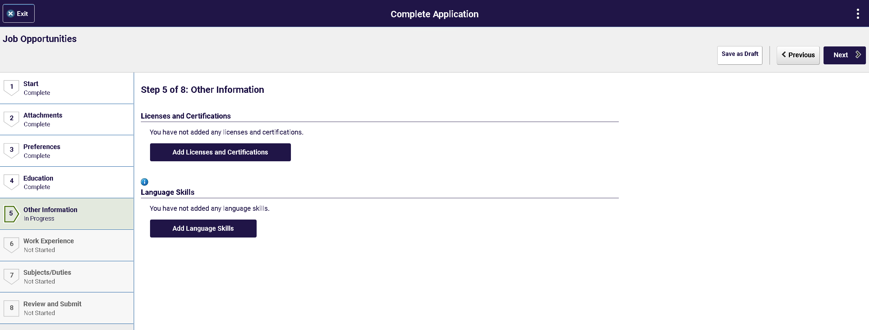
Clicking the Add License and Certifications button to add License/Certifications.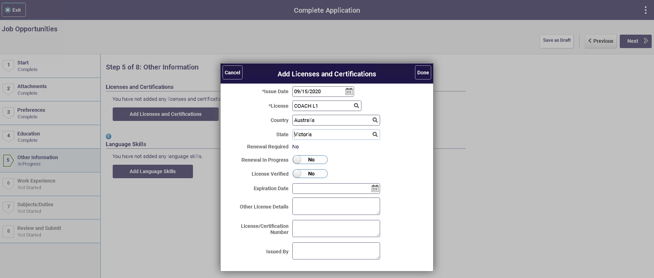
Click the Done button once the information is entered.
Click the Add Language Skills button to add your language skills.
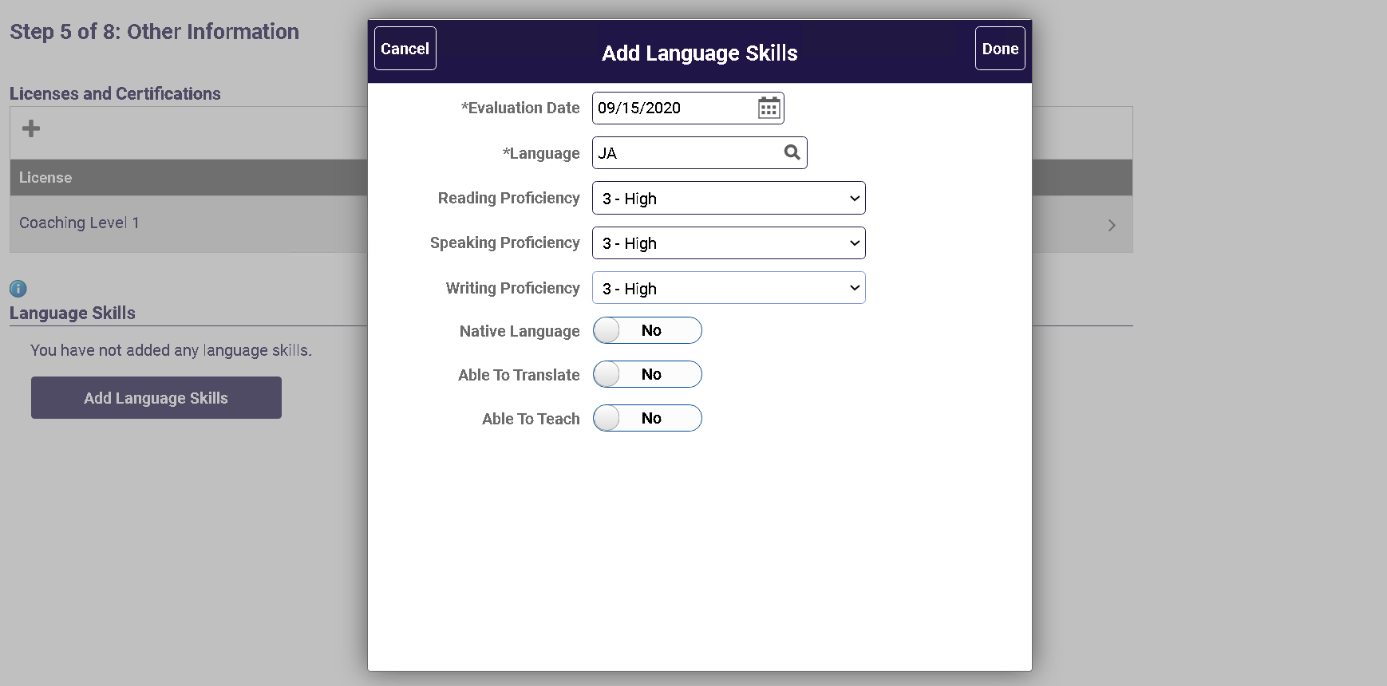
You are able to enter the language several ways. You can:
- Enter the first 3 letters of the language directly in the Language field. This will either enter the language or will give you a minimised search result if there is more than once language beginning with the letters
- Click the look up button on the Language field and use the scroll bar to scroll down and find the language wish to enter
- Click on the Search Criteria button and enter the language in the Description (begins with) field.
Once the language has been entered continue to enter data in the remaining fields as appropriate.
Click the Done button once the information is entered.
Scroll down to enter VIT Registration / WWC Check.
Click on the + under VIT Registration / WWC Check.
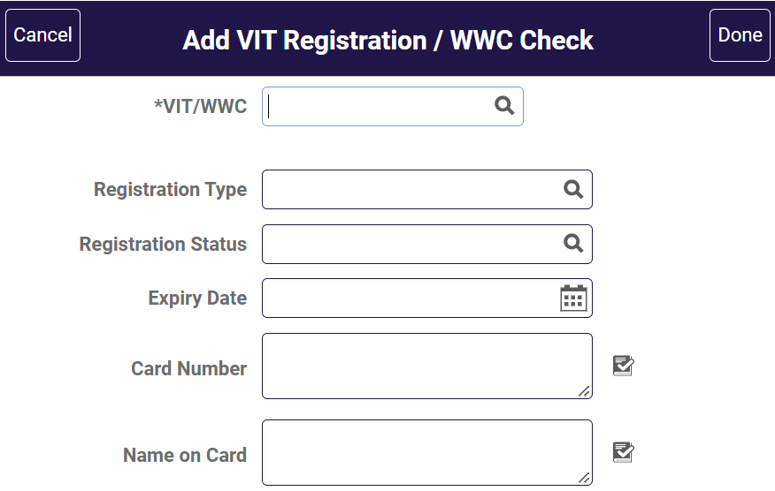
Enter your VIT Registration / WWC Check information.
Note: Interstate Registrant - this is for applicants who are qualified teachers from other states who do not hold a VIT but hold the interstate equivalent. This will identify they are an interstate registrant.
For Victorian teacher applicants a current VIT is required.
Once you have entered your information click the Done button.
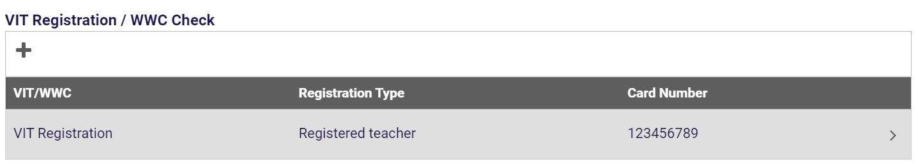
Click the Next button to move to Step 6.
3.6 Step 6 of 9 – Questionnaire
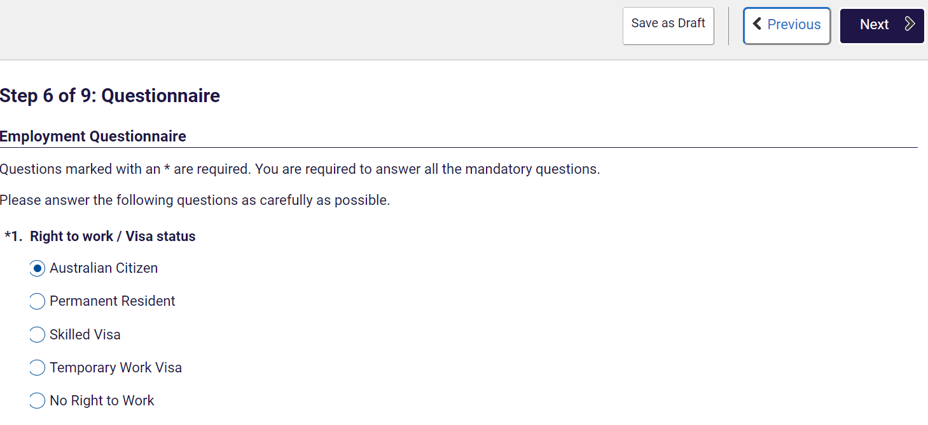
Select the correct radio button for you.
Note: This is a mandatory question.
Click the Next button to go to Step 7.
3.7 Step 7 of 9 – Work Experience
You can add information about your employment history and add your references to your online application.
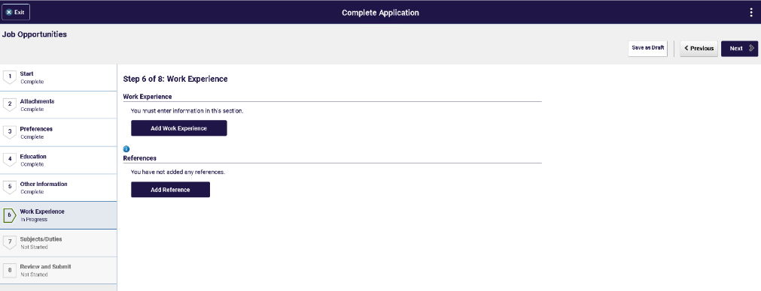
Click the Add Work Experience button.
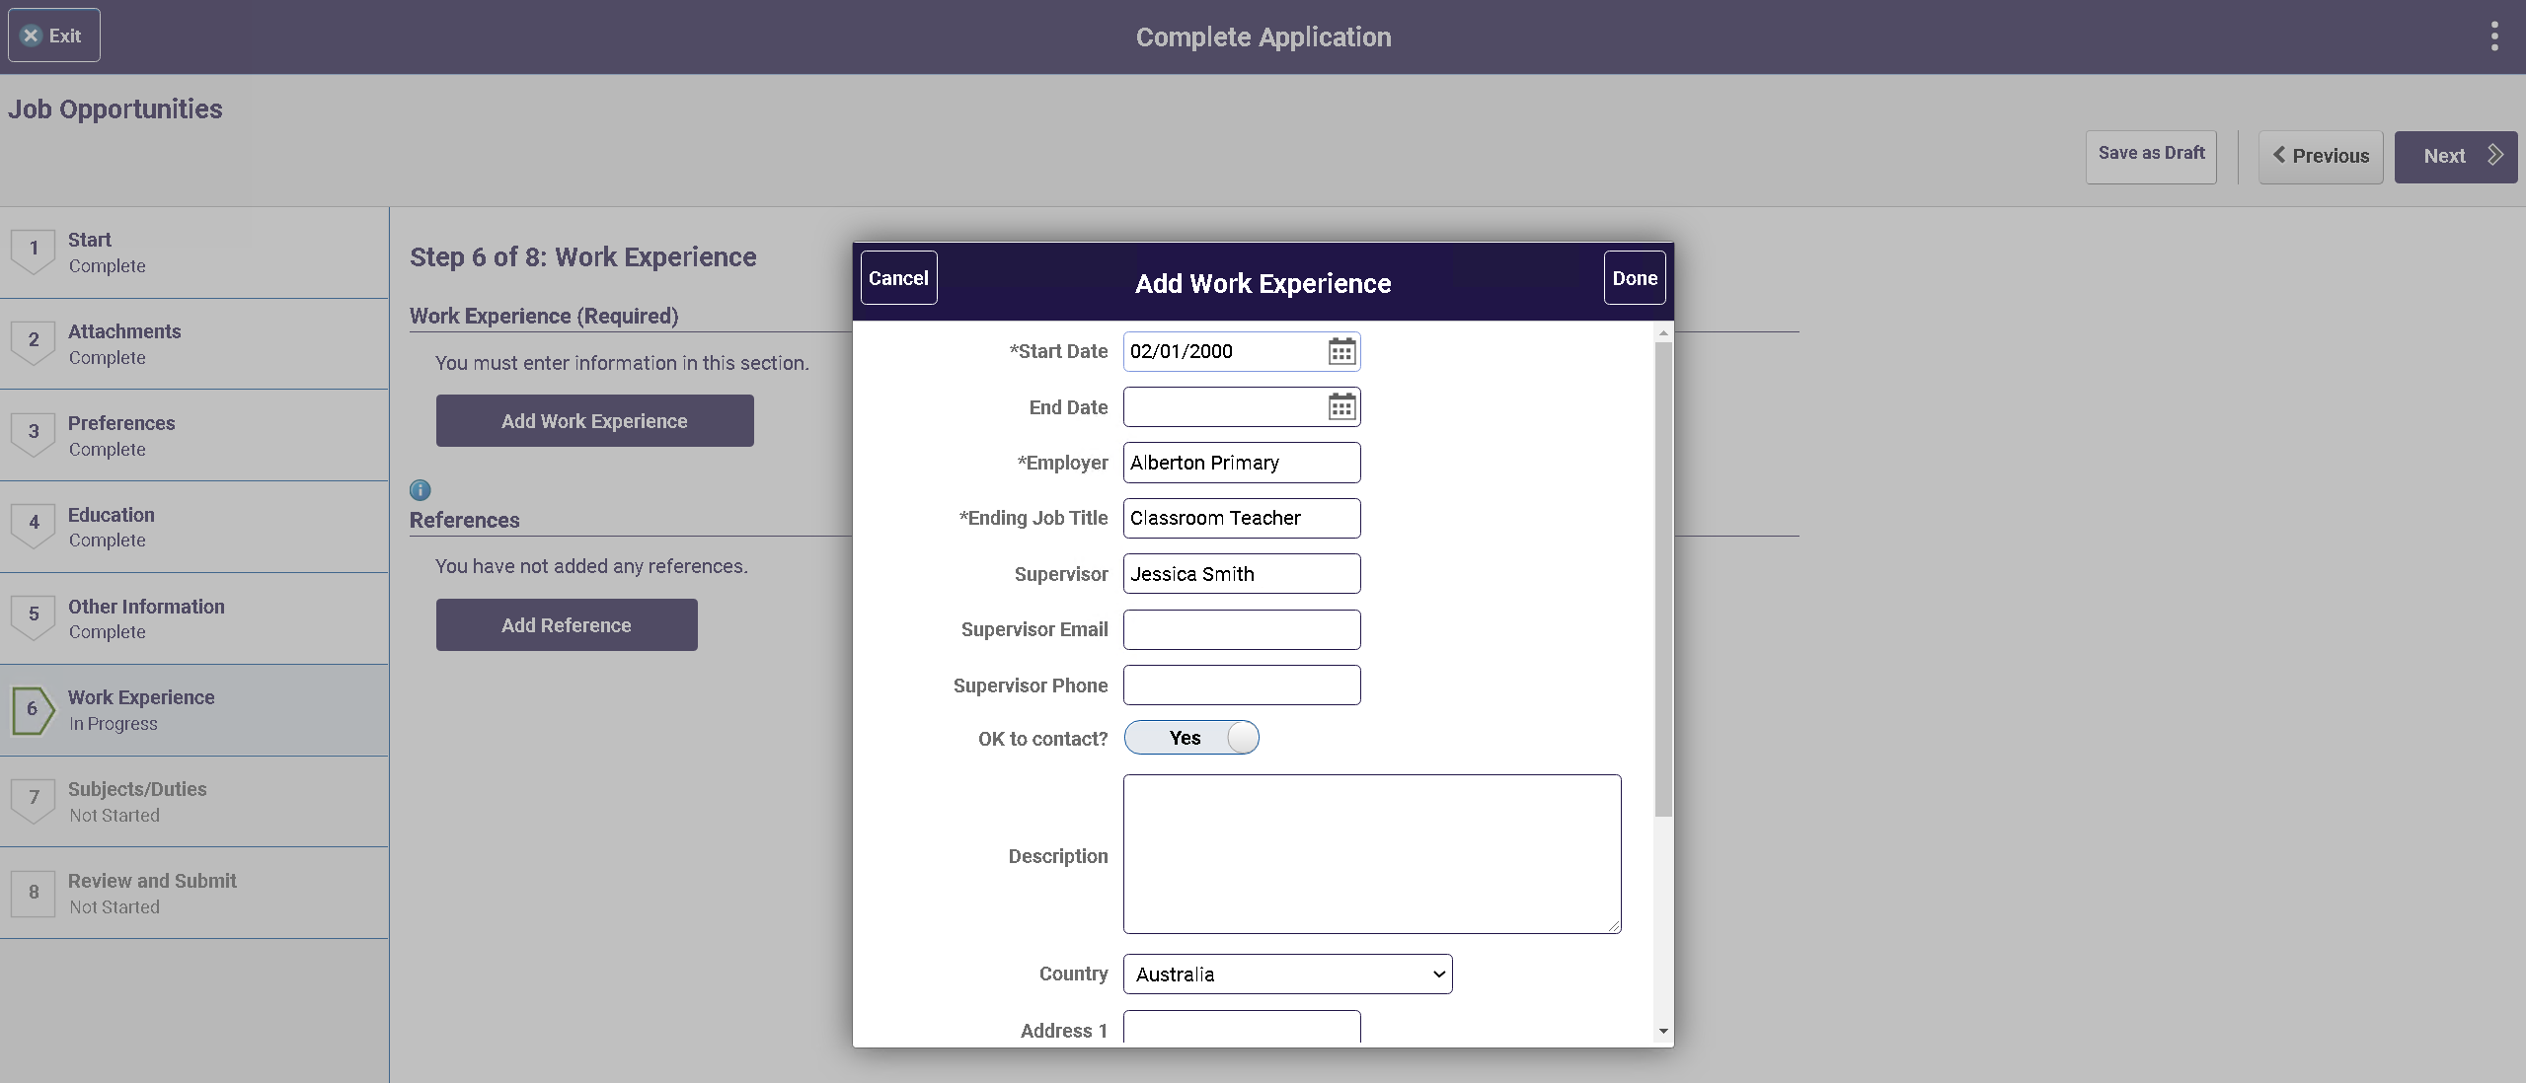
Once you have entered the information click the Done button.
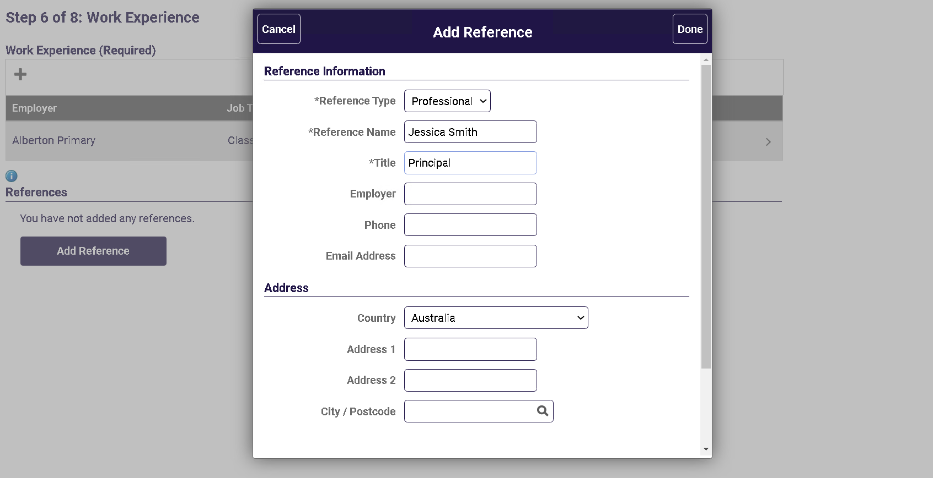
Once you have entered the information click the Done button.
Click Next to move to Step 8.
3.7 Step 8 of 9 – Subjects/Duties
You must enter at least once subject/duty to progress to the next step.
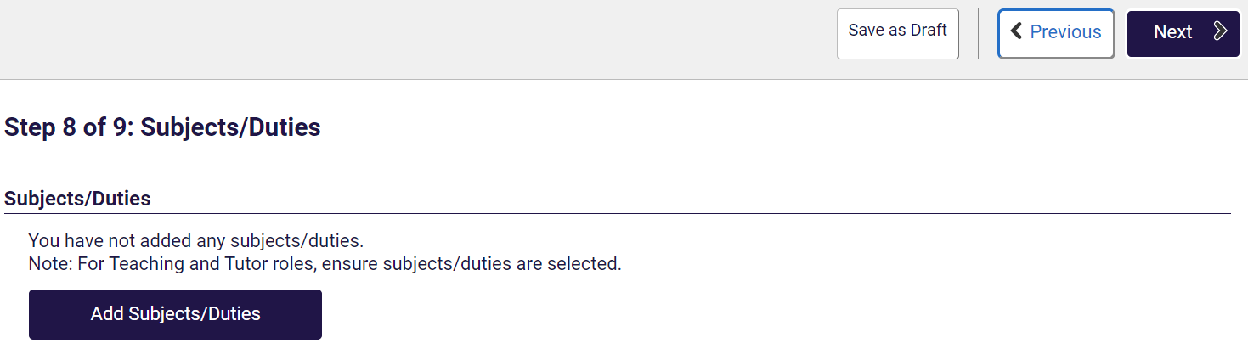
Click on the Add Subjects/Duties button.
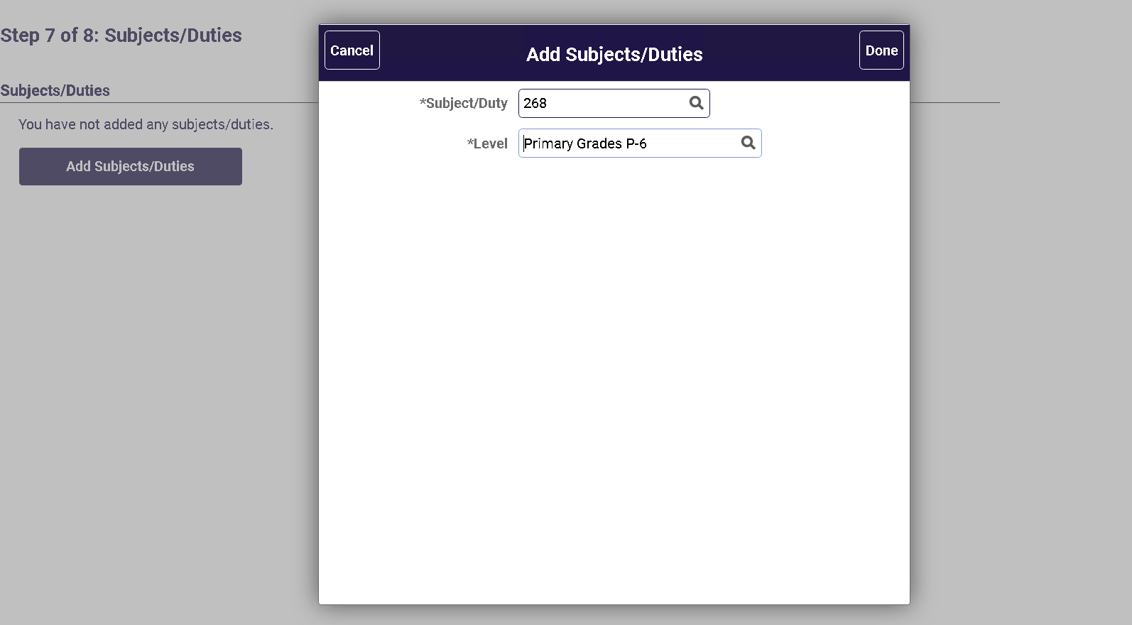
Once you have selected at least one Subject/duty click the Done button.
Click Next to move to Step 9.
3.9 Step 9 of 9 – Review/Submit
At Step 9, you can preview the information that you have added to your profile. To change any of the details you have entered, click the Modify link or the Modify icon in each section. To submit your application, click the “Submit” button.
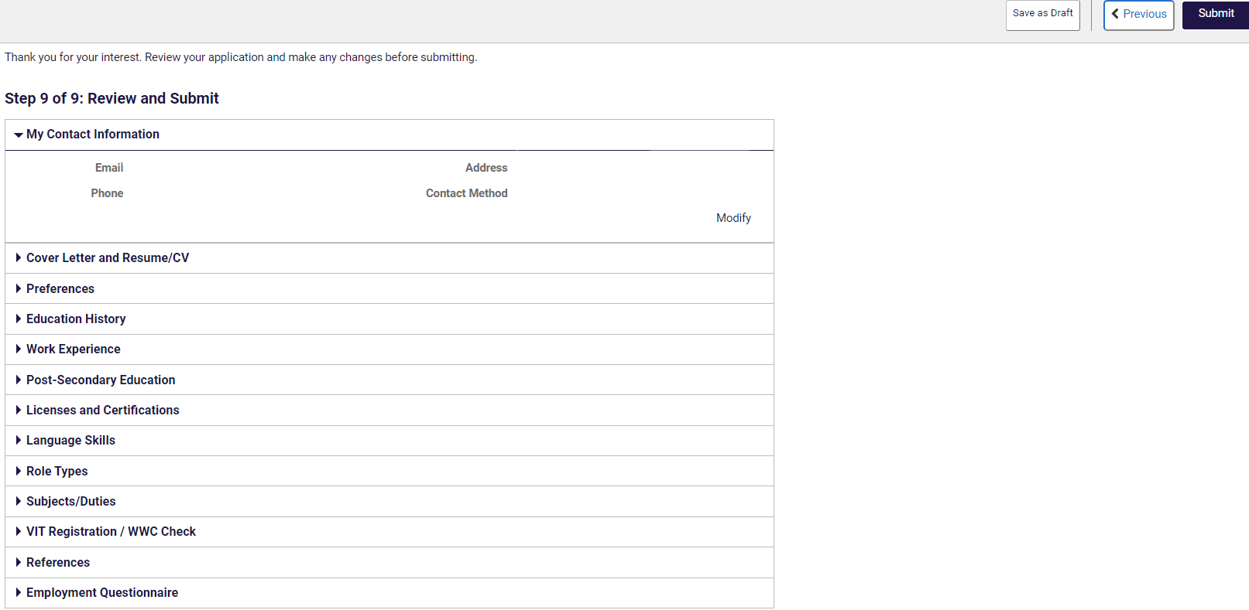
4 Application submitted confirmation
After you have completed and successfully submitted your details to Job Opportunities, a confirmation message will appear on screen.
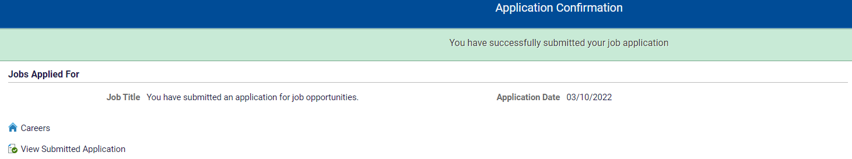
Click the View Submitted Application to see the Application Summary

Click the Careers link on the confirmation message to return to the Careers Home screen.
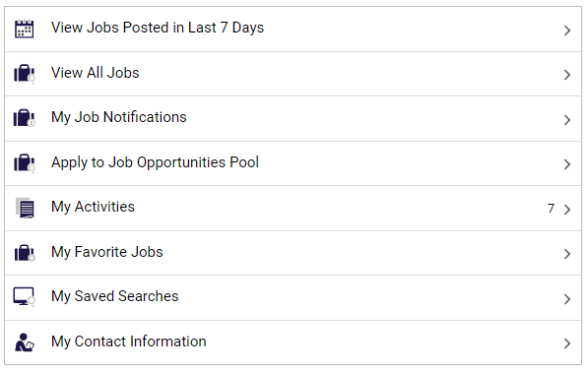
5 My Activities view
In the Careers Home screen, click the My Activities link.
Your Job Opportunity profile will appear here.
- Edit your Job Opportunity profile
You are able to Edit your profile.
To edit your submitted profile click on the Edit button.
Click on the section you wish to edit, make your changes and once satisfied with your profile click Submit.
Once you have clicked submit you will receive a confirmation message as details above.
Your application to Job Opportunities will appear as Job Opportunity.
- Withdraw your Job Opportunity profile
You are able to Withdraw your profile.

In My Activities, click the withdraw button next to the Job Opportunity you wish to withdraw.
A pop-up message will appear asking you to confirm the Withdrawal.
Click the OK button if you wish to continue.
Once your profile is withdrawn you are able to resubmit at a later date.
If you do wish to resubmit, click the resubmit button which will direct you to the start of the application process.
Reminder: before resubmitting ensure you review your entered data.
- Assistance
For additional assistance please contact the Schools Recruitment Unit.
Phone: 1800 641 943 (selection options for Schools Recruitment)
Email: schools.recruitment@education.vic.gov.au

