Victorian Training Market Report
2015 Half Year

Published by the
Communications Division
for the Higher Education and Skills Group
Department of Education and Training
Melbourne
October 2015

©State of Victoria (Department of Education and Training) 2015

The copyright in this document is owned by the State of Victoria (Department of Education and Training), or in the case of some materials, by third parties (third party materials). No part may be reproduced by any process except in accordance with the provisions of the Copyright Act 1968, the National Education Access Licence for Schools (NEALS) (see below) or with permission.

An educational institution situated in Australia which is not conducted for profit, or a body responsible for administering such an institution may copy and communicate the materials, other than third party materials, for the educational purposes of the institution.

Authorised by the Department of Education
and Training,
2 Treasury Place, East Melbourne, Victoria, 3002.
This document is also available on the internet at
http://www.education.vic.gov.au/training/providers/market/pages/reports.aspx.

Contents

Contents 3
Executive Summary 5
Notes on the Data 9
Glossary 13
1. Vocational Training Summary 15
Vocational Training by Accredited / Pre-Accredited Program 15
Qualification Levels 18
Vocational Training Completions 20
Age Profile 22
Gender 23
Government Subsidised Activity by Delivery Region 24
Government Subsidised Activity by Region where the student lives 27
Government Subsidised Training by Training Provider Type 33
Fee-For-Service 37
TAFE Activity 43
Learn Local Activity 52
2. Learners Facing Barriers to Participation 59
Vocational Training Delivery to Learner Groups Facing Barriers 59
Indigenous Students 62
Students with a Disability 63
Students with a Culturally and Linguistically Diverse (CALD) Background 64
Unemployed Students 65
Young People (aged 15 to 19) Without Year 12 or Equivalent and Not at School enrolled in Certificate II or above 66
Students with Low Prior Qualification 67
Foundation Level Training 68
3. Apprenticeships and Traineeships 71
Apprenticeships and Traineeships Overall 71
Apprenticeships 72
Traineeships 78
4. Training in Areas of Value to the Victorian Economy 85
Vocational Training to Support Industry Needs 85
Vocational Training to Support Critical Occupations 88
Vocational Training in Priority Growth Sectors 90

Executive Summary

Introduction
Vocational education and training plays a significant role in helping people move into employment, improve their employment, progress to further education, and for those who face barriers to build a bridge to employment and broader community engagement.
This report draws on the data submitted to the Department of Education and Training by training providers that deliver government subsidised training in Victoria. Training activity in 2015 (half year) is compared to that of previous half years to provide a picture of changes and trends over time.
Throughout this report, references to 2015 or 2015 (half year) mean the period for the first six months of the year.

Overview
- In the first six months of 2015 there were 275,353 students enrolled in 324,994 accredited and pre-accredited government subsidised courses.
  - The number of students in government subsidised training declined by 12 per cent in 2015 compared to the same period in 2014, but was 27 per cent higher than in the same period in 2010.
  - The number of government subsidised enrolments declined by 14 per cent in 2015 compared to the same period in 2014, but was 27 per cent higher than in the same period in 2010.
- The latest data released by the National Centre for Vocational Education Research (NCVER) shows that there was also a decline in government funded VET activity nationally, by 3.5% of students between 2013 (full year) and 2014 (full year).
- The decline in government subsidised enrolments in Victoria from 2014 (half year) to 2015 (half year) is likely due to:
  - a decline in foundation studies by 42 per cent to 29,731 enrolments,
  - a decline in traineeships by 34 per cent to 20,258 enrolments.

Qualification Levels
- About two thirds (67 per cent) of all accredited government subsidised enrolments in 2015 were in Certificate III/IV level courses.
- All qualification levels showed a decline in government subsidised enrolments in the first six months of 2015 compared to the same period in 2014, except enrolments in Diploma and above which increased by 5 per cent in 2015 compared to the same period in 2014. The increase in Diploma and above enrolments was due to an increase in enrolments that attracted VET-FEE-HELP support up by 26 per cent to 17,431 government subsidised enrolments in the first six months in 2015 compared to 2014.
- There were very large increases in fee-for-service enrolments in Diploma and above that attracted VET-FEE-HELP, with 13,077 enrolments in the first six months of 2015 up by 374 per cent on the same period in 2014.

Age Cohorts
- There was a decline in the numbers of students in government subsidised training across all age cohorts, with the 15 to 19 year old cohort having the greatest percentage decline of 18 per cent between 2015 and the same period in 2014.
- The number of students in the 15 to 19 year old cohort in 2015 was also 14 per cent lower than the same time in 2010.
- The number of 15-19 year olds without at least a Year 12 or certificate II, not at school and enrolled in a Certificate II or above declined by 14 per cent in 2015 compared to the same period in 2014.

Foundation
- Foundation studies are a key way of lifting the basic skills (including literacy and numeracy) of learners with existing low skills. In the first six months of 2015 there 28,361 students enrolled in government subsidised Foundation studies, this was down by 40 per cent on the same period in 2014.
- Young people who leave school early before completing a base qualification (i.e. Year 12 or Certificate II), can have significant literacy and numeracy challenges. In the first six months of 2015, there were 3,086 early school leavers who were enrolled in government subsidised foundation studies, this was down by 40 per cent compared to the same period in 2014.

Gender
- There was a decline in the number of male (11 per cent) and female (13 per cent) students in government subsidised training in 2015 compared to the same period in 2014.
- There has been a decline in the proportion of female students in government subsidised training from 50 per cent in 2012 to 47 per cent in 2015.

Participation
- Declines in training activity between 2015 and the same time in 2014 have occurred across the whole state. Training delivery in eastern metropolitan Melbourne showed the largest percentage decline of 24 per cent in this period.
- Due to the decline in training activity from 2014 to 2015, the estimated participation rate of people aged 15 to 64 years in government subsidised training (including accredited and pre-accredited) decreased to 6.8 per cent in 2015 from 7.7 per cent in 2014, but is higher than the rate in 2010 which was 5.6 per cent.

Training Provider Type
- All types of training providers experienced a decline in government subsidised training activity between 2015 and the same period in 2014, with TAFEs showing the largest percentage decline of 18 per cent and Private RTOs showing a decline of 15 per cent.
- Government subsidised enrolments in TAFEs have declined year-on-year since 2012, with the number of enrolments in 2015 lower than in 2010.
- The rate of decline in TAFE market share has slowed. Market share by TAFE providers in government subsidised training fell only marginally in 2015 to 27 per cent, from 28 per cent in the same period in 2014. This decline is significantly less than that seen in previous years, which have been up to eight percentage points.

Apprenticeships and Traineeships
- Apprenticeship numbers have essentially held steady in 2015, despite an overall decline in training activity. There were 35,523 apprentice course enrolments in 2015, slightly above 2014 levels, slightly below that of 2010.
- There were 54,686 students who were enrolled in 55,781 government subsidised apprenticeship or traineeship courses in 2015. The number of students was down by 15 per cent compared to the same period in 2014, and 20 per cent lower than the same period in 2010.
- The number of government subsidised traineeship enrolments has declined by 34 per cent in 2015 compared to the same time in 2014, and declining year-on-year since 2012. The number of enrolments in 2015 is 40 per cent lower than the same period in 2010.

Areas of Value to the Victorian Economy
- The number of government subsidised enrolments related to occupations in demand was 109,714 in 2015, this was 5 per cent lower than in the same period in 2014.
- The number of government subsidised enrolments aligned to the six priority growth sectors was 61,864 in 2015, this was 5 per cent lower than in the same period in 2014.

Fee-For-Service Training
- In 2015 there were 172,332 students undertaking fee-for-service training (at providers that were also government funded), this was 9 per cent higher than in the same period in 2014.

Notes on the Data

This report includes key metrics, such as training delivery by qualification level, course completion, age and gender of learners, regional activity and learners facing barriers to participation. An analysis of alignment to industry needs is also provided.
The main source of vocational training statistics in this publication is the training activity database referred to as Skills Victoria Training System (SVTS). Data included in the report are a snapshot in time and based on data as reported to Higher Education and Skills Group (HESG) in the Department by training providers. The data reported in this report were extracted in July 2015.
Half-year figures for the current year are preliminary as the training activity is still in progress. Therefore, these figures should be treated as indicative only. All data are subject to change until the end of the calendar year.
Data included in this report may differ to those in previous publications as the Department may update classifications from time to time to improve data quality and consistency across years. In addition, changes to reporting and data standards may lead to minor revisions to data previously reported.
Change to how activity is reported
In an effort to improve consistency in reporting, from 2015 all pre-accredited training activity funded by the Adult, Community and Further Education (ACFE) Board has been reported at the module enrolment level rather than a mix of course and module enrolments. This could have the effect of artificially boosting the number of government subsidised course enrolments from 2015.
For example, from 2015, five pre-accredited module enrolments will be reported as five Module Only course enrolments. Prior to 2015, in some instances, this was reported as one course enrolment.
Due to this change, pre-accredited and accredited training data have been identified separately in this report.

Module enrolments in government subsidised accredited and pre-accredited training, 2010 to 2015 (half year)
 | 2010 | 2011 | 2012 | 2013 | 2014 | 2015
Accredited | 2,066,457 | 2,739,706 | 3,725,610 | 3,116,332 | 3,148,725 | 2,776,379
Pre-accredited | 8,149 | 11,582 | 14,407 | 17,371 | 17,108 | 16,438
Total | 2,074,606 | 2,751,288 | 3,740,017 | 3,133,703 | 3,165,833 | 2,792,817

Change in number of module enrolments in government subsidised accredited and pre-accredited training (half year)
 | % change 2010 to 2015 | % change 2011 to 2015 | % change 2012 to 2015 | % change 2013 to 2015 | % change 2014 to 2015
Accredited | 34% | 1% | -25% | -11% | -12%
Pre-accredited | 102% | 42% | 14% | -5% | -4%
Total | 35% | 2% | -25% | -11% | -12%

Special caveats and notes
- From 2014, all RTOs must collect and report Total VET Activity (TVA) data. This includes full Australian Vocational Education and Training Management Information Statistical Standard (AVETMISS) data, in accordance with the National VET Provider Collection Data Requirements Policy.
Whilst some private Registered Training Organisations (RTOs) and Learn Local providers may have submitted fee-for-service data in the past, from 2014 all private RTOs and Learn Local providers were required to submit this data. Hence, fee-for-service data for these providers are only shown from 2014.
- Following the review of the ‘Victoria’s Funded Courses Report’ by the Department in 2014, it was identified that some RTOs have enrolled students in qualifications that had been superseded. In response, the Department strengthened the teach-out and transition requirements specified in the 2015 Standards for RTOs and notified all RTOs that these requirements would be applied by the Department for funding purposes. The Victorian VET Student Statistical Collection Guidelines have been updated accordingly and will take effect from 2016. The changes will ensure students are undertaking the most up-to-date and relevant training and will allow superseded qualifications to be accurately captured and reported.
It was estimated that for the first half of 2015, less than 1 per cent of government subsidised course enrolments were duplicate records as a result of superseded qualifications, with more than 50% of these duplicate enrolments in apprenticeship qualifications. Due to this, information on new course commencements has been excluded from this report, but will be included in the full year report following system changes that will more accurately account for superseded courses.
- In 2015 some minor issues were identified in data coded on the student’s prior education levels. Changes to the VET data system are currently in progress to correct these issues. The changes will be reflected in the final end-of-year report.
- Improved measurement has been applied to the levels of pre-accredited enrolment activity, through two improvements to the counting rules. The first is the introduction of measurement of pre-accredited activity as ‘module’ enrolments, rather than course enrolments. In pre-accredited vocational training, a module, not a course, is the unit of activity. The second has strengthened the accuracy of pre-accredited data through applying a program filter, ‘ACE Funded’.
- For the purposes of this report, the term Learn Local is used interchangeably with Adult and Community Education (ACE). However, it should be noted that only Learn Local organisations report through to the Adult, Community and Further Education (ACFE) Board. ACE organisations are self-identified and are not required to report through to the Board. There were a very small number of Learn Local organisations that self-identified to SVTS as private RTOs and therefore are not included in the count of Learn Local organisations.
- To ensure a degree of consistency of foundation courses in this report, any course that was identified in the foundation skills list of courses, whether in 2015 or previous years, is considered for the purposes of this report as a foundation course.
- A ‘-‘ shown in a table indicates that the figure was nil.

Reporting scope
- This report includes government subsidised and fee-for-service activity in all sectors.
- The previous approach of publishing reported completions has been replaced by a new methodology that more accurately reports VET course completions and completion rates.

What’s new
- Responding to changes in pre-accredited reporting, pre-accredited and accredited training data is now identified separately in this report.
- Separate TAFE fee-for-service reporting across the report has been removed and included in two specific sections: ‘Fee-for-Service’ and ‘TAFE Activity’.
- Fee-for-service data is now included for all sectors.

Glossary
Term | Definition
Accredited training | An accredited program of study that leads to vocational qualifications and credentials that are recognised across Australia. Only registered training organisations that meet government quality standards such as TAFE, private providers, enterprise registered training organisations and vocational divisions of universities can provide nationally recognised training. It includes accredited courses, endorsed training package qualifications and associated subjects.
ACFE | Through the Adult, Community and Further Education (ACFE) Board, the Victorian Government provides funding to community-based organisations, known as Learn Local organisations, and two adult education institutions, the Council of Adult Education (CAE) and Adult Migrant Education Services (AMES), for delivery of education and training programs to a broad range of Victorians over compulsory school-leaving age - young people, older people, people with special needs, people from diverse cultural backgrounds – with a special focus on people who have had limited prior access to education.
Australian Qualifications Framework (AQF) | The Australian Qualifications Framework (commonly known as the AQF) is a unified system of national qualifications in schools, vocational education and training (TAFEs and private providers) and the higher education sector (mainly universities).
Domestic student | A student that resides and undertakes training in Australia.
Foundation | Foundation skills courses help address basic skills gaps for vocational education and training students. Gaining these base level skills in literacy, numeracy and workforce preparation skills improve a student’s chances following training of employment, provide opportunities for further education and broader social participation.
Government subsidised | Course or training activity that attracts a level of funding or subsidy from the Victorian Government, for example funding entitlement under the Victorian Training Guarantee (VTG).
Industry code (ANZSIC) | The Australian and New Zealand Standard Industrial Classification (ANZSIC) is a classification that provides a framework for organising data about industry by grouping business units carrying out similar productive activities.
International student | An international student that undertakes training in Australia.
Offshore student | A student (Australian or non-Australian) that undertakes training outside of Australia.
Pre-accredited training | Pre-accredited programs are modular learning opportunities that provide re-engagement with learning and skill development. They can focus on foundation or vocational skills and are customised to meet the needs of the learner or learner group, but do not have formal assessment or a credential awarded.
Region | One of the four Departmental administrative regions or nine regional areas.
Total VET Activity (TVA) | Following agreement by all Skills Ministers, all RTOs must collect and report 'Total VET Activity' data on funded and fee-for-service VET activity. This includes full Australian Vocational Education and Training Management Information Statistical Standard (AVETMISS) data, in accordance with the National VET Provider Collection Data Requirements Policy.

Vocational Training Summary

Vocational Training by Accredited / Pre-Accredited Program

This section provides an overview of training activity measured in terms of student numbers and course enrolments.
Key points
- There were 275,353 students enrolled in government subsidised training (including both pre-accredited and accredited) in 2015 (half year), this was 12 per cent lower than 2014 (half year), but 27 per cent higher than the same period in 2010.
- The decrease in the number of students in 2015 (half year) was due to a decline in both the number of students undertaking accredited training (12 per cent lower than 2014 half year) and pre-accredited training (3 per cent lower than 2014 half year).
- The number of government subsidised course enrolments reported in 2015 (half year) was 324,994, this was 14 per cent lower than 2014 (half year), but 27 per cent higher than the same period in 2010.
- The decrease in the number of course enrolments in 2015 (half year) was due to a decline in both accredited course enrolments (15 per cent lower than 2014 half year) and pre-accredited course enrolments (2 per cent lower than 2014 half year).

Table 1.1.1: | Students in government subsidised accredited and pre-accredited training, 2010 to 2015 (half year)
 | 2010 | 2011 | 2012 | 2013 | 2014 | 2015
Accredited | 211,528 | 260,287 | 347,186 | 297,659 | 301,453 | 265,244
Pre-accredited | 5,835 | 8,491 | 10,895 | 11,698 | 11,984 | 11,593
Total* | 216,884 | 267,959 | 356,858 | 307,787 | 311,933 | 275,353
* | A student can enrol in both accredited and pre-accredited training. The total has eliminated any duplicates.

Table 1.1.2: | Change in number of students in government subsidised accredited and pre-accredited training (half year)
 | % change 2010 to 2015 | % change 2011 to 2015 | % change 2012 to 2015 | % change 2013 to 2015 | % change 2014 to 2015
Accredited | 25% | 2% | -24% | -11% | -12%
Pre-accredited | 99% | 37% | 6% | -1% | -3%
Total* | 27% | 3% | -23% | -11% | -12%
* | A student can enrol in both accredited and pre-accredited training. The total has eliminated any duplicates.

Figure 1.1: | Students enrolled in government subsidised accredited and pre-accredited training, 2010 to 2015 (half year)
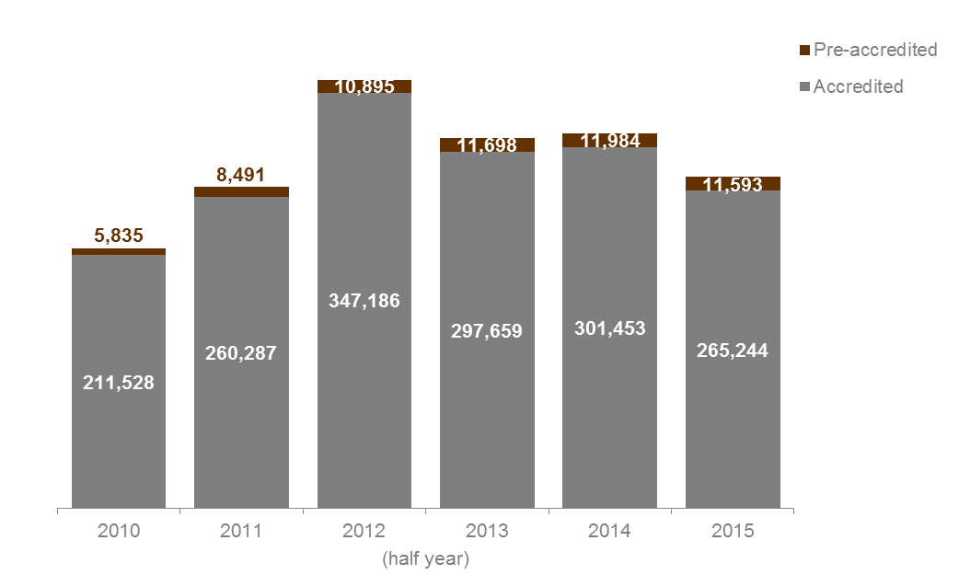

Table 1.2.1: | Course enrolments in government subsidised accredited and pre-accredited training, 2010 to 2015 (half year)
 | 2010 | 2011 | 2012 | 2013 | 2014 | 2015
Accredited | 247,685 | 309,420 | 444,501 | 383,963 | 362,784 | 310,089
Pre-accredited | 7,939 | 10,976 | 13,594 | 15,197 | 15,257 | 14,905
Total | 255,614 | 320,396 | 458,094 | 399,159 | 378,040 | 324,994

Table 1.2.2: | Change in number of course enrolments in government subsidised accredited and pre-accredited training (half year)
 | % change 2010 to 2015 | % change 2011 to 2015 | % change 2012 to 2015 | % change 2013 to 2015 | % change 2014 to 2015
Accredited | 25% | 0% | -30% | -19% | -15%
Pre-accredited | 88% | 36% | 10% | -2% | -2%
Total | 27% | 1% | -29% | -19% | -14%

Figure 1.2: | Course enrolments in government subsidised accredited and pre-accredited training, 2010 to 2015 (half year)
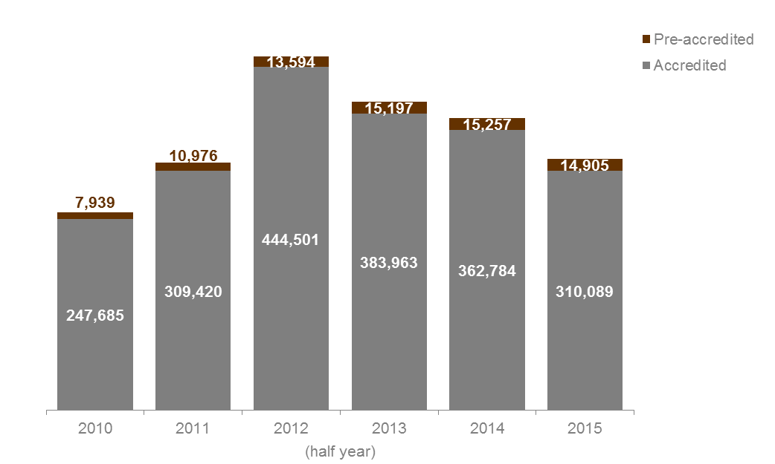

Qualification Levels

Lower level qualifications such as Certificate I and II provide literacy, numeracy and work preparation skills to people without post-school qualifications so that they have the opportunity to go on to further study or secure employment. Mid-level skills are essential to the Victorian economy and help drive economic activity across the state.

Government Subsidised Accredited Course Enrolments
Key points
- From 2014 (half year) to 2015 (half year), enrolments have declined across all qualification levels except Diploma and above and Module only.
- In 2015 (half year), there were 50,167 government subsidised enrolments in accredited training at the Diploma and above qualification level, this was higher than 2014 (half year) by 5 per cent.
- The 2015 (half year) data shows that there were 208,293 government subsidised course enrolments in accredited training at the Certificate III to IV levels, a decline of 13 per cent from the same period in 2014. In 2015 (half year), the share of Certificate III to IV enrolments was 67 per cent of all government subsidised accredited enrolments.
- Government subsidised course enrolments in accredited training at the Certificate I to II levels were lower in 2015 than 2014 by 34 per cent.

Table 1.3.1: | Government subsidised course enrolments in accredited training by qualification level, 2010 to 2015 (half year)
 | 2010 | 2011 | 2012 | 2013 | 2014 | 2015
Cert I/II | 49,464 | 64,171 | 100,982 | 102,604 | 58,244 | 38,613
Cert III/IV | 125,027 | 168,436 | 251,713 | 215,642 | 240,455 | 208,293
Diploma & Above | 50,010 | 62,882 | 76,953 | 53,662 | 47,961 | 50,167
VET FEE-HELP* | 7,452 | 9,630 | 9,732 | 14,551 | 13,875 | 17,431
Without any  VET FEE-HELP* | 42,558 | 53,252 | 67,221 | 39,111 | 34,086 | 32,736
Module Only | 9,099 | 3,003 | 1,298 | 799 | 1,852 | 2,006
Secondary Education** | 6,429 | 6,280 | 6,590 | 7,360 | 8,108 | 6,113
Other*** | 7,655 | 4,648 | 6,965 | 3,886 | 6,164 | 4,897
Total**** | 247,685 | 309,420 | 444,501 | 383,963 | 362,784 | 310,089
* | In 2014 a small number of contracted training providers failed to submit information on VET FEE-HELP.
** | Includes VCE/VCAL courses of study.
*** | ‘Other’ includes statement of attainment, other non-award courses or not elsewhere classified.
**** | The 2010 and 2013 totals include 1 enrolment and 10 enrolments respectively in Higher Education. There were no enrolments in Higher Education after 2013.

Table 1.3.2: | Change in number of government subsidised course enrolments in accredited training by qualification level (half year)
 | % change 2010 to 2015 | % change 2011 to 2015 | % change 2012 to 2015 | % change 2013 to 2015 | % change 2014 to 2015
Cert I/II | -22% | -40% | -62% | -62% | -34%
Cert III/IV | 67% | 24% | -17% | -3% | -13%
Diploma & Above | 0% | -20% | -35% | -7% | 5%
VET FEE-HELP* | 134% | 81% | 79% | 20% | 26%
Without any  VET FEE-HELP* | -23% | -39% | -51% | -16% | -4%
Module Only | -78% | -33% | 55% | 151% | 8%
Secondary Education** | -5% | -3% | -7% | -17% | -25%
Other*** | -36% | 5% | -30% | 26% | -21%
Total**** | 25% | 0% | -30% | -19% | -15%
* | In 2014 a small number of contracted training providers failed to submit information on VET FEE-HELP.
** | Includes VCE/VCAL courses of study.
*** | ‘Other’ includes statement of attainment, other non-award courses or not elsewhere classified.
**** | The 2010 and 2013 totals include 1 enrolment and 10 enrolments respectively in Higher Education. There were no enrolments in Higher Education after 2013.

Vocational Training Completions

Apart from the community and social benefits associated with higher levels of educational attainment, there is strong evidence that people who complete vocational training qualifications are at an advantage in the labour market in terms of employment and wage outcomes compared with those who do not complete their courses. Whilst completions are important, it is understood that some people undertake VET training with no intention of completing, i.e. they are undertaking their training to gain skill sets.

Completion Rate of Government Subsidised Qualifications
At any given point in time, the course completion rate is the proportion of courses completed of all courses commenced in the same year. For example, by July 2015, 32 per cent of courses that were commenced in 2014 were reported as completed. This completion rate (of courses that commenced in 2014) will increase if the training activity data is extracted at a later date. That is, it would be expected that some of the training that was still in progress would have been completed or discontinued. This is particularly the case for courses that take more than a year to complete, such as an apprenticeship which may take up to four years.
This section provides a snapshot taken in mid-2015 of reported completion rates by courses that commenced between 2009 and 2014. Data presented in this section does not include bridging and enabling courses and other non-award courses.
Key points
- There has been a gradual decline in the percentage of government subsidised courses being completed, from 42 per cent in 2011 (full year) to 32 per cent in 2014 (full year).

Figure 1.3.1: | Reported course completion rate of government subsidised training by year of course commencement, 2009 to 2014
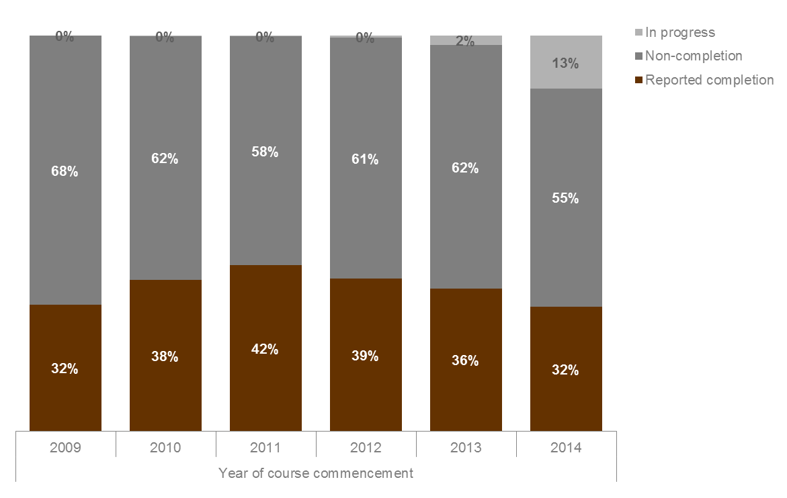

Figure 1.3.2: | Number of reported course completed, not completed and still in progress of government subsidised training by year of course commencement, 2009 to 2014
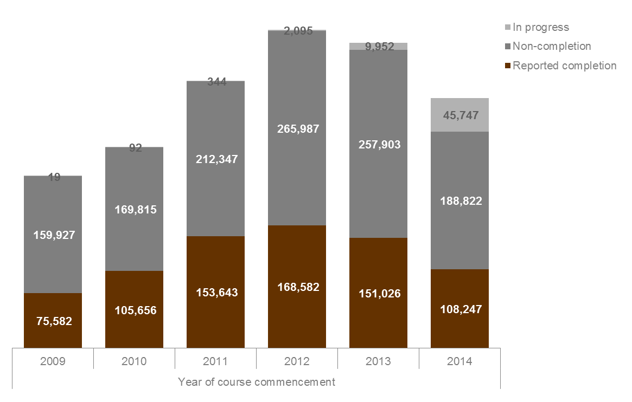

Age Profile

To support the increased workforce participation levels required by the Victorian economy over the next decade, improved engagement with education and training by all age groups is required.

Government Subsidised Accredited Training
Key points
- Young people aged 15 to 24 accounted for 43 per cent of all students enrolled in government subsidised training in 2015 (half year), down from 44 per cent in 2014 (half year).
- The most significant decline in age groups between 2014 and 2015 (half year) was by 15 to 19 year olds. In 2015 (half year) there were 51,692 15-19 year olds enrolled in training, this was 18 per cent lower than the 2014 result.
- The numbers of students enrolled in government subsidised training in 2015 (half year) were lower than those in 2014 across all age groups except ‘Other’ (age under 15 year old, 65 years and over or not stated) where there was an increase of 9 per cent.

Table 1.4.1: | Students enrolled in government subsidised accredited training by age group, 2010 to 2015 (half year)
 | 2010 | 2011 | 2012 | 2013 | 2014 | 2015
15 to 19* | 60,270 | 70,549 | 87,002 | 68,553 | 62,942 | 51,692
20 to 24 | 49,527 | 60,562 | 76,213 | 67,019 | 69,370 | 62,328
25 to 44 | 67,391 | 86,053 | 119,737 | 105,855 | 111,410 | 98,725
45 to 64 | 31,719 | 40,901 | 59,516 | 52,151 | 53,781 | 48,180
Other** | 2,621 | 2,222 | 4,718 | 4,081 | 3,950 | 4,319
Total | 211,528 | 260,287 | 347,186 | 297,659 | 301,453 | 265,244
* | From 2014 students still at school (covering the 15 to 19 age group) could no longer access Victorian Training Guarantee funded training, unless part of an approved School Based Apprenticeship or Traineeship (SBAT).
** | ‘Other’ includes age under 15 years old, 65 years and over or not stated.

Table 1.4.2: | Change in number of students enrolled in government subsidised accredited training by age group (half year)
 | % change 2010 to 2015 | % change 2011 to 2015 | % change 2012 to 2015 | % change 2013 to 2015 | % change 2014 to 2015
15 to 19* | -14% | -27% | -41% | -25% | -18%
20 to 24 | 26% | 3% | -18% | -7% | -10%
25 to 44 | 46% | 15% | -18% | -7% | -11%
45 to 64 | 52% | 18% | -19% | -8% | -10%
Other** | 65% | 94% | -8% | 6% | 9%
Total | 25% | 2% | -24% | -11% | -12%
* | From 2014 students still at school (covering the 15 to 19 age group) could no longer access Victorian Training Guarantee funded training, unless part of an approved School Based Apprenticeship or Traineeship (SBAT).
** | ‘Other’ includes age under 15 years old, 65 years and over or not stated.

Gender

The vocational training system is also focused on accessibility and gender equality, ensuring all Victorians have the same opportunity to succeed in their lives and maintain well-being through education and training.

Government Subsidised Accredited Training
Key points
- In 2015 (half year) there were 141,244 male students enrolled in government subsidised accredited training, this was 11 per cent lower than in 2014.
- In 2015 (half year) there were 123,614 female students enrolled in government subsidised accredited training, this was 13 per cent lower than in 2014.
- In 2015 (half year) about 47 per cent of all students enrolled in government subsidised accredited training were female. This has declined since 2012 (half year), when 50 per cent of students were female.

Table 1.5.1: | Students enrolled in government subsidised accredited training by gender, 2010 to 2015 (half year)
 | 2010 | 2011 | 2012 | 2013 | 2014 | 2015
Female | 100,431 | 124,378 | 174,444 | 143,523 | 142,446 | 123,614
Male | 110,480 | 135,493 | 172,429 | 153,970 | 158,747 | 141,244
Not stated | 617 | 416 | 313 | 166 | 260 | 386
Total | 211,528 | 260,287 | 347,186 | 297,659 | 301,453 | 265,244

Table 1.5.2: | Change in number of students enrolled in government subsidised accredited training by gender (half year)
 | % change 2010 to 2015 | % change 2011 to 2015 | % change 2012 to 2015 | % change 2013 to 2015 | % change 2014 to 2015
Female | 23% | -1% | -29% | -14% | -13%
Male | 28% | 4% | -18% | -8% | -11%
Not stated | -37% | -7% | 23% | 133% | 48%
Total | 25% | 2% | -24% | -11% | -12%

Government Subsidised Activity by Delivery Region
This section focuses on the delivery of government subsidised training by location, as defined by four Departmental administrative regions and nine regional areas, to provide a greater level of detail on training delivery.
As students may be enrolled with training providers outside their local area, it is important not to conflate training delivery at the regional level with regional participation.

Key points
- All regions showed a decline in the number of government subsidised enrolments in accredited training between 2014 and 2015 (half year).
- Of the four Departmental administrative regions, the North-Eastern region had the largest percentage decrease of enrolments between 2014 and 2015 (half year) of 22 per cent, but the largest decline in enrolment numbers was in South-Western region with a decrease of 29,130 enrolments. The North-Western region had the lowest decrease (both in terms of percentage and enrolment number) of 6 per cent (4,317 enrolments) over the same period.
- Of the nine regional areas, the Eastern Metropolitan region had the largest percentage decrease of enrolments between 2014 and 2015 (half year) of 24 per cent, but the largest decline in enrolment number was in Western Metropolitan region with a decrease of 22,624 enrolments. The Northern Metropolitan region had the lowest decrease of 4 per cent over the same period, whilst in terms of enrolment numbers the Grampians region had the lowest decrease of 918 enrolments.

Table 1.6.1: | Government subsidised enrolments in accredited training by Departmental administrative delivery region, 2010 to 2015 (half year)
 | 2010 | 2011 | 2012 | 2013 | 2014 | 2015
North-Eastern Victoria | 49,153 | 62,906 | 75,311 | 71,276 | 59,541 | 46,221
North-Western Victoria | 49,907 | 58,322 | 80,889 | 69,399 | 68,482 | 64,165
South-Eastern Victoria | 59,821 | 68,751 | 100,016 | 87,804 | 80,023 | 74,317
South-Western Victoria | 81,907 | 112,679 | 180,130 | 150,352 | 154,221 | 125,091
Interstate | 93 | 14 | 63 | 39 | 194 | 6
Other* | 7,566 | 7,489 | 10,285 | 7,306 | 2,218 | 1,408
Total** | 247,685 | 309,420 | 444,501 | 383,963 | 362,784 | 310,089
* | 'Other' includes on-line delivery and workplace delivery where the location cannot be defined.
** | Where a course was delivered across more than one region, an enrolment in this course is also counted in more than one region. The total has eliminated any duplicates.

Table 1.6.2: | Change in number of government subsidised enrolments in accredited training by Departmental administrative delivery region (half year)
 | % change 2010 to 2015 | % change 2011 to 2015 | % change 2012 to 2015 | % change 2013 to 2015 | % change 2014 to 2015
North-Eastern Victoria | -6% | -27% | -39% | -35% | -22%
North-Western Victoria | 29% | 10% | -21% | -8% | -6%
South-Eastern Victoria | 24% | 8% | -26% | -15% | -7%
South-Western Victoria | 53% | 11% | -31% | -17% | -19%
Interstate | -94% | -57% | -90% | -85% | -97%
Other* | -81% | -81% | -86% | -81% | -37%
Total | 25% | 0% | -30% | -19% | -15%
* | 'Other' includes on-line delivery and workplace delivery where the location cannot be defined.

Table 1.7.1: | Government subsidised enrolments in accredited training by delivery regional area, 2010 to 2015 (half year)
 | 2010 | 2011 | 2012 | 2013 | 2014 | 2015
Barwon South West | 22,730 | 28,017 | 45,375 | 29,977 | 29,167 | 23,612
Grampians | 8,349 | 9,684 | 11,996 | 10,472 | 9,930 | 9,012
Loddon Mallee | 15,706 | 18,882 | 24,737 | 19,701 | 17,432 | 15,139
Hume | 14,829 | 14,954 | 21,543 | 28,085 | 19,328 | 15,683
Gippsland | 12,878 | 11,618 | 12,333 | 9,180 | 9,894 | 8,770
Eastern Metropolitan | 34,324 | 47,952 | 53,769 | 43,297 | 40,279 | 30,587
Western Metropolitan | 50,836 | 75,014 | 122,784 | 109,981 | 115,188 | 92,564
Southern Metropolitan | 46,943 | 57,135 | 87,685 | 78,629 | 70,138 | 65,555
Northern Metropolitan | 34,201 | 39,440 | 56,153 | 49,698 | 51,054 | 49,031
Interstate | 93 | 14 | 63 | 39 | 194 | 6
Other* | 7,566 | 7,489 | 10,285 | 7,306 | 2,218 | 1,408
Total** | 247,685 | 309,420 | 444,501 | 383,963 | 362,784 | 310,089
* | 'Other' includes on-line delivery and workplace delivery where the location cannot be defined.
** | Where a course was delivered across more than one region, an enrolment in this course is also counted in more than one region. The total has eliminated any duplicates.

Table 1.7.2: | Change in number of government subsidised enrolments in accredited training by delivery regional area (half year)
 | % change 2010 to 2015 | % change 2011 to 2015 | % change 2012 to 2015 | % change 2013 to 2015 | % change 2014 to 2015
Barwon South West | 4% | -16% | -48% | -21% | -19%
Grampians | 8% | -7% | -25% | -14% | -9%
Loddon Mallee | -4% | -20% | -39% | -23% | -13%
Hume | 6% | 5% | -27% | -44% | -19%
Gippsland | -32% | -25% | -29% | -4% | -11%
Eastern Metropolitan | -11% | -36% | -43% | -29% | -24%
Western Metropolitan | 82% | 23% | -25% | -16% | -20%
Southern Metropolitan | 40% | 15% | -25% | -17% | -7%
Northern Metropolitan | 43% | 24% | -13% | -1% | -4%
Interstate | -94% | -57% | -90% | -85% | -97%
Other* | -81% | -81% | -86% | -81% | -37%
Total | 25% | 0% | -30% | -19% | -15%
* | 'Other' includes on-line delivery and workplace delivery where the location cannot be defined.

Government Subsidised Activity by Region where the student lives
The following presents data on students undertaking government subsidised training by the area where they live. Areas are defined as four Departmental administrative regions and nine regional areas. Students may undertake their training locally or travel to locations outside their local area.

Key points
- All regions showed a decline in the number of students participating in government subsidised accredited training between 2014 and 2015 (half year).
- Of the four Departmental administrative regions, the North-Eastern region had the largest percentage decline in the number of students enrolled in government subsidised accredited training between 2014 and 2015 (half year) of 15 per cent.
- Of the nine regional areas, the Grampians, Hume and Eastern Metropolitan regions had the largest percentage decline in the number of students enrolled in government subsidised accredited training between 2014 and 2015 (half year) of 15 per cent.
- Of the nine regional areas, there was a 13 per cent decline between 2014 and 2015 (half year) in the number of students living in regional Victoria enrolled in government subsidised accredited training. In metropolitan Melbourne there was a decrease of 12 per cent over the same period.

Table 1.8.1: | Students enrolled in government subsidised accredited training by residential area - Departmental administrative region, 2010 to 2015 (half year)
 | 2010 | 2011 | 2012 | 2013 | 2014 | 2015
North-Eastern Victoria | 45,169 | 55,567 | 70,332 | 59,395 | 57,062 | 48,381
North-Western Victoria | 47,591 | 59,721 | 75,375 | 65,654 | 67,502 | 59,629
South-Eastern Victoria | 57,707 | 69,527 | 94,092 | 80,890 | 80,767 | 71,888
South-Western Victoria | 56,763 | 71,994 | 102,547 | 87,519 | 91,294 | 80,464
Interstate | 2,944 | 3,256 | 4,183 | 3,823 | 3,671 | 3,468
Other* | 1,354 | 222 | 657 | 378 | 1,157 | 1,414
Total | 211,528 | 260,287 | 347,186 | 297,659 | 301,453 | 265,244
* | 'Other' includes not stated and unknown.

Table 1.8.2: | Change in number of students enrolled in government subsidised accredited training by residential area - Departmental administrative region (half year)
 | % change 2010 to 2015 | % change 2011 to 2015 | % change 2012 to 2015 | % change 2013 to 2015 | % change 2014 to 2015
North-Eastern Victoria | 7% | -13% | -31% | -19% | -15%
North-Western Victoria | 25% | 0% | -21% | -9% | -12%
South-Eastern Victoria | 25% | 3% | -24% | -11% | -11%
South-Western Victoria | 42% | 12% | -22% | -8% | -12%
Interstate | 18% | 7% | -17% | -9% | -6%
Other* | 4% | 537% | 115% | 274% | 22%
Total | 25% | 2% | -24% | -11% | -12%
* | 'Other' includes not stated and unknown.

Table 1.9.1: | Students enrolled in government subsidised accredited training by residential regional area, 2010 to 2015 (half year)
 | 2010 | 2011 | 2012 | 2013 | 2014 | 2015
Barwon South West | 18,587 | 22,163 | 29,457 | 22,361 | 21,849 | 18,752
Grampians | 9,039 | 10,773 | 13,846 | 11,873 | 11,749 | 10,040
Loddon Mallee | 12,872 | 15,856 | 21,012 | 17,320 | 15,761 | 14,031
Hume | 12,342 | 13,948 | 17,446 | 16,496 | 15,648 | 13,313
Gippsland | 12,939 | 13,036 | 14,770 | 11,919 | 11,559 | 10,497
Eastern Metropolitan | 32,827 | 41,619 | 52,886 | 42,899 | 41,414 | 35,068
Western Metropolitan | 29,137 | 39,058 | 59,244 | 53,285 | 57,696 | 51,672
Southern Metropolitan | 44,768 | 56,491 | 79,322 | 68,971 | 69,208 | 61,391
Northern Metropolitan | 34,719 | 43,865 | 54,363 | 48,334 | 51,741 | 45,598
Interstate | 2,944 | 3,256 | 4,183 | 3,823 | 3,671 | 3,468
Other* | 1,354 | 222 | 657 | 378 | 1,157 | 1,414
Total | 211,528 | 260,287 | 347,186 | 297,659 | 301,453 | 265,244
* | 'Other' includes not stated and unknown.

Table 1.9.2: | Change in number of students enrolled in government subsidised accredited training by residential regional area (half year)
 | % change 2010 to 2015 | % change 2011 to 2015 | % change 2012 to 2015 | % change 2013 to 2015 | % change 2014 to 2015
Barwon South West | 1% | -15% | -36% | -16% | -14%
Grampians | 11% | -7% | -27% | -15% | -15%
Loddon Mallee | 9% | -12% | -33% | -19% | -11%
Hume | 8% | -5% | -24% | -19% | -15%
Gippsland | -19% | -19% | -29% | -12% | -9%
Eastern Metropolitan | 7% | -16% | -34% | -18% | -15%
Western Metropolitan | 77% | 32% | -13% | -3% | -10%
Southern Metropolitan | 37% | 9% | -23% | -11% | -11%
Northern Metropolitan | 31% | 4% | -16% | -6% | -12%
Interstate | 18% | 7% | -17% | -9% | -6%
Other* | 4% | 537% | 115% | 274% | 22%
Total | 25% | 2% | -24% | -11% | -12%
* | 'Other' includes not stated and unknown.

Participation Rates of 15 to 64 Year olds
This section presents estimates of the proportion of the population undertaking government subsidised training over time and by geographical region (both Departmental administrative region and regional area). Students may undertake their training locally or travel to locations outside their local region.
Key points
- In 2015 (half year), 6.8 per cent of 15 to 64 year olds in the Victorian population were participating in government subsidised training (both accredited and pre-accredited), this was down on 2014 (half year) by 0.9 percentage points.
- By Departmental administrative region where the student resides, the South-Western region had the highest participation rate in government subsidised accredited training at 7.7 per cent in 2015 (half year) and the North-Eastern region had the lowest at 5.5 per cent.
- By regional area where the student resides, Barwon South West and Western Metropolitan regions had the highest participation rate in government subsidised accredited training at 7.8 per cent in 2015 (half year) and Eastern Metropolitan region had the lowest at 4.9 per cent.

Figure 1.4: | Estimated participation rate of students aged 15 to 64 years in government subsidised training, 2010 to 2015 (half year)
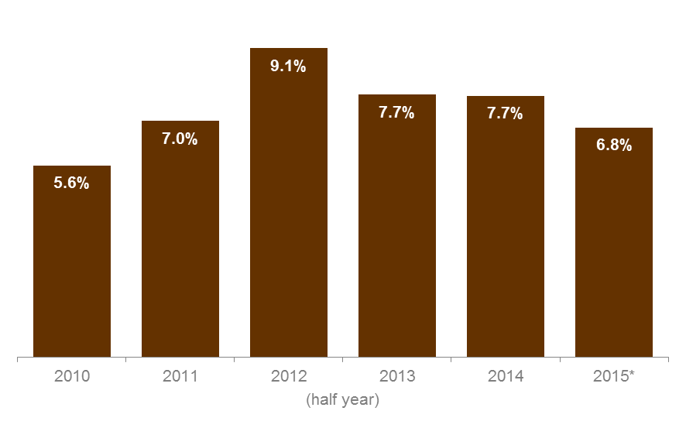
* | The 2014 estimated resident population published by the Australian Bureau of Statistics was used to calculate the participation rate in both 2014 (half year) and 2015 (half year), as the 2015 population data at the state level was not yet available.

Figure 1.5.1: | Estimated participation rate of students aged 15 to 64 years in government subsidised accredited training by Departmental administrative region, 2014 to 2015 (half year)
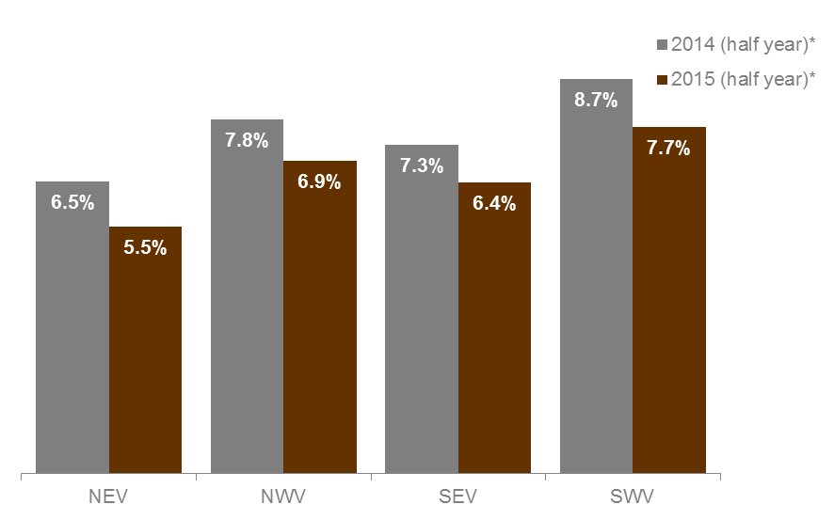
* | The 2013 estimated resident population published by the Australian Bureau of Statistics was used to calculate the participation rate for each Departmental administrative region in both 2014 (half year) and 2015 (half year), as the 2014 and 2015 population data at the sub-state level was not yet available.

Note: see next page for Departmental administrative region names.

Figure 1.5.2: | Estimated participation rate of students aged 15 to 64 years in government subsidised accredited training by regional area, 2014 to 2015 (half year)
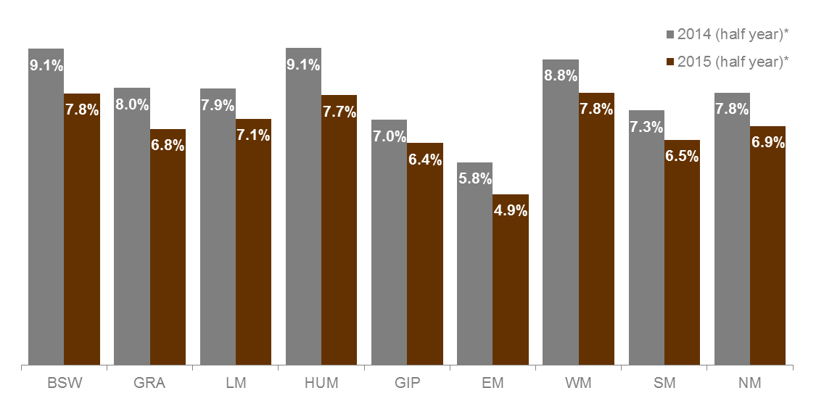
* | The 2013 estimated resident population published by the Australian Bureau of Statistics was used to calculate the participation rate for each regional area in both 2014 (half year) and 2015 (half year), as the 2014 and 2015 population data at the sub-state level was not yet available.

Note: see next page for regional area names.
Departmental administrative regions |  | Regional areas
NEV | North-Eastern Victoria | BSW | Barwon South West
NWV | North-Western Victoria | GRA | Grampians
SEV | South-Eastern Victoria | LM | Loddon Mallee
SWV | South-Western Victoria | HUM | Hume
 |  | GIP | Gippsland
 |  | EM | Eastern Metropolitan
 |  | WM | Western Metropolitan
 |  | SM | Southern Metropolitan
 |  | NM | Northern Metropolitan

Government Subsidised Training by Training Provider Type

Key points
- All provider types showed a decline in the number of government subsidised enrolments in accredited training between 2014 and 2015 (half year).
- In 2015 (half year) 59 per cent of all government subsidised enrolments in accredited training were with Private RTOs. The share held by TAFEs was 27 per cent in 2015 (half year), down from 28 per cent in 2014.

Table 1.10.1: | Number of government subsidised enrolments in accredited training by sector, 2010 to 2015 (half year)
 | 2010 | 2011 | 2012 | 2013 | 2014 | 2015
Private RTO | 52,638 | 112,042 | 200,513 | 179,956 | 214,310 | 182,951
Learn Local | 24,656 | 21,491 | 31,510 | 24,893 | 21,051 | 19,155
TAFE and University
TAFE | 121,795 | 127,562 | 157,119 | 138,260 | 100,224 | 82,680
University | 48,596 | 48,325 | 55,359 | 40,854 | 27,199 | 25,303
Total | 247,685 | 309,420 | 444,501 | 383,963 | 362,784 | 310,089

Table 1.10.2: | Change in number of government subsidised enrolments in accredited training by sector (half year)
 | % change 2010 to 2015 | % change 2011 to 2015 | % change 2012 to 2015 | % change 2013 to 2015 | % change 2014 to 2015
Private RTO | 248% | 63% | -9% | 2% | -15%
Learn Local | -22% | -11% | -39% | -23% | -9%
TAFE and University
TAFE | -32% | -35% | -47% | -40% | -18%
University | -48% | -48% | -54% | -38% | -7%
Total | 25% | 0% | -30% | -19% | -15%

Table 1.11: | Percentage share of government subsidised enrolments in accredited training for each year by sector, 2010 to 2015 (half year)
 | 2010 | 2011 | 2012 | 2013 | 2014 | 2015
Private RTO | 21% | 36% | 45% | 47% | 59% | 59%
Learn Local | 10% | 7% | 7% | 6% | 6% | 6%
TAFE and University
TAFE | 49% | 41% | 35% | 36% | 28% | 27%
University | 20% | 16% | 12% | 11% | 7% | 8%
Total | 100% | 100% | 100% | 100% | 100% | 100%

Figure 1.6: | Percentage share of government subsidised enrolments in accredited training by sector, 2010 to 2015 (half year)
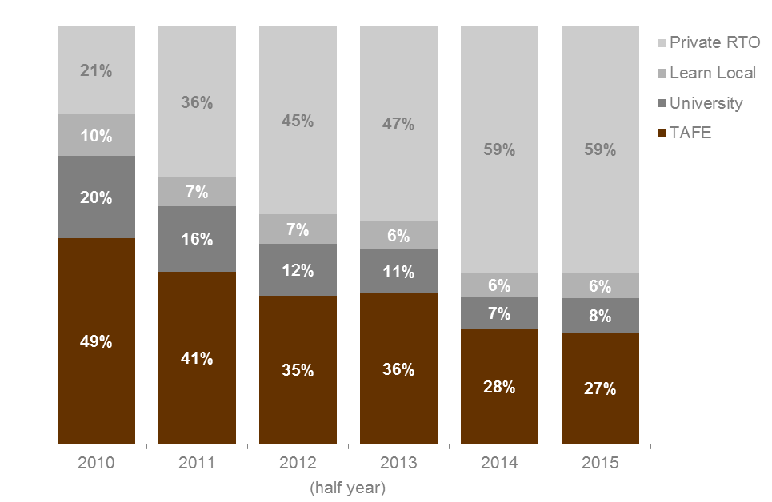

Table 1.12: | Government subsidised course enrolments (AQF I and higher only), proportional share across sectors by occupation, 2015 (half year)
Percentages total across rows in the table below
 |  | TAFE | University | Private RTO | Learn Local | Total (number)
Clerical and Administrative Workers |  | 13% | 5% | 80% | 2% | 31,238
Community and Personal Service Workers |  | 16% | 5% | 71% | 9% | 80,491
Labourers |  | 30% | 4% | 63% | 2% | 19,768
Machinery Operators and Drivers |  | 9% | 0% | 90% | 0% | 22,443
Managers |  | 23% | 4% | 72% | 0% | 6,995
Professionals |  | 37% | 21% | 37% | 5% | 15,399
Sales Workers |  | 21% | 5% | 72% | 2% | 4,885
Technicians and Trades Workers |  | 44% | 13% | 43% | 1% | 89,121
Other* |  | 20% | 9% | 44% | 27% | 26,733
Total (AQF I+ only) |  | 26% | 8% | 60% | 6% | 297,073
* | ‘Other’ includes courses that were not able to be coded directly into the Australian and New Zealand Standard Classification of Occupation.

Table 1.13: | Government subsidised course enrolments (AQF I and higher only), proportional share across sectors by industry, 2015 (half year)
Percentages total across rows in the table below
 |  | TAFE | University |  | Private RTO | Learn Local | Total (number)
Accommodation and Food Services |  | 28% |  | 1% | 70% | 1% | 14,303
Administrative and Support Services |  | 33% |  | 2% | 63% | 3% | 5,372
Agriculture, Forestry and Fishing |  | 46% |  | 2% | 48% | 5% | 4,991
Arts and Recreation Services |  | 29% |  | 11% | 57% | 3% | 9,968
Construction |  | 44% |  | 13% | 43% | 0% | 45,271
Cross-industry |  | 17% |  | 8% | 73% | 2% | 32,185
Education and Training |  | 21% |  | 6% | 62% | 10% | 5,448
Electricity, Gas, Water and Waste Services |  | 35% |  | 6% | 59% | 0% | 1,433
Financial and Insurance Services |  | 3% |  | 5% | 92% | 0% | 1,279
Health Care and Social Assistance |  | 17% |  | 5% | 68% | 10% | 69,302
Information Media and Telecommunications |  | 30% |  | 36% | 34% | 0% | 2,640
Manufacturing |  | 23% |  | 6% | 71% | 0% | 27,086
Mining |  | 46% |  | 0% | 54% | 0% | 55
Other Services |  | 41% |  | 5% | 52% | 1% | 14,607
Professional, Scientific and Technical Services |  | 49% |  | 35% | 16% | 0% | 9,038
Public Administration and Safety |  | 18% |  | 7% | 75% | 0% | 5,148
Rental, Hiring and Real Estate Services |  | 39% |  | 2% | 59% | 0% | 1,478
Retail Trade |  | 35% |  | 7% | 57% | 2% | 5,572
Transport, Postal and Warehousing |  | 11% |  | 1% | 88% | 0% | 15,073
Wholesale Trade |  | 22% |  | 22% | 57% | 0% | 91
Other* |  | 20% |  | 9% | 44% | 27% | 26,733
Total (AQF I+ only) |  | 26% |  | 8% | 60% | 6% | 297,073
* | ‘Other’ includes foundation skills and LOTE courses, and courses that were not able to be coded directly into the Australian and New Zealand Standard Industry Classification.

Fee-For-Service

Following agreement from all Skills Ministers nationwide, all RTOs must collect and report ‘Total VET Activity’ data (including government subsidised/funded and fee-for-service activity) as part of their registration requirements from 2014. It would be anticipated that the 2014 fee-for-service data could be incomplete for some providers as they fully comply with this requirement.
Fee-for-service data in this report are based on what has been provided to Higher Education and Skills Group in the Department by training providers.
Key points
- In 2015 (half year) there were a total of 172,332 fee-for-service students. This was an increase of 9 per cent from the same period in 2014.
- In 2015 (half year) the share of domestic, international and offshore fee-for-service students was 84 per cent, 7 per cent and 9 per cent respectively. This has remained relatively unchanged since the same period in 2014.
- The percentage share of fee-for-service enrolments undertaken by domestic and international students in TAFE has decreased by 10 percentage points between 2014 and 2015 (half year), from 47 to 37 per cent for domestic students and from 73 to 63 per cent for international students. In the same period, Private RTOs have increased their share from 35 to 44 per cent for domestic students and from 4 to 18 per cent for international students.
- The number of enrolments in fee-for-service training for domestic students at Diploma & Above has increased by 92 per cent (from 12,111 to 23,243 enrolments) between 2014 and 2015 (half year). Of these enrolments, the number accessing VET FEE-HELP has increased from 2,760 to 13,077 in the same period.
- Most domestic students undertaking fee-for-service training were in the 25 to 44 year old age group (62,076 students in 2015 half year, representing 43 per cent of the domestic fee-for-service cohort).
- Of the domestic students in the 15 to 19 year old age group, there were 8,206 that were not at school and undertaking fee-for-service training in 2015 (half year), this was 5 per cent lower than the 2014 result. Apart from this sub-cohort of students not at school, participation in fee-for-service training increased across all age groups between 2014 and 2015 (half year).
- Most fee-for-service training for domestic students has been delivered in the South-Western region, which represents 37 per cent of all fee-for-service enrolments in 2015 (half year).
- In 2015 (half year), whilst TAFEs had the largest proportion of fee-for-service enrolments in the Labourers, Technicians and Trade Workers occupation categories, Private RTOs had the largest proportion for all other occupation categories (apart from ‘Other’), particularly in the categories of Machinery Operators and Drivers and Sales Workers.

Table 1.14: | Students in fee-for-service training, 2014 to 2015 (half year)
 | 2014 | 2015 |  | % change 2014 to 2015
Domestic | 131,683 | 145,443 |  | 10%
International | 10,220 | 11,382 |  | 11%
Offshore | 16,156 | 15,611 |  | -3%
Total* | 157,501 | 172,332 |  | 9%
* | Domestic, international and offshore student numbers do not add to the total as a student may be in multiple categories (e.g. both Domestic and International) in a given reporting year.

Table 1.15: | Course enrolments in fee-for-service training, 2014 to 2015 (half year)
 | 2014 | 2015 |  |  | % change 2014 to 2015
Domestic | 155,790 | 173,510 |  | 11%
International | 11,491 | 14,529 |  | 26%
Offshore | 22,252 | 19,309 |  | -13%
Total* | 189,098 | 207,322 |  | 10%
* | Domestic, international and offshore course enrolments do not add to the total as an enrolment may be in multiple categories (e.g. both Domestic and International) in a given reporting year.

Table 1.16.1: | Fee-for-service domestic enrolments by sector, 2014 to 2015 (half year)
 | 2014 | 2015 |  | % change 2014 to 2015
Private RTO | 54,654 | 75,828 |  | 39%
Learn Local | 15,314 | 17,879 |  | 17%
TAFE and University
TAFE | 73,343 | 64,514 |  | -12%
University | 12,479 | 15,289 |  | 23%
Total | 155,790 | 173,510 |  | 11%

Table 1.16.2: | Percentage share of fee-for-service domestic enrolments for each year by sector, 2014 to 2015 (half year)
 | 2014 | 2015
Private RTO | 35% | 44%
Learn Local | 10% | 10%
TAFE and University
TAFE | 47% | 37%
University | 8% | 9%
Total | 100% | 100%

Figure 1.7: | Percentage share of fee-for-service domestic enrolments by sector, 2014 to 2015 (half year)
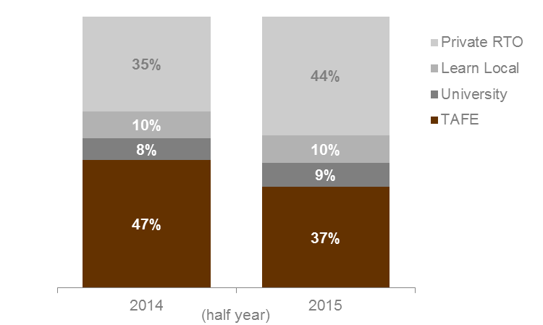

Domestic Fee-For-Service Enrolments by Qualification Level
Table 1.17: | Fee-for-service domestic enrolments by qualification level, 2014 to 2015 (half year)
 | 2014 | 2015 |  | % change 2014 to 2015
Cert I/II | 43,327 | 38,467 |  | -11%
Cert III/IV | 56,613 | 58,981 |  | 4%
Diploma & Above | 12,111 | 23,243 |  | 92%
VET FEE-HELP* | 2,760 | 13,077 |  | 374%
Without any  VET FEE-HELP* | 9,351 | 10,166 |  | 9%
Higher Education | 1,383 | 1,415 |  | 2%
Module Only | 12,377 | 22,006 |  | 78%
Other | 28,998 | 27,971 |  | -4%
Secondary Education** | 565 | 707 |  | 25%
Total*** | 155,790 | 173,510 |  | 11%
* | In 2014 a small number of contracted training providers failed to submit information on VET FEE-HELP.
** | Includes VCE/VCAL courses of study.
*** | Total includes 416 unknown in 2014 (half year) and 720 unknown in 2015 (half year).

Domestic Fee-For-Service Students by Age Group
Table 1.18: | Domestic students enrolled in fee-for-service training by age group, 2014 to 2015 (half year)
 | 2014 | 2015 |  | % change 2014 to 2015
15 to 19 | 26,680 | 28,062 |  | 5%
20 to 24 | 17,625 | 19,984 |  | 13%
25 to 44 | 55,189 | 62,076 |  | 12%
45 to 64 | 29,567 | 32,474 |  | 10%
Other** | 2,622 | 2,847 |  | 9%
Total | 131,683 | 145,443 |  | 10%
* | 'Other' includes age under 15 years old, 65 years and over or not stated.

Domestic Fee-For-Service Enrolments by Delivery Region
This section focuses on the delivery of fee-for-service training by location as defined by four Departmental administrative regions and nine regional areas. Training courses can be undertaken by both students who live locally and students who travel from outside the local area.

Table 1.19.1: | Fee-for-service domestic enrolments by Departmental administrative delivery region, 2014 to 2015 (half year)
 | 2014 | 2015 |  | % change 2014 to 2015
North-Eastern Victoria | 29,073 | 33,666 |  | 16%
North-Western Victoria | 26,409 | 28,802 |  | 9%
South-Eastern Victoria | 37,634 | 37,937 |  | 1%
South-Western Victoria | 59,333 | 64,715 |  | 9%
Interstate | 1,460 | 2,147 |  | 47%
Other* | 2,185 | 6,595 |  | 202%
Total** | 155,790 | 173,510 |  | 11%
* | 'Other' includes on-line delivery and workplace delivery where the location cannot be defined.
** | Where a course was delivered across more than one region, an enrolment in this course is also counted in more than one region. The total has eliminated any duplicates.

Table 1.19.2: | Fee-for-service domestic enrolments by delivery regional area, 2014 to 2015 (half year)
 | 2014 | 2015 |  | % change 2014 to 2015
Barwon South West | 12,861 | 12,153 |  | -6%
Grampians | 5,357 | 4,331 |  | -19%
Loddon Mallee | 8,431 | 8,179 |  | -3%
Hume | 11,140 | 11,471 |  | 3%
Gippsland | 8,962 | 6,694 |  | -25%
Eastern Metropolitan | 17,934 | 22,195 |  | 24%
Western Metropolitan | 41,140 | 48,234 |  | 17%
Southern Metropolitan | 28,676 | 31,258 |  | 9%
Northern Metropolitan | 17,984 | 20,623 |  | 15%
Interstate | 1,460 | 2,147 |  | 47%
Other* | 2,185 | 6,595 |  | 202%
Total** | 155,790 | 173,510 |  | 11%
* | 'Other' includes on-line delivery and workplace delivery where the location cannot be defined.
** | Where a course was delivered across more than one region, an enrolment in this course is also counted in more than one region. The total has eliminated any duplicates.

Domestic Fee-For-Service Enrolments by Occupation
Table 1.20: | Fee-for-service domestic enrolments (AQF I and higher only), proportional share across sectors by occupation, 2015 (half year)
Percentages total across rows in the table below
 |  | TAFE | University | Private RTO | Learn Local | Total (number)
Clerical and Administrative Workers |  | 33% | 11% | 55% | 1% | 18,705
Community and Personal Service Workers |  | 28% | 4% | 58% | 9% | 28,269
Labourers |  | 64% | 7% | 26% | 3% | 20,054
Machinery Operators and Drivers |  | 35% | 1% | 63% | 2% | 9,981
Managers |  | 28% | 19% | 52% | 1% | 1,409
Professionals |  | 34% | 15% | 48% | 3% | 11,230
Sales Workers |  | 16% | 2% | 81% | 1% | 3,788
Technicians and Trades Workers |  | 59% | 9% | 31% | 1% | 13,177
Other* |  | 54% | 14% | 15% | 18% | 15,493
Total (AQF I+ only) |  | 42% | 8% | 44% | 6% | 122,106
* | 'Other' includes courses that were not able to be coded directly into the Australian and New Zealand Standard Classification of Occupation.

International Fee-For-Service Enrolments by Sector
Table 1.21.1: | Fee-for-service onshore international enrolments by sector, 2014 to 2015 (half year)
 | 2014 | 2015 |  | % change 2014 to 2015
Private RTO | 465 | 2,597 |  | 458%*
Learn Local | 23 | 12 |  | -48%
TAFE and University
TAFE | 8,409 | 9,115 |  | 8%
University | 2,594 | 2,805 |  | 8%
Total | 11,491 | 14,529 |  | 26%
* | In 2014 there were 15 Private RTOs that reported that they provided training, this increased to 21 in 2015 (half year).

Table 1.21.2: | Percentage share of fee-for-service onshore international enrolments for each year by sector, 2014 to 2015 (half year)
 | 2014 | 2015
Private RTO | 4% | 18%
Learn Local | 0% | 0%
TAFE and University
TAFE | 73% | 63%
University | 23% | 19%
Total | 100% | 100%

Figure 1.8: | Percentage share of fee-for-service onshore international enrolments by sector, 2014 to 2015 (half year)
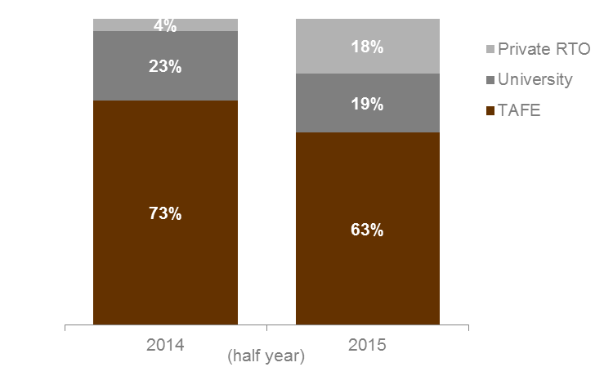

TAFE Activity
TAFEs are valued public institutions that play a significant role in meeting the needs of the economy while also strengthening their communities. TAFEs work to address skills needs, support the development of work-ready training graduates and lower barriers to participation for disadvantaged and high needs learners across the state.
This section provides an overview of the training activity of TAFEs. It includes information on both government subsidised training and fee-for-service training activity.

TAFE - Overall delivery
Key points
- In 2015 (half year) there were 129,131 students studying at TAFE in government subsidised and fee-for-service (including domestic and international) training. This was the lowest over 2010 to 2015 (half year) and 11 per cent lower than 2014 (half year).
- Both government subsidised and fee-for-service TAFE enrolments (for domestic and international students) declined to their lowest point in 2015 (half year) to 156,304 enrolments, within the period 2010 to 2015. The 2015 (half year) result was down by 14 per cent compared to 2014 (half year).

Table 1.22.1: | Students in government subsidised and fee-for-service training at TAFE, 2010 to 2015 (half year)
 | 2010 | 2011 | 2012 | 2013 | 2014 | 2015
Government subsidised | 103,223 | 101,213 | 109,183 | 94,195 | 82,449 | 71,591
Fee-for-service* | 82,321 | 74,934 | 77,660 | 64,152 | 68,708 | 60,534
Domestic | 71,931 | 65,856 | 70,511 | 58,367 | 61,544 | 54,257
International | 10,712 | 9,203 | 7,277 | 5,852 | 7,231 | 6,352
Total** | 177,697 | 169,449 | 179,663 | 151,559 | 145,761 | 129,131
* | Domestic and international fee-for-service student numbers do not add to the fee-for-service total as a student may be in multiple categories (e.g. both Domestic and International) in a given year.
** | Government subsidised and fee-for-service enrolments do not add to the total as a student may be enrolled in both at the same time.

Table 1.22.2: | Change in number of students in government subsidised and fee-for-service training at TAFE (half year)
 | % change 2010 to 2015 | % change 2011 to 2015 | % change 2012 to 2015 | % change 2013 to 2015 | % change 2014 to 2015
Government subsidised | -31% | -29% | -34% | -24% | -13%
Fee-for-service* | -26% | -19% | -22% | -6% | -12%
Domestic | -25% | -18% | -23% | -7% | -12%
International | -41% | -31% | -13% | 9% | -12%
Total** | -27% | -24% | -28% | -15% | -11%
* | Domestic and international fee-for-service student numbers do not add to the fee-for-service total as a student may be in multiple categories (e.g. both Domestic and International) in a given year.
** | Government subsidised and fee-for-service enrolments do not add to the total as a student may be enrolled in both at the same time.

Table 1.23.1: | Course enrolments in government subsidised and fee-for-service training at TAFE, 2010 to 2015 (half year)
 | 2010 | 2011 | 2012 | 2013 | 2014 | 2015
Government subsidised | 121,795 | 127,562 | 157,119 | 138,260 | 100,224 | 82,680
Fee-for-service* | 94,249 | 86,186 | 92,762 | 76,421 | 81,751 | 73,624
Domestic | 79,378 | 74,017 | 83,137 | 68,622 | 73,343 | 64,514
International | 14,886 | 12,170 | 9,637 | 7,800 | 8,409 | 9,115
Total | 216,044 | 213,748 | 249,881 | 214,681 | 181,975 | 156,304
* | Domestic and international fee-for-service course enrolment numbers do not add to the fee-for-service total as an enrolment may be in multiple categories (e.g. both Domestic and International) in a given year.

Table 1.23.2: | Change in number of course enrolments in government subsidised and fee-for-service training at TAFE (half year)
 | % change 2010 to 2015 | % change 2011 to 2015 | % change 2012 to 2015 | % change 2013 to 2015 | % change 2014 to 2015
Government subsidised | -32% | -35% | -47% | -40% | -18%
Fee-for-service* | -22% | -15% | -21% | -4% | -10%
Domestic | -19% | -13% | -22% | -6% | -12%
International | -39% | -25% | -5% | 17% | 8%
Total | -28% | -27% | -37% | -27% | -14%
* | Domestic and international fee-for-service course enrolment numbers do not add to the fee-for-service total as an enrolment may be in multiple categories (e.g. both Domestic and International) in a given year.

TAFE Government Subsidised Training - Apprenticeships and Traineeships
Key points
- TAFEs are a major provider of apprentice training, in 2015 (half year) there were 21,436 government subsidised apprentice enrolments delivered by TAFEs, which represented a 60 per cent share of all government subsidised apprentice enrolments across all sectors.
- In 2015 (half year) TAFEs delivered 3,117 government subsidised trainee enrolments, which accounted for a 15 per cent share of all government subsidised trainee enrolments across all sectors.

Table 1.24: | Government subsidised apprentice enrolments at TAFE, 2010 to 2015 (half year)
 | 2010 | 2011 | 2012 | 2013 | 2014 | 2015
Number | 23,000 | 23,945 | 23,845 | 21,129 | 21,233 | 21,436
TAFE share | 65% | 64% | 63% | 61% | 62% | 60%

Table 1.25: | Government subsidised trainee enrolments at TAFE, 2010 to 2015 (half year)
 | 2010 | 2011 | 2012 | 2013 | 2014 | 2015
Number | 8,327 | 7,979 | 9,200 | 5,758 | 4,834 | 3,117
TAFE share | 24% | 17% | 14% | 14% | 16% | 15%

TAFE Government Subsidised Training – Learners Facing Barriers
Key points
- In 2015 (half year) there were 1,266 Indigenous students enrolled in government subsidised training at TAFEs. This represented a 32 per cent share of all Indigenous students in government subsidised training across all sectors.
- In 2015 (half year) there were 13,771 unemployed students enrolled in government subsidised training at TAFE. This represented a 17 per cent share of all unemployed students in government subsidised training across all sectors.
- In 2015 (half year) there were 5,880 student with a disability enrolled in government subsidised training at TAFEs. This represented a 22 per cent share of all disabled students in government subsidised training across all sectors.
- In 2015 (half year) there were 12,689 students from a culturally and linguistically diverse background (CALD) enrolled in government subsidised training at TAFEs. This represented a 14 per cent share of all CALD students in government subsidised training across all sectors.
- In 2015 (half year) there were 6,329 young people without at least Year 12 or a Certificate II, not at school and enrolled in government subsidised training in a Certificate II or above at TAFE. This represented a 48 per cent share of all these students in government subsidised training across all sectors.
- In 2015 (half year) there were 34,764 older students not holding a Certificate III or above and enrolled in government subsidised training at TAFE. This represented a 23 per cent share of all these students in government subsidised training across all sectors.

Table 1.26: | Indigenous students enrolled in government subsidised training at TAFE, 2010 to 2015 (half year)
 | 2010 | 2011 | 2012 | 2013 | 2014 | 2015
Number | 1,742 | 1,706 | 1,702 | 1,496 | 1,511 | 1,266
TAFE share | 60% | 49% | 41% | 38% | 36% | 32%

Table 1.27: | Unemployed students enrolled in government subsidised training at TAFE, 2010 to 2015 (half year)
 | 2010 | 2011 | 2012 | 2013 | 2014 | 2015
Number | 18,328 | 18,686 | 20,543 | 20,093 | 16,381 | 13,771
TAFE share | 47% | 35% | 27% | 25% | 18% | 17%

Table 1.28: | Disabled students enrolled in government subsidised training at TAFE, 2010 to 2015 (half year)
 | 2010 | 2011 | 2012 | 2013 | 2014 | 2015
Number | 8,026 | 8,372 | 8,395 | 7,376 | 6,603 | 5,880
TAFE share | 45% | 38% | 30% | 28% | 23% | 22%

Table 1.29: | Culturally and Linguistically Diverse (CALD) students enrolled in government subsidised training at TAFE, 2010 to 2015 (half year)
 | 2010 | 2011 | 2012 | 2013 | 2014 | 2015
Number | 19,136 | 18,605 | 16,844 | 16,973 | 14,110 | 12,689
TAFE share | 42% | 32% | 20% | 21% | 15% | 14%

Table 1.30: | Young people without at least Year 12 or a Certificate II, not at school and enrolled in government subsidised training in Certificate II or above at TAFE, 2010 to 2015 (half year)
 | 2010 | 2011 | 2012 | 2013 | 2014 | 2015
Number | 10,352 | 9,795 | 9,742 | 7,829 | 7,292 | 6,329
TAFE share | 58% | 50% | 45% | 47% | 47% | 48%

Table 1.31: | Older students not holding a Certificate III or above and enrolled in government subsidised training at TAFE, 2010 to 2015 (half year)
 | 2010 | 2011 | 2012 | 2013 | 2014 | 2015
Number | 45,981 | 49,260 | 54,341 | 46,630 | 34,745 | 34,764
TAFE share | 47% | 37% | 29% | 29% | 20% | 23%

TAFE Fee-For-Service Training Activity
This section provides an overview of domestic fee-for-service activity by TAFEs.
Key points
- In 2015 (half year), 36 per cent of domestic TAFE fee-for-service enrolments were at the Certificate I and II level.
- In 2015 (half year), 25 to 44 year olds had the highest level of domestic fee-for-service enrolments at TAFE at 27,114, which represented 42 per cent of all domestic TAFE fee-for-service enrolments.
- In 2015 (half year), 20,361 domestic fee-for-service enrolments were delivered by TAFEs in regional Victoria, this was down by 15 per cent on 2014 (half year).
- In 2015 (half year), 42,474 domestic fee-for-service enrolments were delivered by TAFEs in metropolitan Melbourne, this was down by 10 per cent on 2014 (half year).
- In 2015 (half year), the top occupation was Food Preparation Assistants with 2,870 domestic fee-for-service enrolments, down on 2014 (half year) by 58 per cent.

Table 1.32.1: | Domestic fee-for-service enrolments at TAFE by qualification level, 2010 to 2015 (half year)
 | 2010 | 2011 | 2012 | 2013 | 2014* | 2015*
Cert I/II | 20,923 | 19,897 | 25,960 | 24,425 | 26,650 | 23,198
Cert III/IV | 18,385 | 17,476 | 23,021 | 20,591 | 21,522 | 20,747
Diploma & Above | 2,610 | 2,772 | 3,980 | 3,919 | 5,372 | 6,197
Higher Education | 1,151 | 1,278 | 1,360 | 1,307 | 1,336 | 1,337
Module Only | 0 | 0 | 0 | 3 | 69 | 9
Other | 36,286 | 32,563 | 28,652 | 18,135 | 17,924 | 12,220
Secondary Education | 23 | 31 | 164 | 242 | 302 | 553
Total | 79,378 | 74,017 | 83,137 | 68,622 | 73,343 | 64,514
* | 168 unknown in 2014 (half year), 253 unknown in 2015 (half year).

Table 1.32.2: | Change in number of domestic fee-for-service enrolments at TAFE by qualification level (half year)
 | % change 2010 to 2015 | % change 2011 to 2015 | % change 2012 to 2015 | % change 2013 to 2015 | % change 2014 to 2015
Cert I/II | 11% | 17% | -11% | -5% | -13%
Cert III/IV | 13% | 19% | -10% | 1% | -4%
Diploma & Above | 137% | 124% | 56% | 58% | 15%
Higher Education | 16% | 5% | -2% | 2% | 0%
Module Only | - | - | - | 200% | -87%
Other | -66% | -62% | -57% | -33% | -32%
Secondary Education | 2,304% | 1,684% | 237% | 129% | 83%
Total | -19% | -13% | -22% | -6% | -12%

Table 1.33.1: | Domestic fee-for-service enrolments at TAFE by age group, 2010 to 2015 (half year)
 | 2010 | 2011 | 2012 | 2013 | 2014 | 2015
15 to 19 | 19,492 | 18,971 | 19,622 | 15,314 | 16,117 | 14,876
At school | 12,119 | 13,365 | 13,788 | 11,560 | 10,858 | 11,410
Not at School | 7,373 | 5,606 | 5,834 | 3,754 | 5,259 | 3,466
20 to 24 | 10,876 | 10,057 | 11,173 | 9,505 | 10,353 | 9,324
25 to 44 | 29,629 | 27,514 | 32,772 | 28,414 | 30,380 | 27,114
45 to 64 | 18,040 | 16,033 | 17,949 | 14,175 | 15,246 | 12,209
Other* | 1,341 | 1,442 | 1,621 | 1,214 | 1,247 | 991
Total | 79,378 | 74,017 | 83,137 | 68,622 | 73,343 | 64,514
* | ‘Other’ includes age under 15 years old, 65 years and over or not stated.

Table 1.33.2: | Change in number of domestic fee-for-service enrolments at TAFE by age group (half year)
 | % change 2010 to 2015 | % change 2011 to 2015 | % change 2012 to 2015 | % change 2013 to 2015 | % change 2014 to 2015
15 to 19 | -24% | -22% | -24% | -3% | -8%
At school | -6% | -15% | -17% | -1% | 5%
Not at School | -53% | -38% | -41% | -8% | -34%
20 to 24 | -14% | -7% | -17% | -2% | -10%
25 to 44 | -8% | -1% | -17% | -5% | -11%
45 to 64 | -32% | -24% | -32% | -14% | -20%
Other* | -26% | -31% | -39% | -18% | -21%
Total | -19% | -13% | -22% | -6% | -12%
* | ‘Other’ includes age under 15 years old, 65 years and over or not stated.

Table 1.34.1: | Domestic fee-for-service enrolments at TAFE by Departmental administrative delivery region, 2010 to 2015 (half year)
 | 2010 | 2011 | 2012 | 2013 | 2014 | 2015
North-Eastern Victoria | 14,843 | 13,158 | 14,663 | 13,582 | 12,986 | 13,440
North-Western Victoria | 14,174 | 13,112 | 14,664 | 15,413 | 14,874 | 14,049
South-Eastern Victoria | 22,696 | 23,136 | 24,551 | 15,883 | 20,133 | 17,794
South-Western Victoria | 20,911 | 18,044 | 23,038 | 16,793 | 23,184 | 17,543
Interstate | 114 | 110 | 153 | 1,094 | 1,339 | 1,807
Other | 6,672 | 6,491 | 6,260 | 6,006 | 979 | 0
Total* | 79,378 | 74,017 | 83,137 | 68,622 | 73,343 | 64,514
* | Where a course was delivered across more than one region, an enrolment in this course is also counted in more than one region. The total has eliminated any duplicates.

Table 1.34.2: | Change in number of domestic fee-for-service enrolments at TAFE by Departmental administrative delivery region (half year)
 | % change 2010 to 2015 | % change 2011 to 2015 | % change 2012 to 2015 | % change 2013 to 2015 | % change 2014 to 2015
North-Eastern Victoria | -9% | 2% | -8% | -1% | 3%
North-Western Victoria | -1% | 7% | -4% | -9% | -6%
South-Eastern Victoria | -22% | -23% | -28% | 12% | -12%
South-Western Victoria | -16% | -3% | -24% | 4% | -24%
Interstate | 1,485% | 1,543% | 1,081% | 65% | 35%
Other | -100% | -100% | -100% | -100% | -100%
Total | -19% | -13% | -22% | -6% | -12%

Table 1.35.1: | Domestic fee-for-service enrolments at TAFE by delivery regional areas, 2010 to 2015 (half year)
 | 2010 | 2011 | 2012 | 2013 | 2014 | 2015
Barwon South West | 10,301 | 9,452 | 9,972 | 6,682 | 6,518 | 5,396
Grampians | 0 | 0 | 0 | 0 | 0 | 139
Loddon Mallee | 3,974 | 2,986 | 4,777 | 4,481 | 4,096 | 3,689
Hume | 8,977 | 8,649 | 9,805 | 8,900 | 6,938 | 7,421
Gippsland | 5,754 | 6,949 | 8,375 | 4,396 | 6,404 | 3,716
Eastern Metropolitan | 5,866 | 4,509 | 4,858 | 4,682 | 6,049 | 6,019
Western Metropolitan | 10,610 | 8,592 | 13,066 | 10,111 | 16,685 | 12,009
Southern Metropolitan | 16,942 | 16,187 | 16,177 | 11,487 | 13,732 | 14,086
Northern Metropolitan | 10,200 | 10,126 | 9,887 | 10,932 | 10,778 | 10,360
Interstate | 114 | 110 | 153 | 1,094 | 1,339 | 1,807
Other | 6,672 | 6,491 | 6,260 | 6,006 | 979 | 0
Total* | 79,378 | 74,017 | 83,137 | 68,622 | 73,343 | 64,514
* | Where a course was delivered across more than one region, an enrolment in this course is also counted in more than one region. The total has eliminated any duplicates.

Table 1.35.2: | Change in number of domestic fee-for-service enrolments at TAFE by delivery regional areas (half year)
 | % change 2010 to 2015 | % change 2011 to 2015 | % change 2012 to 2015 | % change 2013 to 2015 | % change 2014 to 2015
Barwon South West | -48% | -43% | -46% | -19% | -17%
Grampians | - | - | - | - | -
Loddon Mallee | -7% | 24% | -23% | -18% | -10%
Hume | -17% | -14% | -24% | -17% | 7%
Gippsland | -35% | -47% | -56% | -15% | -42%
Eastern Metropolitan | 3% | 33% | 24% | 29% | 0%
Western Metropolitan | 13% | 40% | -8% | 19% | -28%
Southern Metropolitan | -17% | -13% | -13% | 23% | 3%
Northern Metropolitan | 2% | 2% | 5% | -5% | -4%
Interstate | 1,485% | 1,543% | 1,081% | 65% | 35%
Other | -100% | -100% | -100% | -100% | -100%
Total | -19% | -13% | -22% | -6% | -12%

Table 1.36.1: | Top 10 occupations for domestic fee-for-service enrolments at TAFE, 2010 to 2015 (half year)
 | 2010 | 2011 | 2012 | 2013 | 2014 | 2015
Food Preparation Assistants | 3,411 | 3,562 | 4,089 | 3,218 | 6,885 | 2,870
Personal Carers and Assistants | 1,461 | 1,283 | 3,392 | 2,942 | 3,062 | 2,857
Construction and Mining Labourers | 4,229 | 4,398 | 4,065 | 3,218 | 2,866 | 2,592
Office and Practice Managers | 901 | 1,138 | 1,283 | 716 | 1,616 | 2,486
Miscellaneous Labourers | 1,552 | 1,667 | 2,117 | 1,981 | 2,068 | 2,378
Farm, Forestry and Garden Workers | 1,768 | 1,972 | 1,754 | 1,939 | 1,710 | 1,703
Building and Engineering Technicians | 548 | 913 | 1,460 | 1,473 | 2,047 | 1,661
Cleaners and Laundry Workers | 1,161 | 1,027 | 1,303 | 1,512 | 1,459 | 1,649
Personal Service and Travel Workers | 946 | 1,031 | 1,331 | 1,250 | 1,584 | 1,528
Stationary Plant Operators | 763 | 813 | 1,916 | 1,739 | 1,026 | 1,464
Other* | 62,638 | 56,213 | 60,427 | 48,634 | 49,020 | 43,326
Total | 79,378 | 74,017 | 83,137 | 68,622 | 73,343 | 64,514
* | Including training not directly related to an occupation.

Table 1.36.2: | Change in the number of the top 10 occupations for domestic fee-for-service enrolments at TAFE (half year)
 | % change 2010 to 2015 | % change 2011 to 2015 | % change 2012 to 2015 | % change 2013 to 2015 | % change 2014 to 2015
Food Preparation Assistants | -16% | -19% | -30% | -11% | -58%
Personal Carers and Assistants | 96% | 123% | -16% | -3% | -7%
Construction and Mining Labourers | -39% | -41% | -36% | -19% | -10%
Office and Practice Managers | 176% | 118% | 94% | 247% | 54%
Miscellaneous Labourers | 53% | 43% | 12% | 20% | 15%
Farm, Forestry and Garden Workers | -4% | -14% | -3% | -12% | 0%
Building and Engineering Technicians | 203% | 82% | 14% | 13% | -19%
Cleaners and Laundry Workers | 42% | 61% | 27% | 9% | 13%
Personal Service and Travel Workers | 62% | 48% | 15% | 22% | -4%
Stationary Plant Operators | 92% | 80% | -24% | -16% | 43%
Other* | -31% | -23% | -28% | -11% | -12%
Total | -19% | -13% | -22% | -6% | -12%
* | Including training not directly related to an occupation.

Learn Local Activity
Through the Adult, Community and Further Education (ACFE) Board in 2015, the Victorian Government has supported 312 Learn Local providers and two Adult Education Institutions (AEIs), the Council for Adult Education (CAE) and Adult Multicultural Education Services (AMES). These organisations deliver government funded vocational education and training to Victorians with limited prior educational attainment and limited access to vocational education and training. The training is aimed to support learners’ personal development in the knowledge, skills and attributes necessary to participate in society and secure employment.
To 30 June 2015, 11,593 students participated in pre-accredited program delivery with Learn Local providers and 17,129 participated in accredited program delivery with this training sector.

Learn Local (ACE) Pre-accredited Training
Key points
- Enrolment in pre-accredited training remained relatively stable in the 2015 (half year), four per cent lower than the 2014 (half year). This was 102 per cent higher than the same period in 2010.
- In the 2015 (half year), participation in pre-accredited training across Metropolitan Melbourne was up 18 per cent in North-Western Metropolitan Melbourne, declined 10 per cent in Southern Metropolitan Melbourne, and was down three per cent in Eastern Metropolitan Melbourne.
- In the 2015 (half year), participation in pre-accredited training declined overall in Barwon South West, Grampians, Loddon Mallee and Gippsland. The largest decline was in Grampians, 39 per cent lower than the 2014 (half year).
- The two AEIs reported a 36 per cent increase in pre-accredited program participation in the 2015 (half year), compared to the same period in 2014.
- There was increased participation in pre-accredited programs for the majority of ACFE Board Priority Learner cohorts in the 2015 (half year). The participation of people of a culturally and linguistically diverse background (CALD) increased 18 per cent. Males aged 45-64 years increased four per cent, and Vulnerable workers increased four per cent. Reported students in Unemployed and Disability cohorts were stable on the levels of the 2014 (half year). There was a decline of 26 per cent in the participation of Disengaged Youth, but from a relatively low base.

Table 1.37.1: | Government subsidised pre-accredited training, Learn Local (ACE) providers, 2010 to 2015 (half year)
 | 2010 | 2011 | 2012 | 2013 | 2014 | 2015
Students | 5,835 | 8,491 | 10,895 | 11,698 | 11,984 | 11,593
Module Enrolments | 8,149 | 11,582 | 14,407 | 17,371 | 17,108 | 16,438

Table 1.37.2: | Government subsidised pre-accredited training, Learn Local (ACE) providers, change in number of students and module enrolments (half year)
 | % change 2010 to 2015 | % change 2011 to 2015 | % change 2012 to 2015 | % change 2013 to 2015 | % change 2014 to 2015
Students | 99% | 37% | 6% | -1% | -3%
Module Enrolments | 102% | 42% | 14% | -5% | -4%

Figure 1.9: | Students enrolled in government subsidised pre-accredited training with Learn Local (ACE) providers by training delivery area, 2010 to 2015 (half year)
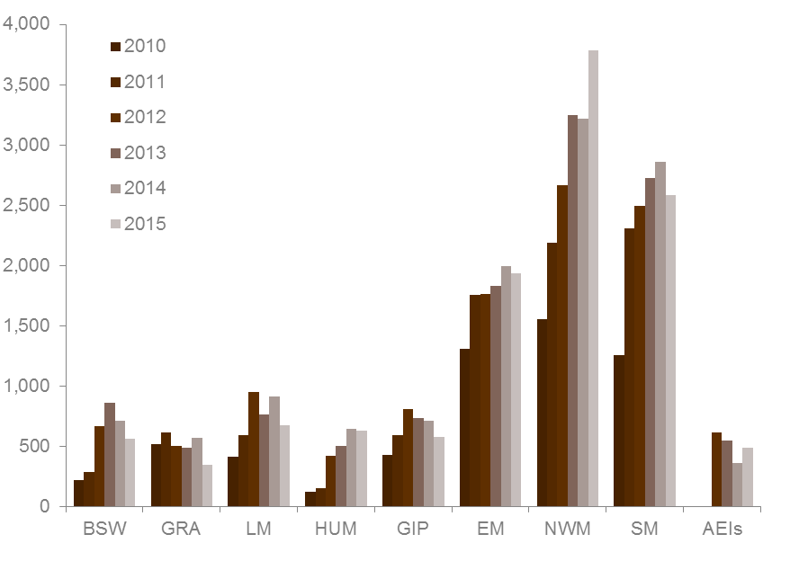
BSW | Barwon South West | HUM | Hume | NWMR | North Western Metropolitan
GRA | Grampians | GIP | Gippsland | SMR | Southern Metropolitan
LM | Loddon Mallee | EMR | Eastern Metropolitan | AEIs | Adult Education Institutes

Table 1.38.1: | ACFE Board Priority Learners enrolled in government subsidised pre-accredited training with Learn Local (ACE) providers, 2010 to 2015 (half year)
 | 2010 | 2011 | 2012 | 2013 | 2014 | 2015
CALD (LOTE) | 1,508 | 2,461 | 3,402 | 3,649 | 3,361 | 3,981
Disability | 1,452 | 2,240 | 2,911 | 3,137 | 3,504 | 3,582
Disengaged Youth | 71 | 135 | 277 | 377 | 472 | 349
Early school leavers | 1,333 | 1,905 | 2,206 | 2,548 | 2,523 | 2,276
Indigenous | 100 | 137 | 181 | 221 | 179 | 167
Males 45 to 64 | 668 | 901 | 1,204 | 1,245 | 1,219 | 1,273
Unemployed | 1,335 | 1,975 | 2,574 | 3,145 | 3,245 | 3,276
Vulnerable workers | 1,447 | 2,112 | 2,688 | 2,831 | 2,813 | 2,921
Note: | ACFE Board Priority Learner categories are not mutually exclusive. Category details available at: www.education.vic.gov.au/Documents/about/research/acfepublications/hardtoreachlearn.pdf

Table 1.38.2: | Change in number of ACFE Board Priority Learners enrolled in government subsidised pre-accredited training with Learn Local (ACE) providers (half year)
 | % change 2010 to 2015 | % change 2011 to 2015 | % change 2012 to 2015 | % change 2013 to 2015 | % change 2014 to 2015
CALD (LOTE) | 164% | 62% | 17% | 9% | 18%
Disability | 147% | 60% | 23% | 14% | 2%
Disengaged Youth | 392% | 159% | 26% | -7% | -26%
Early school leavers | 71% | 19% | 3% | -11% | -10%
Indigenous | 67% | 22% | -8% | -24% | -7%
Males 45 to 64 | 91% | 41% | 6% | 2% | 4%
Unemployed | 145% | 66% | 27% | 4% | 1%
Vulnerable workers | 102% | 38% | 9% | 3% | 4%

Learn Local (ACE) Accredited Training
Key points
- Enrolments in accredited training slightly declined in the 2015 (half year) when compared with the same period in 2014 (nine per cent lower). This was 22 per cent lower than the same period in 2010.
- Participation in accredited training across Metropolitan Melbourne in the 2015 (half year) declined by 42 per cent in Eastern Metropolitan Melbourne, and by one per cent in Southern Metropolitan Melbourne. Participation in North-Western Metropolitan Melbourne was six per cent higher on the same period in 2014.
- Participation in accredited training across regional Victorian declined an average of 14 per cent in the 2015 (half year). The most notable decline was in the Gippsland region, 35 per cent lower than the same period in 2014.
- The two AEIs reported a one per cent increase in the 2015 (half year), compared to the same period in 2014.
- There was a stable rate of participation in accredited training for the majority of ACFE Board Priority Learner cohorts in the 2015 (half year). Increases were reported for CALD students (up 22 per cent), Indigenous students (up 14 per cent), and Males aged 45-64 years (up nine per cent). In contrast, the participation of Disengaged young people declined 15 per cent and Early School Leavers declined seven per cent compared to the same period in 2014.

Table 1.39.1: | Government subsidised accredited training, Learn Local (ACE) providers, 2010 to 2015 (half year)
 | 2010 | 2011 | 2012 | 2013 | 2014 | 2015
Students | 19,927 | 18,164 | 25,189 | 20,500 | 18,234 | 17,129
Course Enrolments | 24,656 | 21,491 | 31,510 | 24,893 | 21,051 | 19,155

Table 1.39.2: | Government subsidised accredited training, Learn Local (ACE) providers, change in number of students and course enrolments (half year)
 | % change 2010 to 2015 | % change 2011 to 2015 | % change 2012 to 2015 | % change 2013 to 2015 | % change 2014 to 2015
Students | -14% | -6% | -32% | -16% | -6%
Course Enrolments | -22% | -11% | -39% | -23% | -9%

Figure 1.10: | Students enrolled in government subsidised accredited training with Learn Local (ACE) providers by training delivery area, 2010 to 2015 (half year)
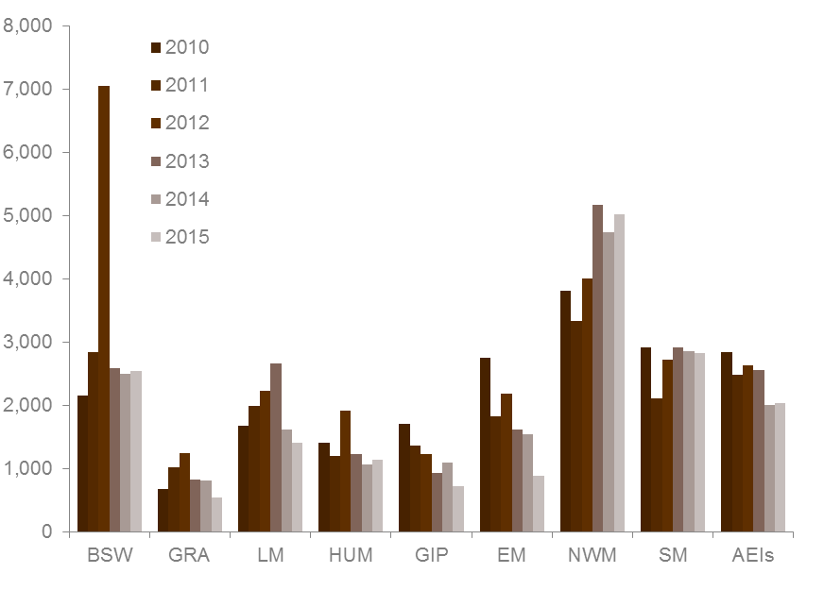
BSW | Barwon South West | HUM | Hume | NWMR | North Western Metropolitan
GRA | Grampians | GIP | Gippsland | SMR | Southern Metropolitan
LM | Loddon Mallee | EMR | Eastern Metropolitan | AEIs | Adult Education Institutes

Table 1.40.1: | ACFE Board Priority Learners enrolled in government subsidised accredited training with Learn Local (ACE) providers, 2010 to 2015 (half year)
 | 2010 | 2011 | 2012 | 2013 | 2014 | 2015
CALD (LOTE) | 4,583 | 4,360 | 5,964 | 5,874 | 5,158 | 6,298
Disability | 3,283 | 3,302 | 4,310 | 3,964 | 4,267 | 4,557
Disengaged Youth | 1,320 | 1,516 | 2,463 | 1,989 | 1,907 | 1,616
Early school leavers | 4,771 | 4,662 | 6,328 | 4,707 | 4,203 | 3,890
Indigenous | 220 | 289 | 354 | 354 | 352 | 401
Males 45 to 64 | 1,505 | 1,368 | 1,630 | 1,411 | 1,386 | 1,504
Unemployed | 5,208 | 5,647 | 8,843 | 7,409 | 6,995 | 6,890
Vulnerable workers | 4,167 | 3,814 | 5,050 | 4,939 | 4,447 | 4,189
Note: | ACFE Board Priority Learner categories are not mutually exclusive. Category details available at: www.education.vic.gov.au/Documents/about/research/acfepublications/hardtoreachlearn.pdf

Table 1.40.2: | Change in number of ACFE Board Priority Learners enrolled in government subsidised accredited training with Learn Local (ACE) providers (half year)
 | % change 2010 to 2015 | % change 2011 to 2015 | % change 2012 to 2015 | % change 2013 to 2015 | % change 2014 to 2015
CALD (LOTE) | 37% | 44% | 6% | 7% | 22%
Disability | 39% | 38% | 6% | 15% | 7%
Disengaged Youth | 22% | 7% | -34% | -19% | -15%
Early school leavers | -18% | -17% | -39% | -17% | -7%
Indigenous | 82% | 39% | 13% | 13% | 14%
Males 45 to 64 | 0% | 10% | -8% | 7% | 9%
Unemployed | 32% | 22% | -22% | -7% | -2%
Vulnerable workers | 1% | 10% | -17% | -15% | -6%

Learners Facing Barriers to Participation

Vocational Training Delivery to Learner Groups Facing Barriers

Young people and adult learners, who may be members of more than one equity group, can have complex and multiple learning needs and may have contact with a range of government services and programs. There is a significant evidence base that demonstrates the value and importance of education and training to these groups. However, higher needs learners may face a combination of barriers to effective engagement in education and training, including low levels of previous educational achievement, low aspirations, poor access to training and broader barriers such as poverty, homelessness and poor health.
Vocational training has continued to be a critical enabler in opening up pathways for higher needs and disadvantaged learners through the provision of tailored services, often in partnership with other service providers.

Students undertaking Government Subsidised Accredited and Pre-Accredited Training
Table 2.1.1: | Students enrolled in government subsidised accredited and pre-accredited training by selected learner groups*, 2010 to 2015 (half year)
 | 2010 | 2011 | 2012 | 2013 | 2014 | 2015
Indigenous | 2,927 | 3,502 | 4,136 | 3,940 | 4,208 | 3,912
Student with a disability | 17,985 | 22,226 | 27,570 | 26,515 | 28,515 | 26,993
CALD | 45,117 | 58,241 | 84,869 | 82,560 | 94,305 | 88,164
Unemployed | 39,205 | 52,961 | 77,032 | 79,176 | 90,760 | 79,042

Young people without at least Year 12 or a Certificate II, not at school and enrolled in government subsidised (accredited) training in Certificate II or above, 2010 to 2015 (half year)
Aged 15-19 | 17,810 | 19,574 | 21,485 | 16,836 | 15,395 | 13,313

Older students not holding a Certificate III or above and enrolled in government subsidised accredited and pre-accredited training, 2010 to 2015 (half year)
Aged 20-64 | 97,133 | 131,678 | 184,433 | 163,178 | 169,691 | 151,397
* | The above groups of students are not mutually exclusive.

Table 2.1.2: | Change in number of students enrolled in government subsidised accredited and pre-accredited training by selected learner group* (half year)
 | % change 2010 to 2015 | % change 2011 to 2015 | % change 2012 to 2015 | % change 2013 to 2015 | % change 2014 to 2015
Indigenous | 34% | 12% | -5% | -1% | -7%
Student with a disability | 50% | 21% | -2% | 2% | -5%
CALD | 95% | 51% | 4% | 7% | -7%
Unemployed | 102% | 49% | 3% | 0% | -13%
Aged 15-19 without at least Year 12 or a Cert II, not at school and enrolled in Cert II or above | -25% | -32% | -38% | -21% | -14%
Aged 20-64 not holding a Cert III or above | 56% | 15% | -18% | -7% | -11%
* | The above groups of students are not mutually exclusive.

Students undertaking Government Subsidised Accredited Training
Table 2.2.1: | Students enrolled in government subsidised accredited training by selected learner groups*, 2010 to 2015 (half year)
 | 2010 | 2011 | 2012 | 2013 | 2014 | 2015
Indigenous | 2,829 | 3,379 | 3,982 | 3,768 | 4,085 | 3,774
Student with a disability | 16,647 | 20,272 | 25,064 | 23,789 | 25,455 | 23,787
CALD | 43,442 | 55,636 | 81,524 | 79,008 | 90,803 | 84,346
Unemployed | 38,003 | 51,266 | 74,855 | 76,671 | 88,196 | 76,433

Young people without at least Year 12 or a Certificate II, not at school and enrolled in government subsidised (accredited) training in Certificate II or above, 2010 to 2015 (half year)
Aged 15-19 | 17,810 | 19,574 | 21,485 | 16,836 | 15,395 | 13,313

Older students not holding a Certificate III or above and enrolled in government subsidised accredited training, 2010 to 2015 (half year)
Aged 20-64 | 94,343 | 127,849 | 179,823 | 158,413 | 164,958 | 146,501
* | The above groups of students are not mutually exclusive.

Table 2.2.2: | Change in number of students enrolled in government subsidised accredited training by selected learner group* (half year)
 | % change 2010 to 2015 | % change 2011 to 2015 | % change 2012 to 2015 | % change 2013 to 2015 | % change 2014 to 2015
Indigenous | 33% | 12% | -5% | 0% | -8%
Student with a disability | 43% | 17% | -5% | 0% | -7%
CALD | 94% | 52% | 3% | 7% | -7%
Unemployed | 101% | 49% | 2% | 0% | -13%
Aged 15-19 without at least Year 12 or a Cert II, not at school and enrolled in Cert II or above | -25% | -32% | -38% | -21% | -14%
Aged 20-64 not holding a Cert III or above | 55% | 15% | -19% | -8% | -11%
* | The above groups of students are not mutually exclusive.

Indigenous Students

Accredited Course Enrolments
Key points
The 2015 (half year) data shows that:
- There were 3,774 Indigenous students who were enrolled in 4,350 government subsidised accredited training courses. This is down by 8 per cent of students and 12 per cent of enrolments from the same period in 2014.
- Apart from Diploma and above, there was a decline in the number of government subsidised accredited course enrolments by Indigenous students across all qualification levels compared to the same period in 2014.
- Seventy three per cent of enrolments by Indigenous students were in Certificate III and above levels.

Table 2.3.1: | Enrolments in government subsidised accredited training by qualification level for Indigenous students, 2010 to 2015 (half year)
 | 2010 | 2011 | 2012 | 2013 | 2014 | 2015
Cert I/II | 1,501 | 1,610 | 1,759 | 1,841 | 1,133 | 921
Cert III/IV | 1,420 | 1,908 | 2,582 | 2,369 | 2,757 | 2,678
Diploma & Above | 286 | 398 | 478 | 402 | 450 | 499
Module Only | 80 | 14 | 9 | 5 | 173 | 18
Secondary Education* | 317 | 185 | 192 | 222 | 316 | 196
Other** | 86 | 39 | 75 | 42 | 107 | 38
Total | 3,690 | 4,154 | 5,095 | 4,881 | 4,936 | 4,350
* | Includes VCE/VCAL courses of study.
** | 'Other' includes statement of attainment, other non-award courses or not elsewhere classified.

Table 2.3.2: | Change in number of enrolments in government subsidised accredited training by qualification level for Indigenous students (half year)
 | % change 2010 to 2015 | % change 2011 to 2015 | % change 2012 to 2015 | % change 2013 to 2015 | % change 2014 to 2015
Cert I/II | -39% | -43% | -48% | -50% | -19%
Cert III/IV | 89% | 40% | 4% | 13% | -3%
Diploma & Above | 74% | 25% | 4% | 24% | 11%
Module Only | -78% | 29% | 100% | 260% | -90%
Secondary Education* | -38% | 6% | 2% | -12% | -38%
Other** | -56% | -3% | -49% | -10% | -64%
Total | 18% | 5% | -15% | -11% | -12%
* | Includes VCE/VCAL courses of study.
** | 'Other' includes statement of attainment, other non-award courses or not elsewhere classified.

Students with a Disability

Accredited Course Enrolments
Key points
The 2015 (half year) data shows that:
- There were 23,787 students with a disability who were enrolled in 27,362 government subsidised accredited training courses. This is down by 7 per cent of students and 10 per cent of enrolments from the same period in 2014.
- Apart from Diploma and above, there was a decline in the number of government subsidised accredited course enrolments by students with a disability across all qualification levels compared to the same period in 2014.
- Fifty eight per cent of enrolments by students with a disability were in Certificate III and above levels.

Table 2.4.1: | Enrolments in government subsidised accredited training by qualification level for students with a disability, 2010 to 2015 (half year)
 | 2010 | 2011 | 2012 | 2013 | 2014 | 2015
Cert I/II | 7,346 | 9,565 | 12,851 | 13,489 | 10,544 | 9,604
Cert III/IV | 7,163 | 10,138 | 14,538 | 13,214 | 14,364 | 12,737
Diploma & Above | 2,998 | 3,815 | 4,287 | 3,174 | 3,003 | 3,134
Module Only | 1,818 | 598 | 323 | 196 | 353 | 223
Secondary Education* | 829 | 918 | 973 | 1,187 | 1,319 | 990
Other** | 854 | 614 | 737 | 631 | 838 | 674
Total | 21,008 | 25,648 | 33,709 | 31,891 | 30,421 | 27,362
* | Includes VCE/VCAL courses of study.
** | 'Other' includes statement of attainment, other non-award courses or not elsewhere classified.

Table 2.4.2: | Change in number of enrolments in government subsidised accredited training by qualification level for students with a disability (half year)
 | % change 2010 to 2015 | % change 2011 to 2015 | % change 2012 to 2015 | % change 2013 to 2015 | % change 2014 to 2015
Cert I/II | 31% | 0% | -25% | -29% | -9%
Cert III/IV | 78% | 26% | -12% | -4% | -11%
Diploma & Above | 5% | -18% | -27% | -1% | 4%
Module Only | -88% | -63% | -31% | 14% | -37%
Secondary Education* | 19% | 8% | 2% | -17% | -25%
Other** | -21% | 10% | -9% | 7% | -20%
Total | 30% | 7% | -19% | -14% | -10%
* | Includes VCE/VCAL courses of study.
** | 'Other' includes statement of attainment, other non-award courses or not elsewhere classified.

Students with a Culturally and Linguistically Diverse (CALD) Background

Accredited Course Enrolments
Key points
The 2015 (half year) data shows that:
- There were 84,346 students from a CALD background enrolled in 97,983 government subsidised accredited training courses. This is down by 7 per cent of students and 9 per cent of enrolments from the same period in 2014.
- There was an increase in the number of government subsidised accredited course enrolments by students from a CALD background in Diploma and above, Module Only and Other qualifications levels compared to the same period in 2014. There was a decrease in enrolments in Certificate I to IV and Secondary Education qualification levels in the same period.
- Seventy nine per cent of enrolments by students from a CALD background were in Certificate III and above levels.

Table 2.5.1: | Enrolments in government subsidised accredited training by students from a CALD background by qualification level, 2010 to 2015 (half year)
 | 2010 | 2011 | 2012 | 2013 | 2014 | 2015
Cert I/II | 11,678 | 15,592 | 26,300 | 29,040 | 21,797 | 16,325
Cert III/IV | 22,872 | 33,511 | 57,370 | 54,805 | 68,800 | 59,640
Diploma & Above | 12,082 | 15,351 | 18,319 | 14,036 | 14,641 | 18,129
Module Only | 3,060 | 882 | 333 | 198 | 313 | 633
Secondary Education* | 1,016 | 1,045 | 909 | 973 | 1,024 | 789
Other** | 2,239 | 2,034 | 3,533 | 1,725 | 1,483 | 2,467
Total | 52,947 | 68,415 | 106,764 | 100,777 | 108,058 | 97,983
* | Includes VCE/VCAL courses of study.
** | 'Other' includes statement of attainment, other non-award courses or not elsewhere classified.

Table 2.5.2: | Change in number of enrolments in government subsidised accredited training by students from a CALD background by qualification level (half year)
 | % change 2010 to 2015 | % change 2011 to 2015 | % change 2012 to 2015 | % change 2013 to 2015 | % change 2014 to 2015
Cert I/II | 40% | 5% | -38% | -44% | -25%
Cert III/IV | 161% | 78% | 4% | 9% | -13%
Diploma & Above | 50% | 18% | -1% | 29% | 24%
Module Only | -79% | -28% | 90% | 220% | 102%
Secondary Education* | -22% | -24% | -13% | -19% | -23%
Other** | 10% | 21% | -30% | 43% | 66%
Total | 85% | 43% | -8% | -3% | -9%
* | Includes VCE/VCAL courses of study.
** | 'Other' includes statement of attainment, other non-award courses or not elsewhere classified.

Unemployed Students

Accredited Course Enrolments
Key points
The 2015 (half year) data shows that:
- There were 76,433 unemployed students who were enrolled in 91,071 government subsidised accredited training courses. This is down by 13 per cent of students and 15 per cent of enrolments from the same period in 2014.
- There was an increase in the number of government subsidised accredited course enrolments by unemployed students in Diploma and above and Module Only qualifications levels compared to the same period in 2014. There was a decrease in enrolments in Certificate I to IV, Secondary Education and Other qualification levels in the same period.
- Seventy five per cent of course enrolments by unemployed students were in Certificate III and above levels.

Table 2.6.1: | Enrolments in government subsidised accredited training by unemployed students by qualification level, 2010 to 2015 (half year)
 | 2010 | 2011 | 2012 | 2013 | 2014 | 2015
Cert I/II | 13,119 | 19,843 | 31,886 | 38,465 | 24,294 | 17,902
Cert III/IV | 18,713 | 29,450 | 51,264 | 49,146 | 67,793 | 56,176
Diploma & Above | 9,747 | 12,678 | 13,415 | 10,190 | 10,271 | 12,358
Module Only | 2,940 | 888 | 384 | 244 | 678 | 1,222
Secondary Education* | 2,182 | 2,294 | 2,534 | 2,552 | 3,011 | 2,174
Other** | 1,720 | 1,059 | 1,835 | 1,086 | 1,353 | 1,239
Total | 48,421 | 66,212 | 101,318 | 101,683 | 107,400 | 91,071
* | Includes VCE/VCAL courses of study.
** | 'Other' includes statement of attainment, other non-award courses or not elsewhere classified.

Table 2.6.2: | Change in number of enrolments in government subsidised accredited training by unemployed students by qualification level (half year)
 | % change 2010 to 2015 | % change 2011 to 2015 | % change 2012 to 2015 | % change 2013 to 2015 | % change 2014 to 2015
Cert I/II | 36% | -10% | -44% | -53% | -26%
Cert III/IV | 200% | 91% | 10% | 14% | -17%
Diploma & Above | 27% | -3% | -8% | 21% | 20%
Module Only | -58% | 38% | 218% | 401% | 80%
Secondary Education* | 0% | -5% | -14% | -15% | -28%
Other** | -28% | 17% | -32% | 14% | -8%
Total | 88% | 38% | -10% | -10% | -15%
* | Includes VCE/VCAL courses of study.
** | 'Other' includes statement of attainment, other non-award courses or not elsewhere classified.

Young People (aged 15 to 19) Without Year 12 or Equivalent and Not at School enrolled in Certificate II or above

Accredited Course Enrolments
Key points
The 2015 (half year) data shows that:
- There were 13,313 students who were aged 15 to 19 without at least Year 12 or a Certificate II and not at school, enrolled in 14,584 government subsidised accredited training courses at Certificate II and above levels. This is down 14 per cent of students and 16 per cent of enrolments from the same period in 2014.

Table 2.7.1: | Enrolments in government subsidised accredited training at Certificate II and above by students aged 15 to 19 without at least Year 12 or a Certificate II and not at school, 2010 to 2015 (half year)
 | 2010 | 2011 | 2012 | 2013 | 2014 | 2015
Cert II | 5,971 | 7,480 | 8,590 | 6,380 | 4,321 | 3,028
Cert III/IV | 12,766 | 13,779 | 15,870 | 12,604 | 12,390 | 10,892
Diploma & Above | 618 | 1,180 | 831 | 457 | 650 | 664
Total | 19,355 | 22,439 | 25,291 | 19,441 | 17,361 | 14,584

Table 2.7.2: | Change in number of enrolments in government subsidised accredited training at Certificate II and above by students aged 15 to 19 without at least Year 12 or a Certificate II and not at school (half year)
 | % change 2010 to 2015 | % change 2011 to 2015 | % change 2012 to 2015 | % change 2013 to 2015 | % change 2014 to 2015
Cert II | -49% | -60% | -65% | -53% | -30%
Cert III/IV | -15% | -21% | -31% | -14% | -12%
Diploma & Above | 7% | -44% | -20% | 45% | 2%
Total | -25% | -35% | -42% | -25% | -16%

Students with Low Prior Qualification

Accredited Course Enrolments
Key points
The 2015 (half year) data shows that:
- There were 146,501 students who were aged 20 to 64 and not holding a Certificate III or above qualification enrolled in 172,122 government subsidised accredited courses. This is down 11 per cent of students and 14 per cent enrolments from the same period in 2014.

Table 2.8.1: | Enrolments in government subsidised accredited training by students aged 20 to 64 not holding a Certificate III or above, 2010 to 2015 (half year)
 | 2010 | 2011 | 2012 | 2013 | 2014 | 2015
Course Enrolments | 109,489 | 150,740 | 226,269 | 199,821 | 201,078 | 172,122
Up-Skilling* | 78,385 | 115,575 | 176,479 | 150,190 | 161,178 | 144,452
* | ‘Up-skilling’ refers to studying at a higher level than their current qualification.

Table 2.8.2: | Change in number of enrolments in government subsidised accredited training by students aged 20 to 64 not holding a Certificate III or above (half year)
 | % change 2010 to 2015 | % change 2011 to 2015 | % change 2012 to 2015 | % change 2013 to 2015 | % change 2014 to 2015
Course Enrolments | 57% | 14% | -24% | -14% | -14%
Up-Skilling* | 84% | 25% | -18% | -4% | -10%
* | ‘Up-skilling’ refers to studying at a higher level than their current qualification.

Foundation Level Training

An efficient and effective training market is vital to provide better outcomes for students and employers, as well as the wider Victorian community. It is particularly important to make sure school leavers and adults without solid literacy and numeracy skills are given the opportunity to acquire them. Gaining these base level skills in literacy, numeracy and workforce preparation will greatly improve a student’s chances following training of employment, provide opportunities for further education and broader social participation.
There were changes in subsidy and courses being included in the foundation skills list at the end of 2013 and in 2014. To ensure a degree of consistency, any course that was identified in the foundation skills list of courses, whether in 2015 or previous years, is considered for the purposes of this report as a foundation course.
Data reported here includes both accredited and pre-accredited training.

Key points
- There were 28,361 students enrolled in 29,731 government subsidised foundation skills courses in 2015 (half year). This is down 40 per cent of students and 42 per cent enrolments from the same period in 2014.
- There were 2,916 early school leavers without a base qualification (i.e. Year 12 or Certificate II) that were enrolled in government subsidised Foundation training in the first six months of 2015, this was down by 40 per cent on the same period in 2014. These students in Foundation training represented only 17 per cent of all early school leavers in training in 2015.

Table 2.9.1: | Government subsidised training in foundation skills courses: student numbers and number of course enrolments, 2010 to 2015 (half year)
 | 2010 | 2011 | 2012 | 2013 | 2014 | 2015
Students | 16,683 | 25,500 | 61,558 | 82,544 | 47,359 | 28,361
Course enrolments | 19,476 | 31,594 | 73,597 | 96,415 | 50,969 | 29,731

Table 2.9.2: | Change in government subsidised training in foundation skills courses: student numbers and number of course enrolments (half year)
 | % change 2010 to 2015 | % change 2011 to 2015 | % change 2012 to 2015 | % change 2013 to 2015 | % change 2014 to 2015
Students | 70% | 11% | -54% | -66% | -40%
Course enrolments | 53% | -6% | -60% | -69% | -42%

Table 2.10.1: | Students enrolled in government subsidised foundation skills courses by age group, 2010 to 2015 (half year)
 | 2010 | 2011 | 2012 | 2013 | 2014 | 2015
15 to 19 | 4,135 | 6,805 | 17,872 | 24,676 | 10,965 | 4,821
20 to 24 | 1,839 | 3,496 | 12,120 | 17,144 | 8,718 | 3,853
25 to 44 | 6,684 | 9,525 | 18,994 | 25,376 | 15,489 | 9,205
45 to 64 | 3,547 | 5,178 | 10,422 | 13,201 | 10,193 | 8,590
Other* | 478 | 496 | 2,150 | 2,147 | 1,994 | 1,892
Total | 16,683 | 25,500 | 61,558 | 82,544 | 47,359 | 28,361
* | 'Other' includes age under 15 years old, 65 years and over or not stated.

Table 2.10.2: | Change in number of students enrolled in government subsidised foundation skills courses by age group (half year)
 | % change 2010 to 2015 | % change 2011 to 2015 | % change 2012 to 2015 | % change 2013 to 2015 | % change 2014 to 2015
15 to 19 | 17% | -29% | -73% | -80% | -56%
20 to 24 | 110% | 10% | -68% | -78% | -56%
25 to 44 | 38% | -3% | -52% | -64% | -41%
45 to 64 | 142% | 66% | -18% | -35% | -16%
Other* | 296% | 281% | -12% | -12% | -5%
Total | 70% | 11% | -54% | -66% | -40%
* | 'Other' includes age under 15 years old, 65 years and over or not stated.

Table 2.11.1: | Early school leavers 15-19 years not at school in government subsidised training, 2010 to 2015 (half year)
 | 2010 | 2011 | 2012 | 2013 | 2014 | 2015
Students in Foundation | 2,594 | 3,328 | 6,907 | 8,259 | 4,853 | 2,916
All students | 21,084 | 22,635 | 24,943 | 20,910 | 20,571 | 17,122
% of students in Foundation | 12% | 15% | 28% | 39% | 24% | 17%

Table 2.11.2: | Change in Early school leavers 15-19 years not at school in government subsidised training, 2010 to 2015 (half year)
 | % change 2010 to 2015 | % change 2011 to 2015 | % change 2012 to 2015 | % change 2013 to 2015 | % change 2014 to 2015
Students in Foundation | 12% | -12% | -58% | -65% | -40%
All students | -19% | -24% | -31% | -18% | -17%

Apprenticeships and Traineeships

Apprenticeships and Traineeships Overall

Key points
- There were 54,686 students who were enrolled in 55,781 government subsidised apprenticeship or traineeship courses in 2015 (half year).
- The number of students enrolled in government subsidised apprenticeship or traineeship courses decreased by 15 per cent from 2014 (half year) to 2015 (half year). The number of enrolments over the same period decreased by 14 per cent.

Table 3.1.1: | Government subsidised training in apprenticeships and traineeships by number of students and course enrolments, 2010 to 2015 (half year)
 | 2010 | 2011 | 2012 | 2013 | 2014 | 2015
Students | 68,590 | 83,641 | 100,820 | 75,208 | 64,528 | 54,686
Course Enrolments | 69,400 | 84,284 | 101,264 | 75,466 | 65,030 | 55,781

Table 3.1.2: | Government subsidised training in apprenticeships and traineeships: change in number of students and course enrolments (half year)
 | % change 2010 to 2015 | % change 2011 to 2015 | % change 2012 to 2015 | % change 2013 to 2015 | % change 2014 to 2015
Students | -20% | -35% | -46% | -27% | -15%
Course Enrolments | -20% | -34% | -45% | -26% | -14%

Apprenticeships

Key points
- In 2015 (half year), there were 35,523 government subsidised apprentice course enrolments. This was an increase of 4 per cent from the same period in 2014.
- In 2015 (half year), 30 per cent of apprentice course enrolments were by students aged 15 to 19. Enrolments by this age group were slightly higher than the same period in 2014.
- The vast majority of apprentice course enrolments were in occupations classified as Technicians and Trade Workers, which include Automotive and Engineering Trades Workers, Construction Trades Workers, Electrotechnology and Telecommunications Trades Workers, Engineering ICT and Science Technicians, Food Trades Workers, Other Technicians and Trades Workers, and Skilled Animal and Horticultural Workers.

Figure 3.1: | Government subsidised apprentice course enrolments, 2010 to 2015 (half year)
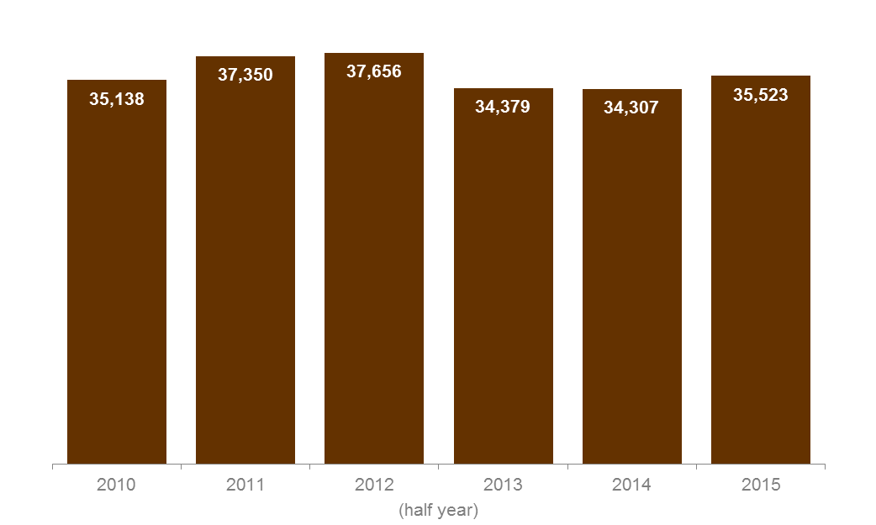

Table 3.2.1: | Number of students and enrolments in government subsidised apprentice courses, 2010 to 2015 (half year)
 | 2010 | 2011 | 2012 | 2013 | 2014 | 2015
Students | 34,924 | 37,244 | 37,618 | 34,245 | 34,020 | 34,591
Course Enrolments | 35,138 | 37,350 | 37,656 | 34,379 | 34,307 | 35,523

Table 3.2.2: | Change in number of students and enrolments in government subsidised apprentice courses (half year)
 | % change 2010 to 2015 | % change 2011 to 2015 | % change 2012 to 2015 | % change 2013 to 2015 | % change 2014 to 2015
Students | -1% | -7% | -8% | 1% | 2%
Course Enrolments | 1% | -5% | -6% | 3% | 4%

Table 3.3.1: | Government subsidised apprentice course enrolments by age group, 2010 to 2015 (half year)
 | 2010 | 2011 | 2012 | 2013 | 2014 | 2015
15 to 19 | 14,480 | 14,711 | 13,916 | 11,447 | 10,564 | 10,713
20 to 24 | 14,797 | 15,771 | 16,588 | 15,484 | 15,540 | 16,024
25 to 44 | 5,414 | 6,275 | 6,560 | 6,639 | 7,013 | 7,506
45 to 64 | 436 | 552 | 585 | 794 | 1,170 | 1,256
Other* | 11 | 41 | 7 | 15 | 20 | 24
Total | 35,138 | 37,350 | 37,656 | 34,379 | 34,307 | 35,523
* | ‘Other’ includes age under 15 years old, 65 years and over or not stated.

Table 3.3.2: | Change in number of government subsidised apprentice course enrolments by age group (half year)
 | % change 2010 to 2015 | % change 2011 to 2015 | % change 2012 to 2015 | % change 2013 to 2015 | % change 2014 to 2015
15 to 19 | -26% | -27% | -23% | -6% | 1%
20 to 24 | 8% | 2% | -3% | 3% | 3%
25 to 44 | 39% | 20% | 14% | 13% | 7%
45 to 64 | 188% | 128% | 115% | 58% | 7%
Other* | 118% | -41% | 243% | 60% | 20%
Total | 1% | -5% | -6% | 3% | 4%
* | ‘Other’ includes age under 15 years old, 65 years and over or not stated.

Table 3.4.1: | Government subsidised apprentice course enrolments by occupation, 2010 to 2015 (half year)
 | 2010 | 2011 | 2012 | 2013 | 2014 | 2015
Clerical and Administrative Workers | 2 | 2 | 4 | 1 | 3 | 0
Community and Personal Service Workers* | 117 | 120 | 103 | 78 | 49 | 46
Labourers** | 50 | 56 | 75 | 106 | 40 | 82
Machinery Operators And Drivers | 2 | 2 | 1 | 0 | 1 | 0
Managers | 0 | 1 | 0 | 0 | 0 | 0
Professionals | 0 | 0 | 1 | 0 | 0 | 0
Sales Workers | 69 | 103 | 227 | 153 | 191 | 244
Technicians And Trades Workers | 34,898 | 37,066 | 37,245 | 34,041 | 34,023 | 35,151
Automotive and Engineering Trades Workers | 7,566 | 7,495 | 8,165 | 7,746 | 7,220 | 7,168
Construction Trades Workers | 12,902 | 14,513 | 14,216 | 12,101 | 11,129 | 11,758
Electrotechnology and Telecommunications Trades Workers | 5,948 | 6,442 | 6,526 | 6,238 | 6,495 | 6,823
Engineering, ICT and Science Technicians | 14 | 23 | 85 | 155 | 478 | 624
Food Trades Workers | 3,263 | 3,310 | 3,237 | 3,002 | 3,791 | 3,788
Other Technicians and Trades Workers | 3,739 | 3,665 | 3,371 | 3,324 | 3,532 | 3,575
Skilled Animal and Horticultural Workers | 1,466 | 1,618 | 1,645 | 1,475 | 1,378 | 1,415
Total | 35,138 | 37,350 | 37,656 | 34,379 | 34,307 | 35,523
* | 'Community and Personal Services' occupational category included courses such as Diploma of Dental Technology and Certificate IV in Racing (Jockey)
** | 'Labourers' occupational category included courses such as Certificate III in Automotive Glazing Technology

Table 3.4.2: | Change in number of government subsidised apprentice course enrolments by occupation (half year)
 | % change 2010 to 2015 | % change 2011 to 2015 | % change 2012 to 2015 | % change 2013 to 2015 | % change 2014 to 2015
Clerical and Administrative Workers | -100% | -100% | -100% | -100% | -100%
Community and Personal Service Workers | -61% | -62% | -55% | -41% | -6%
Labourers | 64% | 46% | 9% | -23% | 105%
Machinery Operators And Drivers | -100% | -100% | -100% | - | -100%
Managers | - | -100% | - | - | -
Professionals | - | - | -100% | - | -
Sales Workers | 254% | 137% | 7% | 59% | 28%
Technicians And Trades Workers | 1% | -5% | -6% | 3% | 3%
Automotive and Engineering Trades Workers | -5% | -4% | -12% | -7% | -1%
Construction Trades Workers | -9% | -19% | -17% | -3% | 6%
Electrotechnology and Telecommunications Trades Workers | 15% | 6% | 5% | 9% | 5%
Engineering, ICT and Science Technicians | 4,357% | 2,613% | 634% | 303% | 31%
Food Trades Workers | 16% | 14% | 17% | 26% | 0%
Other Technicians and Trades Workers | -4% | -2% | 6% | 8% | 1%
Skilled Animal and Horticultural Workers | -3% | -13% | -14% | -4% | 3%
Total | 1% | -5% | -6% | 3% | 4%

Table 3.5.1: | Government subsidised apprentice course enrolments by industry, 2010 to 2015 (half year)
 | 2010 | 2011 | 2012 | 2013 | 2014 | 2015
Accommodation and Food Services | 2,149 | 2,102 | 2,087 | 1,976 | 2,582 | 2,576
Administrative and Support Services | 403 | 457 | 447 | 254 | 105 | 15
Agriculture, Forestry and Fishing | 25 | 33 | 38 | 69 | 121 | 269
Arts and Recreation Services | 477 | 531 | 559 | 523 | 473 | 535
Construction | 18,935 | 21,174 | 21,009 | 18,980 | 18,280 | 19,334
Cross-industry | 1 | 1 | 3 | 0 | 1 | 0
Electricity, Gas, Water and Waste Services | 199 | 230 | 217 | 6 | 339 | 366
Financial and Insurance Services | 1 | 0 | 0 | 0 | 0 | 0
Health Care and Social Assistance | 100 | 99 | 81 | 65 | 27 | 18
Information Media and Telecommunications | 13 | 3 | 1 | 0 | 1 | 89
Manufacturing | 5,338 | 5,367 | 5,486 | 5,321 | 5,382 | 4,869
Other Services | 5,684 | 5,515 | 5,732 | 5,414 | 5,124 | 5,427
Professional, Scientific and Technical Services | 105 | 117 | 110 | 130 | 204 | 240
Public Administration and Safety | 102 | 81 | 94 | 96 | 90 | 77
Retail Trade | 1,499 | 1,540 | 1,693 | 1,502 | 1,561 | 1,694
Transport, Postal and Warehousing | 8 | 0 | 13 | 1 | 8 | 11
Wholesale Trade | 99 | 100 | 86 | 42 | 9 | 3
Total | 35,138 | 37,350 | 37,656 | 34,379 | 34,307 | 35,523

Table 3.5.2: | Change in number of government subsidised apprentice course enrolments by industry (half year)
 | % change 2010 to 2015 | % change 2011 to 2015 | % change 2012 to 2015 | % change 2013 to 2015 | % change 2014 to 2015
Accommodation and Food Services | 20% | 23% | 23% | 30% | 0%
Administrative and Support Services | -96% | -97% | -97% | -94% | -86%
Agriculture, Forestry and Fishing | 976% | 715% | 608% | 290% | 122%
Arts and Recreation Services | 12% | 1% | -4% | 2% | 13%
Construction | 2% | -9% | -8% | 2% | 6%
Cross-industry | -100% | -100% | -100% | - | -100%
Electricity, Gas, Water and Waste Services | 84% | 59% | 69% | 6,000% | 8%
Financial and Insurance Services | -100% | - | - | - | -
Health Care and Social Assistance | -82% | -82% | -78% | -72% | -33%
Information Media and Telecommunications | 585% | 2,867% | 8,800% | - | 8,800%
Manufacturing | -9% | -9% | -11% | -8% | -10%
Other Services | -5% | -2% | -5% | 0% | 6%
Professional, Scientific and Technical Services | 127% | 104% | 118% | 85% | 17%
Public Administration and Safety | -25% | -5% | -18% | -20% | -14%
Retail Trade | 13% | 10% | 0% | 13% | 9%
Transport, Postal and Warehousing | 38% | - | -15% | 1,000% | 38%
Wholesale Trade | -97% | -97% | -97% | -93% | -67%
Total | 1% | -5% | -6% | 3% | 4%

Traineeships

National trends in traineeships
Due to national differences between states and territories on what constitutes a traineeship, it is not possible to exactly identify trends at a national level, however national data from the NCVER on Apprentices and trainees in non-trade occupations (closet to Victoria’s scope of Traineeships) shows that there has been declines across the larger states. The NCVER has previously noted in May 2013 that The substantial growth in non-trade commencements up to the June quarter 2012, and the subsequent decline from the September quarter, is predominantly due to changes [by the Commonwealth government] to incentive payments for existing workers.

Figure 3.3: | Quarterly trend in Apprentices/Trainees (Non-Trade occupations)  in training*

* Source NCVER VocStats

Key points
- In 2015 (half year), there were 20,258 government subsidised trainee course enrolments. This was a decrease of 34 per cent from the same period in 2014.
- In 2015 (half year), 31 per cent of trainee course enrolments were by students aged 15 to 19.
- Trainee course enrolments have decreased each year from 2012 (half year) to 2015 (half year) across all age groups.

Figure 3.3: | Government subsidised trainee course enrolments, 2010 to 2015 (half year)
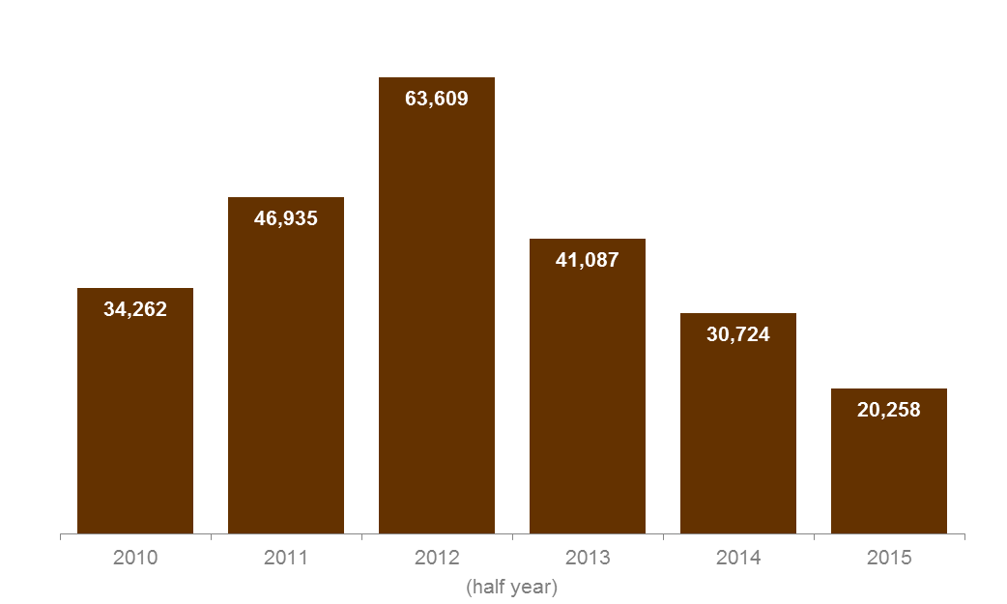

Table 3.6.1: | Number of students and enrolments in government subsidised trainee courses, 2010 to 2015 (half year)
 | 2010 | 2011 | 2012 | 2013 | 2014 | 2015
Students | 33,728 | 46,419 | 63,221 | 40,977 | 30,533 | 20,109
Course Enrolments | 34,262 | 46,935 | 63,609 | 41,087 | 30,724 | 20,258

Table 3.6.2: | Change in number of students and enrolments in government subsidised trainee courses (half year)
 | % change 2010 to 2015 | % change 2011 to 2015 | % change 2012 to 2015 | % change 2013 to 2015 | % change 2014 to 2015
Students | -40% | -57% | -68% | -51% | -34%
Course Enrolments | -41% | -57% | -68% | -51% | -34%

Table 3.7.1: | Government subsidised trainee course enrolments by age group, 2010 to 2015 (half year)
 | 2010 | 2011 | 2012 | 2013 | 2014 | 2015
15 to 19 | 13,851 | 15,512 | 17,349 | 9,879 | 8,128 | 6,269
20 to 24 | 8,158 | 10,260 | 11,719 | 7,259 | 5,633 | 4,650
25 to 44 | 8,735 | 13,725 | 21,251 | 14,287 | 10,247 | 5,937
45 to 64 | 3,421 | 7,250 | 12,926 | 9,350 | 6,510 | 3,304
Other* | 97 | 188 | 364 | 312 | 206 | 98
Total | 34,262 | 46,935 | 63,609 | 41,087 | 30,724 | 20,258
* | ‘Other’ includes age under 15 years old, 65 years and over or not stated.

Table 3.7.2: | Change in number of government subsidised trainee course enrolments by age group (half year)
 | % change 2010 to 2015 | % change 2011 to 2015 | % change 2012 to 2015 | % change 2013 to 2015 | % change 2014 to 2015
15 to 19 | -55% | -60% | -64% | -37% | -23%
20 to 24 | -43% | -55% | -60% | -36% | -17%
25 to 44 | -32% | -57% | -72% | -58% | -42%
45 to 64 | -3% | -54% | -74% | -65% | -49%
Other* | 1% | -48% | -73% | -69% | -52%
Total | -41% | -57% | -68% | -51% | -34%
* | ‘Other’ includes age under 15 years old, 65 years and over or not stated.

Table 3.8.1: | Government subsidised trainee course enrolments by qualification level, 2010 to 2015 (half year)
 | 2010 | 2011 | 2012 | 2013 | 2014 | 2015
Cert I/II | 7,610 | 6,807 | 3,138 | 1,553 | 2,065 | 1,387
Cert III/IV | 25,402 | 35,892 | 51,049 | 33,639 | 26,664 | 17,389
Diploma & above | 1,201 | 4,236 | 9,422 | 5,895 | 1,995 | 1,482
Total* | 34,262 | 46,935 | 63,609 | 41,087 | 30,724 | 20,258
* | The total for 2010 includes 49 enrolments at non-AQF level, e.g. statement of attainment.

Table 3.8.2: | Change in number of government subsidised trainee course enrolments by qualification level (half year)
 | % change 2010 to 2015 | % change 2011 to 2015 | % change 2012 to 2015 | % change 2013 to 2015 | % change 2014 to 2015
Cert I/II | -82% | -80% | -56% | -11% | -33%
Cert III/IV | -32% | -52% | -66% | -48% | -35%
Diploma & above | 23% | -65% | -84% | -75% | -26%
Total* | -41% | -57% | -68% | -51% | -34%
* | The total for 2010 includes 49 enrolments at non-AQF level, e.g. statement of attainment.

Table 3.9.1: | Government subsidised trainee course enrolments by occupation, 2010 to 2015 (half year)
 | 2010 | 2011 | 2012 | 2013 | 2014 | 2015
Clerical and Administrative Workers | 6,243 | 11,403 | 17,246 | 9,984 | 4,863 | 2,958
Community and Personal Service Workers* | 11,072 | 12,199 | 14,370 | 8,752 | 7,330 | 5,996
Labourers** | 4,030 | 6,338 | 9,956 | 6,567 | 6,298 | 4,235
Machinery Operators And Drivers | 1,998 | 3,596 | 5,418 | 5,927 | 6,215 | 2,547
Managers | 254 | 507 | 965 | 839 | 585 | 525
Professionals | 39 | 408 | 963 | 749 | 165 | 86
Sales Workers | 9,140 | 10,898 | 12,663 | 5,711 | 2,606 | 1,292
Technicians And Trades Workers | 1,436 | 1,586 | 2,028 | 2,558 | 2,657 | 2,619
Total*** | 34,262 | 46,935 | 63,609 | 41,087 | 30,724 | 20,258
* | 'Community and Personal Services' occupational category included courses such as Diploma of Early Childhood Education and Certificate III in Hospitality.
** | 'Labourers' occupational category included courses such as Certificate III in Food Processing and Certificate III in Agriculture.
*** | Totals for 2010 and 2014 include a small number of enrolments that were not able to be coded directly into ANZSCO (50 and 5 respectively).

Table 3.9.2: | Change in number of government subsidised trainee course enrolments by occupation (half year)
 | % change 2010 to 2015 | % change 2011 to 2015 | % change 2012 to 2015 | % change 2013 to 2015 | % change 2014 to 2015
Clerical and Administrative Workers | -53% | -74% | -83% | -70% | -39%
Community and Personal Service Workers | -46% | -51% | -58% | -31% | -18%
Labourers | 5% | -33% | -57% | -36% | -33%
Machinery Operators And Drivers | 27% | -29% | -53% | -57% | -59%
Managers | 107% | 4% | -46% | -37% | -10%
Professionals | 121% | -79% | -91% | -89% | -48%
Sales Workers | -86% | -88% | -90% | -77% | -50%
Technicians And Trades Workers | 82% | 65% | 29% | 2% | -1%
Total* | -41% | -57% | -68% | -51% | -34%
* | Totals for 2010 and 2014 include a small number of enrolments that were not able to be coded directly into ANZSCO (50 and 5 respectively).

Table 3.10.1: | Government subsidised trainee course enrolments by industry, 2010 to 2015 (half year)
 | 2010 | 2011 | 2012 | 2013 | 2014 | 2015
Accommodation and Food Services | 5,456 | 6,033 | 7,649 | 3,627 | 2,915 | 1,931
Administrative and Support Services | 3,178 | 4,393 | 4,857 | 2,789 | 1,932 | 1,177
Agriculture, Forestry and Fishing | 776 | 991 | 1,455 | 1,491 | 1,946 | 1,156
Arts and Recreation Services | 1,612 | 1,917 | 2,213 | 826 | 1,391 | 1,349
Construction | 269 | 334 | 695 | 804 | 488 | 361
Cross-industry | 3,625 | 7,289 | 12,045 | 6,710 | 2,832 | 2,225
Education and Training | 252 | 342 | 356 | 959 | 414 | 374
Electricity, Gas, Water and Waste Services | 94 | 106 | 226 | 134 | 72 | 29
Financial and Insurance Services | 243 | 335 | 414 | 325 | 451 | 106
Health Care and Social Assistance | 4,677 | 5,136 | 5,766 | 4,990 | 4,042 | 3,354
Information Media and Telecommunications | 122 | 109 | 92 | 122 | 200 | 229
Manufacturing | 2,270 | 5,327 | 10,072 | 7,759 | 7,225 | 4,675
Mining | 15 | 6 | 10 | 54 | 44 | 9
Other Services | 421 | 399 | 357 | 220 | 258 | 252
Professional, Scientific and Technical Services | 180 | 209 | 259 | 198 | 165 | 141
Public Administration and Safety | 43 | 30 | 68 | 87 | 175 | 82
Rental, Hiring and Real Estate Services | 178 | 205 | 363 | 206 | 154 | 120
Retail Trade | 8,929 | 10,689 | 12,286 | 5,472 | 2,267 | 1,158
Transport, Postal and Warehousing | 1,788 | 2,863 | 4,007 | 4,042 | 3,685 | 1,518
Wholesale Trade | 84 | 222 | 418 | 271 | 64 | 12
Total* | 34,262 | 46,935 | 63,609 | 41,087 | 30,724 | 20,258
* | Totals for 2010 and 2014 include a small number of enrolments that were not able to be coded directly into ANZSIC (50 and 5 respectively).

Table 3.10.2: | Change in number of government subsidised trainee course enrolments by industry (half year)
 | % change 2010 to 2015 | % change 2011 to 2015 | % change 2012 to 2015 | % change 2013 to 2015 | % change 2014 to 2015
Accommodation and Food Services | -65% | -68% | -75% | -47% | -34%
Administrative and Support Services | -63% | -73% | -76% | -58% | -39%
Agriculture, Forestry and Fishing | 49% | 17% | -21% | -22% | -41%
Arts and Recreation Services | -16% | -30% | -39% | 63% | -3%
Construction | 34% | 8% | -48% | -55% | -26%
Cross-industry | -39% | -69% | -82% | -67% | -21%
Education and Training | 48% | 9% | 5% | -61% | -10%
Electricity, Gas, Water and Waste Services | -69% | -73% | -87% | -78% | -60%
Financial and Insurance Services | -56% | -68% | -74% | -67% | -76%
Health Care and Social Assistance | -28% | -35% | -42% | -33% | -17%
Information Media and Telecommunications | 88% | 111% | 150% | 88% | 15%
Manufacturing | 106% | -12% | -54% | -40% | -35%
Mining | -40% | 50% | -10% | -83% | -80%
Other Services | -40% | -37% | -30% | 14% | -2%
Professional, Scientific and Technical Services | -22% | -33% | -46% | -29% | -14%
Public Administration and Safety | 91% | 173% | 21% | -6% | -53%
Rental, Hiring and Real Estate Services | -33% | -41% | -67% | -42% | -22%
Retail Trade | -87% | -89% | -91% | -79% | -49%
Transport, Postal and Warehousing | -15% | -47% | -62% | -62% | -59%
Wholesale Trade | -86% | -95% | -97% | -96% | -82%
Total* | -41% | -57% | -68% | -51% | -34%
* | Totals for 2010 and 2014 include a small number of enrolments that were not able to be coded directly into ANZSIC (50 and 5 respectively).

Training in Areas of Value to the Victorian Economy

Vocational training plays a key role in providing the jobs and skills Victoria’s economy needs to ensure its future growth. This section looks at training which delivers job outcomes – referred to here as ‘industry-aligned training’. This covers government subsidised training in AQF qualifications, and excludes training in foundation skills, education pathways and low-level courses in languages other than English.

Vocational Training to Support Industry Needs
Vocational training delivers a pipeline of skilled workers across a range of industries to meet the current and future skill needs of employers.
Key points
- The number of government subsidised industry-aligned course enrolments reported in 2015 (half year) was 270,340. This was 10 per cent lower than 2014 (half year).
- The decrease in the number of course enrolments in 2015 (half year) was due to a decline across a range of industries, most notably in Transport, Postal and Warehousing (45 per cent lower than in the 2014 half year), Cross-industry (17 per cent lower than in the 2014 half year) and Manufacturing (18 per cent lower than in the 2014 half year).
- Course enrolments have increased in a number of industries over the same period, including Construction (17 per cent higher than in the 2014 half year) and Electricity, Gas, Water and Waste Services (147 per cent higher than in the 2014 half year, from a relatively low base).

Table 4.1.1: | Government subsidised course enrolments in industry-aligned training by industry, 2010 to 2015 (half year)
 | 2010 | 2011 | 2012 | 2013 | 2014 | 2015
Accommodation and Food Services | 15,580 | 20,451 | 30,537 | 17,012 | 18,995 | 14,303
Administrative and Support Services | 7,882 | 11,126 | 16,547 | 9,534 | 7,761 | 5,372
Agriculture, Forestry and Fishing | 4,128 | 4,540 | 6,315 | 4,052 | 6,885 | 4,991
Arts and Recreation Services | 13,959 | 18,227 | 22,508 | 11,813 | 9,709 | 9,968
Construction | 28,042 | 33,394 | 36,402 | 37,552 | 38,623 | 45,271
Cross-industry* | 34,418 | 43,420 | 70,358 | 42,708 | 38,626 | 32,185
Education and Training | 4,629 | 6,616 | 7,034 | 7,744 | 6,486 | 5,448
Electricity, Gas, Water and Waste Services | 627 | 614 | 765 | 339 | 580 | 1,433
Financial and Insurance Services | 819 | 2,320 | 5,264 | 2,047 | 2,163 | 1,279
Health Care and Social Assistance | 30,030 | 39,951 | 54,076 | 56,348 | 71,209 | 69,302
Information Media and Telecommunications | 2,680 | 3,022 | 3,457 | 2,573 | 2,562 | 2,640
Manufacturing | 15,472 | 20,028 | 26,880 | 26,347 | 33,084 | 27,086
Mining | 167 | 107 | 277 | 236 | 219 | 55
Other Services | 11,928 | 13,717 | 15,255 | 14,466 | 14,475 | 14,607
Professional, Scientific and Technical Services | 10,535 | 10,315 | 10,564 | 8,641 | 8,360 | 9,038
Public Administration and Safety | 2,783 | 3,616 | 5,266 | 4,497 | 5,130 | 5,148
Rental, Hiring and Real Estate Services | 434 | 882 | 1,835 | 1,235 | 1,299 | 1,478
Retail Trade | 13,090 | 17,815 | 26,057 | 10,931 | 7,380 | 5,572
Transport, Postal and Warehousing | 7,871 | 12,086 | 20,920 | 20,872 | 27,629 | 15,073
Wholesale Trade | 305 | 493 | 662 | 590 | 685 | 91
Total** | 205,378 | 262,741 | 360,978 | 279,536 | 301,860 | 270,340

* | Cross-industry includes those qualifications which are considered to be relevant across all industries, for example business administration or project management.
** | Totals exclude training in foundation skills, education pathways and low-level courses in languages other than English.

Table 4.1.2: | Change in number of government subsidised course enrolments in industry-aligned training by industry, 2010 to 2015 (half year)
 | % change 2010 to 2015 | % change 2011 to 2015 | % change 2012 to 2015 | % change 2013 to 2015 | % change 2014 to 2015
Accommodation and Food Services | -8% | -30% | -53% | -16% | -25%
Administrative and Support Services | -32% | -52% | -68% | -44% | -31%
Agriculture, Forestry and Fishing | 21% | 10% | -21% | 23% | -28%
Arts and Recreation Services | -29% | -45% | -56% | -16% | 3%
Construction | 61% | 36% | 24% | 21% | 17%
Cross-industry* | -6% | -26% | -54% | -25% | -17%
Education and Training | 18% | -18% | -23% | -30% | -16%
Electricity, Gas, Water and Waste Services | 129% | 133% | 87% | 323% | 147%
Financial and Insurance Services | 56% | -45% | -76% | -38% | -41%
Health Care and Social Assistance | 131% | 73% | 28% | 23% | -3%
Information Media and Telecommunications | -1% | -13% | -24% | 3% | 3%
Manufacturing | 75% | 35% | 1% | 3% | -18%
Mining | -67% | -49% | -80% | -77% | -75%
Other Services | 22% | 6% | -4% | 1% | 1%
Professional, Scientific and Technical Services | -14% | -12% | -14% | 5% | 8%
Public Administration and Safety | 85% | 42% | -2% | 14% | 0%
Rental, Hiring and Real Estate Services | 241% | 68% | -19% | 20% | 14%
Retail Trade | -57% | -69% | -79% | -49% | -24%
Transport, Postal and Warehousing | 92% | 25% | -28% | -28% | -45%
Wholesale Trade | -70% | -82% | -86% | -85% | -87%
Total** | 32% | 3% | -25% | -3% | -10%

* | Cross-industry includes those qualifications which are considered to be relevant across all industries, for example business administration or project management.
** | Totals exclude training in foundation skills, education pathways and low-level courses in languages other than English.

Vocational Training to Support Critical Occupations

To operate efficiently the economy needs the right mix of skills. Enrolments aligned to critical occupations are monitored in order to assess whether the vocational training system is delivering a pipeline of these skills.
Occupations in demand are those in which employers are unable to fill or have considerable difficulty filling vacancies. Shortages in skills and occupations can limit production, increase workforce workloads, impact on safety and limit innovation. Occupations in demand are defined using the Department’s research into occupations experiencing skill need.
Specialised occupations have a long lead-time for training, a high economic value and a significant match between training and employment. While these occupations are not necessarily in demand now, it is important to maintain a sufficient pipeline of these skills as firms would be significantly impacted should they become difficult to access. They are defined using the former Australian Workforce and Productivity Agency’s (AWPA) list of Specialised Occupations.
Occupations which are in demand and/or specialised can be considered critical to the economy. Note that an occupation in demand may also be specialised – for example Electrical Linesworker is both an in demand occupation and a specialised occupation.
Key points
- Course enrolments aligned to occupations in demand have decreased by 5 per cent between 2014 and 2015 (half year), to 109,714 enrolments.
- There were 90,857 enrolments in qualifications associated with specialised occupations in 2015 (half year). This is 1 per cent lower than the same period in 2014.
- The number of government subsidised enrolments related to critical occupations (specialised and/or in demand) reported in 2015 (half year) was 135,666. This represents a 3 per cent decrease in enrolments compared with 2014 (half year).
- The percentage share of industry-aligned enrolments related to critical occupations (specialised and/or in demand) was 50 per cent in 2015 (half year), up from 46 per cent in 2014 (half year).

Table 4.2.1: | Government subsidised industry-aligned course enrolments related to occupations in demand, 2010 to 2015 (half year)
 | 2010 | 2011 | 2012 |  | 2013 | 2014 | 2015
Occupations in demand* | 69,022 | 87,290 | 105,452 |  | 93,975 | 114,919 | 109,714
Other occupations | 150,652 | 191,016 | 270,773 |  | 185,561 | 186,941 | 160,626
Total** | 205,378 | 262,741 | 360,978 |  | 279,536 | 301,860 | 270,340
* | Occupations in demand are as defined by the Department of Education & Training.
** | Totals exclude training in foundation skills, education pathways and low-level courses in languages other than English.
Note there is a break in series between 2012 and 2013, in line with the Department’s update to its list of skill needs in 2013.

Table 4.2.2: | Government subsidised industry-aligned course enrolments related to specialised occupations, 2010 to 2015 (half year)
 | 2010 | 2011 | 2012 | 2013 |  | 2014 | 2015
Specialised occupations* | 44,849 | 50,024 | 57,020 | 57,980 |  | 92,058 | 90,857
Other occupations | 160,529 | 212,717 | 303,958 | 221,556 |  | 239,126 | 205,918
Total** | 205,378 | 262,741 | 360,978 | 279,536 |  | 301,860 | 270,340
* | Specialised occupations are as defined by the former Australian Workforce and Productivity Agency.
** | Totals exclude training in foundation skills, education pathways and low-level courses in languages other than English.
Note there is a break in series between 2013 and 2014, in line with AWPA’s update to its Specialised Occupation List in 2014.

Table 4.2.3: | Government subsidised industry-aligned course enrolments related to critical occupations (in demand and/or specialised), 2010 to 2015 (half year)
 | 2010 | 2011 | 2012 | 2013 | 2014 | 2015
Critical occupations* | 76,251 | 92,534 | 112,124 | 116,160 | 139,611 | 135,666
Other occupations | 129,127 | 170,207 | 248,854 | 163,376 | 162,249 | 134,674
Total** | 205,378 | 262,741 | 360,978 | 279,536 | 301,860 | 270,340
* | Critical occupations are as defined by the former Australian Workforce and Productivity Agency (specialised occupations) and the Department of Education & Training (occupations in demand).
** | Totals exclude training in foundation skills, education pathways and low-level courses in languages other than English.
Note there is a break in series between 2012 and 2013 and between 2013 and 2014, in line with updates to the respective source lists.

Figure 4.1: | Percentage share of government subsidised industry-aligned course enrolments related to critical occupations (specialised and/or in demand), 2010 to 2015 (half year)
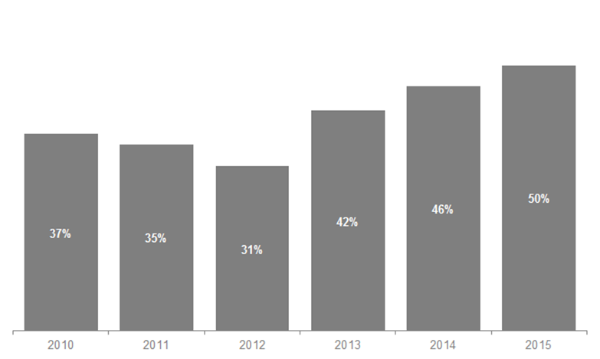
(half year)

Vocational Training in Priority Growth Sectors

The Victorian Government has identified a number of priority sectors which are primed for growth. These are:
- Food and Fibre
- International Education
- Medical Technologies and Pharmaceuticals
- New Energy Technology
- Professional Services
- Defence, Construction and Transport Technologies
Vocational training is one pathway into employment in these sectors. Higher education also plays an important role in skilling the future workforce and, in sectors such as international education and professional services, will account for a higher proportion of employment than vocational training.
Certain sectors, such as medical technology and pharmaceuticals or new energy technology, represent niche or emerging areas in the Victorian economy. As such, training delivery directly aligned to these industries is limited at this stage.
Key points
- The number of government subsidised course enrolments related to the Government’s priority growth areas was 61,864 in 2015 (half year).
- This comprised 23 per cent of total industry-aligned training in 2015 (half year).
- Course enrolments have decreased across a majority of sectors between 2014 and 2015 (half year). The exception to this is Professional Services, where course enrolments have increased by 4 per cent over the period.

Table 4.3.1: | Government subsidised industry-aligned course enrolments related to priority growth sectors, 2010 to 2015 (half year)
 | 2010 | 2011 | 2012 | 2013 | 2014 | 2015
Food and Fibre | 10,567 | 12,054 | 14,920 | 13,086 | 18,089 | 15,654
International Education | 2,907 | 3,507 | 4,125 | 2,829 | 2,762 | 2,543
New Energy Technology | 432 | 451 | 211 | 234 | 49 | 9
Professional Services | 27,088 | 27,621 | 33,641 | 24,478 | 23,338 | 24,349
Transport, Defence and Construction Technology | 3,511 | 6,227 | 10,040 | 13,077 | 20,785 | 19,309
Other industry training | 160,873 | 212,881 | 298,041 | 225,832 | 236,837 | 208,476
Total* | 205,378 | 262,741 | 360,978 | 279,536 | 301,860 | 270,340
* | Totals exclude training in foundation skills, education pathways and low-level courses in languages other than English.
Note that there has been no vocational training delivery in courses directly aligned to Medical Technologies and Pharmaceuticals sector.

Table 4.3.2: | Government subsidised industry-aligned course enrolments related to priority growth sectors, 2010 to 2015 (half year)
 | % change 2010 to 2015 | % change 2011 to 2015 | % change 2012 to 2015 | % change 2013 to 2015 | % change 2014 to 2015
Food and Fibre | 48% | 30% | 5% | 20% | -13%
International Education | -13% | -27% | -38% | -10% | -8%
New Energy Technology | -98% | -98% | -96% | -96% | -82%
Professional Services | -10% | -12% | -28% | -1% | 4%
Transport, Defence and Construction Technology | 450% | 210% | 92% | 48% | -7%
Other Industry Training | 30% | -2% | -30% | -8% | -12%
Total* | 32% | 3% | -25% | -3% | -10%
* | Totals exclude training in foundation skills, education pathways and low-level courses in languages other than English.
Note that there has been no vocational training delivery in courses directly aligned to Medical Technologies and Pharmaceuticals sector.

‘Government-funded Students and Courses’, 2014 (revised September 2015), NCVER. NCVER includes fee-for-service activity from both TAFEs and Universities as government-funded.
The six priority growth sectors are: Food and Fibre International Education Medical Technologies and Pharmaceuticals New Energy Technology Professional Services Defence, Construction and Transport Technologies
Student engagement in pre-accredited and accredited training is not mutually exclusive.
Young People (aged 15 to 19) Without Year 12 or Equivalent and Not at School enrolled in Certificate II or above, this excludes students who may undertake a senior secondary program in VET (i.e. VCE or VCAL) or studies at the Certificate I level, including some Foundation courses.
Early school leavers are young people (aged 15 to 19 years) without Year 12 or equivalent and not at school enrolled in government subsidised training, may include training at Certificate level or senior secondary programs (i.e. VCE or VCAL).
NCVER media release 17 May 2013

