The Vocational Education & Training Market   
Quarter 1 2013

**Overview**

Between 2008 and 2012 there was a 76 per cent increase in government funded enrolments in the Victorian VET system. In 2012 over 600,000 people were training in Victoria. The vast majority of these, nearly 510,000, were in government subsidised training, up 18 per cent from 2011. Steady growth has occurred at all qualification levels and across TAFE, private and adult and community education providers.

There were 278,200 government subsidised enrolments in the first quarter of 2013. While the data is preliminary (see note on last page), it does represent a reduction of 7 per cent when compared to Q1 2012. In contrast, there was marked growth in vocational training activity in areas of critical importance to the Victorian economy, addressing skills shortages and occupations with specialised skill requirements. Government subsidised enrolments in these areas have increased by 4 per cent.

**VET Performance in Victoria**

There were 21,000 fewer government subsidised enrolments in the first quarter of 2013 when compared to Q1 2012. However, these figures should be considered in a broader context; there was a 28 per cent increase (an increase of 61,500 enrolments) compared to the same period in 2011. Similarly, there were 38,700 TAFE domestic fee for service[1] enrolments in Q1 2013. This is down by 6 per cent (or 2,500 enrolments) compared to Q1 2012, but up by 12 per cent (4,200 extra enrolments) compared to the same quarter in 2011. This trend of year-on-year growth followed by a decline between Q1 2012 and Q1 2013 occurred across all provider types, i.e. TAFE, private and adult and community education providers.

**Chart 1: Government Subsidised and TAFE Fee for Service Enrolments, 2008 to 2012, Q1 2011 to Q1 2013**

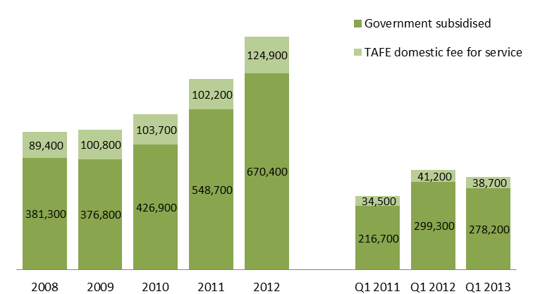

**Government Subsidised Training Delivery**

The number of students enrolled in government subsidised VET training was 226,000 in Q1 2013, representing a   
9 per cent decline compared to Q1 2012. Student contact hours decreased by 5 per cent over the same period.

**Table 1: Government Subsidised VET delivery, 2008 to 2012, Q1 2012 and Q1 2013**



**Responsiveness to Industry Skills Needs**

Training delivery against skill needs for specific industry sectors shows positive performance with a 4 per cent increase in government subsidised enrolments in courses related to specialised or in shortage occupations (81,100 enrolments at Q1 2012 to 84,600 at Q1 2013). Training in these critical courses now accounts for 40 per cent of government subsidised enrolments (excluding foundation and short courses) up from 33 per cent at the same point last year. This has been driven by strong growth in the health care and welfare sector (particularly childcare, and aged and disability carers), and moderate increases for training in road transport and auto mechanics.

**Profile of Vocational Education and Training Government Subsidy**

As part of the Refocusing VET reform, from July 2012 five funding bands for government subsidised training were introduced. The funding is highest in areas that provide the greatest contribution to employment and productivity. The subsidies for training where there is not a strong need and good employment prospects have been reduced to better target areas of greatest public benefit and future jobs growth.

Proportionally there has been a marked shift in commencement patterns when comparing the first quarter of 2013 with Q1 2012. Figures from the first quarter of 2013 show 65 per cent of all government subsidised commencing enrolments were within subsidy bands A and B (Chart 2). This compared with 52 per cent of commencements in subsidy bands A and B in Q1 2012. Courses with less vocational outcome, or in labour market oversupply (Band D & E) represented 11 per cent of all government subsidised commencements in the first quarter of 2013, down from 25 per cent over the same period in 2012.

**Chart 2: Commencing enrolments by Funding Bands, Q1 2012, Q1 2013 and July-December 2012**

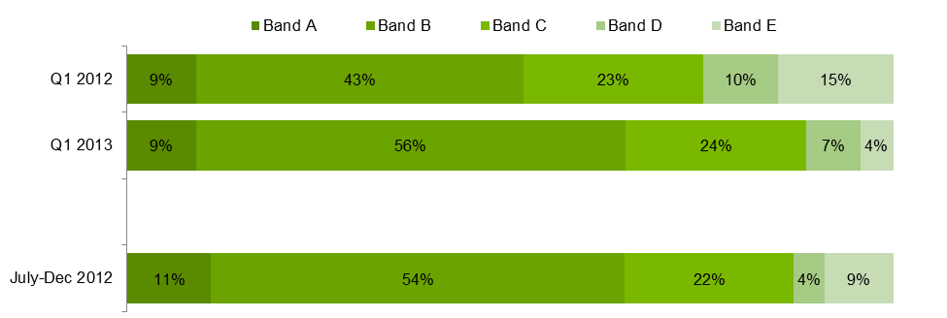

**Apprenticeships and traineeships**

Approximately half of the fall in government subsidised enrolments in Q1 2013 can be attributed to a reduction in apprenticeship and traineeship training. In Q1 2013 there were 61,800 government subsidised apprentice and trainee enrolments, which represents a 16 per cent decline (or 12,100 fewer enrolments) compared to Q1 2012.

These trends are attributable to a number of factors. Apprentice numbers are highly correlated with business conditions. Fifty six per cent of all apprentices are employed in the construction sector which has faced a challenging 12 months.

**Chart 3: Government Subsidised Enrolments by Apprentices and Trainees, 2008 to 2012, Q1 2011 to Q1 2013**

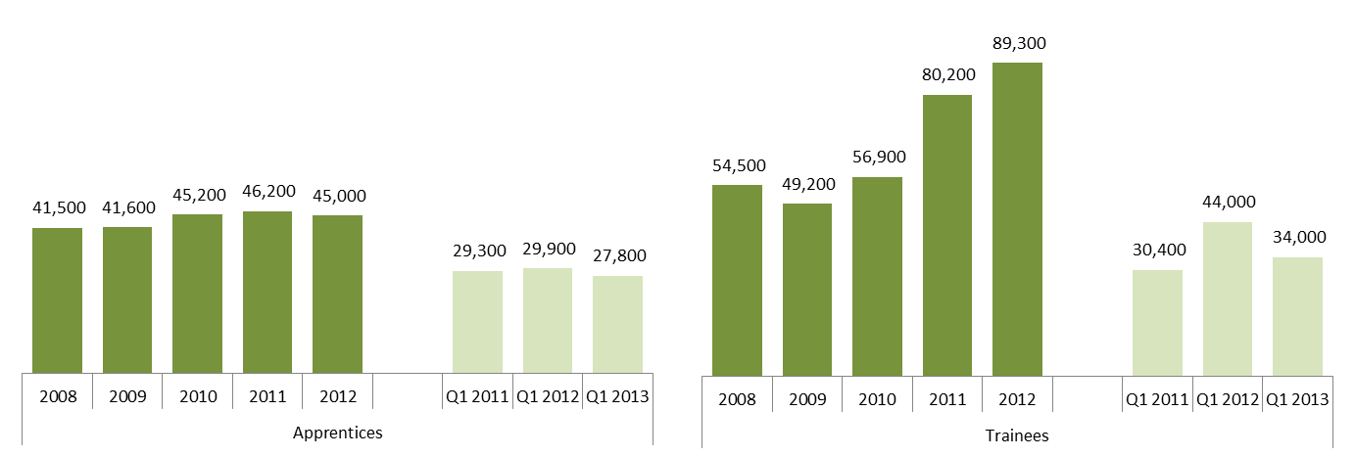

**Delivery by qualification level**

The number of government subsidised enrolments at the Certificate I-II levels increased by 2,300 or 4 per cent in the first quarter of 2013 compared to Q1 2012, but there were declines in enrolments at the Certificate III-IV levels (down by 6 per cent) Diploma & Above (down by 17 per cent), Module only training (down by 16 per cent) and secondary school subjects (down by 16 per cent). Government subsidised enrolments in Diploma & above courses were broadly at similar levels to that in Q1 2011.

Proportionally, Certificate III to IV remains the largest qualification group (60 per cent) across Australian Qualification Framework (AQF) courses (i.e. Certificate I-II, Certificate III-IV and Diploma & Above).

**Chart 4: Government Subsidised Enrolments by Qualification Level, Q1 2011 to Q1 2013**

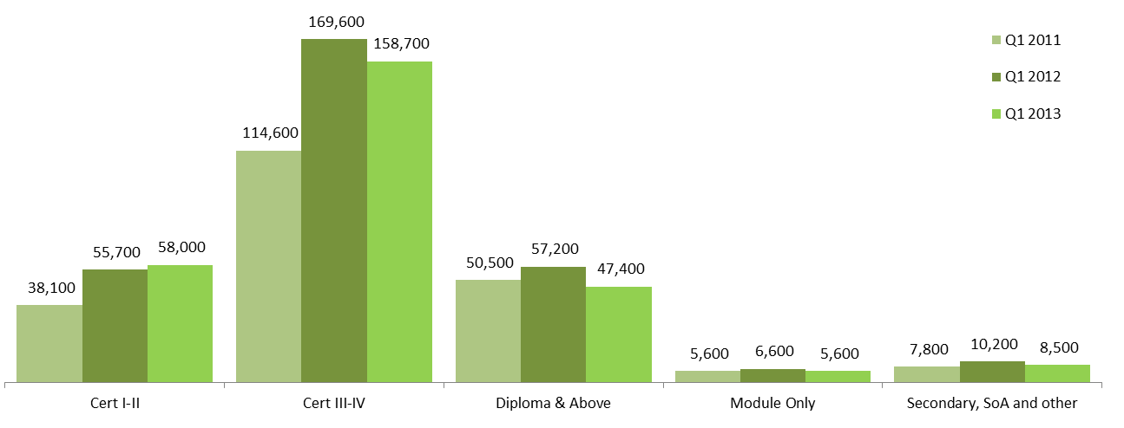

**Government Subsidised Training Delivery by Regional Area, by Higher Need Learners**

The first quarter of 2013 data show that the overall decline in government subsidised course enrolments has occurred across most regions compared to Q1 2012, except Hume, Western Metropolitan and Northern Metropolitan region areas which show an increase of 42 per cent, 3 per cent and 2 per cent respectively.

**Chart 5: Government Subsidised Enrolments by regional area, Q1 2011 to Q1 2013**

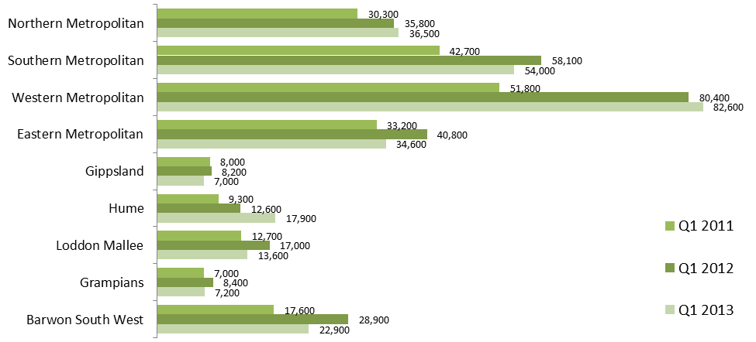

Against a drop of 9 per cent in overall student numbers in Q1 2013 when compared to Q1 in 2012, higher need learners are still actively engaged in vocational education and training. The preliminary data show that there were small increases in the numbers of Indigenous students and unemployed students undertaking government subsidised training courses in Q1 2013.

**Table 2: Number of Government Subsidised Students by Higher Needs Learner Group*, 2008 to 2012, Q1 2012 and Q1 2013**



*Numbers in the above cohort groups are not mutually exclusive. CALD – Culturally and Linguistically Diverse

**Notes about the data**

*The Victorian Training Market Report is compiled on the basis of training activity data submitted to the Department of Education and Early Child Development by funded training providers. Data included in the Report is based on reported date, i.e. the date training activity data is submitted to the Department. Quarter 1 2013 includes training activity data that was submitted to the Department between January and March 2013.*

*The commentary contained in the report generally compares first quarter reported figures for 2013 with first quarter figures in 2012. Full year figures from 2008 to 2012 are included to show longer term trends. The figures in the first quarter are a snapshot in time and should be treated as indicative only as they are based on preliminary enrolment data reported to the Department by training providers.*

*In some cases some providers may not have submitted their full quarter’s training data which could impact on the overall state result for the quarter. In particular, some providers may have students who have commenced a course in the later part of a quarter and as a consequence of provider processes this information may not be reported to the Department until the following quarter. For example, two TAFEs had about 2,000 course commencements that occurred in Quarter 1 2013, but were not reported until Quarter 2 2013 (quarter so far i.e. April-May 2013). Such activity not reported in Quarter 1 will be included as part of the Quarter 2 Training Market Report, which will include training activity cumulative up to June 2013.*

*All data is subject to change until the end of the calendar year.*

*Owing to the preliminary nature of this VET data, figures in the first quarter should be treated as being indicative only. Figures are generally rounded to the nearest 100.*

1. *Data includes government subsidised activities in all sectors at all qualification levels, and domestic fee for service activities in the TAFE sector at Australian Qualification Framework (Certificate I and above).*